Real-World E-Commerce
Microservices Architecture
HLD, LLD, React Frontend, Docker/Kubernetes, Kafka, AWS, CI/CD & Payment Idempotency — Architecture Review Edition
A Complete, End-to-End System Design Walkthrough for a Node.js + React E-Commerce Platform

Prepared by: Vicky Kumar

Topics: HLD · LLD · React State Management · Cart Service · Docker/Kubernetes · Kafka · Database Design · AWS · CI/CD · Payment Idempotency · Refunds & Reconciliation · Observability

Contents
Part I — Requirements & Architecture
1. Executive Summary
1.1 Architecture Review — Priority Improvements
2. High-Level Design (HLD) — includes Functional & Non-Functional Requirements
3. Low-Level Design (LLD) — Order Service
4. Frontend Architecture — React Application
5. Monolith vs. Microservices
6. Decomposing a System (Domain-Driven Design)
Part II — Communication & Data
7. Service Communication: Synchronous & Asynchronous
8. Apache Kafka Deep Dive
9. Database Design, Optimization & Selection Rationale
10. Error Handling & Cascading Failure Prevention
11. Idempotency Deep Dive: Payment APIs
Part III — Infrastructure & Deployment
12. Docker & Kubernetes: How They Fit
13. AWS Services Mapping & Deployment Architecture
14. CI/CD Pipeline
Part IV — Operations & Quality
15. Logging & Monitoring in Production
16. Production Directory Structure
17. Step-by-Step Code Walkthrough
18. Putting It All Together: End-to-End Flow
19. System-Wide Edge Cases
20. Common Pitfalls in Production Systems
21. Key Takeaways & Production Readiness
Part V — Appendices
Appendix A: Architecture Decision Records (ADRs)
Appendix B: Capacity Planning & Traffic Estimation
Appendix C: Threat Model (STRIDE) for Checkout & Payment
Appendix D: Security Architecture — Defense in Depth
Appendix E: Distributed Systems Concepts Reference

1. Executive Summary
This document is a full system-design pass over an e-commerce platform, presented the way it would be reviewed in a real engineering organization: first the High-Level Design (HLD) — the big picture of services, data flow, and infrastructure — then the Low-Level Design (LLD) — the internal structure of one service in enough detail to actually implement it. Around that core, this guide covers the operational concerns that separate a toy demo from a production system: how Docker and Kubernetes package and run the services, how Apache Kafka moves events between them reliably at scale, how each service's database is modelled, and how the system is observed once it's live (logging, metrics, tracing, alerting).

1.1 Architecture Principles

One service owns each business capability and its data; other services integrate through APIs and domain events, never direct database access.
Checkout follows one canonical Saga: Order → Inventory Reservation → Payment → Order Confirmation → Fulfillment → Notification, with durable compensation and reconciliation.
Critical mutations are idempotent, database-to-event publication uses an outbox, and important consumers use inbox/deduplication.
Production readiness is measured through SLOs, business signals, capacity assumptions, security controls, tested recovery and safe deployment automation.
💡 Convention used throughout: solid arrows in diagrams represent synchronous (request/response) calls; dashed arrows represent asynchronous, event-driven communication through Kafka; dotted arrows represent telemetry (metrics/logs) flowing to the observability stack.

2. High-Level Design (HLD)
High-Level Design answers one question: "What are the major moving parts, and how do they fit together?" It deliberately stays away from class names or SQL columns — that's LLD's job (Section 3). HLD is what you'd sketch on a whiteboard in a design-review meeting.

2.1 Functional Requirements
Functional requirements describe WHAT the system must let a shopper, and the business, actually do — independent of how it's built. Everything else in this document exists to satisfy this list under the constraints in Section 2.2.
ID | Requirement | Primary service(s)
FR-1 | A visitor can register, log in, and log out; sessions persist via JWT + refresh tokens. | Auth & User
FR-2 | A shopper can browse, search, and filter the product catalog, and view a single product's details. | Product Catalog
FR-3 | A shopper can add items to a cart, adjust quantities, and remove items, with cart state surviving a page reload. | Cart Service + Frontend
FR-4 | A shopper can place an order for the items in their cart, providing a shipping address. | Order
FR-5 | The system reserves stock for an order and prevents overselling when demand exceeds available inventory. | Inventory
FR-6 | A shopper can pay for an order via a card or wallet through a third-party payment gateway. | Payment
FR-7 | A shopper receives an email/SMS confirmation when an order is placed, paid, and shipped. | Notification
FR-8 | A shopper can view their order history and the current status of an in-progress order in real time. | Order + Frontend
FR-9 | A retried or duplicated request (network retry, double-click, duplicate event delivery) never results in a duplicate order or duplicate charge. | Order + Payment (Section 11)
FR-10 | An admin can provision, monitor, and redeploy the underlying infrastructure and services without shopper-facing downtime. | Platform / Admin (Section 13)
💡 FR-9 and FR-10 are easy to overlook because no shopper explicitly "asks" for them, but they are functional requirements in the same sense as FR-4 — the system either behaves correctly under retries and redeploys, or it doesn't. Treating them as functional (not just "nice-to-have" reliability work) is why Sections 3.4, 10, and 11 exist at all.

2.2 Non-Functional Requirements
Non-functional requirements describe HOW WELL the system must do the above — the quality attributes and constraints that shape every architectural decision in the rest of this document, even though a shopper never sees them directly.
Requirement | Target / Approach
Availability | 99.9%+ — no single service outage should take down checkout or browsing entirely (fault isolation, circuit breakers).
Scalability | Each service scales independently via Kubernetes HPA based on CPU/traffic; Product Catalog and Order scale far more than Auth.
Consistency | Strong consistency (ACID) within a service's own database; eventual consistency across services via Kafka events.
Latency | Client-facing reads (catalog, order status) target < 200ms p95 via Redis caching and indexed queries.
Durability | Kafka replication factor 3 + database backups/snapshots ensure no data loss on node failure.
Observability | Every request traceable end-to-end via correlation IDs, centralized logs, and metrics dashboards (Sections 10 & 15).
Security | TLS everywhere, JWT-based auth at the Gateway, least-privilege IAM per service (Section 13.8), and PCI-DSS scope minimized by never storing raw card data — Payment forwards directly to Stripe/PayPal (Section 8's external gateway).
Maintainability | Service boundaries follow SRP/Bounded Context (Section 6) so one team can change one service without coordinating a lockstep release across all six.
Cost efficiency | Managed AWS services (Section 13) trade a per-unit cost premium for eliminated operational burden; HPA and right-sized resource requests (Section 12.5) avoid paying for idle capacity.
Disaster recovery | RPO/RTO targets defined per data store (Section 13.11), not left implicit.
💡 Every NFR above maps to a specific mechanism described later, rather than being an aspiration: Availability → Section 10's circuit breakers and Section 12.6's PodDisruptionBudgets; Scalability → Section 12.2's HPA; Consistency → Section 9.5's Saga pattern; and so on. If a future requirement can't be traced to a concrete mechanism this way, that's a sign the design doesn't actually satisfy it yet.

2.3 Services in the System
The platform is decomposed into seven business services plus an API Gateway. Cart is an explicit capability because cart persistence, guest-cart merging and checkout preparation have their own lifecycle and consistency rules.
Service | Responsibility | Talks to
API Gateway | Single entry point: auth, rate limiting, routing, SSL termination. | All services (sync)
Auth & User Service | User profiles, JWT issuance, RBAC. | Gateway (sync)
Product Catalog Service | Product listings/details, Redis-cached reads. | Gateway (sync)
Cart Service | Cart contents, quantities, persistence and checkout-ready cart view. | Gateway (sync); Redis/PostgreSQL
Order Service | Order creation, checkout workflow, order state machine. | Gateway (sync); Kafka (async publish)
Inventory Service | Stock levels, reservations, warehouse sync. | Kafka (async consume/publish)
Payment Service | Stripe/PayPal integration, transaction processing. | Kafka (async consume/publish); external gateway (sync)
Notification Service | Emails/SMS on order and payment events. | Kafka (async consume only)

2.4 System Architecture Diagram
The diagram below is the single most important artifact in this document — every later section zooms into one piece of it.
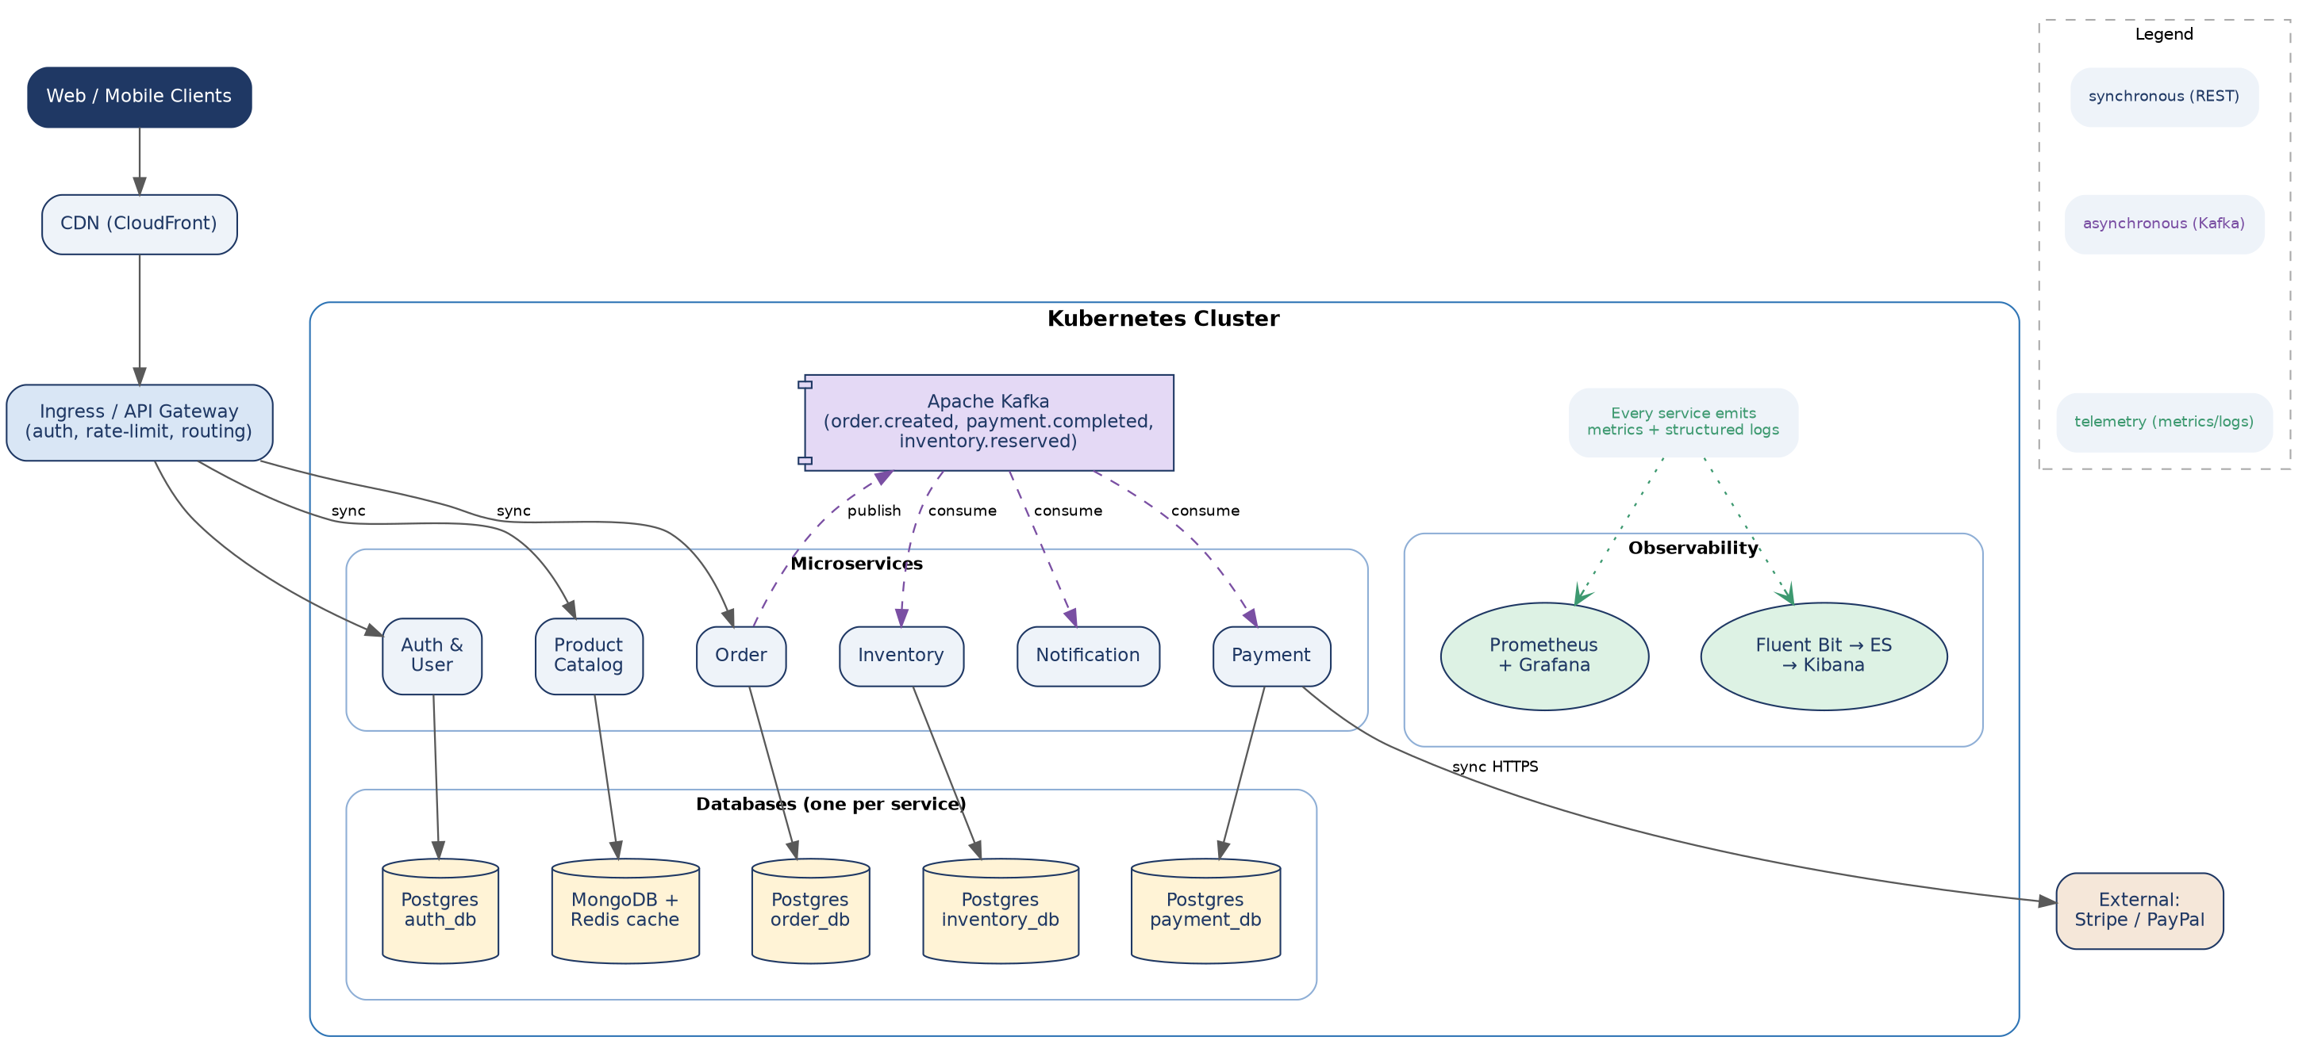
Figure 1 — High-level architecture: client traffic, Kubernetes-hosted services, per-service databases, the Kafka event backbone, and the observability stack.

2.5 Reading the Diagram: Two Kinds of Traffic
Notice the two distinct paths through the system:
- Solid arrows (synchronous): the client's request path — Client → CDN → Ingress/Gateway → a service → its database → response. This path must be fast because a human is waiting.
- Dashed arrows (asynchronous): the event path — a service publishes to Kafka, and any number of other services consume independently, on their own schedule. Nothing on this path blocks the original client request.
Section 7 explains why this split exists, and Section 18 walks through one complete order from the moment a client clicks "Buy" to the confirmation email being sent, referencing exactly these two paths.

3. Low-Level Design (LLD) — Order Service
If HLD is the map, LLD is the street-level view of one building. We zoom into the Order Service — the most business-critical service — and design it down to layers, classes/modules, and the database transaction boundary.

3.1 Internal Architecture Diagram
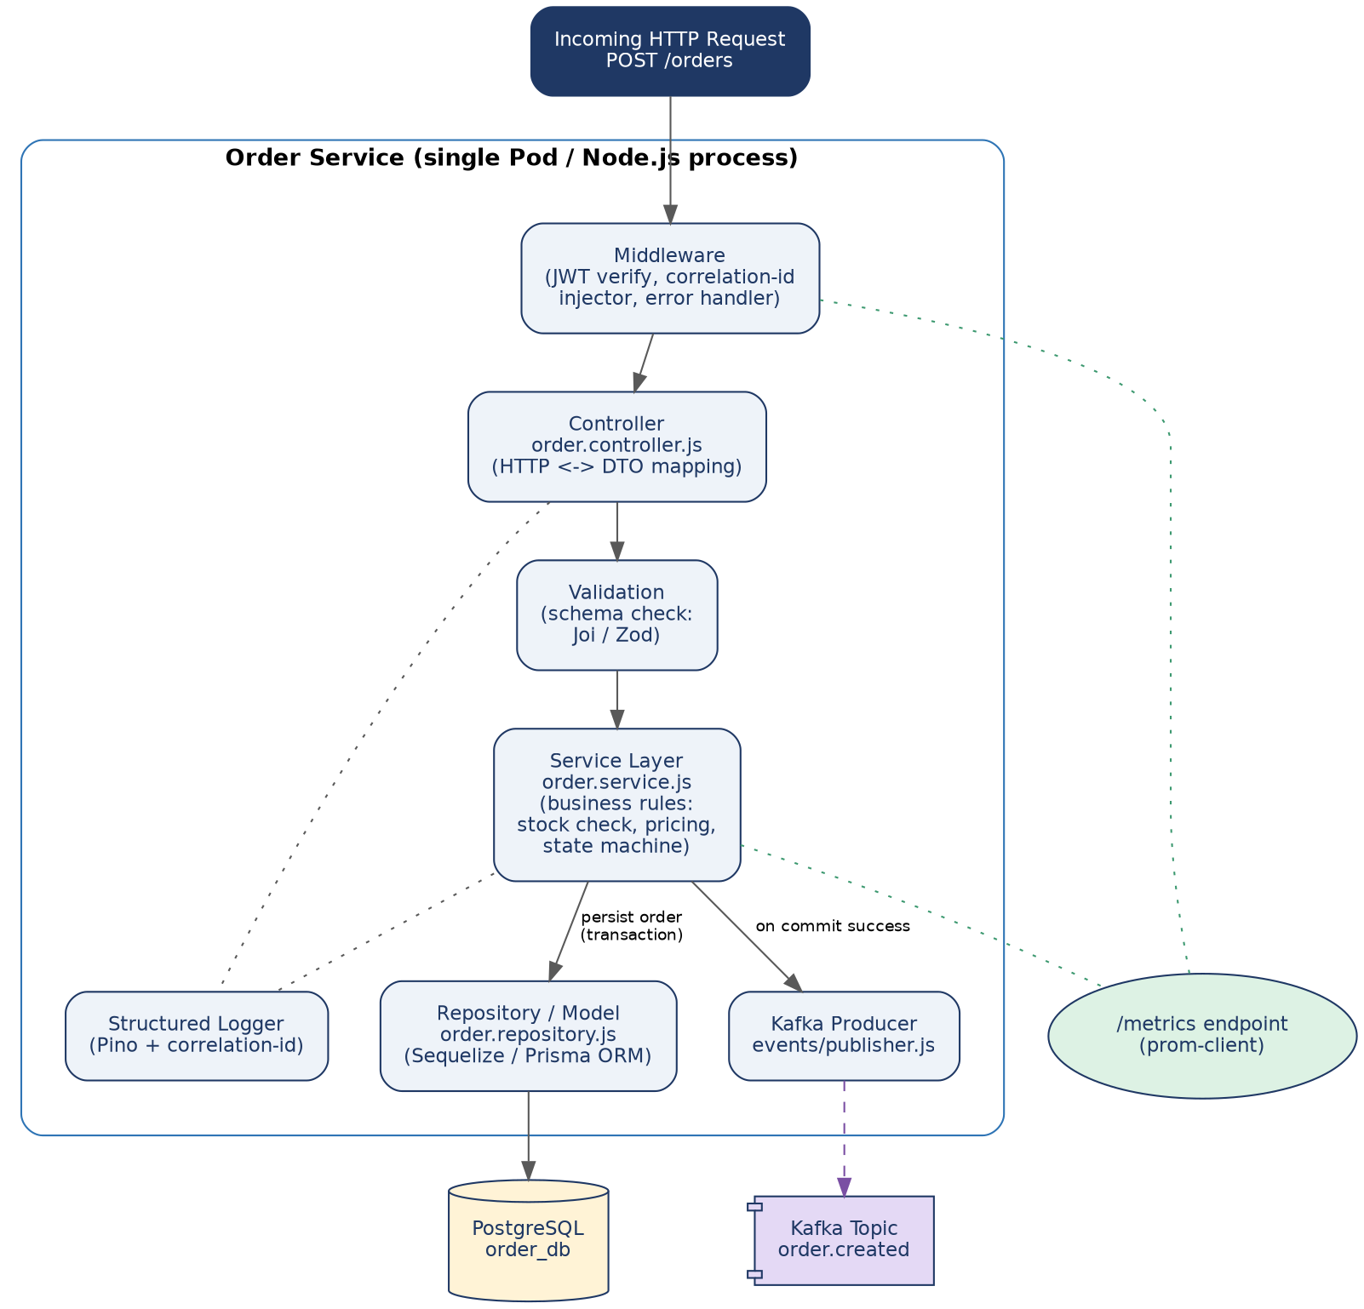
Figure 2 — Order Service internals: one HTTP request flows top-to-bottom through middleware, controller, validation, business logic, and out to both the database and Kafka.

3.2 Layer Responsibilities
Layer | Responsibility | Should NOT do
Middleware | JWT verification, inject/propagate x-correlation-id, catch unhandled errors. | Business logic or DB access.
Controller | Parse HTTP request into a DTO, call the service layer, format the HTTP response. | SQL queries or pricing rules.
Validation | Schema-check the incoming payload (Joi/Zod) before it reaches business logic. | Talk to the database.
Service (business logic) | Stock availability check, price calculation, order state transitions. | Know about Express, HTTP status codes, or SQL syntax.
Repository / Model | The ONLY layer allowed to run queries; maps rows ↔ domain objects (ORM). | Contain business rules.
Kafka Producer | Serialize and publish domain events after a successful DB commit. | Decide business rules about when to publish.

3.3 Order State Machine
The Order Service's core business rule is a state machine — an order can only move forward through specific, valid transitions. Modeling this explicitly (rather than as a loose status string anyone can overwrite) prevents invalid states like a "shipped" order silently reverting to "pending."
Current State | Event | Next State
PENDING | Inventory reserved (inventory.reserved event) | STOCK_RESERVED
PENDING | Inventory unavailable / reservation expired | CANCELLED
STOCK_RESERVED | Payment completed (payment.completed event) | CONFIRMED
STOCK_RESERVED | Payment failed / timeout | CANCELLED
CONFIRMED | Fulfillment starts | PROCESSING
PROCESSING | Warehouse ships the order | SHIPPED
SHIPPED | Carrier confirms delivery | DELIVERED
PENDING / STOCK_RESERVED / CONFIRMED | Customer or system cancels | CANCELLED

3.4 Concurrency Control: What Happens When Requests Collide
This is one of the most common real-world questions, and the state machine in Section 3.3 doesn't answer it by itself: what actually happens when two requests hit the system at almost the same instant? There are two distinct scenarios, and this system handles them with two different techniques.
Scenario A: Two different shoppers buy the last unit of a product
Shopper A and Shopper B both click "Buy" on the last remaining unit within milliseconds of each other. Both requests reach separate pods of the Inventory Service (Figure 5) at nearly the same time.
The naive, broken approach reads the quantity, checks it in application code, then writes:
// BROKEN — classic check-then-act race condition
const stock = await db.query('SELECT quantity FROM stock_levels WHERE product_id = $1', [id]);
if (stock.quantity > 0) {
await db.query('UPDATE stock_levels SET quantity = quantity - 1 WHERE product_id = $1', [id]);
// Both A and B can pass the check above before EITHER has written —
// both proceed, quantity goes to -1, and the product is oversold.
}

The fix is to never let application code decide based on a value it read a moment ago — push the check INTO the same atomic SQL statement as the write, so the database's own row lock does the deciding:
// CORRECT — the WHERE clause makes the check and the write one atomic operation
const result = await db.query(
'UPDATE stock_levels SET quantity = quantity - 1 WHERE product_id = $1 AND quantity >= 1',
[productId]
);

if (result.rowCount === 0) {
throw new OutOfStockError(productId); // someone else got there first — or it was already 0
}
// rowCount === 1 means THIS request's decrement is the one that succeeded, guaranteed by
// Postgres taking a row-level lock for the duration of the UPDATE.
Whichever request's UPDATE reaches Postgres first acquires a row lock on that stock_levels row; the second request's UPDATE simply waits until the first transaction commits, then re-evaluates quantity >= 1 against the now-updated value and correctly fails with rowCount = 0. Nothing in the application code has to know locking happened — the database guarantees it.
Scenario B: The same shopper's checkout click fires twice
A slow network causes the browser to retry, or the shopper double-clicks "Place Order" before the button visually disables. This is NOT a stock race — it's a duplicate-request problem, and it's solved differently: by the Idempotency-Key pattern (Section 11), not by database locking. The frontend (Section 4.5) generates one key per checkout attempt and sends the same key on both the original click and any retry, so the Order Service's idempotency check (Section 11.1) short-circuits the second request and returns the first request's result instead of creating a second order.
💡 Rule of thumb used throughout this design: races between DIFFERENT requests for the SAME resource (two shoppers, one stock row) are solved with atomic SQL / row locks. Duplicate delivery of the SAME logical request (retries, double-clicks, at-least-once Kafka redelivery) is solved with idempotency keys. They look similar but need different fixes — using idempotency keys alone would not stop two different shoppers from oversubscribing stock, and using row locks alone would not stop a single retried request from creating two orders.

Locking Strategies Used in This System
Strategy | How it works | Where it's used here
Atomic conditional UPDATE | The check and the write are the same SQL statement; the database's row lock makes it safe with zero application-level locking code. | Inventory decrement (Scenario A above) — the simplest and cheapest option whenever the operation is a single-row, single-statement change.
Pessimistic locking (SELECT ... FOR UPDATE) | Explicitly locks a row for the duration of a multi-statement transaction, blocking other transactions from reading-for-update the same row until commit. | Order state transitions that involve reading the current state, validating a transition is legal (Section 3.3's table), and THEN writing — a single UPDATE can't express "only if the current status is PENDING" as cleanly as a locked read-check-write.
Optimistic locking (version column) | Each row has a version integer; updates include WHERE version = :expected and increment it, failing (0 rows affected) if another writer already moved the version forward. | Order updates driven by Kafka consumers, where two consumer instances could theoretically process related events for the same order close together — optimistic locking detects the conflict without holding a database lock for the entire event-processing duration.
-- Pessimistic locking example: transitioning an order's state safely
BEGIN;
SELECT status FROM orders WHERE id = $1 FOR UPDATE; -- locks this row; other transactions
-- trying to lock it now wait here
-- application code checks: is 'PENDING' -> 'CONFIRMED' a legal transition (Section 3.3)?
UPDATE orders SET status = 'CONFIRMED', updated_at = now() WHERE id = $1;
COMMIT; -- lock is released; any waiting transaction now sees the NEW status
-- Optimistic locking example: a Kafka consumer updating order status
UPDATE orders
SET status = 'PROCESSING', version = version + 1
WHERE id = $1 AND version = $2; -- $2 is the version this consumer last read
-- rowCount === 0 means another writer updated this order first; re-fetch and decide
-- whether to retry, skip (already handled), or raise for manual review.
💡 Postgres's default isolation level (READ COMMITTED) is sufficient for all three techniques above because each relies on row-level locking or a version check rather than on transaction-level snapshot guarantees. SERIALIZABLE isolation is deliberately avoided for hot paths like checkout — it prevents anomalies none of these flows are exposed to, while adding serialization-failure retries the team would otherwise not need to handle.

3.5 Sample API Contract
A concrete REST contract for creating an order — this is what the Gateway proxies through to the Order Service's controller.
POST /api/v1/orders
Headers: Authorization: Bearer <jwt>, x-correlation-id: <uuid>, Idempotency-Key: <uuid>
Request body:
{
"items": [{ "productId": "p-101", "quantity": 2 }],
"shippingAddress": { "line1": "...", "city": "Noida", "zip": "110001" }
}
Response 201 Created:
{
"orderId": "o-8841",
"status": "PENDING",
"totalAmount": 2499.00,
"createdAt": "2026-09-04T10:12:00Z"
}
A clear request/response contract like this is what LLD should produce — precise enough that a frontend and backend engineer can build against it independently.

3.6 API Versioning Strategy
The contract in Section 3.5 will change over time — a new required field, a renamed key, a different validation rule. Without a versioning strategy, changing it breaks every client that hasn't updated yet, including the mobile app version still installed on shoppers' phones from six months ago.
Approach | How it works | Why chosen here
URI versioning | /api/v1/orders vs. /api/v2/orders | Chosen for this system: it's visible in logs and API gateway routing rules at a glance, making it trivial to route v1 and v2 traffic to different service versions during a migration.
Header versioning | Accept: application/vnd.ecommerce.v2+json | Rejected as primary strategy: correct but invisible in casual log inspection and harder to test with a browser URL bar — reserved as a secondary option for fine-grained per-resource versioning if URI versioning ever proves too coarse.
No versioning (evolve in place) | Only ever add optional fields, never remove or repurpose one | Used WITHIN a version wherever possible — the cheapest form of compatibility — but doesn't help for genuinely breaking changes like a renamed field or changed status enum.
- Backward-compatible changes (adding an optional field, adding a new enum value a client can ignore) ship into the CURRENT version — no version bump needed.
- Breaking changes (removing a field, changing a field's type, changing required-ness) ship as a new version, with the old version kept running until client adoption data (tracked via the API Gateway's access logs) shows the old version's traffic has dropped to zero.
- A deprecation is announced via a Deprecation and Sunset HTTP response header on the old version, giving consumers (including the team's own frontend, Section 4) a machine-readable countdown rather than an email that gets missed.
💡 This system's Gateway routes /api/v1/* and /api/v2/* to different Kubernetes Service names (order-service-v1, order-service-v2), so both versions can run as separate Deployments and be scaled/rolled back independently during a migration window.

4. Frontend Architecture — React Application
The backend sections above assume a client exists that calls the Gateway. This section designs that client: a React + TypeScript single-page app, with the same rigor applied to state management, error handling, and resilience as the backend services.

4.1 Architecture Diagram
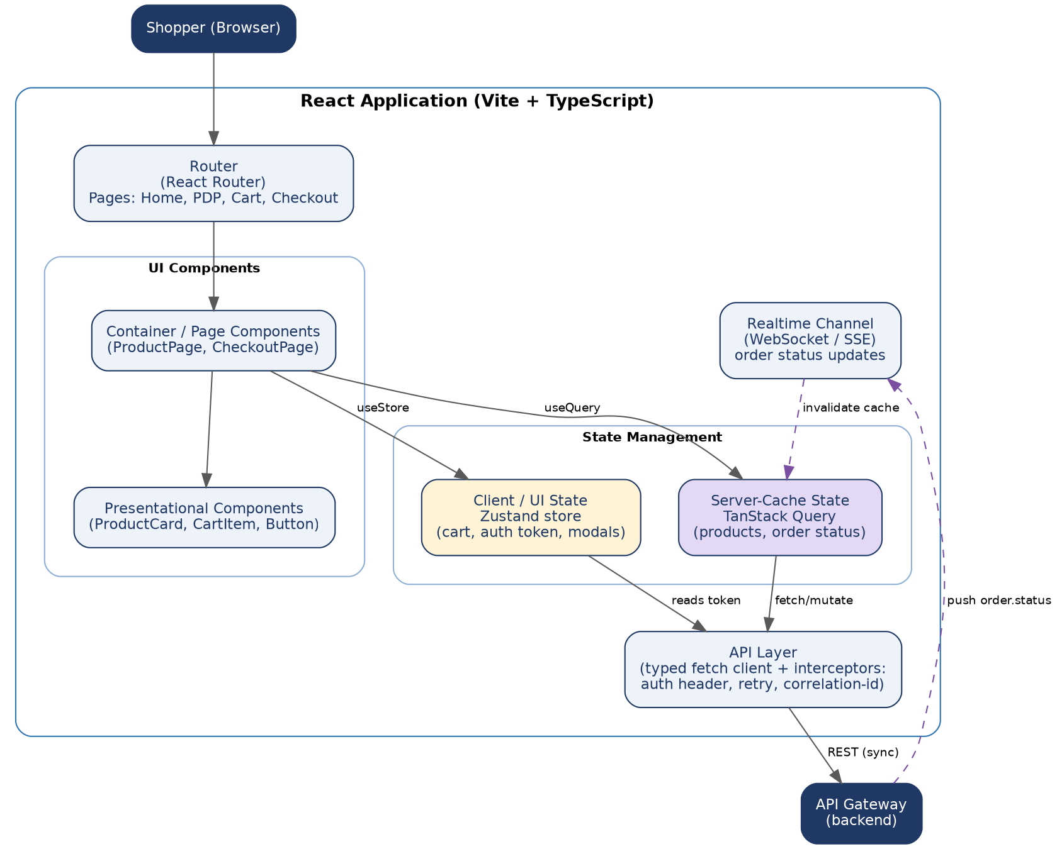
Figure 6 — Two deliberately separate state layers (server-cache vs. client/UI state) feeding a shared API layer, plus a realtime channel for order-status pushes.

4.2 State Management: Two Kinds of State, Two Tools
The most common React architecture mistake is treating all state the same way — putting server data (products, order status) into the same Redux store as pure UI state (is the cart drawer open). They have different lifecycles and different problems, so this design uses two separate tools:
State type | Tool | Why
Server-cache state (products, cart pricing, order status) | TanStack Query (React Query) | Server data needs caching, background refetch, de-duplication of in-flight requests, and cache invalidation — TanStack Query does all of this out of the box, instead of hand-rolling it in Redux thunks.
Client / UI state (cart contents pre-checkout, auth token, modal open/closed) | Zustand | Local-only, synchronous state with no server round-trip needed. Zustand avoids Redux's boilerplate (actions/reducers/dispatch) for state that isn't shared with a server cache.
💡 Why not just Redux Toolkit for everything? RTK Query (Redux's own data-fetching layer) is a perfectly valid alternative to TanStack Query and solves the same caching problem. The two-layer split (server cache vs. client state) is the important decision; which specific library implements each layer is a secondary choice.

4.3 Example: Add-to-Cart with Optimistic Update
A concrete pattern that shows both layers cooperating: updating the cart should feel instant (optimistic UI), but must roll back cleanly if the server rejects it (e.g., item went out of stock between page load and click).
// features/cart/useAddToCart.ts
import { useMutation, useQueryClient } from '@tanstack/react-query';
import { useCartStore } from './cartStore'; // Zustand

export function useAddToCart() {
const queryClient = useQueryClient();
const addItemLocally = useCartStore((s) => s.addItem);
const rollbackLocally = useCartStore((s) => s.removeItem);

return useMutation({
mutationFn: (item) => api.post('/cart/items', item),
onMutate: async (item) => {
addItemLocally(item); // optimistic: update UI immediately
return { item };
},
onError: (err, item, context) => {
rollbackLocally(context.item.id); // server rejected it: roll back
toast.error('Could not add item — it may be out of stock.');
},
onSettled: () => {
queryClient.invalidateQueries({ queryKey: ['cart'] }); // reconcile with server truth
},
});
}

What to notice
- onMutate updates the UI before the network call resolves — the shopper never sees a loading spinner for a simple cart add.
- onError explicitly reverses the optimistic change — without this, a failed request silently leaves stale data on screen.
- onSettled always re-syncs with the server afterward, so any drift between optimistic guess and server truth self-corrects.

4.4 Realtime Order Status
Once checkout is placed, the order moves through the state machine in Section 3.3 asynchronously (payment, inventory, shipping) — the page shouldn't need a manual refresh to see "Payment confirmed." A lightweight WebSocket (or Server-Sent Events) connection, fed by the backend's Kafka consumers, pushes status changes to the client, which simply invalidates the relevant TanStack Query cache entry so the UI re-fetches and re-renders.

4.5 Frontend Error Handling & Resilience

4.6 Authentication Storage & Browser Security
The frontend should treat the access token as short-lived and avoid persisting long-lived refresh tokens in localStorage. A safer browser model is an HttpOnly, Secure, SameSite refresh-token cookie, rotation on refresh, server-side revocation for suspicious sessions, and CSRF protection where cookie-authenticated requests are used.
The API client should never accept a client-calculated total as authoritative. Checkout sends item IDs and quantities; the backend derives price, discounts, taxes, shipping and final amount from server-owned data.
- Network errors: TanStack Query's built-in retry (with backoff) handles transient failures automatically; a global error boundary catches anything unrecoverable and shows a friendly fallback instead of a blank screen.
- Stale cache after payment: cap cache time (staleTime) tightly for anything price-related, and explicitly invalidate the product cache when a price-change event is pushed, so a shopper never checks out at a stale price.
- Offline / flaky connections: mutations (like "place order") are guarded against double-submission by disabling the submit button on isPending and by the idempotency key described in Section 11 — the frontend generates the key once per checkout attempt and reuses it on retry.
- Race conditions: rapid quantity changes in the cart use TanStack Query's request cancellation (AbortController) so an old, slow response can't overwrite a newer one.

5. Monolith vs. Microservices: When & Why
Dimension | Monolithic Architecture | Microservices Architecture
Deployment | Single unit — a minor fix requires redeploying the entire codebase. | Independent — each service ships through its own CI/CD pipeline.
Scaling | Vertical or full-stack duplication (expensive, all-or-nothing). | Selective, horizontal scaling of only the service under load.
Fault Isolation | A memory leak or uncaught exception can crash the whole application. | Failures are contained within individual service boundaries.
Complexity | Low initial setup complexity; code complexity grows over time. | Higher infra/networking complexity; lower per-service code complexity.

💡 Rule of thumb: most successful microservice systems started as well-organized monoliths and split only when specific services needed independent scaling, deployment cadence, or ownership. Splitting too early pays the distributed-systems tax with none of the payoff.

6. Decomposing a System: Domain-Driven Design Basics

6.1 Single Responsibility Principle (SRP)
A service should represent one business capability. If a service does two unrelated jobs (handling payments AND sending marketing emails), that's a signal it should be two services.

6.2 Bounded Context
The same real-world concept can mean different things in different services:
- In Auth: a "User" holds a password hash, roles, and login history.
- In Order: a "User" holds shipping addresses and order history.
Each service owns its own model shaped around what IT needs — no shared "User" library across services.
💡 Pitfall: a shared "models" package imported by every service quietly rebuilds a monolith, coupling every service to that package's release schedule.

7. Service Communication: Synchronous & Asynchronous

7.1 Synchronous (REST / gRPC)
Analogy: a phone call — the caller waits for an answer. Used when an immediate response is required, e.g. a client fetching product details to render a page.
Production hardening for synchronous calls:
- Timeouts on every outgoing call — never wait forever.
- Retries with exponential backoff + jitter for transient failures only (not for 4xx client errors).
- Circuit breakers (Section 10) to fail fast once a dependency is clearly unhealthy.

7.2 Asynchronous (Event-Driven via Kafka)
Analogy: posting a notice on a public bulletin board — the sender doesn't wait for, or even know, who reads it. The Order Service publishes an order.created event; Payment, Inventory, and Notification each consume it independently.
Production hardening for asynchronous consumers:
- Idempotency: processing the same event twice (redelivery is normal) must not double-charge a card or double-send an email.
- Dead-letter topics: events that repeatedly fail processing are moved aside for manual inspection instead of blocking the partition forever.

7.3 Choosing Between Them
Situation | Pattern | Why
Client needs data to render a page now | Synchronous (REST) | Immediate response required.
A service must react to something that happened | Asynchronous (Kafka) | Decouples sender from receiver; sender doesn't wait.
Multiple services need the same occurrence | Asynchronous (pub/sub) | One event, many independent consumers, zero coupling between them.
An internal call chain is 3+ services deep | Reconsider — favor async | Deep sync chains cause cascading failures.

7.4 Kafka vs. RabbitMQ — Picking a Broker
Aspect | Apache Kafka | RabbitMQ
Model | Distributed append-only log; consumers track their own offset. | Traditional message broker; broker tracks delivery/ack per message.
Best for | High-throughput event streams, event sourcing, replay, analytics. | Task queues, RPC-style work distribution, complex routing rules.
Message replay | Yes — consumers can rewind to an earlier offset and reprocess. | No — once acked and consumed, the message is gone.
Ordering | Guaranteed within a partition (by key). | Guaranteed within a single queue, not across consumers.
This system's choice | Kafka for the order/payment/inventory event backbone (Section 8). | Could still be used for simpler internal task queues if needed.

8. Apache Kafka Deep Dive
Kafka is the event backbone in Figure 1 — the shared "nervous system" that lets Order, Payment, Inventory, and Notification react to each other without ever calling one another directly.

8.1 Why Kafka for This System
- Throughput: an e-commerce platform during a sale can generate thousands of order events per second — Kafka is built for this scale.
- Replay: if the Notification Service ships a bug, it can be fixed and re-run from an earlier offset to resend missed notifications — impossible with a queue that deletes messages after delivery.
- Multiple independent consumers: new services (e.g., a future Analytics Service) can subscribe to order.created without the Order Service changing at all.

8.2 Core Concepts
Concept | What it means here
Topic | A named event stream, e.g. order.created, payment.completed, inventory.reserved.
Partition | A topic is split into partitions for parallelism; each partition is a strictly ordered log.
Partition key | Order events are keyed by order_id, guaranteeing all events for one order land in the same partition and stay in order.
Offset | A consumer's position (a pointer) in a partition — Kafka doesn't delete on read, it just tracks where each consumer is.
Consumer group | A set of consumer instances sharing the work of one topic; each partition is read by exactly one consumer within a group.
Replication factor | Each partition is copied to multiple brokers (e.g. 3) so a broker failure doesn't lose data.

8.3 Topic, Partition & Consumer Group Layout
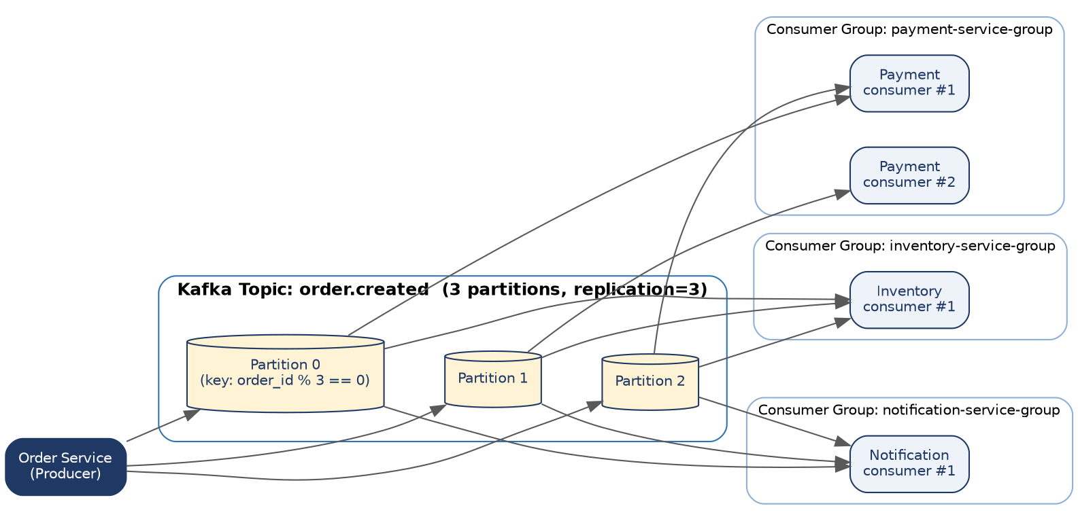
Figure 3 — order.created has 3 partitions; the Payment, Notification, and Inventory services each consume it independently via their own consumer group, so all three groups see every event.

8.4 Producer Example (kafkajs)
// order-service/events/kafkaProducer.js
const { Kafka } = require('kafkajs');

const kafka = new Kafka({
clientId: 'order-service',
brokers: process.env.KAFKA_BROKERS.split(','), // e.g. ['kafka-0:9092','kafka-1:9092']
});
const producer = kafka.producer({ idempotent: true }); // exactly-once per partition

async function publishOrderCreated(order) {
await producer.connect();
await producer.send({
topic: 'order.created',
messages: [{
key: order.id, // ensures per-order ordering
value: JSON.stringify({ event: 'ORDER_CREATED', data: order, ts: Date.now() }),
headers: { 'x-correlation-id': order.correlationId },
}],
});
}

module.exports = { publishOrderCreated };
What to notice
- • idempotent: true enables Kafka producer idempotence, preventing duplicate producer records caused by producer retries. This is not end-to-end exactly-once processing; external side effects still require idempotency and reconciliation.
- • key: order.id preserves ordering for events for the same order when those events are published to the same Kafka topic with the same partitioning scheme.
- The correlation ID travels as a Kafka header, so it can be picked up by the consumer's logger too (Section 15.2).

8.5 Consumer Example (kafkajs)
// notification-service/events/kafkaConsumer.js
const { Kafka } = require('kafkajs');
const kafka = new Kafka({ clientId: 'notification-service', brokers: process.env.KAFKA_BROKERS.split(',') });
const consumer = kafka.consumer({ groupId: 'notification-service-group' });

async function start() {
await consumer.connect();
await consumer.subscribe({ topic: 'order.created', fromBeginning: false });

await consumer.run({
eachMessage: async ({ message }) => {
const payload = JSON.parse(message.value.toString());
const alreadySent = await hasNotificationBeenSent(payload.data.id); // idempotency check
if (!alreadySent) {
await sendConfirmationEmail(payload.data);
await markNotificationSent(payload.data.id);
}
// offset is committed automatically after eachMessage resolves
},
});
}

start().catch(console.error);
💡 hasNotificationBeenSent()/markNotificationSent() is the idempotency check mentioned in Section 7.2 — with Kafka's default "at-least-once" delivery, redelivery WILL happen occasionally, so this check is not optional in a production consumer.

8.6 Schema Registry & Event Evolution
The Kafka examples above serialize events as plain JSON, which works but has no guardrail: nothing stops the Order Service from renaming a field and silently breaking every consumer that reads it. A schema registry (Confluent Schema Registry, or AWS Glue Schema Registry when using MSK) adds that guardrail.
- Every event schema (e.g., OrderCreated v1) is registered centrally as an Avro or Protobuf schema, and the registry enforces a compatibility mode — this system uses BACKWARD compatibility, meaning a new schema version must still be readable by consumers built against the previous version.
- Allowed under BACKWARD compatibility: adding a new optional field with a default value. Rejected by the registry at publish time: removing a field, renaming a field, or changing a field's type — the producer's deploy fails fast in CI rather than silently breaking Notification Service in production three services away.
- Each message carries a small schema ID instead of the full schema, so the wire format stays compact — consumers fetch the schema definition from the registry (and cache it) the first time they see a new schema ID.
💡 Why not just JSON with a versioned event type field (as shown in Section 8.4's code)? That approach is simpler to start with and is what a small team should reach for first — it's what this guide's code examples use for readability. A schema registry earns its operational overhead once enough independent teams/services produce and consume events that a human-reviewed convention is no longer enough to prevent accidental breaking changes.

8.7 Consumer Rebalancing & Delivery Semantics in Practice
Section 8.2 introduced consumer groups; this is what actually happens operationally when a consumer group's membership changes — e.g., during a rolling deployment of the Payment Service (Section 12.4).
- A new Payment Service pod starts up and joins the payment-service-group consumer group.
- Kafka's group coordinator triggers a rebalance: partition ownership is reassigned across all group members (including the new pod), which briefly pauses consumption for the whole group.
- Each consumer resumes reading from its newly assigned partition(s) starting at the last COMMITTED offset for that partition — not from wherever the previous owner happened to be mid-processing.
- If the previous owner had read a message but not yet finished processing it when the rebalance happened, that message gets redelivered to whichever consumer now owns the partition — this is precisely the at-least-once redelivery case Section 8.5's idempotency check exists for.
This is also why this system deliberately does NOT rely on Kafka's exactly-once semantics (EOS) transactions for the order/payment/inventory event flow, even though Kafka supports them: EOS guarantees exactly-once processing WITHIN Kafka (producer to topic to consumer offset commit), but the moment a consumer's side effect leaves Kafka's transaction boundary — charging a card via Stripe, sending an email — EOS can no longer cover it. The idempotency-key pattern (Section 11) is the mechanism that actually has to hold at that boundary regardless, so this system invests there rather than in Kafka-level EOS configuration, which would add operational complexity without removing the need for Section 11's checks.

9. Database Design, Optimization & Selection Rationale
Section 6 established the rule: one database per service, never shared. This section makes that concrete with an actual schema, explains WHY each service picked its specific database technology, and covers the optimization techniques a real deployment needs at scale.

9.1 Database Selection Rationale
Every choice below trades something away — the goal is picking the right trade-off per service, not one database for the whole system.
Service | Chosen DB | Why chosen | What we gave up
Order / Payment / Inventory | PostgreSQL | Money and stock counts need ACID transactions and foreign-key integrity; multi-row transactions (Section 9.2's outbox write) must be atomic. | Horizontal write-scaling is harder than a NoSQL store — mitigated with read replicas and eventual sharding by order date/region if needed.
Product Catalog | MongoDB | Product attributes vary wildly by category (a shirt has size/color, a laptop has RAM/CPU) — a flexible document schema avoids constant migrations. Also naturally high read, low write. | Weaker multi-document transactional guarantees — acceptable because catalog data isn't financial and Redis absorbs most reads anyway.
Auth & User | PostgreSQL | User/role/permission relationships are inherently relational, and strong consistency matters for security-critical data. | Nothing significant — this is a straightforward relational fit.
Session / hot-read cache | Redis | Sub-millisecond in-memory reads for product pages and session lookups; takes load off the primary databases entirely. | Data is not durable by default — treated purely as a cache, never the source of truth (cache-aside pattern, Section 9.4).

9.2 Order Service — Entity Relationship Diagram
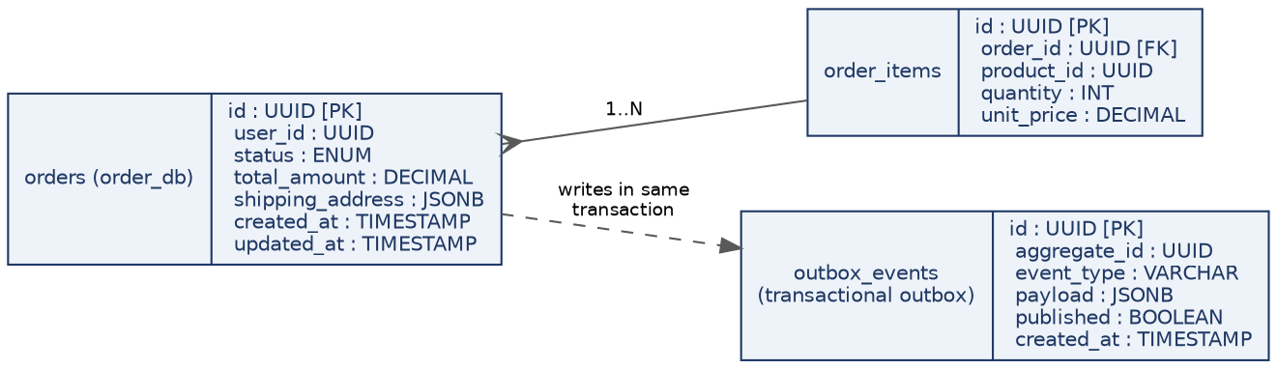
Figure 4 — orders and order_items are written in one transaction alongside outbox_events, solving the dual-write problem described below.

9.3 The Dual-Write Problem & the Outbox Pattern
A subtle bug many teams hit: the Order Service saves the order to Postgres, THEN calls Kafka to publish order.created. What if the process crashes between those two steps? The order exists in the database, but the event was never published — Payment and Inventory never find out.
The transactional outbox pattern fixes this: instead of publishing to Kafka directly, the service writes the event into an outbox_events table in the SAME database transaction as the order itself. A separate lightweight process (or Kafka Connect's Debezium connector) tails that table and publishes to Kafka. Since the order row and the outbox row are committed atomically, the event can never be "lost" relative to the order.

9.4 Query & Access-Pattern Optimization
- Indexing: composite index on orders(user_id, created_at DESC) makes "a user's order history" — the single most common Order query — an index-only scan instead of a table scan.
- Cache-aside for the catalog: the Product Service checks Redis first; on a miss it reads MongoDB and populates the cache with a TTL. A price or stock update explicitly invalidates the key rather than waiting for TTL expiry, so stale prices (flagged in Section 4.5) are minimized.
- Read replicas: Order and Payment Postgres instances run with one or more read replicas; reporting/analytics queries and "get my order history" reads are routed to a replica, keeping the primary free for writes.
- Connection pooling: PgBouncer sits in front of Postgres so hundreds of short-lived pod connections don't exhaust the database's native connection limit.
- Avoiding N+1 queries: fetching an order with its items uses a single JOIN (or a batched IN query) in the repository layer, never a loop issuing one query per item.
- Table partitioning: as the orders table grows, it's range-partitioned by created_at (e.g., monthly) so old-order archival and index maintenance don't lock the whole table.
- Denormalized read models: the Order Service keeps a small denormalized copy of product name/price at order time (not a live join to the Catalog DB) — this also correctly preserves historical pricing even after the product's price later changes.

9.5 Cross-Service Consistency: The Saga Pattern
Order Service creates order (PENDING) and publishes order.created.
- Inventory Service atomically reserves stock and publishes inventory.reserved, or publishes inventory.rejected.
- Payment Service consumes inventory.reserved, charges the customer, and publishes payment.completed or payment.failed.
- On payment.failed, Inventory releases the reservation and Order moves to CANCELLED. Every reservation has a TTL/expiry path so stock cannot remain held forever if an event or consumer is lost.
💡 This is a choreographed saga — each service reacts to events with no central coordinator. Larger systems sometimes use an orchestrated saga instead (a dedicated Order Orchestrator service explicitly calling each step) when the workflow gets too complex to follow via events alone.

10. Error Handling & Cascading Failure Prevention
A distributed system fails in ways a monolith never does: one slow dependency can exhaust every caller's threads/connections and take the whole platform down with it — a cascading failure. This section covers the specific techniques used to stop that, and why each one was chosen over the alternative.

10.1 API Gateway & Centralized Auth
The Gateway validates JWTs and enforces rate limits before a request reaches any internal service, so individual services can trust that anything reaching them already passed the gate, instead of every service re-implementing auth.

10.2 Timeouts, Retries & Backoff
Why chosen: a call with no timeout can hang a request thread indefinitely, and an unbounded retry can turn a brief blip into a self-inflicted traffic spike (a "retry storm") that makes the outage worse.
Technique | Rule used | Reasoning
Timeout | Every outbound call has an explicit budget (e.g. 2s for Payment gateway calls). | Bounds worst-case latency; a hung dependency can never hang the caller forever.
Retry | Only on retryable errors (network/5xx/timeout), never on 4xx client errors. | Retrying a 400 Bad Request just repeats a guaranteed failure and wastes capacity.
Exponential backoff + jitter | Wait doubles each retry, plus a small random jitter. | Jitter prevents every failed caller from retrying at the exact same instant and re-causing the spike that just recovered from.
Max retry budget | Cap at 2–3 attempts, then fail fast. | Past this point, the dependency is genuinely down — more retries only delay the inevitable failure response.

10.3 Circuit Breakers
Analogy: an electrical circuit breaker. If Payment starts failing repeatedly, a breaker (e.g. the opossum library) trips and fails fast instead of letting callers queue up waiting threads. After a cooldown, it allows a trial request through to check recovery.
Why chosen over just retrying: retries help with brief blips; a circuit breaker is for sustained outages, where continuing to retry would only pile up load on an already-struggling dependency and delay its recovery.

10.4 Bulkhead Pattern
Named after a ship's bulkheads, which stop one flooded compartment from sinking the whole vessel. Applied here: the Order Service uses a separate, size-limited connection pool/thread pool for calls to Payment vs. calls to its own database. If Payment is slow, it can only ever exhaust its OWN pool — order reads/writes keep working normally.

10.5 Graceful Degradation & Fallbacks
Why chosen: for read paths, a slightly stale or reduced response is almost always better than a hard error page.
- If the Product Service's live stock check times out, the page falls back to the last cached stock_hint (Section 9.1) with a "low confidence" flag, rather than failing the whole page load.
- If Recommendations (a non-critical service) is down, the product page simply omits the "You may also like" section instead of failing the entire request — this is why non-critical calls are made in parallel and awaited independently, not chained into the critical path.

10.6 Centralized Error Handling Middleware
// middleware/errorHandler.js
function errorHandler(err, req, res, next) {
const status = err.statusCode || 500;
logger.error({ correlationId: req.correlationId, err: err.message, stack: err.stack });

res.status(status).json({
error: {
code: err.code || 'INTERNAL_ERROR',
message: status >= 500 ? 'Something went wrong. Please try again.' : err.message,
correlationId: req.correlationId, // lets the shopper's bug report be traced instantly
},
});
}
module.exports = errorHandler;
- 5xx messages are deliberately generic to the client (never leak stack traces/internals) while the full error is logged server-side against the correlation ID.
- 4xx messages stay specific ("Item out of stock") because the client needs that detail to react correctly.

10.7 Distributed Tracing & Correlation IDs
The Gateway assigns every request an x-correlation-id. Every service's logger includes that ID, and it also rides along as a Kafka message header (Section 8.4) — so one ID can trace a request across both synchronous hops and asynchronous event chains, and directly into the error-handler output above.

10.8 Network & Secrets Security
- Traffic between pods is restricted using Kubernetes NetworkPolicies (e.g., only the Gateway may call Order Service directly).
- Service-to-service traffic can be encrypted with mutual TLS via a service mesh (Istio/Linkerd) in larger deployments.
- Credentials live in Kubernetes Secrets / AWS Secrets Manager (Section 13), never in the image or source code.

11. Idempotency Deep Dive: Payment APIs
This is the single highest-stakes correctness problem in the whole system: a network retry must never charge a customer twice. If a client calls POST /payments and the response is lost to a timeout (even though the charge actually succeeded on Payment's end), the client's natural reaction — retry — must be provably safe.

11.1 The Idempotency-Key Pattern
- The client (frontend, Section 4.5) generates a unique Idempotency-Key (a UUID) once, before the first attempt at a given payment.
- Every retry of that SAME logical payment reuses the SAME key — this is the critical part; a new key per retry defeats the whole mechanism.
- The Payment Service checks an idempotency_keys table for that key BEFORE processing: if found and completed, it returns the ORIGINAL stored response immediately, without charging again.
- If the key is new, it processes the payment, stores the result against the key, and returns it.
- If the key exists but is still IN_PROGRESS (a concurrent duplicate request arrived while the first was still processing), the second request is rejected with 409 Conflict rather than racing the first.

11.2 Idempotency Store Schema
Column | Type | Purpose
idempotency_key | UUID [PK] | The client-supplied key from the Idempotency-Key header.
request_hash | VARCHAR | Hash of the request body — detects a client incorrectly reusing a key for a DIFFERENT payload.
status | ENUM | IN_PROGRESS, COMPLETED, or FAILED.
response_body | JSONB | The stored response to replay on retry, once COMPLETED.
created_at / expires_at | TIMESTAMP | Keys are retained ~24h, then purged — long enough to cover realistic client retry windows.

11.3 Implementation Sketch
// payment-service/middleware/idempotency.js
async function idempotencyMiddleware(req, res, next) {
const key = req.header('Idempotency-Key');
if (!key) return res.status(400).json({ error: 'Idempotency-Key header is required' });

const hash = sha256(JSON.stringify(req.body));
const existing = await db.idempotencyKeys.findOne({ idempotency_key: key });

if (existing) {
if (existing.request_hash !== hash) {
return res.status(422).json({ error: 'Idempotency-Key reused with a different request body' });
}
if (existing.status === 'IN_PROGRESS') return res.status(409).json({ error: 'Request already in progress' });
if (existing.status === 'COMPLETED') return res.status(200).json(existing.response_body); // safe replay
}

await db.idempotencyKeys.insert({ idempotency_key: key, request_hash: hash, status: 'IN_PROGRESS' });
req.idempotencyKey = key;
next();
}
💡 This check-then-insert must use a unique DB constraint on idempotency_key plus a single atomic upsert (INSERT ... ON CONFLICT DO NOTHING in Postgres) — a naive "check, then insert" without that constraint has its own race condition between the check and the insert.

11.4 Exactly How Concurrent Duplicates Are Resolved at the Database Level
Section 11.3's note glossed over a subtlety worth spelling out fully, because it's the same class of race condition as Section 3.4: what if the SAME idempotency key arrives twice at almost the same instant — not a slow retry seconds later, but truly concurrent, e.g., a client that fires the request and, 50ms later before any response arrives, fires an automatic retry?
-- The actual table definition — the UNIQUE constraint is what makes this safe
CREATE TABLE idempotency_keys (
idempotency_key UUID PRIMARY KEY,
request_hash VARCHAR(64) NOT NULL,
status VARCHAR(20) NOT NULL DEFAULT 'IN_PROGRESS',
response_body JSONB,
created_at TIMESTAMPTZ NOT NULL DEFAULT now(),
expires_at TIMESTAMPTZ NOT NULL DEFAULT now() + interval '24 hours'
);

-- The insert that replaces the naive "check, then insert":
INSERT INTO idempotency_keys (idempotency_key, request_hash, status)
VALUES ($1, $2, 'IN_PROGRESS')
ON CONFLICT (idempotency_key) DO NOTHING
RETURNING idempotency_key; -- returns a row ONLY if this call actually inserted it
Because idempotency_key is the PRIMARY KEY, Postgres enforces uniqueness at the storage engine level — two concurrent INSERTs for the same key cannot both succeed, even if they arrive on different database connections at the exact same microsecond. One of them wins the RETURNING row; the other gets back zero rows, meaning "someone else already claimed this key." Here is the exact timeline for two truly concurrent requests carrying the same key:
Time | Request 1 | Request 2
t=0ms | INSERT ... ON CONFLICT DO NOTHING fires | INSERT ... ON CONFLICT DO NOTHING fires (same millisecond)
t=1ms | Postgres's unique index serializes the two inserts internally — Request 1 happens to be ordered first by the storage engine | —
t=2ms | Row inserted; RETURNING gives back the key → this request proceeds to actually call Stripe | 0 rows returned by RETURNING → this request knows it lost the race
t=3ms | — | Request 2 now runs the SELECT from Section 11.3: status is IN_PROGRESS → returns 409 Conflict immediately, without ever calling Stripe
t=400ms | Stripe responds; Request 1 UPDATEs the row to status = 'COMPLETED' with the response body | (already returned 409, long since finished)
t=450ms | Request 1 returns 201 Created to its caller | If the client retries again now, it will hit COMPLETED and get the safe 200 replay from Section 11.3, not another 409
💡 The key mechanical point: the database's unique-index enforcement is what makes this safe, not application logic. No amount of careful if-statements in Node.js can substitute for this, because two Node.js processes (or even two requests on the same process's connection pool) can genuinely execute their JavaScript at the same instant — only the database's atomic constraint check has a single, consistent view of "has this key been claimed yet."

11.5 Layering On Top of the Payment Gateway's Own Idempotency
Stripe and PayPal both accept their own idempotency key on the charge call. The Payment Service's internal key (Section 11.2) and the gateway's key are complementary, not redundant: the internal key protects against the CLIENT retrying the call to the Payment Service; the gateway key additionally protects against the Payment Service itself retrying its own outbound call to Stripe (e.g., after a bulkhead-limited timeout in Section 10.4) without double-charging at the gateway level.

11.6 Idempotency Edge Cases

11.7 Payment Reconciliation & Refunds
Payment is a distributed boundary with an external system, so a periodic reconciliation job should compare Payment records, gateway transaction status and verified webhook events. Unknown outcomes should become REQUIRES_RECONCILIATION rather than being automatically retried as a new charge.
Refunds need their own idempotency key and lifecycle (REQUESTED → SUBMITTED → CONFIRMED / FAILED). A refund operation must be safe to retry and must never create two provider refunds for the same business reason.
- Same key, different amount: treated as a client bug — rejected with 422 (Section 11.3), never silently processed with either amount.
- Key reused after expiry (>24h): treated as a brand-new payment — this is why the expiry window must comfortably exceed any realistic client retry timeout.
- Consumer crash mid-processing (status stuck IN_PROGRESS forever): a background sweeper job resolves keys stuck IN_PROGRESS past a short threshold (e.g. 2 minutes) by checking the actual gateway transaction status and correcting the row.
- Webhook-driven confirmation arrives before the synchronous response: the webhook handler (Stripe calling back asynchronously) updates the SAME idempotency-keyed row rather than creating a second record, keyed by the gateway's own transaction reference.

12. Docker & Kubernetes: How They Fit
Docker and Kubernetes solve two different problems. Docker packages a single service into a portable, reproducible unit. Kubernetes runs, scales, and heals many of those units across a cluster of machines.

12.1 Docker's Role: Packaging
Every service (from the directory structure in Section 16) is built into its own container image via a multi-stage Dockerfile — one stage installs dependencies and builds, a second, minimal stage runs the app, keeping the final image small.
# order-service/Dockerfile
FROM node:20-alpine AS build
WORKDIR /app
COPY package*.json ./
RUN npm ci --omit=dev
COPY . .

FROM node:20-alpine
WORKDIR /app
COPY --from=build /app .
ENV NODE_ENV=production
EXPOSE 3003
USER node
CMD ["node", "server.js"]
Multi-stage build keeps the final image lean and runs as a non-root user (node) — a basic production security practice.

12.2 Kubernetes' Role: Orchestration
Once each service is an image, Kubernetes takes over the operational concerns a monolith never had to think about: which machine runs which container, what happens when one crashes, and how many copies should be running right now.
Kubernetes Object | Purpose
Pod | The smallest deployable unit — one running instance of a service's container.
Deployment | Declares "I want 3 replicas of order-service" and keeps that true, replacing crashed pods automatically.
Service (ClusterIP) | A stable internal address (order-service:3003) that load-balances across whichever pods are currently healthy.
Ingress | Routes external HTTPS traffic into the cluster and into the right Service — this is where the API Gateway logic often lives.
ConfigMap / Secret | Externalizes environment configuration and credentials so they aren't baked into the image.
HorizontalPodAutoscaler (HPA) | Automatically adds/removes pods based on CPU or custom metrics (e.g. Kafka consumer lag).
StatefulSet | Used for stateful workloads (e.g. self-hosted Kafka brokers) that need stable network identity and storage.

12.3 Deployment Topology Diagram
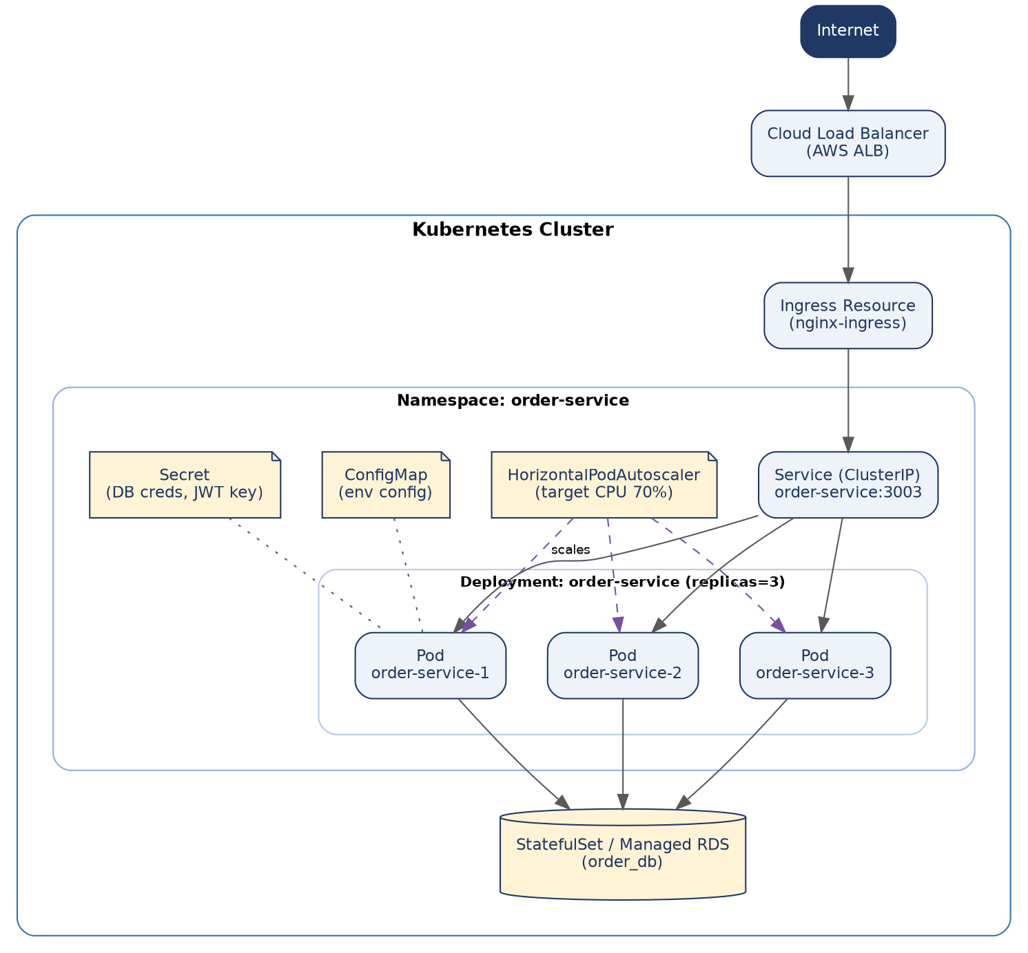
Figure 5 — order-service running as 3 pods behind a ClusterIP Service, fronted by an Ingress, scaled by an HPA, and configured via ConfigMap/Secret.

12.4 Minimal Deployment Manifest
apiVersion: apps/v1
kind: Deployment
metadata:
name: order-service
spec:
replicas: 3
selector:
matchLabels: { app: order-service }
template:
metadata:
labels: { app: order-service }
spec:
containers:
- name: order-service
image: registry/order-service:1.4.0
ports: [{ containerPort: 3003 }]
envFrom:
- configMapRef: { name: order-service-config }
- secretRef: { name: order-service-secrets }
resources:
requests: { cpu: "200m", memory: "256Mi" }
limits: { cpu: "500m", memory: "512Mi" }
readinessProbe:
httpGet: { path: /health/ready, port: 3003 }
livenessProbe:
httpGet: { path: /health/live, port: 3003 }
What to notice
- resources.requests/limits prevent one misbehaving pod from starving others on the same node — a monolith on a single VM never needed this.
- readinessProbe stops the Service from sending traffic to a pod that's still starting up; livenessProbe tells Kubernetes to restart a pod that has become unresponsive.
- The image is tagged with a version (1.4.0), never :latest — reproducible deployments require knowing exactly what's running.

12.5 Resource Sizing Methodology
The requests/limits numbers in Section 12.4 aren't guesses — an admin arrives at them methodically, and re-checks them as traffic patterns change:
- Start from load-test data (Section 14.6), not intuition: run the service under a representative load profile and record actual CPU/memory usage via Prometheus (Section 15.1).
- Set requests to roughly the p50 (median) observed usage — this is what the Kubernetes scheduler reserves for the pod on a node, so setting it too high wastes cluster capacity, and too low causes the scheduler to over-pack nodes.
- Set limits to roughly the p99 observed usage plus headroom for traffic spikes — this is the hard ceiling; a CPU limit throttles the pod's CPU time, while a memory limit that's exceeded gets the pod OOMKilled.
- Re-run this exercise after any significant code change (a new dependency, a new code path) and on a recurring cadence (e.g., quarterly) as real production traffic patterns emerge — initial sizing from a load test is a starting point, not a permanent setting.
Symptom | Likely cause | Fix
Pod repeatedly OOMKilled | Memory limit set below actual peak usage. | Raise the memory limit, or investigate a memory leak if usage grows unbounded over the pod's lifetime rather than plateauing.
CPU throttling shows in metrics but pod isn't crashing | CPU limit set below the burst the code needs (e.g., during JSON serialization of a large response). | Raise the CPU limit, or address the underlying inefficiency (Section 9.4's pagination/indexing guidance) rather than only scaling around it.
Cluster autoscaler constantly adding/removing nodes | requests set far higher than actual steady-state usage, wasting reserved capacity on every node. | Lower requests toward the measured p50; let limits (not requests) absorb legitimate spikes.

12.6 Pod Disruption Budgets & Network Policies
Two more Kubernetes objects worth naming explicitly, since both directly prevent real incidents this system has to plan for.
# order-service PodDisruptionBudget — protects against voluntary disruptions
apiVersion: policy/v1
kind: PodDisruptionBudget
metadata: { name: order-service-pdb }
spec:
minAvailable: 2 # at least 2 of the 3 replicas (Section 12.4) must stay up
selector:
matchLabels: { app: order-service }
Without a PodDisruptionBudget, a routine cluster operation — draining a node for a Kubernetes version upgrade, or the cluster autoscaler scaling down — could terminate 2 of Order Service's 3 pods simultaneously, leaving only 1 to absorb all traffic. The PDB tells Kubernetes "never let a voluntary disruption take availability below this line," and Kubernetes will delay the drain/scale-down until it can proceed safely.
# order-service NetworkPolicy — enforces Section 10.8's "Gateway only" rule at the network layer
apiVersion: networking.k8s.io/v1
kind: NetworkPolicy
metadata: { name: order-service-netpol }
spec:
podSelector: { matchLabels: { app: order-service } }
policyTypes: [Ingress]
ingress:
- from:
- podSelector: { matchLabels: { app: api-gateway } }
ports: [{ port: 3003 }]
# No other pod's traffic is allowed in — a compromised Notification Service pod, for
# example, cannot directly reach Order Service even if it discovers the address.
💡 Without this NetworkPolicy, Kubernetes' default is to allow all pod-to-pod traffic within the cluster — meaning a single compromised or misbehaving pod could call any other service directly. Explicit NetworkPolicies turn that default off service by service, which is why Section 10.8 lists this as a security control rather than an optional hardening step.

13. AWS Services Mapping & Deployment Architecture
Section 12 described Kubernetes concepts generically. This section maps every piece of the system onto concrete AWS services, so the architecture in Figure 1 becomes something actually deployable.

13.1 Service Mapping Table
AWS service | Production role | Network exposure | HA / scaling | Security & operations
Amazon Route 53 | Public DNS, health checks and failover routing | Internet-facing DNS | Global managed service | DNSSEC where required; controlled TTLs; health-check based failover
Amazon CloudFront | CDN for React assets and cacheable public content | Public edge; private S3 origin | Global edge network | OAC to S3; HTTPS; cache policies; response security headers
AWS WAF | Block common web attacks and abusive traffic | Attached to CloudFront and/or ALB | Managed service | Managed rule groups; rate-based rules; app-specific rules
Amazon S3 | Stores React build and static assets | Private bucket; CloudFront only | Regional durability | Block public access; versioning; encryption; OAC
Application Load Balancer | TLS termination and HTTP routing into EKS | Public subnets | Multi-AZ; target health checks | ACM certificates; WAF; access logs; strict listeners
Amazon EKS | Runs API services, workers and event consumers | Private application subnets | Multi-AZ; HPA + node autoscaling | Pod Security; NetworkPolicy; Pod Identity; private API endpoint
Amazon ECR | Private container image registry | AWS managed service | Managed | Immutable SHA tags; lifecycle policy; enhanced vulnerability scanning
Amazon RDS for PostgreSQL | Order, Payment, Inventory and Auth persistence | Private data subnets | Multi-AZ; replicas for read scale | PITR; encryption; backups; parameter groups; restricted SGs
Amazon DocumentDB (optional) | Flexible catalog/product documents | Private data subnets | Cluster across AZs | Encryption; backups; private access; access-pattern indexes
Amazon ElastiCache for Redis | Hot reads, sessions and derived cache | Private data subnets | Replication + automatic failover | TLS/auth; TTLs; never authoritative business state
Amazon MSK | Kafka domain-event streaming | Private subnets | Multi-AZ; RF >= 3 for production topics | IAM/TLS auth; topic policies; lag alerts; retention
Amazon SQS + SNS | Simple jobs, retries and fan-out | AWS service endpoints | Managed | DLQs; visibility timeout; redrive policy; least-privilege IAM
AWS Secrets Manager | DB credentials, provider keys and signing secrets | Private AWS API path where endpoints are used | Managed | KMS encryption; rotation; audit through CloudTrail
Amazon CloudWatch + OpenTelemetry | Logs, metrics, traces and alarms | AWS managed / controlled egress | Managed backends | Retention policies; structured logs; trace propagation
CloudTrail + Config + Security Hub | Audit, configuration drift and security findings | AWS control plane | Managed | Centralized security account; findings and alert routing

13.2 Deployment Architecture Diagram
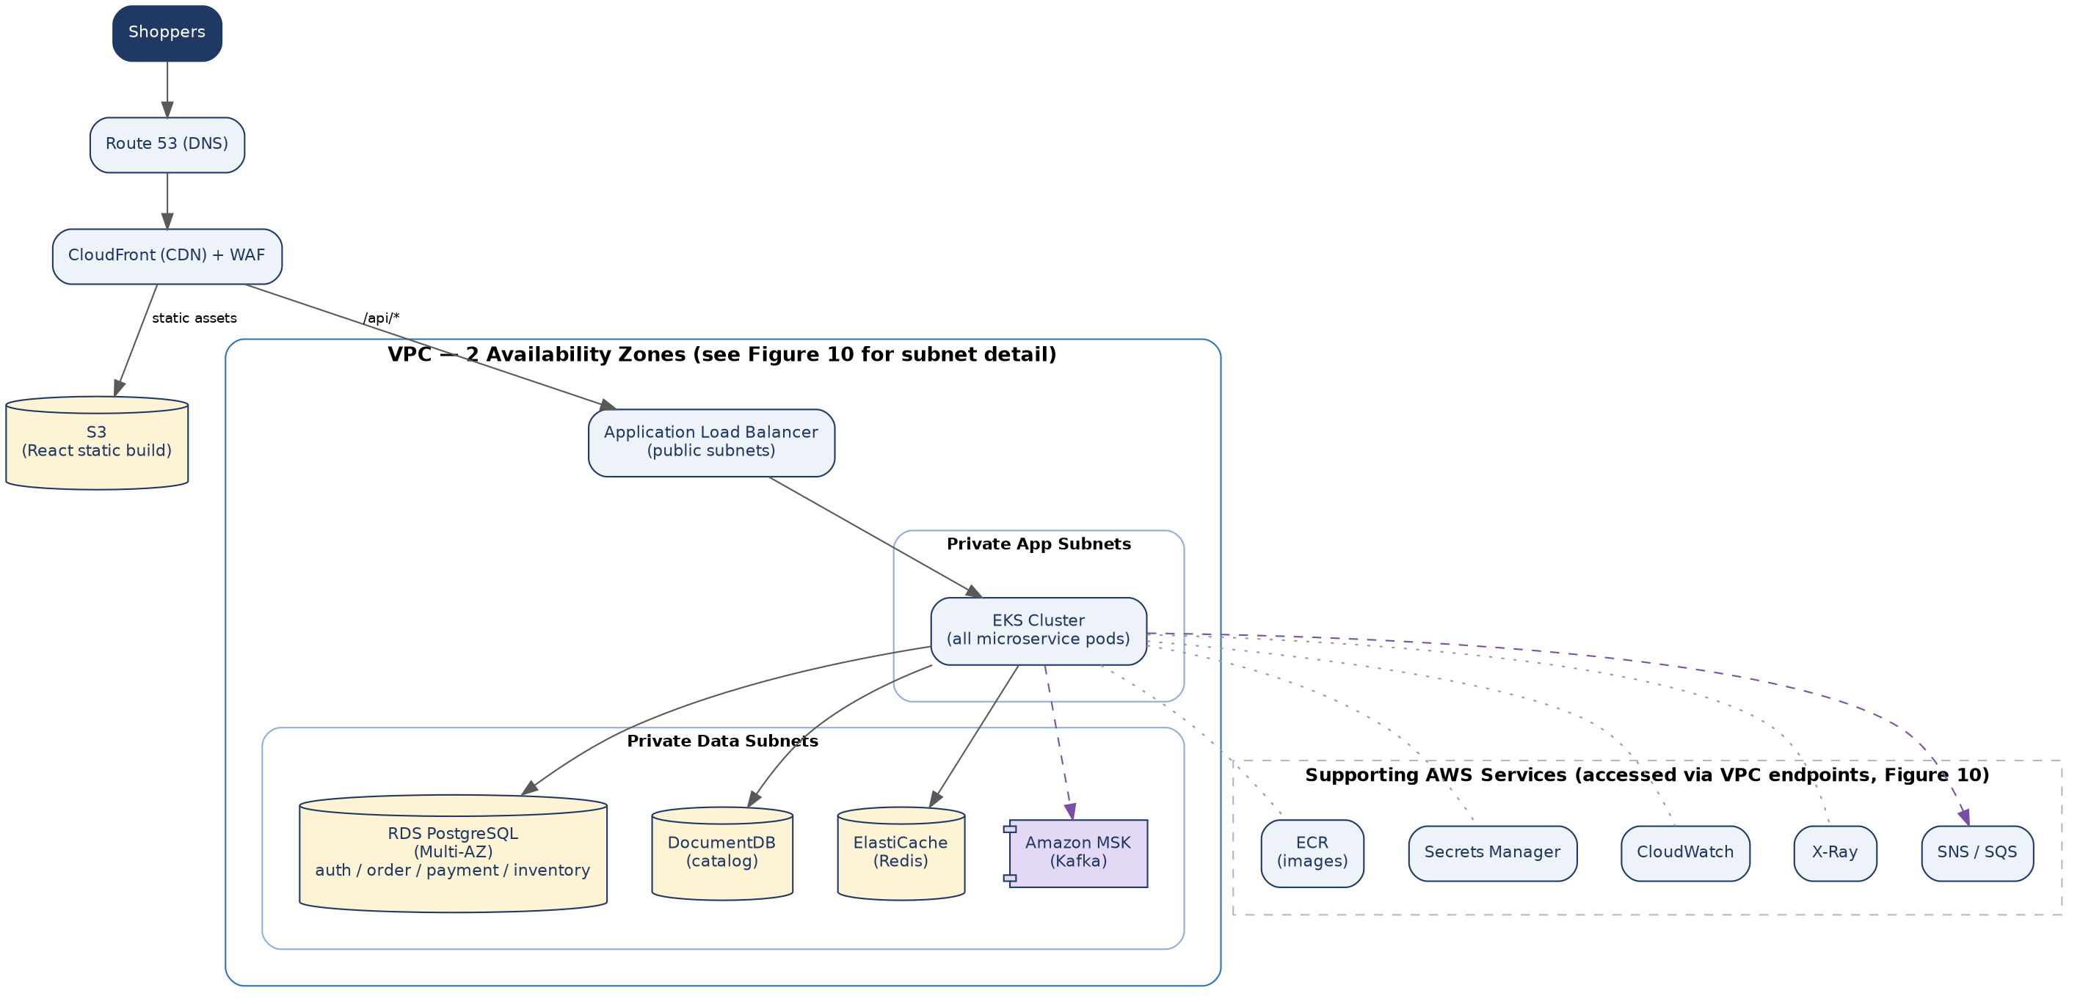
Figure 7 — the same logical architecture from Figure 1, mapped onto a VPC with public subnets (ALB only) and private subnets (EKS, databases, cache, Kafka).

13.3 Network Design Notes
- Only the ALB sits in public subnets; EKS nodes, RDS, ElastiCache, and MSK all sit in private subnets with no direct internet route — outbound internet access (e.g., for calling Stripe) goes through a NAT Gateway.
- Security groups are scoped tightly: RDS's security group only accepts inbound traffic from the EKS node security group, never from 0.0.0.0/0.
- Each environment (dev/staging/prod, Section 14) gets its own VPC or at minimum its own set of subnets, so a staging misconfiguration can't reach production data.

13.4 Admin's View: VPC & Subnet Layout
Figure 7 showed the logical picture. This is the same VPC from an infrastructure admin's console — the actual CIDR blocks, Availability Zones, and subnet tiers someone provisioning this account would create.
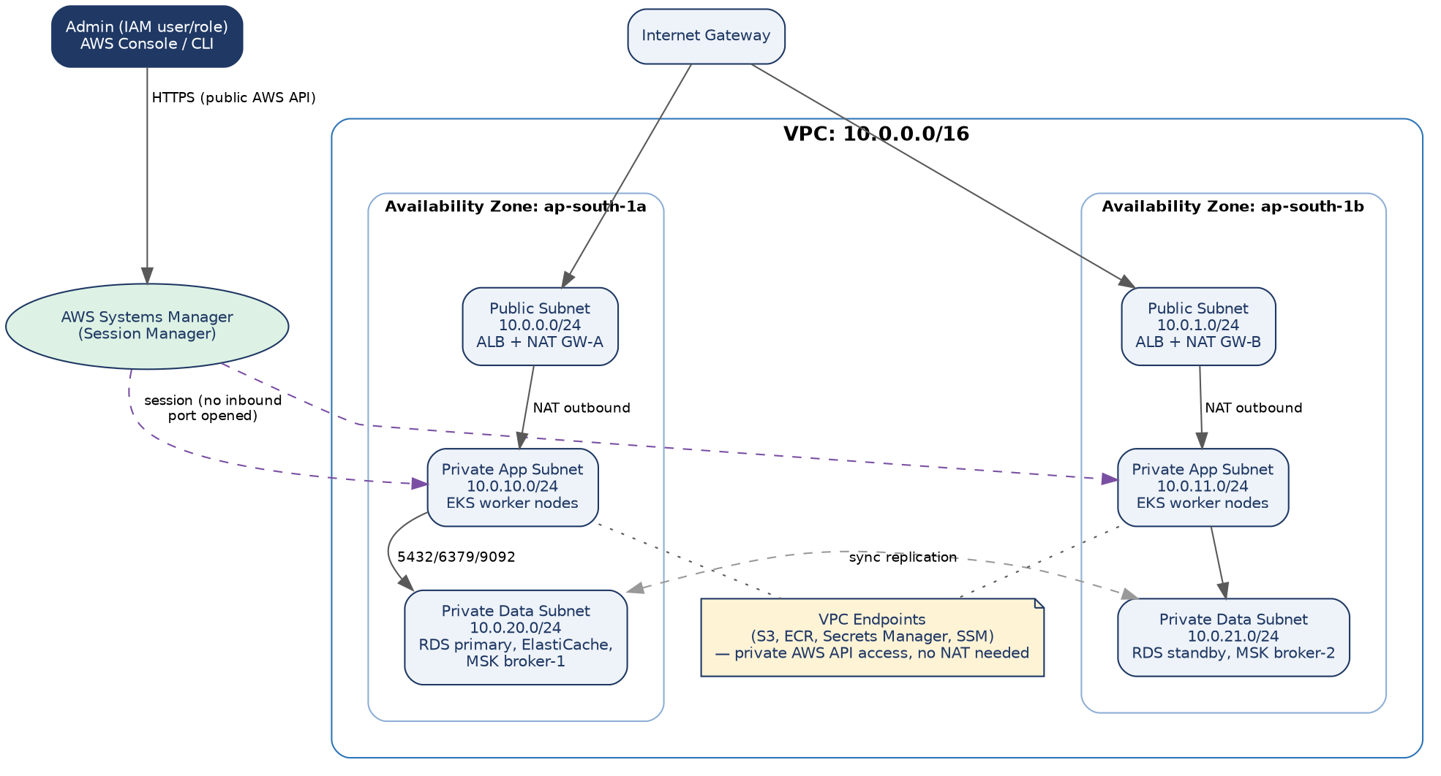
Figure 10 — a 2-AZ VPC with three subnet tiers per AZ. Admin access into private subnets goes through AWS Systems Manager Session Manager, never a public bastion host or an open SSH port.

13.5 Subnet & CIDR Plan
Tier | AZ ap-south-1a | AZ ap-south-1b | Hosts
Public | 10.0.0.0/24 | 10.0.1.0/24 | ALB, NAT Gateway
Private — App | 10.0.10.0/24 | 10.0.11.0/24 | EKS worker nodes (all microservice pods)
Private — Data | 10.0.20.0/24 | 10.0.21.0/24 | RDS, ElastiCache, MSK brokers
💡 Two AZs is the minimum for the Multi-AZ RDS failover and EKS node-group spread used elsewhere in this guide; a production account typically adds a third AZ for extra resilience margin, following the same pattern.

13.6 Why This Layout (Reasoning)
Design decision | Reasoning
Three subnet tiers instead of two | Separating "App" from "Data" lets a security group rule say EKS nodes only — never "anything in this VPC" — can reach RDS/Kafka, which is both a security boundary and a clearer audit story.
No public IPs on data or app subnets | Removes an entire class of exposure: a misconfigured security group on a private-subnet resource still isn't reachable from the internet, because there's no route to one.
NAT Gateway per AZ (not one shared NAT) | If one AZ's NAT Gateway or the whole AZ fails, the other AZ's workloads keep their outbound internet path — avoids a single NAT becoming a cross-AZ single point of failure.
VPC Endpoints for S3 / ECR / Secrets Manager / SSM | Traffic to these AWS services stays on the AWS network backbone instead of routing out through NAT — lower latency, lower NAT data-processing cost, and one less thing that breaks if NAT has an issue.
Systems Manager Session Manager instead of a bastion host | A bastion host means a permanently open SSH port and a server to patch. Session Manager needs zero inbound ports open and every session is logged to CloudTrail — a strictly better security posture for the same admin capability.

13.7 Provisioning Order: Standing Up the Account
This is the actual sequence an admin follows the first time this infrastructure is created — later changes go through Terraform/CI (Section 13.9), but understanding the raw order matters for debugging and for onboarding a new admin.
- Create the VPC (10.0.0.0/16) and enable DNS hostnames/resolution.
- Create the Internet Gateway and attach it to the VPC.
- Create 6 subnets across 2 AZs per the CIDR plan in Section 13.5.
- Create 2 NAT Gateways (one per public subnet), each with its own Elastic IP.
- Create route tables: a public route table (0.0.0.0/0 → IGW) attached to the public subnets, and one private route table per AZ (0.0.0.0/0 → that AZ's NAT Gateway) attached to its app and data subnets.
- Create the VPC Endpoints for S3, ECR (api + dkr), Secrets Manager, and SSM (ssm, ssmmessages, ec2messages) in the private route tables.
- Create security groups: alb-sg (inbound 443 from 0.0.0.0/0), eks-node-sg (inbound from alb-sg on service ports, inbound from itself for pod-to-pod), rds-sg (inbound 5432 from eks-node-sg only), redis-sg (inbound 6379 from eks-node-sg only), msk-sg (inbound 9092/9094 from eks-node-sg only).
- Create the EKS cluster control plane, specifying the private app subnets (both AZs) for worker-node placement.
- Create the workload identity configuration. Prefer EKS Pod Identity for EKS workloads; retain an OIDC/IRSA path when a specific integration requires it.
- Create the managed node group(s) in the private app subnets, attached to eks-node-sg.
- Create the RDS Multi-AZ instances (Order/Auth/Payment/Inventory) in the private data subnets, attached to rds-sg, with a DB subnet group spanning both AZs.
- Create the ElastiCache Redis replication group and the MSK cluster in the same private data subnets, attached to their respective security groups.
- Create the ECR repositories (one per service) and the S3 bucket + CloudFront distribution for the React build.
- Install the AWS Load Balancer Controller into the cluster (via Helm) so Kubernetes Ingress resources provision real ALBs automatically.
- Bootstrap ArgoCD into the cluster and point it at the GitOps manifest repository (Section 14.2) — from this point on, deployments are Git commits, not manual console actions.

13.8 IAM Roles & Workload Identity (EKS Pod Identity / IRSA)
A naive setup gives every pod the EKS node's IAM role, which means every service can call every AWS API the node can — a Product Service pod could technically read Payment's secrets. IAM Roles for Service Accounts (IRSA) fixes this: each Kubernetes ServiceAccount gets its OWN narrow IAM role, assumed only by pods using that ServiceAccount, via the OIDC provider created in Section 13.7.
Kubernetes ServiceAccount | IAM Role permissions | Explicitly NOT allowed
order-service-sa | Read order-service/* secrets in Secrets Manager; publish to MSK topic order.created. | No S3, no other service's secrets, no IAM/EC2 admin actions.
payment-service-sa | Read payment-service/* secrets (gateway API keys); read/write its own RDS via IAM auth token. | No access to Order's or Auth's secrets; cannot modify IAM policies.
notification-service-sa | Consume MSK topics; send via SES (if used) for transactional email. | No database write access to any service's DB — it is read-only via events.
ci-deploy-role (used by GitHub Actions OIDC) | Push to ECR; update the GitOps manifest repo. | No direct kubectl/cluster-admin access — it never touches the cluster directly (Section 14.2's ArgoCD does that).
💡 Why OIDC federation for CI instead of long-lived AWS access keys in GitHub Secrets? A long-lived key that leaks is valid until manually rotated; an OIDC-federated role issues short-lived credentials scoped to that specific workflow run, so a leaked credential expires in minutes rather than being a standing risk.

13.9 Infrastructure as Code (Terraform Skeleton)
Everything in Section 13.7 is, in practice, defined once in Terraform rather than clicked through the console — this is what actually gets committed, reviewed, and re-run for staging/prod parity.
# infra/vpc.tf
module "vpc" {
source = "terraform-aws-modules/vpc/aws"
name = "ecommerce-${var.env}"
cidr = "10.0.0.0/16"
azs = ["ap-south-1a", "ap-south-1b"]
public_subnets = ["10.0.0.0/24", "10.0.1.0/24"]
private_subnets = ["10.0.10.0/24", "10.0.11.0/24"] # app tier
intra_subnets = ["10.0.20.0/24", "10.0.21.0/24"] # data tier, no NAT route
enable_nat_gateway = true
single_nat_gateway = false # one NAT per AZ, per Section 13.6
}

# infra/eks.tf
module "eks" {
source = "terraform-aws-modules/eks/aws"
cluster_name = "ecommerce-${var.env}"
cluster_version = var.eks_version
vpc_id = module.vpc.vpc_id
subnet_ids = module.vpc.private_subnets
enable_irsa = true

eks_managed_node_groups = {
default = { min_size = 3, max_size = 10, desired_size = 3, instance_types = ["m6i.large"] }
}
}

# infra/rds.tf
module "order_db" {
source = "terraform-aws-modules/rds/aws"
identifier = "order-db-${var.env}"
engine = "postgres"
multi_az = true
subnet_ids = module.vpc.intra_subnets
vpc_security_group_ids = [aws_security_group.rds_sg.id]
}
Running terraform plan against this before every apply is what lets an admin see exactly what will change in staging or prod before it happens — the same discipline as a code review, applied to infrastructure.

13.10 Deploying the Application Onto Provisioned Infrastructure
Once Section 13.7/13.9's infrastructure exists, getting the actual application running is a separate, repeatable set of steps — this is what a new admin (or a disaster-recovery rebuild) runs against a fresh cluster.
# 1. Point kubectl at the new cluster
aws eks update-kubeconfig --name ecommerce-prod --region ap-south-1

# 2. Install cluster-wide add-ons
helm install aws-load-balancer-controller eks/aws-load-balancer-controller \
-n kube-system --set clusterName=ecommerce-prod
helm install external-secrets external-secrets/external-secrets -n kube-system

# 3. Bootstrap ArgoCD, pointed at the GitOps repo
kubectl create namespace argocd
kubectl apply -n argocd -f https://raw.githubusercontent.com/argoproj/argo-cd/stable/manifests/install.yaml
argocd app create ecommerce --repo https://github.com/org/ecommerce-gitops.git \
--path environments/prod --dest-namespace default --sync-policy automated

# 4. ArgoCD reconciles every Deployment/Service/Ingress from the repo automatically —
# no further manual kubectl apply is needed for application rollout from here on.
- Step 1 is the only step run by a human against a brand-new cluster; everything after step 3 is self-driving via ArgoCD's continuous reconciliation loop.
- external-secrets syncs the AWS Secrets Manager entries from Section 13.8 into native Kubernetes Secrets, so application manifests never hard-code a secret ARN or value.

13.11 Disaster Recovery & Backup Strategy
Provisioning the infrastructure (Section 13.7) answers "how does this get built"; disaster recovery answers "what happens when part of it is destroyed." Every data store in Section 9 has an explicit backup and recovery plan — "RDS backs itself up" is not a DR plan on its own until the recovery time and recovery point are stated and tested.
Data store | Backup mechanism | RPO (max data loss) | RTO (max time to restore)
RDS PostgreSQL (Order/Auth/Payment/Inventory) | Automated snapshots + continuous WAL archiving; Multi-AZ synchronous standby. | < 5 minutes (point-in-time recovery from WAL) | Minutes — Multi-AZ failover is automatic; a full PITR restore to a new instance takes longer, targeted at under 1 hour.
DocumentDB (Catalog) | Automated continuous backups, restorable to any point in the retention window. | < 5 minutes | Under 1 hour to restore a new cluster from a snapshot.
MSK (Kafka) | Replication factor 3 across AZs (Section 8.2) is the primary protection — brokers are ephemeral by design. | Near-zero for committed messages (replicated before ack) | Minutes — a failed broker is automatically replaced; data isn't "restored" so much as already durable elsewhere.
ElastiCache (Redis) | Not backed up as a source of truth — it's a cache (Section 9.1). Multi-AZ with automatic failover for availability only. | N/A — data is derived from Postgres/Mongo, never authoritative | Seconds — failover to a replica; a cold cache simply repopulates from the cache-aside pattern (Section 9.4).
RPO (Recovery Point Objective) and RTO (Recovery Time Objective) are stated per store because they genuinely differ: losing 5 minutes of session cache is a non-event, while losing 5 minutes of Order/Payment writes is a serious incident — the numbers above reflect that Postgres gets the tightest guarantees precisely because it holds the money- and stock-critical data identified back in Section 9.1.
- Backups are tested, not just taken: a scheduled job restores the latest Order DB snapshot into an isolated environment and runs a smoke-test query monthly — an untested backup is a hypothesis, not a guarantee.
- Cross-region snapshot copies (RDS's automated cross-region snapshot copy) protect against a full region outage, not just an AZ failure, at the cost of the snapshot's copy lag becoming part of the effective RPO for that specific failure mode.

13.12 Multi-Region Considerations
Everything in this guide so far describes a single-region, multi-AZ deployment — the right starting point for most systems, since multi-AZ already protects against the far more common failure (a single data center/AZ issue) at a fraction of the operational cost of multi-region. Multi-region is a deliberate, later step taken for two different reasons, which lead to two different architectures:
Goal | Architecture | Trade-off introduced
Disaster recovery only (survive a full region outage) | Active-passive: a warm standby stack in a second region, kept in sync via RDS cross-region read replicas and MSK MirrorMaker, scaled to zero/minimal until needed. | Failover requires a DNS cutover (Route 53 health-check-based failover) and promoting the read replica to primary — RTO measured in tens of minutes, not seconds.
Lower latency for geographically distant shoppers | Active-active: full stacks in multiple regions, each serving local traffic. | Introduces genuine distributed-data problems — which region "owns" a given order, how inventory counts stay consistent across regions — that are a significantly larger design effort than anything else in this guide, and are only justified once latency data actually shows it's needed.
💡 This system's recommended default is active-passive DR, not active-active: it delivers real resilience against the highest-impact failure (a region going down) without taking on active-active's cross-region consistency problem, which the Saga pattern (Section 9.5) already has to solve WITHIN one region and shouldn't have to solve across two at the same time.

13.13 AWS Reference Architecture: Control Plane, Data Plane and Trust Boundaries
The deployment is divided into three planes. This makes the AWS architecture easier to secure, scale and operate because each plane has a different trust model and failure domain.
• Public edge: Route 53 → CloudFront/WAF → ALB. End users never connect directly to EKS nodes, pods, databases, Redis or Kafka brokers.
• Application data plane: EKS services and workers access RDS, DocumentDB, Redis, MSK and SQS through private networking and explicit identities.
• AWS management plane: EKS API, ECR, Secrets Manager, CloudWatch, CloudTrail and deployment tooling are administrative surfaces and should not share the same access path as shopper traffic.
• External payment providers use controlled outbound connectivity. AWS API traffic should prefer VPC endpoints where supported, reserving NAT for true public-internet dependencies.

13.14 End-to-End AWS Request Path
Browser
|
v
Route 53
|
v
CloudFront + AWS WAF
|\
| +------> S3 (React build; bucket private)
v
Application Load Balancer + ACM
|
v
EKS Ingress / API Gateway
|
+--> Auth / Catalog / Cart / Order
|
+--> RDS / DocumentDB / Redis
|
+--> MSK / SQS
Payment provider path:
Payment Service -> controlled egress -> Stripe/PayPal
Observability path:
EKS + AWS services -> CloudWatch/OpenTelemetry -> dashboards/alerts
Only the first hop is public. Once traffic enters the AWS VPC, the design relies on private subnets, load-balancer target groups, Kubernetes service discovery, database security groups, NetworkPolicy and least-privilege IAM.

13.15 VPC, Subnets and Route Tables

Use a multi-AZ VPC with separate public, private-application and private-data tiers. The public tier contains only internet-facing load-balancers and controlled egress components; application and stateful resources stay private.
Tier | Typical resources | Default route | Design rule
Public | ALB, public NAT Gateway | 0.0.0.0/0 → Internet Gateway | No application pods or databases
Private application | EKS nodes and pods | 0.0.0.0/0 → NAT or approved egress | No public IPs; spread across AZs
Private data | RDS, Redis, DocumentDB, MSK | No direct internet route | Only approved security groups and identities may connect
Private AWS endpoints | ECR, S3, Secrets Manager, SSM and other supported APIs | VPC endpoint | Prefer private AWS service access over NAT
• Size subnets for VPC CNI pod addresses as well as EC2 node addresses. A cluster can exhaust pod IPs before CPU becomes the scaling bottleneck.
• Reserve unused CIDR space so a third AZ or an additional workload tier can be introduced without redesigning the VPC.
• Use separate VPCs for production and non-production when the business impact of an accidental cross-environment connection is high; otherwise, enforce strict subnet, security-group and IAM isolation.

13.16 EKS Production Baseline
Control | Recommended baseline | Reason
Cluster endpoint | Private access enabled; public access disabled or tightly restricted | Reduces administrative exposure and keeps in-VPC control-plane traffic private
Node pools | Separate system and application pools | Protects cluster add-ons from bursty workloads
Pod scaling | HPA on CPU plus request rate, queue depth or Kafka lag where appropriate | CPU alone does not capture queue-driven saturation
Node scaling | Karpenter or another node autoscaler aligned with HPA | Ensures scaled pods can obtain underlying capacity
Placement | Topology spread constraints + anti-affinity for critical replicas | Prevents replicas concentrating on one node/AZ
Disruption | PDB + readiness + preStop + graceful termination | Improves availability during maintenance and rollouts
Security | Pod Security Standards + non-root + read-only filesystem where possible + NetworkPolicy | Reduces blast radius of a compromised pod
AWS identity | EKS Pod Identity preferred; IRSA when a specific integration needs it | Scopes AWS permissions to workload identities instead of node roles
• Parameterize the EKS version and maintain an explicit upgrade policy. Do not let the architecture document become the source of truth for a specific Kubernetes minor version.
variable "eks_version" {
type = string
default = "<approved-supported-version>"
}
module "eks" {
source = "terraform-aws-modules/eks/aws"
cluster_name = "ecommerce-${var.env}"
cluster_version = var.eks_version
}

13.17 CloudFront, S3, TLS and WAF

• Keep the S3 bucket private and expose the React application through CloudFront. Use Origin Access Control (OAC) rather than public bucket access so users cannot bypass the distribution.
• Use CloudFront for cacheable public assets and ALB for API traffic. Keep cache policies explicit so authorization headers and dynamic API responses are not accidentally cached.
• Use ACM certificates and redirect HTTP to HTTPS. Keep certificate ownership in the platform layer so application teams do not manage private keys in source repositories.
• Use WAF managed rules as the baseline, then apply narrower rate limits to authentication, checkout, payment and admin endpoints.
• Use immutable, content-hashed frontend assets so a rollback can safely restore an older build without fighting browser/CDN caches.

13.18 Security Groups and East-West Traffic Matrix
Source | Destination | Port / protocol | Allowed? | Purpose
Internet | CloudFront / ALB | 443/TCP | Yes | Public HTTPS
CloudFront | S3 | 443/TCP | Yes | Static assets through OAC
ALB | Gateway pods | 443/TCP or service port | Yes | Ingress to API gateway
Approved EKS services | RDS PostgreSQL | 5432/TCP | Yes | Transactional data
Approved EKS services | Redis | 6379/TCP or TLS port | Yes | Cache/session access
Approved EKS consumers | MSK | Kafka TLS/IAM port | Yes | Domain events
EKS pods | AWS APIs | 443/TCP | Prefer VPC endpoints | Secrets/ECR/S3/CloudWatch/etc.
EKS pods | Internet | 443/TCP | Only explicit dependencies | Stripe/PayPal and other external APIs
Internet | RDS/Redis/MSK/EKS nodes | Any | No | Data-plane isolation
Security groups protect VPC interfaces and managed services; Kubernetes NetworkPolicy protects pod-level east-west traffic. Use both layers rather than assuming one replaces the other.

13.19 IAM and Workload Identity

Identity | Typical permissions | Explicitly denied
order-service | Read own secrets; access Order DB; publish order events | Other service secrets; IAM administration; unrestricted S3
inventory-service | Read own secrets; access Inventory DB; publish inventory events | Payment credentials; unrelated buckets
payment-service | Read payment secrets; access Payment DB; publish payment events | Order/Auth secrets; IAM policy changes
notification-service | Consume required topics; send through notification provider | Unrelated database writes
deployment role | Push images to ECR; update GitOps desired state | Routine cluster-admin across production

Use EKS Pod Identity for workload-to-AWS permissions where practical. The important property is not the mechanism name but the isolation boundary: a payment pod should receive payment permissions and nothing else. Keep CI credentials short-lived via OIDC federation rather than long-lived static AWS keys.

13.20 Managed Data Services: Production Operating Model

Service | Baseline | Critical controls
RDS PostgreSQL | Multi-AZ primary; replicas only when read traffic requires them | PITR; encryption; backups; connection limits; pooling; CPU/IOPS/storage alarms
DocumentDB | Multi-AZ cluster when catalog scale requires it | Indexes by access pattern; backups; encryption; private connectivity; restore tests
ElastiCache Redis | Replication + automatic failover for hot-path resilience | TLS/auth; TTLs; eviction policy; no authoritative business state
MSK | Multi-AZ cluster; RF >= 3 for production topics | Monitor broker CPU/storage, under-replicated partitions, lag, throughput and retention
S3 | Private bucket via CloudFront OAC | Versioning; lifecycle; encryption; controlled bucket policy

For Kafka, production readiness requires client-side resilience as well as broker redundancy. Consumers must handle broker movement, rebalances and redelivery without duplicating business side effects.

13.21 NAT, VPC Endpoints and Egress Strategy

Private workloads should use public internet egress only when necessary. NAT provides controlled IPv4 egress; VPC gateway/interface endpoints keep supported AWS service calls inside AWS networking and reduce NAT dependence.
• With zonal NAT Gateways, route each private subnet to the NAT in the same AZ so a single-AZ failure does not remove outbound connectivity from healthy AZs.
• Prefer S3 gateway endpoints and interface endpoints for AWS services such as ECR, Secrets Manager and Systems Manager when they are part of the workload path.
• Define an external egress allowlist for third-party APIs, monitor egress bytes, and investigate new destinations as a security signal.
• Evaluate Regional NAT Gateway when it materially simplifies HA and routing. Make the choice from actual egress requirements and cost, not from a default assumption.

13.22 Infrastructure Provisioning and Deployment Flow
Stage | Actions | Validation gate
1. Foundation | VPC, subnets, route tables, endpoints, security groups, DNS | Terraform plan + policy checks
2. Data | RDS, Redis, DocumentDB, MSK, S3 | Connectivity + encryption + backup verification
3. EKS | Cluster, node pools, workload identity, autoscaling | Cluster health + IAM tests
4. Platform | Load Balancer Controller, External Secrets, telemetry | Controller + certificate + secret-sync checks
5. Application | Gateway, services and consumers via GitOps | Readiness + migrations + smoke tests
6. Verify | Synthetic checkout and critical-path tests | SLO + latency + error + lag checks
7. Promote | Canary and progressive traffic shift | Automatic rollback thresholds armed
Terraform
-> VPC / EKS / RDS / MSK / Redis / IAM
|
v
Platform bootstrap
-> Load Balancer Controller / External Secrets / Telemetry
|
v
GitOps
-> Gateway / Services / Consumers / Ingress
|
v
Canary
-> 5% -> 25% -> 50% -> 100% (only while SLOs remain healthy)
The operating rule is that infrastructure is Terraform-controlled, platform add-ons are repeatable bootstrap components, and application desired state is GitOps-controlled. Production should not depend on an engineer manually editing live Kubernetes objects.

13.23 Zero-Downtime Deployment Mechanics

• New pods become Ready before old pods are drained. Readiness should reflect real dependency readiness, not simply process startup.
• Use graceful shutdown and preStop behavior so in-flight HTTP requests and Kafka processing can drain safely.
• Use expand → migrate → contract for database changes so old and new application versions can coexist during the rollout.
• Keep API and event schemas backward-compatible for the entire rollout window; producers may be upgraded before every consumer.
• Canary decisions should use both technical and business metrics: 5xx rate, p95 latency, checkout success, payment failures, order creation rate and Kafka lag.

13.24 Observability and AWS Operations
Area | Signals | Actionable alerts
ALB / edge | Requests, 4xx/5xx, target response time, WAF blocks | 5xx spike, latency breach, WAF anomaly
EKS | Restarts, CPU/memory, pending pods, node pressure | OOM, CrashLoopBackOff, unschedulable pods
RDS | Connections, CPU, storage, IOPS, replica lag | Connection exhaustion, storage > 80%, replica lag
MSK | Broker CPU/storage, under-replicated partitions, consumer lag | URP > 0, sustained lag growth, broker saturation
Business | Checkout success, payment success, reservation failures, refunds | Checkout SLO breach, payment anomaly
Security | CloudTrail, GuardDuty/Security Hub, WAF | Credential misuse, unusual API calls, attack spike
Use OpenTelemetry context propagation so one trace can cross the Gateway, services, Kafka producer/consumer and external integration boundaries. Correlation IDs remain useful in logs, but trace context should be the primary dependency and latency correlation mechanism.

13.25 Cost Controls and Capacity Planning
Cost area | Primary lever | Guardrail
EKS | Right-size node pools and autoscale | Requests based on measured usage; avoid idle capacity
NAT | Minimize NAT bytes with endpoints; choose zonal vs Regional NAT deliberately | Track bytes and monthly egress spend
MSK | Size brokers/partitions from throughput and retention | Load-test before traffic events
RDS | Scale from IOPS/connections/read load | Do not add replicas without measured demand
CloudWatch/logs | Tiered retention | Keep hot retention short; archive only required audit data
S3/CloudFront | Long-lived immutable caching | Use hashed filenames and lifecycle rules

Capacity planning should start from business traffic. Translate peak orders/minute into API QPS, database writes, Kafka events/second, consumer concurrency and VPC IP consumption, then validate the model with load testing.
Example
Peak orders/min = 600
Peak checkout QPS ~= 10
Average domain events/order = 8
Kafka event rate ~= 80 events/sec
Design burst factor = 5x
Target event capacity ~= 400 events/sec
Validate: partitions, broker throughput, DB IOPS, pod replicas, subnet IPs

13.26 DR and Region Failover

Failure | Primary response | Target
Pod failure | Kubernetes reschedules the pod | Seconds to minutes
Node / AZ failure | Replica spreading + autoscaling | Minutes
RDS primary failure | Managed Multi-AZ failover | Minutes
MSK broker failure | Replicated partitions + client failover | Minutes
Regional outage | Warm standby + replicated state/events | Tens of minutes, based on tested RTO

The default remains single-region, multi-AZ. A second region is a separate resilience project: define data ownership, replication lag, failover authority, DNS behavior and duplicate-processing rules before calling the architecture multi-region ready.

13.27 Secrets, Rotation and Configuration Hygiene

• Store credentials in AWS Secrets Manager; never commit secrets to Git, bake them into images or place provider keys in ConfigMaps.
• Enable automatic rotation where the credential type supports it, and make services tolerant of credential changes so rotation does not require a full platform restart.
• Use KMS-backed encryption for sensitive stores and audit secret access through CloudTrail.
• Treat configuration and secret names as stable contracts. Rotate values without casually renaming keys that would force simultaneous application changes.

13.28 AWS Production Readiness Checklist
• Only CloudFront/ALB is internet-facing for the application; databases and EKS worker nodes are private.
• EKS API access is private or tightly restricted.
• S3 blocks public access and is reachable from the browser through CloudFront OAC.
• WAF protections and endpoint-specific rate limits are tested.
• Every workload uses a dedicated service account and least-privilege AWS identity.
• Backups, PITR and restore tests are documented for each source-of-truth store.
• MSK has explicit partitioning, retention, authentication and lag policies.
• Terraform owns infrastructure state; GitOps owns application desired state.
• Canary rollback is automatic and uses technical plus business metrics.
• AZ-failure, dependency-failure and regional-failover drills are scheduled and measured.

13.29 AWS Reference Documentation

Official AWS references used to refine this deployment guidance:
• Amazon EKS VPC and subnet considerations — https://docs.aws.amazon.com/eks/latest/best-practices/subnets.html
• Amazon EKS cluster endpoint access — https://docs.aws.amazon.com/eks/latest/userguide/cluster-endpoint.html
• Amazon EKS Pod Identity — https://docs.aws.amazon.com/eks/latest/userguide/pod-identities.html
• CloudFront Origin Access Control for S3 — https://docs.aws.amazon.com/AmazonCloudFront/latest/DeveloperGuide/private-content-restricting-access-to-s3.html
• Amazon MSK best practices — https://docs.aws.amazon.com/msk/latest/developerguide/bestpractices.html
• Amazon VPC NAT Gateway basics — https://docs.aws.amazon.com/vpc/latest/userguide/nat-gateway-basics.html
• AWS Secrets Manager rotation — https://docs.aws.amazon.com/secretsmanager/latest/userguide/rotating-secrets.html

14. CI/CD Pipeline
The pipeline turns a git push into a safely deployed change, with automated gates at every stage instead of manual deploys.

14.1 Continuous Integration
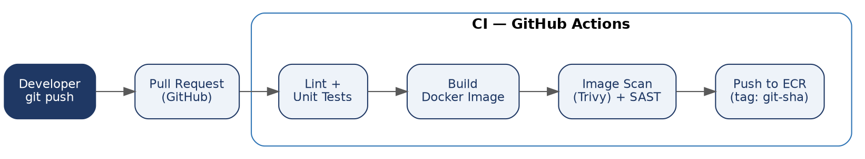
Figure 8 — every pull request runs lint/tests, builds and scans an image, then pushes it to ECR tagged with the commit SHA (never :latest, for the same reproducibility reason as Section 12.4).

14.2 Continuous Deployment (GitOps)
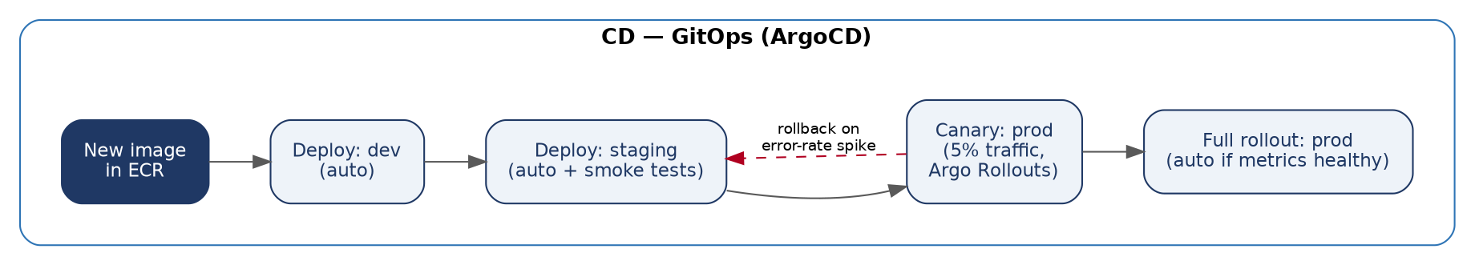
Figure 9 — ArgoCD watches a Git repo of Kubernetes manifests (the "desired state") and automatically reconciles the cluster to match it; promotion between environments is a Git commit, not a manual kubectl apply.
- Dev: every merge to main auto-deploys immediately — this environment is expected to be occasionally broken.
- Staging: auto-deploys after dev, followed by automated smoke tests (a scripted checkout flow hitting real staging services).
- Canary in prod: Argo Rollouts shifts 5% of production traffic to the new version while watching error-rate and latency metrics from Prometheus/CloudWatch.
- Full rollout: promotes automatically only if canary metrics stay healthy for a set window; otherwise Argo Rollouts automatically reverts traffic to the previous version — a rollback that requires no human to be paged at 2 a.m. for a bad deploy.

14.3 Sample GitHub Actions Workflow
# .github/workflows/ci.yml
name: CI
on: [pull_request]
jobs:
build-test-scan:
runs-on: ubuntu-latest
steps:
- uses: actions/checkout@v4
- uses: actions/setup-node@v4
with: { node-version: '20' }
- run: npm ci
- run: npm run lint && npm test -- --coverage
- run: docker build -t $ECR_REPO:${{ github.sha }} .
- name: Scan image
run: trivy image --exit-code 1 --severity HIGH,CRITICAL $ECR_REPO:${{ github.sha }}
- name: Push to ECR
run: |
aws ecr get-login-password | docker login --username AWS --password-stdin $ECR_REGISTRY
docker push $ECR_REPO:${{ github.sha }}
- name: Update GitOps manifest repo
run: ./scripts/bump-image-tag.sh order-service ${{ github.sha }}
The last step is the GitOps handoff: CI's only job is to produce a scanned image and update a manifest; ArgoCD (not this workflow) performs the actual deployment.

14.4 Testing Strategy: The Test Pyramid
The "Lint + Unit Tests" box in Figure 8 hides a deliberately shaped set of test types — deliberately more unit tests than integration tests, and more integration tests than end-to-end tests, because each layer up gets slower and more brittle.
Layer | What it tests | Example in this system | Runs where
Unit tests | A single function/class in isolation, with all dependencies mocked. | Order Service's state-machine transition logic (Section 3.3) — given a state and event, does it return the correct next state or reject an illegal one? | Every CI run, on every PR; must complete in well under a minute.
Integration tests | A service against a REAL (containerized) database/Kafka, but other services mocked. | The Order repository layer actually writing to a throwaway Postgres container and reading it back, verifying the outbox pattern (Section 9.3) really writes both rows in one transaction. | Every CI run, using Testcontainers to spin up ephemeral Postgres/Kafka.
Contract tests | That a producer's event/API shape matches what its consumers actually expect — without either side running the other's full code. | Section 14.5 below. | Every CI run for both the producer and consumer repos.
End-to-end tests | A full user journey through real, deployed services. | The staging smoke test from Section 14.2: place an order, verify the confirmation email arrives. | Only after deployment to staging (Figure 9) — too slow and flaky to run on every PR.
💡 The common anti-pattern this pyramid avoids: a suite dominated by end-to-end tests. They're the most realistic but also the slowest and the most likely to fail for reasons unrelated to the code change (a flaky network call, a timing issue) — a large e2e suite becomes something engineers learn to ignore or re-run rather than trust, which defeats its purpose.

14.5 Contract Testing for Kafka Events
Unit tests catch bugs within the Order Service; they cannot catch "the Order Service renamed a field, and the Notification Service — in a completely different repository — will silently break in production." Contract testing (using a tool like Pact) closes that gap without requiring either service to run the other's code in CI.
- The consumer (Notification Service) writes a contract test stating what it expects an order.created event to look like — which fields it reads and their types — and Pact generates a contract file from that expectation.
- The contract file is published to a shared Pact Broker.
- The producer (Order Service)'s CI pipeline fetches the latest contract from the broker and verifies its ACTUAL event output against it — if Order Service's CI run fails this verification, the breaking change is caught in Order Service's own pull request, before it ever merges, let alone deploys.
This is deliberately the opposite direction of an integration test: instead of Notification Service testing against a real Order Service, Order Service tests against Notification Service's stated expectations — which scales to many consumers without the producer needing to know about, or run, each one individually.

14.6 Load & Chaos Testing
CI's tests (Section 14.4) verify correctness. They say nothing about whether the system holds up under Black-Friday-level traffic, or recovers cleanly when a dependency actually fails — two different, deliberately destructive kinds of testing that run outside the per-PR pipeline.
- Load testing (k6 or Gatling): a scripted ramp-up simulating realistic checkout traffic is run against staging before major sales events, validating the resource sizing from Section 12.5 and the HPA thresholds from Section 12.2 against real numbers rather than estimates.
- Chaos testing (AWS Fault Injection Simulator, or Chaos Mesh in-cluster): deliberately kills a random Order Service pod, or injects latency into the Payment Service's calls, IN A CONTROLLED WINDOW, to verify the circuit breakers (Section 10.3), bulkheads (Section 10.4), and PodDisruptionBudget (Section 12.6) behave as designed — rather than discovering their behavior for the first time during a real incident.
💡 Both load and chaos tests run against staging (or a dedicated pre-prod environment), never directly against production — the goal is to find the breaking point and the failure behavior on purpose, on a schedule the team controls, which is the entire value of doing this proactively rather than waiting for an actual outage to teach the same lesson.

15. Logging & Monitoring in Production
Once services are distributed across many pods, you can't just SSH in and tail a log file. Production systems centralize both metrics (numbers over time) and logs (discrete events) so an engineer can answer "what's happening right now" and "what happened during that incident" from one place.

15.1 Metrics: Prometheus + Grafana
Each service exposes a /metrics HTTP endpoint (via prom-client in Node.js). Prometheus scrapes this endpoint on a schedule and stores the time-series data; Grafana queries Prometheus to render dashboards.
// shared/metrics.js
const client = require('prom-client');
client.collectDefaultMetrics(); // CPU, memory, event loop lag, etc.

const httpDuration = new client.Histogram({
name: 'http_request_duration_seconds',
help: 'Duration of HTTP requests in seconds',
labelNames: ['method', 'route', 'status_code'],
});

app.get('/metrics', async (req, res) => {
res.set('Content-Type', client.register.contentType);
res.end(await client.register.metrics());
});
A useful mental model for what to measure is the RED method for services (Rate, Errors, Duration) and the USE method for resources (Utilization, Saturation, Errors) — e.g., for Order Service: request rate, error rate, p95 latency (RED); and CPU/memory utilization, queue depth (USE).
- Order Service: requests/sec, error rate by status code, p95/p99 latency, DB connection pool saturation.
- Kafka consumers: consumer lag per partition (how far behind real-time a consumer is) — the single most important Kafka health metric.
- Databases: query latency, active connections, replication lag.

15.2 Logging: Structured Logs + EFK Stack
Every service logs structured JSON (via Pino) rather than free-text lines, so logs are machine-parseable. Each pod's stdout is collected by a Fluent Bit DaemonSet running on every Kubernetes node, shipped to Elasticsearch, and browsed/searched in Kibana (the "EFK" stack — an ELK stack using Fluent Bit instead of Logstash).
{
"level": "info",
"time": "2026-09-04T10:12:03.221Z",
"service": "order-service",
"correlationId": "c4e1f2a0-...",
"orderId": "o-8841",
"msg": "Order persisted, publishing ORDER_CREATED"
}
A structured log line — searching Kibana for correlationId: c4e1f2a0-... surfaces this exact request's journey across every service it touched.

15.3 Alerting
Prometheus's Alertmanager evaluates rules against the collected metrics (e.g., "error rate > 5% for 5 minutes" or "Kafka consumer lag > 10,000 messages") and routes notifications to Slack or PagerDuty, so humans are pulled in only when a threshold is actually breached — not by watching dashboards all day.

15.4 Distributed Tracing
Metrics tell you THAT something is slow; traces tell you WHERE. Tools like OpenTelemetry (instrumenting each service) combined with Jaeger or Grafana Tempo let you visualize one request as a timeline of spans across the Gateway, Order Service, its database call, and even the asynchronous hop through Kafka to Payment — turning the correlation ID from Section 10.7 into an actual visual waterfall.

15.5 SLOs, SLIs & Error Budgets

15.6 Business Metrics & Reconciliation Signals

Dashboards should include business-level signals in addition to infrastructure metrics: checkout acceptance rate, payment success rate, inventory reservation failure rate, expired reservations, refund backlog, Kafka consumer lag by critical group, outbox backlog/age, and orders stuck in intermediate states beyond their expected duration.
Alerting should distinguish infrastructure incidents from business-correctness incidents. A growing outbox backlog or orders stuck in PAYMENT_PENDING can indicate a distributed workflow failure even when HTTP error rates remain low.
Section 2.2 stated availability and latency targets. This section is how those targets are made operational, rather than aspirational numbers nobody checks.
Term | Meaning | Example in this system
SLI (Service Level Indicator) | A specific, measured metric. | The proportion of checkout requests completed in under 500ms, measured from the Gateway's histogram (Section 15.1).
SLO (Service Level Objective) | The target value for an SLI, over a time window. | 99.5% of checkout requests complete in under 500ms, measured over a rolling 30 days.
Error budget | The allowed "failure" remaining under the SLO — 100% minus the SLO. | A 99.5% SLO allows 0.5% of requests to be slow/failed — roughly 3.6 hours of full downtime-equivalent per 30 days, spendable on deploys, experiments, or absorbed by real incidents.
The error budget is what turns Section 14's canary rollout (Figure 9) from a vague safety measure into a concrete decision rule: if a canary deploy would burn through a large fraction of the remaining monthly error budget in a short window, Argo Rollouts' automated analysis blocks the promotion — the same mechanism protects against both a genuinely broken deploy and a slow accumulation of minor regressions that individually look acceptable.
- When the error budget is healthy (little of it spent), the team has room to ship faster and take on riskier changes.
- When the error budget is nearly exhausted, the team's priority explicitly shifts to reliability work over new features until it recovers — this is what stops "launch velocity" and "reliability" from being a purely political argument, by giving both sides a shared, pre-agreed number.

16. Production Directory Structure for Node.js
order-service/
├── src/
│ ├── config/ # Environment variables & DB connection
│ ├── controllers/ # Route controllers / request handling
│ ├── services/ # Business logic layer
│ ├── models/ # Database schemas / ORM models
│ ├── events/ # Kafka producers and consumers
│ ├── middleware/ # Express auth, rate-limiting, error handlers
│ ├── utils/ # Structured loggers, correlation injectors
│ └── app.js # Express application setup
├── tests/ # Unit, integration, and e2e tests
├── Dockerfile # Multi-stage container definition
├── k8s/ # deployment.yaml, service.yaml, hpa.yaml
├── package.json
└── server.js # Server entry point
- controllers/ only translates HTTP ↔ service calls; almost no business logic.
- services/ holds business rules, independent of HTTP or SQL — easy to unit test.
- models/ is the only layer allowed to talk to the database.
- events/ isolates Kafka details so the rest of the app doesn't know about topics/partitions directly.
- k8s/ keeps this service's deployment manifests versioned alongside its code.

17. Step-by-Step Code Walkthrough
This section keeps the original RabbitMQ-based walkthrough for the API Gateway, since a reverse-proxy gateway pattern is broker-agnostic; Section 8 already covered the Kafka producer/consumer equivalents used for the main event backbone. Real systems sometimes mix both: Kafka for high-volume domain events, and a simpler queue for lower-volume task-style jobs.

17.1 API Gateway (Express + HTTP Proxy)
// gateway/server.js
const express = require('express');
const { createProxyMiddleware } = require('http-proxy-middleware');
const rateLimit = require('express-rate-limit');

const app = express();
const limiter = rateLimit({ windowMs: 15 * 60 * 1000, max: 100 });
app.use(limiter);

app.use('/api/v1/users', createProxyMiddleware({ target: 'http://user-service:3001', changeOrigin: true }));
app.use('/api/v1/products', createProxyMiddleware({ target: 'http://product-service:3002', changeOrigin: true }));
app.use('/api/v1/orders', createProxyMiddleware({ target: 'http://order-service:3003', changeOrigin: true }));

app.listen(3000, () => console.log('API Gateway running on port 3000'));
- rateLimit runs before any proxy route, stopping abusive traffic at the front door.
- Internal hostnames like order-service resolve via Kubernetes' internal DNS to the Service object from Figure 5.

18. Putting It All Together: One Order, Start to Finish
- Browser sends POST /api/v1/orders. It hits the Ingress → API Gateway (Figure 1), never the Order Service directly.
- The pod's middleware → controller → validation → service layer validates the cart, requests the current product price from the Product Catalog Service, calculates the order total, and writes orders + order_items + an outbox_events row in ONE Postgres transaction (Figure 4). Inventory remains the source of truth for stock; Order Service does not read the Inventory database directly.
- A relay process reads the new outbox row and publishes order.created to Kafka, keyed by order_id (Section 8.4) — guaranteeing the event is never lost relative to the DB write.
- Independently, Inventory Service consumes order.created and attempts the reservation. Only after inventory.reserved does Payment Service charge the customer and publish payment.completed (or payment.failed). This sequencing avoids charging for an order that could not reserve stock.
- If Payment fails, Inventory consumes payment.failed and releases its reservation; Order Service moves the order to CANCELLED. If a later fulfillment failure occurs after payment has succeeded, the design must issue a compensating refund and record the refund outcome for reconciliation.
- This is the core shape of the event-driven flow: the synchronous request only accepts the order, while inventory, payment, fulfillment, notifications and compensations proceed as independently retryable state transitions.

19. System-Wide Edge Cases
Individual sections above called out edge cases local to that topic. This section collects the ones that only appear when several parts of the system interact — the cases that actually show up in production incident reviews.
Edge case | Where it bites | How this design handles it
Double-click / duplicate order submission | Frontend + Order Service | Frontend disables the submit button on isPending (Section 4.5) AND reuses the same Idempotency-Key (Section 11.1) on any retry, so even a duplicate network request is a safe no-op.
Two shoppers buy the last unit simultaneously | Inventory Service | Stock decrement is a single atomic SQL UPDATE ... WHERE quantity >= requested_qty; the second request's UPDATE affects zero rows and is rejected as out-of-stock, rather than both succeeding.
Payment succeeds but the response is lost (network drop) | Payment Service ↔ Gateway | Idempotency-Key replay (Section 11.3) returns the original success response on retry instead of charging again.
Inventory reserved but Payment then fails | Cross-service consistency | Saga compensating action (Section 9.5): Inventory releases the reservation on payment.failed.
Kafka consumer crashes mid-message | Any consumer | At-least-once delivery means the message is redelivered after the consumer group rebalances; the idempotency check (Section 8.5) prevents duplicate side effects.
Price changes between "add to cart" and "checkout" | Frontend + Order Service | Order Service re-validates price at checkout by calling the Product Catalog Service, not by reading the Catalog DB directly. The frontend's cached price is display-only; the final amount is calculated server-side.
Currency rounding across services | Payment / Order | All monetary values are stored as integer minor units (cents), never floats, and rounding rules are applied once, centrally, in the Payment Service — not independently in each service that touches an amount.
Clock skew between services | Logging / event ordering | Kafka's own broker-assigned offsets — not each service's wall-clock timestamp — are relied on for ordering; timestamps are for display/audit only.
Webhook arrives before the synchronous response returns | Payment Service | The webhook handler updates the same idempotency-keyed row by gateway transaction reference (Section 11.6) rather than racing the synchronous code path.
A shopper's session/JWT expires mid-checkout | Auth + Frontend | The API layer's 401 interceptor triggers a silent refresh-token exchange; if that also fails, the cart state (Zustand, Section 4.2) is preserved locally so the shopper doesn't lose their cart after re-login.
Cascading retries from many clients at once (thundering herd) | Any synchronous dependency | Exponential backoff + jitter (Section 10.2) spreads retries out in time instead of all clients retrying on the same schedule.
A Kubernetes node is terminated mid-request | Any service | readinessProbe (Section 12.4) removes the pod from the Service's rotation before termination completes; combined with client-side retry, the shopper's request is transparently served by a different pod.
Inventory reservation expires | Inventory + Order | A reservation carries an expiry/lease. A sweeper and/or scheduled event releases expired holds and moves the order to an explicit failure state if payment has not completed.
Payment succeeds but later fulfillment fails | Payment + Order + Fulfillment | Use a compensating refund flow with a durable refund record, webhook reconciliation, and a manual-review state if the provider outcome is unknown.
Webhook is duplicated or forged | Payment Service | Verify the provider signature before processing, deduplicate by provider event ID, and make webhook handling idempotent.
Cart and catalog diverge | Cart + Catalog | Cart stores product IDs and quantities; price and availability are re-read from authoritative services at checkout. Never trust client-supplied totals.

20. Common Pitfalls in Production Systems
- Sharing a database or a shared models library across services — quietly recreates a monolith.
- Chaining synchronous calls 3+ services deep — one slow link causes a cascading failure.
- Non-idempotent Kafka/queue consumers — duplicate delivery is normal, not an edge case.
- Publishing to Kafka before the DB transaction commits (or vice versa without an outbox) — the classic dual-write bug (Section 9.3).
- Skewed Kafka partition keys (e.g., keying by a low-cardinality field) — creates "hot" partitions that one consumer can't keep up with.
- No resource requests/limits on Kubernetes pods — one noisy-neighbor pod can starve others on the same node.
- Ignoring consumer lag as a metric — a slowly growing lag is often the first sign of trouble, long before errors appear.
- Skipping correlation IDs early — debugging a multi-service, part-sync-part-async bug without them is extremely painful.
- Reusing a fresh Idempotency-Key on every retry (instead of the same key) — silently defeats the entire idempotency mechanism in Section 11.
- Mixing server-cache data and client-only UI state in one frontend store — recreates cache-invalidation bugs that TanStack Query already solves (Section 4.2).
- Deploying straight to production without a canary stage — the first signal of a bad deploy becomes a customer complaint instead of an automated rollback (Section 14.2).

20.1 Architecture Decision Checklist
- Every cross-service workflow has an explicit state machine, timeout, retry policy, compensation path, and reconciliation path.
- No service reads another service's database directly; synchronous APIs and domain events are the integration boundaries.
- Every externally triggered mutation has an idempotency strategy, including payment, refunds, webhooks, and important consumer side effects.
- Each production SLO has a measurable SLI, alert threshold, owner, and a tested runbook.
- Infrastructure and application rollouts support safe rollback, backward-compatible migrations, and schema/event compatibility checks.

21. Key Takeaways & Production Readiness
The architecture is complete when correctness, security, operability and scale are treated as one system rather than isolated concerns.

21.1 Key Design Guarantees
Each cross-service workflow has an explicit state machine, timeout, retry policy, compensation path and reconciliation path.
Inventory is the source of truth for stock and reservations; reservations expire safely and stock movements are auditable.
Payment state is modeled independently from Order state, with idempotent authorization, capture and refund handling and verified webhooks.
Safe change delivery combines API/event compatibility, zero-downtime migrations, canary rollout and automated rollback.

21.2 Recommended Build Order
1. Run the complete stack locally with Docker Compose and verify checkout, inventory-race and idempotency behavior.
2. Add integration, contract, concurrency, load and failure-injection tests before production rollout.
3. Deploy to EKS with GitOps, observability, SLOs, tested backups and canary delivery.
4. Introduce regional DR or other advanced complexity only when measurable business requirements justify it.

Appendix A: Architecture Decision Records (ADRs)
The rationale tables throughout this document (Sections 6, 7.4, 9.1, 12, 13) explain why each choice was made, but they don't formally record what was explicitly considered and rejected. An Architecture Decision Record (ADR) captures that — the context, the decision, the alternatives that were on the table, and the consequences accepted — so a future engineer (or auditor) can see the reasoning was deliberate, not accidental, without having to reconstruct it from a chat log or a departed engineer's memory.
💡 Format: each ADR follows Context → Decision → Alternatives Considered → Consequences. New architectural decisions for this system should be added here going forward, numbered sequentially — an ADR log is only useful if it stays current.

ADR-001: Microservices over a Modular Monolith
Field | Detail
Context | The platform needed independent scaling (Product Catalog reads vs. Order writes), independent deployability across teams, and fault isolation for checkout (Section 1's motivating pain points).
Decision | Decompose into six bounded-context services (Section 2.3) communicating via REST (sync) and Kafka (async), each owning its own database (Section 6).
Alternatives considered | Modular monolith (single deployable, internally modular) — rejected: doesn't solve independent scaling or independent deploy cadence, though it remains the right starting point for smaller teams (Section 5).  Serverless (Lambda per endpoint, Step Functions for orchestration) — rejected for the core transactional path: cold starts and 15-minute execution limits complicate long-running Saga orchestration and persistent Kafka consumers, though it remains attractive for bursty, stateless tasks (e.g., image thumbnailing).
Consequences | Gained: independent scaling/deployment, fault isolation. Accepted cost: distributed-systems complexity — network calls, eventual consistency, and everything in Sections 9–11 exists to manage that cost.

ADR-002: Apache Kafka over RabbitMQ for the Core Event Backbone
Field | Detail
Context | Order, Payment, Inventory, and Notification need to react to domain events (order.created, payment.completed) at high, bursty throughput, with the ability to replay history for new consumers (Section 8.1).
Decision | Use Kafka (Amazon MSK) as the event backbone for domain events; keep RabbitMQ-style patterns available for lower-volume, simpler task queues (Section 6.4).
Alternatives considered | RabbitMQ for everything — rejected as the primary backbone: no replay, and ordering guarantees don't extend across multiple consumers the way a partitioned Kafka topic's do (Section 6.4's comparison table).  AWS SNS/SQS only — rejected as the primary backbone: adequate for simple fan-out but lacks partition-level ordering and consumer-group replay semantics the Saga pattern (Section 9.5) relies on; still used for low-volume supporting tasks (Section 13.1).
Consequences | Gained: replay, high throughput, ordered per-key delivery. Accepted cost: operational complexity of consumer groups/rebalancing (Section 8.7) and the need for schema governance (Section 8.6).

ADR-003: PostgreSQL for Transactional Services, MongoDB for Catalog
Field | Detail
Context | Order/Payment/Inventory need ACID guarantees for money and stock; Product Catalog needs a flexible, frequently-changing schema across very different product categories (Section 9.1).
Decision | PostgreSQL (RDS Multi-AZ) for Order/Auth/Payment/Inventory; MongoDB (DocumentDB) for Product Catalog, fronted by Redis for hot reads.
Alternatives considered | A single shared PostgreSQL instance for all services — rejected: reintroduces cross-service coupling through a shared schema, the exact anti-pattern Section 6 warns against.  DynamoDB for Order — rejected: the multi-row, multi-table transaction the outbox pattern needs (Section 9.3) is far more natural in a relational database than in DynamoDB's single-item transaction model at this scale.
Consequences | Gained: the right consistency/flexibility trade-off per service. Accepted cost: two different database technologies to operate, back up, and staff for (Section 13.11's DR plan is written per-technology for this reason).

ADR-004: EKS over ECS/Fargate for Container Orchestration
Field | Detail
Context | The team wanted a portable, ecosystem-standard orchestrator with fine-grained autoscaling, and anticipated needing service-mesh and custom-controller flexibility (Section 12).
Decision | Amazon EKS (managed Kubernetes control plane), with managed node groups in private subnets (Section 13.7).
Alternatives considered | ECS on Fargate — rejected: simpler to operate, but the team's IRSA-equivalent (task roles), HPA-equivalent, and NetworkPolicy-equivalent tooling is less mature and less portable outside AWS than Kubernetes-native primitives (Sections 12.5–12.6).  Self-managed Kubernetes (kubeadm on EC2) — rejected: the operational burden of running the control plane itself outweighs the marginal cost savings versus EKS for a team this size.
Consequences | Gained: portability, a large ecosystem (ArgoCD, Prometheus Operator, cert-manager), and fine-grained scaling control. Accepted cost: EKS's control-plane cost and a steeper operational learning curve than Fargate.

ADR-005: Idempotency Keys over Kafka Exactly-Once Semantics for Payments
Field | Detail
Context | A network retry or duplicate event delivery must never double-charge a customer (FR-9, Section 2.1); Kafka supports exactly-once semantics (EOS) transactions.
Decision | Implement application-level idempotency keys, stored in Postgres with a unique constraint (Section 11), as the primary safety mechanism for Payment.
Alternatives considered | Rely on Kafka EOS end-to-end — rejected as sufficient on its own: EOS only covers the producer-to-topic-to-offset-commit boundary; the moment a consumer calls out to Stripe (a side effect outside Kafka's transaction), EOS can no longer guarantee exactly-once (Section 8.7).
Consequences | Gained: a correctness guarantee that holds regardless of which broker or delivery mechanism is used. Accepted cost: an extra database round-trip and table (idempotency_keys) that must itself be sized, indexed, and periodically purged (Section 11.2).

ADR-006: Active-Passive Disaster Recovery over Active-Active Multi-Region
Field | Detail
Context | The business requires surviving a full AWS region outage, but has no current requirement for sub-100ms latency to geographically distant shoppers (Section 13.12).
Decision | Single-region, multi-AZ as the default deployment, with an active-passive warm-standby second region for DR only.
Alternatives considered | Active-active multi-region — rejected for now: introduces cross-region data-ownership and inventory-consistency problems on top of the Saga pattern's existing complexity (Section 9.5), without a measured business requirement (latency data) to justify it.
Consequences | Gained: real resilience against the highest-impact failure at a fraction of active-active's operational cost. Accepted cost: DR failover RTO is measured in tens of minutes (a DNS cutover and replica promotion), not seconds — acceptable given the current requirement is disaster recovery, not latency.

Appendix B: Capacity Planning & Traffic Estimation
Section 12.5 sizes Kubernetes resource requests/limits from load-test data; this appendix is the back-of-envelope math that determines what that load test should even simulate — the numbers a solution architect works out BEFORE the first line of infrastructure code is written, and revisits as real traffic data replaces assumptions.

B.1 Assumptions (to be replaced with real data post-launch)
Assume a mid-sized regional e-commerce platform: 500,000 monthly active users, a 3% daily conversion-to-purchase rate among active shoppers, and a Black-Friday-style peak of 8x average traffic.

B.2 Baseline Traffic Estimate
Metric | Average day | Peak (8x sale-day multiplier)
Daily active users (DAU) | ~50,000 (10% of MAU) | ~150,000
Orders per day | ~1,500 (3% of DAU) | ~36,000 (peak conversion also rises)
Orders per second (sustained) | ~0.02 (negligible) | ~2.5 sustained, bursting higher at flash-sale start
Product read requests/sec (browsing:checkout ratio ~20:1) | ~5–10 | ~150–200
Kafka events/sec (order.created + downstream fan-out, ~4 events/order) | < 1 | ~10
💡 These are the numbers Section 12.5's Step 1 ("start from load-test data") should actually load-test AGAINST — a load test that only simulates average-day traffic never validates the HPA thresholds (Section 12.2) or connection-pool sizing (Section 9.4) that matter during the one week a year they're actually tested by real traffic.

B.3 Storage Growth Projection
Data store | Per-order footprint | Annual growth (at ~500K orders/year)
orders + order_items (Postgres) | ~2 KB per order (order + ~2.5 line items average) | ~1 GB/year raw — negligible for RDS storage, but relevant for index bloat and the partitioning strategy in Section 9.4
outbox_events (Postgres) | ~1 KB per event, ~4 events/order, purged after ~7 days once published | Bounded — this table's steady-state size, not its growth rate, is what matters; a stuck consumer (Section 8.7) is what causes unbounded growth, which is why it needs its own alert (Section 15.3)
idempotency_keys (Postgres) | ~0.5 KB per key, purged after 24h (Section 11.2) | Bounded by the 24h TTL — steady-state size is roughly (peak orders/sec × 86,400), not cumulative
Kafka topic retention | ~1 KB/event, default 7-day retention | Bounded by retention policy, not order volume — sized for the schema-registry/replay use case in Section 8.6, not as a permanent log

B.4 Connection Pool Sizing (worked example for Order Service)
Section 9.4 mentions PgBouncer without giving the arithmetic; here it is, worked through for Order Service specifically:
1. Peak Order Service replica count from Section 12.2's HPA: assume it scales to 10 pods under the 8x peak load above.
2. Each pod's Node.js connection pool is configured for 10 connections (a typical default) — 10 pods × 10 connections = 100 potential direct connections to Postgres at peak.
3. RDS's max_connections for the chosen instance class may be well under 100 once other services and admin/reporting connections are counted — this is precisely the number that motivates routing pod connections through PgBouncer in transaction-pooling mode, which can serve 100 application-side connections from a much smaller number of actual Postgres backend connections.
4. The concrete sizing rule: set PgBouncer's default_pool_size to comfortably exceed the DATABASE's realistic concurrent-transaction capacity (informed by load testing, Section 14.6), not the application's connection-pool setting — the whole point of pooling is that these two numbers don't have to match.

Appendix C: Threat Model (STRIDE) for Checkout & Payment
Section 10.8 lists network/secrets security controls and Section 13.19 covers IAM, but neither is a threat model — a systematic walk through what could go wrong. STRIDE (Spoofing, Tampering, Repudiation, Information Disclosure, Denial of Service, Elevation of Privilege) applied to the checkout/payment flow specifically, since it's the highest-value target in the system.
STRIDE category | Concrete threat in this flow | Mitigation (existing section)
Spoofing | An attacker forges a JWT or replays a stolen session token to place orders as another shopper. | Short-lived JWTs with refresh-token rotation (Section 4.6); Gateway-level signature verification before any service is reached (Section 10.1).
Tampering | A request is intercepted and the order total or shipping address is modified in transit, or a client-supplied price is trusted at checkout. | TLS everywhere (Section 2.2); Order Service always re-validates price server-side from the Catalog DB rather than trusting the client's cached value (Section 19's price-change edge case).
Repudiation | A shopper disputes having placed an order or authorized a charge, and there's no reliable record to settle the dispute. | Correlation-ID-tagged structured logs (Section 15.2) plus the idempotency_keys table's stored request/response (Section 11.2) provide an auditable record of exactly what was requested and processed.
Information Disclosure | Card details, addresses, or internal error details (stack traces) leak via an API response or log line. | Card data never touches this system's own database — Payment forwards directly to Stripe/PayPal (Section 2.2's PCI-DSS scope note); 5xx responses are deliberately generic while full detail stays server-side (Section 10.6).
Denial of Service | A scripted burst of checkout attempts (or a competitor's bot) exhausts Order/Payment capacity during a sale. | Gateway-level rate limiting (Section 10.1); circuit breakers and bulkheads prevent one overloaded dependency from cascading into a full outage (Sections 10.3–10.4).
Elevation of Privilege | A compromised Notification Service pod (read-only by design) attempts to call Order Service's internal write endpoints directly. | NetworkPolicies restrict which pods may call which services at the network layer (Section 12.6); IRSA/Pod Identity scopes each service's AWS permissions independently (Section 13.19), so a compromised pod's blast radius is contained to its own narrow role.
💡 A threat model is a living document, not a one-time checklist: it should be revisited whenever a new integration is added (e.g., a new payment method, a new third-party webhook) — Section 21.2's recommended build order should include a threat-model review as a gate before any new integration reaches production, alongside the testing and observability gates already listed there.

Appendix D: Security Architecture — Defense in Depth
Security controls appear throughout this document wherever they're most relevant to the topic at hand — Section 2.2's NFRs, Section 4.6's token storage, Section 10.8's network policies, Section 13's IAM, Appendix C's threat model. This appendix pulls the full picture together into one place, layer by layer, from the browser to the database, so the question "how is X actually secured end-to-end" has one answer to point to rather than six scattered ones.

D.1 The Model: Zero Trust, Defense in Depth
The guiding principle is Zero Trust: no request is trusted by virtue of WHERE it came from (inside the VPC, inside the cluster) — every hop authenticates and authorizes independently, and every layer assumes the layer before it could fail. This is why the controls below overlap rather than forming a single chain: a gap in one layer is still caught by the next.
Layer | Primary control | Section
Browser / client | CSP, secure token storage, dependency scanning | D.2
Edge / CDN | WAF, DDoS protection, TLS termination | D.3
API Gateway | JWT validation, rate limiting, request schema validation | D.3
Service-to-service (mesh) | Mutual TLS, cryptographic workload identity, per-route authorization | D.4
Event backbone (Kafka) | SASL/mTLS authentication, per-topic ACLs, encryption in transit | D.5
Data at rest | KMS encryption, least-privilege DB users, field-level protection for PII | D.6
Container / Kubernetes | Non-root images, read-only filesystem, Pod Security Standards, signed images | D.7
Supply chain | Dependency and image scanning, SBOM, pinned base images | D.8
Observability | Centralized audit logging, anomaly detection, incident response | D.9
💡 Read this table as independent layers, not a single wall: an attacker who somehow bypasses the WAF still hits JWT validation at the Gateway; one who somehow forges a JWT still can't move laterally between services without a valid mesh identity (D.4); one who compromises a pod still can't read another service's database credentials (D.6/D.8's least-privilege scoping).

D.2 Frontend / Client Security
Section 4.6 already covers where tokens live in the browser; this section covers the other client-side risks a modern React SPA has to defend against.
Risk | Control
Cross-Site Scripting (XSS) — injected script reads tokens or acts as the shopper | React escapes rendered content by default; dangerouslySetInnerHTML is banned outside a reviewed allowlist (e.g., sanitized rich-text product descriptions via DOMPurify). A strict Content-Security-Policy header (script-src 'self', no inline scripts) is enforced at the CDN so even a successful injection can't execute or exfiltrate to an attacker-controlled domain.
Cross-Site Request Forgery (CSRF) | The access token travels in an Authorization header, not an automatically-sent cookie, so a forged cross-site form post has no valid credential to attach — CSRF is structurally avoided for the API itself rather than relying solely on tokens/SameSite cookies.
Clickjacking | frame-ancestors 'none' in the CSP (and X-Frame-Options: DENY for older browsers) stops the checkout page from being embedded in a hidden iframe on an attacker's site.
Malicious or compromised npm dependency | npm audit / Snyk runs in CI (Section 14.1) alongside the container image scan (Trivy), and lockfiles are committed so a dependency's version can't silently drift between a developer's machine and the production build.
Client-supplied price/total trusted at checkout | The API client never sends a computed total as authoritative — the Order Service always re-derives price server-side from the Catalog DB (Section 19's price-change edge case; Appendix C's Tampering row).

D.3 Edge & API Gateway Security
Everything from the internet lands here before it ever reaches a service, which is why this layer carries the broadest, coarsest controls.
• TLS termination happens at CloudFront/ALB using ACM-managed certificates with automatic renewal — no service ever handles a raw, unencrypted request from the public internet.
• AWS WAF (Section 13.1) filters common attack signatures (SQLi, XSS payloads, known bad IP reputation lists) before a request reaches the ALB, and rate-based rules throttle a single IP's request rate independently of the Gateway's own per-user rate limiting (Section 10.1).
• The Gateway validates the JWT's signature, issuer, audience, and expiry on every request — not just its presence — before proxying anywhere, and rejects malformed request bodies against a schema (Section 3's API contracts) before they reach business logic.
• Internal service addresses (order-service.default.svc.cluster.local) are never resolvable from outside the cluster — the Gateway is the only component with a public-facing route, which is what makes the internal Zero Trust layer in D.4 meaningful rather than redundant.

D.4 Service-to-Service Security: Securing Communication Between Microservices
This is the layer most system designs leave implicit — "it's all inside our VPC, so it's trusted" — which is exactly the assumption Zero Trust rejects. Section 10.8 and 12.6 already establish NetworkPolicies as a coarse allow-list ("only pods labeled api-gateway may open a connection to order-service on port 3003"). That controls WHICH pods can connect. It says nothing about WHO is on each end of that connection, or whether the traffic itself could be read or altered by anything sitting on the network path. Two further controls close that gap.
D.4.1 Mutual TLS via a Service Mesh
A service mesh (Istio or Linkerd) is installed alongside Kubernetes and injects a lightweight proxy (a "sidecar") into every pod. All traffic in and out of a pod's application container is transparently routed through its sidecar — the application code itself makes plain, unencrypted HTTP calls exactly as shown in Section 13's code samples, and never has to know encryption is happening.
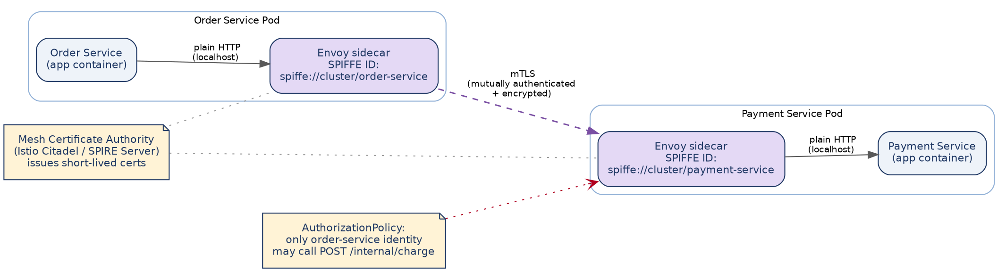
Figure 11 — Order Service's sidecar and Payment Service's sidecar each hold a short-lived certificate proving their identity; traffic between the two sidecars is encrypted and mutually authenticated, while each application container only ever talks to its own local sidecar in plain HTTP.
• Every workload gets a cryptographic identity (a SPIFFE ID, e.g. spiffe://cluster/order-service) issued by the mesh's certificate authority — NOT an IP address or a Kubernetes label, which can be spoofed far more easily than a private key.
• Certificates are short-lived (rotated automatically, often hourly) — a leaked certificate is a much smaller, self-healing window of exposure than the multi-year TLS certificates typically used for public-facing endpoints.
• Because encryption happens at the sidecar, application code (the Section 13 Express examples) needs zero changes to gain mTLS — this is precisely why the mesh is the practical way to add encryption-in-transit across dozens of internal service-to-service calls without touching every codebase.
D.4.2 Service-Level Authorization (Not Just Authentication)
mTLS answers "who is calling" cryptographically. It does not answer "should this caller be allowed to call this specific endpoint" — that is a separate, explicit authorization policy, enforced at the mesh layer independent of whatever the application code itself checks.
# Istio AuthorizationPolicy — payment-service only accepts /internal/charge
# calls from workloads with the order-service identity; everything else is denied
# by default, even if it originates from inside the same cluster.
apiVersion: security.istio.io/v1
kind: AuthorizationPolicy
metadata: { name: payment-internal-charge, namespace: default }
spec:
selector: { matchLabels: { app: payment-service } }
action: ALLOW
rules:
- from:
- source: { principals: ["cluster.local/ns/default/sa/order-service"] }
to:
- operation: { paths: ["/internal/charge"], methods: ["POST"] }
💡 This is the mesh-level analogue of IRSA (Section 13.19): IRSA scopes what a service can do against AWS APIs; the mesh AuthorizationPolicy scopes what a service can do against OTHER SERVICES. A compromised Notification Service pod (Appendix C's Elevation-of-Privilege row) is blocked twice over — once by the NetworkPolicy that never opens a route to it, and again by this policy even if it somehow reached Payment's network address.
D.4.3 Propagating User Identity Across Internal Calls
A subtlety many designs miss: once the Gateway validates a shopper's JWT, how does Order Service — several hops and possibly a Kafka event later — know which authenticated user this action is actually for, without re-trusting a client-supplied user ID?
• The Gateway forwards the original, still-valid JWT (or a short-lived internal token derived from it, carrying only the user ID and roles, not the full external claims) as an internal header on the downstream call — internal services verify this token's signature exactly as the Gateway does, rather than trusting an unsigned X-User-Id header that any caller could set arbitrarily.
• For asynchronous flows, the user ID travels as part of the signed event payload (Section 8's order.created event already carries the authenticated order owner), so a consumer never has to "look up" who a request was for from an untrusted source.

D.5 Kafka / Event Backbone Security
The event backbone (Section 8) carries order, payment, and inventory data between services and deserves the same authentication and authorization rigor as any synchronous call.
Control | What it prevents
SASL/SCRAM or mutual TLS authentication to MSK brokers | An unauthenticated workload connecting directly to the Kafka bootstrap endpoint and reading or writing arbitrary topics.
Per-topic ACLs (e.g., order-service may PRODUCE to order.created but not CONSUME it; notification-service may only CONSUME, never PRODUCE) | A compromised or misconfigured consumer publishing forged events — Notification Service, for example, has no technical ability to publish a fake payment.completed event even if compromised.
Encryption in transit (TLS) between brokers and clients | Payload interception on the network path — relevant because event payloads (Section 9.2's ERD) include order totals and shipping addresses.
Encryption at rest (KMS-backed) for MSK's underlying storage | Data exposure from the underlying EBS volumes backing the Kafka brokers, independent of application-level access controls.

D.6 Data-at-Rest & Database Security
• Every RDS instance, DocumentDB cluster, and ElastiCache replication group is encrypted at rest with a KMS customer-managed key (Section 13.11's backups inherit this encryption automatically).
• Each service connects to its database with its OWN least-privilege database user — Order Service's DB user can read/write only the order_db schema's tables and cannot even see the payment_db schema exists, enforced at the PostgreSQL grant level, not just at the network layer (Section 6's database-per-service rule, made concrete).
• Reporting/analytics queries connect through a separate, read-only database user pointed at a read replica (Section 9.4) — a compromised reporting credential can leak data but can never modify it.
• PII fields (shipping address, phone number) are protected by RDS's encryption at rest as a baseline; where a specific field is highly sensitive, application-level field encryption (encrypting before INSERT, decrypting only in the service that owns the data) is used so even a raw database dump or a misconfigured snapshot share doesn't expose it in plaintext.
• Card data specifically never reaches this system's own database in any form, encrypted or not — Payment forwards directly to Stripe/PayPal (Section 2.2's PCI-DSS scope note) — the strongest possible mitigation for that data class is simply not storing it at all.

D.7 Container & Kubernetes Hardening
Control | Detail
Non-root containers | Every Dockerfile (Section 13's example) runs as a dedicated non-root user; a container breakout attempt starts with far fewer privileges on the host.
Read-only root filesystem | Pods are configured with readOnlyRootFilesystem: true wherever the app doesn't need to write locally, so a compromised process can't drop a persistent payload onto the container's own filesystem.
Dropped Linux capabilities | Pods drop all default Linux capabilities and add back only what's strictly required (rarely any, for a typical Node.js service) rather than running with the container runtime's broad default set.
Pod Security Standards (restricted profile) | Enforced cluster-wide via an admission controller — a manifest requesting privileged mode, host networking, or root is rejected at deploy time, not caught later in an audit.
Signed images + admission control | Images are signed during CI (cosign/Sigstore) and an admission webhook rejects any image without a valid signature from the pipeline — this stops a compromised registry credential from getting an unauthorized image deployed even if it reaches ECR.
Kubernetes RBAC | Separate from IRSA/IAM (Section 13.19, which governs AWS API access) — Kubernetes RBAC governs who can kubectl exec into a pod, read a Secret, or modify a Deployment, scoped per namespace and per human/CI identity.

D.8 Supply Chain Security
• Container images are scanned for known CVEs at build time (Trivy, Section 14.1) and base images are pinned to a specific digest, not a floating tag, so a base-image update can't silently introduce a vulnerability between builds.
• A Software Bill of Materials (SBOM) is generated for each image at build time, giving a complete, queryable inventory of every package and version shipped — essential for rapidly answering "are we affected" the next time a widely-used library has a disclosed CVE (as with Log4Shell).
• Application dependencies (npm) are scanned separately from container OS packages (D.2), since the two have different update cadences and different tooling.

D.9 Security Monitoring & Incident Response
• AWS GuardDuty continuously analyzes VPC Flow Logs, DNS logs, and CloudTrail for anomalous behavior (e.g., an EKS node suddenly port-scanning internally, or API calls from an unusual region) and feeds findings into the same alerting path as Section 15.3.
• CloudTrail logs every AWS API call (who, from where, what action) — the audit trail that answers "what did this IAM role actually do" after the fact, independent of the application's own structured logs (Section 15.2).
• Structured application logs, GuardDuty findings, and CloudTrail are all ingested into the same centralized logging pipeline (Section 15.2's EFK stack) so a security investigation and an operational debugging session use the same correlation-ID-driven tooling rather than two disconnected systems.
• A documented incident response runbook covers the specific, high-value scenario this section is built around: a suspected compromised service credential is rotated immediately via Secrets Manager (Section 13.8) without a full redeploy, and the corresponding IRSA role's recent AWS API activity is pulled from CloudTrail within minutes, not hours.

D.10 Compliance Snapshot
Requirement | How this architecture addresses it
PCI-DSS (card payment data) | Card data never touches this system's infrastructure — Payment forwards directly to a PCI-compliant gateway (Stripe/PayPal), which minimizes this system's own PCI-DSS scope to the network segment that merely calls out to the gateway, not one that stores or processes card numbers.
GDPR / data-subject rights (EU shoppers' PII) | Auth & User Service is the single owner of PII (Section 6's bounded context), which is what makes a "right to erasure" request tractable — it's one service's data model to redact/anonymize, plus a cascading event (user.deleted) other services react to for their own denormalized copies (Section 9.3's outbox pattern), rather than a manual hunt across six databases.
SOC 2 / general audit readiness | ADRs (Appendix A) plus CloudTrail (D.9) together answer both halves an auditor asks for: WHY a control exists and PROOF it's actually enforced in practice, rather than a policy document with no corresponding technical evidence.
💡 This snapshot is deliberately not a compliance certification — actual PCI-DSS/GDPR/SOC 2 compliance requires a formal audit against the current, deployed system, not a design document. What this architecture provides is a foundation that makes each requirement tractable rather than an afterthought bolted on post-launch.

Appendix E: Distributed Systems Concepts Reference
Sections 3.4 and 9 use specific concurrency and consistency techniques (row locks, the outbox pattern, Sagas) without always naming the underlying theory they rest on. This appendix makes that theory explicit — database transaction isolation, the CAP trade-off, and two mechanisms (circuit breakers, rate limiters) referenced earlier by name but not fully specified — so the reasoning in the rest of the document connects to standard distributed-systems vocabulary.

E.1 Database Transaction Isolation Levels
Section 3.4 showed HOW this system prevents race conditions (atomic UPDATEs, SELECT ... FOR UPDATE, optimistic version checks). Isolation level is the DATABASE-WIDE setting that determines what a transaction can even see of other transactions' uncommitted or concurrently-committed work — the backdrop those techniques operate against.
E.1.1 The Anomalies (What Isolation Protects Against)
Anomaly | What happens
Dirty read | Transaction A reads a row that Transaction B has modified but not yet committed. If B then rolls back, A has read data that never officially existed.
Non-repeatable read | Transaction A reads a row twice within the same transaction and gets different values, because Transaction B committed a change to that row in between.
Phantom read | Transaction A re-runs the same WHERE-clause query twice and gets a different SET OF ROWS the second time, because Transaction B inserted or deleted a matching row in between.
Lost update | Transactions A and B both read the same row, both compute a new value based on that read, and whichever writes second silently overwrites the first's change with no error — exactly the failure mode Section 3.4's atomic UPDATE and optimistic-locking techniques exist to prevent.
E.1.2 The Four Standard Isolation Levels
Level | Prevents | Still allows | Used in this system?
READ UNCOMMITTED | Nothing | Dirty reads, non-repeatable reads, phantoms | No — Postgres doesn't actually implement this level distinctly; it behaves as READ COMMITTED even if requested.
READ COMMITTED | Dirty reads | Non-repeatable reads, phantoms | Yes — this is Postgres's default and what every service in this system runs under. Combined with Section 3.4's row-level locking and atomic statements, it's sufficient for every workflow in this document.
REPEATABLE READ | Dirty reads, non-repeatable reads | Phantoms (Postgres's implementation actually also prevents phantoms, stricter than the SQL standard requires) | Not used by default — considered for the rare multi-statement report that must see a fully consistent snapshot across several queries, e.g., a financial reconciliation job (Section 11.7) that reads several tables and must not see a partial mid-transaction state.
SERIALIZABLE | All of the above | Nothing — transactions behave as if run one at a time | Deliberately avoided on hot paths (Section 3.4's closing note) — it can abort a transaction with a serialization failure purely because of a conflicting concurrent transaction, requiring application-level retry logic, which adds latency and complexity checkout can't afford.
💡 Why READ COMMITTED plus explicit locking, rather than a stricter isolation level, is the right default here: SERIALIZABLE gives the database full responsibility for correctness but at the cost of unpredictable retries under load. This system instead makes correctness explicit and local — Section 3.4's atomic UPDATE ... WHERE quantity >= 1 doesn't need a stricter isolation level to be correct, because the WHERE clause and the row lock already make the check-and-write atomic regardless of what isolation level the rest of the transaction runs under.
E.1.3 Setting Isolation Explicitly When It's Needed
-- Section 11.7's reconciliation job: needs a consistent snapshot across
-- multiple SELECTs, but is a background job, not a latency-sensitive checkout path,
-- so paying REPEATABLE READ's cost here is a reasonable, scoped trade-off.
BEGIN TRANSACTION ISOLATION LEVEL REPEATABLE READ;
SELECT SUM(amount) FROM transactions WHERE status = 'COMPLETED' AND ...;
SELECT SUM(amount) FROM refunds WHERE status = 'COMPLETED' AND ...;
-- Both SELECTs see the exact same snapshot of the database, even if new
-- transactions/refunds are committed by other connections while this runs.
COMMIT;

E.2 CAP Theorem: Where This System Sits
The CAP theorem states that a distributed system can only guarantee two of three properties during a network partition: Consistency (every read sees the latest write), Availability (every request gets a response), and Partition tolerance (the system keeps working despite network failures between nodes). Partition tolerance isn't really optional for a multi-AZ, multi-service system (Section 13's VPC spans two AZs, and network partitions between them, however rare, must be survivable) — so the real, everyday choice this system makes repeatedly is Consistency vs. Availability, not whether to have partition tolerance at all.
Component | Choice | Reasoning
Within one service's own database (e.g., Order's Postgres) | CP — consistency over availability | A Multi-AZ RDS failover briefly pauses writes rather than accepting a write that could later conflict with the new primary (Section 13.11) — for money and stock counts, a few seconds of unavailability is preferable to inconsistent data.
Across services (e.g., Order status vs. Payment status) | AP — availability over immediate consistency | The Saga pattern (Section 9.5) accepts that Order and Payment are briefly inconsistent (order shows PENDING while payment is still processing) rather than blocking the whole checkout on a distributed transaction across two databases — this is exactly why Section 9.5 uses eventual consistency via events instead of two-phase commit.
Product Catalog reads | AP — availability over immediate consistency | Redis-cached product data (Section 9.4) may lag the source of truth by seconds; a shopper seeing a slightly stale price on a listing page is a far smaller cost than the catalog page failing to load.
💡 This is why Section 9.5 explicitly chose a Saga over a distributed two-phase-commit (2PC) transaction spanning Order and Payment's databases: 2PC would push this system toward CP across services (blocking until every participant confirms), which conflicts with Section 2.2's availability target far more than the eventual consistency a Saga accepts.

E.3 Circuit Breaker State Machine
Section 10.3 introduces circuit breakers by analogy; this is the actual state machine libraries like opossum implement, which explains precisely when calls are allowed through and when they're rejected instantly.
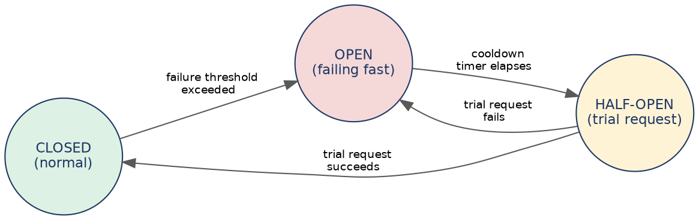
Figure 12 — the three states every circuit breaker cycles through. Only CLOSED and HALF-OPEN ever let a real request reach the dependency; OPEN rejects instantly without attempting the call.
State | Behavior
CLOSED | Normal operation — every call passes through to the dependency (e.g., Payment calling Stripe). Failures are counted; once the failure rate crosses a threshold within a rolling window, the breaker trips to OPEN.
OPEN | Every call fails immediately with an error, without even attempting to reach the dependency — this is what protects the caller's own thread/connection pool (Section 10.4's bulkhead) from piling up on a dependency that's already struggling. After a cooldown period, the breaker moves to HALF-OPEN.
HALF-OPEN | A single trial request is allowed through. If it succeeds, the breaker resets to CLOSED (the dependency has recovered). If it fails, the breaker returns to OPEN and the cooldown timer restarts.

E.4 Rate Limiting Algorithms
Section 10.1 mentions Gateway-level rate limiting without specifying the algorithm. The choice matters — different algorithms allow different burst behavior for the same average rate.
Algorithm | How it works | Trade-off
Fixed window | Count requests in discrete windows (e.g., 100 per minute, resetting at :00 of every minute). | Simple, but allows a burst of 2x the limit right at a window boundary (100 requests at 0:59, another 100 at 1:00).
Sliding window log | Track the timestamp of every request in the current window; count how many fall within the last N seconds from now. | Precise, no boundary burst issue, but memory cost scales with request volume — expensive at this system's peak traffic (Appendix B's ~200 req/sec).
Token bucket (used at this system's Gateway) | A bucket holds up to N tokens, refilled at a steady rate; each request consumes one token, and requests are rejected only when the bucket is empty. | Allows legitimate short bursts (a shopper's page loading several resources at once) while still enforcing a steady average rate — the best fit for shopper-facing traffic shape, and why express-rate-limit's default algorithm (a token-bucket variant) was accepted without customization in Section 13's Gateway code.

