Running the app with Docker
FastAPI Full-Stack Application · generated from docs/docker.md
This guide covers everything you need to run the Todo app in Docker:
- What runs where
- Prerequisites
- Set up environment variables
- Start the application
- Develop with live reload
- Stop the application
- Restart and rebuild
- Check that everything works
- Production-like mode
- Troubleshooting
- Command cheat sheet

1. What runs where
docker-compose.yml defines four services:
Service | Container | URL on your machine | What it is
frontend | todo-frontend | http://localhost:5173 | React app on the Vite dev server (hot reload)
backend | todo-backend | http://localhost:8000 (docs: http://localhost:8000/docs) | FastAPI with fastapi dev (auto-reload)
db | todo-db | localhost:5432 | PostgreSQL 18
pgadmin | todo-pgadmin | http://localhost:5050 | pgAdmin 4, a web UI for the database

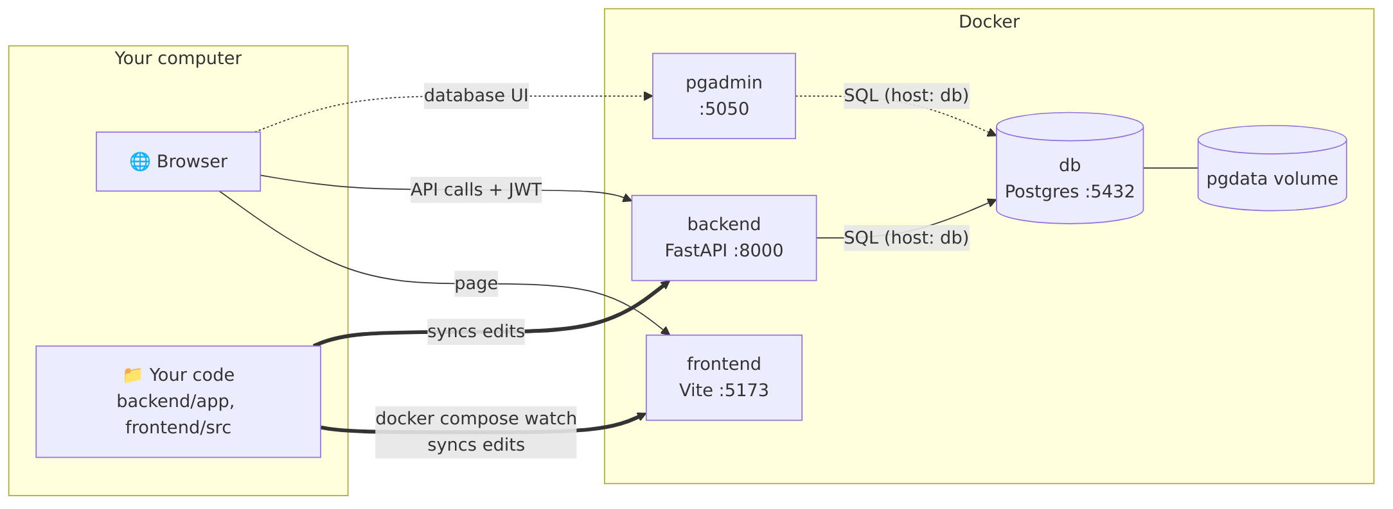
Inside Docker's network, containers reach each other by service name, so the backend connects to the database at host db. Your browser runs on your machine, so it uses localhost.
Startup order is enforced with health checks:
- db starts first, and is ready when pg_isready succeeds.
- backend and pgadmin start once db is ready. backend is ready when /api/health answers.
- frontend starts once backend is ready.

2. Prerequisites
- Docker Desktop (Windows/macOS) or Docker Engine (Linux), with Docker Compose v2.24 or newer. docker compose watch and the !override tag used by the production file need it. Check with:
POWERSHELL
docker compose version
- Docker Desktop must be running. If you see failed to connect to the docker API, start it and wait until the whale icon says "running".
- Free ports: 5173, 8000, 5432, 5050.

3. Set up environment variables
All configuration lives in one file: .env in the project root. It is git-ignored, so your passwords never get committed. The committed template is .env.example, which holds variable names and harmless defaults only, with no passwords.

3.1 Create .env
POWERSHELL
cd D:\path\to\fast-api
Copy-Item .env.example .env

3.2 Fill in the empty values
Open .env and fill in the three empty values. To generate strong random values:
POWERSHELL
# Run once per value and paste the output into .env
python -c "import secrets; print(secrets.token_hex(32))"
If Python isn't installed, use docker run --rm python:3.14-slim python -c "import secrets; print(secrets.token_hex(32))".
Variable | Required | Example / default | Used by | Notes
POSTGRES_USER | ✅ | todo | db, backend, pgadmin | Database user
POSTGRES_DB | ✅ | todo | db, backend, pgadmin | Database name
POSTGRES_PASSWORD | ✅ | (generate) | db, backend, pgadmin | Use letters and digits only (token_hex), because : or \ break pgAdmin's password file
SECRET_KEY | ✅ | (generate) | backend | Signs JWTs. Changing it logs everyone out
ACCESS_TOKEN_EXPIRE_MINUTES |  | 30 | backend | Login lifetime
ALLOWED_ORIGINS |  | http://localhost:5173,http://127.0.0.1:5173 | backend | CORS allow-list, comma-separated
SQL_ECHO |  | false | backend | true prints every SQL query in the backend logs
VITE_API_URL |  | http://localhost:8000/api | frontend | Where the browser sends API calls. Public: never put secrets in VITE_*
PGADMIN_EMAIL | ✅ | admin@example.com | pgadmin | pgAdmin login (must look like an email)
PGADMIN_PASSWORD | ✅ | (generate) | pgadmin | pgAdmin login password

3.3 How the values reach each service
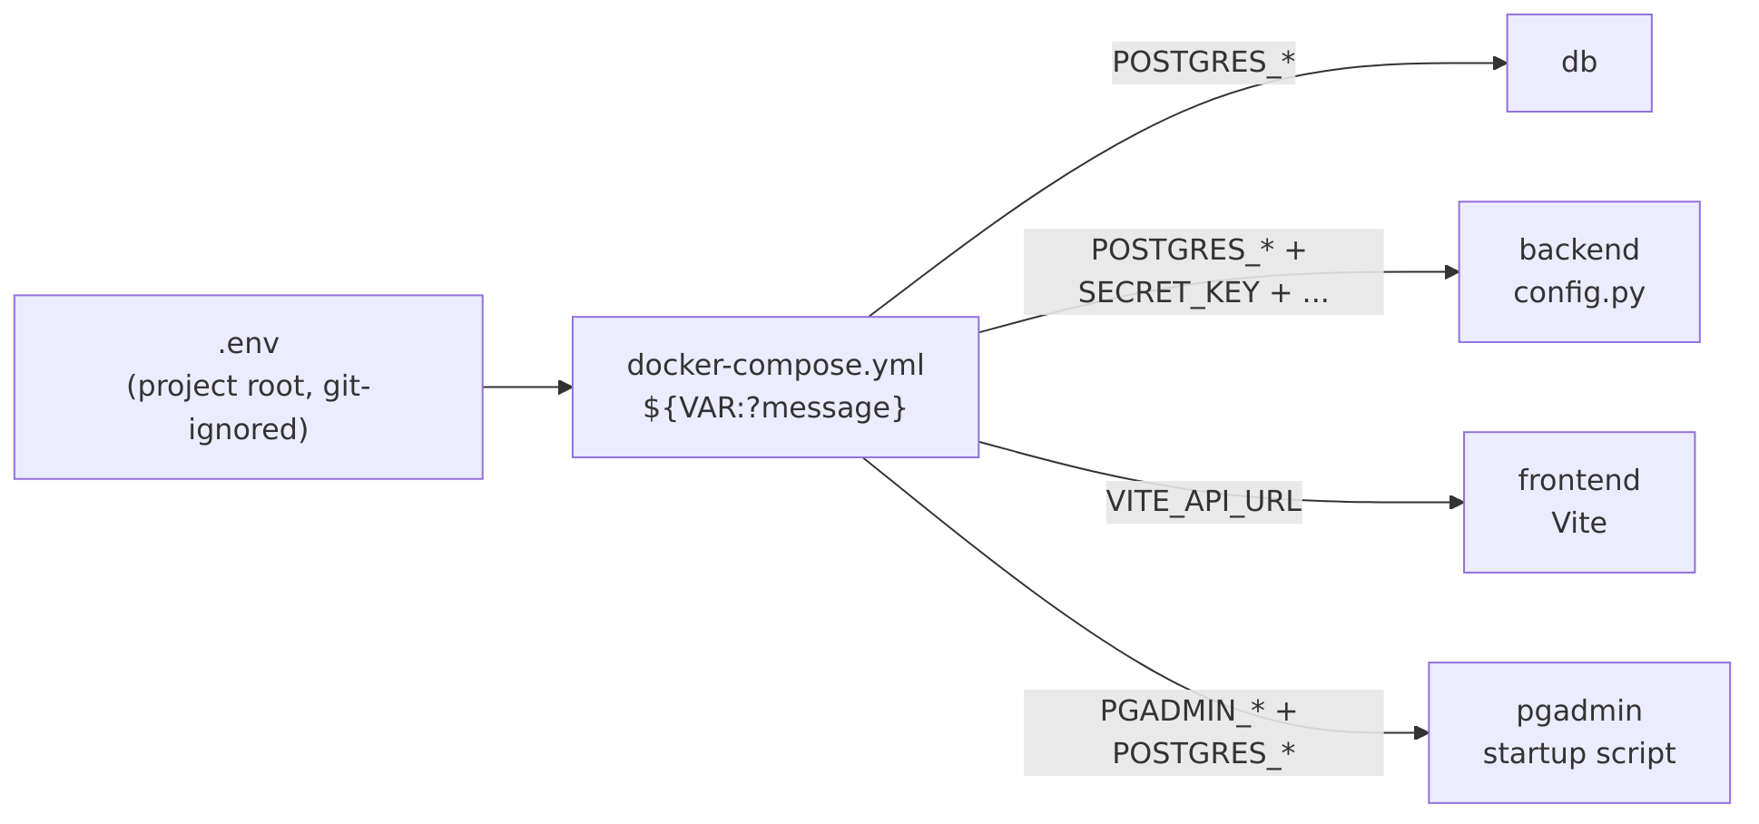
- Docker Compose reads .env automatically and substitutes ${VAR} in docker-compose.yml.
- Required values use ${VAR:?message}. If one is missing, Compose stops before starting anything:
required variable POSTGRES_PASSWORD is missing a value: Set POSTGRES_PASSWORD in .env
- The backend's config.py has no default passwords or keys. It also refuses to start if one is missing.
- pgAdmin's server list and password file are generated at container start from these variables, so no file with a password exists in the repo.
- Running outside Docker (uv run, npm run dev) reads the same .env.

3.4 Check your .env without starting anything
POWERSHELL
docker compose config --quiet
No output means every required value is set.

3.5 Changing a value later
You changed | Do this
SECRET_KEY, ALLOWED_ORIGINS, SQL_ECHO, ACCESS_TOKEN_EXPIRE_MINUTES | docker compose up -d (recreates only the affected containers)
VITE_API_URL | docker compose up -d frontend
PGADMIN_EMAIL / PGADMIN_PASSWORD | Only applied when pgAdmin's data is first created. Reset pgAdmin (see Troubleshooting)
POSTGRES_PASSWORD | See below. Postgres only reads it when the database is first created

Changing POSTGRES_PASSWORD while keeping your data:
POWERSHELL
# 1. Set the new password inside Postgres (runs with the OLD .env still in place)
docker compose exec db psql -U todo -d todo -c "ALTER USER todo WITH PASSWORD 'the-new-password';"
# 2. Put the same value in .env as POSTGRES_PASSWORD
# 3. Recreate the services that use it
docker compose up -d
docker compose rm -sf pgadmin; docker volume rm fast-api_pgadmin-data; docker compose up -d pgadmin

4. Start the application
From the project root:
POWERSHELL
docker compose up --build --watch
Part | Meaning
up | Create and start all services
--build | Build the images first (needed the first time and after Dockerfile changes)
--watch | Sync code changes into the running containers (see section 5)

The first build takes a few minutes; later starts take seconds. When you see the services' logs, open:
- App: http://localhost:5173
- API docs: http://localhost:8000/docs
- pgAdmin: http://localhost:5050. Log in with PGADMIN_EMAIL / PGADMIN_PASSWORD, then open Servers → Todo DB (docker). It connects without asking for the database password.
Run in the background instead. This frees the terminal, but there's no live sync unless you add watch:
POWERSHELL
docker compose up --build -d # start in the background
docker compose watch # optional: sync changes (Ctrl+C stops syncing only)
docker compose logs -f # optional: follow the logs

5. Develop with live reload (no manual restarts)
With --watch (or docker compose watch), you edit files normally in VS Code and the running containers update by themselves:
You edit | What happens | How fast
backend/app/**/*.py | File is synced into the container, and fastapi dev restarts the server | ~1–2 s
frontend/src/** (.jsx, .css, ...) | File is synced, and Vite hot module reload updates the browser without a page refresh | instant
frontend/index.html, vite.config.js | Synced; Vite reloads the page or restarts itself | ~1–2 s
backend/pyproject.toml / uv.lock (uv add <pkg>) | Image is rebuilt and the container recreated automatically | ~10–60 s
frontend/package.json / package-lock.json (npm install <pkg>) | Image is rebuilt and the container recreated automatically | ~10–60 s

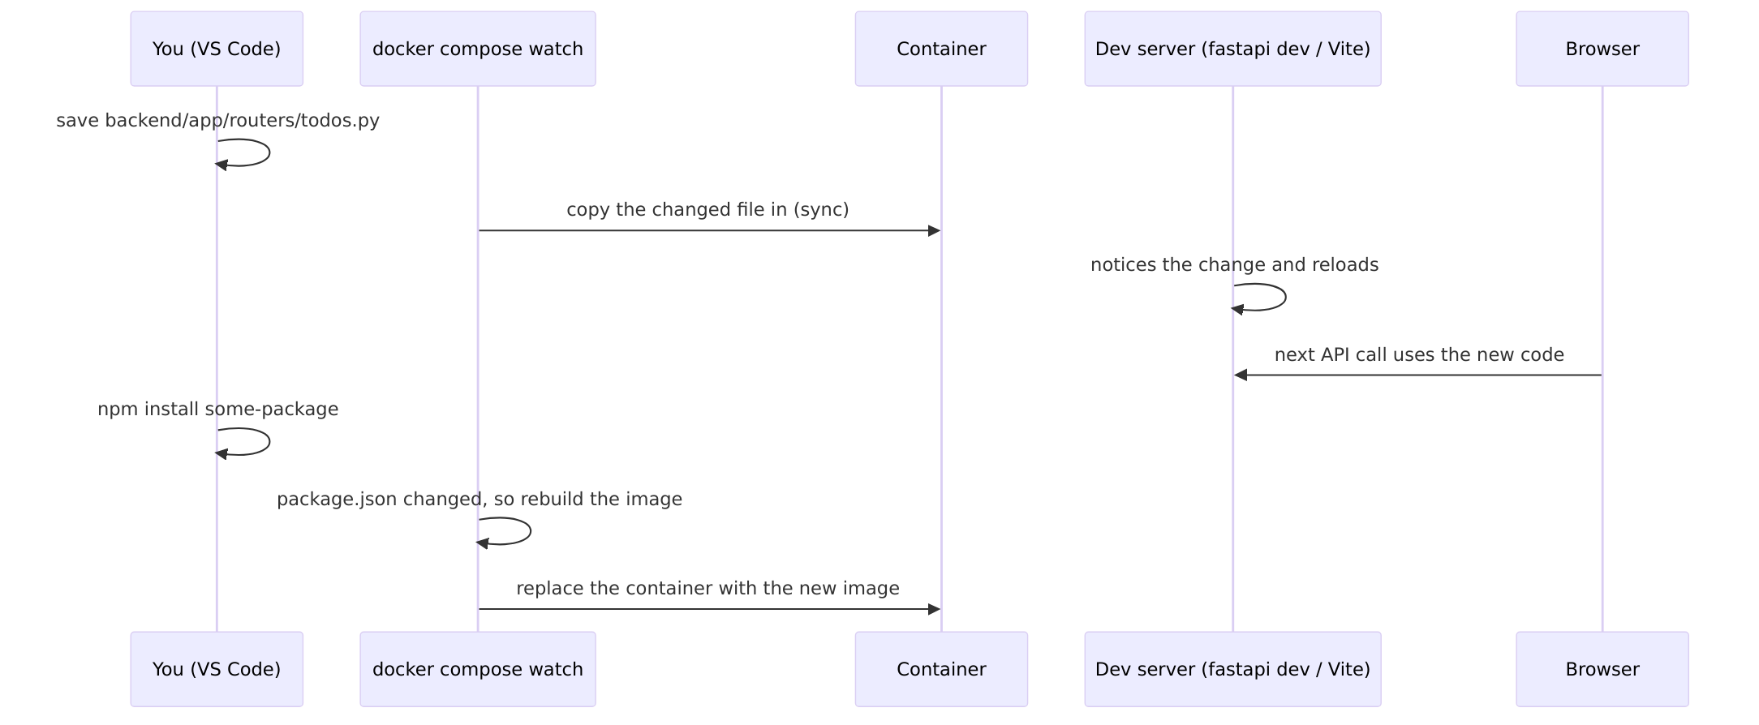
The rules live in the develop.watch section of each service in docker-compose.yml:
- action: sync copies changed files into the container.
- action: rebuild rebuilds the image and recreates the container, used for dependency files.
Why watch instead of bind-mounting the code folder? On Windows, file-change events from a mounted folder often don't reach Linux containers, so auto-reload silently stops working. watch copies the files in, so the dev servers always see the change.
Adding a dependency (with watch running):
POWERSHELL
cd backend; uv add httpx # backend: rebuild happens automatically
cd frontend; npm install dayjs # frontend: rebuild happens automatically
Changes that are NOT picked up automatically:
Change | Do this
Dockerfile | docker compose up -d --build <service>
docker-compose.yml | docker compose up -d
.env | docker compose up -d (see 3.5)
SQLAlchemy model columns (models.py) | Code reloads, but existing tables are not altered: create_all only creates missing tables. Reset the data with docker compose down -v (or add Alembic migrations)

6. Stop the application
Command | Containers | Data (database, pgAdmin settings)
Ctrl+C in the up --watch terminal | Stopped | Kept
docker compose stop | Stopped (not removed) | Kept
docker compose down | Stopped and removed | Kept
docker compose down -v | Stopped and removed | ⚠️ Deleted: removes the pgdata and pgadmin-data volumes, so the database is empty next time

Use docker compose down day to day. Use down -v only when you want a fresh, empty database.

7. Restart and rebuild
Situation | Command
Start again after stop / down | docker compose up -d (add --watch and drop -d for live sync)
Restart one service (for example after it crashed) | docker compose restart backend
Restart everything | docker compose restart
Rebuild one image after editing its Dockerfile | docker compose up -d --build backend
Rebuild everything from scratch (ignore build cache) | docker compose build --no-cache; docker compose up -d
Apply .env or docker-compose.yml changes | docker compose up -d

With --watch running, code changes need none of these: see section 5.

8. Check that everything works

8.1 Service status
POWERSHELL
docker compose ps
All four should show (healthy):
NAME STATUS
todo-backend Up 2 minutes (healthy)
todo-db Up 2 minutes (healthy)
todo-frontend Up 2 minutes (healthy)
todo-pgadmin Up 2 minutes (healthy)
(health: starting) is normal for up to about 30 seconds after starting. (unhealthy) means: check the logs.

8.2 Per-service checks
Service | Check | Expected
backend | curl http://localhost:8000/api/health | {"status":"ok"}
backend → db | docker compose logs backend | Select-String "Database ready" | a Database ready line
db | docker compose exec db pg_isready | accepting connections
frontend | Open http://localhost:5173 | Login page
pgadmin | Open http://localhost:5050, log in, expand Todo DB (docker) | Connects without a password prompt

8.3 Full API test
With the stack running, from the project root:
POWERSHELL
npx newman run postman/Todo-API.postman_collection.json -e postman/Todo-API-local.postman_environment.json
This runs 34 requests (auth, CRUD, security, CORS, logout) with 171 checks. They should all pass.

8.4 Logs
POWERSHELL
docker compose logs -f # all services
docker compose logs -f backend # one service (request timing lines appear here)
docker compose logs --tail 50 db # last 50 lines

8.5 Look inside the database
POWERSHELL
docker compose exec db psql -U todo -d todo # use your POSTGRES_USER / POSTGRES_DB
SQL
\dt
SELECT username, created_at FROM users;
SELECT jti, revoked_at, user_agent FROM tokens;
\q

9. Production-like mode
docker-compose.prod.yml layers on top of the dev file:
- Backend: runs fastapi run, without reload.
- Frontend: a static build served by nginx, with no Node.
- No watch.
POWERSHELL
docker compose -f docker-compose.yml -f docker-compose.prod.yml up --build -d
It uses the same URLs. Go back to dev mode with docker compose up --build -d (or --watch).
VITE_API_URL is baked into the JavaScript at build time in this mode. Rebuild the frontend after changing it.

10. Troubleshooting
Symptom | Cause / fix
required variable X is missing a value | .env is missing or X is empty. See section 3
failed to connect to the docker API | Docker Desktop isn't running
Bind for 0.0.0.0:5432 failed: port is already allocated | Something else uses the port, often a Postgres installed on Windows or another project. Stop it, or change the left side of ports: (for example "5433:5432")
Backend logs: password authentication failed for user | POSTGRES_PASSWORD in .env doesn't match the existing database. Postgres only reads it on first creation. Use the ALTER USER steps in 3.5, or start fresh with docker compose down -v (deletes data)
pgAdmin asks for the database password | pgAdmin's saved settings are from an older config. Reset pgAdmin (below)
Can't log in to pgAdmin with the .env credentials | They're stored when pgAdmin's data is first created. After 3 wrong tries the account is locked. Reset pgAdmin (below)
Code changes don't show up | Make sure watch is running (docker compose up --watch or docker compose watch). Check its terminal for sync messages
Frontend shows "Cannot reach server" | Backend not healthy yet. Check docker compose ps and docker compose logs backend
Browser console shows a CORS error | Your frontend URL isn't in ALLOWED_ORIGINS. Edit .env, then docker compose up -d

Reset pgAdmin (removes only pgAdmin's settings, not your database):
POWERSHELL
docker compose rm -sf pgadmin
docker volume rm fast-api_pgadmin-data
docker compose up -d pgadmin
Start completely fresh (⚠️ deletes all database data):
POWERSHELL
docker compose down -v
docker compose up --build --watch

11. Command cheat sheet
POWERSHELL
# First time
Copy-Item .env.example .env # then fill in the empty values
docker compose config --quiet # check .env (no output = OK)

# Daily development
docker compose up --build --watch # start + live reload (Ctrl+C to stop)
docker compose down # stop and remove containers (data kept)

# Status and logs
docker compose ps # all should be (healthy)
docker compose logs -f backend # follow one service's logs

# Restarting
docker compose restart backend # restart one service
docker compose up -d --build backend # rebuild one service (after Dockerfile edits)
docker compose up -d # apply .env / compose file changes

# Database
docker compose exec db psql -U todo -d todo
docker compose down -v # ⚠️ wipe the database and start fresh

# Production-like
docker compose -f docker-compose.yml -f docker-compose.prod.yml up --build -d

