Ex. No. : 03 Date: 23/02/2026
Register No.: 231701030 Name: V.J.LAKSHNAN

Wire framing and Prototyping with Figma

Aim
To design and develop a mobile-based telemedicine application that enables accessible, reliable, and real-time healthcare services for rural communities, even in low or no internet conditions.
Procedure:
The app is a smart telemedicine platform designed to bridge the healthcare gap by connecting patients with doctors through simple and efficient communication methods. Below is the core user flow based on the project:
User Flow
• Launch the mobile application to access healthcare services with a simple and user-friendly interface.
• Select consultation mode (audio, video, or chat) based on internet availability, including a voice-only mode for low bandwidth conditions.
• Report symptoms by entering health issues, duration, and other relevant details.
• Connect with a qualified doctor who provides diagnosis and medical advice in real time.
• Receive digital prescriptions securely within the app after consultation.
• Store health data locally using offline storage, which syncs automatically when internet connectivity is available.
• Utilize multi-language support to communicate effectively without language barriers.
This flow ensures accessible, continuous, and efficient healthcare delivery using a mobile-first approach tailored for rural environments.

Output
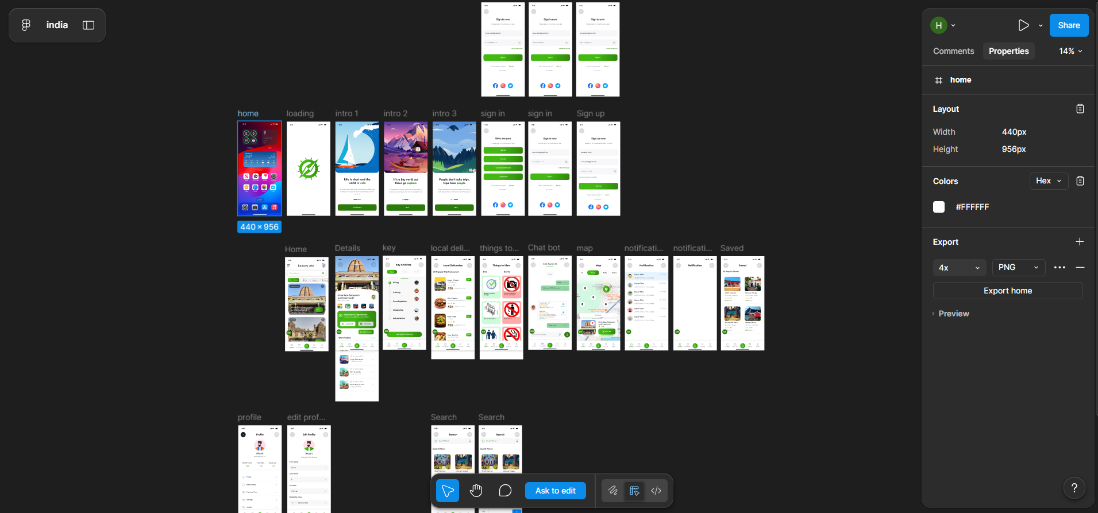

Result:
Hence the experiment is completed and the output is verified.

