**Aim: to redesign canteen menu at ease of use andcase of functionally**

**(grid and menu use)**

**Procedure:**

1.choose any reference image and make it more effective using grid and menu

2.recreate the image don’t paste it directly

3.add more details for reference

4.select the element and change by grid and menu

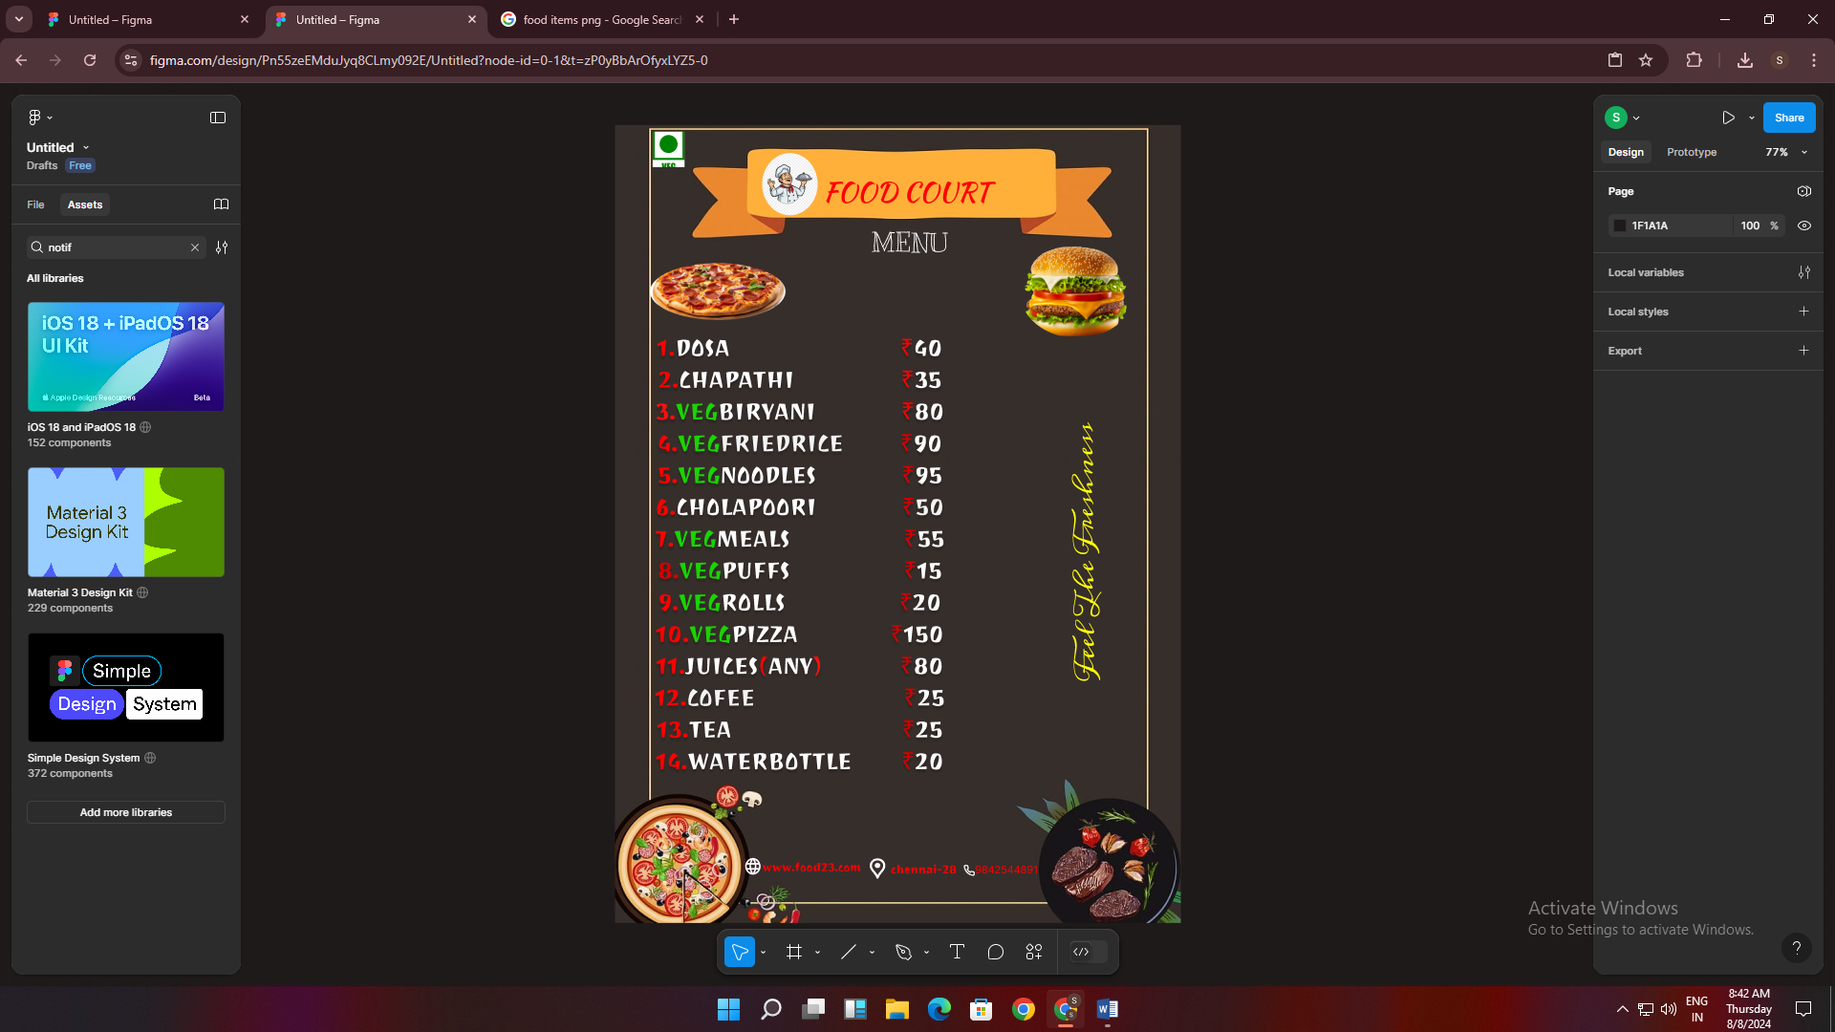.

Result:

thus the canteen menu has been redesigned at the ease of

Use and ease of functionality