**Aim: TO DESIGN A SUPERHERO APP**

**Procedure:**

1.choose any reference image and make it more effective using grid and menu

2.recreate the image don’t paste it directly

3.add more details for reference

4.select the element and change by grid and menu

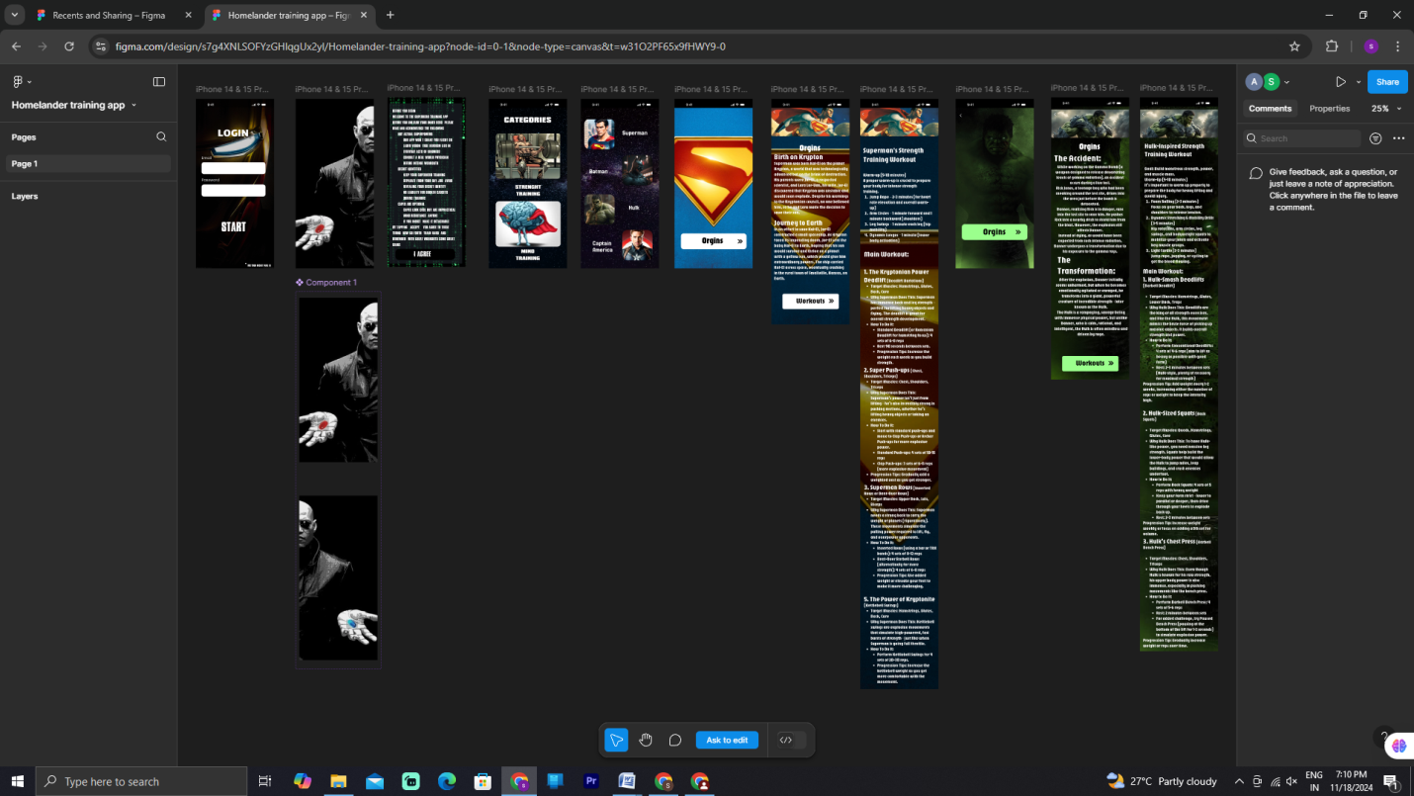

Result:

thus theSUPERHERO APP has been redesigned at the ease of

Use and ease of functionality