**Aim: To design a Hobby App**

**Procedure:**

1.choose any frame and make it more effective using text and color

2.create the image don’t paste it directly

3.add more details for The hobby

4.give the prototype connection

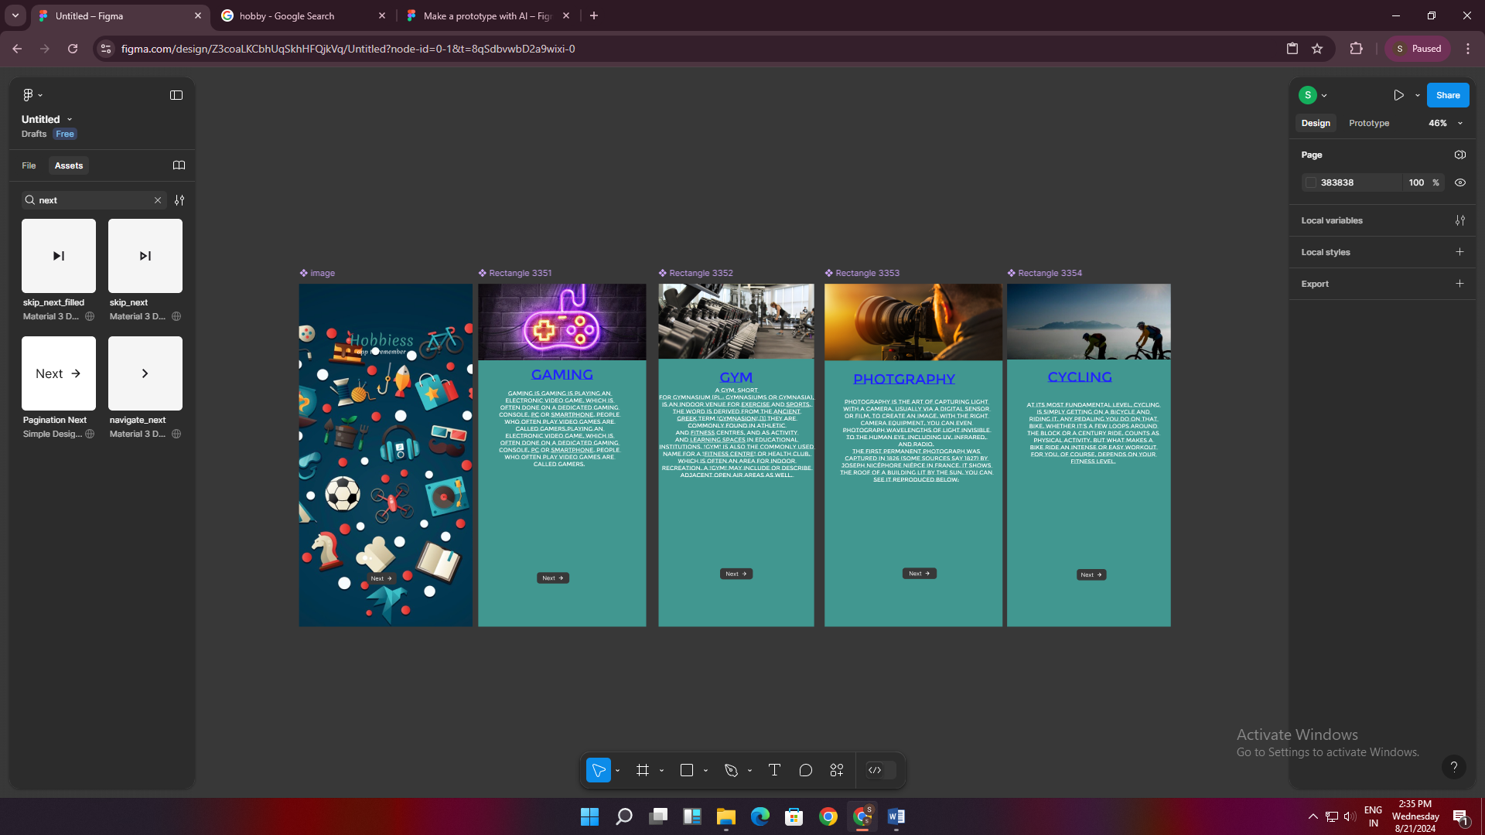

Result:

Thus the Hobby app has been created .