AJACE INC. · ECHOMIND ENTERPRISE · ISO 9001:2015 EVIDENCE

EchoMind Enterprise – ISO 9001:2015 Audit Package

Document control
Field | Value
Document ID | EM26-00
Title | EchoMind Enterprise – ISO 9001:2015 Audit Package
Version | 1.0
Date | 2026-10-06
Status | APPROVED — 2026-10-07 (AR-2026-001)
Product / area | EchoMind Enterprise (repository RW2523/echomind-enterprise)
Prepared by | Richard Watson Stephen Amudha (Lead Engineer)
Reviewed by | Alexander Peter (EchoMind Project Lead)
Quality assurance | Sheryl Nazareth (QA / MR)
Approved by | Anita Johan (Managing Director) — 2026-10-07

1. Purpose and scope
Single entry point to the 2026 evidence for the EchoMind Product area, structured like the 2025 'EchoMind LLM Appliance Project Documentation' so the auditor can follow the same path.

2. §0 — the 2025 evidence describes a predecessor product
The 2025 pack (fileiso9001.zip) documents a different implementation. Comparing it with this repository:
Aspect | 2025 EchoMind LLM Appliance | 2026 EchoMind Enterprise
Repositories | 5 repos under preetham-ganesh/ajace-echomind-* (api, ui, vectordb, transcribe-pc, ollama-pc) | 1 repo: RW2523/echomind-enterprise (backend, frontend, voice, docker)
User interface | Streamlit, port 8501 | React + Vite, served by nginx
LLM | llama3.1:8b via Ollama | Qwen3-30B-A3B NVFP4 on TensorRT-LLM
Hardware | RTX 4090 PC appliance (university pilot) | NVIDIA DGX Spark (GB10)
Project tracking | Jira project SCRUM / EMD on ajace.atlassian.net | Git history + docs/qms registers; GitHub project board created 2026-10-06
Start | 2025 (pilot shipped Sep 2025) | First commit 2026-02-05

Position to state at the audit (to be confirmed by Alexander / Richard and briefed to the MR): the 2025 corrective actions applied to the predecessor; equivalent controls have been re-established for the rebuilt product, evidenced below.

3. Audit checklist
Audit area / phase | Evidence (this pack) | Status
Project initiation & planning | EM26-12 Scheduling Review; SDLC record; GitHub history and project board (SCR-10/11/20) | Available
Requirements (8.2) | SOP-04; README/CAPABILITIES; REG-09 NFRs; EM26-13 | Partial — no customer contract
Design & development (8.3) | SOP-05; docs/*_FLOW.md; REG-07; REG-10 reviews; EM26-11 | Available
External providers (8.4) | SOP-09; REG-02; EM26-14/14b | Partial — licences unverified
Production / service provision (8.5) | SOP-08; TC-EM-OPS-105; REG-08 deployments | Available
Testing & verification (8.6) | EM26-15; 13 test cases (4 runs); regression REG-2026-01 | Available — all executable cases pass on v1.4.1
Release & traceability (8.5.2, 8.6) | v1.4.0 and v1.4.1 tags; /api/version (SCR-09); REG-08; FRM-03 records | Partial — release records unauthorised
Nonconforming output (8.7) | REG-04 (16 entries); QA-FAIL/DEF/REG records; GitHub issues | Available
Monitoring & measurement (9.1) | REG-09 NFR register; eval reports | Partial — NC-2026-008
Lessons learnt / improvement (10) | EM26-16, 16b; REG-04 corrective actions | Available

4. 2025 EchoMind findings — position for the new product
2025 finding | 2026 evidence | Status
#6 — 8.2.2 Minor NC: NFRs not recorded/monitored | REG-09 NFR register (28 rows) → EM26-17 workbook | Measured, targets not yet agreed (A-1)
#7 — 9.1.1 Obs: no actions from deliverable reviews | REG-10 review/action log → EM26-18 workbook; RF-2026-001 (22 actions closed) | Addressed
#10 — 9.3.2 Minor NC: EchoMind risks absent from MR minutes | REG-03 + EM26-02d input pack | Corporate action — table at next MR

5. Project management — repository and tracking board
Work, defects and corrective actions are tracked as GitHub issues on the project board https://github.com/users/RW2523/projects/2 (65 tickets: 14 features, 16 defects/NCs, 3 reviews, 32 tasks), each linked to its REG-04/REG-10 record and fix commits. The board was set up on 2026-10-06; earlier work was transcribed to it from git and the registers, and each such ticket says so.
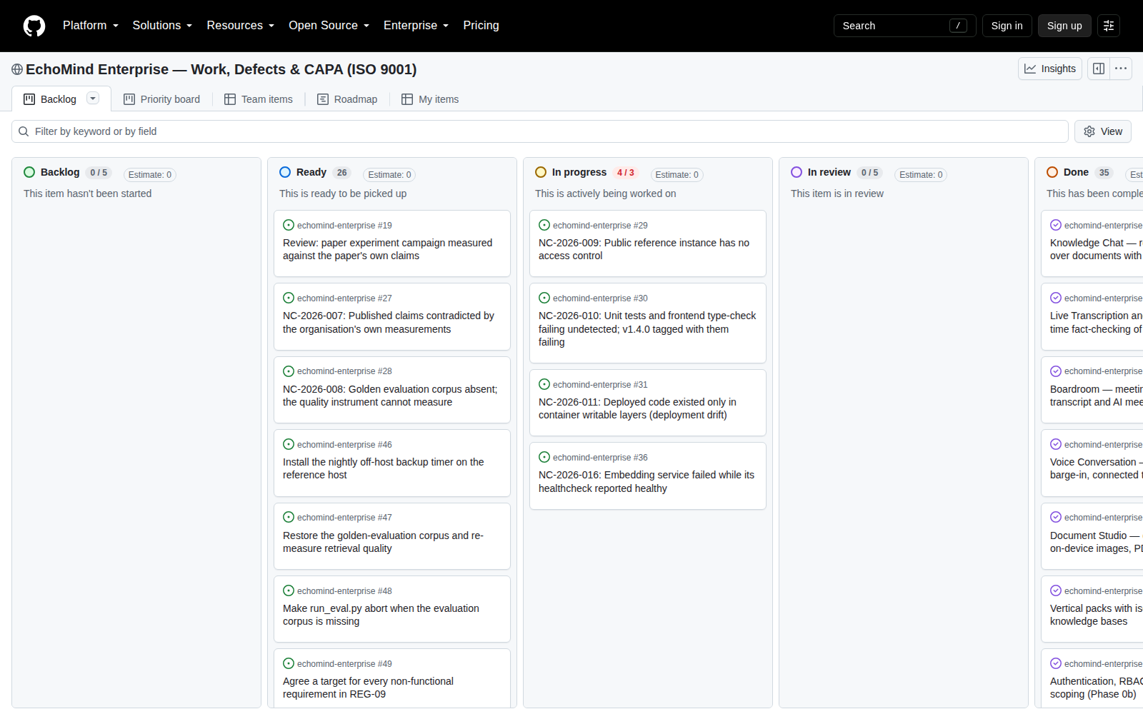
SCR-20 — project board (replaces the 2025 Jira SCRUM board)
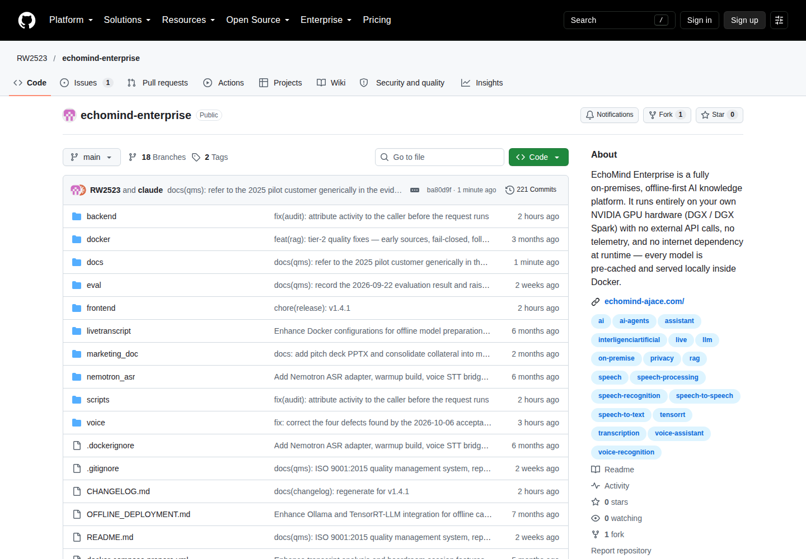
SCR-10 — repository on GitHub
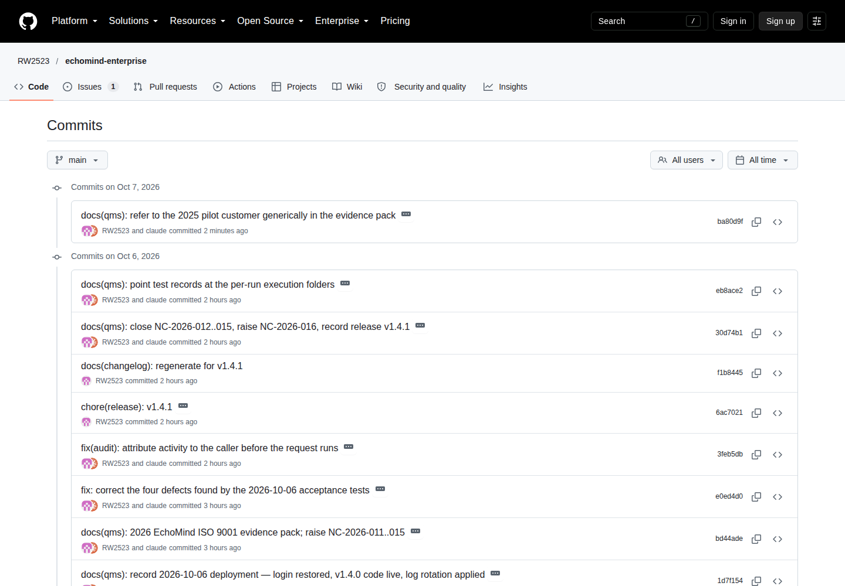
SCR-11 — commit history

6. The product
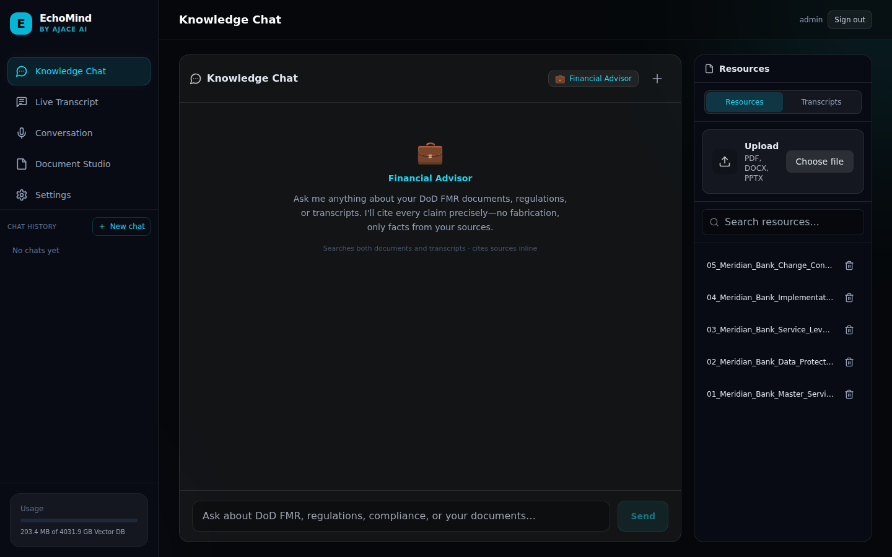
SCR-03 — Knowledge Chat after login
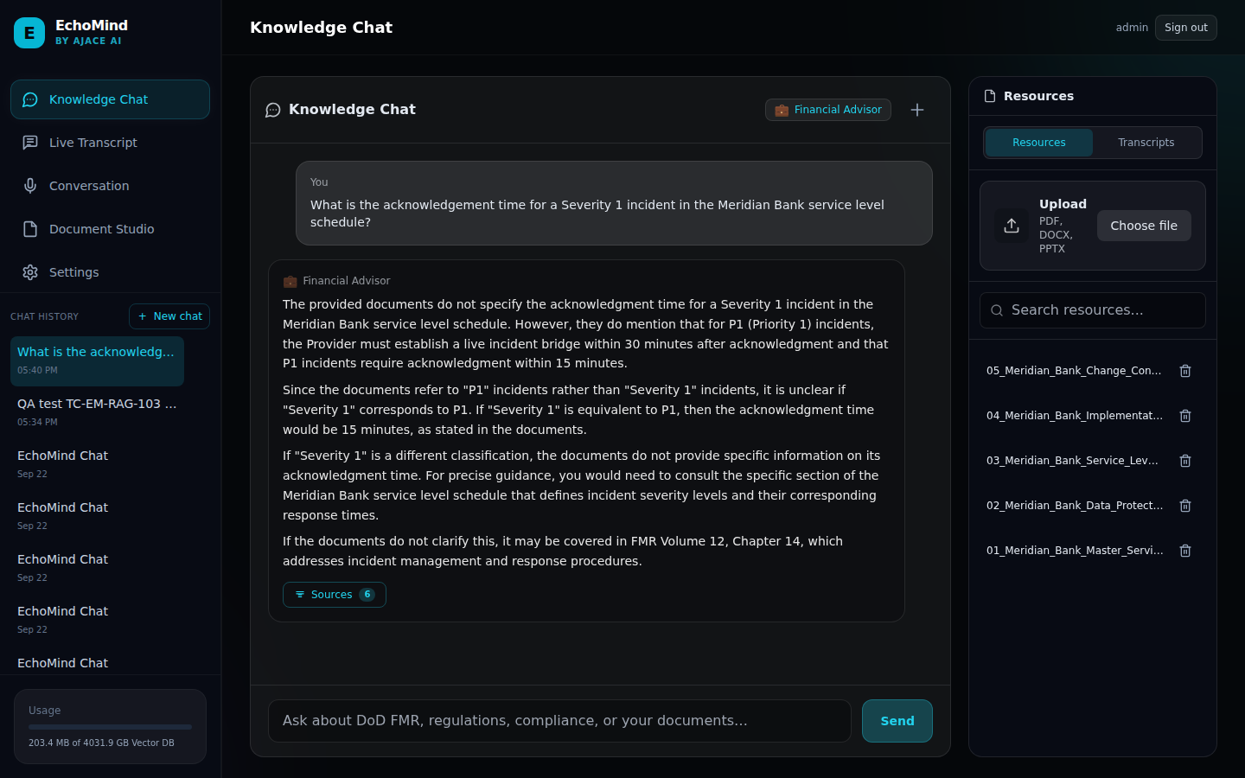
SCR-04 — grounded answer with sources

7. Release and traceability
All three services report release v1.4.1 (commit f1b8445) — see SCR-09 and REG-08.
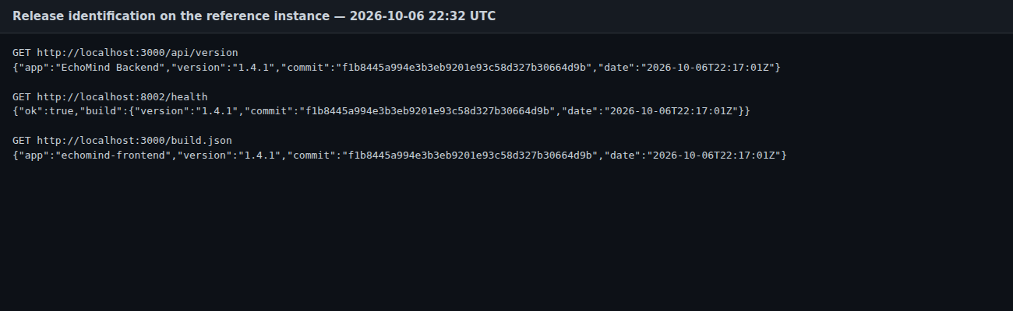
SCR-09 — /api/version on the reference instance

8. Pack contents
See 00_Overview_and_Map/EM26-00_Evidence_Map_2025_to_2026.xlsx and README.md for every file, its ISO clause and its 2025 counterpart.

Verification and approval
Role | Name | Signature | Date
Prepared by — Lead Engineer | Richard Watson Stephen Amudha | Richard Watson Stephen Amudha | 2026-10-07
Reviewed by — EchoMind Project Lead | Alexander Peter | Alexander Peter | 2026-10-07
Quality assurance — QA / MR | Sheryl Nazareth | Sheryl Nazareth | 2026-10-07
Approved by — Managing Director | Anita Johan | Anita Johan | 2026-10-07
Signatures are the typed names of the role holders. Review and approval were confirmed by each of them on 2026-10-07 and are recorded in docs/qms/records/approvals/2026-10-07_AR-2026-001_document_approval.md (SOP-01 §6).

