AJACE INC. · ECHOMIND ENTERPRISE · ISO 9001:2015 EVIDENCE

EchoMind Test Case – TC-EM-AUTH-101: Login, session and access control

Document control
Field | Value
Document ID | TC-EM-AUTH-101
Title | EchoMind Test Case – TC-EM-AUTH-101: Login, session and access control
Version | 1.0
Date | 2026-10-06
Status | EXECUTED — record
Product / area | EchoMind Enterprise (repository RW2523/echomind-enterprise)
Executed (initial) | 2026-10-06 21:34:08 UTC
Initial result | Fail
Re-test (v1.4.1) | 2026-10-06 22:28:05 UTC
Final result | Pass
Prepared by | Richard Watson Stephen Amudha (Lead Engineer)
Reviewed by | Alexander Peter (EchoMind Project Lead)
Quality assurance | Sheryl Nazareth (QA / MR)
Approved by | Anita Johan (Managing Director) — 2026-10-07

Objective
Verify that the application requires a login, rejects invalid credentials and unauthenticated API calls, enforces roles, records activity, gates the voice WebSocket, and ends sessions on logout.

Preconditions
- Reference instance running with AUTH_ENABLED=1 and VOICE_AUTH_ENABLED=1.
- Admin account available (credentials held in the deployment environment, never written to records).
- Test user created during the test and deleted afterwards.

Test data
- Admin account; a temporary standard user qa_tc101_* with a random password.
- Protected endpoints: /api/docs/list, /api/chat/list, /api/auth/users, POST /api/docs/delete-all.

Main flow and execution record
Executed 2026-10-06 21:34:08 UTC by an automated run (run_tests.py) against the reference instance; responsible tester: Richard Watson Stephen Amudha (Lead Engineer); results reviewed by Alexander Peter (EchoMind Project Lead).
Step | Action | Expected | Actual (as observed) | Result
AC-101.1 | GET /api/auth/config | auth_enabled true | HTTP 200 {'auth_enabled': True} | Pass
AC-101.2 | Log in with valid admin credentials | HTTP 200, session cookie issued, role admin | HTTP 200, cookie set, role admin | Pass
AC-101.3 | Log in with an invalid password | HTTP 401, no session | HTTP 401 {'detail': 'Invalid username or password'} | Pass
AC-101.4 | Call protected APIs without a session | HTTP 401 for every call | /api/docs/list → 401, /api/chat/list → 401, /api/auth/users → 401, POST /api/docs/delete-all → 401 | Pass
AC-101.5 | Standard (non-admin) user calls an admin-only API | Admin API refused (403); normal API allowed (200) | create user HTTP 200; login 200; GET /api/auth/users → 403; GET /api/docs/list → 200 | Pass
AC-101.6 | Inspect session token lifetime | Token expires (finite lifetime configured) | exp − iat = 720 minutes (12 h); configured by AUTH_TOKEN_TTL_MIN | Pass
AC-101.7 | Log out, then replay the old session token | Old token rejected (401) after logout | logout HTTP 200; replayed token → HTTP 200 — token still accepted after logout (stateless JWT, no revocation) | Fail
AC-101.8 | Check the activity log for the test user's activity | Entries with timestamp, user and action | 150 recent events; 1 for qa_tc101_6ff12; e.g. {"ts": "2026-10-06T21:34:09Z", "username": "qa_tc101_6ff12", "role": "user", "method": "POST", "path": "/api/auth/logout", "status": 200, "ip": "172.22.0.6"} | Pass
AC-101.9 | Open the voice WebSocket without and with a session | 403 without, 101 with | without session → 403; with session → 101 | Pass

Re-test on release v1.4.1 (run 4)
Executed 2026-10-06 22:28:05 UTC after the defect corrections and release v1.4.1. Earlier re-tests (runs 2 and 3) are retained in Execution_Records/.
Step | Actual (as observed) | Result
AC-101.1 | HTTP 200 {'auth_enabled': True} | Pass
AC-101.2 | HTTP 200, cookie set, role admin | Pass
AC-101.3 | HTTP 401 {'detail': 'Invalid username or password'} | Pass
AC-101.4 | /api/docs/list → 401, /api/chat/list → 401, /api/auth/users → 401, POST /api/docs/delete-all → 401 | Pass
AC-101.5 | create user HTTP 200; login 200; GET /api/auth/users → 403; GET /api/docs/list → 200 | Pass
AC-101.6 | exp − iat = 720 minutes (12 h); configured by AUTH_TOKEN_TTL_MIN | Pass
AC-101.7 | logout HTTP 200; replayed token → HTTP 401 | Pass
AC-101.8 | 150 recent events; 1 for qa_tc101_6bb5e; e.g. {"ts": "2026-10-06T22:28:06Z", "username": "qa_tc101_6bb5e", "role": "user", "method": "POST", "path": "/api/auth/logout", "status": 200, "ip": "172.22.0.6"} | Pass
AC-101.9 | without session → 403; with session → 101 | Pass

Alternate flows / negative cases
- Invalid password → 401.
- No session → 401 on every protected call.
- Standard user → 403 on admin-only API.
- Replay of a logged-out token → must be 401.

Postconditions
- Temporary user deleted.
- No data created other than activity-log entries.
- Temporary user qa_tc101_6ff12 created for the test and deleted afterwards (HTTP 200).

Pass / fail criteria
Pass if every step meets its expected result. Any failed step is logged as a defect in REG-04 and linked below.

Result
Initial execution (v1.4.0 code): Fail — defect(s) raised: NC-2026-012
Re-test on v1.4.1 (run 4): Pass

Traceability
- ISO 9001:2015 clause(s): 8.5.3, 8.6
- Area: Security / access control
- Execution evidence: 15_Testing/Execution_Records/run1/ (initial) and run4/ (v1.4.1 re-test)
- Linked record: REG-04 NC-2026-012

Attachments / evidence
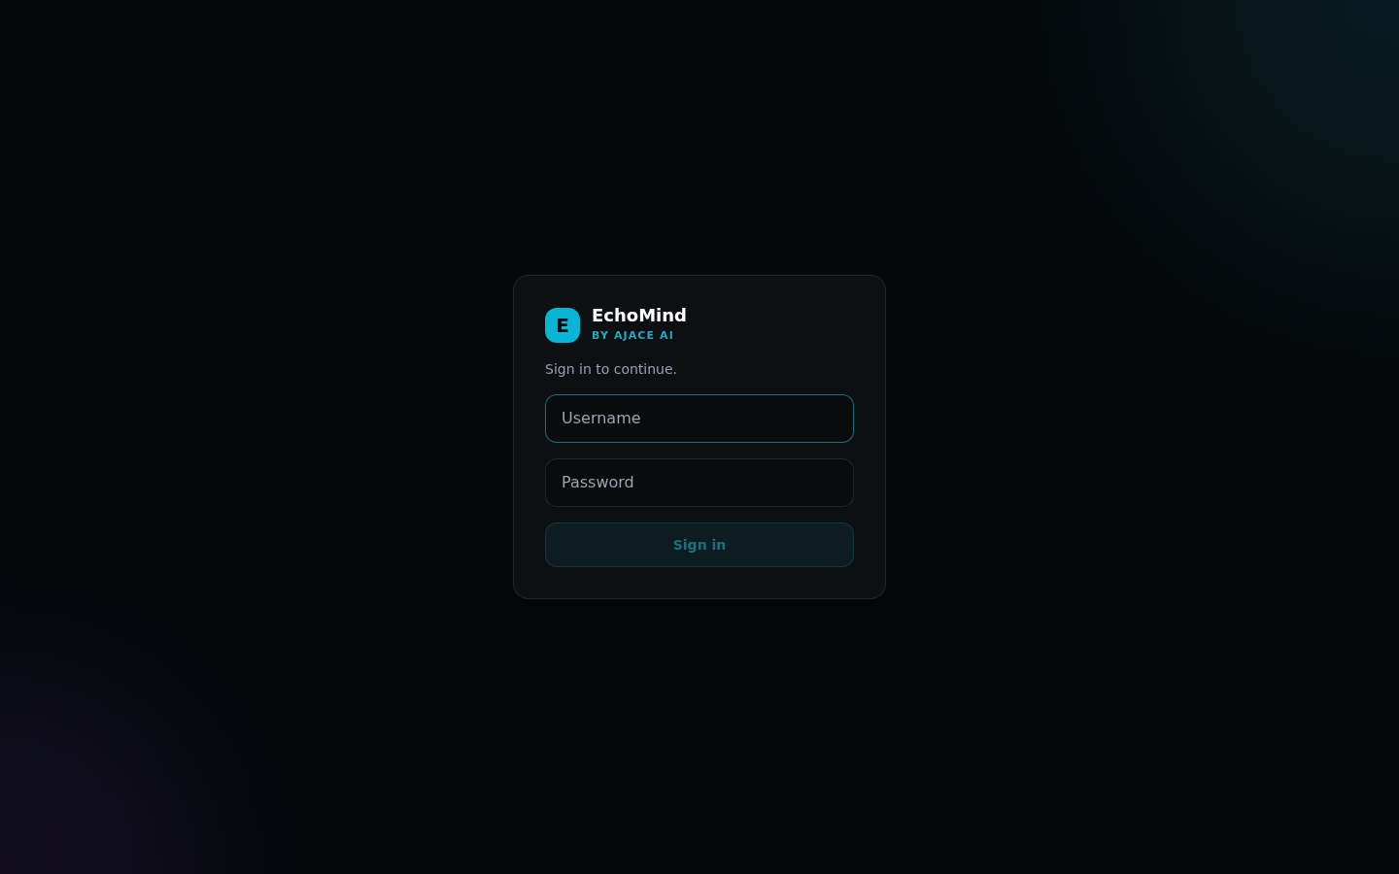
SCR-01_login_gate — Login gate shown before any content
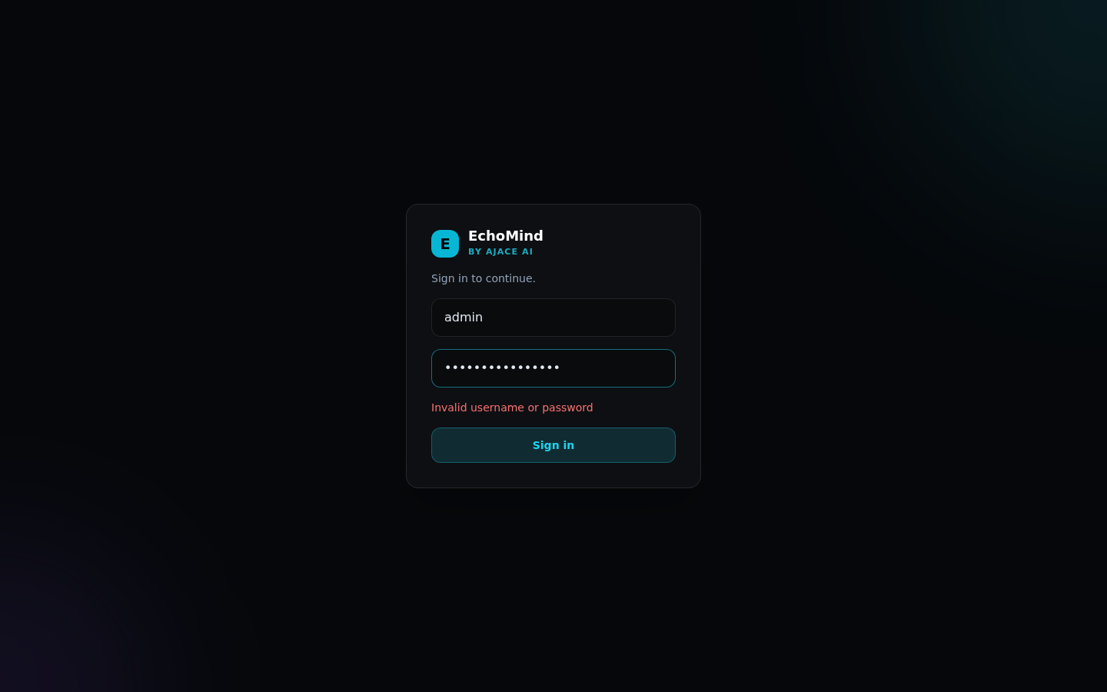
SCR-02_login_rejected — Invalid credentials rejected
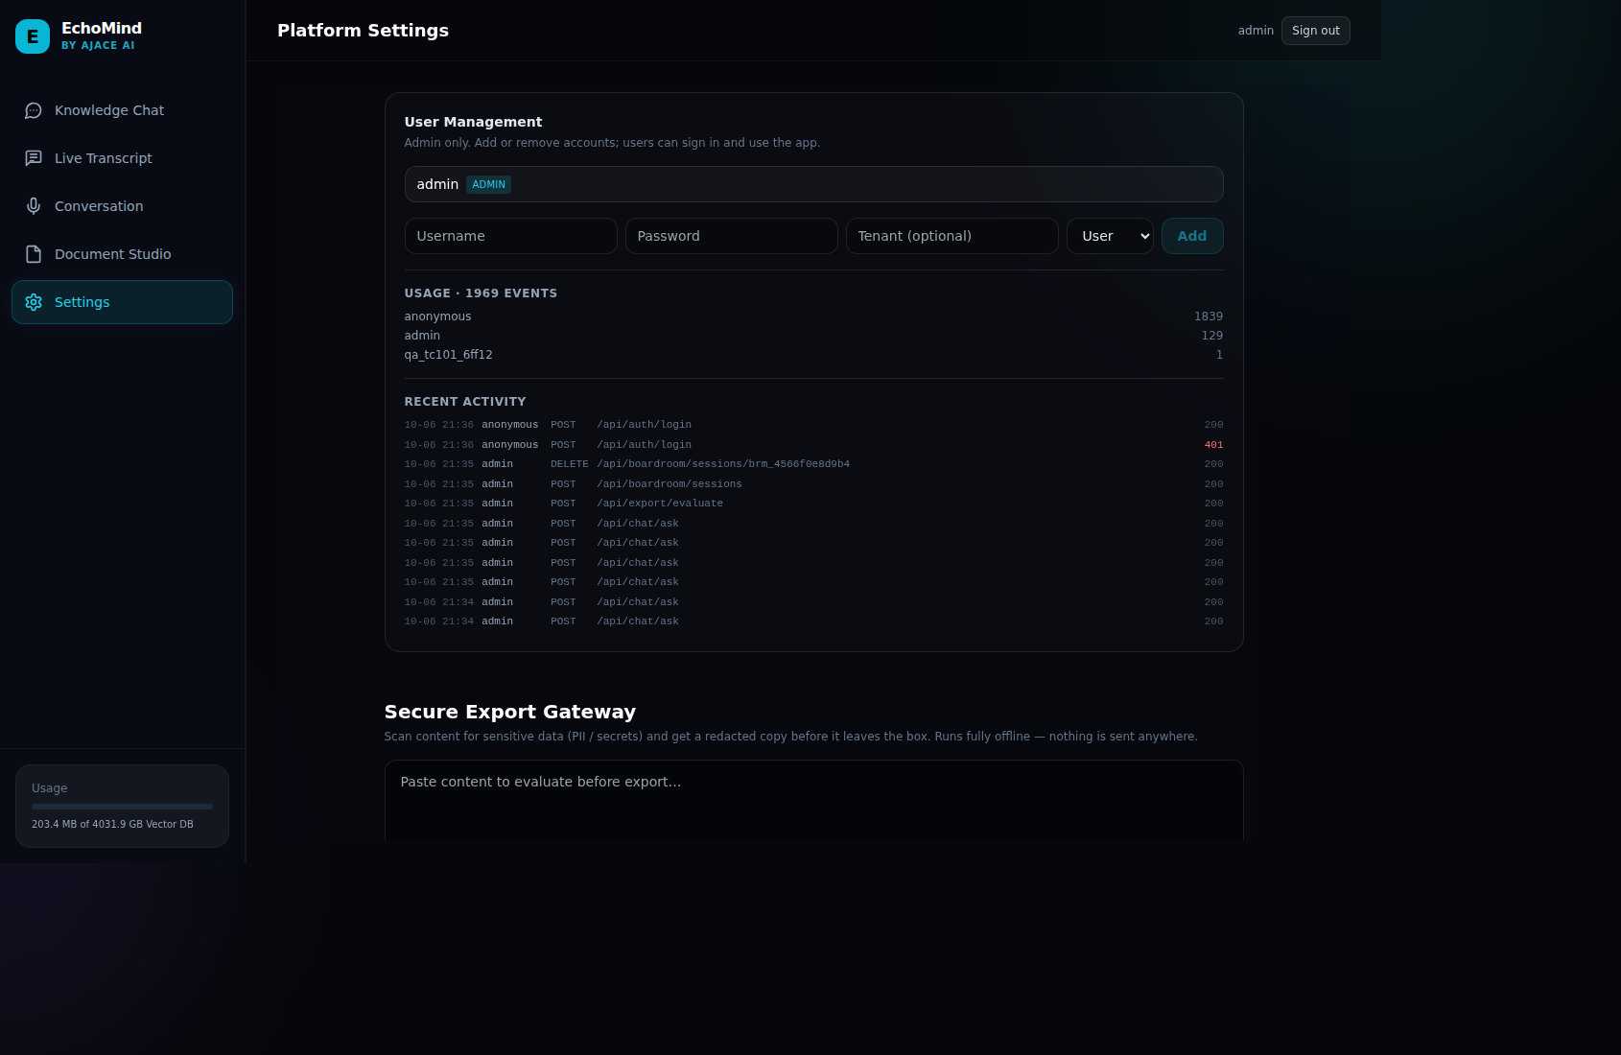
SCR-08_settings_admin — Admin: user management, usage and recent activity log

