AJACE INC. · ECHOMIND ENTERPRISE · ISO 9001:2015 EVIDENCE

Defect Linking Evidence – DEF-2026-01 (QA-FAIL-2026-01 → NC-2026-010 → fix commits)

Document control
Field | Value
Document ID | DEF-2026-01
Title | Defect Linking Evidence – DEF-2026-01 (QA-FAIL-2026-01 → NC-2026-010 → fix commits)
Version | 1.0
Date | 2026-10-06
Status | RECORD
Product / area | EchoMind Enterprise (repository RW2523/echomind-enterprise)
Prepared by | ________________
Reviewed by | ________________

Objective
Show how a failed test was logged as a defect, linked to its root cause and fixed, with traceability from test to commit. In 2025 this was done in Jira; for the rebuilt product the defect record is REG-04 and the fix is traceable through the git commit history on GitHub.

Linkage
Item | Reference | Where
Failed test | QA-FAIL-2026-01 (2026-09-28) | 15_Testing/Failures/
Defect record | NC-2026-010 (S3) | docs/qms/registers/REG-04
Fix — tests | commit 5ddf8a6 (2026-09-28) | github.com/RW2523/echomind-enterprise/commit/5ddf8a6
Fix — types | commit 736ea61 (2026-09-28) | github.com/RW2523/echomind-enterprise/commit/736ea61
Regression | REG-2026-01 (2026-10-06): 40/40, 127/127, tsc 0 | 15_Testing/Failures/
Corrective action | CI on every push (open) | COMPLETION_CHECKLIST D7
QA-FAIL-2026-02…05 | NC-2026-012…015 → fix e0ed4d0 (+14 regression tests) | Closed; verified in run 4
QA-FAIL-2026-06 | NC-2026-012 re-test regression → fix 3feb5db | Closed; verified in run 4
QA-FAIL-2026-07 | NC-2026-016 → CPU embeddings (REG-07 DC-2026-005) | Correction verified; corrective action open

Observation
Every failure is linked failed test → REG-04 defect → fix commit → re-test. The same chain is tracked as issues on the GitHub project board (users/RW2523/projects/2).
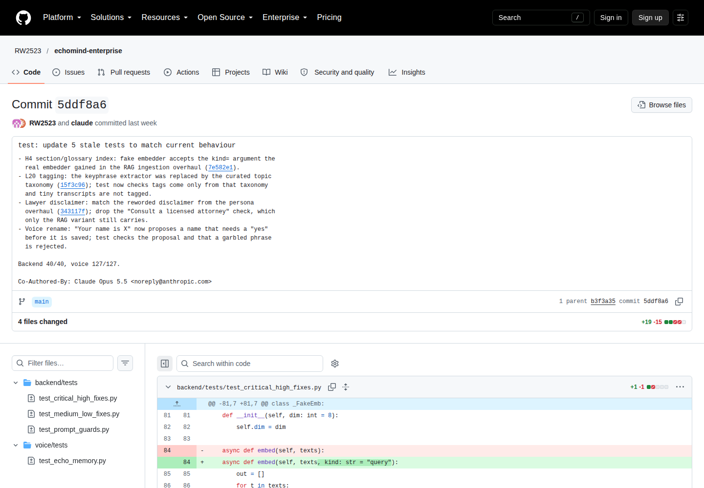
SCR-13 — fix commit 5ddf8a6 (NC-2026-010) on GitHub
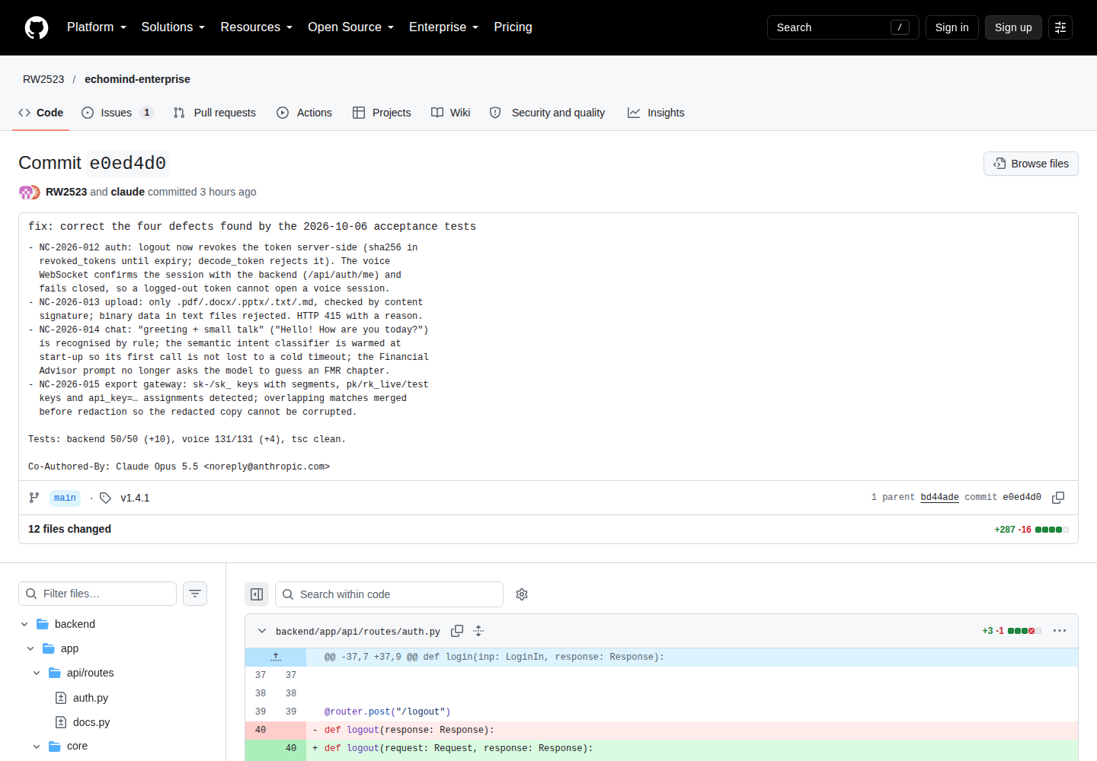
SCR-19 — fix commit e0ed4d0 (NC-2026-012…015) on GitHub
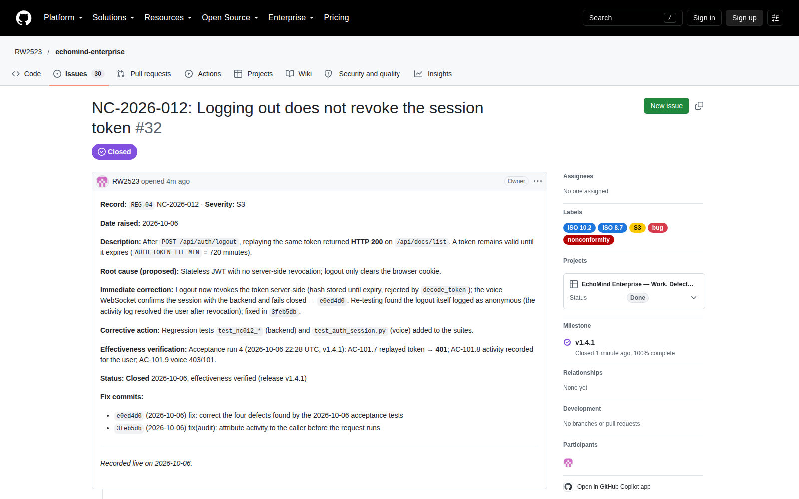
SCR-21 — defect ticket #32 (NC-2026-012) with fix commits and closure
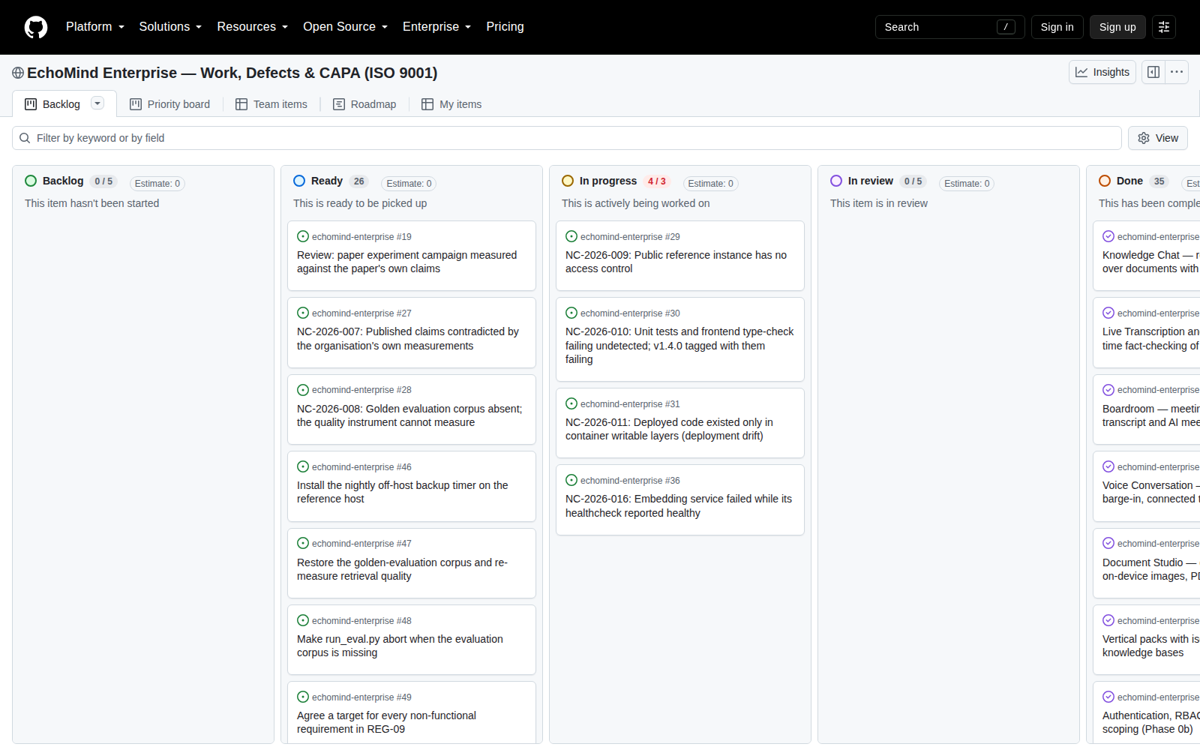
SCR-20 — project board

