AJACE INC. · ECHOMIND ENTERPRISE · ISO 9001:2015 EVIDENCE

EchoMind Test Case – TC-EM-EXP-108: Secure export gateway — PII and secret detection with redaction

Document control
Field | Value
Document ID | TC-EM-EXP-108
Title | EchoMind Test Case – TC-EM-EXP-108: Secure export gateway — PII and secret detection with redaction
Version | 1.0
Date | 2026-10-06
Status | EXECUTED — record
Product / area | EchoMind Enterprise (repository RW2523/echomind-enterprise)
Executed (initial) | 2026-10-06 21:35:12 UTC
Initial result | Fail
Re-test (v1.4.1) | 2026-10-06 22:28:47 UTC
Final result | Pass
Prepared by | ________________
Reviewed by | ________________

Objective
Verify that the export gateway detects personal data and secrets and that its redacted copy contains none of the original values.

Preconditions
- User authenticated.

Test data
- Synthetic text with an e-mail address, phone number, a published sample SSN (078-05-1120) and a dummy API key sk-test-…. No real personal data used.

Main flow and execution record
Executed 2026-10-06 21:35:12 UTC by an automated run (run_tests.py) against the reference instance; responsible tester: ________________.
Step | Action | Expected | Actual (as observed) | Result
EXP-108.1 | Evaluate text containing an email, phone, SSN and API key (synthetic values) | Each flagged | HTTP 200; 3 findings: ['email', 'phone', 'ssn'] | Pass
EXP-108.2 | Inspect the redacted copy | No original sensitive value remains | redacted copy present: True; values still present: ['sk-test-4f9a8b7c6d5e4f3a2b1c0d9e8f7a6b5c'] | Fail

Re-test on release v1.4.1 (run 4)
Executed 2026-10-06 22:28:47 UTC after the defect corrections and release v1.4.1. Earlier re-tests (runs 2 and 3) are retained in Execution_Records/.
Step | Actual (as observed) | Result
EXP-108.1 | HTTP 200; 4 findings: ['api_key', 'email', 'phone', 'ssn'] | Pass
EXP-108.2 | redacted copy present: True; values still present: none | Pass

Alternate flows / negative cases
- Any sensitive value left in the redacted copy → failure.

Postconditions
- None — the evaluation endpoint stores nothing.

Pass / fail criteria
Pass if every step meets its expected result. Any failed step is logged as a defect in REG-04 and linked below.

Result
Initial execution (v1.4.0 code): Fail — defect(s) raised: NC-2026-015
Re-test on v1.4.1 (run 4): Pass

Traceability
- ISO 9001:2015 clause(s): 8.5.3
- Area: Secure export gateway
- Execution evidence: 15_Testing/Execution_Records/run1/ (initial) and run4/ (v1.4.1 re-test)
- Linked record: REG-04 NC-2026-015

Attachments / evidence
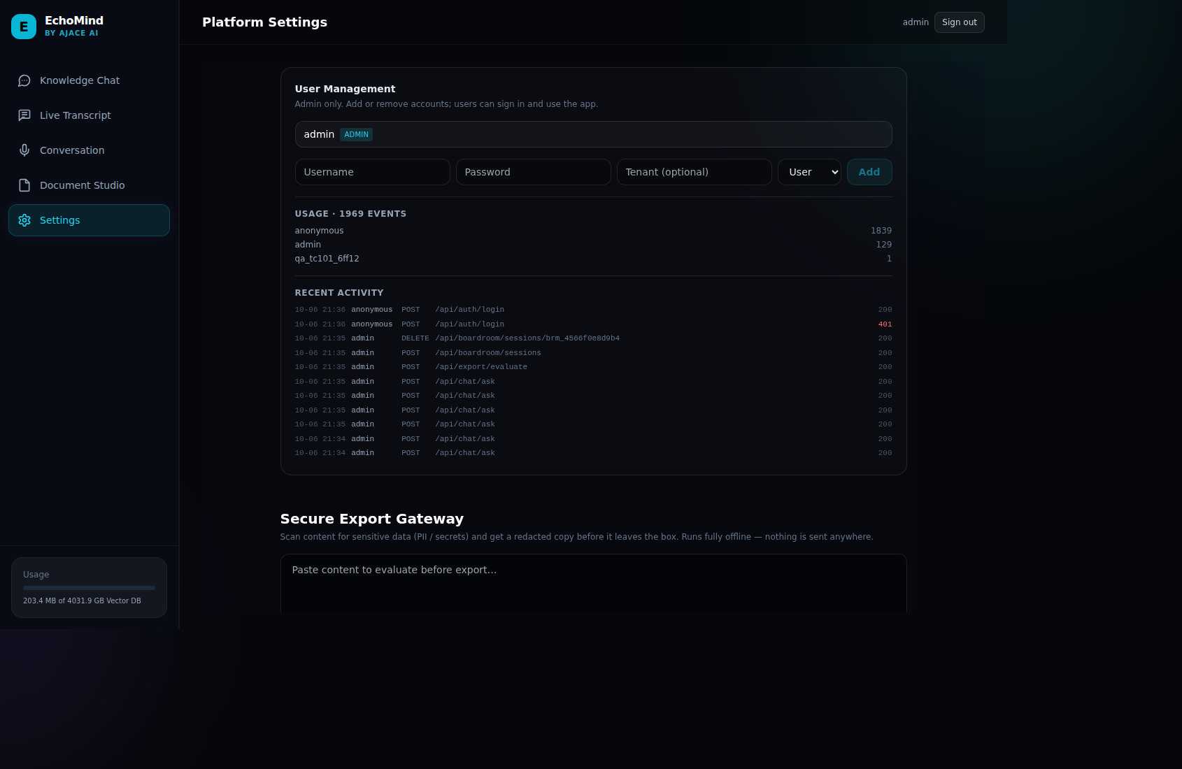
SCR-08_settings_admin — Secure Export Gateway panel (Settings)

