AJACE INC. · ECHOMIND ENTERPRISE · ISO 9001:2015 EVIDENCE

EchoMind Test Case – TC-EM-TRN-112: Live transcription end to end (microphone → transcript → live check)

Document control
Field | Value
Document ID | TC-EM-TRN-112
Title | EchoMind Test Case – TC-EM-TRN-112: Live transcription end to end (microphone → transcript → live check)
Version | 1.0
Date | 2026-10-06
Status | EXECUTED — record
Product / area | EchoMind Enterprise (repository RW2523/echomind-enterprise)
Executed (initial) | 2026-10-06 21:35:19 UTC
Initial result | Not executed
Re-test (v1.4.1) | 2026-10-06 22:28:53 UTC
Final result | Not executed
Prepared by | ________________
Reviewed by | ________________

Objective
End to end: speak into Live Transcript; verify the transcript, topic tags and Silent Assistant checks (Supported / Contradicted / Unverified).

Preconditions
- Browser with microphone permission; user authenticated.

Test data
- 30–60 s of speech referring to a Meridian SLA figure, one correct and one incorrect.

Main flow and execution record
Executed 2026-10-06 21:35:19 UTC by an automated run (run_tests.py) against the reference instance; responsible tester: ________________.
Step | Action | Expected | Actual (as observed) | Result
TRN-112.1 | Speak into Live Transcript; verify transcript, tags and Silent Assistant checks | See test case | Requires a microphone session; scheduled as a manual test. Backend transcription unit tests pass (TC-EM-UNIT-109). | Not executed

Re-test on release v1.4.1 (run 4)
Executed 2026-10-06 22:28:53 UTC after the defect corrections and release v1.4.1. Earlier re-tests (runs 2 and 3) are retained in Execution_Records/.
Step | Actual (as observed) | Result
TRN-112.1 | Requires a microphone session; scheduled as a manual test. Backend transcription unit tests pass (TC-EM-UNIT-109). | Not executed

Alternate flows / negative cases
- Incorrect figure must be labelled Contradicted with quoted proof.

Postconditions
- Delete the test transcript.

Pass / fail criteria
Pass if every step meets its expected result. Any failed step is logged as a defect in REG-04 and linked below.

Result
Initial execution (v1.4.0 code): Not executed
Re-test on v1.4.1 (run 4): Not executed

Traceability
- ISO 9001:2015 clause(s): 8.3.4
- Area: Live transcription
- Execution evidence: 15_Testing/Execution_Records/run1/ (initial) and run4/ (v1.4.1 re-test)

Attachments / evidence
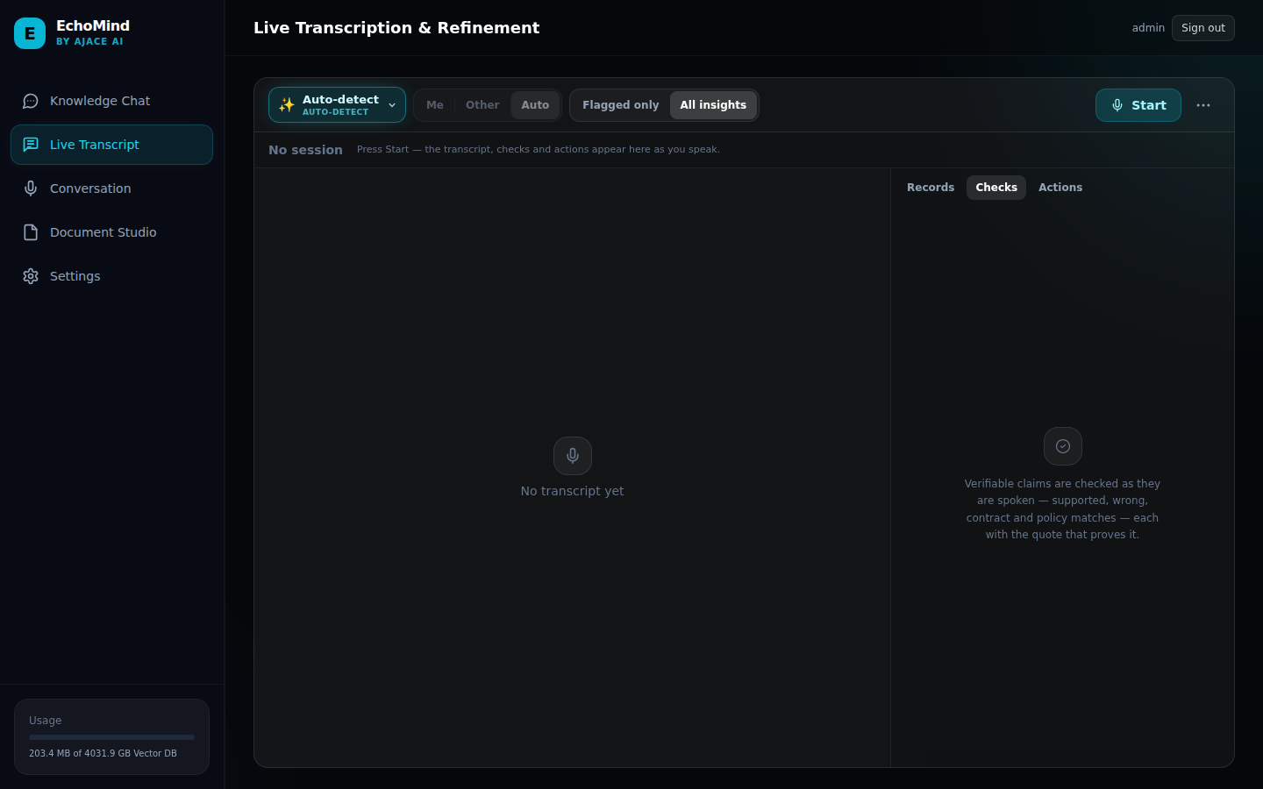
SCR-05_live_transcript — Live Transcription & Refinement view

