AJACE INC. · ECHOMIND ENTERPRISE · ISO 9001:2015 EVIDENCE

Regression Testing on Defects – REG-2026-01

Document control
Field | Value
Document ID | REG-2026-01
Title | Regression Testing on Defects – REG-2026-01
Version | 1.0
Date | 2026-10-06
Status | EXECUTED — record
Product / area | EchoMind Enterprise (repository RW2523/echomind-enterprise)
Prepared by | ________________
Reviewed by | ________________

Objective
Verify that the corrected defect (NC-2026-010) stays fixed and that no new failures appear.

Execution
Suite | Result (2026-10-06) | Evidence
Backend unit suite (repo HEAD, in the backend container) | 50 passed in 0.81s | SCR-17; Execution_Records/*_pytest.txt
Voice unit suite | 131 passed in 0.13s | SCR-17; Execution_Records/*_pytest.txt
Frontend type-check (tsc --noEmit) | 0 errors; exit=0 | SCR-17; Execution_Records/*_pytest.txt

Acceptance re-test (run 4, v1.4.1)
Test case | Initial (run 1) | Final (run 4)
TC-EM-AUTH-101 | Fail | Pass
TC-EM-DOC-102 | Fail | Pass
TC-EM-RAG-103 | Fail | Pass
TC-EM-ISO-104 | Pass | Pass
TC-EM-OPS-105 | Pass | Pass
TC-EM-REL-106 | Pass | Pass
TC-EM-EXP-108 | Fail | Pass
TC-EM-UNIT-109 | Pass | Pass
TC-EM-DGEN-110 | Pass | Pass
TC-EM-BRD-111 | Pass | Pass
TC-EM-TRN-112 | Not executed | Not executed
TC-EM-BKP-113 | Pass | Pass
TC-EM-EVAL-114 | Blocked | Blocked

Result
Passed. The suites now include 14 regression tests for NC-2026-012…015 (backend 50, voice 131). All executable acceptance cases pass on v1.4.1. Re-testing between runs caught two further problems (QA-FAIL-2026-06, -07), both corrected before run 4 — see EM26-15.
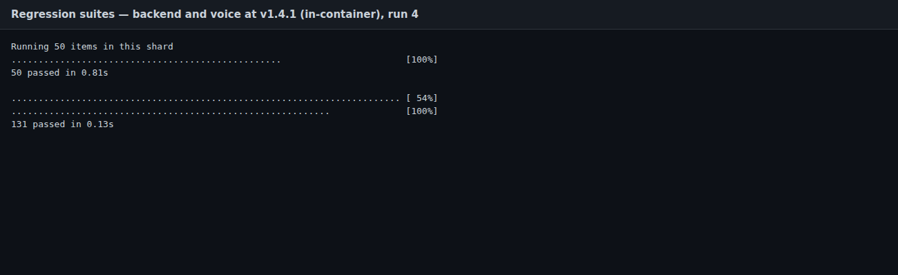
SCR-17 — regression suite output

