AJACE INC. · ECHOMIND ENTERPRISE · ISO 9001:2015 EVIDENCE

EchoMind Test Case – TC-EM-OPS-105: Service stack health, controlled restart and configuration rejection

Document control
Field | Value
Document ID | TC-EM-OPS-105
Title | EchoMind Test Case – TC-EM-OPS-105: Service stack health, controlled restart and configuration rejection
Version | 1.0
Date | 2026-10-06
Status | EXECUTED — record
Product / area | EchoMind Enterprise (repository RW2523/echomind-enterprise)
Executed (initial) | 2026-10-06 21:35:10 UTC
Initial result | Pass
Re-test (v1.4.1) | 2026-10-06 22:28:45 UTC
Final result | Pass
Prepared by | ________________
Reviewed by | ________________

Objective
Verify that the six services run healthy, that an invalid configuration change is rejected without affecting running services, and that a service recovers after a controlled restart. (2026 equivalent of the 2025 Portainer stacks test.)

Preconditions
- Docker Compose stack deployed (profile public).

Test data
- Deliberately invalid compose override (mem_limit: notanumber).
- Controlled restart of the frontend service.

Main flow and execution record
Executed 2026-10-06 21:35:10 UTC by an automated run (run_tests.py) against the reference instance; responsible tester: ________________.
Step | Action | Expected | Actual (as observed) | Result
OPS-105.1 | List the six services | All up; healthchecked services healthy | backend: Up 2 hours (healthy); cloudflared: Up 2 hours; frontend: Up 2 hours; ollama: Up 2 hours (healthy); trtllm: Up 2 hours (healthy); voice: Up 2 hours (healthy) | Pass
OPS-105.2 | Validate a deliberately invalid compose override | Rejected; running services untouched | ; running services unchanged: True | Pass
OPS-105.3 | Restart the frontend service | Returns HTTP 200 within 30 s | HTTP 200 after 1.5s | Pass
OPS-105.4 | Smoke test after restart (API via frontend proxy) | API reachable | /api/version HTTP 200 | Pass

Re-test on release v1.4.1 (run 4)
Executed 2026-10-06 22:28:45 UTC after the defect corrections and release v1.4.1. Earlier re-tests (runs 2 and 3) are retained in Execution_Records/.
Step | Actual (as observed) | Result
OPS-105.1 | backend: Up 10 minutes (healthy); cloudflared: Up 2 hours; frontend: Up About a minute; ollama: Up 47 seconds (healthy); trtllm: Up 3 hours (healthy); voice: Up 3 minutes (healthy) | Pass
OPS-105.2 | ; running services unchanged: True | Pass
OPS-105.3 | HTTP 200 after 1.4s | Pass
OPS-105.4 | /api/version HTTP 200 | Pass

Alternate flows / negative cases
- Invalid configuration → rejected, running services unchanged.

Postconditions
- All six services up and healthy.

Pass / fail criteria
Pass if every step meets its expected result. Any failed step is logged as a defect in REG-04 and linked below.

Result
Initial execution (v1.4.0 code): Pass
Re-test on v1.4.1 (run 4): Pass

Traceability
- ISO 9001:2015 clause(s): 8.5.1, 7.1.3
- Area: Service operation
- Execution evidence: 15_Testing/Execution_Records/run1/ (initial) and run4/ (v1.4.1 re-test)

Attachments / evidence
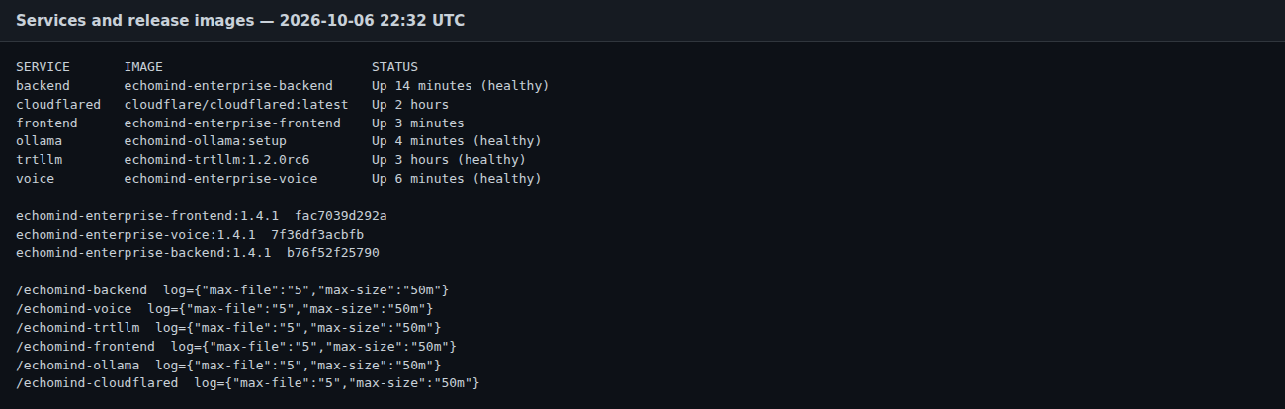
SCR-16_service_stack_status — Service stack status and log-rotation configuration

