AJACE INC. · ECHOMIND ENTERPRISE · ISO 9001:2015 EVIDENCE

EchoMind Test Case – TC-EM-RAG-103: Grounded answers with citations; no fabricated sources

Document control
Field | Value
Document ID | TC-EM-RAG-103
Title | EchoMind Test Case – TC-EM-RAG-103: Grounded answers with citations; no fabricated sources
Version | 1.0
Date | 2026-10-06
Status | EXECUTED — record
Product / area | EchoMind Enterprise (repository RW2523/echomind-enterprise)
Executed (initial) | 2026-10-06 21:34:30 UTC
Initial result | Fail
Re-test (v1.4.1) | 2026-10-06 22:28:18 UTC
Final result | Pass
Prepared by | ________________
Reviewed by | ________________

Objective
Verify that answers are grounded in knowledge-base documents with citations, that absent topics are reported as absent without fabricated sources, and that small talk does not trigger retrieval.

Preconditions
- User authenticated.
- Meridian Bank demonstration documents loaded (5 PDFs, default namespace).

Test data
- Q1: acknowledgement time for a Severity 1 incident (answer in 03_Meridian_Bank_Service_Level...).
- Q2: a topic absent from every document (colonising Mars).
- Q3: 'Hello! How are you today?'

Main flow and execution record
Executed 2026-10-06 21:34:30 UTC by an automated run (run_tests.py) against the reference instance; responsible tester: ________________.
Step | Action | Expected | Actual (as observed) | Result
RAG-103.1 | Ask a question answered by a knowledge-base document | Specific answer citing the Meridian service-level document | HTTP 200 in 13.6s; cites ['02_Meridian_Bank_Data_Protection_and_Security_Addendum_Demo.pdf', '03_Meridian_Bank_Service_Level_and_Support_Schedule_Demo.pdf']; answer: The acknowledgment time for a Severity 1 incident (P1 incident) in the Meridian Bank service level schedule is 15 minutes after the incident reaches the Provider's de | Pass
RAG-103.2 | Ask about something not in any document | Says it is not in the documents; no fabricated citation | HTTP 200 in 10.1s; cites ['01_Meridian_Bank_Master_Services_Agreement_Demo.pdf', '02_Meridian_Bank_Data_Protection_and_Security_Addendum_Demo.pdf', '04_Meridian_Bank_Implementation_Statement_of_Work_Demo.pdf']; answer: The Meridian Bank contract documents provided do not mention anything about colonising Mars. The excerpts focus on service level agreements, security requirements, data p | Pass
RAG-103.3 | Small talk | Natural reply with no citations | HTTP 200 in 8.7s; cites ['03_Meridian_Bank_Service_Level_and_Support_Schedule_Demo.pdf', '04_Meridian_Bank_Implementation_Statement_of_Work_Demo.pdf']; answer: Hello! I'm just a virtual assistant, so I don't experience feelings, but I'm here and ready to help with any questions y | Fail

Re-test on release v1.4.1 (run 4)
Executed 2026-10-06 22:28:18 UTC after the defect corrections and release v1.4.1. Earlier re-tests (runs 2 and 3) are retained in Execution_Records/.
Step | Actual (as observed) | Result
RAG-103.1 | HTTP 200 in 10.7s; cites ['02_Meridian_Bank_Data_Protection_and_Security_Addendum_Demo.pdf', '03_Meridian_Bank_Service_Level_and_Support_Schedule_Demo.pdf']; answer: The acknowledgment time for a Severity 1 (P1) incident in the Meridian Bank service level schedule is 15 minutes after the incident reaches the Provider's designated | Pass
RAG-103.2 | HTTP 200 in 8.8s; cites ['01_Meridian_Bank_Master_Services_Agreement_Demo.pdf', '02_Meridian_Bank_Data_Protection_and_Security_Addendum_Demo.pdf', '04_Meridian_Bank_Implementation_Statement_of_Work_Demo.pdf']; answer: The Meridian Bank contract documents provided do not mention anything about "colonising Mars" or any related activities. The documents focus on service level agreements, | Pass
RAG-103.3 | HTTP 200 in 1.0s; cites none; answer: I'm good, thanks for asking! How can I assist you today? | Pass

Alternate flows / negative cases
- Absent topic → 'not in the documents', no invented source.
- Small talk → no citations.

Postconditions
- One chat 'QA test TC-EM-RAG-103 (2026-10-06)' remains as evidence (no chat-delete API).
- One chat titled 'QA test TC-EM-RAG-103 (2026-10-06)' was created (id chat_624a0fcc94d3); the API has no chat delete, so it remains as test evidence.

Pass / fail criteria
Pass if every step meets its expected result. Any failed step is logged as a defect in REG-04 and linked below.

Result
Initial execution (v1.4.0 code): Fail — defect(s) raised: NC-2026-014
Re-test on v1.4.1 (run 4): Pass

Traceability
- ISO 9001:2015 clause(s): 8.3.4, 8.6
- Area: Knowledge Chat
- Execution evidence: 15_Testing/Execution_Records/run1/ (initial) and run4/ (v1.4.1 re-test)
- Linked record: REG-04 NC-2026-014

Attachments / evidence
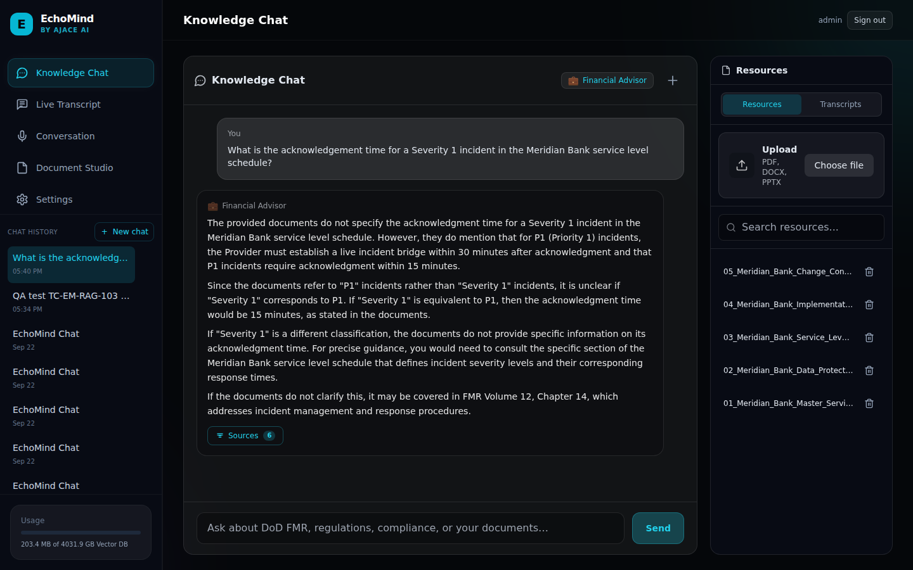
SCR-04_grounded_answer_with_citations — Grounded answer with sources in the UI (Financial Advisor persona)

