AJACE INC. · ECHOMIND ENTERPRISE · ISO 9001:2015 EVIDENCE

EchoMind Test Case – TC-EM-BRD-111: Boardroom session lifecycle (smoke)

Document control
Field | Value
Document ID | TC-EM-BRD-111
Title | EchoMind Test Case – TC-EM-BRD-111: Boardroom session lifecycle (smoke)
Version | 1.0
Date | 2026-10-06
Status | EXECUTED — record
Product / area | EchoMind Enterprise (repository RW2523/echomind-enterprise)
Executed (initial) | 2026-10-06 21:35:18 UTC
Initial result | Pass
Re-test (v1.4.1) | 2026-10-06 22:28:52 UTC
Final result | Pass
Prepared by | ________________
Reviewed by | ________________

Objective
Smoke test the boardroom session lifecycle: create, retrieve, delete.

Preconditions
- User authenticated.

Test data
- Session titled 'QA test TC-EM-BRD-111'.

Main flow and execution record
Executed 2026-10-06 21:35:18 UTC by an automated run (run_tests.py) against the reference instance; responsible tester: ________________.
Step | Action | Expected | Actual (as observed) | Result
BRD-111.1 | Create a boardroom session | HTTP 200 with a session id | HTTP 200; id brm_4566f0e8d9b4; | Pass
BRD-111.2 | Retrieve the session | HTTP 200 | HTTP 200 | Pass
BRD-111.3 | Delete the session | Deleted; subsequent GET 404 | DELETE HTTP 200; GET after delete HTTP 404 | Pass

Re-test on release v1.4.1 (run 4)
Executed 2026-10-06 22:28:52 UTC after the defect corrections and release v1.4.1. Earlier re-tests (runs 2 and 3) are retained in Execution_Records/.
Step | Actual (as observed) | Result
BRD-111.1 | HTTP 200; id brm_c4474aae0970; | Pass
BRD-111.2 | HTTP 200 | Pass
BRD-111.3 | DELETE HTTP 200; GET after delete HTTP 404 | Pass

Alternate flows / negative cases
- Retrieval after delete → 404.

Postconditions
- Session deleted.

Pass / fail criteria
Pass if every step meets its expected result. Any failed step is logged as a defect in REG-04 and linked below.

Result
Initial execution (v1.4.0 code): Pass
Re-test on v1.4.1 (run 4): Pass

Traceability
- ISO 9001:2015 clause(s): 8.5.1
- Area: Boardroom
- Execution evidence: 15_Testing/Execution_Records/run1/ (initial) and run4/ (v1.4.1 re-test)

Attachments / evidence
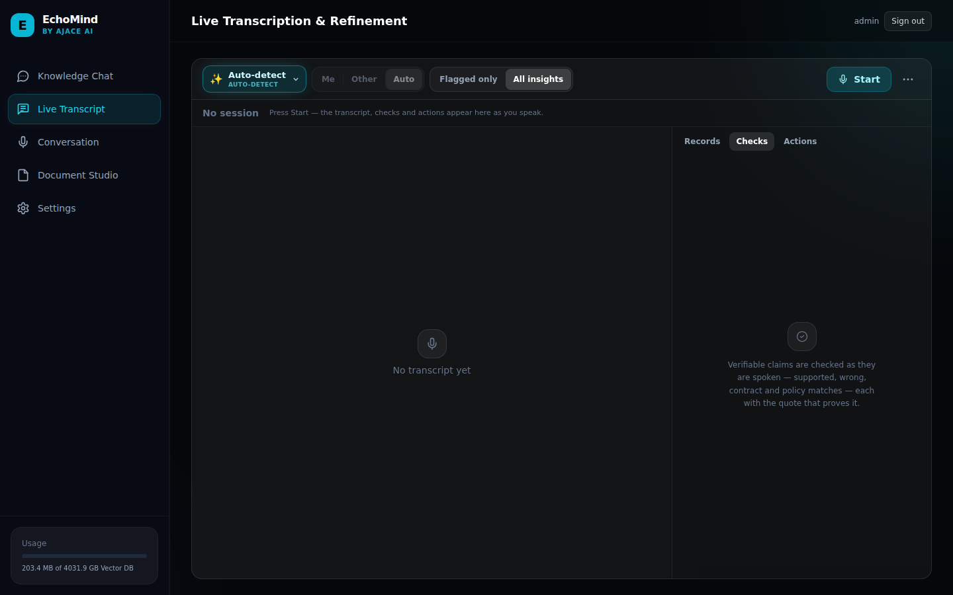
SCR-05_live_transcript — Live Transcript view (Boardroom capture starts here)

