AJACE INC. · ECHOMIND ENTERPRISE · ISO 9001:2015 EVIDENCE

EchoMind Test Case – TC-EM-DGEN-110: Document Studio availability (smoke)

Document control
Field | Value
Document ID | TC-EM-DGEN-110
Title | EchoMind Test Case – TC-EM-DGEN-110: Document Studio availability (smoke)
Version | 1.0
Date | 2026-10-06
Status | EXECUTED — record
Product / area | EchoMind Enterprise (repository RW2523/echomind-enterprise)
Executed (initial) | 2026-10-06 21:35:18 UTC
Initial result | Pass
Re-test (v1.4.1) | 2026-10-06 22:28:52 UTC
Final result | Pass
Prepared by | ________________
Reviewed by | ________________

Objective
Smoke test: Document Studio templates and the on-device image generator are available.

Preconditions
- User authenticated.

Test data
- GET /api/docgen/templates; GET /api/docgen/image-status.

Main flow and execution record
Executed 2026-10-06 21:35:18 UTC by an automated run (run_tests.py) against the reference instance; responsible tester: ________________.
Step | Action | Expected | Actual (as observed) | Result
DGEN-110.1 | List document templates | Templates returned | HTTP 200; 25 templates | Pass
DGEN-110.2 | Query on-device image generator status | Status returned | HTTP 200; {'backend': 'diffusers', 'enabled': True, 'mode': 'on-device', 'model': 'stabilityai/sdxl-turbo'} | Pass

Re-test on release v1.4.1 (run 4)
Executed 2026-10-06 22:28:52 UTC after the defect corrections and release v1.4.1. Earlier re-tests (runs 2 and 3) are retained in Execution_Records/.
Step | Actual (as observed) | Result
DGEN-110.1 | HTTP 200; 25 templates | Pass
DGEN-110.2 | HTTP 200; {'backend': 'diffusers', 'enabled': True, 'mode': 'on-device', 'model': 'stabilityai/sdxl-turbo'} | Pass

Alternate flows / negative cases
- Generation not run (needs ~18 GB GPU; ~6 GB free on the shared device).

Postconditions
- None.
- Generation itself not exercised: it loads SDXL-Turbo (~18 GB GPU) and the shared GPU had ~6 GB free.

Pass / fail criteria
Pass if every step meets its expected result. Any failed step is logged as a defect in REG-04 and linked below.

Result
Initial execution (v1.4.0 code): Pass
Re-test on v1.4.1 (run 4): Pass

Traceability
- ISO 9001:2015 clause(s): 8.5.1
- Area: Document Studio
- Execution evidence: 15_Testing/Execution_Records/run1/ (initial) and run4/ (v1.4.1 re-test)

Attachments / evidence
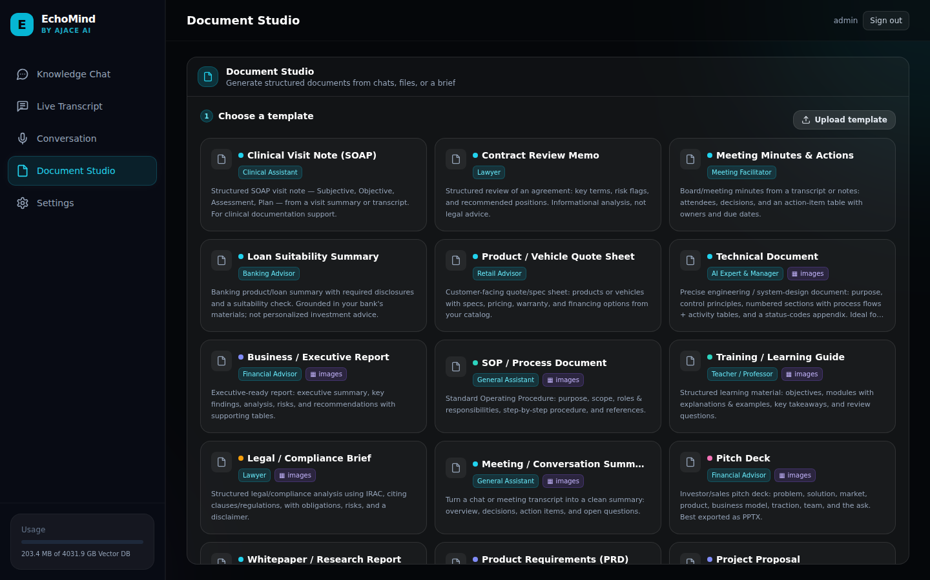
SCR-07_document_studio — Document Studio template gallery

