AJACE INC. · ECHOMIND ENTERPRISE · ISO 9001:2015 EVIDENCE

EchoMind Test Case – TC-EM-UNIT-109: Automated regression suites (backend, voice, frontend type-check)

Document control
Field | Value
Document ID | TC-EM-UNIT-109
Title | EchoMind Test Case – TC-EM-UNIT-109: Automated regression suites (backend, voice, frontend type-check)
Version | 1.0
Date | 2026-10-06
Status | EXECUTED — record
Product / area | EchoMind Enterprise (repository RW2523/echomind-enterprise)
Executed (initial) | 2026-10-06 21:35:12 UTC
Initial result | Pass
Re-test (v1.4.1) | 2026-10-06 22:28:47 UTC
Final result | Pass
Prepared by | ________________
Reviewed by | ________________

Objective
Run the automated suites against the repository HEAD in the production containers: backend unit tests, voice unit tests and the frontend type-check.

Preconditions
- Backend and voice containers running.

Test data
- backend/tests (40), voice/tests (38 functions / 127 cases), frontend tsc --noEmit.

Main flow and execution record
Executed 2026-10-06 21:35:12 UTC by an automated run (run_tests.py) against the reference instance; responsible tester: ________________.
Step | Action | Expected | Actual (as observed) | Result
UNIT-109.1 | Backend unit suite (repo HEAD, in the backend container) | All pass | 40 passed in 0.57s | Pass
UNIT-109.2 | Voice unit suite | All pass | 127 passed in 0.19s | Pass
UNIT-109.3 | Frontend type-check (tsc --noEmit) | 0 errors | 0 errors; exit=0 | Pass

Re-test on release v1.4.1 (run 4)
Executed 2026-10-06 22:28:47 UTC after the defect corrections and release v1.4.1. Earlier re-tests (runs 2 and 3) are retained in Execution_Records/.
Step | Actual (as observed) | Result
UNIT-109.1 | 50 passed in 0.81s | Pass
UNIT-109.2 | 131 passed in 0.13s | Pass
UNIT-109.3 | 0 errors; exit=0 | Pass

Alternate flows / negative cases
- Any failure → raise a defect (as NC-2026-010).

Postconditions
- Temporary copies in the containers removed.

Pass / fail criteria
Pass if every step meets its expected result. Any failed step is logged as a defect in REG-04 and linked below.

Result
Initial execution (v1.4.0 code): Pass
Re-test on v1.4.1 (run 4): Pass

Traceability
- ISO 9001:2015 clause(s): 8.3.4, 8.6
- Area: Automated regression
- Execution evidence: 15_Testing/Execution_Records/run1/ (initial) and run4/ (v1.4.1 re-test)
- Linked record: REG-04 NC-2026-010

Attachments / evidence
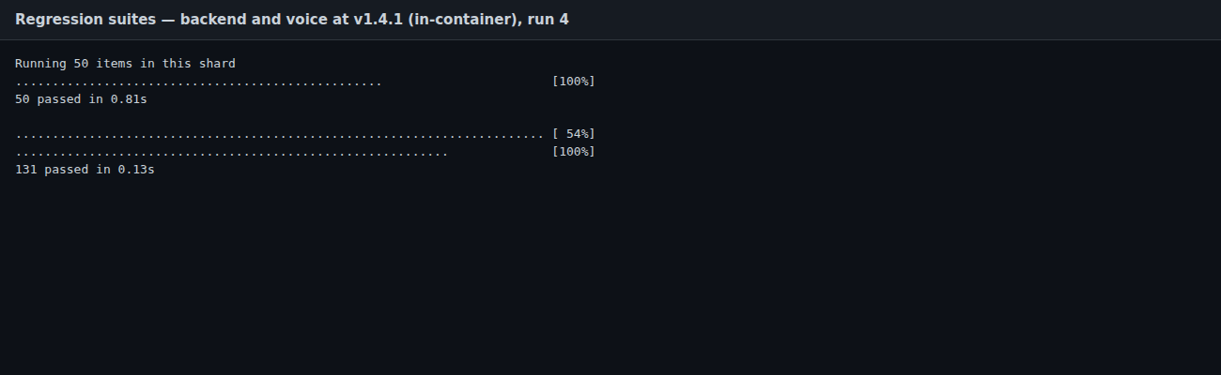
SCR-17_regression_suites — Regression suite output, 2026-10-06

