AJACE INC. · ECHOMIND ENTERPRISE · ISO 9001:2015 EVIDENCE

EchoMind Test Case – TC-EM-REL-106: Release identification and traceability

Document control
Field | Value
Document ID | TC-EM-REL-106
Title | EchoMind Test Case – TC-EM-REL-106: Release identification and traceability
Version | 1.0
Date | 2026-10-06
Status | EXECUTED — record
Product / area | EchoMind Enterprise (repository RW2523/echomind-enterprise)
Executed (initial) | 2026-10-06 21:35:12 UTC
Initial result | Pass
Re-test (v1.4.1) | 2026-10-06 22:28:47 UTC
Final result | Pass
Prepared by | ________________
Reviewed by | ________________

Objective
Verify that a running instance reports the release and source revision it runs, and that this matches the tagged release and changelog.

Preconditions
- Release v1.4.0 tagged; BUILD_* set for the running services.

Test data
- Tag v1.4.0; /api/version; voice /health; CHANGELOG.md.

Main flow and execution record
Executed 2026-10-06 21:35:12 UTC by an automated run (run_tests.py) against the reference instance; responsible tester: ________________.
Step | Action | Expected | Actual (as observed) | Result
REL-106.1 | GET /api/version | Reports version, commit and build date | HTTP 200 {'app': 'EchoMind Backend', 'version': '1.4.0', 'commit': 'eaa7b1a049574f497595a887f99e4089cdd6a57b', 'date': '2026-10-06T19:55:58Z'} | Pass
REL-106.2 | Compare the reported commit with the v1.4.0 tag | Identical | reported eaa7b1a04957; tag v1.4.0 → eaa7b1a04957 | Pass
REL-106.3 | CHANGELOG has a v1.4.0 section | Present | ## [1.4.0] - 2026-09-22 present | Pass
REL-106.4 | Voice /health reports its build | Version 1.4.0 | {"ok":true,"build":{"version":"1.4.0","commit":"eaa7b1a049574f497595a887f99e4089cdd6a57b","date":"2026-10-06T19:55:58Z"}} | Pass

Re-test on release v1.4.1 (run 4)
Executed 2026-10-06 22:28:47 UTC after the defect corrections and release v1.4.1. Earlier re-tests (runs 2 and 3) are retained in Execution_Records/.
Step | Actual (as observed) | Result
REL-106.1 | HTTP 200 {'app': 'EchoMind Backend', 'version': '1.4.1', 'commit': 'f1b8445a994e3b3eb9201e93c58d327b30664d9b', 'date': '2026-10-06T22:17:01Z'} | Pass
REL-106.2 | reported f1b8445a994e; tag v1.4.1 → f1b8445a994e | Pass
REL-106.3 | ## [1.4.1] present | Pass
REL-106.4 | {"ok":true,"build":{"version":"1.4.1","commit":"f1b8445a994e3b3eb9201e93c58d327b30664d9b","date":"2026-10-06T22:17:01Z"}} | Pass

Alternate flows / negative cases
- Mismatch between reported commit and tag → nonconformity (8.5.2).

Postconditions
- None.

Pass / fail criteria
Pass if every step meets its expected result. Any failed step is logged as a defect in REG-04 and linked below.

Result
Initial execution (v1.4.0 code): Pass
Re-test on v1.4.1 (run 4): Pass

Traceability
- ISO 9001:2015 clause(s): 8.5.2, 8.6
- Area: Release / traceability
- Execution evidence: 15_Testing/Execution_Records/run1/ (initial) and run4/ (v1.4.1 re-test)

Attachments / evidence
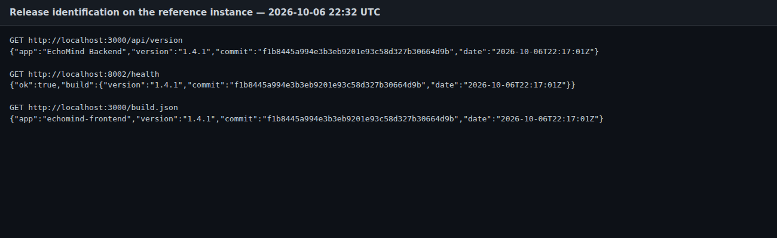
SCR-09_api_version — GET /api/version on the reference instance
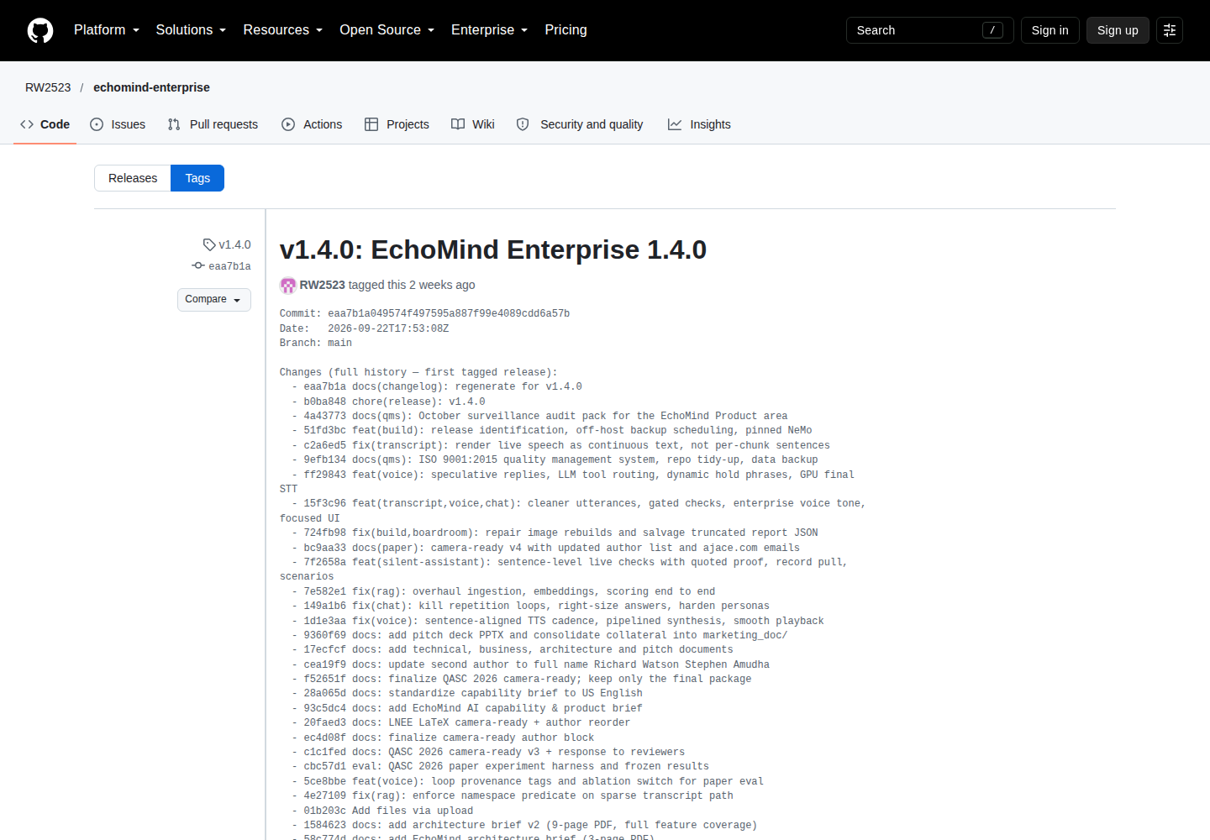
SCR-12_github_tag_v1.4.0 — Annotated tag v1.4.0 on GitHub

