# Description

### Overview

WeJoy is an open-source program written for Linux, that allows a user to write scripts that take input from game controllers, and then reroute that input to either a keyboard or any number of virtual game controllers. WeJoy uses the “joydev” API[1] provided by Linux to read data from connected controllers and uses the “udev”[2] API to query joysticks for information. This also puts a limitation on the type of controllers that can be used, limiting the usage of this application to USB controllers. WeJoy then uses the “uinput”[3] API to create a virtual keyboard and any number of virtual controllers to send scripted events to.

### History

WeJoy was started by Johannes Bergmark (Vantskruv on GitHub), and began in March 2015. WeJoy began as a simple copy and paste of libsuinput[4] and parts of unnamed_Lua_binder[5], with a small wrapper around it to allow uinput functions to be called from a Lua script.

### Lua

WeJoy uses a scripting language called Lua to provide the ability for uses to define how different actions relate to each other. This gives the advantage of giving the user complete control over how the joystick works, but also means we can use a simple Lua API for passing control to and taking control from the script.

### API

WeJoy uses four APIs to make the application function. It uses the joydev API, which gives a developer the ability to poll for Joystick events. It also uses the udev API, as it allows a developer to query information about connected devices, such as the vender and product ids of a controller. These are then used in scripts to select what device you want to listen to. WeJoy then uses the suinput API as it provides a wrapper around uinput, which gives a developer the ability to create and control virtual input devices such as controllers and keyboards.

WeJoy also uses a Lua scripting API that allows us to interface with user defined scripts written in Lua. This allows the application to be extremely extendable, as the user is in control of what different inputs and outputs do.

### Domain

WeJoy exists in the domain of input device emulation, input device interfacing and scripting.

#### **Scripting**

This project uses the Lua scripting framework to provide a simple scripting framework that can be extended to provide any response to an incoming request. Scripting provides the ability for a user to write a series of scripts that bind together different actions, without the requirement of compiling, to make it easy to change scripts or write many scripts. A good scripting language requires an easy to understand but flexible language to sit as a translation layer between input controllers and output controllers. This language needs to allow the user to easily write scripts that can handle user input, and then forward that to another device such as a virtual controller or keyboard. This also means that the scripting system needs to have a decent API for talking to virtual devices. One caveat of this system is that scripts tend to run slower than compiled code. However, in most cases the scripts are simple enough that any performance loss is negligible.

#### **Device Emulation and Device Interfacing**

Device emulation gives us the ability to interface with many applications without directly targeting them. For example, we can create a virtual game controller, and then talk to any game that supports controllers, without specifically writing something for a specific game.

Device interfacing allows us to get data from real-world hardware, and pass that through to our scripts. This means we can directly map between a real and virtual controller, or even map a controller to a keyboard. For example, one could use this to make their gamepad control the keyboard if their game does not support keyboard input, or even combine two real controllers into one virtual controller as many games do not support multiple controllers.

There needs to be careful attention paid to the speed of this interface. If the emulated device or interfaced device reacts too slow, then this application would not be useful, as someone may want to use it to play a game, and in that case, a quick reaction time is required. We also need to make sure that we can handle multiple types of devices, so we need to make sure that our interface is flexible enough to handle a wide variety of joysticks and user input devices, but it also needs to be rigid enough that someone can specify a specific joystick on their system and know that that is the device they are interfacing with. The emulation also needs to be flexible enough to handle emulating a wide variety of output devices, with a varying number of buttons and joystick axes.

### Component Architecture

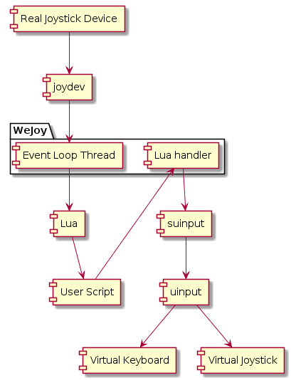  
Figure 1

#### **Event Driven and Pipelined Architecture**

Figure 2 – WeJoy Structure

WeJoy is modelled after an event driven, pipelined architecture. When a user moves their joystick, the event is passed through a pipeline until it effects the virtual joystick defined by a Lua script. The first input to WeJoy is the Event Loop Thread. As shown in *Figure 1*, it is triggered after a real joystick sends an event to joydev, which the event loop thread polls for updates.

When the event loop thread receives an event, it calls a function in the user script through Lua, and then the user is responsible for calling a function in the Lua handler if they would like to control a virtual keyboard or joystick from their program.

If the Lua handler needs to control a virtual keyboard, it does this through suinput. suinput then tells uinput what change we would like to make to the keyboard and uinput changes the state of the virtual keyboard. This also applies to adjusting a virtual joystick, only a different method is called from Lua.

As an example, a user may wish for the first button on their first controller to press the ‘A’ key on their keyboard. The user would write a script with the content seen in Appendix A, and then they would start WeJoy. When the user presses the first button, joydev receives an event, and then the Event Loop Thread polls the joydev and finds that the first button has been pushed. It then calls the function d0_b0_event in the user script. The example Lua script then directly calls the send_keyboard_event with the A key and the state of the button. This tells the Lua handler that you want to press a keyboard key, and then it uses the suinput API to tell uinput to press a key on the virtual keyboard. Releasing the first button has the same effect, only it will turn the key off.

### Components

#### **Event loop Thread**

The event loop thread is responsible for requesting data from the joystick API and passing that data on to Lua. The event loop thread loops forever, and it receives an event structure from the joystick API, and then parses this to work out what functions to call inside the Lua script.

#### **Lua Handler**

The Lua handler is called directly by the Lua script and is responsible for giving the scripts the ability to control virtual devices. It takes in arguments like what button to press and has a function for keyboard control and a function for joystick control.

### Data Structures

One of the main data structures on WeJoy is the event structure. While it is redefined in joystick.h, it is a structure provided by joydev, and is where data is written to when we poll joydev for data. It contains information about when a joystick event occurred, the type of event, what axis / button was affected and what the affected input was set to.

There are a few data structures in the Lua script to give the user the ability to define the joysticks they would like to connect. There is a devices data structure, that stores several devices. Each device has a set vendor and product id, and since this is unique for each different kind of joystick, this is enough to identify that a specific controller is sending events. There is also a v_devices data structure that stores information about user defined virtual devices. A v_device stores the number of buttons and the number of axes that a virtual device has.

# Appendix

### A: Demonstration Lua script

**function** d0_b0_event(value)  
 send_keyboard_event(KEY_A, value)  
**end**

1. <https://www.kernel.org/doc/Documentation/input/joystick-api.txt>
2. [http://man7.org/Linux/man-pages/man3/libudev.3.html](http://man7.org/linux/man-pages/man3/libudev.3.html)
3. <https://www.kernel.org/doc/html/v4.16/input/uinput.html>
4. <https://github.com/tuomasjjrasanen/libsuinput>
5. [https://github.com/eliasdaler/unnamed_Lua_binder](https://github.com/eliasdaler/unnamed_lua_binder)