**Names:** RWAKIGARAMA Regis

**ID:** 24458

**Web Tech Final Project Documentation**

**Name Of the Project:** **Kizigenza car rental**

**Objective**

Kizigenza Car Rental aims to provide a platform where users can easily rent or book cars online. The system will facilitate users to browse available cars, make bookings, manage their reservations, and receive email notifications regarding their bookings.

**Functionalities**

**Landing page of a system**

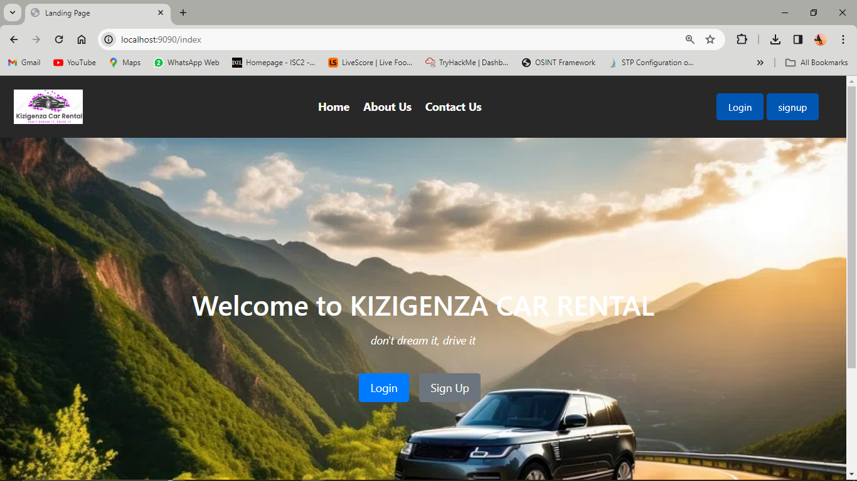

**About Us**

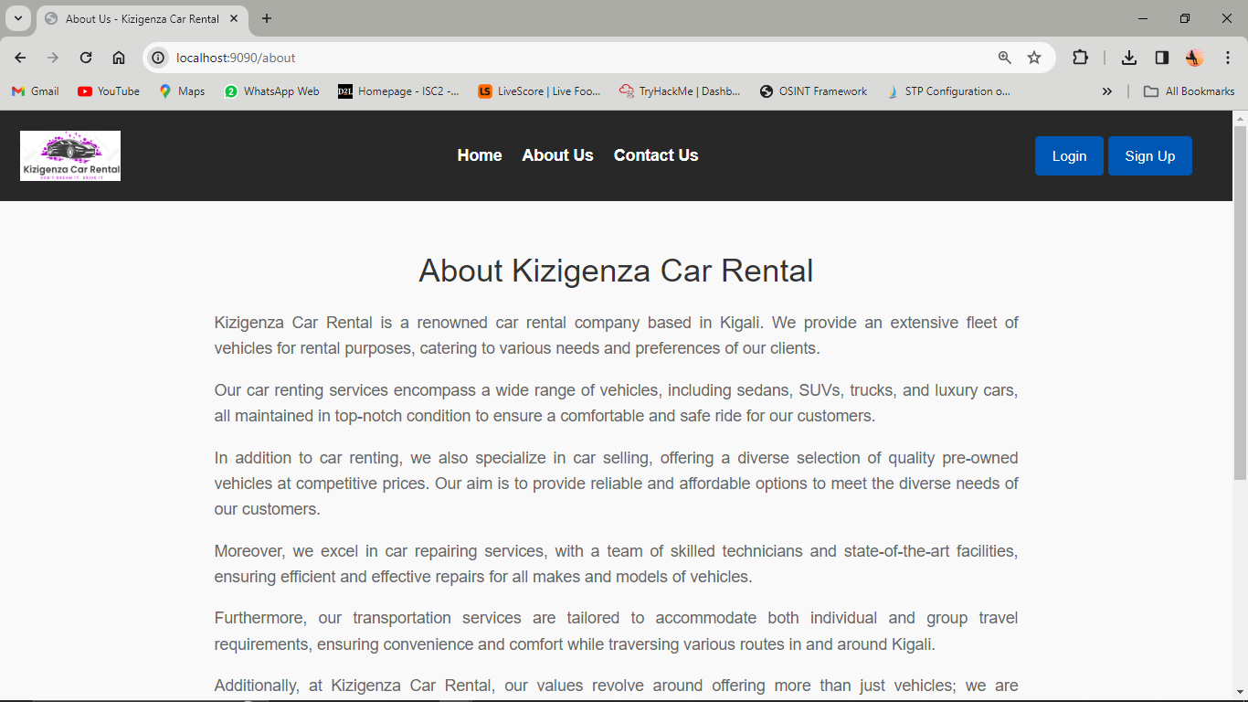

**Contact Us**

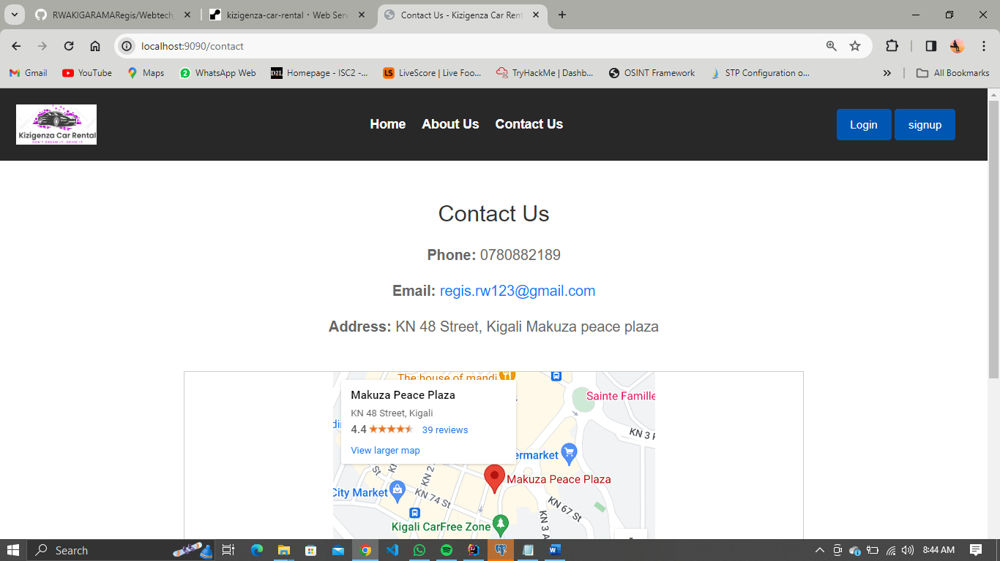

1. **User Registration and Authentication:**

* Users can create accounts and log in securely to access the car rental system.
* Signup might require details such as name, email, and also password.

**Login**

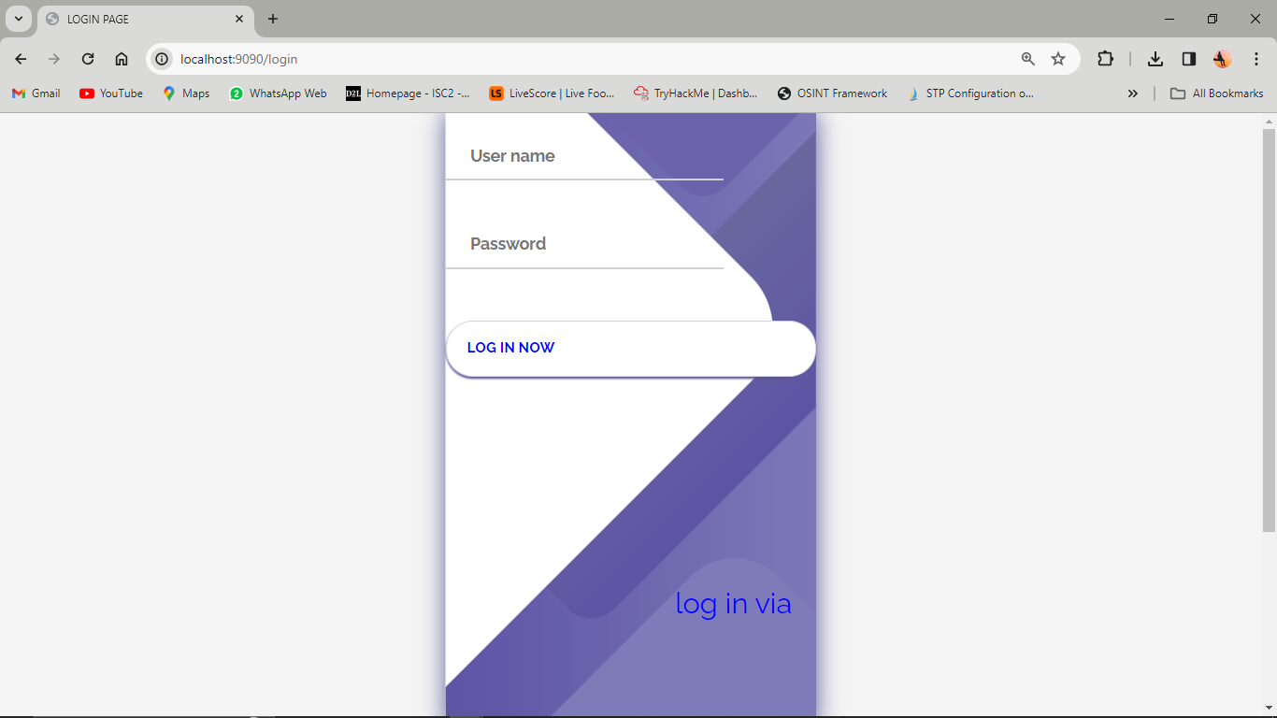

**Signup**

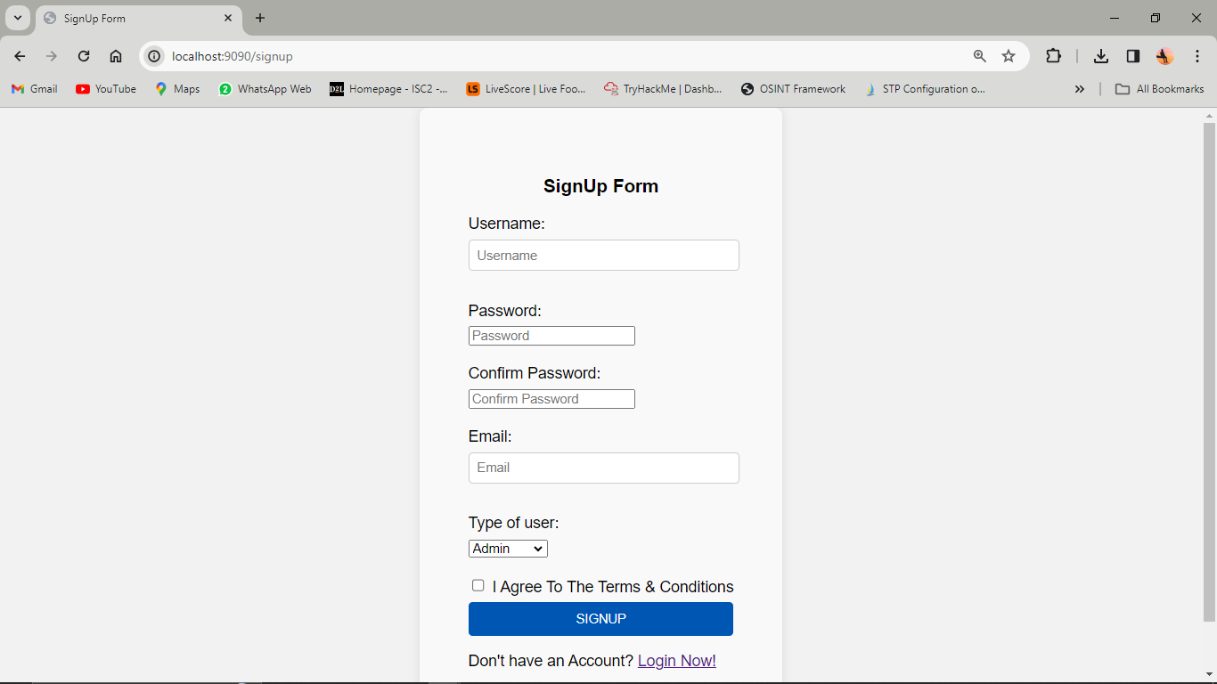

2. **Car Listings and Details:**

* The system displays a list of available cars with details like make, model, year, rental rates, availability status, and images.
* Users can search, filter, and view detailed information about each car, including specifications and rental terms.

**Customer dashboard**

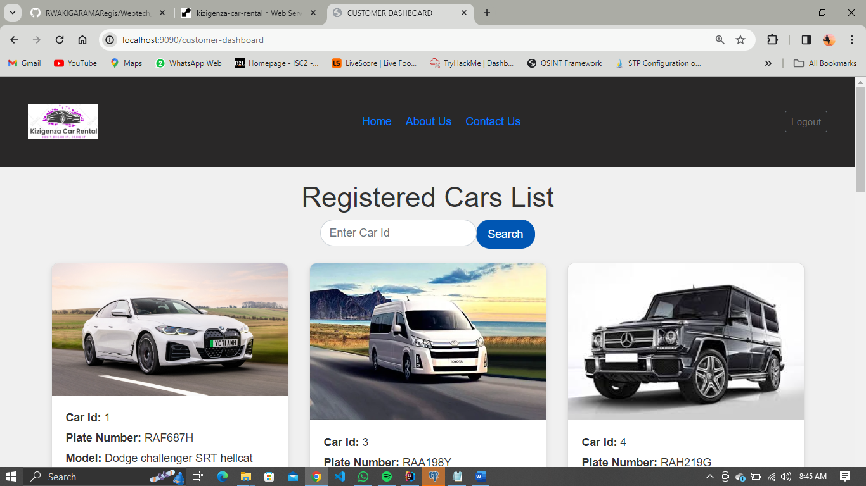

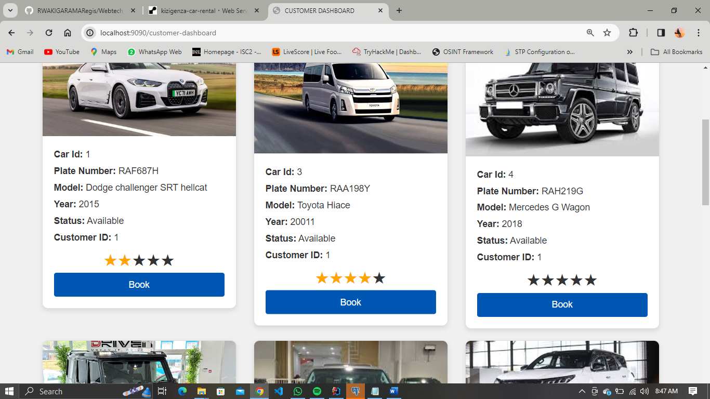

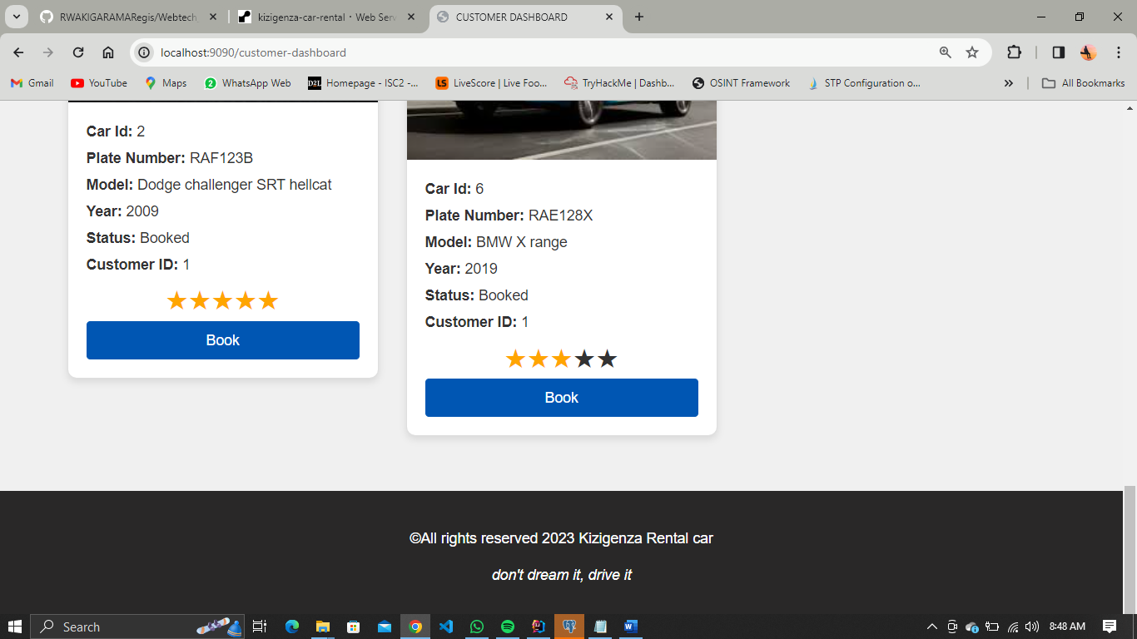

3. **Booking Process:**

• Users can select a car, choose rental dates, and make a booking.

• The system checks for car availability and confirms the reservation.

**Booking form**

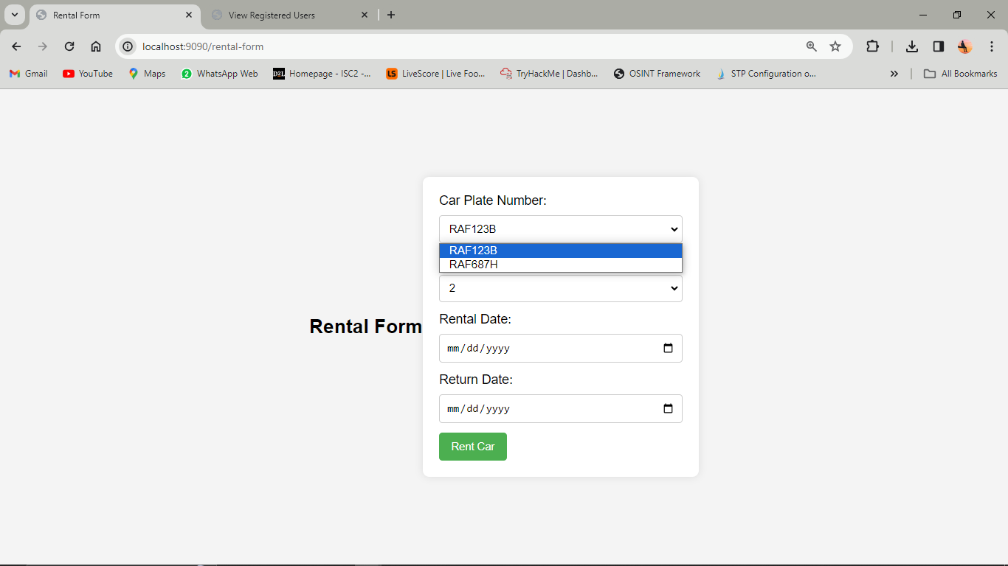

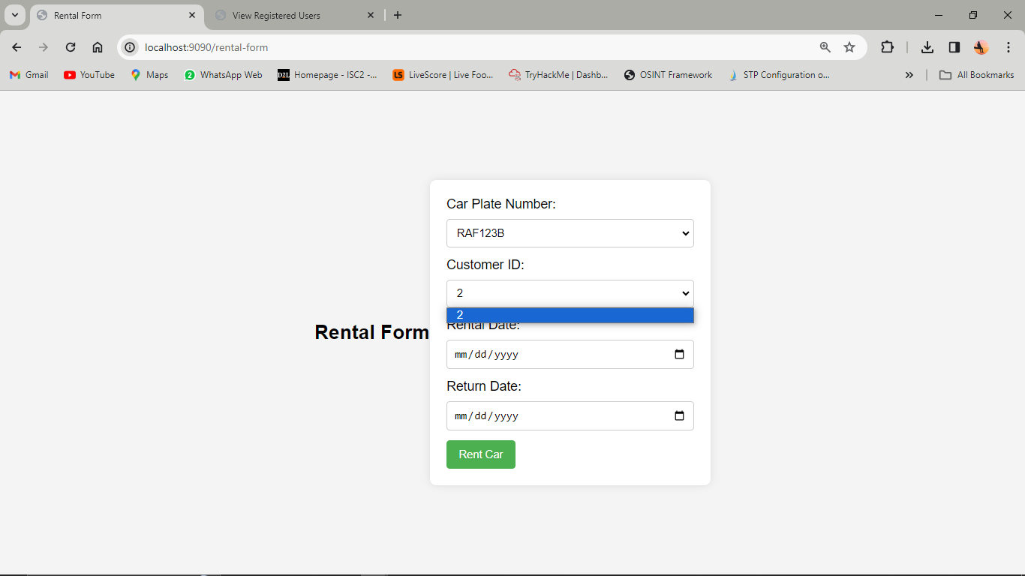

And after to rent car or booking the customer get email for inform her/his booking in our company.

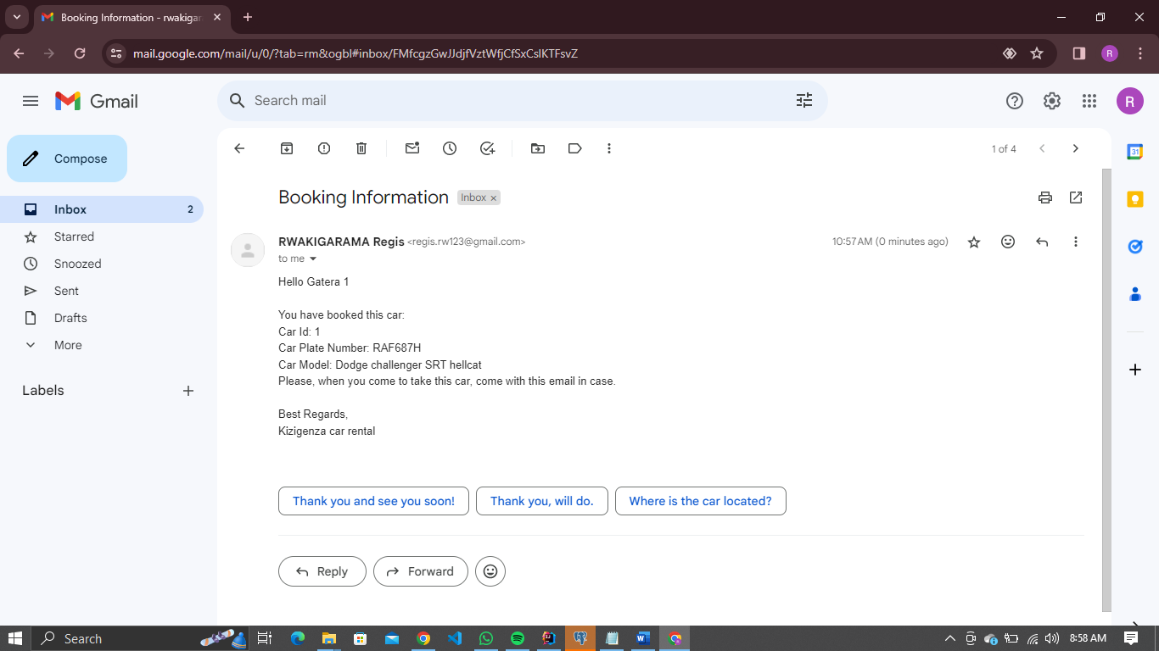

4. Admin Dashboard:

* An admin panel is available for staff to manage car listings, user accounts, bookings, and handle support requests.
* Admins can add new cars, update details, track reservations, and handle customer inquiries.

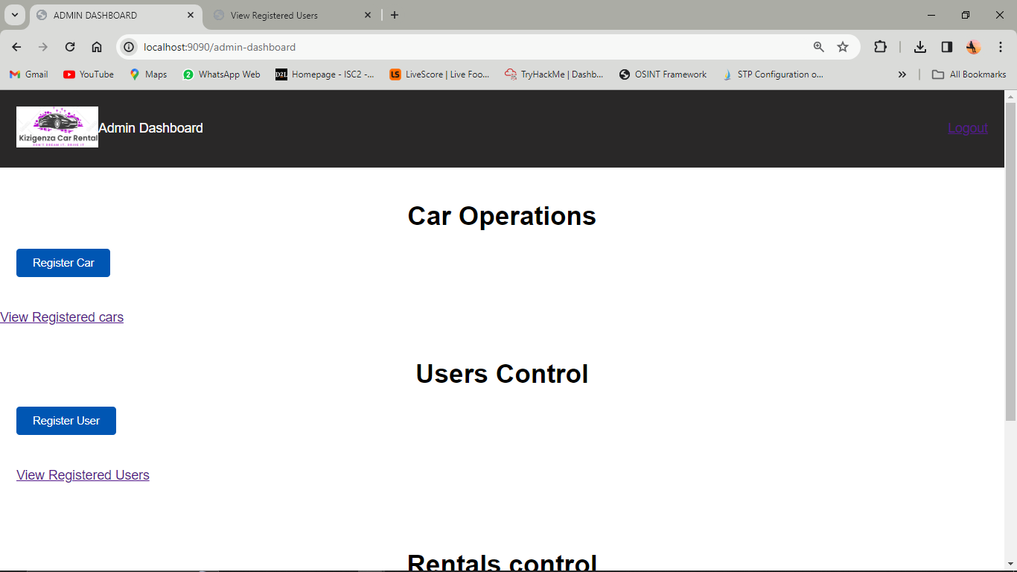

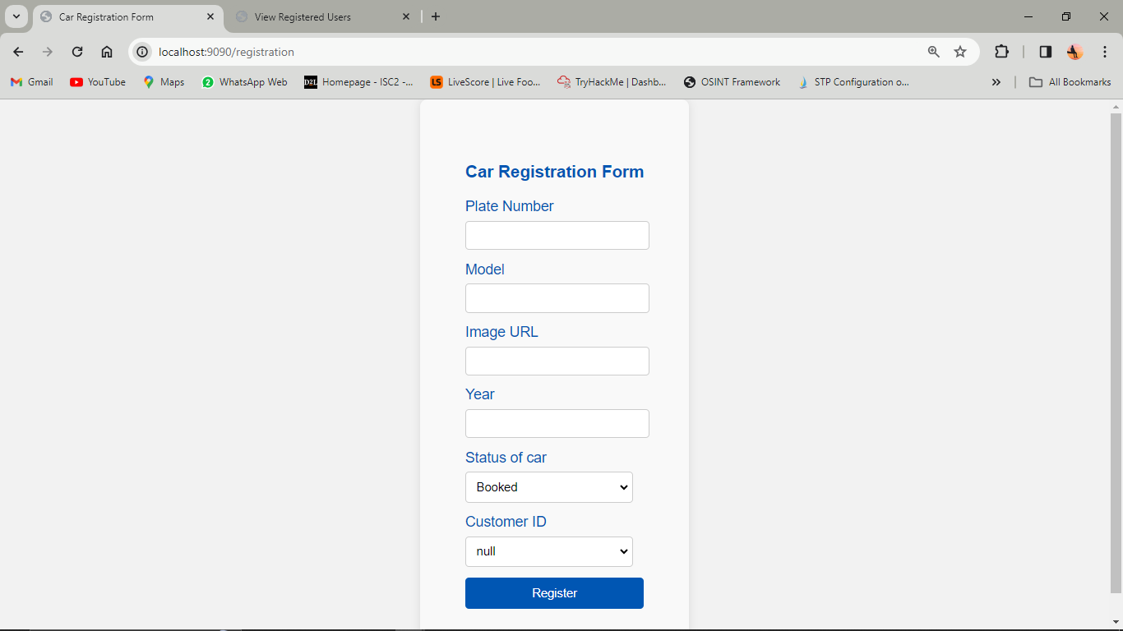

**TO view all lists are registered**

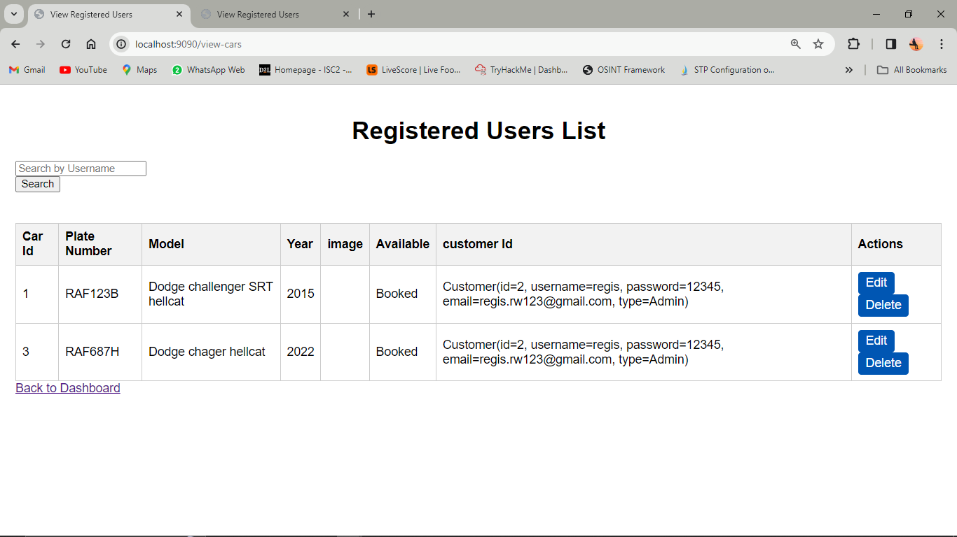

**To list all Users are registered**

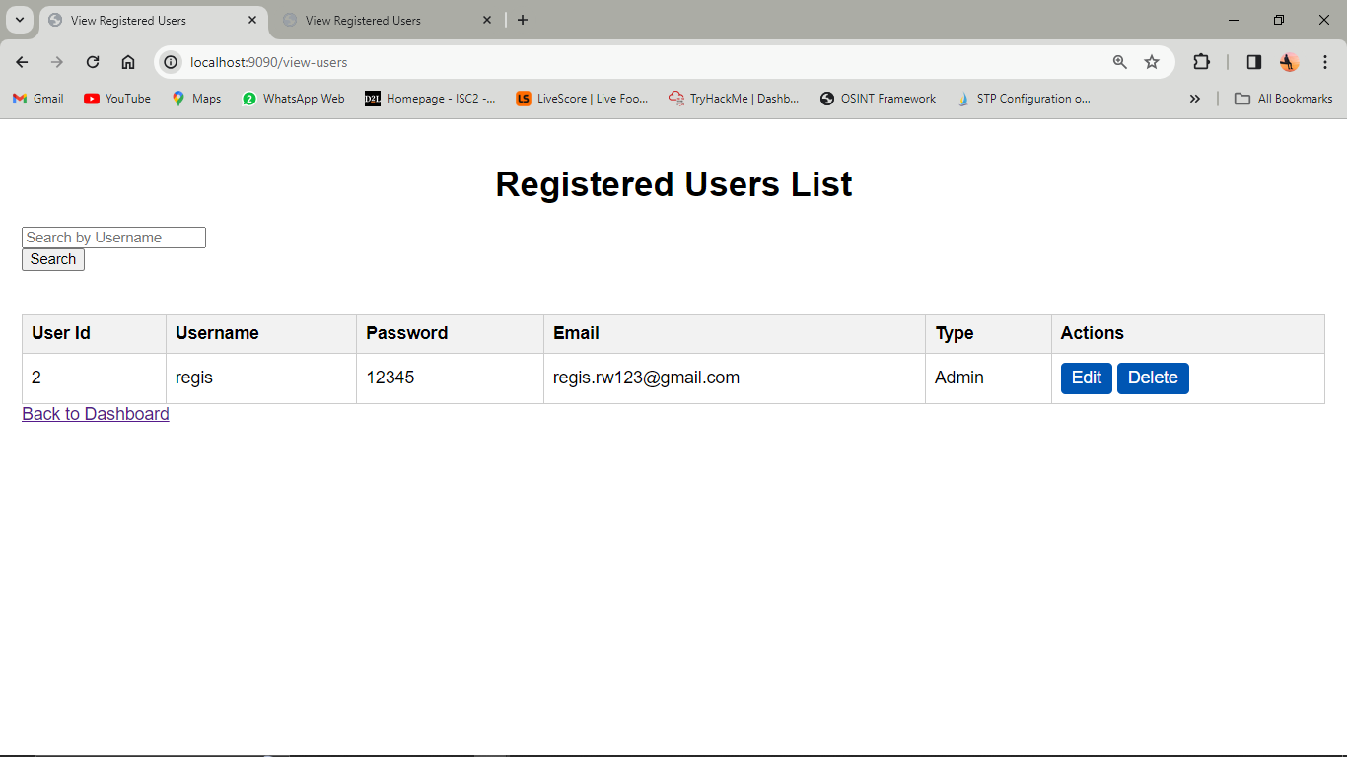

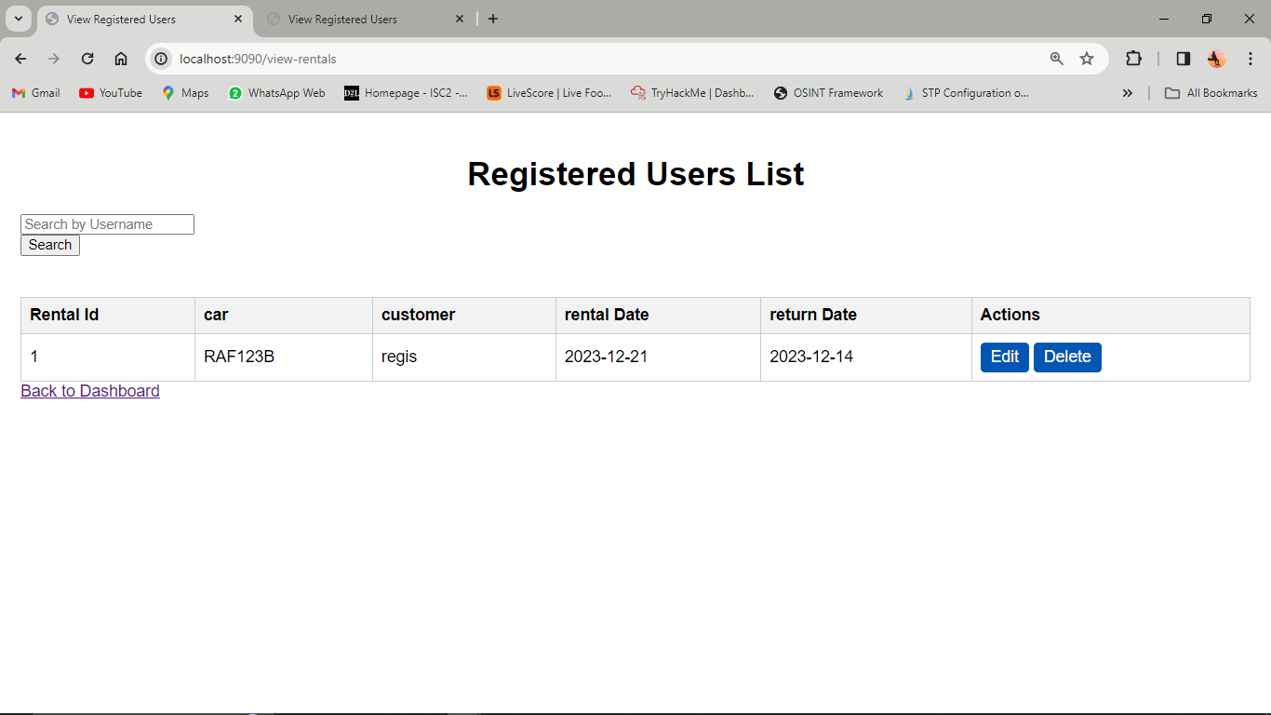

9. Customer Support:

* Contact information and support channels (such as, email, or phone) are available for users to reach out for assistance or inquiries.

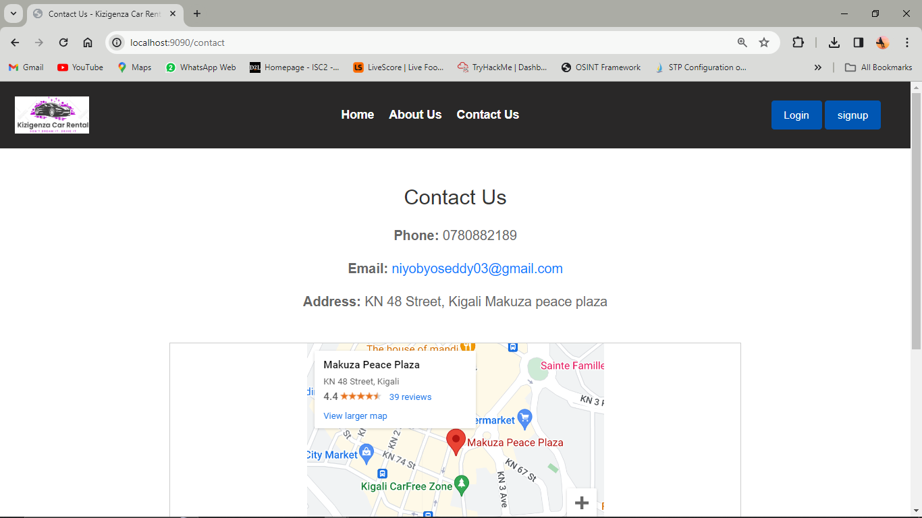

**Technologies Used**

* **Backend:** IntelliJ IDEA
* **Frontend**: Html, CSS and JavaScript
* **Database:** PostgreSQL for storing car details, user information, and bookings.

**DATABASE Schema**

