SIGCHI Extended Abstracts Sample   
File: Note Initial Caps

Permission to make digital or hard copies of part or all of this work for personal or classroom use is granted without fee provided that copies are not made or distributed for profit or commercial advantage and that copies bear this notice and the full citation on the first page. Copyrights for third-party components of this work must be honored. For all other uses, contact the owner/author(s).

*CHI 2020 Extended Abstracts, April 25–30, 2020, Honolulu, HI, USA.*

© 2020 Copyright is held by the owner/author(s).

ACM ISBN 978-1-4503-6819-3/20/04.

DOI: https://doi.org/10.1145/3334480.XXXXXXX

*update the above block & DOI per your rightsreview confirmation (provided after acceptance)

|  |  |
| --- | --- |
| First Author  University of Author  Authortown, CA 94022, USA  author1@anotherco.edu  Second Author  VP, Authoring  Authorship Holdings, Ltd.  Awdur SA22 8PP, UK author2@author.ac.uk  Third Author  Fourth Author  Lēkhaka Interaction Labs  Bengaluru 560 080, India  author3@anotherco.com author4@hci.anotherco.com | Fifth Author  YetAnotherCo, Inc.  Authorton, BC V6M 22P Canada  author5@yetanotherco.ca  Sixth Author  Université de Auteur-Sud  40222 Auteur, France  author6@author.fr  Seventh Author  Department of Skrywer,  University of Umbhali,  Cape Town, South Africa author7@umbhaliu.ac.za |

# Abstract

This sample paper describes the formatting requirements for SIGCHI Extended Abstract Format, and this sample file offers recommendations on writing for the worldwide SIGCHI readership. Please review this document even if you have submitted to SIGCHI conferences before, as some format details have changed relative to previous years. Abstracts should be about 150 words and are required.

# Author Keywords

Authors’ choice; of terms; separated; by semicolons; include commas, within terms only; required.

# CSS Concepts

• **Human-centered computing~Human computer interaction (HCI)**; *Haptic devices*; User studies; Please use the 2012 Classifiers and see this link to embed them in the text: <https://dl.acm.org/ccs/ccs_flat.cfm>

# Introduction

This format is to be used for submissions that are published in the conference publications. We wish to give this volume a consistent, high-quality appearance. We therefore ask that authors follow some simple guidelines. In essence, you should format your paper exactly like this document. The easiest way to do this is to replace the content with your own material.

# ACM Copyrights & Permission Policy

# Good Utilization of the Side Bar

**Preparation**: Do not change the text box size or position. Do copy text box to other pages. You may change the surrounding box to be visible or invisible, up to you.

**Materials:** This cannot appear higher or lower on the page because of pagination and specific headers added during the indexing and pagination process. A 0.75 inch rule is beneficial to break this apart from the body text. The text in this text box should remain the same size as the Body Text: 8.5 Verdana or Arial (with use of **bold** and *italics* to highlight points)

**Images & Figures:** Images and figures can be placed in this section. They should be captioned in the manner of other images and figures.

Accepted extended abstracts and papers will be distributed in the Conference Publications. They will also be placed in the ACM Digital Library, where they will remain accessible to thousands of researchers and practitioners worldwide. To view ACM’s copyright and permissions policy, see: <http://www.acm.org/publications/policies/copyright_policy>

# Page Size

All SIGCHI submissions should be US letter (8.5x11 inches) and not A4. US Letter is a standard option on all versions of Microsoft Word, as well as most other document preparation programs.

# Text Formatting

Please use an 8.5-point Verdana font, or other sans serifs font as close as possible in appearance to Verdana in which these guidelines have been set. (The “Normal” style for this document automatically gives you this font setting.) Arial 9-point font is a reasonable substitute for Verdana as it has a similar x-height. Please use serif or non-proportional fonts only for special purposes, such as distinguishing source code text.

## Text styles

The template uses MS Word text styles to facilitate text formatting, and we highly recommend you use these Styles instead of manually applying formatting. The applicable text styles are:

* Normal—for body text. Don’t use “Default Paragraph Font”.
* Heading 1, Heading 2, Heading 3
* Bullet list
* Numbered list
* Caption
* References—for bibliographic entries

Additionally, here is an example of footnoted text.[1] (The footnote is created with the “footnote…” command under the “Insert” menu in MS Word). As stated in the footnote, footnotes should rarely be used.

## Language, style, and content

The written and spoken language of SIGCHI is English. Spelling and punctuation may use any dialect of English (e.g., British, Canadian, US, etc.) provided this is done consistently. Hyphenation is optional. To ensure suitability for an international audience, please pay attention to the following:

* Write in a straightforward style. Try to avoid long sentences and complex sentence structures. Use semicolons carefully.
* Use common and basic vocabulary (e.g., use the word “unusual” rather than the word “arcane”).
* Briefly define or explain all technical terms. The terminology common to your practice/discipline may be different in other design practices/disciplines.
* Explain all acronyms the first time they are used in your text—e.g., “Digital Signal Processing (DSP)”.
* Explain local references (e.g., not everyone knows all city names in a particular country).
* Explain “insider” comments. Ensure that your whole audience understands any reference whose meaning you do not describe (e.g., do not assume that everyone has used an Android phone or a particular application).
* Explain colloquial language and puns. Understanding phrases like “red herring” requires a cultural knowledge of English. Humor and irony are difficult to translate.
* Use unambiguous forms for culturally localized concepts, such as times, dates, currencies, and numbers (e.g., “1-5- 97” or “5/1/97” may mean 5 January or 1 May, and “seven o’clock” may mean 7:00 am or 19:00). For currencies, indicate equivalences: “Participants were paid ₩22, or roughly US$29.”
* Be careful with the use of gender-specific pronouns (*he*, *she*) and other gendered words (*chairman*, *manpower*, *man-months*). Use inclusive language that is gender-neutral (e.g., *she* *or* *he*, *they*, *s/he*, *chair*, *staff*, *staff-hours*, *person-years*). See the *Guidelines for Bias-Free Writing* for further advice and examples regarding gender and other personal attributes [9]. Be particularly aware of considerations around writing about people with disabilities.
* If possible, use the full (extended) alphabetic character set for names of persons, institutions, and places (e.g., Grønbæk, Lafreniére, Sánchez, Nguyễn, Universität, Weißenbach, Züllighoven, Århus, etc.). These characters are already included in most versions and variants of Times, Helvetica, and Arial fonts.

# Figures and Tables

The examples on this and following pages should help you get a feel for how screen-shots and other figures should be placed in the template. *Be sure to make images large enough so the important details are legible and clear.* Your document may use color figures, which are included in the page limit; the figures must be usable when printed in black and white.



**Figure 1**: Insert a caption below each figure. We suggest selecting the image and then using Insert, Caption. Then if you use Insert, Cross-Reference then your Figure numbering referencing will be consistent. Make sure you use the Caption style for text formatting.

If you aren’t familiar with Word’s handling of pictures, we offer one tip: the “format picture” dialog is the key to controlling position of pictures and the flow of text around them. You access these controls by selecting your picture, then choosing “Picture…” from the “Format” menu. As for the “picture” tab in that dialog, we recommend using Photoshop, Preview, or other graphics software to scale images, rather than scaling them after you have placed them in Word.

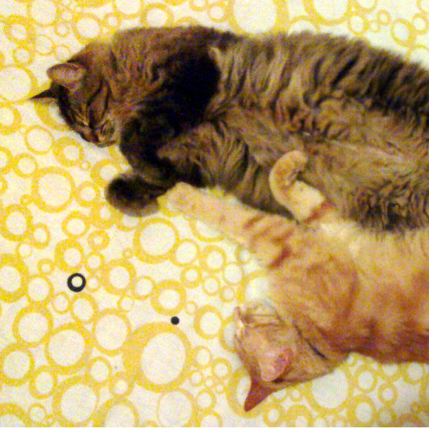

Figure : In this image, the cats are tesselated to save space. You, too, can save space by placing images in the sidebar. Images should have captions and be within the boundaries of the text box on Page 2. Photo CC-BY jofish on Flickr.

| **Objects** | **Caption –  pre-2002** | **Caption – 2003 and beyond** |
| --- | --- | --- |
| Tables | Above | Below |
| Captions | Below | Below |

**Table 1**: Tables should have the caption below. Use Table – SIGCHI style. Use 0.75 rules/borders at 75% grey for your tables, align decimals or center text in the cells. For improved accessibility, header rows of tables should be marked. In Word, right click a header row, and select Table Properties | Row | Repeat as header at the top of each page. Avoid spurious decimal points.

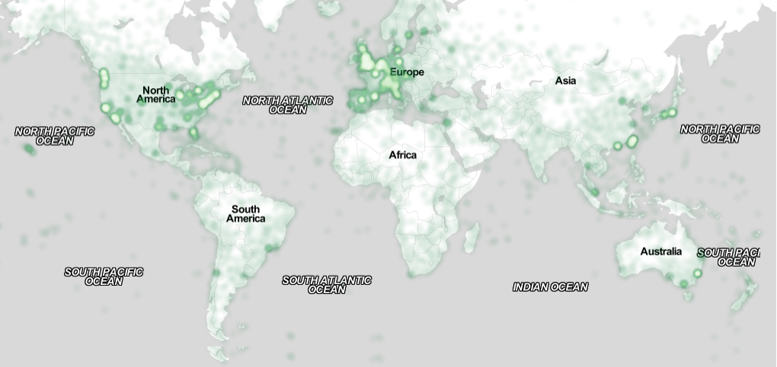

Figure : You can make figures as wide as you need, up to a maximum of the full width of both columns. To achieve this, select the figure and the caption, choose “columns” under the “Format” menu, pick the “One” (single column) icon at the top of the dialog, and make sure you are making the change only for “selected text” (at the bottom of the dialog). Image CC-BY-ND ayman on Flickr

Page 5 shows a treatment of large figures, too big to fit inside a single column of text. All figures should include alt text (figure description) for improved accessibility – see next.

# Accessibility

|  | **First** | **Second** |
| --- | --- | --- |
| child | 22 | 44 |
| adult | 22 | 16 |
| Gene | 22 | 11 |
| Cliff | 34 | 22 |

Table 2: A narrow table in the margin

So long as you don’t type outside the right margin, it’s okay to put annotations over here on the right, too. Remember to use the annotation text style.

The Executive Council of SIGCHI has committed to making SIGCHI conferences more inclusive for researchers, practitioners, and educators with disabilities. As a part of this goal, all authors are expected to work on improving the accessibility of their submissions. Specifically, we encourage authors to carry out the following five steps:

1. Add alternative text (figure description) to all figures
2. Mark table headings
3. Generate a tagged PDF
4. Verify the default language
5. Set the tab order to “Use Document Structure”

For links to detailed instructions and resources, please see:

https://chi2020.acm.org/authors/papers/guide-to-an-accessible-submission/

# Producing and Testing PDF Files

We recommend that you produce a PDF version of your submission well before the final deadline.

Test your PDF file by viewing or printing it with the same software the publisher will use, Adobe Acrobat Reader Version 10, which is widely available at no cost. Note that most reviewers will use a North American/European version of Acrobat Reader, so please check your PDF accordingly.

# Acknowledgements

We thank all the volunteers, publications support, staff, and authors who wrote and provided helpful comments on previous versions of this document. As well authors 1, 2, & 3 gratefully acknowledge the grant from NSF (#1234-2222-ABC). Author 4 for example may want to acknowledge a supervisor/manager from their original employer. This whole paragraph is just for example. Some of the references cited in this paper are included for illustrative purposes only.

# References format

Your references should be published materials accessible to the public. Internal technical reports may be cited only if they are easily accessible (i.e., you provide the address for obtaining the report within your citation) and may be obtained by any reader for a nominal fee. Proprietary information may not be cited. Private communications should be acknowledged in the main text, not referenced (e.g., “[Golovchinsky, personal communication]”).

User a numbered list of references at the end of the article, ordered alphabetically by first last name of first author. References must be the same font size as other body text. References should be in alphabetical order by last name of first author. Format your references like the examples in this document. Example reference formatting for individual journal articles 3, an entire journal special issue 6, websites 14, tweets 1, patents 5, articles in conference proceedings 7, videos 8, books 9, theses 10 and book chapters 11 is given here. This formatting is a slightly abbreviated version of the format automatically generated by the ACM Digital Library http://dl.acm.org as “ACM Ref”: the easiest method is to look the reference up in the Digital Library, click on the ACM Ref link, and cut and paste the result and edit to match the examples. More details of reference formatting are available at:

<http://acm.org/publications/submissions/latex_style>

Note that the hyperlink style used throughout this document uses blue links; however, URLs that appear in the references section may appear in black.

# References

1. @_CHINOSAUR. 2014. VENUE IS TOO COLD. #BINGO #CHI2016. Tweet. (1 May, 2014). Retrieved February 2, 2014 from https://twitter.com/_CHINOSAUR/status/461864317415989248
2. ACM. How to Classify Works Using ACM’s Computing Classification System. 2014. Retrieved August 22, 2014 from http://www.acm.org/class/how_to_use.html.
3. Ronald E. Anderson. 1992. Social impacts of computing: Codes of professional ethics. *Soc Sci Comput Rev* 10, 2: 453-469.
4. Anna Cavender, Shari Trewin, Vicki Hanson. 2014. Accessible Writing Guide. Retrieved August 22, 2014 from http://www.sigaccess.org/welcome-to-sigaccess/resources/accessible-writing-guide/
5. Morton L. Heilig. 1962. Sensorama Simulator, U.S. Patent 3,050,870, Filed January 10, 1961, issued August 28, 1962.
6. Jofish Kaye and Paul Dourish. 2014. Special issue on science fiction and ubiquitous computing. *Personal Ubiquitous Comput*. 18, 4 (April 2014), 765-766. http://dx.doi.org/10.1007/s00779-014-0773-4
7. Scott R. Klemmer, Michael Thomsen, Ethan Phelps-Goodman, Robert Lee, and James A. Landay. 2002. Where do web sites come from?: capturing and interacting with design history. In *Proceedings of the SIGCHI Conference on Human Factors in Computing Systems* (CHI '02), 1-8. http://doi.acm.org/10.1145/503376.503378
8. Psy. 2012. Gangnam Style. Video. (15 July 2012.). Retrieved August 22, 2014 from https://www.youtube.com/watch?v=9bZkp7q19f0
9. Marilyn Schwartz. 1995. *Guidelines for Bias-Free Writing.* Indiana University Press, Bloomington, IN.
10. Ivan E. Sutherland. 1963. *Sketchpad, a Man-Machine Graphical Communication System*. Ph.D Dissertation. Massachusetts Institute of Technology (MIT), Cambridge, MA.
11. Langdon Winner. 1999. Do artifacts have politics? In The Social Shaping of Technology (2nd. ed.), Donald MacKenzie and Judy Wajcman (Eds.). Open University Press, Buckingham, UK, 28-40.

1. Use footnotes sparingly, if at all.