https://rws7-dev-ed.lightning.force.com/lightning/setup/NavigationMenus/home
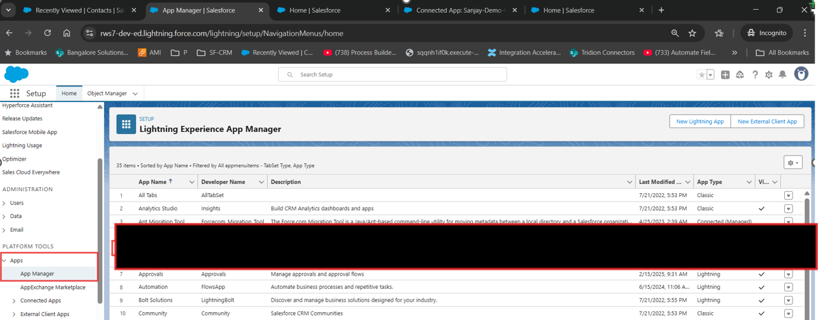

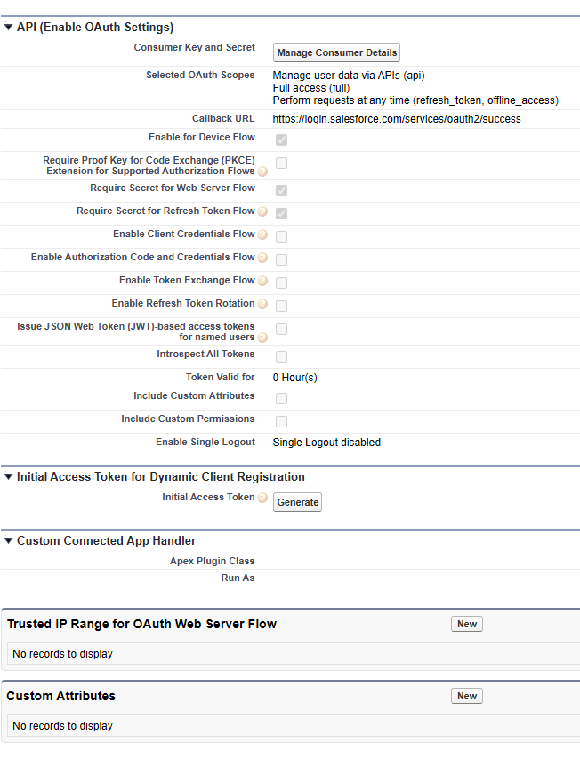
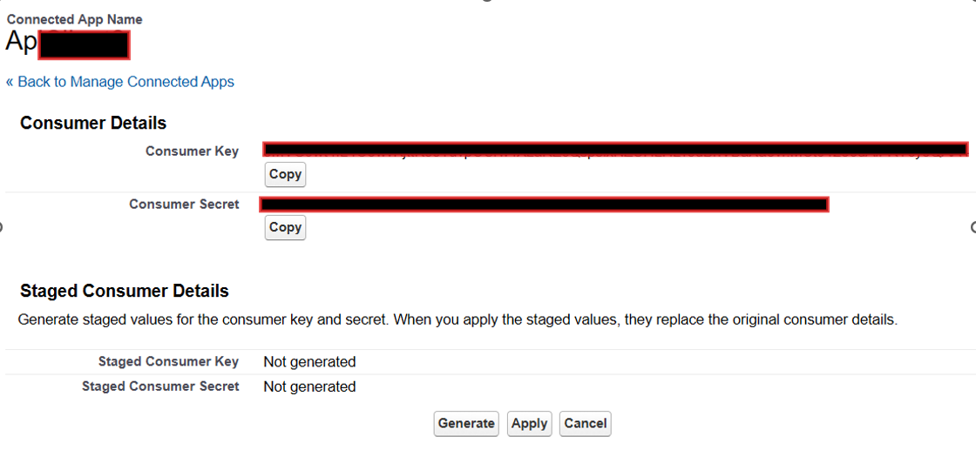

https://rws7-dev-ed.my.salesforce.com/p/setup/custent/CustomObjectsPage?setupid=CustomObjects&retURL=%2Fui%2Fsetup%2FSetup%3Fsetupid%3DDevTools
Create Object in the object manager
Visitor Tracking
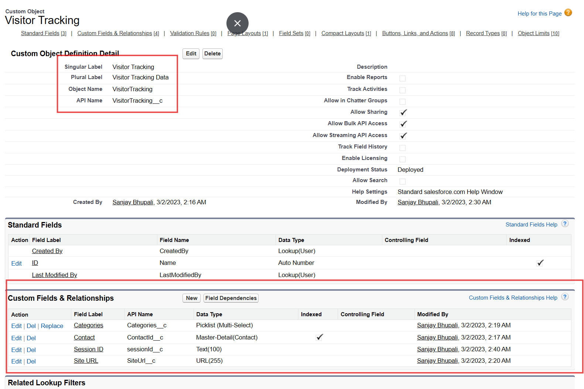
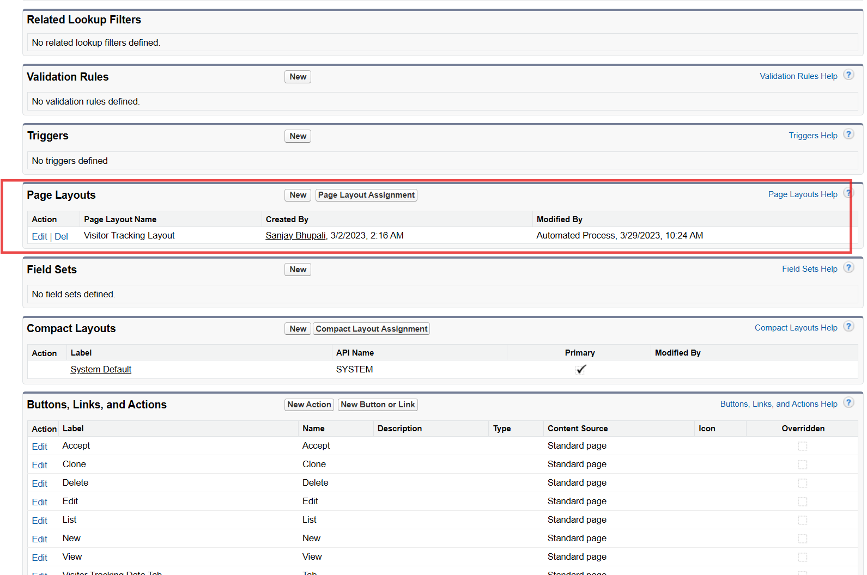
Visitor Tracking Layout
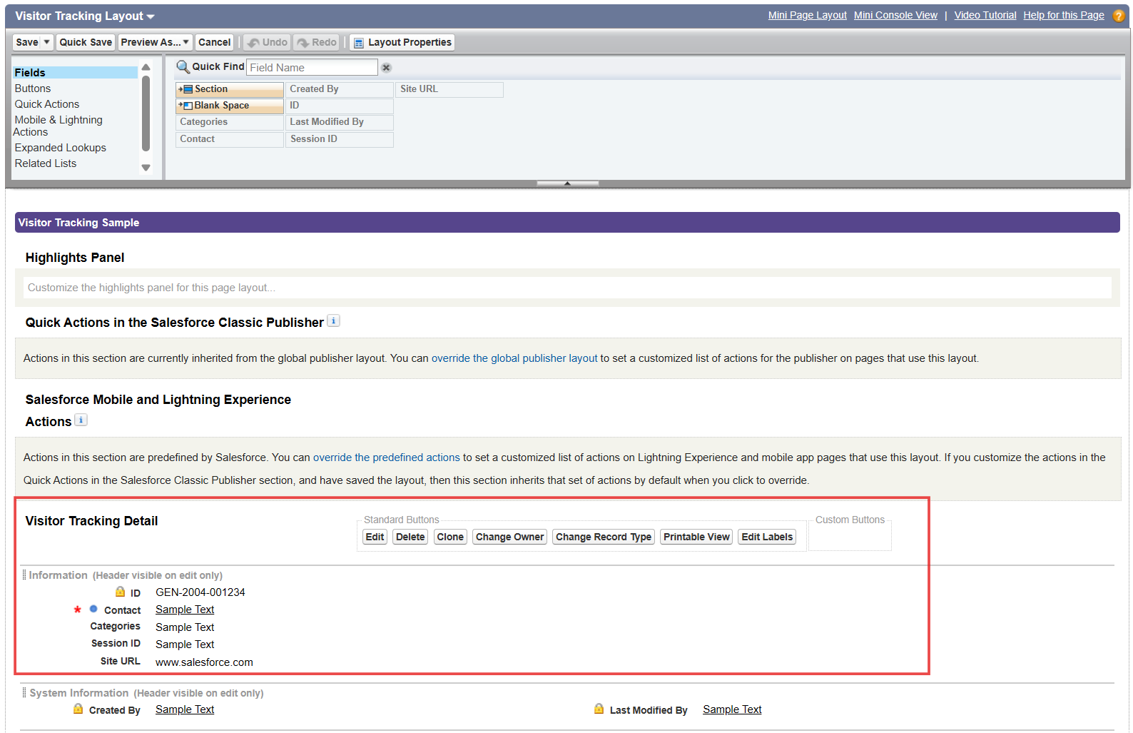

Categories
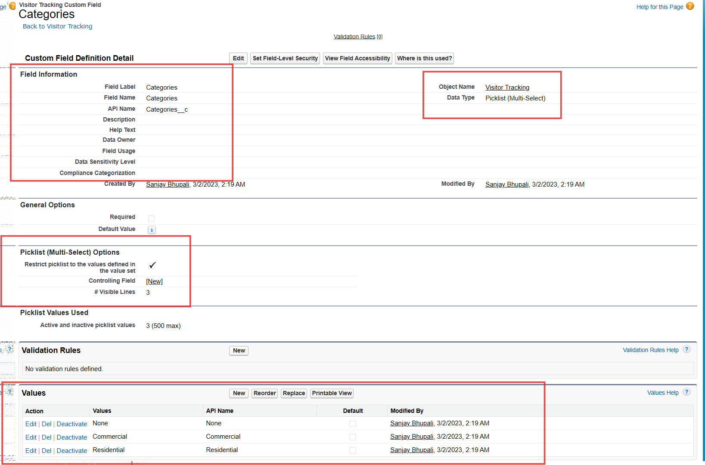

Contact
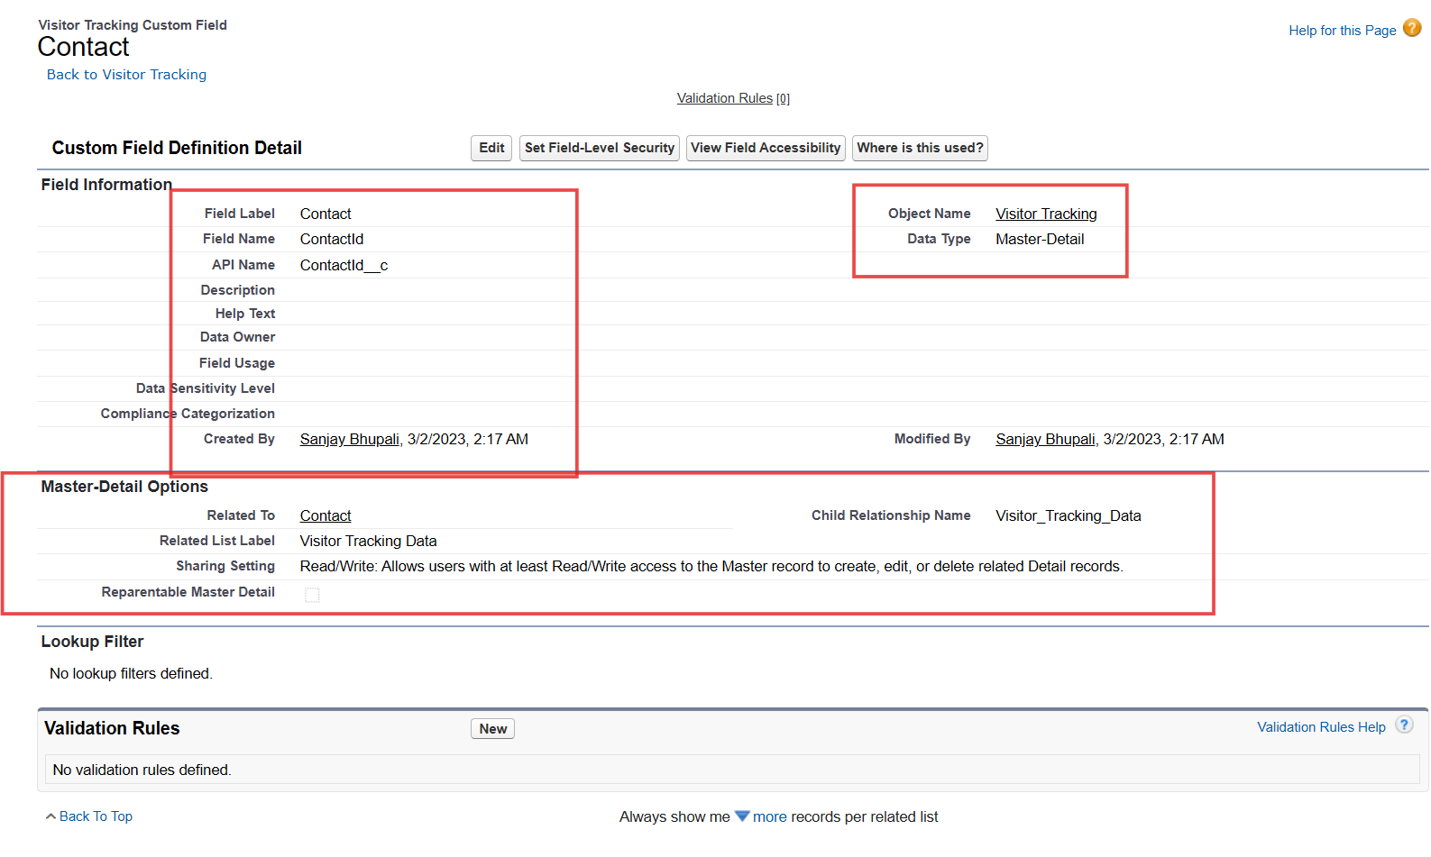

Contact fields
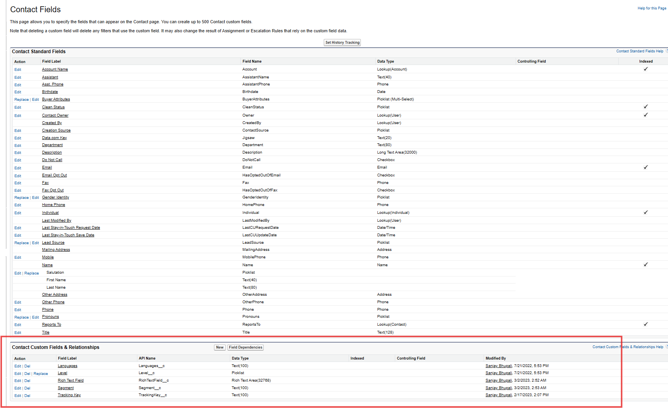

Contact form – Custom fields
Language
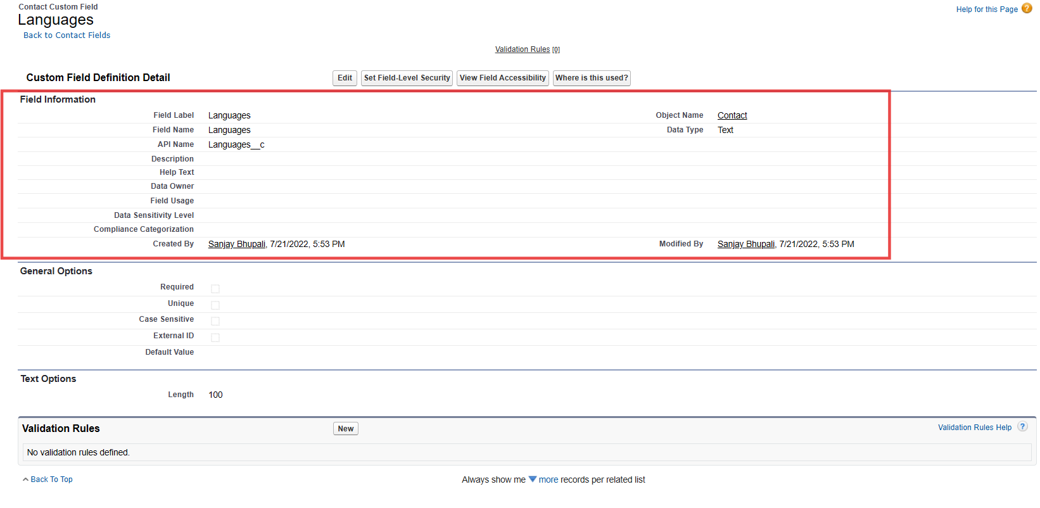
Segment
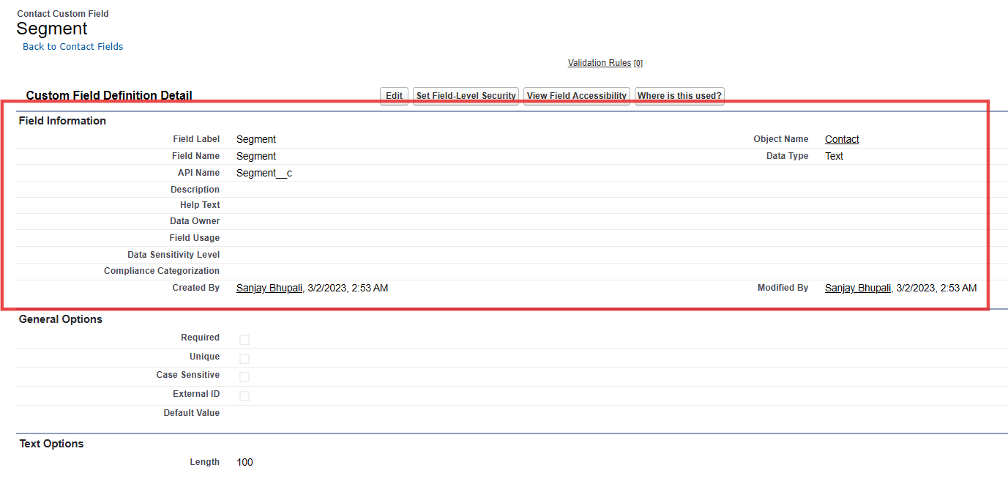

Tracking Key
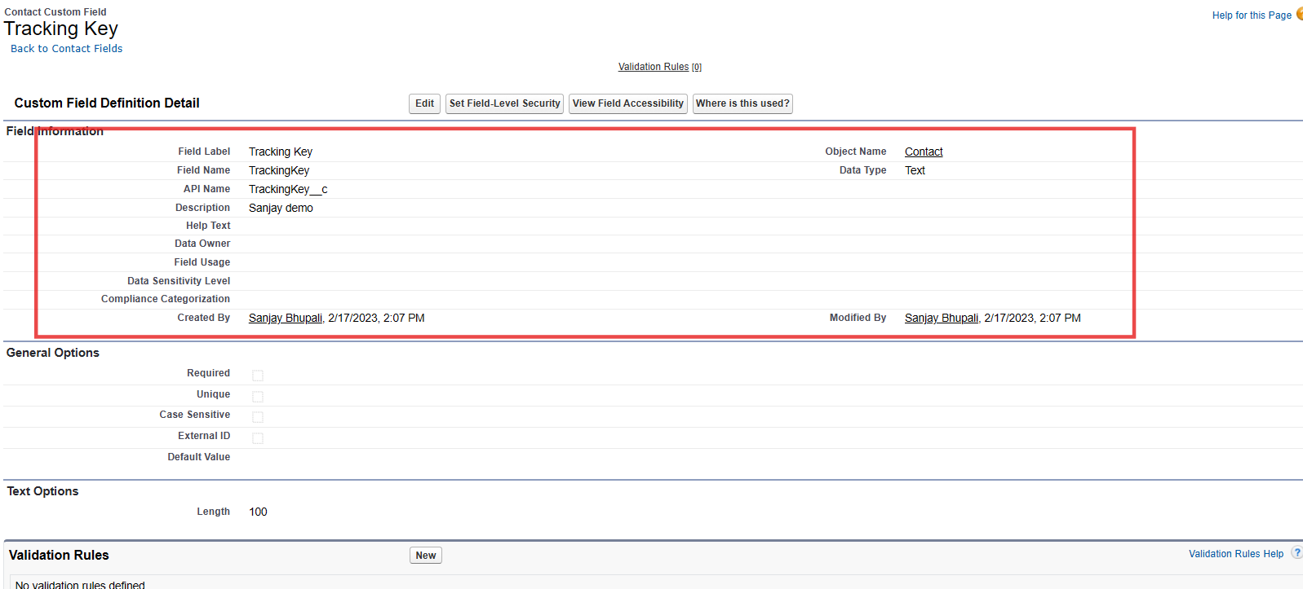
Rich Text Field
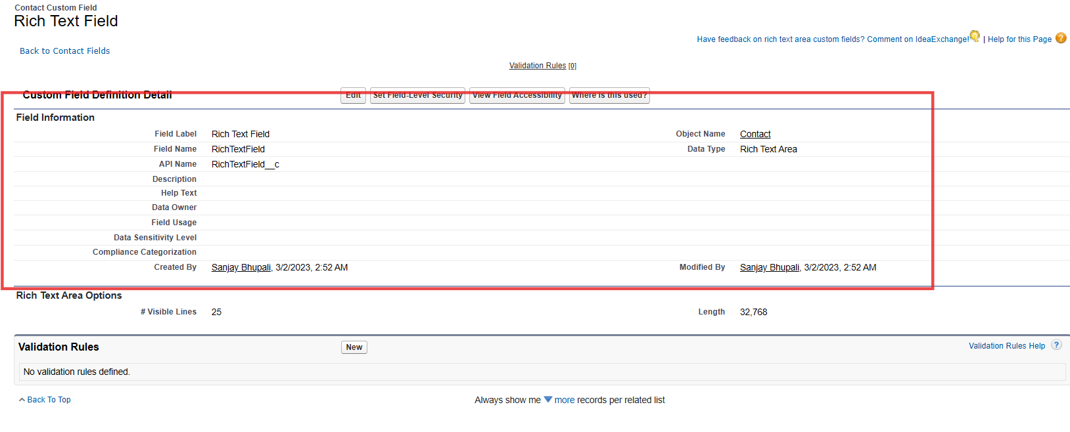

Contact Page Layouts
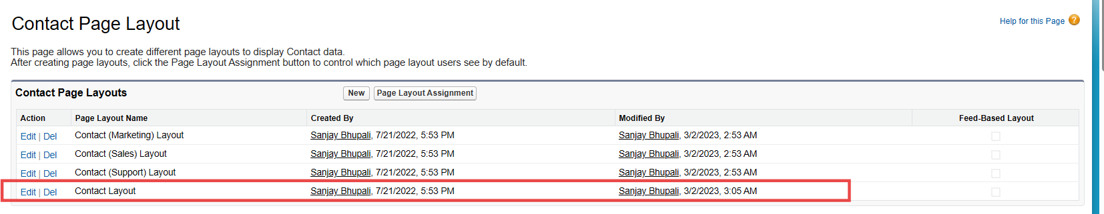
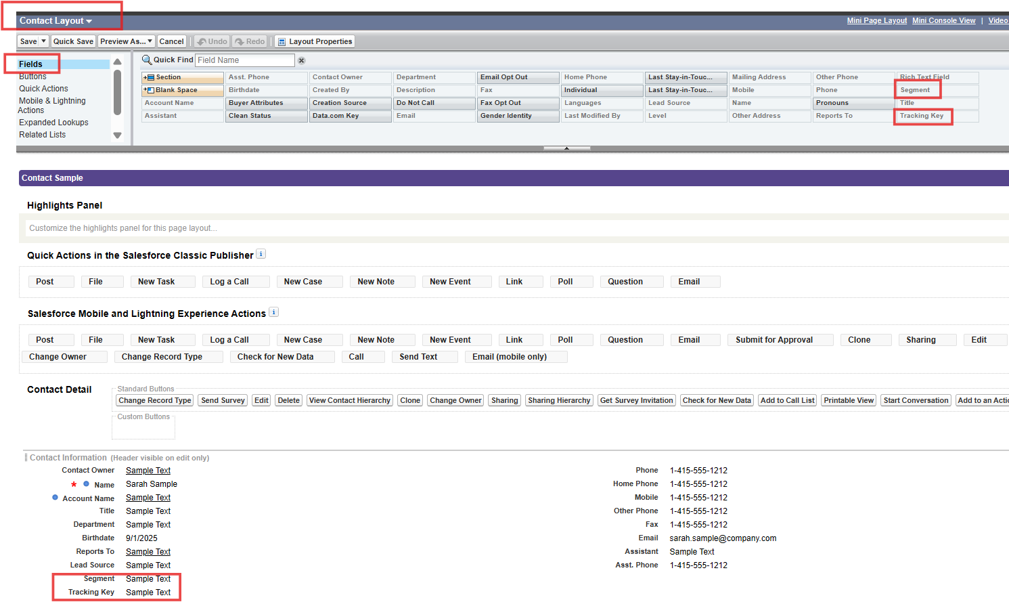
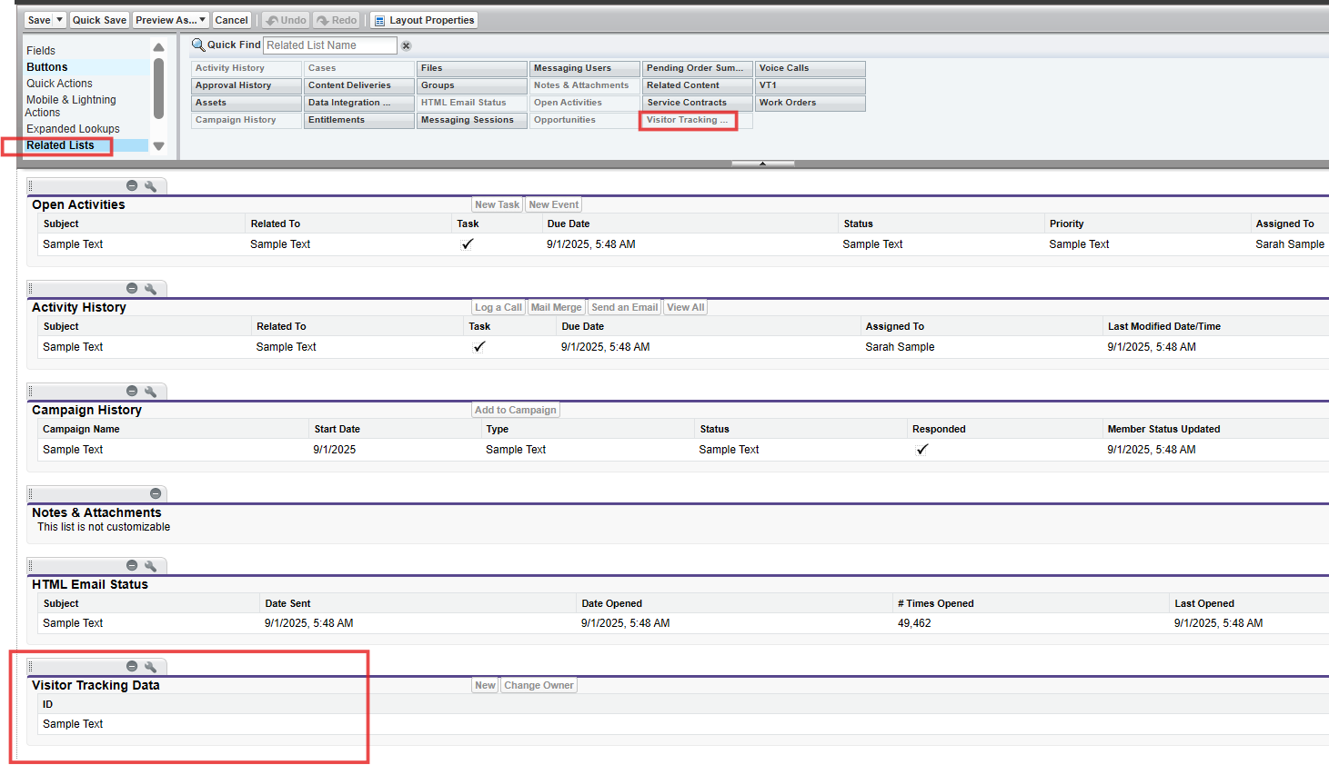

Process Builder
https://rws7-dev-ed.lightning.force.com/lightning/setup/ProcessAutomation/home
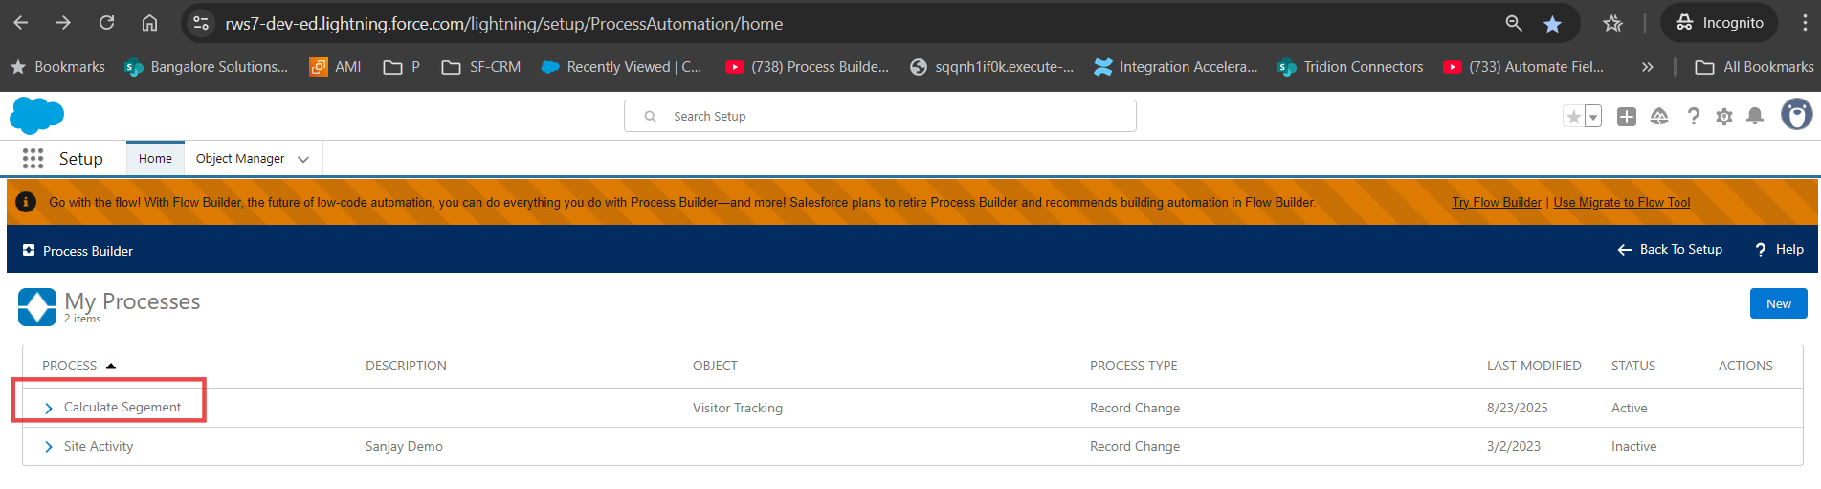

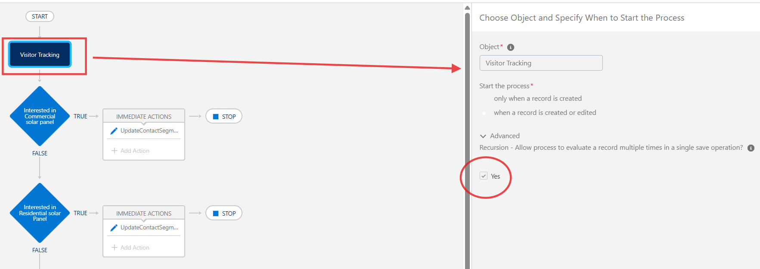

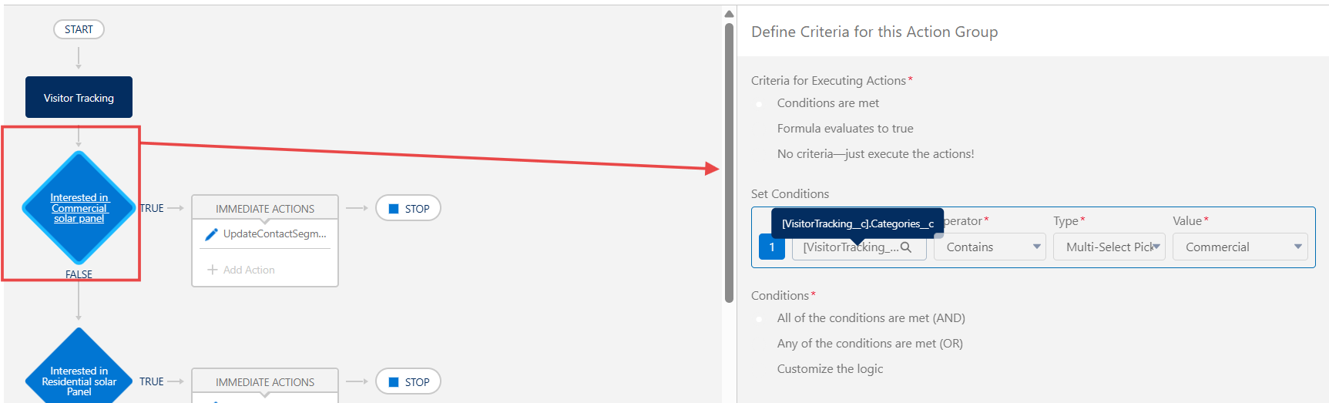

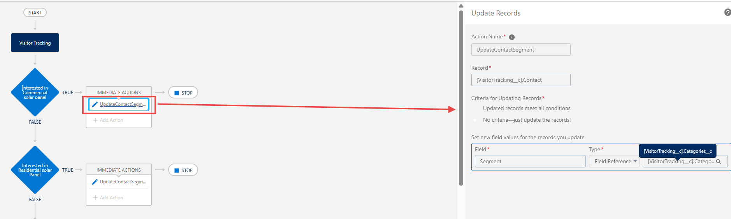

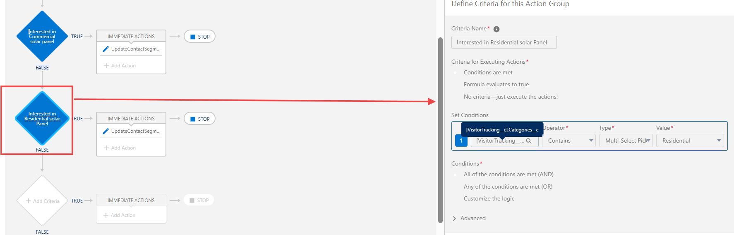
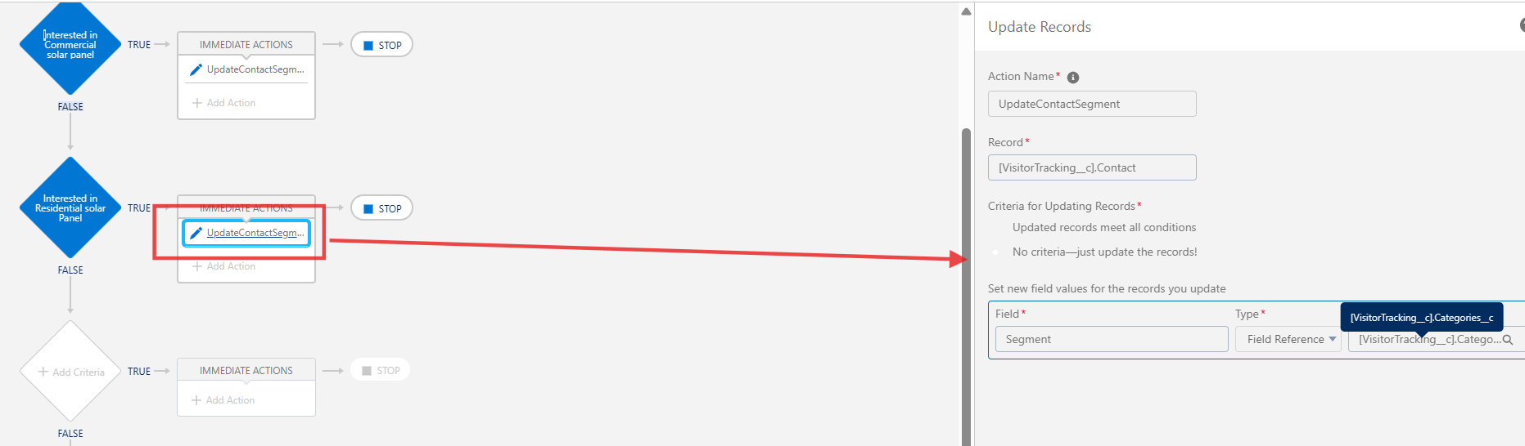
Final workflow
