User Guide

SDL XLIFF Split/Merge Application  
2010

Contents

1. Introduction 3

2. About the SDL XLIFF Split/Merge Application 3

3. Technical Requirements 3

4. Installation Instructions 4

5. Usage instructions 4

5.1. Performing Split of SDL XLIFF Files 4

5.2. Working with Split Files 9

5.3. Performing Merge of SDL XLIFF Files 9

# Introduction

Tool for performing split operation of large SDL XLIFF files and merge operation of split files with the intention of having different people work on different parts of the file in parallel.

# About the SDL XLIFF Split/Merge Application

SDL XLIFF Split/Merge Application allows users to perform split of large SDL XLIFF files and merge split files into a single SDL XLIFF file.

A user can add an SDL XLIFF file for split or load files from Trados Studio projects. The tool allows to split one or more files simultaneously. All the files added for split have to be pre-processed in Trados Studio 2009. The split operation can be performed according to any of these three criteria: split by word count, split into any number of equal parts, or split into any number of parts after the specified segment numbers. For the first two criteria the user can also indicate file segment statuses in order to exclude all segments with these statuses from the word-count, and specify a maximum translation correspondence score (percent) in order to include segments with this score in the word-count. The application produces a number of split files and a Split Info file[1]. The user can redistribute the split files among translators to process separately in Trados Studio 2009.

**Note:** There are some usage restrictions for split files. Please refer to the section for details.

The tool allows to merge the processed/modified split files. Only files split by SDL XLIFF Split/Merge application can be merged back into a single file. To perform the merge, the user will have to put all the split files to the same directory, and indicate the path to the original SDL XLIFF file[2] and the Split Info file. After the merge operation finishes, the original SDL XLIFF file will be replaced with the merged file[3].

Please refer to the section for detailed instructions about how to use the tool.

# Technical Requirements

The user must have SDL Trados Studio 2009 SP3 installed to use this tool.

This tool requires SDL XLIFF files to be pre-processed in SDL Trados Studio 2009 SP2 or SP3. The use of this tool with SDL XLIFF files produced in earlier versions of SDL Trados Studio was not tested.

# Installation Instructions

To install the Split/Merge Application, use the following file:

SDLXLIFFSplit.msi

After the installation process is successfully completed, you can start the application from Start -> All Programs -> SDL -> OpenExchange Apps -> SDL XLIFF Split and Merge.

To uninstall the Split/Merge Application, use Add or Remove Programs from Start -> Control Panel. In the Currently Installed Programs dialog box, click on “SDL XLIFF Split and Merge” and click the “Remove” button.

# Usage instructions

## Performing Split of SDL XLIFF Files

To perform a split, you must have an SDL XLIFF file that was pre-processed in SDL Trados Studio 2009 SP2 or SP3. You must also have the SDL XLIFF Split/Merge Application installed.

1. Start the tool by running SplitSDLXLIFF.exe.
2. Select the “Split SDL XLIFF files” task and click “Next”:

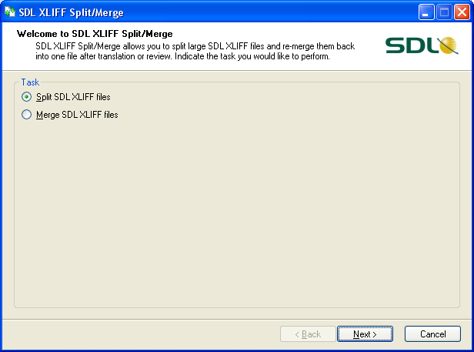

1. Add the SDL XLIFF file(s) you want to split (from the target-language folder of your Studio project structure) and indicate the target folder where the split files should be created. Click “Next”:

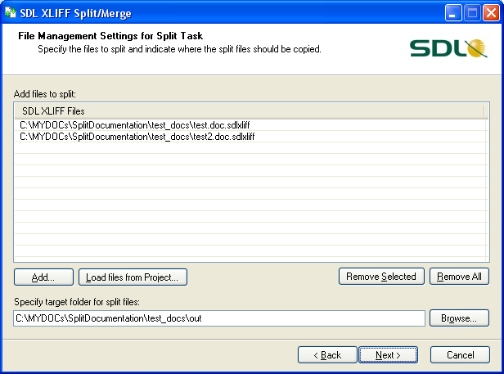

To specify the files which should be split, you can Drag & Drop the SDL XLIFF files into the view or use the “Add” button.

The tool also allows you to specify a SDL Trados Studio 2009 project file (*.sdlproj). In this case all SDL XLIFF files from all target languages of the project will be added to the view.

**Note:** Merged Trados Studio files cannot be processed in the Split/Merge Application. Please, use the original files from which you created the merged file.

1. Specify the rules of how the files should be split – Split Options (you can use the default options):

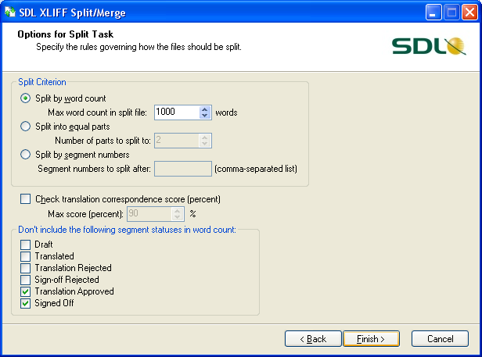

You can change the split options:

* Split Criterion – the rule that determines how to split the file. One of the following can be selected:

1. Split by words count. Indicate the maximum number of words that the split files should contain (any value from 100 to 10000);
2. Split into equal parts. Indicate the number of equal parts into which the file should be split (any value from 2 to 100);
3. Split by segment numbers. Indicate the number(s) of the segment(s) after which the split should be performed (comma-separated list of segment ids).

* Maximum translation correspondence score of segments for word-count (optional). Segments with a higher score will not be included in the total word-count (for Split by words count and Split into equal parts criteria only).
* Non-countable segments. Non-countable segments will not be included in the total word-count (for Split by words count and Split into equal parts criteria only).

1. Once the split options are defined, click the “Finish” button.

The tool will generate split files folder(s) in the Target Folder containing the split files (*.sdlxliff), and one Split Info file (*.splitinfo) in each folder. The name of each folder is the name of the SDL XLIFF file and has the ending “.splits”. It contains the split files generated from that file.

The structure of folders/files produced from files ***test.doc.sdlxliff*** and ***test2.doc.sdlxliff*** by the application split operation looks like this:

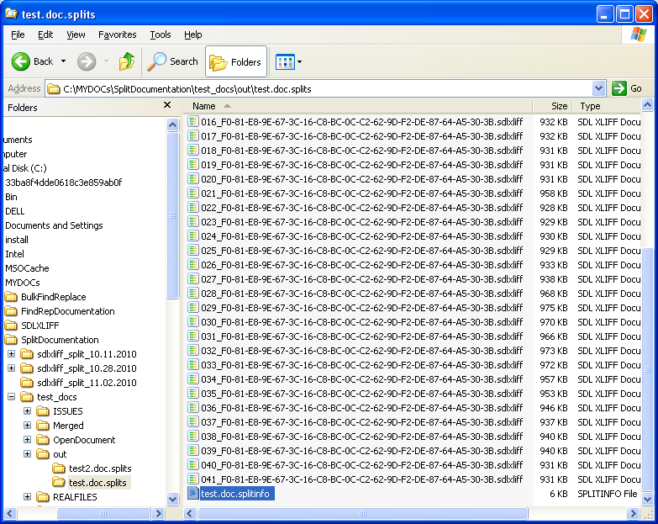

The split files can be added to a new project, or sent to the translators separately, and edited separately in SDL Trados Studio 2009.

**Note:** After the split operation has finished, the split report will be displayed in report window. In some cases operation warnings may be displayed in the report window to notify about errors or deviations from the expected results.

1. When the “Split into equal parts” option is selected under Split Criterion and the input file is too small, or the number of split parts too high, you get the following warning:

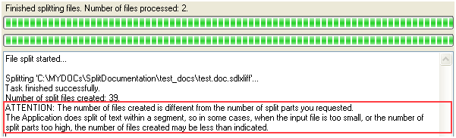

To avoid the files-number mismatch warning, please do not use the “Split into equal parts” option to split very small files into a large number of parts. If you need to create a large number of split files from the original file, use the “Split by words count” option.

1. When the “Split by segment numbers” option is selected and any of the indicated segment numbers does not exist in the input file, you will get the following warning:

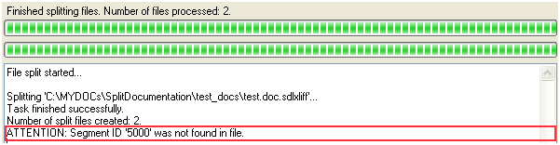

1. When the “Split by segment numbers” option is selected and the segment number indicated is not the last one in the translation unit/group, the file will be split after the last segment in the translation unit/group and you will get the following warning:

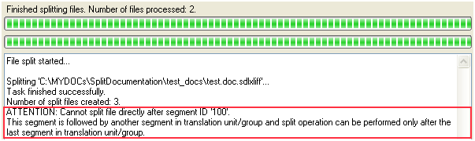

To avoid this warning, try not to split segments that are part of the same context.

If you try to split files that were not pre-processed in SDL Trados Studio 2009 SP2 or SP3, you will get the following error message:

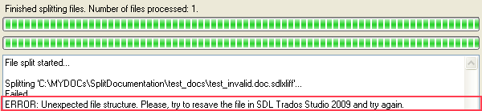

To be able to process the file in Split/Merge tool, resave the file in SDL Trados Studio 2009.

## Working with Split Files

Split files can be added to a Studio project, or opened with the “Open Document” command and processed in Trados Studio 2009.

In Trados Studio, the translator can do the following modifications to split files:

* add/edit/remove target text of segments;
* change segments statuses;
* lock/unlock segments;
* add/edit/remove selection-level, segment-level and file-level comments;
* add/edit/remove tags;
* change target text formatting.

The translator can also apply the Filters to split files, view the Confirmation Statistics, perform Find and Replace, and other search operations in source or target text.

Split files have one particular feature – they do not contain the original source document; that’s why split files have some usage restrictions. Please note that these restrictions concern split files and do not concern merged files.

The following operations that cannot be performed on split files in Trados Studio:

* the “Save Source As…”/”Save Target As…” option is not supported;
* Source/Target Preview (including preview in MS Word) is not supported;
* Some Batch Tasks, such as “Export Files” and “Generate Target Translations”, are not supported.

After editing the split files, they can be merged back into a single file.

## Performing Merge of SDL XLIFF Files

To merge the split files back, you must have the **Original SDL XLIFF file** from which the split files were created, **all the split files**, and the **Split Info file** that was generated during the split operation. You must also have the SDL XLIFF Split/Merge Application installed.

1. Start the tool by running SplitSDLXLIFF.exe.
2. Select the “Merge SDL XLIFF files” task and click “Next”:

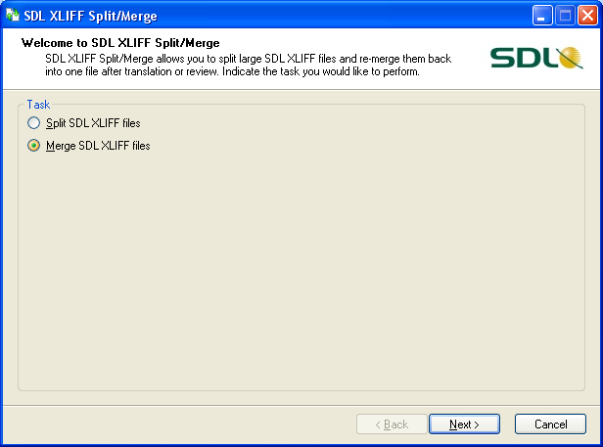

1. Specify the path to the Original SDL XLIFF File and the path to the split files folder:

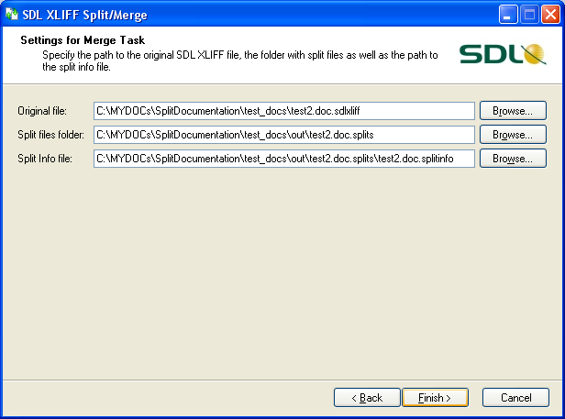

To specify file paths, you can use Drag & Drop from Windows Explorer.

After the Split files folder has been indicated, the tool will search for the Split info file automatically. If the Split info file was moved from the Split files folder, the user will have to indicate the file’s new location manually.

1. Once the merge settings have been defined, click the “Finish” button.

The tool will generate the Merged SDL XLIFF File and replace the Original SDL XLIFF file with the new one. The Original file will be saved as backup file (*.backup).

Now you have the whole file translated and merged and can deliver it to the customer.

1. Special file produced by the SDL XLIFF Split/Merge Application which has the “.splitinfo” extension. This file contains important information about the original SDL XLIFF file and is used to merge back the split files.
2. From which the SDL XLIFF file split files were created
3. SDL XLIFF file which was produced as a result of the merge operation and which contains all the content of the edited split files.