**Rural Water Supply and Sanitation System**



**BTech/III Year CSE/V Semester**

**15CSE302/Database Management Systems**

**Project Review -2**

|  |  |
| --- | --- |
| Rollno | Name |
| CB.EN.U4CSE18212 | **V. ASHWIN** |
| CB.EN.U4CSE18227 | **GUBBALA SRI RAM** |
| CB.EN.U4CSE18234 | **KOTTALA CHANDRA MOHAN REDDY** |
| CB.EN.U4CSE18266 | **VENKATASUBRAMANIAN. N** |

**Amrita School of Engineering, Coimbatore**

**Department of Computer Science and Engineering**

**2020 -2021 Odd Semester**

Table of Contents

**Chapter Title Page number**

Chapter 4 Normalization 3

Chapter 5 Creation of Tables 20

Chapter 6 User Interface Design 27

References 35

Chapter 4 Normalization

# Write out the relation including all attribute names. Provide at least 3-5 records as sample data for the relation. Write down all Functional Dependencies. and draw dependency diagram

## Initial Water_Supply_and_Sanitation Table:

**Water_Supply_and_Sanitation**(Pincode, Panchayat, District, EmpID, FName, LName, EContact, JobCode, Designation, Shift, WSID, WStatus, WCapacity, WEstimation, Month, Year, Usage, SSID, SStatus, SEstimation, FID, Persons, FHead, Consumption, FContact, TransactionID, AccountNumber, Amount, DDate, ExpenseID, EDate, EAmount)

## Functional Dependencies:

Pincode  Panchayat, District

EmpID  EContact, DOB, LName, FName, JobCode

JobCode  Designation, Shift

WSID  WEstimation, WCapacity, WStatus, Pincode

WSID, Month, Year  Usage

SSID  SEstimation, SStatus, Pincode

FID  FContact, Consumption, FHead, Persons, Pincode

TransactionID  Amount, AccountNumber, DDate

ExpenseID  EDate, EAmount, EMPID, WSID, SSID

## Dependency Diagram:

# A. Find FD closure and attribute closure B. Determine Canonical Cover C. Determine super keys D. Identify Anomalies

## Functional Dependency Closure:

{Pincode}+ = {Panchayat, District}

{Panchayat}+ = {Panchayat}

{District}+ = {District}

{EmpID}+ = {EmpID, FName, LName, EContact, JobCode, Pincode, Panchayat, District}

{FName}+ = {FName}

{LName}+ = {LName}

{EContact}+ = {EContact}

{JobCode}+ = {JobCode, Designation, Shift}

{Designation}+ = {Designation}

{Shift}+ = {Shift}

{WSID}+ = {WSID, WEstimation, WStatus, WCapacity, Pincode, Panchayat, District}

{WStatus}+ = {WStatus}

{WCapacity}+ = {WCapacity}

{WEstimation}+ = {WEstimation}

{Month}+ = {Month}

{Year}+ = {Year}

{Usage}+ = {Usage}

{WSID, Month, Year} + = {WSID, WEstimation, WCapacity, WStatus, Pincode, Panchayat,  District ,Month, Year, Usage}

 {SSID}+ = {SSID, SEstimation, SStatus, Pincode, Panchayat, District}

{SStatus}+ = {SStatus}

{SEstimation}+ = {SEstimation}

{FID}+ = {FID, FContact, Consumption, FHead, Persons, Pincode, Panchayat, District}

{Persons}+ = {Persons}

{FHead}+ = {FHead}

{Consumption}+ = {Consumption}

{FContact}+ = {FContact}

{TransactionID}+ = {TransactionID, Amount, AccountNumber, DDate, DContact}

{AccountNumber}+ = {AccountNumber}

{Amount}+ = {Amount}

{DDate}+ = {DDate}

{DContact}+ = {DContact}

{ExpenseID}+ = {ExpenseID, EDate, EAmount}

{EDate}+ = {EDate}

{EAmount}+ = {EAmount}

## Attribute Closure:

{Pincode}+ = {Pincode, Panchayat, District}

{JobCode}+ = {Designation, Shift}

{EmpID}+ = {EmpID, EContact, LName, FName, Pincode, Panchayat, District}

{WSID}+ = {WSID, WEstimation, Capacity, WStatus, Pincode, Panchayat, District}

{WSID, Month, Year} + = {WSID, WEstimation, WCapacity, WStatus, Pincode, Panchayat,  District , Month, Year, Usage}

{SSID}+ = {SSID, SEstimation, SStatus, Pincode, Panchayat, District}

{FID}+ = {FID, FContact, Consumption, FHead, Persons, Pincode, Panchayat, District}

{TransactionID}+ =  {TransactionID , Amount, AccountNumber, DDate, DContact}

{ExpenseID}+ = {ExpenseID,  EDate, EAmount, EMPID, WSID, SSID}

## Canonical Cover:

EmpID  FName

EmpID  LName

EmpID  EContact

EmpID  JobCode

EmpID  Pincode

JobCode  Designation

JobCode  Shift

WSID  WStatus

WSID  WCapacity

WSID  WEstimation

WSID  Pincode

SSID  SStatus

SSID  SEstimation

SSID  Pincode

FID  Persons

FID  FHead

FID  Consumption

FID  FContact

FID  Pincode

WSID Month Year  Usage

ExpenseID  EDate

ExpenseID  EAmount

ExpenseID  WSID

ExpenseID  EmpID

ExpenseID  SSID

ExpenseID  DContact

TransactionID  AccountNumber

TransactionID  Amount

TransactionID  DDate

Pincode  Panchayat

Pincode  District

## Superkeys:

EmpID, WSID, SSID, Pincode, Month, Year, ExpenseID, TransactionID

## Anomalies:

In Employee Table, Shift depends on Designation which is not a primary key.​

This brought in partial dependency which created creation, updation and deletion anomalies.

 ​

We resolved this by decomposing those attributes to a new Jobs Table which acted as a foreign key in the Employee Table.

# To check if the relation is in First normal form

* Each table should have a primary key.
* The values in each column of a table should be atomic.
* There should not be any repeating groups

## Conditions satisfied and violated by the relation Water_Supply_And_Sanitation_System:

1. Composite Primary Key is present.
2. There are non-atomic values present in the relation.
   1. There can be more than one EmpID, WSID and SSID mapped to one Pincode.
   2. There is a many to many relationship present here.
3. There are no repeating groups.

**Solution:**

To reduce the table into 1NF, we make the values atomic by splitting them into different tuples in the same relations.

# Identify the Partial dependencies and Decompose the table and check if it is 2NF

## Conditions for a relation to be in Second Normal Form:

* The relation must be in 1NF
* All non-key attributes are fully functionally dependent on the primary key.

## Dependencies:

Pincode  Panchayat, District

EmpID  EContact, DOB, LName, FName, JobCode

JobCode Designation, Shift

WSID  WEstimation, WCapacity, WStatus, Pincode

WSID, Month, Year Usage

SSID  SEstimation, SStatus, Pincode

FID  FContact, Consumption, FHead, Persons, Pincode

TransactionID  Amount, AccountNumber, DDate

ExpenseID  EDate, EAmount, EMPID, WSID, SSID

The partial dependencies have been normalized by decomposing the relations into the following relations.

Location - (**Pincode**, WSID, SSID, EmpID, FID, Panchayat, District)

Employee - (**EmpID**, FName, LName, EContact, JobCode, Pincode, Designation, Shift)

Water Sources - (**WSID**, WStatus, WCapacity, WEstimation, Pincode )

WaterUsage - (**WSID, Month, Year**, Usage)

Sanitation Systems - (**SSID**, SStatus, SEstimation, Pincode )

Families - (**FID**, Persons, FHead, Consumption, FContact, Pincode)

Donation - ( **TransactionID**, AccountNumber, Amount, DDate )

Expenditure - ( **ExpenseID**, EDate, EmpID, WSID, SSID, EAmount )

# Check Transitive dependencies and Decompose the table and check if it is 3NF

## Conditions for Third normal form:

* The relation must be in 2NF
* No non-key attribute should be transitively dependent on the primary key.

EmpID  EContact, DOB, LName, FName, JobCode

JobCode  Designation, Shift

The transitive dependencies have been normalized by decomposing the relations into the following relations

Employee - (**EmpID**, FName, LName, EContact, JobCode, Pincode)

Job - ( **JobCode**, Designation, Shift )

# Check if it is Lossless decomposition using chase method and Check if it is Dependency preserving

By chase method, we have found that the decompositions are lossless.

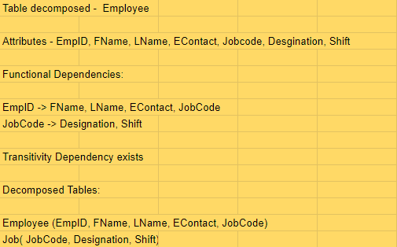

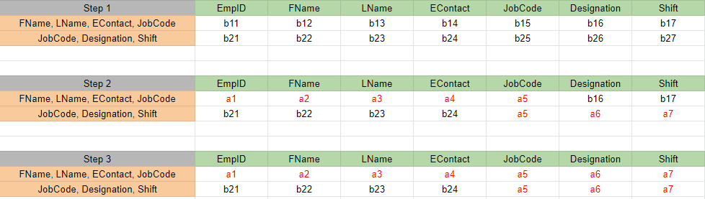

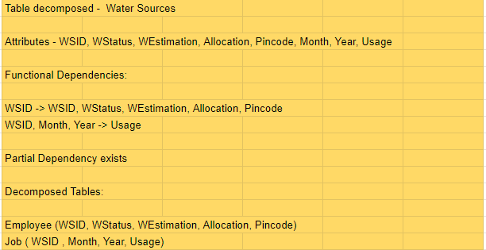

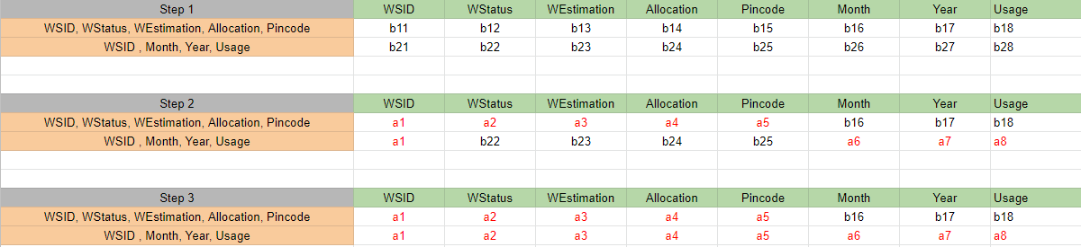

## Dependency preserving:

All the below listed dependencies have can be found in the decomposed tables as shown in the functional dependency diagram. Hence dependency is preserved.

Dependencies:

Pincode  Panchayat, District

EmpID  EContact, DOB, LName, FName, JobCode

JobCode Designation, Shift

WSID  WEstimation, WCapacity, WStatus, Pincode

WSID, Month, Year Usage

SSID  SEstimation, SStatus, Pincode

FID  FContact, Consumption, FHead, Persons, Pincode

TransactionID  Amount, AccountNumber, DDate

ExpenseID  EDate, EAmount, EMPID, WSID, SSID

## Normalize to BCNF:

All the relations after being normalized to 3NF are present in BCNF as there are no non-key attribute determining is determining a key attribute.

# Final schema with Primary keys and dependency diagram.

Location - (**Pincode**, WSID, SSID, EmpID, FID, Panchayat, District)

Employee - (**EmpID**, FName, LName, EContact, JobCode, Pincode)

Job - ( **JobCode**, Designation, Shift )

Water Sources - (**WSID**, WStatus, WCapacity, WEstimation, Pincode )

WaterUsage - ( **WSID, Month, Year**, Usage)

Sanitation Systems - (**SSID**, SStatus, SEstimation, Pincode )

Families - ( **FID**, Persons, FHead, Consumption, FContact, Pincode)

Donation - ( **TransactionID**, AccountNumber, Amount, DDate )

Expenditure - ( **ExpenseID**, EDate, EmpID, WSID, SSID, EAmount )

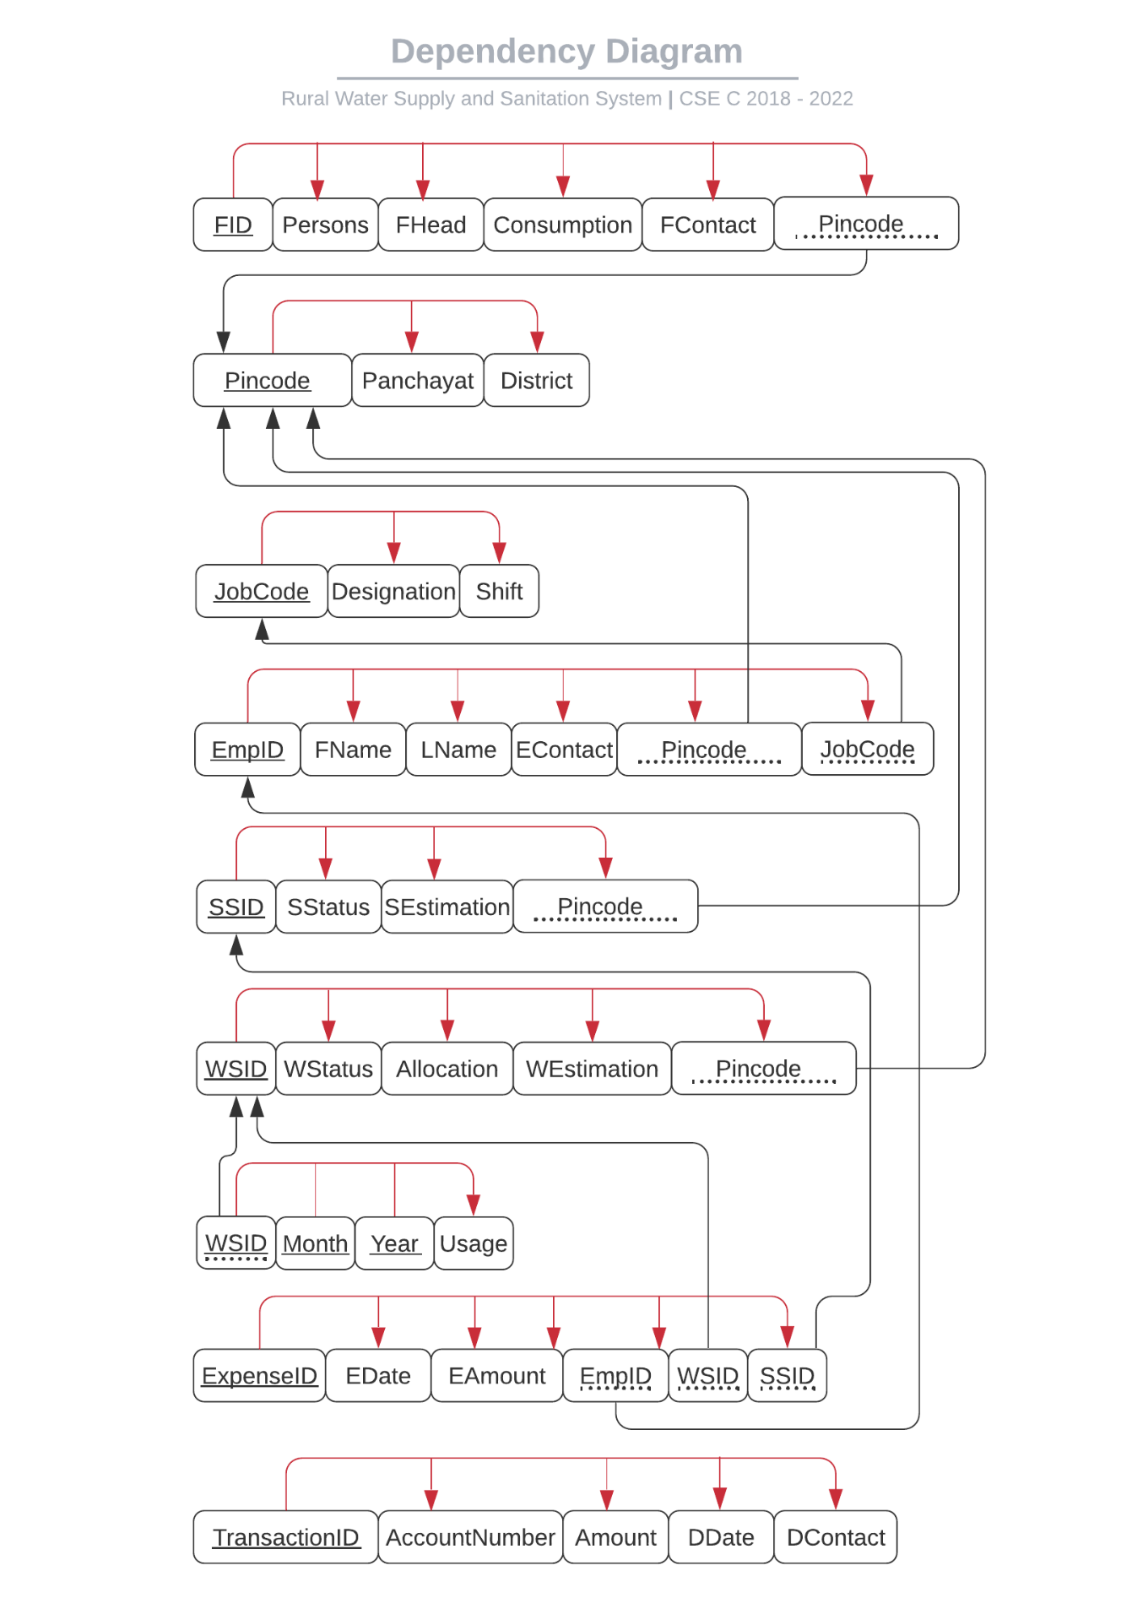

**Relations:**

## Location

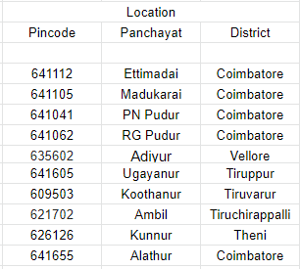

## Jobs

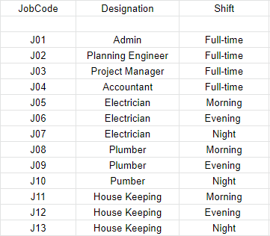

## Employee

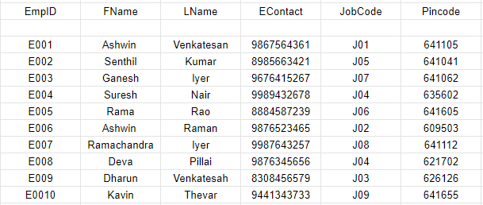

## WaterSources

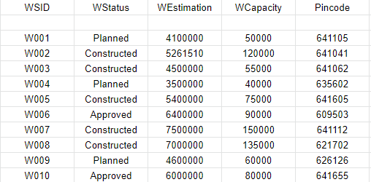

## WaterUsage

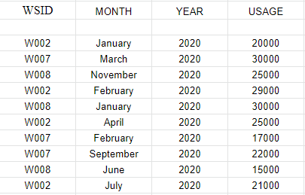

## SanitationSystems

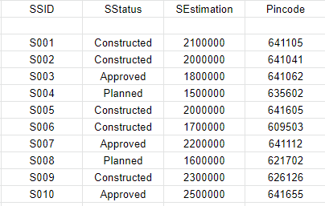

## Families

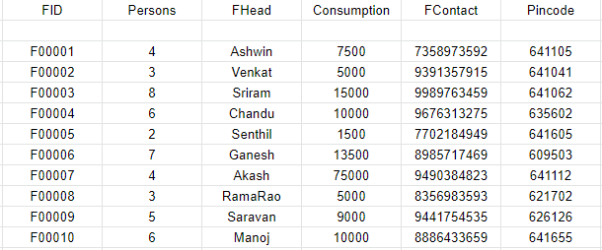

## Donations

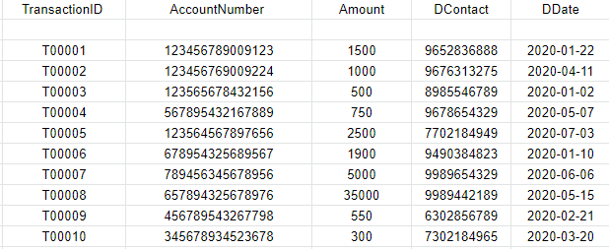

## Expenditure

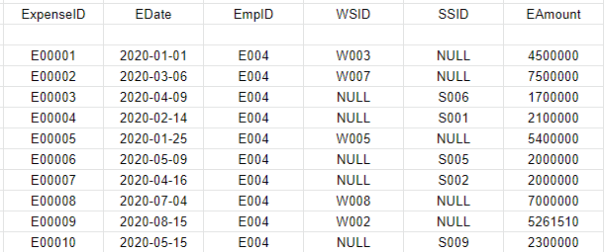

Chapter 5 Creation of Tables

# A. Include the create command for ALL THE TABLES, sample insert commands B. Minimum 10 meaningful records to be inserted C. Data from all the tables

1. **Location Table:**

create table Location

(

Pincode number(6) not null,

Panchayat varchar2(15),

District varchar2(20),

constraint pk_Pincode primary key (Pincode)

)

insert into Location values(641112,'Ettimadai','Coimbatore');

insert into Location values(641105,'Madukarai','Coimbatore');

insert into Location values(641041,'PN Pudur','Coimbatore');

insert into Location values(641062,'RG Pudur','Coimbatore');

insert into Location values(635602,'Adiyur','Vellore');

insert into Location values(641605,'Ugayanur','Tiruppur');

insert into Location values(609503,'Koothanur','Tiruppur');

insert into Location values(621702,'Ambil','Tiruchirappalli');

insert into Location values(626126,'Kunnur','Theni');

insert into Location values(641655,'Alathur','Coimbatore');

1. **Job** **Table:**

create table Job

(

JobCode varchar2(3) not null,

Designation varchar2(20),

Shift varchar2(15),

constraint pk_JobCode primary key (JobCode)

)

insert into Job values('J01','Admin','Full-time');

insert into Job values('J02','Planning Engineer','Full-time');

insert into Job values('J03','Project Manager','Full-time');

insert into Job values('J04','Accountant','Full-time');

insert into Job values('J05','Electrician','Morning');

insert into Job values('J06','Electrician','Evening');

insert into Job values('J07','Electrician','Night');

insert into Job values('J08','Plumber','Morning');

insert into Job values('J09','Plumber','Evening');

insert into Job values('J10','Pumber','Night');

insert into Job values('J11','House Keeping','Morning');

insert into Job values('J12','House Keeping','Evening');

insert into Job values('J13','House Keeping','Night');

1. **Employee Table:**

create table Employee

(

EmpID varchar2(4) not null,

FName varchar2(20),

LName varchar2(20),

EContact number(10),

JobCode varchar2(3),

Pincode number(6),

constraint pk_EmpID primary key (EmpID),

constraint fk_JobCode FOREIGN KEY(JobCode) REFERENCES Job(JobCode),

constraint fk_Pincode FOREIGN KEY(Pincode) REFERENCES Location(Pincode)

)

insert into Employee values('E001','Ashwin','Venkatesan',9867564361,'J01',641105);

insert into Employee values('E002','Senthi','kumar',8985663421,'J05',641041);

insert into Employee values('E003','Ganesh','Iyer',9676415267,'J07',641062);

insert into Employee values('E004','Suresh','Nair',9989432678,'J04',635602);

insert into Employee values('E005','Rama','Rao',8884587239,'J06',641605);

insert into Employee values('E006','Ashwin','Raman',9876523465,'J02',609503);

insert into Employee values('E007','Ramachandra','Iyer',9987643257,'J08',641112);

insert into Employee values('E008','Deva','Pillai',9876345656,'J04',621702);

insert into Employee values('E009','Dharun','Venkatesah',6308456579,'J03',626126);

insert into Employee values('E0010','Kavin','Thevar',9441343733,'J09',641655);

1. **WaterSource** **Table:**

create table WaterSource

(

WSID varchar2(4) not null,

WStatus varchar2(15),

WEstimation number(7),

WCapacity number(6),

Pincode number(6),

constraint pk_WSID primary key (WSID),

constraint fk_WPincode FOREIGN KEY(Pincode) REFERENCES Location(Pincode)

)

insert into WaterSource values('W002','Constructed',5261510,120000,641041);

insert into WaterSource values('W007','Constructed',7500000,150000,641112);

insert into WaterSource values('W008','Constructed',7000000,135000,621702);

1. **WaterUsage Table:**

create table WaterUsage

(

WSID varchar2(4) not null,

MONTH varchar2(10) not null,

YEAR number(4) not null,

USAGE number(6),

constraint pk_WSID_MONTH_YEAR primary key (WSID, MONTH, YEAR),

constraint fk_WSID FOREIGN KEY(WSID) REFERENCES WaterSource(WSID)

)

insert into WaterUsage values('W002','January',2020,20000);

insert into WaterUsage values('W007','March',2020,30000);

insert into WaterUsage values('W008','November',2020,25000);

insert into WaterUsage values('W002','February',2020,9000);

insert into WaterUsage values('W008','January',2020,30000);

insert into WaterUsage values('W002','April',2020,25000);

insert into WaterUsage values('W007','February',2020,17000);

insert into WaterUsage values('W007','September',2020,22000);

insert into WaterUsage values('W008','June',2020,15000);

insert into WaterUsage values('W002','July',2020,21000);

1. **SanitationSystems** **Table:**

create table SanitationSystems

(

SSID varchar2(4) not null,

SStatus varchar2(15),

SEstimation number(10),

Pincode number(6),

constraint pk_SSID primary key (SSID),

constraint fk_SPincode FOREIGN KEY(Pincode) REFERENCES Location(Pincode)

)

insert into SanitationSystems values('S001','Constructed',2100000,641105);

insert into SanitationSystems values('S005','Constructed',2000000,641605);

insert into SanitationSystems values('S006','Constructed',1700000,609503);

1. **Families** **Table:**

create table Families

(

FID varchar2(6) not null,

Persons number(2),

FHead varchar2(10),

Consumption number(5),

FContact number(10),

Pincode number(6),

constraint pk_FID primary key (FID),

constraint fk_FPincode FOREIGN KEY(Pincode) REFERENCES Location(Pincode)

)

insert into Families values('F00001',4,'Ashwin',7500,7358973592,641105);

insert into Families values('F00002',3,'Venkat',5000,9391357915,641041);

insert into Families values('F00003',8,'Sriram',15000,9989763459,641062);

insert into Families values('F00004',6,'Chandu',10000,9676313275,635602);

insert into Families values('F00005',2,'Senthil',1500,7702184949,641605);

insert into Families values('F00006',7,'Ganesh',13500,8985717469,609503);

insert into Families values('F00007',4,'Akash',75000,9490384823,641112);

insert into Families values('F00008',3,'RamaRao',5000,8356983593,621702);

insert into Families values('F00009',5,'Saravan',9000,9441754535,626126);

insert into Families values('F00010',6,'Manoj',10000,8886433659,641655);

1. **Donations** **Table:**

create table Donations

(

TransactionID varchar2(6) not null,

AccountNumber number(15),

Amount number(10,2),

DContact number(10),

DDate varchar2(25),

constraint pk_TransactionID primary key (TransactionID)

)

insert into Donations values('T00001',123456789009123,1500,9652836888,'2020-01-22');

insert into Donations values('T00002',123456769009224,1000,9676313275,'2020-04-11');

insert into Donations values('T00003',123565678432156,500,8985546789,'2020-01-02');

insert into Donations values('T00004',567895432167889,750,9678654329,'2020-05-07');

insert into Donations values('T00005',123564567897656,2500,7702184949,'2020-07-03');

insert into Donations values('T00006',678954325689567,1900,9490384823,'2020-01-10');

insert into Donations values('T00007',789456345678956,5000,9989654329,'2020-06-06');

insert into Donations values('T00008',657894325678976,35000,9989442189,'2020-05-15');

insert into Donations values('T00009',456789543267798,550,6302856789,'2020-02-21');

insert into Donations values('T00010',345678934523678,300,7302184965,'2020-03-20');

1. **Expenditure Table:**

create table Expenditure

(

ExpenseID varchar2(6) not null,

EDate varchar2(25),

EmpID varchar2(4),

WSID varchar2(4),

SSID varchar2(4),

EAmount number(10,2),

constraint pk_ExpenseID primary key (ExpenseID),

constraint fk_EmpID FOREIGN KEY(EmpID) REFERENCES Employee(EmpID),

constraint fk_EWSID FOREIGN KEY(WSID) REFERENCES WaterSource(WSID),

constraint fk_SSID FOREIGN KEY(SSID) REFERENCES SanitationSystems(SSID)

)

insert into Expenditure values('E00001','2020-01-01','E004','W003','NULL',15000);

insert into Expenditure values('E00002','2020-03-06','E009','W007','NULL',20000);

insert into Expenditure values('E00003','2020-04-09','E005','NULL','S006',10000);

insert into Expenditure values('E00004','2020-02-14','E001','NULL','S003',25000);

insert into Expenditure values('E00005','2020-01-25','E002','W004','NULL',5000);

insert into Expenditure values('E00006','2020-05-09','E003','NULL','S005',7500);

insert into Expenditure values('E00007','2020-04-16','E007','NULL','S002',12500);

insert into Expenditure values('E00009','2020-08-15','E004','W002','NULL',15000);

insert into Expenditure values('E00010','2020-05-15','E008','NULL','S008',12000);

Chapter 6 User Interface Design

# Location Table:

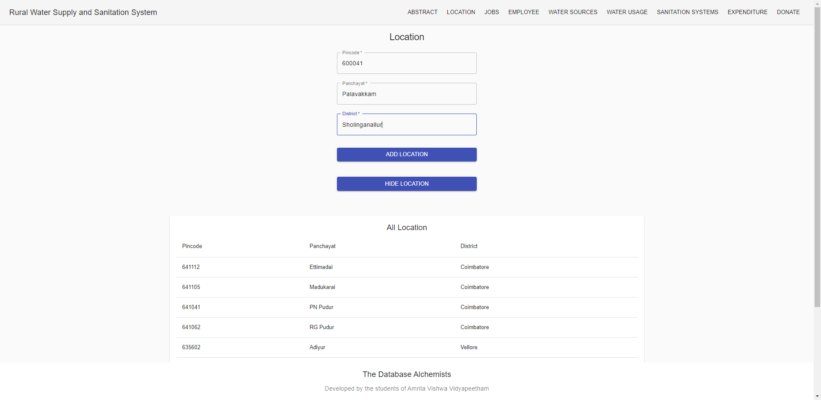

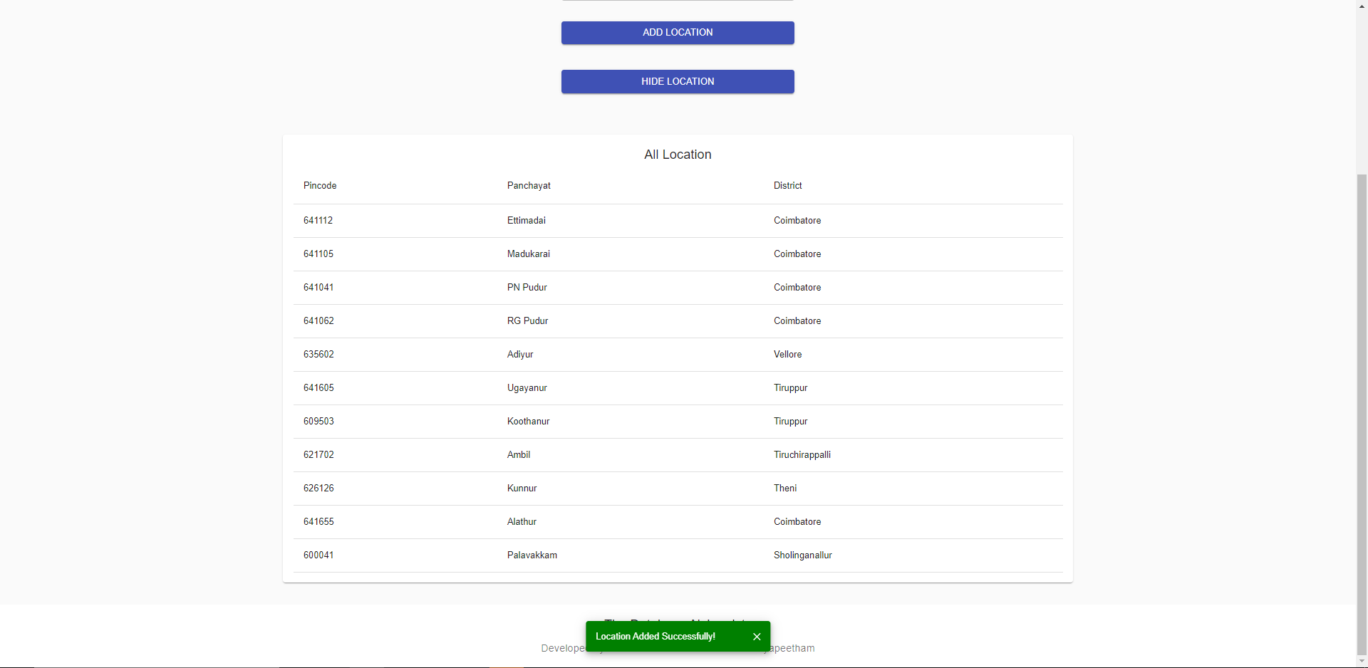

# Jobs Table:

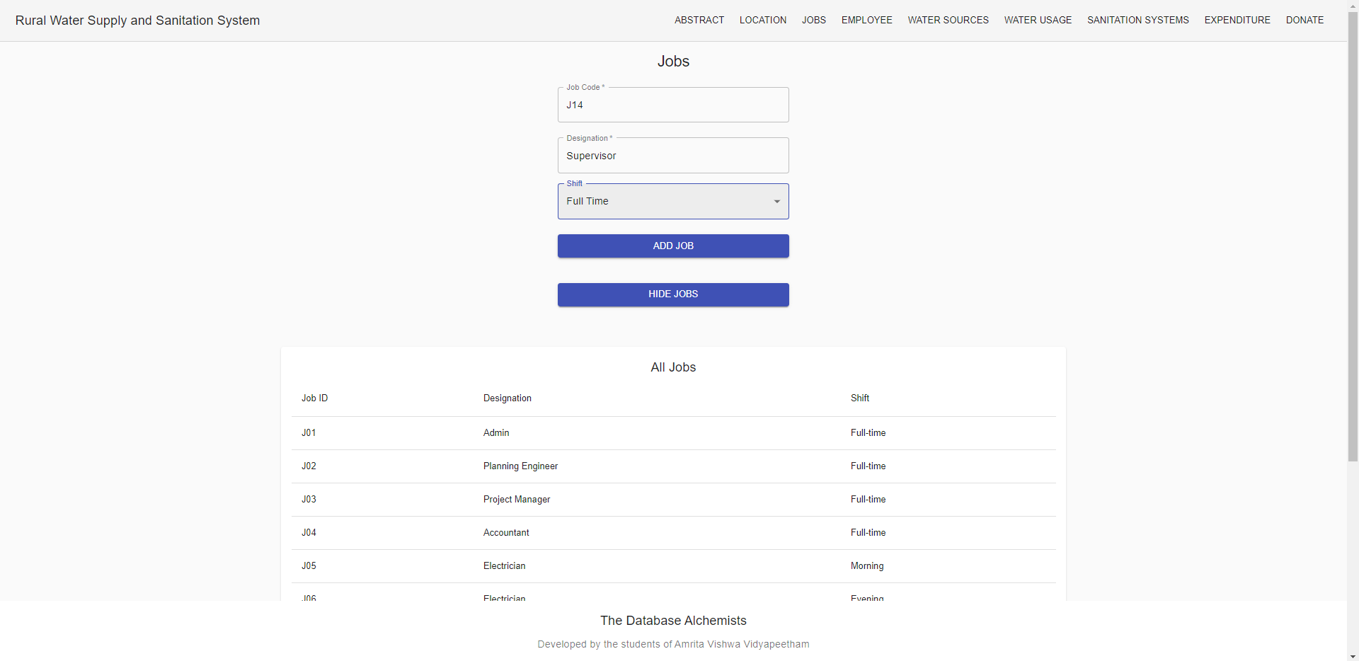

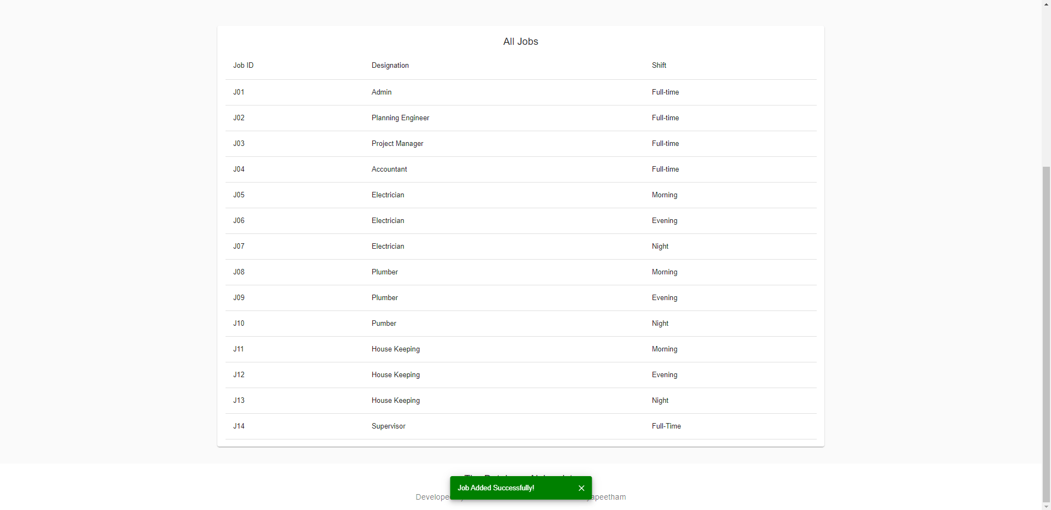

# Employee Table:

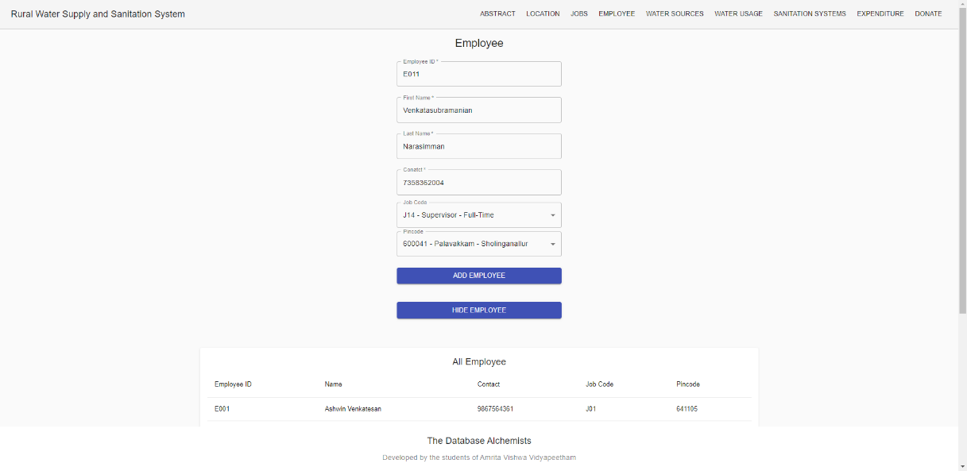

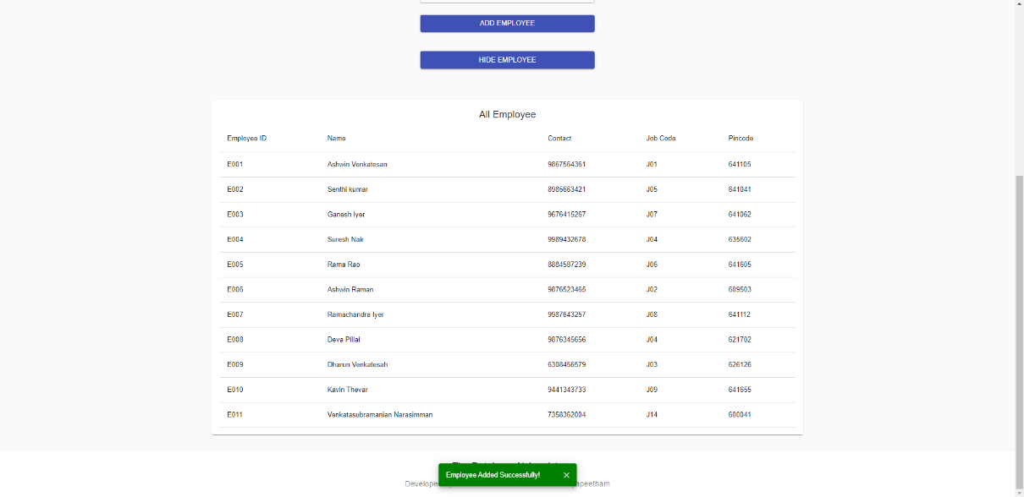

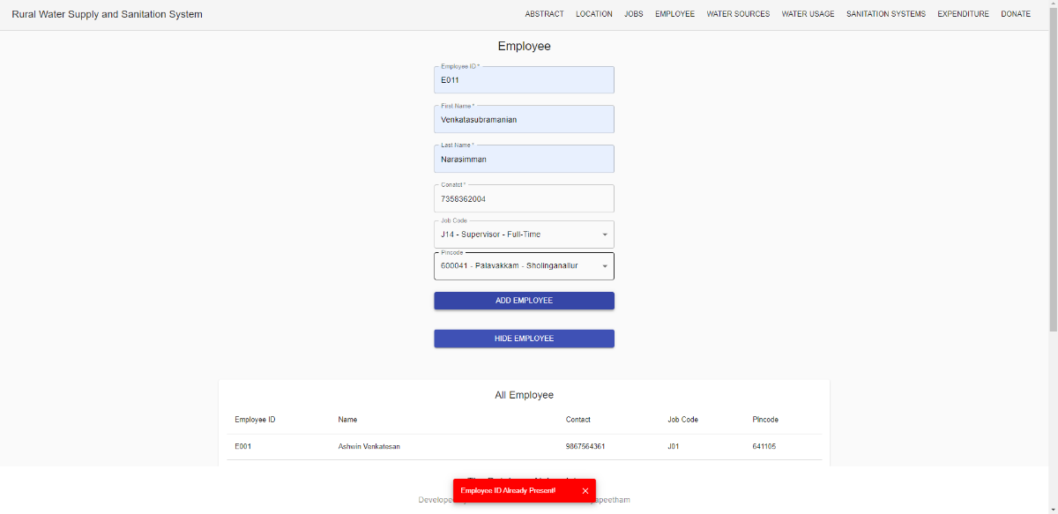

Primary Key EmpID Unique Validation!

# Water Sources Table:

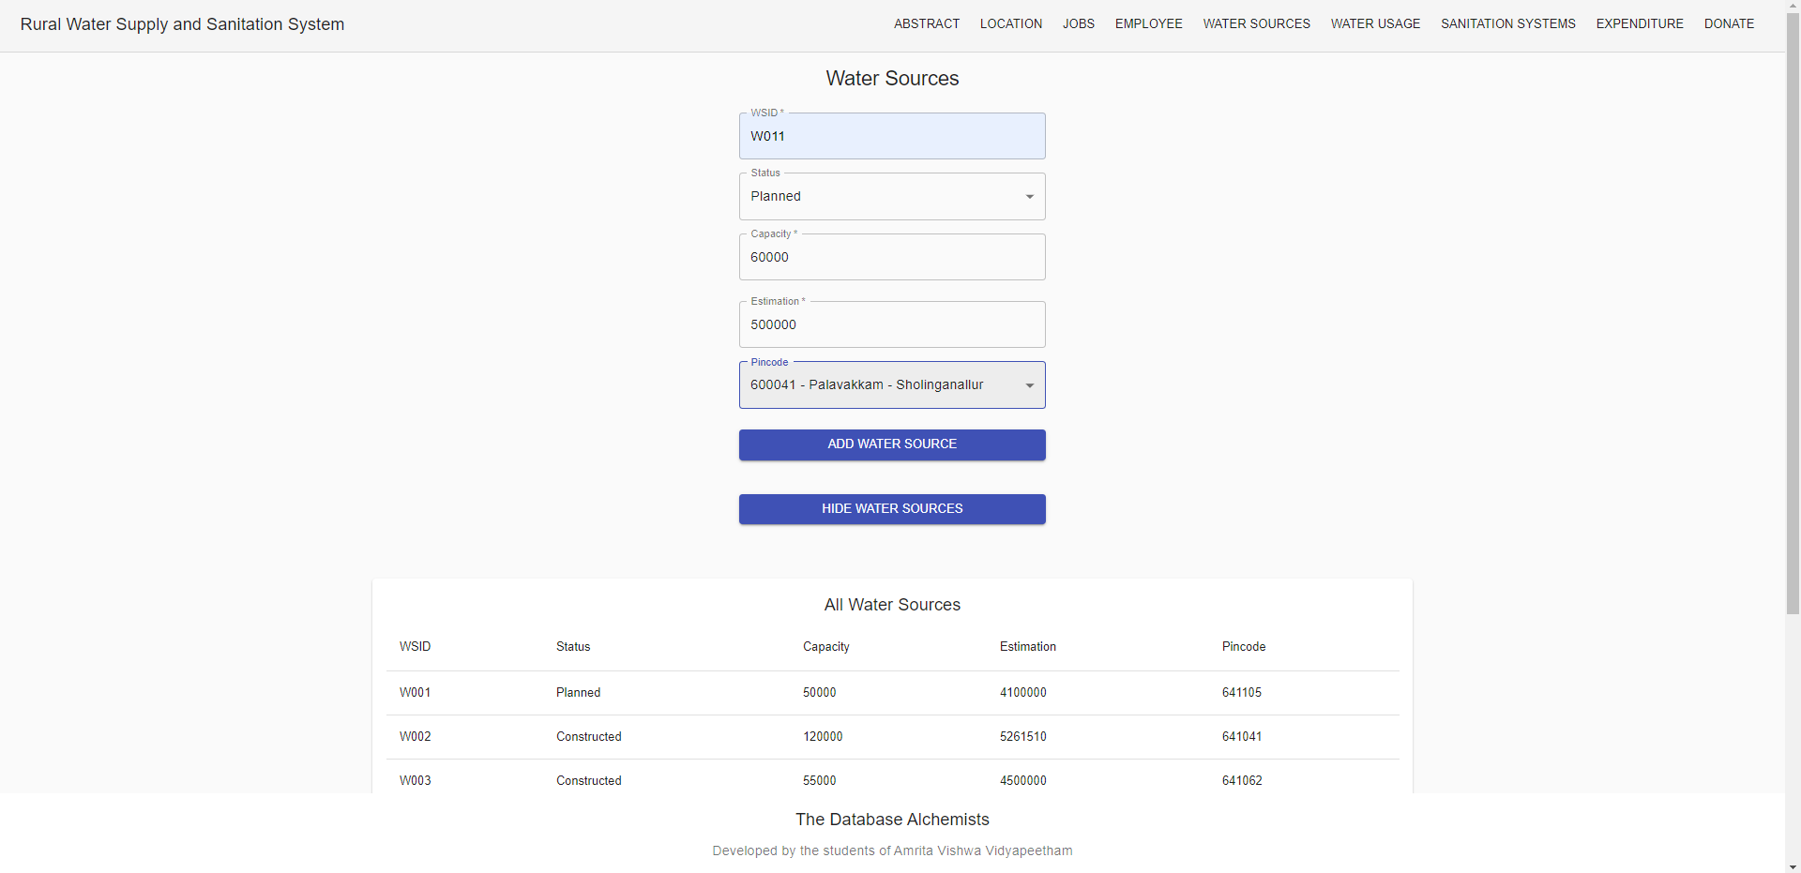

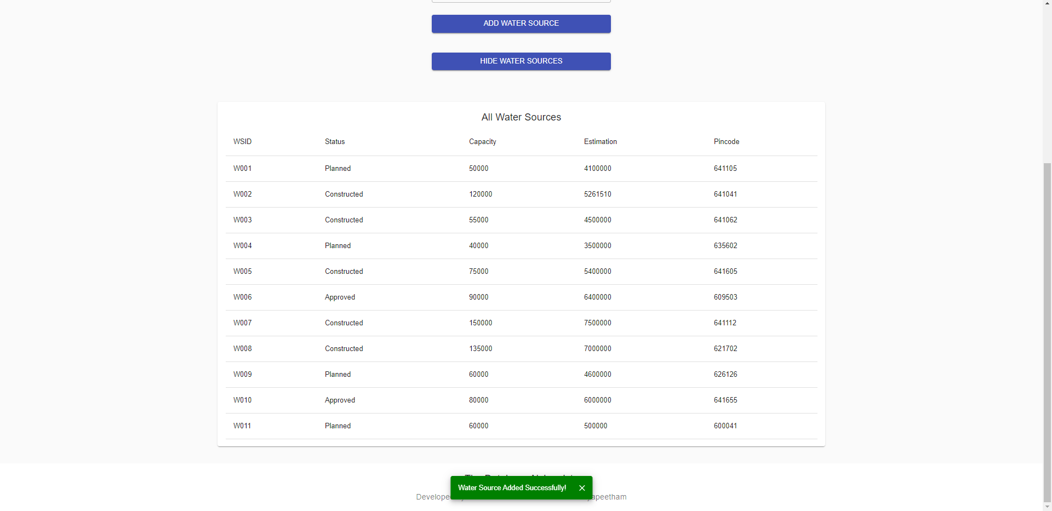

# Water Usage Table:

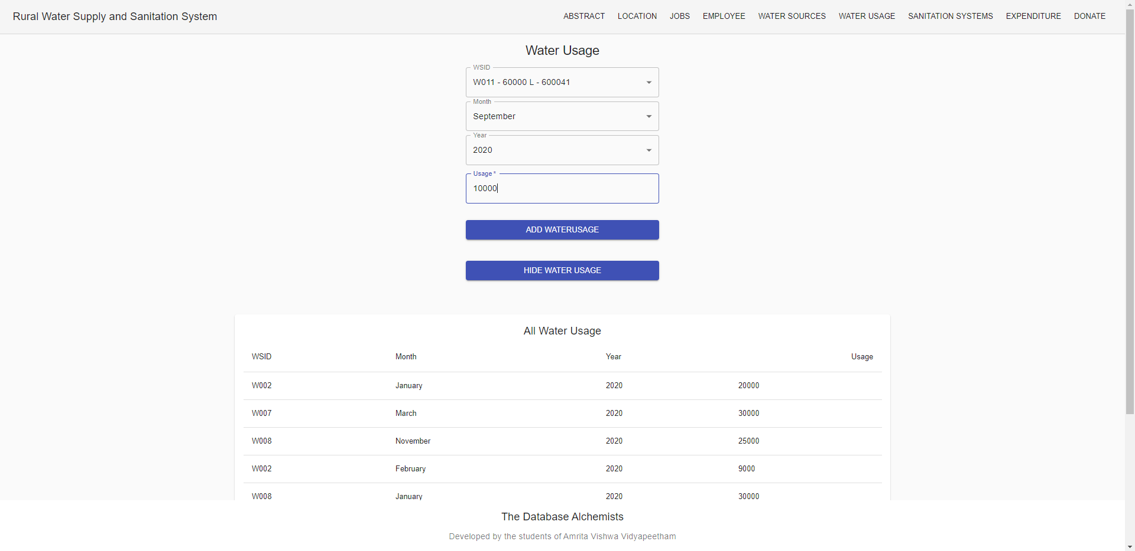

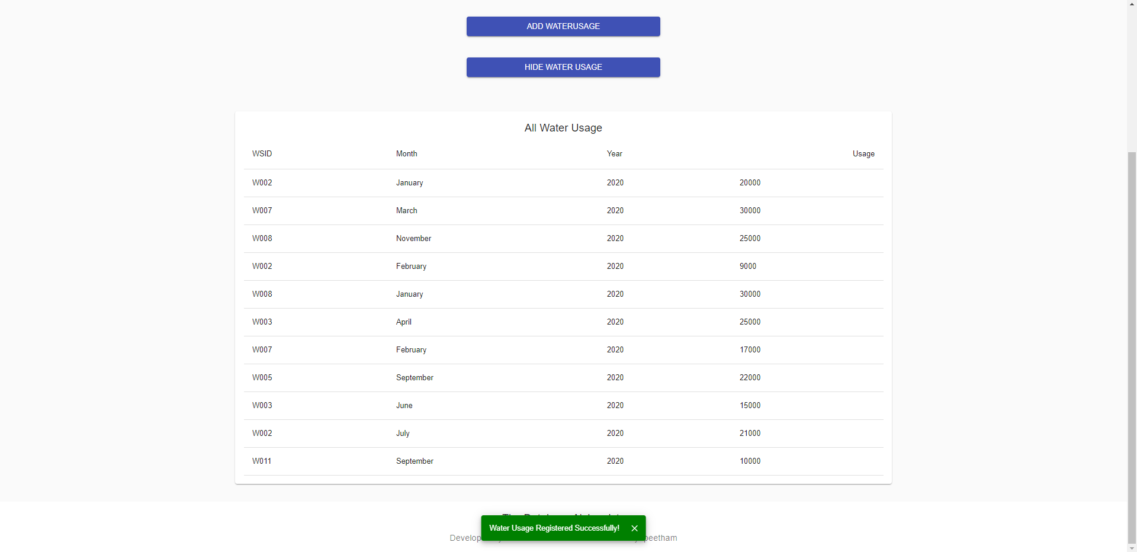

# Sanitation Systems Table:

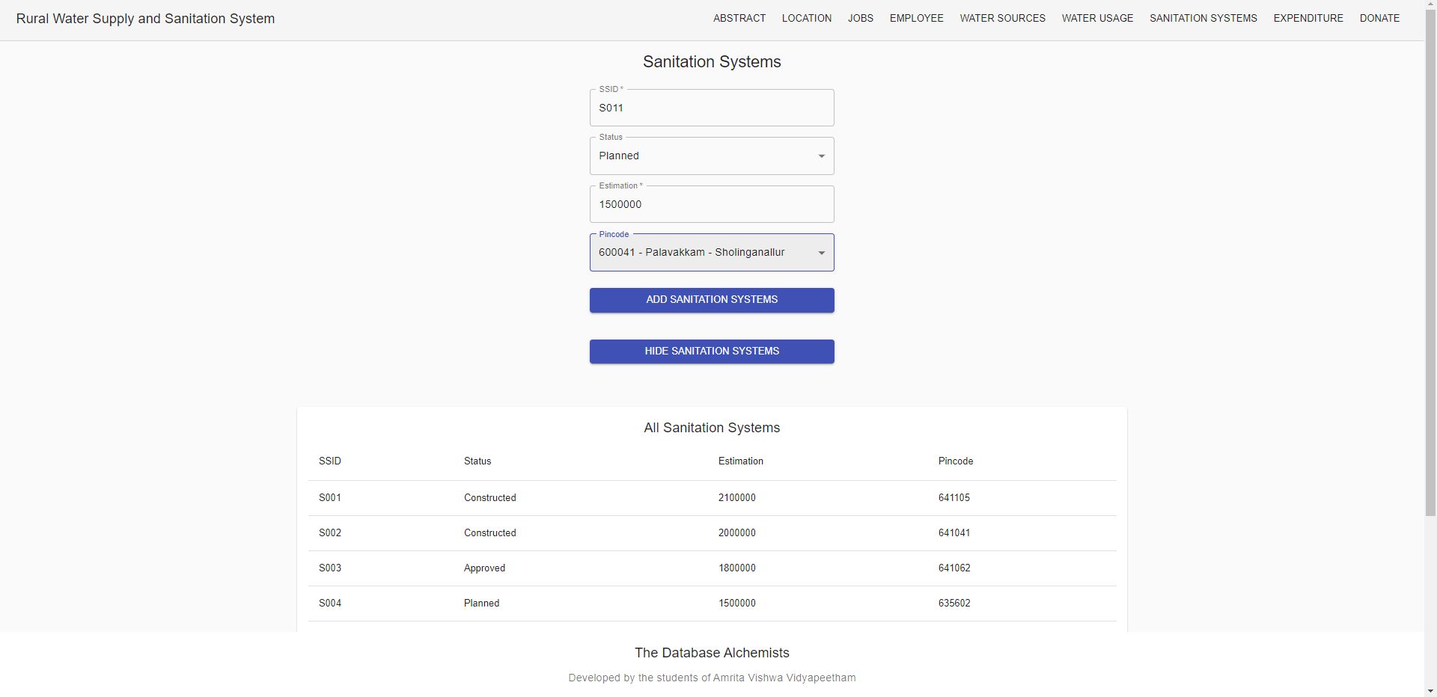

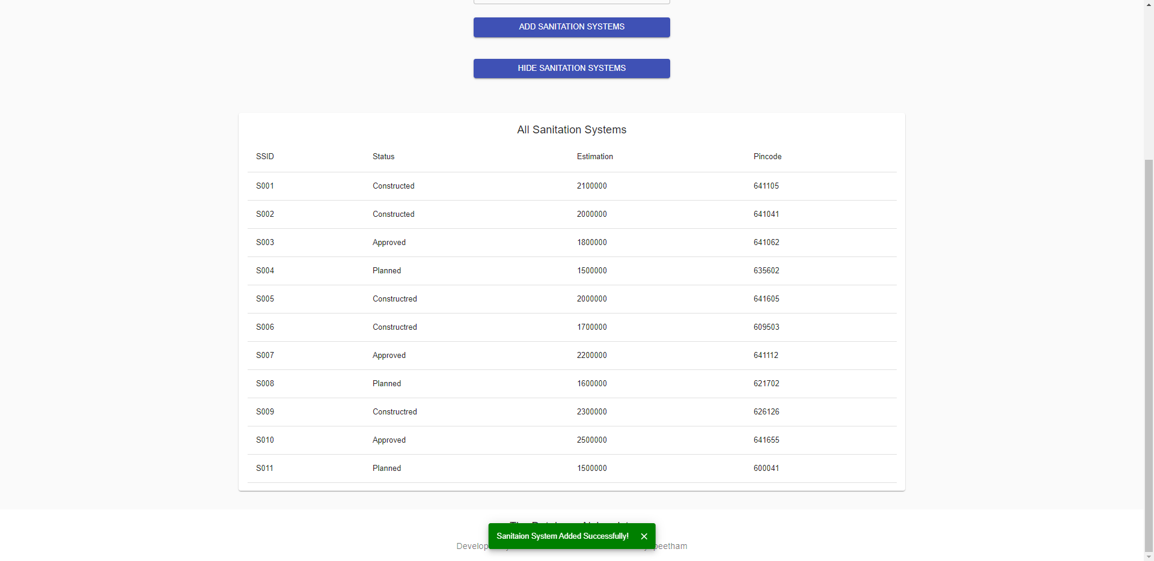

# Expenditure Table:

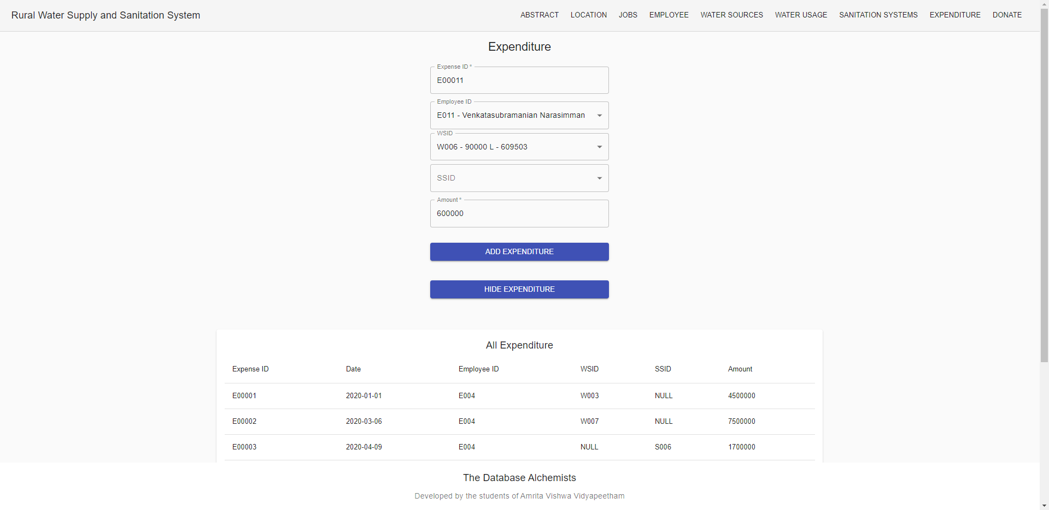

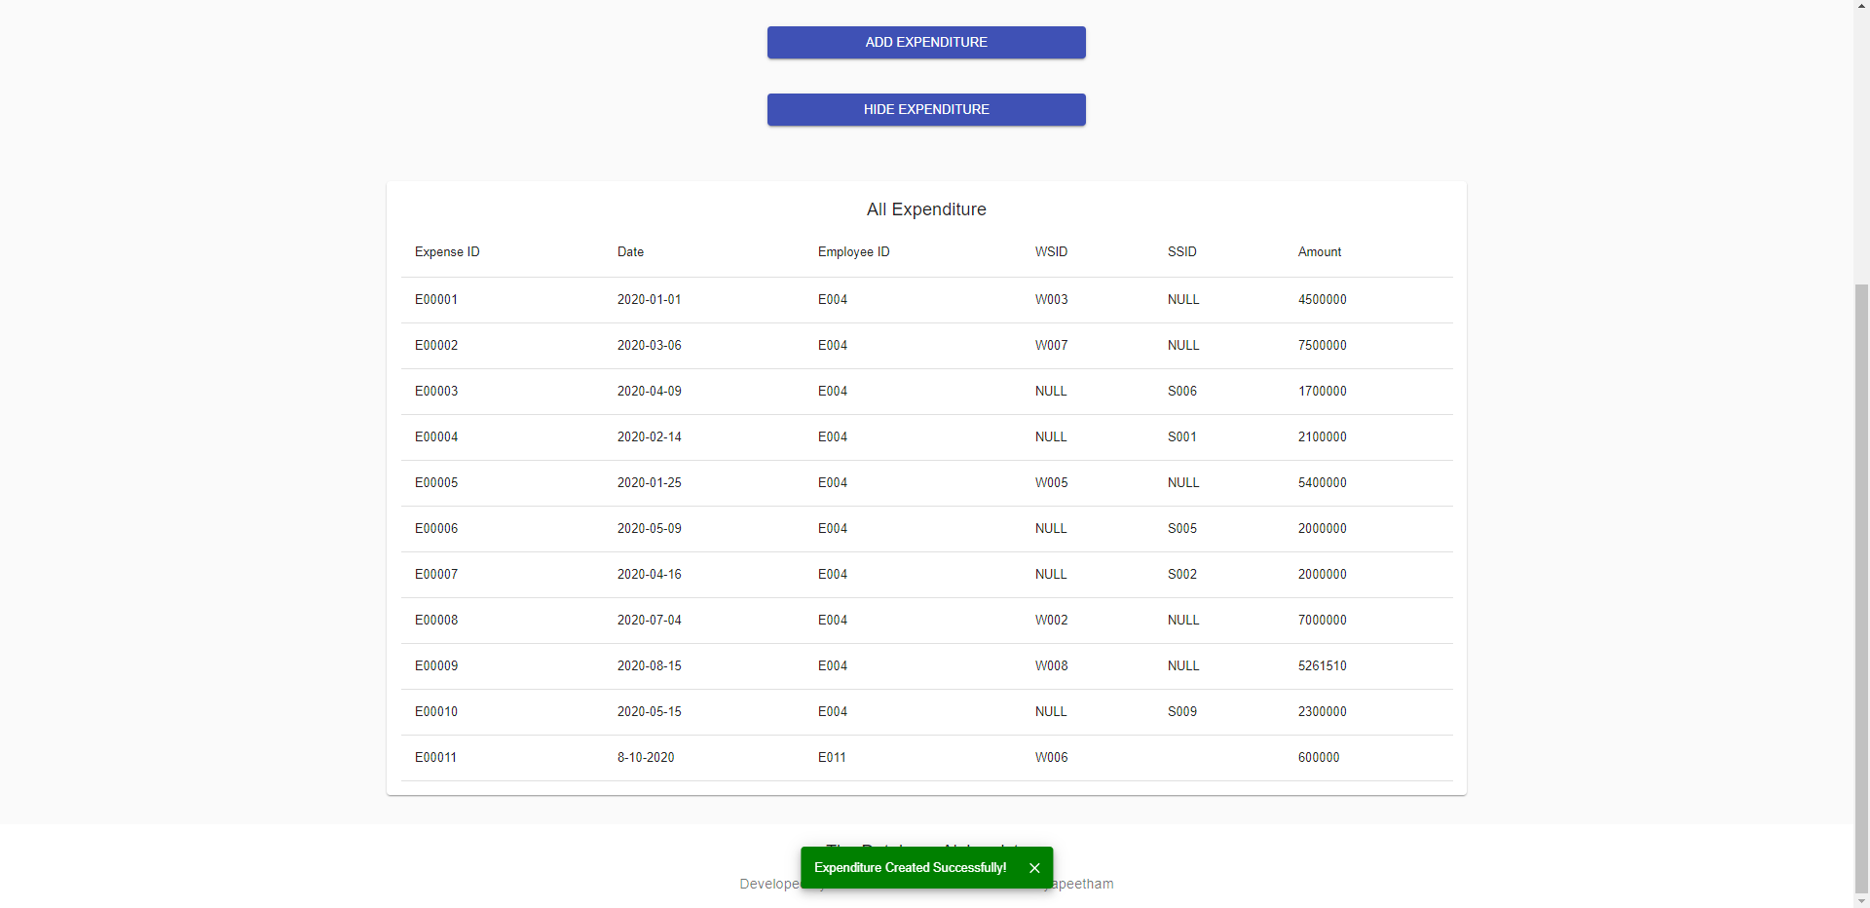

# Donation Table:

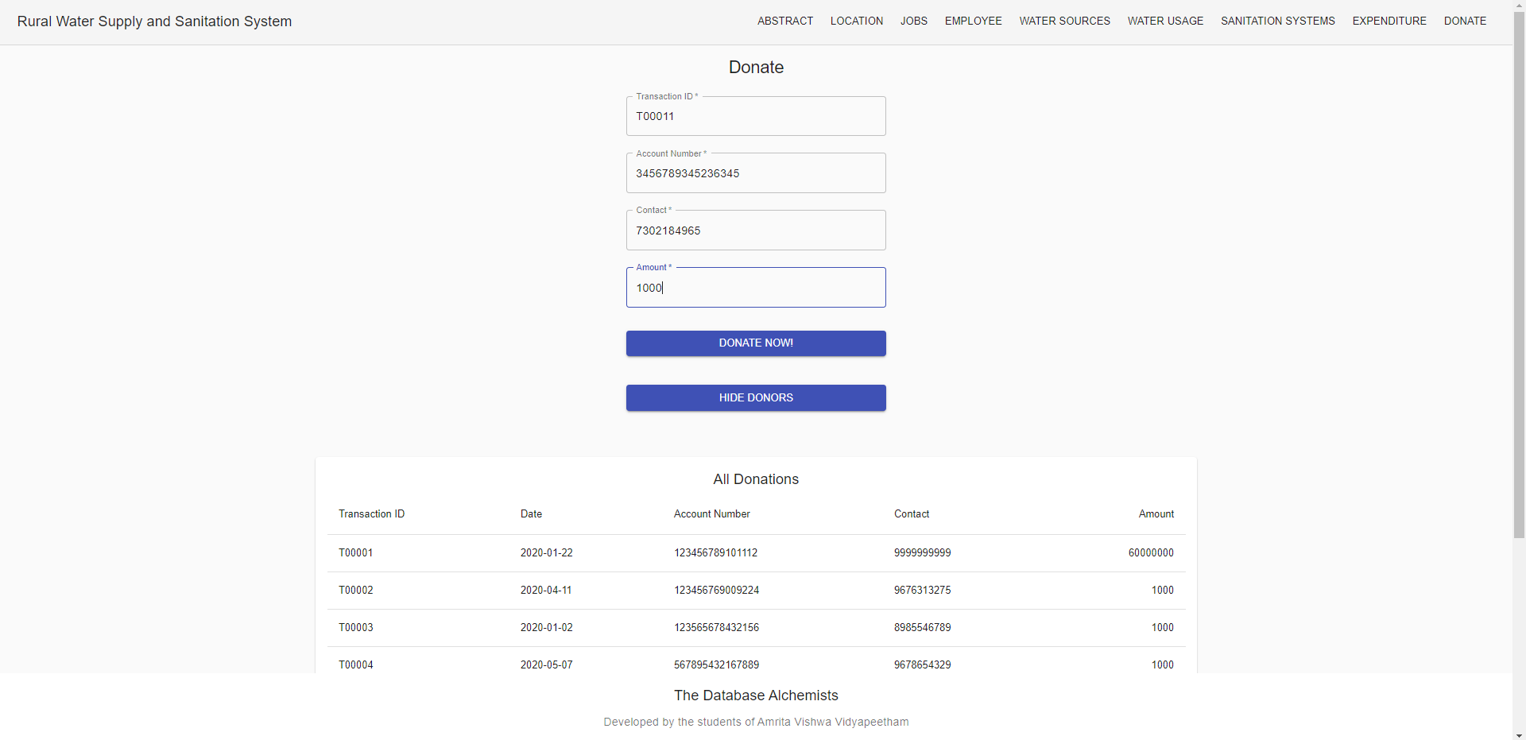

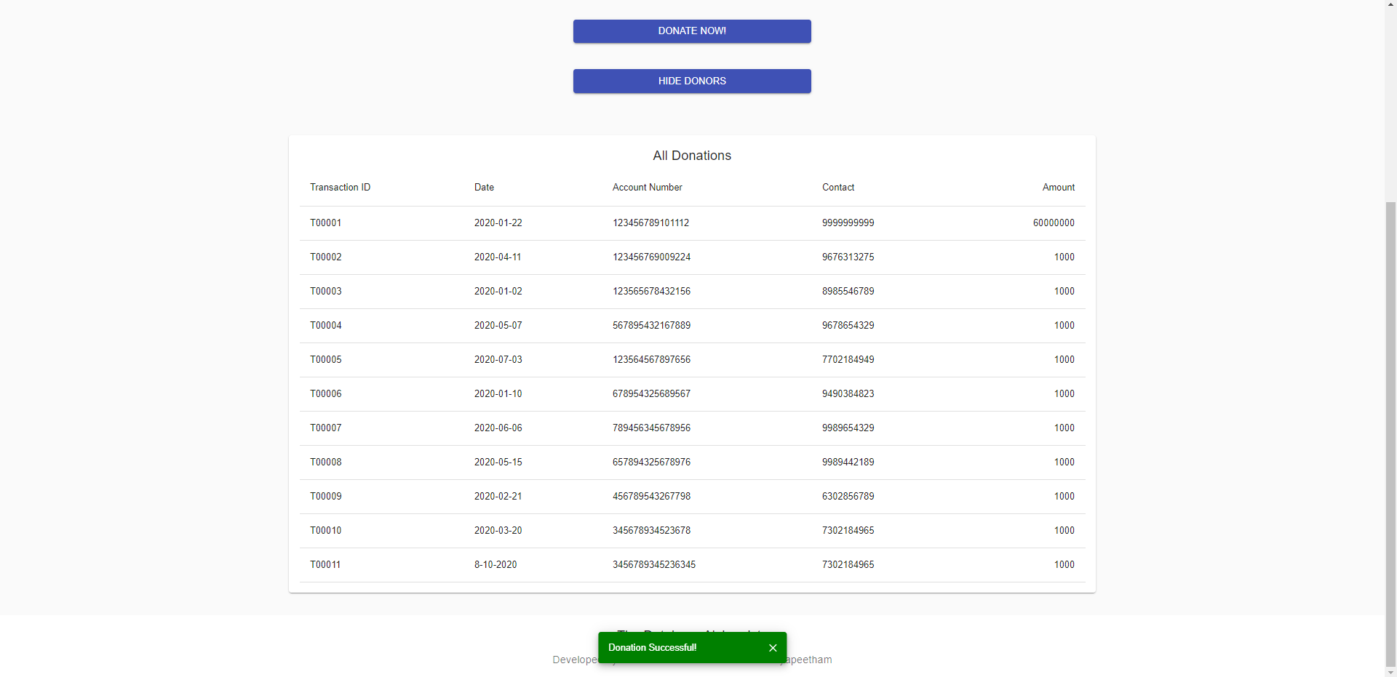

References

**React Tutorial for Beginners - Programming with Mosh**

Website: YouTube

Date of Visit: 01/10/2020 – 09/10/2020

URL: https://www.youtube.com/watch?v=Ke90Tje7VS0

**Example Live Project - Kerala Rural Water Supply and Sanitation Agency**

Website: jalanidhi.kerala.gov.in

Date of Visit: 07/09/2020 – 09/10/2020

URL: <https://jalanidhi.kerala.gov.in/page/render/reference/Jalanidhi_Analytics>