

# IBPSA Project 1 – Update about open-source tool development for Model Predictive Control

## Project overview

IBPSA Project 1 (<https://ibpsa.github.io/project1/>) will create open-source software that builds the basis of next generation computing tools for the design and operation of building and district energy and control systems. It extends work conducted under the IEA EBC Annex 60 (<https://www.iea-annex60.org/>). All work is open-source and built on three standards:

* IFC for data modeling at the building scale,
* CityGML for data modeling at the district scale, and
* Modelica for modeling the performance of building and district energy systems.

The project is conducted from summer 2017 to summer 2022. It coordinates and further develops the work of its more than 30 participating organizations. The project is developing in Task 1 a Modelica library for energy modeling, a Building Optimization Performance Test framework and a Modelica library for MPC. In Task 2, it is developing GIS/BIM data model to Modelica translators for individual building and community energy systems. Task 3 is developing a District Energy System Validation Suite and coordinates case studies.

This article describes the ongoing work on the Building Optimization Performance Test framework and the Modelica library for MPC that are being developed in Task 1 under the Work Package 1.2.

## Advanced building HVAC control

Advanced Control Strategies (ACS) for HVAC in buildings have been researched for many years. This includes technologies such as Model Predictive Control (MPC) and a renewed interest in data-driven techniques due to the advent of artificial intelligence. In the literature, many different approaches are compared using simulation-based studies or measurements on test cells or actual buildings. However, more often than not, different examples and different performance indicators are used in these reports. This hampers the objective comparison of approaches and the identification of best practices. Furthermore, a lot of model development work is repeated, slowing down actual advances on MPC technologies.

The objective of Work Package 1.2 of the IBPSA Project 1 is to overcome these hurdles in three ways: By 1) developing a standardized test framework for objective comparison of ACS, 2) developing a Modelica model library for use within a Model Predictive Controller, and 3) testing different control approaches using this standardized test framework.

## The Building Optimization Performance Test

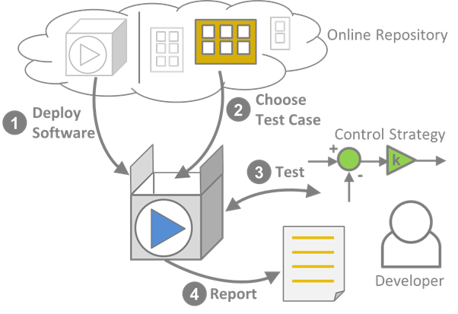

*Figure 1: Workflow of BOPTEST, consisting of optionally deploying a test case, choosing a test case from a repository of test cases, conducting the test of the control strategy and obtaining a standardized report of the control performance.*

The Building Optimization Performance Test (BOPTEST) is a computing environment that is being developed with the goal of testing ACS and objectively comparing ACS on a set of standardized test cases, as shown in Figure 1. The BOPTEST environment has been implemented such that predefined emulators can be used to compute standardized key performance indices, allowing a comparison of different ACS on the same test setup. The simulations are being developed with sufficient level of physical detail and temporal resolution for simulating closed-loop control behavior. Furthermore, the framework will provide a library of emulators that can readily be used to test the performance of a controller across a set of buildings. To ensure transparency, all development is open source. The first version of BOPTEST has been implemented as is summarized below first from the user perspective and then from the developer perspective.

From the user perspective, BOPTEST is software that encapsulates the necessary functionality to control a virtual building, using a so-called emulator, and evaluate the performance of such control. A set of emulators for users to choose from is under development. They cover a range of complexities and system types, including single and multi-zone residences and offices with air and water-based systems. To evaluate the performance of a controller, a set of key performance indicators (KPI) are automatically calculated based on data from these emulators. These KPIs include energy consumption, operating costs, CO2 emissions, thermal comfort, and computational time of the controller. The project team is working to develop other ways of evaluating a controller, such as cost savings relative to a baseline controller and projected installation costs and effort. Interaction with the emulator is done through a HTTP-based API. This API includes methods to view the available control inputs and measurement outputs from the emulator, choose a controller communication step size, overwrite control signals and setpoints in the emulator, advance time in the emulator, read measurement data, retrieve forecasts of weather, energy prices, and internal loads, and retrieve calculated KPI values.

From a developer perspective, the BOPTEST software is delivered using containerization with Docker. This allows for the exact specification and deployment of a light-weight virtual machine on almost any computing resource, whether it be locally or in the cloud, on Linux, MacOS or Windows. The Docker container uses Python to manage the simulation of the emulator, calculate KPIs, generate forecasts, and implement the HTTP-based API. The set of emulators are written using Modelica and packaged as a Functional Mockup Unit (FMU) that contains all needed resources such as weather data, energy prices and schedules. A set of specialized Modelica blocks have been developed to aid in the overwriting of virtually any control signals within the emulator, either local actuator commands or supervisory setpoints, as well as identify sensor signals that are available to users as measurements. An FMU representing one of the virtual buildings, known as the test case FMU, is then used within the Docker container for testing. This approach ensures that consistent and sufficiently detailed results are obtained across different computing platforms. Furthermore, the controller can be implemented in any language as long as it can communicate through the HTTP-based API.

More details on BOPTEST can be found in the paper presented at Building Simulation 2019[1], and the development can be followed and joined at <https://github.com/ibpsa/project1-boptest>.

## The IBPSA MPC library

IBPSA Project 1 will also develop a library of model for use within a Model Predictive Controller. This library, called IbpsaMpc Library, is implemented using Modelica, an equation-based, object-oriented modeling language that is extensively used in IBPSA Project 1 and well suited to formulated models for use within Model Predictive Control. Earlier collaboration efforts within the IEA EBC Annex 60 Project have focused on developing a joint library for *simulation* using Modelica models and has coordinated development efforts of four other Modelica libraries. WP 1.2 will now do a similar joint development for *optimization* applications, which requires models that have additional specific properties for use by optimization packages.

The development of this open-source IbpsaMpc library has recently started at <https://github.com/ibpsa/modelica-ibpsa-mpc>. The developed models will automatically be tested using a custom unit testing framework that is tailored to optimization-oriented modeling.

## Outlook

The next steps of Work Package 1.2 are focused on getting BOPTEST ready for initial tests of various MPC controllers from the participating institutions and continued development of the MPC library. One immediate task is the completion of an initial subset of virtual building emulators. New feature development and improvements to the BOPTEST software will be conducted as needed to begin this testing. The MPC library development will continue with the development of maintenance processes, implementation of a unit testing framework, and ultimately population of the library with component models.

## Further information

For further information about the IBPSA Project 1 and how to join this joint collaboration, please visit <https://ibpsa.github.io/project1>.

1. D. H. Blum, F. Jorissen, S. Huang, Y. Chen, J. Arroyo, K. Benne, Y. Li, V. Gavan, L. Rivalin, L. Helsen, D. Vrabie, M. Wetter, and M. Sofos. (2019). “Prototyping the BOPTEST framework for simulation-based testing of advanced control strategies in buildings.” In *Proc. of the 16th International Conference of IBPSA*, Sep 2 – 4. Rome, Italy.