**Template for description of application case studies – IBPSA Project 1 WP3.2**

**1. Title and authors**

***-Provide a title for the application case study***

Two-pipe active beam system for simultaneous heating and cooling of office buildings

***-Name the authors that are responsible for the case study***

Alessandro Maccarini / Department of the Built Environment, Aalborg University / Denmark

**2.**  **General Description:**

***-Formulate a general outline of the case study by including: objective, description of HVAC/district system and main results (if already available)***

This case study aims to evaluate the energy performance of a novel active beam system for office buildings. The system consists of two parts: an air handling unit (AHU) to satisfy ventilation requirements, and a water circuit to meet sensible heating and cooling loads. The novelty of the system is in relation to the water circuit, which is able to provide simultaneous heating and cooling through a single loop (two-pipe) that is near the room temperature.

In particular, the water circuit is designed to operate with constant water flow rate and supply temperature of about 22°C, which is delivered to all the thermal zones in the building, no matter whether a single zone needs heating or cooling. The AHU consists of supply and return fans, heating and cooling coils and a rotary heat recovery unit. It operates as a CAV system, delivering a constant air mass flow rate with constant supply temperature of 21°C.

The system presents two main advantages. First, surplus heat from warm zones in a building can be transferred to cold zones, reducing the total energy use. Second, because the system works with water temperatures of around 22°C, devices such as heat pumps and dry coolers operate more efficiently. The use of such temperatures also enhances a self-regulating effect, as the rate of heat transfer is very sensitive to changes in room temperatures. This lead to reductions in system cost and control complexity, as individual room-temperature feedback-control systems are not required.

Results from simulations studies showed that the two-pipe system used approximately 18% less primary energy than a conventional four-pipe system.

***-What’s the status of the case study?***

On going

Completed

***-Which is the scale of the simulation?***

Component

Building

District

***-Which location (weather file) have you used?***

Copenhagen / Denmark

**3.**  **Diagram and picture**

***-Include at least two pictures for your case study:***

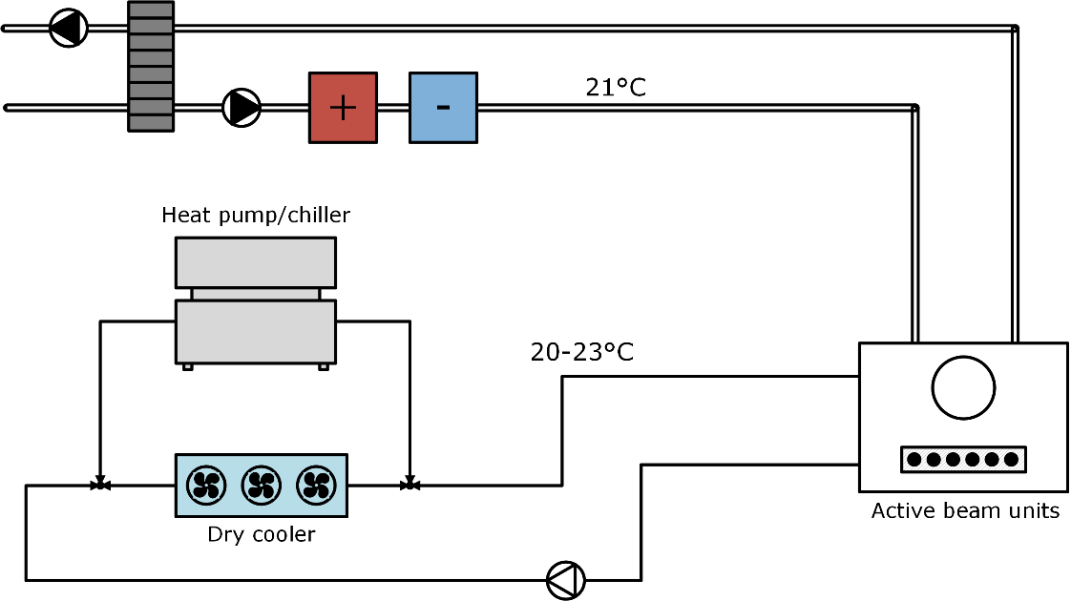

Fig.1 Diagram of the HVAC system

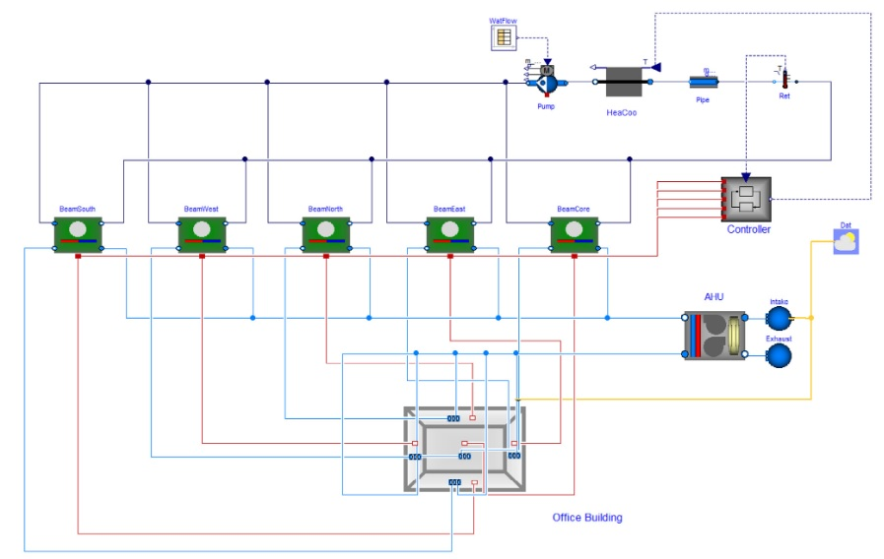

Fig.2 Modelica model

**4.** **Thermal zone modeling**

***-How many buildings have you modelled?***

1

***-How many thermal zones per building have you modelled? How many in total?***

5 thermal zones, following the office reference building developed by the US Department of Energy (DOE). This consist of four perimeter zones (one per each orientation) and one internal zone.

***-What’s the complexity of the thermal zone model (Low order / High order)?***

High order

***-(only for district simulations) Are network and buildings coupled or decoupled?***

Coupled

Decoupled

**5. Modelica libraries and tools:**

***-Which Modelica library have you used? (Keep in mind that IBPSA library is for developers, not for users)***

AixLib

Buildings

BuildingSystems

IDEAS

Other …………………………..

***-Which simulation tools have you used?***

Dymola

OpenModelica

JModelica

Other …………………………..

***-Have you used additional tool, package or automation workflow (e.g. BuildingsPy, StrOBe, Teaser etc.)? If yes, please specify which is the purpose of using the tool***

No

***-What’s the simulation run period?***

1 year with a pre-simulation of two weeks

***-What’s the computation time?***

30 min

***-Which solver and tolerance have you used?***

Radau 1e-6

***-Please provide specifications of computer machine***

1.6 GHz

**6.** **Were all the needed Modelica components available in the library? Or you had to develop some new models?**

No active beam model was included in the Buildings library. Therefore a new model has been developed.

**7.**  **Is there any specific reason for the use of Modelica instead of other building/district simulations programs?**

Modelica was mainly chosen because it allows modeling of non-conventional HVAC configurations, and in this case, this refers to the water piping layout. The main characteristic of the two-pipe active beam system is that it consists of a single water circuit for both heating and cooling. Most the building simulation programs, however, do not usually allow such configuration as heating and cooling are considered as two separated processes.

**8.**  **Is there any reference available for the case study? (papers, reports, etc.)**

-A. Maccarini, M. Wetter, A. Afshari, G. Hultmark, NC. Bergsöe and A. Vorre. *Energy saving potential of a two-pipe system for simultaneous heating and cooling of office buildings*. Energy and Buildings, 134:234 – 247, 2017