**Template for description of application case studies – IBPSA Project 1 WP3.2**

**1. Title and authors**

***-Provide a title for the application case study***

Feasibility study of a 5th generation district heating and cooling system in Køge Nord

***-Name the institution and the authors that are responsible for the case study***

Alessandro Maccarini / Department of the Built Environment, Aalborg University / Denmark

**2.**  **General Description:**

***-Formulate a general outline of the case study by including: objective, description of HVAC/district system and main results (if already available)***

5th generation district heating and cooling (5GDHC) systems are an emerging technology that can contribute to the decarbonization of the heating and cooling sector in cities and communities thanks to their ability to exploit a multitude of renewables and urban excess heat sources.

The objective of this case study is to assess the technical feasibility of a 5GDHC system in the new urban area of Køge Nord (Denmark). When fully developed, the area will consist of approximately 15 large office buildings and 60 residential buildings and 3 industrial buildings.

The concept of the system is illustrated in Fig.1. The district piping network consists of two pipes. The warmer pipe has temperatures between 12°C and 20°C, while the cold pipe has 8-16°C. The district network uses aquifer thermal energy storage (ATES) technologies as long-term source/sink to provide heating and cooling to buildings. Buildings are equipped with decentralized “prosumer” substations including heat pumps, direct-cooling heat exchangers and circulations pumps, and they are connected to both lines. In the case of a heating demand, the circulation pump withdraws water from the warm pipe, uses it in a heat pump to reach temperatures suitable for space heating (and/or DHW), and then discharges the cooled water to the cold line. In case of a cooling demand, the system works in the other direction. Depending on the heating and cooling demands of the connected buildings, the fluid flow in the network can change direction. The total difference between heating and cooling flows needs to be balanced by the ATES system.

This project started only recently, therefore no results are available.

***-What’s the status of the case study?***

On going

Completed

***-Which is the scale of the simulation?***

Component

Building

District

***-Which location (weather file) have you used?***

Copenhagen / Denmark

**3.**  **Diagram and picture**

***-Include at least two pictures for your case study:***

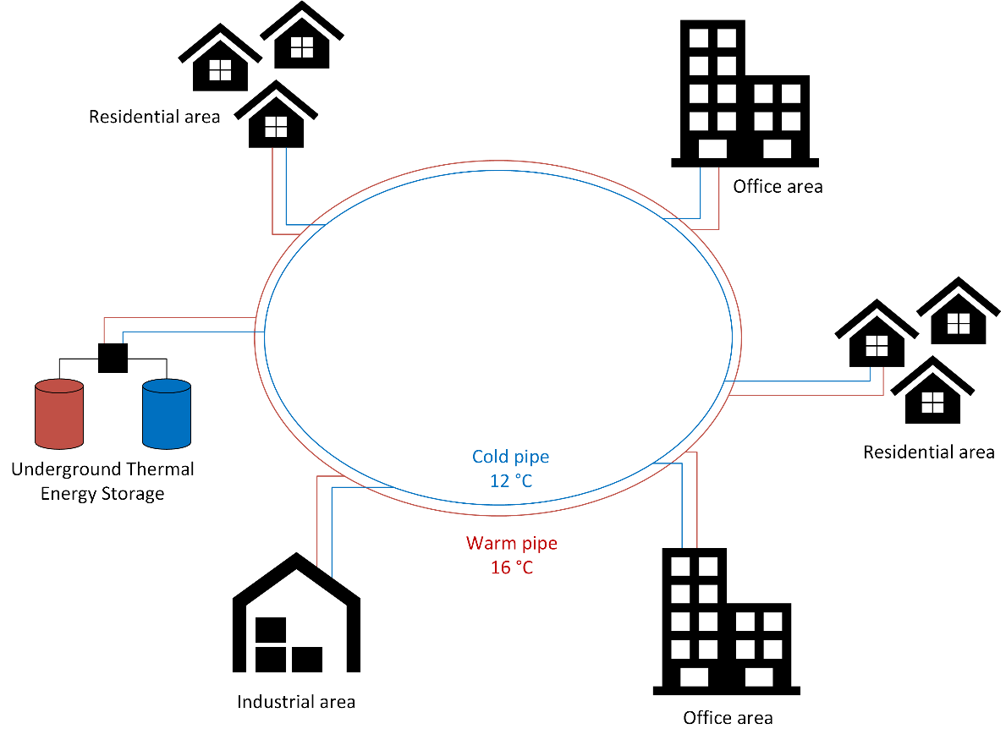

Fig.1 Diagram of the district network

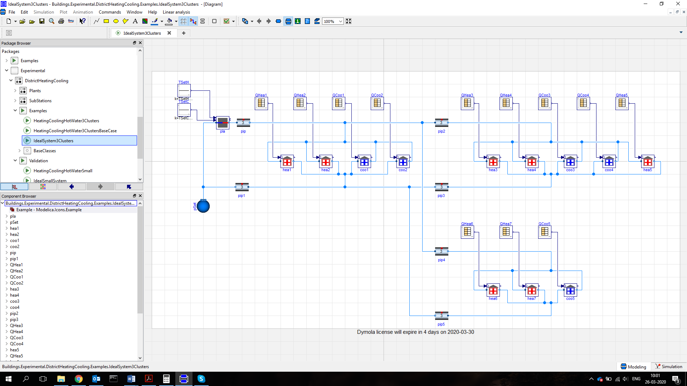

Fig.2 Modelica model *(taken from Buildings library – just as example)*

**4.** **Thermal zone modeling**

***-How many buildings have you modelled?***

78

***-How many thermal zones per building have you modelled? How many in total?***

2 thermal zones for residential buildings (day and night)

5 thermal zones for office buildings (one per each orientation and internal)

(Industrial buildings are modeled as heat sources)

Total number of thermal zones is 195.

***-What’s the complexity of the thermal zone model (Low order / High order)?***

Low order

***-(only for district simulations) Are network and buildings coupled or decoupled?***

Coupled

Decoupled

**5. Modelica libraries and tools:**

***-Which Modelica library have you used? (Keep in mind that IBPSA library is for developers, not for users)***

AixLib

Buildings

BuildingSystems

IDEAS

Other …………………………..

***-Which simulation tools have you used?***

Dymola

OpenModelica

JModelica

Other …………………………..

***-Have you used any additional tool, package or automation workflow (e.g. BuildingsPy, StrOBe, Teaser etc.)? If yes, please specify which was the purpose.***

StrOBe was used to create stochastic occupant behaviors for the residential buildings. Teaser was used to develop Modelica models of buildings starting from CityGML files.

***-What’s the simulation run period?***

1 year with a pre-simulation of two weeks

***-What’s the computation time?***

4 hours

***-Which solver and tolerance have you used?***

Radau 1e-6

***-Please provide specifications of computer machine***

1.6 GHz

**6.** **Were all the needed Modelica components available in the library? Or you had to develop some new models?**

No ATES model was included in the Buildings library. Therefore a new model is under development.

**7.**  **Is there any specific reason for the use of Modelica instead of other building/district simulations programs?**

Modelica was mainly chosen for its multi-physical modeling approach, as the 5GDHC system integrates different engineering domains (building physics, hydraulics, controls and electrical grids).

**8.**  **Is there any reference available for the case study? (papers, reports, etc.)**

Not yet