Normal version

theta = 0.05; kappa = 0.3; sigma = 0.1; rho = -0.6; v0 = 0.04

sigma_lv = 1.0; beta_lv = 1.0; # slv params

MC

array([0.27307241, 0.24997718, 0.22660578, 0.20295686, 0.18016529,

0.16092765, 0.14984499, 0.14786934, 0.15148064, 0.1572248 ])

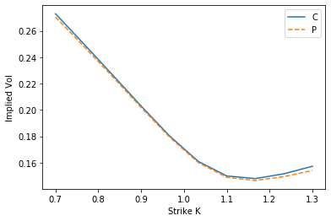

ADI

array([0.27122033, 0.24777835, 0.22387952, 0.19921896, 0.17461985,

0.15356811, 0.14492319, 0.14584897, 0.15118858, 0.15800707])

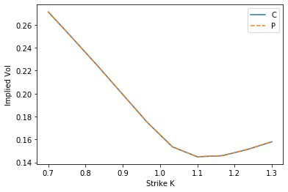

theta = 0.05; kappa = 0.3; sigma = 0.1; rho = -0.6; v0 = 0.04

sigma_lv = 1.0; beta_lv = 0.5; # slv params

MC

array([0.2476634 , 0.23529714, 0.22501058, 0.21569121, 0.20653645,

0.19828964, 0.1909262 , 0.18425003, 0.17842426, 0.17280506])

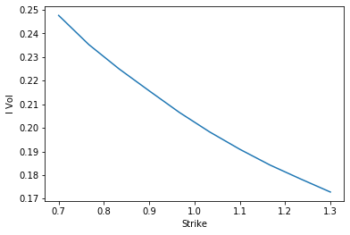

FD ADI

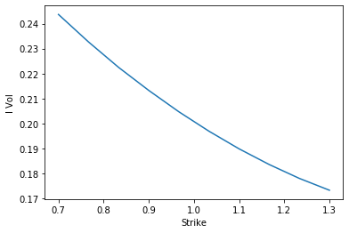

array([0.24366825, 0.23264675, 0.22245735, 0.21325299, 0.20470284,

0.19692816, 0.18987371, 0.18360071, 0.17805278, 0.17330829])

theta = 0.05; kappa = 0.3; sigma = 0.5; rho = -0.6; v0 = 0.04

sigma_lv = 1.0; beta_lv = 0.5; # slv params

MC

array([0.28069186, 0.25600892, 0.23073069, 0.20560856, 0.18116193,

0.15977438, 0.14637802, 0.14332994, 0.14615682, 0.15111873])

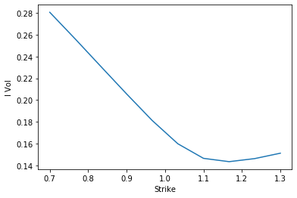

ADI

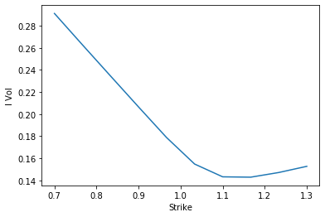

array([0.2911965 , 0.26272553, 0.23454562, 0.20648644, 0.17875119,

0.15475196, 0.1431815 , 0.14286219, 0.14709008, 0.15268852])

When ADI is stable:

tri_xx_new.diag_1

Out[15]:

array([ 0. , 0. , 0. , ..., 30.61949703,

29.80117217, 0.77521565])  
tri_xx_new.diag_2

Out[16]:

array([ 0. , 0. , 0. , ..., -60.42061983,

-58.80584167, -0.77521565])

**from** scipy.sparse.linalg **import** eigs

sci_tri **=** sparse.diags([tri_1_new.diag_1,tri_1_new.diag_2,tri_1_new.diag_3],[**-**1,0,1])

vals, vecs **=** eigs(sci_tri, k**=**500)

In [15]:

vals[0]**/**vals[**-**1]

Out[15]:

(3.1459499660401407+0j)

In [16]:

Unsatable

**from** scipy.sparse.linalg **import** eigs

sci_tri **=** sparse.diags([tri_1_new.diag_1,tri_1_new.diag_2,tri_1_new.diag_3],[**-**1,0,1])

vals, vecs **=** eigs(sci_tri, k**=**500)

In [15]:

vals[0]**/**vals[**-**1]

Out[15]:

(3.6975124141748656+0j)

theta = 0.05; kappa = 0.3; sigma = 0.5; rho = -0.6; v0 = 0.04

sigma_lv = 1.0; beta_lv = 1.5; # slv params

MC

array([0.24318517, 0.22942675, 0.21278283, 0.19456645, 0.17614421,

0.16022187, 0.15141017, 0.15167754, 0.15712005, 0.16448264])

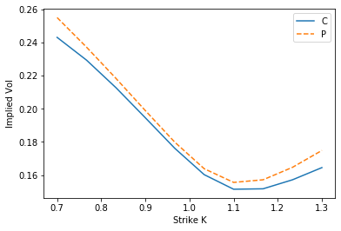

ADI

array([0.25329763, 0.23432865, 0.21420963, 0.19276723, 0.17104174,

0.15267192, 0.1461841 , 0.14870526, 0.15541602, 0.16356043])

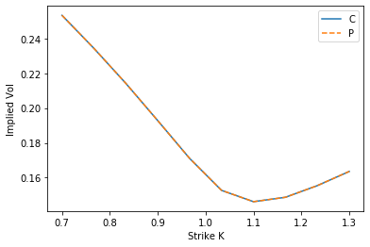

In [ ]: