**Arman Daniel Marcus Robert**

**Code Search Engine Architecture Diagram:**

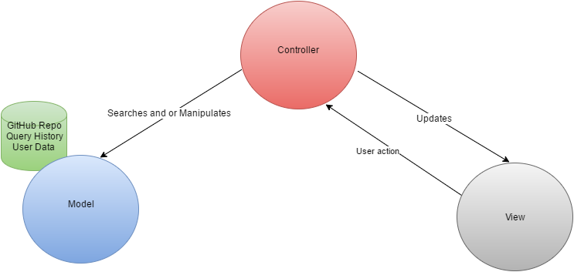

**Elaboration:**

The diagram above shows a three layer MVC type architecture.

-View: What the user sees and interacts with (search bar, filter options, etc.)

-Controller: Where the logic occurs -responds to user actions, takes data from the UI , formats it in a way that can be used for it to search the model and then searches the model and updates it (ex: inserts queries and URLS for the search history). The controller will then decide what to do with results from a search based on what the user action was and will update the view accordingly.

-Model: Holds data such as search history (queries, URLS, etc.) and user data (ex: login info, settings, etc.). The GitHub repo itself will be considered part of the model for simplicity.