Untitled

# Level 1

## R Markdown

This is an R Markdown document. Markdown is a simple formatting syntax for authoring HTML, PDF, and MS Word documents. For more details on using R Markdown see <http://rmarkdown.rstudio.com>.

When you click the **Knit** button a document will be generated that includes both content as well as the output of any embedded R code chunks within the document. You can embed an R code chunk like this:

summary(cars)

## speed dist   
## Min. : 4.0 Min. : 2.00   
## 1st Qu.:12.0 1st Qu.: 26.00   
## Median :15.0 Median : 36.00   
## Mean :15.4 Mean : 42.98   
## 3rd Qu.:19.0 3rd Qu.: 56.00   
## Max. :25.0 Max. :120.00

## Including Plots

You can also embed plots, for example:

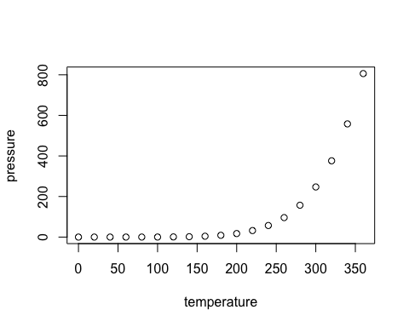

Figure 1. testing 123

Note that the echo = FALSE parameter was added to the code chunk to prevent printing of the R code that generated the plot.

## Table

knitr::kable(mtcars[1:10, 1:4], caption="Table 1. Testing")

Table 1. Testing

|  |  |  |  |  |
| --- | --- | --- | --- | --- |
|  | mpg | cyl | disp | hp |
| Mazda RX4 | 21.0 | 6 | 160.0 | 110 |
| Mazda RX4 Wag | 21.0 | 6 | 160.0 | 110 |
| Datsun 710 | 22.8 | 4 | 108.0 | 93 |
| Hornet 4 Drive | 21.4 | 6 | 258.0 | 110 |
| Hornet Sportabout | 18.7 | 8 | 360.0 | 175 |
| Valiant | 18.1 | 6 | 225.0 | 105 |
| Duster 360 | 14.3 | 8 | 360.0 | 245 |
| Merc 240D | 24.4 | 4 | 146.7 | 62 |
| Merc 230 | 22.8 | 4 | 140.8 | 95 |
| Merc 280 | 19.2 | 6 | 167.6 | 123 |