绝密★启用前
2011年普通高等学校招生全国统一考试（上海卷）
英语试卷
（满分150分，考试时间100分钟）

考生注意：
- 考试时间120分钟, 试卷满分150分。
- 本考试设试卷和答题纸两部分。试卷分为第I卷（第1－12页）和第II卷（第13页），全卷共13页。所有答题必须涂（选择题）或写（非选择题）在答题纸上，做在试卷上一律不得分。
答题前,务必在答题纸上填写准考证号和姓名,并将核对后的条形码贴在指定位置上,在答题纸反而清楚地填写姓名。
第I卷 (105分)
I. Listening Comprehension
Section A
Directions: In Section A;you will hear ten short conversations between two speakers. At the end of each conversation, a question will be asked about what was said. The conversations and the questions will be spoken only once. After you hear a conversation and the question about it, read the four possible answers on your paper, and decide which one is the best answer to the question you have heard.
- A. At a train station. B. At an airport.
C. At a travel agency. D. At a bus station.
- A. $5. B. $10.
C. $15. D. $50.
- A. Receptionist and guest. B. Salesperson and customer.
C. Doctor and patient. D. Waiter and diner.
- A. Excited. B. Dissatisfied.
C. Bored. D. Exhausted.
- A. Her hair has changed. B. She isn’t satisfied with her hair style.
C. She prefers to wear long hair. D. The man has changed his hair style.
- A. It is too early to watch the Talent Show. B. He will go to bed in five minutes.
C. He would rather watch TV than go to bed. D. He is old enough to stay up.
- A. She has got everything ready. B. She never hesitates over what to take.
C. She hates packing by herself. D. She needs more time for packing.
- A. They should wait for John for a while. B. They should stay here for the night.
C. They should start the meeting right away. D. They should call John at once.
- A. She is unwilling to move into a new flat. B. Her neighbors get along well with her.
C. She can’t tell the man why she is moving. D. Her neighbors usually play their TV loud.
- A. Ask for directions. B. Try a different route.
C. Go back for the map. D. Cancel their trip.
Section B
Directions: In Section B, you will hear two short passages, and you will be asked to questions on each of the passages. The passages will be read twice, but the questions will be spoken only once. When you hear a question, read the four possible answers on your paper and decide which one would be the blest answer to the question you have heard.
Questions 11 through 13 are based on the following passage.
- A. A political system. B. Religion.
C. Working language. D. Race.
- A. Discuss current issues. B. Join in a writing competition.
C. Attend an arts and crafts competition. D. Celebrate their friendship.
- A. The Commonwealth Games. B. An important holiday.
C. The Commonwealth members. D. An international association.
Questions 14 through 16 are based on the following news.
- A. Equipping students with knowledge. B. Qualifying students for certain jobs.
C. Developing students’ habits of mind. D. Helping students to go to graduate school.
- A. The ability to have critical analysis. B. Creative use of leisure time.[来源:学科网ZXXK]
C. Logical use of information. D. Willingness to accept uncertainty.
- A. Goals to reach in a college education. B. Roles of knowledge in students’ growth.
C. Qualifications needed for a job. D. Importance of after-class activities.
Section C
Directions: In Section C, you will hear two longer conversations. The conversations will be read twice. After you hear each conversation, you are required to fill in the numbered blanks with the information you have heard. Write your answers on your answer sheet.
Blanks 17 through 20 are based on the following conversation.
Complete the form. Write ONE WORD for each answer.
Complaint Form
Caller: Mary White
Phone No.: 17 .
Location of Problem: A 18 restaurant , 449 Shanghai Street
Details: It dumps its 19 on the street.
It doesn’t put bottles and cans in 20 bins.
Blanks 21 through 24 are based on the following conversation.
Complete the form. Write NO MORE THAN THREE WORDS for each answer.
How long does short memory last? | It lasts only 21 .
What is an example of medium term memory? | Buying bread, a sort of 22 of things to do.
What is long term memory concerned with? | 23 that happen in your life such as your wedding.
How is long term memory different from the others? | It 24 .

II. Grammar and Vocabulary
Section A
Directions: Beneath each of the following sentences there are four choices marked A, B, C and D. Choose the one answer that best completes the sentence.
- Graduation is a good time to thank those who have helped you ______ the tough years.
A. through B. up C. with D. from
- To stay awake, he finished a cup of coffee and ordered ______.
A. the other B. other C. the others D. another
- It’s no use ______ without taking action.
A. complain B. complaining C. being complained D. to be complained
- I ______ worry about my weekend—I always have my plans ready before it comes.
A. can’t B. mustn’t C. daren’t D. needn’t
- When Mom looked back on the early days of their marriage, she wondered how they had managed with ______ money.
A. so few B. such few C. so little D. such little
- It doesn’t matter if they want to come to your party, ______?
A. doesn’t it B. does it C. don’t they D. do they
- After getting lost in a storm, a member of the navy team ______ four days later.
A. rescued B. was rescued C. has rescued D. had been rescued
- The rare fish, ______ from the cooking pot, has been returned to the sea.
A. saved B. saving C. to be saved D. having saved
- At one point I made up my mind to talk to Uncle Sam. Then I changed my mind, ______ that he could do nothing to help.
A. to realize B. realized C. realizing D. being realized
- Did you predict that many students ______ up for the dance competition?
A. would sign B. signed C. have signed D. had signed
- There is clear evidence ______ the most difficult feeling of all to interpret is bodily pain.
A. what B. if C. how D. that
- If a lot of people say a film is not good, I won’t bother to see it, or I’ll wait ______ it comes out on DVD.
A. whether B. after C. though D. until
- The police officers in our city work hard ______ the rest of us can live a safe life.
A. in case B. as if C. in order that D. only if
- The message you intend to convey through words may be the exact opposite of ______ others actually understand.
A. why B. that C. which D. what
- You’ll find taxis waiting at the bus station ______ you can hire to reach your host family.
A. which B. where C. when D. as
- Today we have chat rooms, text messaging, emailing… but we seem ______ the art of communicating face-to-face.
A. losing B. to be losing C. to be lost D. having lost

Section B
Directions: Complete the following passage by using the words in the box. Each word can only be used once. Note that there is one word more than you need.
A. launched B. unpleasant C. applying D. technically E. impact
F. coating G. fixed H. miraculously I. superior J. advances
How would you like to wear the same underwear (内衣裤) for weeks? Owing to the work that has gone into developing intelligent materials, this may not be as 41 as it sounds. Self-cleaning clothes have now been created, and these new materials provide 42 resistance to dirt as well as water. As a result, they require much less cleaning than traditional materials.
The creation of self-cleaning clothes provides an example of how nature helps scientists develop better products. This self-cleaning nature is known as the “lotus effect”. The name comes, of course, from the lotus leaves, which are famous for growing in muddy lakes and rivers while remaining almost 43
clean. By observing nature, scientists are 44 the qualities of the lotus leaves to the materials they have engineered. Because of this, some remarkable new products have been 45 . Among them are special windows that are resistant to dirt and water. A special 46 on these windows not only prevents dirt from sticking to their surfaces, but also allows dust to be easily washed off by the rain. In fact, these new windows have already been 47 to some cars. Even when traveling at high speed through rain, these cars never have to use their windshield wipers (雨刮器).
Although we have already seen some practical applications, even more dramatic 48 will be made in the future, and they will, perhaps, change our world completely. Undoubtedly, technology is an important development, and it will have an even bigger 49 on our lives.

III. Reading Comprehension
Section A
Directions: For each blank in the following passage there are four words or phrases marked A, B, C and D. Fill in each blank with the word or phrase that best fits the context.
Everyone in business has been told that success is all about attracting and retaining (留住) customers. It sounds simple and achievable. But, 50 , words of wisdom are soon forgotten. Once companies have attracted customers they often 51 the second half of the story. In the excitement of beating off the competition, negotiating prices, securing orders, and delivering the product, managers tend to become carried away. They forget what they regard as the boring side of business— 52 that the customer remains a customer.
53 to concentrate on retaining as well as attracting customers costs business huge amounts of money annually. It has been estimated that the average company loses between 10 and 30 per cent of its customers every years. In constantly changing 54 , this is not surprising. What is surprising is the fact that few companies have any idea how many customers they have lost.
Only now are organizations beginning to wake up to those lost opportunities and calculate the 55
implications. Cutting down the number of customers a company loses can make a big 56 in its performance. Research in the US found that a five per cent decrease in the number of defecting (流失的) customers led to 57 increases of between 25 and 85 per cent.
In the US, Domino’s Pizza estimates that a regular customer is worth more than $5,000 over ten years. A customer who receives a poor quality product or service on their first visit and 58 never returns, is losing the company thousands of dollars in 59 profits (more if you consider how many people they are likely to tell about their bad experience).
The logic behind cultivating customer 60 is impossible to deny. “In practice most companies’ marketing effort is focused on getting customers, with little attention paid to 61 them”, says Adrian Payne of Cornfield University’ School of Management. “Research suggests that there is a close relationship between retaining customers and making profits. 62 customers tend to buy more, are predictable and usually cost less to service than new customers. Furthermore, they tend to be less price 63 , and may provide free word-of-mouth advertising. Retaining customers also makes it 64 for competitors to enter a market or increase their share of a market.
- A. in particular B. in reality C. at least D. first of all
- A. emphasize B. doubt C. overlook D. believe
- A. denying B. ensuring C. arguing D. proving
- A. Moving B. Hoping C. Starting D. Failing
- A. markets B. tastes C. prices D. expenses
- A. culture B. social C. financial D. economical
- A. promise B. plan C. mistake D. difference
- A. cost B. opportunity C. profit D. budget
- A. as a result B. on the whole C. in conclusion D. on the contrary
- A. huge B. potential C. extra D. reasonable
- A. beliefs B. loyalty C. habits D. interest
- A. altering B. understanding C. keeping D. attracting
- A. Assumed B. Respected C. Established D. Unexpected
- A. agreeable B. flexible C. friendly D. sensitive
- A. unfair B. difficult C. essential D. convenient
Section B
Directions: Read the following three passages. Each passage is followed by several questions or unfinished statements. For each of them there are four choices marked A, B, C and D. Choose the one that fits best according to the information given in the passage you have just read.
A
The teacher who did the most to encourage me was, as it happened, my aunt. She was Myrtle C. Manigault, the wife of my mother’s brother Bill. She taught in second grade at all-black Summer School in Camden, New Jersey.
During my childhood and youth, Aunt Myrtle encouraged me to develop every aspect of my potential, without regard for what was considered practical or possible for black females. I liked to sing; she listened to my voice and pronounced it good. I couldn’t dance; she taught me the basic dancing steps. She took me to the theatre not just children’s theatre but adult comedies and dramas—and her faith that I could appreciate adult plays was not disappointed.
My aunt also took down books from her extensive library and shared them with me. I had books at home, but they were all serious classics. Even as a child I had a strong liking for humor, and I’ll never forget the joy of discovering Don Marquis’s Archy & Mehitabel through her.
Most important, perhaps, Aunt Myrtle provided my first opportunity to write for publication. A writer herself for one of the black newspapers, she suggested my name to the editor as a “youth columnist”. My column, begun when I was fourteen, was supposed to cover teenage social activities—and it did—but it also gave me the freedom to write on many other subjects as well as the habit of gathering material, the discipline of meeting deadlines, and, after graduation from college six years later, a solid collection of published material that carried my name and was my passport to a series of writing jobs.
Today Aunt Myrtle is still an enthusiastic supporter of her “favourite niece”. Like a diamond, she has reflected a bright, multifaceted (多面的) image of possibilities to every pupil who has crossed her path.
- Which of the following did Aunt Myrtle do to the author during her childhood and youth?
A. She lent her some serious classics. B. She cultivated her taste for music.
C. She discovered her talent for dancing. D. She introduced her to adult plays.
- What does Archy and Mehitabel in Paragraph 3 probably refer to?
A. A book of great fun. B. A writer of high fame.
C. A serious masterpiece. D. A heartbreaking play.
- Aunt Myrtle recommended the author to a newspaper editor mainly to ______.[来源:学&科&网Z&X&X&K]
A. develop her capabilities for writing B. give her a chance to collect material
C. involve her in teenage social activities D. offer her a series of writing jobs
- We can conclude from the passage that Aunt Myrtle was a teacher who ______.
A. trained pupils to be diligent and well-disciplined
B. gave pupils confidence in exploiting their potential
C. emphasized what was practical or possible for pupils.
D. helped pupils overcome difficulties in learning
B
Humpback whales
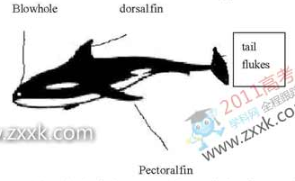
Humpback whales are sometimes called performers of the ocean. This is because they can make impressive movements when they dive. The name “humpback”, which is the common name for this whale, refers to the typical curve shape the whale’s back forms as it dives.[来源:Zxxk.Com]  Sometimes the humpback will dive with a fantastic movement, known as a breach. During breaching the whale uses its powerful tail flukes to lift nearly two-thirds of its body out of the water in a giant leap. A breach might also include a sideways twist with fins stretched out like wings, as the whale reaches the height of the breach.  A humpback whale breathes air at the surface of the water through two blowholes which are located near the top of the head. It blows a double stream of water that can rise up to 4 meters above the water.  The humpback has a small dorsal fin located towards the tail flukes about two-thirds of the way down its back. Other distinguishing features include large pectoral fins, which may be up to a third of the body length, and unique black and white spots on the underside of the tail flukes. These markings are like fingerprints: no two are the same.  Humpback whales live in large groups. They communicate with each other through complex “songs”.[来源:Z。xx。k.Com] | Quick Facts[来源:Z§xx§k.Com]
 | Size: | 14m~18m in length  30~50 tons in weight
 | Living | Open ocean and shallow coastline waters
 | Environment: | From warm tropical (热带的) waters, where they breed, to cold polar waters, where they eat.
 | Diet: | Shellfish, plants and fish of small size
 | Hunting: | Sometimes in groups, in which several whales form a circle under the water, blowing bubbles that form a “net” around a school of fish. The fish are then forced up to the surface in a concentrated mass.
 | Current state: | endangered; it is estimated that there are about 5000~7000 humpback whales worldwide.
- According to Quick Facts, a humpback whale ______.
A. cannot survive in waters near the shore B. doesn’t live in the same waters all the time
C. lives mainly on underwater plants D. prefers to work alone when hunting food
- To make a breach, a humpback whale must ______.
A. use its tail flukes to leap out of the water B. twist its body sideways to jump high.
C. blow two streams of water D. communicate with a group of humpbacks.
- From the passage we can learn that a humpback whale ______.
A. has its unique markings on it tail flukes B. has black and white fingerprints
C. gets its name from the way it hunts D. is a great performer due to its songs
C
Human remains of ancient settlements will be reburied and lost to science under a law that threatens research into the history of humans in Britain, a group of leading archeologists (考古学家) says. In a letter addressed to the justice secretary, Ken Clarke, 40 archaeologists write of their “deep and widespread concern” about the issue. It centers on the law introduced by the Ministry of Justice in 2008 which requires all human remains unearthed in England and Wales to be reburied within two years, regardless of their age. The decision means scientists have too little time to study bones and other human remains of national and cultural significance.
“Your current requirement that all archaeologically unearthed human remains should be reburied, whether after a standard period of two years or a further special extension, is contrary to basic principles of archaeological and scientific research and of museum practice,” they write.
The law applies to any pieces of bone uncovered at around 400 dig sites, including the remains of 60 or so bodies found at Stonehenge in 2008 that date back to 3,000 BC. Archaeologists have been granted a temporary extension to give them more time, but eventuallly the bones will have to be returned to the ground.
The arrangements may result in the waste of future discoveries at sites such as Happisburgh in Norfolk, where digging is continuing after the discovery of stone tools made by early humans 950,000 years ago. If human remains were found at Happisburgh, they would be the oldest in northern Europe and the first indication of what this species was. Under the current practice of the law those remains would have to be reburied and effectively destroyed.
Before 2008, guidelines allowed for the proper preservation and study of bones of sufficient age and historical interest, while the Burial Act 1857 applied to more recent remains. The Ministry of Justice assured archaeologists two years ago that the law was temporary, but has so far failed to revise it.
Mike Parker Pearson, an archaeologist at Sheffield University, said: “Archaeologists have been extremely patient because we were led to believe the ministry was sorting out this problem, but we feel that we cannot wait any longer.”
The ministry has no guidelines on where or how remains should be reburied, or on what records should be kept.
- According to the passage, scientists are unhappy with the law mainly because ______.
A. it is only a temporary measure on the human remains
B. it is unreasonable and thus destructive to scientific research
C. it was introduced by the government without their knowledge
D. it is vague about where and how to rebury human remains
- Which of the following statements is true according to the passage?
A. Temporary extension of two years will guarantee scientists enough time.
B. Human remains of the oldest species were dug out at Happisburgh.
C. Human remains will have to be reburied despite the extension of time.
D. Scientists have been warned that the law can hardly be changed.
- What can be inferred about the British law governing human remains?
A. The Ministry of Justice did not intend it to protect human remains.
B. The Burial Act 1857 only applied to remains uncovered before 1857.
C. The law on human remains hasn’t changed in recent decades.
D. The Ministry of Justice has not done enough about the law.
- Which of the following might be the best title of the passage?
A. New discoveries should be reburied, the government demands.
B. Research time should be extended, scientists require.
C. Law on human remains needs thorough discussion, authorities say.
D. Law could bury ancient secrets for ever, archeologists warn.

Section C
Directions: Read the following text and choose the most suitable heading from A-F for each paragraph. There is one extra heading which you do not need.
A. Manufacturing industry in information economy
B. News in the age of information
C. Argument about individual accounts and their reliability
D. Be your own investigative journalist
E. Don’t believe everything you read in the newspapers.
F. Information is presented in an entertaining way.
- ______
With the arrival of the age of “information economy”, intellectual work is becoming a more important source of wealth than manufacturing. Organizations in all walks of life are doing more to spread their information. So people of the Public Relations are hired to speak for them. A lot of our news is actually collected from press releases and reports of events intentionally staged for journalists. In the information age, journalists spend their time, not investigating, but passing on the words of a spokesperson.
- ______
There is a joke in the novel Scoop about the newspaper’s owner, Lord Copper. The editors can never disagree with him. When he’s right about something they answer “definitely”, and when he’s wrong they say “to some extent, Lord Copper.” It seems reasonable to suppose that, in the real world, the opinions of such powerful people still influence the journalists and editors who work for them.
- ______
In countries where the news is not officially controlled, it may be provided by commercial organizations who depend on advertising. The news has to attract viewers and maintain its audience ratings. I suspect that some stories get air-time just because there happen to be exciting pictures to show. In Britain, we have the tabloid newspapers which millions of people read simply for entertainment. There is progressively less room for historical background, or statistics, which are harder to present as a sensational story.
- ______
There is an argument that with spreading access to the internet and cheap technology for recording sound and images we will all be able to find exactly the information we want. People around the world will be able to publish their own eye-witness accounts and compete with the widely-accepted news-gatherers on equal terms. But what it will mean also is that we’ll be subjected to a still greater amount of nonsense and lies. Any web log may contain the latest information of the year, or equally, a made-up story that you will never be able to check.
- ______
Maybe the time has come to do something about it, and I don’t just mean changing your choice of TV channel or newspaper. In a world where everyone wants you to listen to their version, you only have two choices: switch off altogether or start looking for sources you can trust. The investigative journalist of the future is everyone who wants to know the truth.

Section D
Directions: Read the passage carefully. Then answer the questions or complete the statements in the fewest possible words.
Sociologists have long recognised that organisations of less than 200 individuals can operate through the free flow of information among the members. Once their size goes beyond this figure, the organizations are getting less flexible. So it seems necessary to prevent total disorder resulting from failures of communication.
One solution to this problem would, of course, be to structure large organisations into smaller units of a size that can act as a group. By allowing these groups to build reliance on each other, larger organizations can be built up. However, merely having groups of, say, 150 will never of itself be a complete solution to the problems of the organization. Something else is needed: the people involved must be able to build direct personal relationships. To allow free flow of information, they have to be able to communicate with each other in a casual way. Maintaining too formal a structure of relationships inevitably prevents the way a system works.
The importance of this was drawn to my attention two years ago by the case of a TV station. Whether by chance or by design, it so happened that there were almost exactly 150 people in the station. The whole process worked very smoothly as an organization for many years until they were moved into purpose-built accommodation. Then, for no apparent reason, the work seemed to be more difficult to do, not to say less satisfying.
It was some time before they work out what the problem was. It turn out that, when the architects were designing the new building, they decided that the coffee room where everyone ate their sandwiches at lunch times was an unnecessary luxury and so did away with it. And with that, they accidentally destroyed the close social networks that strengthened the whole organization. What had apparently been happening was that, as people gathered informally over their sandwiches in the coffee room, useful information was casually being exchanged.
(Note: Answer the questions or complete the statements in NO MORE THAN EIGHT WORDS.)
- What size of an organization may lead to communication failures?
- What are the two solutions to the communication problem within a large organization?
- After the TV station moved into new accommodation, its operation ___________________________.
- From the case of the TV station, we can conclude it is ____________________________________ that make(s) an organization more successful.

第Ⅱ卷 (共45分)
I. Translation
Directions: Translate the following sentences into English, using the words given in the brackets.
- 你为什么不在网上订票? (Why)
- 我常把王海误认为他的双胞胎弟弟，因为他们长得太像了。(mistake)
- 对父母而言，没有什么能与孩子的身心健康相比。 (compare)
- 自从出国留学后，她就不再和我们保持联系了。 (No longer)
- 如果能找到任何适合你的学习方法，你的学习效率就可能明显提高。(whatever)

II. Guided Writing
Directions: Write an English composition in 120—150 words according to the instructions given below in Chinese.
假如你是启明中学（Ming Qi Middle School）的李明，想申请一个扶贫项目，帮助贫困地区的儿童。根据以下启事，写一封申请信（信中不能提到真实姓名和学校）。

启事
国际儿童基金会将资助中学生开展扶贫项目，以帮助贫困地区的儿童。申请成功者将获得项目经费2000元。
有意者请来信告知：
1） 你个人的基本情况；
2） 你对申请项目的基本设想；
3） 项目经费的使用计划。
联系方式: 2011hope@icf.org
2011

参考答案
01—05. BAABA 06—10. CDCDC 11—13. CDD 14—16. CBA
17. 655038 18. seafood 19. rubbish 20. recycling
21. a few seconds 22. a shopping list 23. Major events 24. is permanent
25—29. ADBDC 30—34. BBACA 35—40. DDCDAB
41—45. BIHCA 46—49. FGJE
50—54. BCBDA 55—59. CDCAB 60—64. BCCDB
65—68. DAAB 69—71. BAA 72—75. BCDD 76—80. BEFCD
81. An organization of more than 200 individuals.
82. Structuring smaller organizations and building direct personal relationships.
83. seemed to be more difficult / less satisfying
84. the close social networks / the free flow of information / the causal communication
- Why not / Why don’t you book tickets online / reserve the ticket(s) on the Internet?
- I often mistake Wang Hai for his twin brother because they look so similar / very much alike.
- As for parents, nothing can be compared with their children’s physical and mental health.
- No longer has she kept in touch with us since she went abroad for further study / education.
- If you can find whatever learning method (that) suits you, your study / learning efficiency is likely to improve remarkably.

Listening Comprehension
Section A
- W: It’s nice of you to come here to pick me up, Mr. Smith.
M: Don’t mention it. How was the flight?
Q: Where does the conversation most probably take place?
- W: I wonder if there is a service charge for our meal.
M: I think so. The menu said the service charge is 10%.
Q: How much is the service charge if the food costs 50 dollars?
- M: Here is your room key and the checkout time is 12 noon.
W: Thanks for reminding me.
Q: What is the most probable relationship between the two speakers?
- W: Sorry, sir. We are working on your order right now and we’ll be delivering it soon.
M: Soon? How soon is soon?
Q: How does the man feel?
- M: Hi, Jane. It’s been ages. You haven’t changed a bit!
W: Except for the hair!
Q: What does the woman mean?
- W: OK, Mathew. Time for bed.
M: But mom, the talent show is starting in 5 minutes.
Q: What does the man mean?
- M: Hi, Jenny. How are you getting on with your packing?
W: I’m still deciding what to take with me.
Q: What can we learn about Jenny?
- M: Everybody is here except John. Shall we start the meeting?
W: If we wait for John. We might be here all night.
Q: What does the woman mean?
- M: I’m glad you are finally moving.
W: I can’t tell you how happy I am. I won’t have to listen to my neighbor’s TV.
Q: What can we learn about the woman?
- M: Oh, we left our road map at home.
W: Well, since we haven’t gone very far. We might as well just turn around.
Q: What will the speakers probably do?
Section B
Blank 11-13 are based on the following Passage.
The Common Wealth is a group of 54 countries. The member states all use English as a common working language and have similar legal and education systems, but represent nearly every religion, race and political system on the planet. The Common Wealth is active in a huge number of areas such as health and economics. The heads of government meeting is held every two years where the leaders of the member states get together to discuss current issues. Common Wealth Day is held in the second week of March every year when Common Wealth’s citizens, particularly children, have a chance to celebrate their friendship. The Common Wealth also holds sporting and arts events. There is an annual writer’s price and a yearly arts and crafts competition. Perhaps the most well-known event sponsored by organization is the Common Wealth games, which is held every four years in one of the member countries. The games have gained another name, the friendly games because of their reputation for good-natured competitiveness.
Questions:
- What do the member states of the Common Wealth have in common?
- What do people do on Common Wealth Day according to the passage?
- What is the passage mainly about?
Blank 14-16 are based on the following speech.
There is a popular belief that a college education is something to be endured in order to become qualified to obtain certain kinds of jobs or to go to graduate school. This is not what we are trying to do at Harvard. The most obvious goal of a college educationer is to give knowledge, but it is far from the most important. Remarkably few of the facts you learn here will remain in your memory for many years, and some of those that do might be proved false by new knowledge. At Harvard, we have looked to other things we can give that will last a little longer. Among these things are certain habits of mind, such as the ability to have more critical analysis, to make more accurate and logical use of information and so forth. In addition to these habits of thought, it is our hope that we can help you develop certain attitudes of mind like a willingness to accept uncertainty and the lack of definite truth. Beyond providing these qualities, a college education should try to lay a foundation for the creative use of leisure time which can be cultivated in the classroom. Yet, the cultivation of this ability will also occur outside of the classroom. For example, on sports fields, in music rooms, and so on.
Questions:
- Which of the following is regarded as the most important at Harvard?
- Which quality mentioned below can be cultivated both inside and outside the classroom?
- What is the speech mainly about?
Section C
Blank 17-20 are based on the following conversation.
W: Good morning! Green Sense. Can I help you?
M: Hello, my name is Mary White and I want to complain about a sea food restaurant.
W: OK, can I take down your telephone number?
M: My phone number is 655038.
W: Good! So what would you like to complain about?
M: Actually two things. First, the restaurant dumps its rubbish on the street and you can imagine what that attracts—rats!
W: Right! I’ve got that! And the second problem?
M: The restaurant doesn’t put bottles and cans in recycling bins. It’s not responsible.
W: Got it! What’s the address of the sea food restaurant?
M: It’s 449 Shanghai Street.
W: OK! We’ll look into it and call you back.
M: Thank you. Goodbye!
Complete the form. Write ONE WORD for each answer.
Blank 21-24 are based on the following conversation.
W: What’s the article about?
M: It’s basically about memory. And it says you’ve got three memories: short term, medium term and long term.
W: Um…
M: They say that short term memory lasts only a few seconds. So you just sort of read something and you remember the beginning of the sentence just until you get to the end of the sentence.
W: Um…
M: And then medium term memory. The example they give is something like trying to remember that you’ve got to buy bread.
W: Like a sort of a shopping list of things to do?
M: Yeah! After you buy bread, you don’t need to store that memory. So it’s erased.
W: Just sort of a day-to-day management.
M: Eh…then long-term memory. They are talking about the major events that happen in your life such as your wedding.
W: And you never forget them.
M: Yeah…I suppose so. Permanent memory.

2011年全国普通高等学校招生统一考试
上海 英语试卷
第I卷 (105分)

I. Listening Comprehension

Section A
Directions: In Section A;you will hear ten short conversations between two speakers. At the end of each conversation, a question will be asked about what was said. The conversations and the questions will be spoken only once. After you hear a conversation and the question about it, read the four possible answers on your paper, and decide which one is the best answer to the question you have heard.
- A. At a train station. B. At an airport.
C. At a travel agency. D. At a bus station.
- A. $5. B. $10.
C. $15. D. $50.
- A. Receptionist and guest. B. Salesperson and customer.
C. Doctor and patient. D. Waiter and diner.
- A. Excited. B. Dissatisfied.
C. Bored. D. Exhausted.
- A. Her hair has changed. B. She isn’t satisfied with her hair style.
C. She prefers to wear long hair. D. The man has changed his hair style.
- A. It is too early to watch the Talent Show. B. He will go to bed in five minutes.
C. He would rather watch TV than go to bed. D. He is old enough to stay up.
- A. She has got everything ready. B. She never hesitates over what to take.
C. She hates packing by herself. D. She needs more time for packing.
- A. They should wait for John for a while. B. They should stay here for the night.
C. They should start the meeting right away. D. They should call John at once.
- A. She is unwilling to move into a new flat. B. Her neighbors get along well with her.
C. She can’t tell the man why she is moving. D. Her neighbors usually play their TV loud.
- A. Ask for directions. B. Try a different route.
C. Go back for the map. D. Cancel their trip.

Section B
Directions: In Section B, you will hear two short passages, and you will be asked to questions on each of the passages. The passages will be read twice, but the questions will be spoken only once. When you hear a question, read the four possible answers on your paper and decide which one would be the blest answer to the question you have heard.

Questions 11 through 13 are based on the following passage.
- A. A political system. B. Religion.
C. Working language. D. Race.
- A. Discuss current issues. B. Join in a writing competition.
C. Attend an arts and crafts competition. D. Celebrate their friendship.
- A. The Commonwealth Games. B. An important holiday.
C. The Commonwealth members. D. An international association.

Questions 14 through 16 are based on the following news.
- A. Equipping students with knowledge. B. Qualifying students for certain jobs.
C. Developing students’ habits of mind. D. Helping students to go to graduate school.
- A. The ability to have critical analysis. B. Creative use of leisure time.[来
C. Logical use of information. D. Willingness to accept uncertainty.
- A. Goals to reach in a college education. B. Roles of knowledge in students’ growth.
C. Qualifications needed for a job. D. Importance of after-class activities.

Section C
Directions: In Section C, you will hear two longer conversations. The conversations will be read twice. After you hear each conversation, you are required to fill in the numbered blanks with the information you have heard. Write your answers on your answer sheet.

Blanks 17 through 20 are based on the following conversation.
Complete the form. Write ONE WORD for each answer.
Complaint Form
Caller: Mary White
Phone No.: 17 .
Location of Problem: A 18 restaurant , 449 Shanghai Street
Details: It dumps its 19 on the street.
It doesn’t put bottles and cans in 20 bins.
Blanks 21 through 24 are based on the following conversation.
Complete the form. Write NO MORE THAN THREE WORDS for each answer.
How long does short memory last? | It lasts only 21 .
What is an example of medium term memory? | Buying bread, a sort of 22 of things to do.
What is long term memory concerned with? | 23 that happen in your life such as your wedding.
How is long term memory different from the others? | It 24 .

II. Grammar and Vocabulary

Section A
Directions: Beneath each of the following sentences there are four choices marked A, B, C and D. Choose the one answer that best completes the sentence.
- Graduation is a good time to thank those who have helped you ______ the tough years.
A. through B. up C. with D. from
- To stay awake, he finished a cup of coffee and ordered ______.
A. the other B. other C. the others D. another
- It’s no use ______ without taking action.
A. complain B. complaining C. being complained D. to be complained
- I ______ worry about my weekend—I always have my plans ready before it comes.
A. can’t B. mustn’t C. daren’t D. needn’t
- When Mom looked back on the early days of their marriage, she wondered how they had managed with ______ money.
A. so few B. such few C. so little D. such little
- It doesn’t matter if they want to come to your party, ______?
A. doesn’t it B. does it C. don’t they D. do they
- After getting lost in a storm, a member of the navy team ______ four days later.
A. rescued B. was rescued C. has rescued D. had been rescued
- The rare fish, ______ from the cooking pot, has been returned to the sea.
A. saved B. saving C. to be saved D. having saved
- At one point I made up my mind to talk to Uncle Sam. Then I changed my mind, ______ that he could do nothing to help.
A. to realize B. realized C. realizing D. being realized
- Did you predict that many students ______ up for the dance competition?
A. would sign B. signed C. have signed D. had signed
- There is clear evidence ______ the most difficult feeling of all to interpret is bodily pain.
A. what B. if C. how D. that
- If a lot of people say a film is not good, I won’t bother to see it, or I’ll wait ______ it comes out on DVD.
A. whether B. after C. though D. until
- The police officers in our city work hard ______ the rest of us can live a safe life.
A. in case B. as if C. in order that D. only if
- The message you intend to convey through words may be the exact opposite of ______ others actually understand.
A. why B. that C. which D. what
- You’ll find taxis waiting at the bus station ______ you can hire to reach your host family.
A. which B. where C. when D. as
- Today we have chat rooms, text messaging, emailing… but we seem ______ the art of communicating face-to-face.
A. losing B. to be losing C. to be lost D. having lost
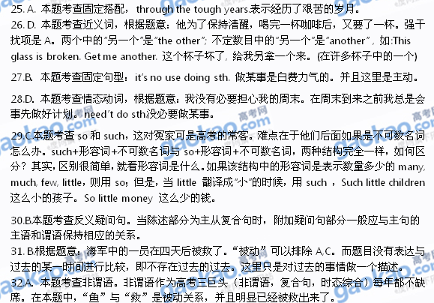
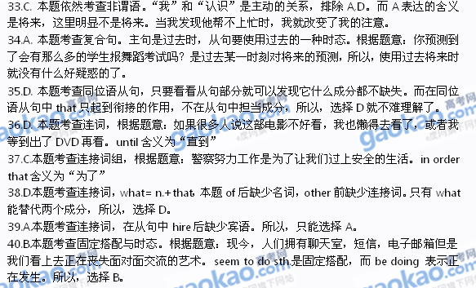

Section B
Directions: Complete the following passage by using the words in the box. Each word can only be used once. Note that there is one word more than you need.
A. launched B. unpleasant C. applying D. technically E. impact
F. coating G. fixed H. miraculously I. superior J. advances
How would you like to wear the same underwear (内衣裤) for weeks? Owing to the work that has gone into developing intelligent materials, this may not be as 41 as it sounds. Self-cleaning clothes have now been created, and these new materials provide 42 resistance to dirt as well as water. As a result, they require much less cleaning than traditional materials.
The creation of self-cleaning clothes provides an example of how nature helps scientists develop better products. This self-cleaning nature is known as the “lotus effect”. The name comes, of course, from the lotus leaves, which are famous for growing in muddy lakes and rivers while remaining almost 43
clean. By observing nature, scientists are 44 the qualities of the lotus leaves to the materials they have engineered. Because of this, some remarkable new products have been 45 . Among them are special windows that are resistant to dirt and water. A special 46 on these windows not only prevents dirt from sticking to their surfaces, but also allows dust to be easily washed off by the rain. In fact, these new windows have already been 47 to some cars. Even when traveling at high speed through rain, these cars never have to use their windshield wipers (雨刮器).
Although we have already seen some practical applications, even more dramatic 48 will be made in the future, and they will, perhaps, change our world completely. Undoubtedly, technology is an important development, and it will have an even bigger 49 on our lives.
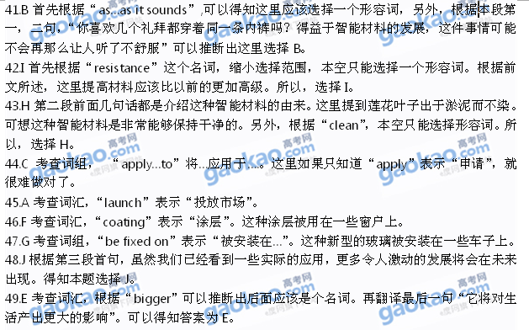
III. Reading Comprehension

Section A
Directions: For each blank in the following passage there are four words or phrases marked A, B, C and D. Fill in each blank with the word or phrase that best fits the context.
Everyone in business has been told that success is all about attracting and retaining (留住) customers. It sounds simple and achievable. But, 50 , words of wisdom are soon forgotten. Once companies have attracted customers they often 51 the second half of the story. In the excitement of beating off the competition, negotiating prices, securing orders, and delivering the product, managers tend to become carried away. They forget what they regard as the boring side of business— 52 that the customer remains a customer.
53 to concentrate on retaining as well as attracting customers costs business huge amounts of money annually. It has been estimated that the average company loses between 10 and 30 per cent of its customers every years. In constantly changing 54 , this is not surprising. What is surprising is the fact that few companies have any idea how many customers they have lost.
Only now are organizations beginning to wake up to those lost opportunities and calculate the 55
implications. Cutting down the number of customers a company loses can make a big 56 in its performance. Research in the US found that a five per cent decrease in the number of defecting (流失的) customers led to 57 increases of between 25 and 85 per cent.
In the US, Domino’s Pizza estimates that a regular customer is worth more than $5,000 over ten years. A customer who receives a poor quality product or service on their first visit and 58 never returns, is losing the company thousands of dollars in 59 profits (more if you consider how many people they are likely to tell about their bad experience).
The logic behind cultivating customer 60 is impossible to deny. “In practice most companies’ marketing effort is focused on getting customers, with little attention paid to 61 them”, says Adrian Payne of Cornfield University’ School of Management. “Research suggests that there is a close relationship between retaining customers and making profits. 62 customers tend to buy more, are predictable and usually cost less to service than new customers. Furthermore, they tend to be less price 63 , and may provide free word-of-mouth advertising. Retaining customers also makes it 64 for competitors to enter a market or increase their share of a market.
- A. in particular B. in reality C. at least D. first of all
- A. emphasize B. doubt C. overlook D. believe
- A. denying B. ensuring C. arguing D. proving
- A. Moving B. Hoping C. Starting D. Failing
- A. markets B. tastes C. prices D. expenses
- A. culture B. social C. financial D. economical
- A. promise B. plan C. mistake D. difference
- A. cost B. opportunity C. profit D. budget
- A. as a result B. on the whole C. in conclusion D. on the contrary
- A. huge B. potential C. extra D. reasonable
- A. beliefs B. loyalty C. habits D. interest
- A. altering B. understanding C. keeping D. attracting
- A. Assumed B. Respected C. Established D. Unexpected
- A. agreeable B. flexible C. friendly D. sensitive
- A. unfair B. difficult C. essential D. convenient
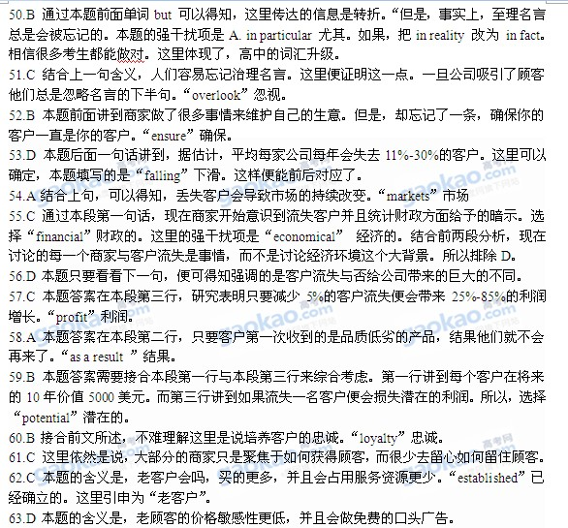

Section B
Directions: Read the following three passages. Each passage is followed by several questions or unfinished statements. For each of them there are four choices marked A, B, C and D. Choose the one that fits best according to the information given in the passage you have just read.

A
The teacher who did the most to encourage me was, as it happened, my aunt. She was Myrtle C. Manigault, the wife of my mother’s brother Bill. She taught in second grade at all-black Summer School in Camden, New Jersey.
During my childhood and youth, Aunt Myrtle encouraged me to develop every aspect of my potential, without regard for what was considered practical or possible for black females. I liked to sing; she listened to my voice and pronounced it good. I couldn’t dance; she taught me the basic dancing steps. She took me to the theatre not just children’s theatre but adult comedies and dramas—and her faith that I could appreciate adult plays was not disappointed.
My aunt also took down books from her extensive library and shared them with me. I had books at home, but they were all serious classics. Even as a child I had a strong liking for humor, and I’ll never forget the joy of discovering Don Marquis’s Archy & Mehitabel through her.
Most important, perhaps, Aunt Myrtle provided my first opportunity to write for publication. A writer herself for one of the black newspapers, she suggested my name to the editor as a “youth columnist”. My column, begun when I was fourteen, was supposed to cover teenage social activities—and it did—but it also gave me the freedom to write on many other subjects as well as the habit of gathering material, the discipline of meeting deadlines, and, after graduation from college six years later, a solid collection of published material that carried my name and was my passport to a series of writing jobs.
Today Aunt Myrtle is still an enthusiastic supporter of her “favourite niece”. Like a diamond, she has reflected a bright, multifaceted (多面的) image of possibilities to every pupil who has crossed her path.
- Which of the following did Aunt Myrtle do to the author during her childhood and youth?
A. She lent her some serious classics. B. She cultivated her taste for music.
C. She discovered her talent for dancing. D. She introduced her to adult plays.
- What does Archy and Mehitabel in Paragraph 3 probably refer to?
A. A book of great fun. B. A writer of high fame.
C. A serious masterpiece. D. A heartbreaking play.
- Aunt Myrtle recommended the author to a newspaper editor mainly to ______.[来
A. develop her capabilities for writing B. give her a chance to collect material
C. involve her in teenage social activities D. offer her a series of writing jobs
- We can conclude from the passage that Aunt Myrtle was a teacher who ______.
A. trained pupils to be diligent and well-disciplined
B. gave pupils confidence in exploiting their potential
C. emphasized what was practical or possible for pupils.
D. helped pupils overcome difficulties in learning

B
Humpback whales
Humpback whales are sometimes called performers of the ocean. This is because they can make impressive movements when they dive. The name “humpback”, which is the common name for this whale, refers to the typical curve shape the whale’s back forms as it dives.[来  Sometimes the humpback will dive with a fantastic movement, known as a breach. During breaching the whale uses its powerful tail flukes to lift nearly two-thirds of its body out of the water in a giant leap. A breach might also include a sideways twist with fins stretched out like wings, as the whale reaches the height of the breach.  A humpback whale breathes air at the surface of the water through two blowholes which are located near the top of the head. It blows a double stream of water that can rise up to 4 meters above the water.  The humpback has a small dorsal fin located towards the tail flukes about two-thirds of the way down its back. Other distinguishing features include large pectoral fins, which may be up to a third of the body length, and unique black and white spots on the underside of the tail flukes. These markings are like fingerprints: no two are the same.  Humpback whales live in large groups. They communicate with each other through complex “songs”. | Quick Facts[
 | Size: | 14m~18m in length  30~50 tons in weight
 | Living | Open ocean and shallow coastline waters
 | Environment: | From warm tropical (热带的) waters, where they breed, to cold polar waters, where they eat.
 | Diet: | Shellfish, plants and fish of small size
 | Hunting: | Sometimes in groups, in which several whales form a circle under the water, blowing bubbles that form a “net” around a school of fish. The fish are then forced up to the surface in a concentrated mass.
 | Current state: | endangered; it is estimated that there are about 5000~7000 humpback whales worldwide.
- According to Quick Facts, a humpback whale ______.
A. cannot survive in waters near the shore B. doesn’t live in the same waters all the time
C. lives mainly on underwater plants D. prefers to work alone when hunting food
- To make a breach, a humpback whale must ______.
A. use its tail flukes to leap out of the water B. twist its body sideways to jump high.
C. blow two streams of water D. communicate with a group of humpbacks.
- From the passage we can learn that a humpback whale ______.
A. has its unique markings on it tail flukes B. has black and white fingerprints
C. gets its name from the way it hunts D. is a great performer due to its songs

C
Human remains of ancient settlements will be reburied and lost to science under a law that threatens research into the history of humans in Britain, a group of leading archeologists (考古学家) says. In a letter addressed to the justice secretary, Ken Clarke, 40 archaeologists write of their “deep and widespread concern” about the issue. It centers on the law introduced by the Ministry of Justice in 2008 which requires all human remains unearthed in England and Wales to be reburied within two years, regardless of their age. The decision means scientists have too little time to study bones and other human remains of national and cultural significance.
“Your current requirement that all archaeologically unearthed human remains should be reburied, whether after a standard period of two years or a further special extension, is contrary to basic principles of archaeological and scientific research and of museum practice,” they write.
The law applies to any pieces of bone uncovered at around 400 dig sites, including the remains of 60 or so bodies found at Stonehenge in 2008 that date back to 3,000 BC. Archaeologists have been granted a temporary extension to give them more time, but eventuallly the bones will have to be returned to the ground.
The arrangements may result in the waste of future discoveries at sites such as Happisburgh in Norfolk, where digging is continuing after the discovery of stone tools made by early humans 950,000 years ago. If human remains were found at Happisburgh, they would be the oldest in northern Europe and the first indication of what this species was. Under the current practice of the law those remains would have to be reburied and effectively destroyed.
Before 2008, guidelines allowed for the proper preservation and study of bones of sufficient age and historical interest, while the Burial Act 1857 applied to more recent remains. The Ministry of Justice assured archaeologists two years ago that the law was temporary, but has so far failed to revise it.
Mike Parker Pearson, an archaeologist at Sheffield University, said: “Archaeologists have been extremely patient because we were led to believe the ministry was sorting out this problem, but we feel that we cannot wait any longer.”
The ministry has no guidelines on where or how remains should be reburied, or on what records should be kept.
- According to the passage, scientists are unhappy with the law mainly because ______.
A. it is only a temporary measure on the human remains
B. it is unreasonable and thus destructive to scientific research
C. it was introduced by the government without their knowledge
D. it is vague about where and how to rebury human remains
- Which of the following statements is true according to the passage?
A. Temporary extension of two years will guarantee scientists enough time.
B. Human remains of the oldest species were dug out at Happisburgh.
C. Human remains will have to be reburied despite the extension of time.
D. Scientists have been warned that the law can hardly be changed.
- What can be inferred about the British law governing human remains?
A. The Ministry of Justice did not intend it to protect human remains.
B. The Burial Act 1857 only applied to remains uncovered before 1857.
C. The law on human remains hasn’t changed in recent decades.
D. The Ministry of Justice has not done enough about the law.
- Which of the following might be the best title of the passage?
A. New discoveries should be reburied, the government demands.
B. Research time should be extended, scientists require.
C. Law on human remains needs thorough discussion, authorities say.
D. Law could bury ancient secrets for ever, archeologists warn.
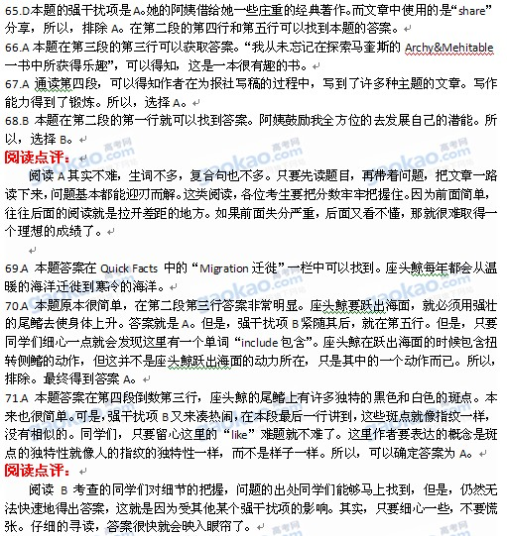
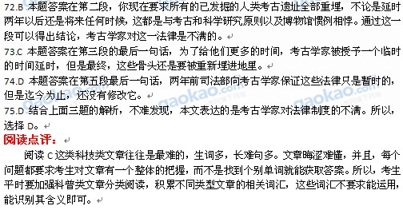

Section C
Directions: Read the following text and choose the most suitable heading from A-F for each paragraph. There is one extra heading which you do not need.
A. Manufacturing industry in information economy
B. News in the age of information
C. Argument about individual accounts and their reliability
D. Be your own investigative journalist
E. Don’t believe everything you read in the newspapers.
F. Information is presented in an entertaining way.
- ______
With the arrival of the age of “information economy”, intellectual work is becoming a more important source of wealth than manufacturing. Organizations in all walks of life are doing more to spread their information. So people of the Public Relations are hired to speak for them. A lot of our news is actually collected from press releases and reports of events intentionally staged for journalists. In the information age, journalists spend their time, not investigating, but passing on the words of a spokesperson.
- ______
There is a joke in the novel Scoop about the newspaper’s owner, Lord Copper. The editors can never disagree with him. When he’s right about something they answer “definitely”, and when he’s wrong they say “to some extent, Lord Copper.” It seems reasonable to suppose that, in the real world, the opinions of such powerful people still influence the journalists and editors who work for them.
- ______
In countries where the news is not officially controlled, it may be provided by commercial organizations who depend on advertising. The news has to attract viewers and maintain its audience ratings. I suspect that some stories get air-time just because there happen to be exciting pictures to show. In Britain, we have the tabloid newspapers which millions of people read simply for entertainment. There is progressively less room for historical background, or statistics, which are harder to present as a sensational story.
- ______
There is an argument that with spreading access to the internet and cheap technology for recording sound and images we will all be able to find exactly the information we want. People around the world will be able to publish their own eye-witness accounts and compete with the widely-accepted news-gatherers on equal terms. But what it will mean also is that we’ll be subjected to a still greater amount of nonsense and lies. Any web log may contain the latest information of the year, or equally, a made-up story that you will never be able to check.
- ______
Maybe the time has come to do something about it, and I don’t just mean changing your choice of TV channel or newspaper. In a world where everyone wants you to listen to their version, you only have two choices: switch off altogether or start looking for sources you can trust. The investigative journalist of the future is everyone who wants to know the truth.
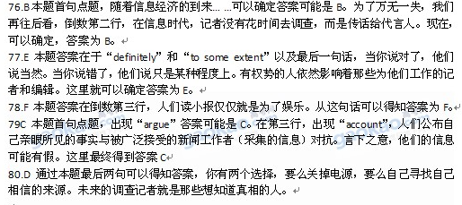

Section D
Directions: Read the passage carefully. Then answer the questions or complete the statements in the fewest possible words.
Sociologists have long recognised that organisations of less than 200 individuals can operate through the free flow of information among the members. Once their size goes beyond this figure, the organizations are getting less flexible. So it seems necessary to prevent total disorder resulting from failures of communication.
One solution to this problem would, of course, be to structure large organisations into smaller units of a size that can act as a group. By allowing these groups to build reliance on each other, larger organizations can be built up. However, merely having groups of, say, 150 will never of itself be a complete solution to the problems of the organization. Something else is needed: the people involved must be able to build direct personal relationships. To allow free flow of information, they have to be able to communicate with each other in a casual way. Maintaining too formal a structure of relationships inevitably prevents the way a system works.
The importance of this was drawn to my attention two years ago by the case of a TV station. Whether by chance or by design, it so happened that there were almost exactly 150 people in the station. The whole process worked very smoothly as an organization for many years until they were moved into purpose-built accommodation. Then, for no apparent reason, the work seemed to be more difficult to do, not to say less satisfying.
It was some time before they work out what the problem was. It turn out that, when the architects were designing the new building, they decided that the coffee room where everyone ate their sandwiches at lunch times was an unnecessary luxury and so did away with it. And with that, they accidentally destroyed the close social networks that strengthened the whole organization. What had apparently been happening was that, as people gathered informally over their sandwiches in the coffee room, useful information was casually being exchanged.
(Note: Answer the questions or complete the statements in NO MORE THAN EIGHT WORDS.)
- What size of an organization may lead to communication failures?
- What are the two solutions to the communication problem within a large organization?
- After the TV station moved into new accommodation, its operation_____________________
- From the case of the TV station, we can conclude it is ________________________________ that make(s) an organization more successful.
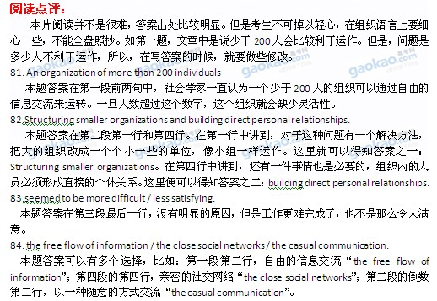
第Ⅱ卷 (共45分)

I. Translation
Directions: Translate the following sentences into English, using the words given in the brackets.
- 你为什么不在网上订票? (Why)
- 我常把王海误认为他的双胞胎弟弟，因为他们长得太像了。(mistake)
- 对父母而言，没有什么能与孩子的身心健康相比。 (compare)
- 自从出国留学后，她就不再和我们保持联系了。 (No longer)
- 如果能找到任何适合你的学习方法，你的学习效率就可能明显提高。(whatever)

II. Guided Writing
Directions: Write an English composition in 120—150 words according to the instructions given below in Chinese.
假如你是启明中学（Ming Qi Middle School）的李明，想申请一个扶贫项目，帮助贫困地区的儿童。根据以下启事，写一封申请信（信中不能提到真实姓名和学校）。

启事
国际儿童基金会将资助中学生开展扶贫项目，以帮助贫困地区的儿童。申请成功者将获得项目经费2000元。
有意者请来信告知：
1） 你个人的基本情况；
2） 你对申请项目的基本设想；
3） 项目经费的使用计划。
联系方式: 2011hope@icf.org
2011

