HAM10000 Pilot — MedGemma-4B-it Findings Report
Zero-Shot Skin Lesion Classification

1. Overview and Experimental Setup
- Model: google/medgemma-4b-it, evaluated zero-shot (no fine-tuning, no few-shot examples)
- Dataset: HAM10000 dermatoscopic skin lesion dataset, 7 diagnostic classes
- Sample: same 105 images (15 per class) used for the earlier Qwen2.5-VL pilot, via identical random seed
- Task: the model is shown an image and a list of the 7 candidate diagnoses, and must respond with exactly one class code
- Scoring: exact-match accuracy against the reference label
7 of 105 responses (6.7%) could not be parsed into a valid class code — these are treated as incorrect in the headline accuracy below.

2. Quantitative Results
Metric | Value | Note
Overall accuracy | 16.2% | 17/105 correct; 95% CI: [9.1%, 23.2%]
Random baseline (1 of 7) | 14.3% | For reference only
Unparsed responses | 6.7% | 7/105 — see Section 5

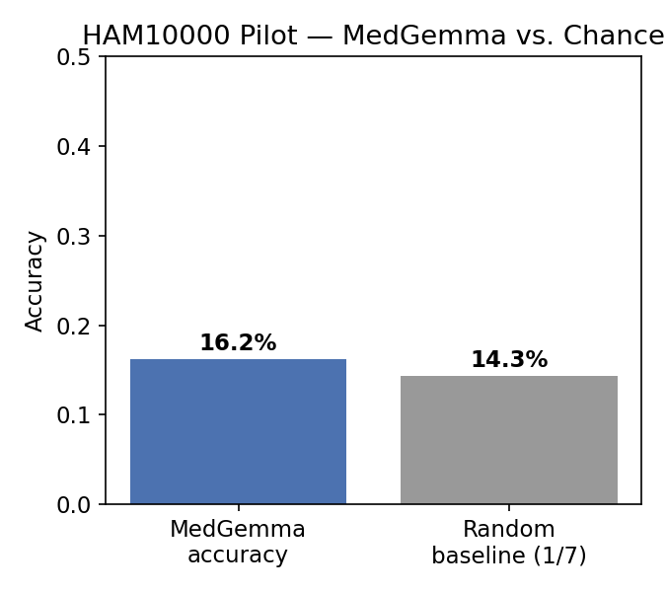
MedGemma's accuracy sits only marginally above the 7-class random baseline, with a wide confidence interval reflecting the small sample size.

3. Per-Class Performance
Class | Precision | Recall | F1-score | Support
akiec | 0.000 | 0.000 | 0.000 | 15
bcc | 0.062 | 0.067 | 0.065 | 15
bkl | 0.333 | 0.067 | 0.111 | 15
df | 0.000 | 0.000 | 0.000 | 15
mel | 0.218 | 0.800 | 0.343 | 15
nv | 0.130 | 0.200 | 0.158 | 15
vasc | 0.000 | 0.000 | 0.000 | 15

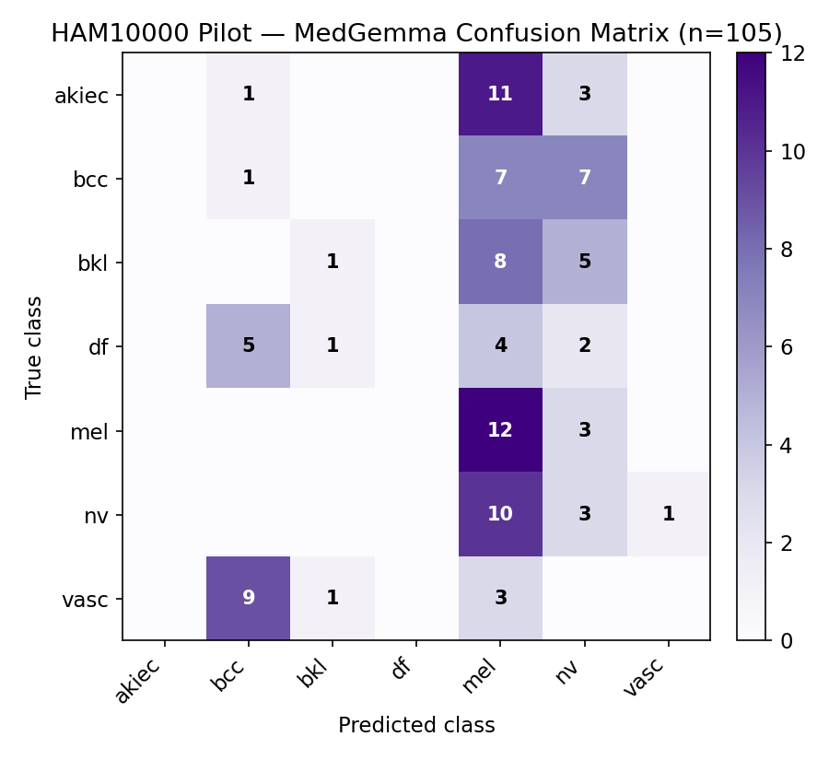

4. Class Prediction Distribution
MedGemma never predicted 2 of the 7 classes (akiec, df) across all 105 images, and predicted 2 more (bkl, vasc) only once or three times combined. Its predictions collapsed heavily onto melanoma (mel) — predicted 55 times out of 105, more than half of all responses — despite melanoma being the true label only 15 times.
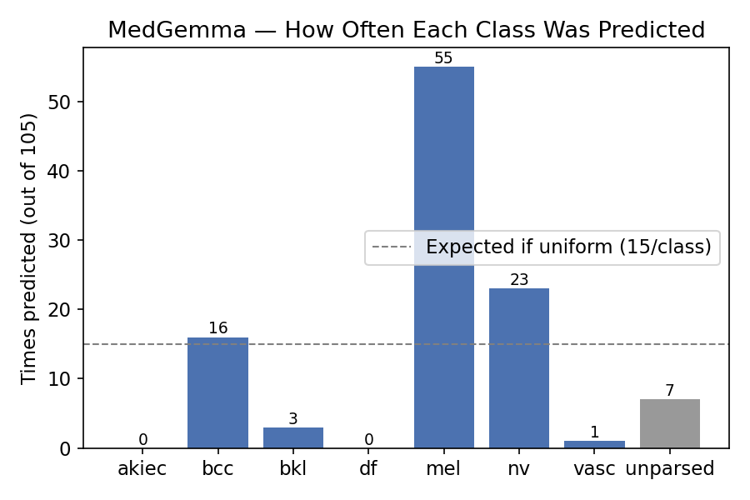
Class | Times Predicted | Times True
mel | 55 | 15
nv | 23 | 15
bcc | 16 | 15
bkl | 3 | 15
vasc | 1 | 15
akiec, df combined | 0 | 30

5. Qualitative Error Analysis
The dominant pattern is a strong melanoma bias: akiec was misread as mel in 11 of 15 cases, and bcc was split fairly evenly between mel (7 of 15) and nv (7 of 15) — rarely predicted as bcc itself despite that being an available option. Vascular lesions (vasc) were most often misread as bcc (9 of 15), a different confusion pattern than melanoma over-calling.
Confusion | Count | Example image IDs | Direction
akiec → mel | 11 / 15 | ISIC_0024646, ISIC_0027753 | Precancerous lesion read as melanoma
vasc → bcc | 9 / 15 | ISIC_0027937, ISIC_0027983 | Vascular lesion read as basal cell carcinoma
bcc → nv | 7 / 15 | ISIC_0025031, ISIC_0024931 | Basal cell carcinoma read as benign mole
bcc → mel | 7 / 15 | ISIC_0031597, ISIC_0031062 | Basal cell carcinoma read as melanoma

A distinct finding from the unparsed responses: all 7 unparsed cases produced the exact same invalid output, “bcl” — not a random parsing failure, but a consistent, repeated non-answer, occurring across df (3 cases), vasc (2 cases), bkl (1 case), and nv (1 case). This suggests MedGemma has a specific failure mode on certain images — possibly conflating the “bcc” and “bkl” codes into a non-existent third token — rather than simply failing to follow the output-format instruction.

6. Discussion
At n = 105 (15 per class), the confidence interval on overall accuracy is wide (roughly 9–23%), and three classes (akiec, df, and effectively bkl/vasc) have zero or near-zero correct predictions, so per-class metrics for these classes should be read as directional rather than precise.
The melanoma-collapse pattern (55 of 105 predictions) is the most consistent finding and mirrors a documented failure mode in the zero-shot VLM literature, where models default to whichever diagnosis is most frequently discussed in training data rather than genuinely discriminating between visually similar classes.
The repeated “bcl” non-answer (Section 5) is worth a closer look in the full-scale study — if it recurs at larger sample sizes, it may indicate a specific confusion in how MedGemma represents the bcc/bkl class boundary, which would be a genuinely interesting, model-specific finding rather than generic zero-shot noise.

