HAM10000 Pilot — Findings Report
Zero-Shot Skin Lesion Classification — Qwen2.5-VL-3B-Instruct

1. Overview and Experimental Setup
- Model: Qwen2.5-VL-3B-Instruct, evaluated zero-shot (no fine-tuning, no few-shot examples)
- Dataset: HAM10000 dermatoscopic skin lesion dataset, 7 diagnostic classes
- Sample: 105 images, stratified 15 per class
- Task: the model is shown an image and a list of the 7 candidate diagnoses, and must respond with exactly one class code
- Scoring: exact-match accuracy against the reference label
All 105 model responses parsed cleanly into one of the 7 class codes, with no unparsable outputs.

2. Quantitative Results
Metric | Value | Note
Overall accuracy | 22.9% | 95% CI: [14.8%, 30.9%]
Random baseline (1 of 7) | 14.3% | For reference only

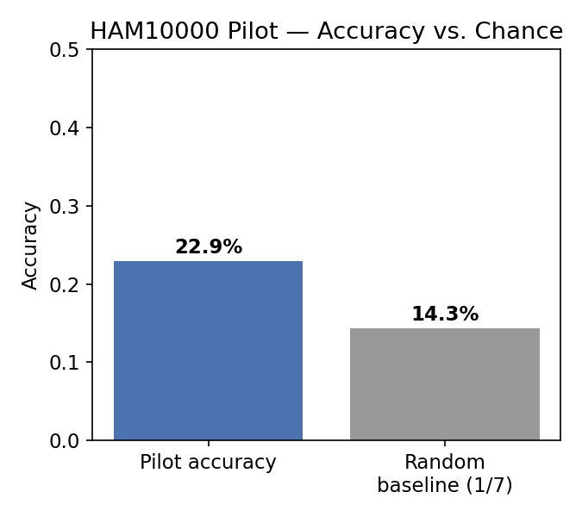
The pilot accuracy is above the 7-class random baseline, but the per-class breakdown below shows this is driven almost entirely by strong performance on one class (melanoma) rather than balanced performance across all 7.

3. Per-Class Performance
Class | Precision | Recall | F1-score | Support
akiec | 0.500 | 0.200 | 0.286 | 15
bcc | 0.000 | 0.000 | 0.000 | 15
bkl | 0.154 | 0.267 | 0.195 | 15
df | 0.000 | 0.000 | 0.000 | 15
mel | 0.250 | 0.800 | 0.381 | 15
nv | 0.200 | 0.333 | 0.250 | 15
vasc | 0.000 | 0.000 | 0.000 | 15

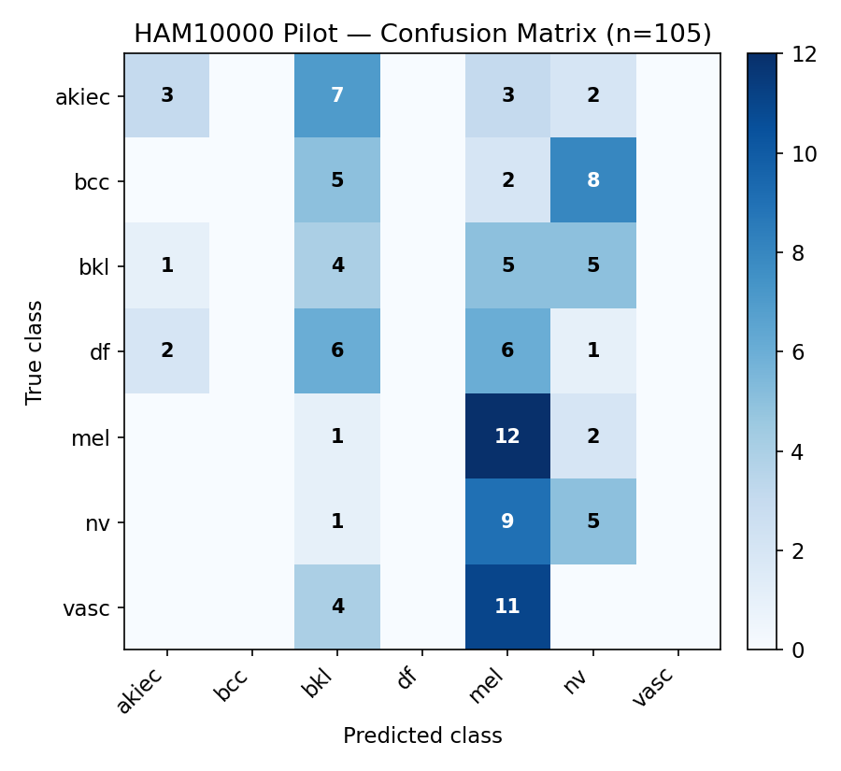

4. Class Prediction Distribution — the Central Finding
The model never once predicted three of the seven classes — basal cell carcinoma (bcc), dermatofibroma (df), and vascular lesions (vasc) — across all 105 images, regardless of the true label. Its predictions instead collapsed onto four classes, heavily concentrated on melanoma (mel), which it predicted 48 times out of 105 despite melanoma being the true label only 15 times.
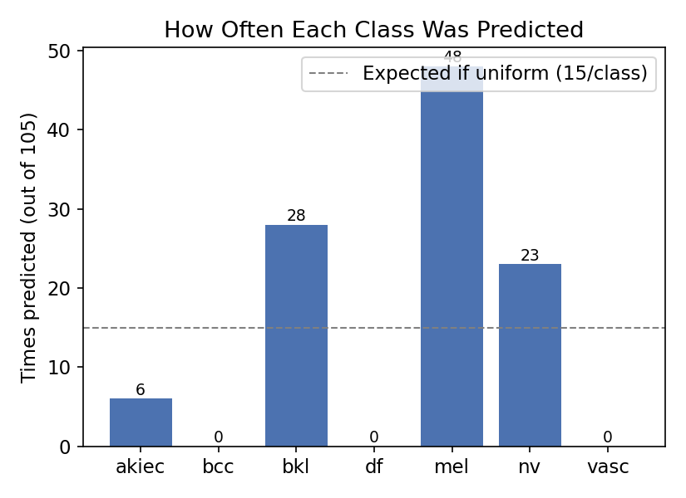
Class | Times Predicted | Times True | Ratio
mel | 48 | 15 | 3.2× over-predicted
bkl | 26 | 15 | 1.7× over-predicted
nv | 25 | 15 | 1.7× over-predicted
akiec | 6 | 15 | 0.4× under-predicted
bcc, df, vasc combined | 0 | 45 | Never predicted

5. Qualitative Error Analysis
Since three classes were never predicted, every true instance of bcc, df, and vasc was necessarily misclassified. The clearest pattern: vascular lesions (vasc) were misread as melanoma in 11 of 15 cases — a striking specific confusion given these are visually distinct lesion types in principle.
Confusion | Count | Example image IDs | Direction
vasc → mel | 11 / 15 | ISIC_0027937, ISIC_0027983 | Vascular lesion read as melanoma
bcc → nv | 9 / 15 | ISIC_0031597, ISIC_0025031 | Basal cell carcinoma read as benign mole
akiec → bkl | 6 / 15 | ISIC_0029041, ISIC_0026702 | Precancerous lesion read as benign keratosis
df → mel | 6 / 15 | ISIC_0030427, ISIC_0024845 | Dermatofibroma read as melanoma

The bcc → nv pattern is clinically notable in the opposite direction from the others: it under-calls a malignant condition (basal cell carcinoma) as benign (nevus), whereas the vasc/df → mel pattern over-calls benign or non-melanoma lesions as melanoma. The model does not have one single directional bias — it has collapsed its usable vocabulary to roughly four classes and is sorting most images into whichever of those four looks closest, rather than reliably distinguishing all seven.

6. Discussion
This pattern is consistent with documented limitations of general-purpose, non-dermatology-tuned VLMs on HAM10000's fine-grained 7-class task, not an artifact of this pipeline. Independent evaluations report GPT-4V at 30.8% and LLaVA at 6.7% accuracy on a HAM10000 zero-shot subset, and a separate study found LLaVA-1.6 at only 3.18% zero-shot accuracy on HAM10000 — this pilot's 22.9% sits within that same broad range for untuned general VLMs. Class-collapse toward a single dominant category has also been separately documented: CLIP-like zero-shot models on dermatology tasks have been reported to default heavily toward predicting the benign nevus class.
At n = 105 (15 per class), the confidence interval on overall accuracy is wide (roughly 15–31%), and three classes have zero correct predictions, so per-class precision/recall for bcc, df, and vasc cannot be meaningfully distinguished from each other at this sample size — the finding that matters here is qualitative (which classes collapse, and into what) rather than the precise percentages.

