VQA-RAD Pilot — MedGemma-4B-it Findings Report
Zero-Shot Closed-Ended Medical VQA

1. Overview and Experimental Setup
- Model: google/medgemma-4b-it, evaluated zero-shot (no fine-tuning, no few-shot examples)
- Dataset: VQA-RAD closed-ended (yes/no) subset
- Sample: same 100 question-answer pairs used for the earlier Qwen2.5-VL pilot (50 true “yes” / 50 true “no”), via identical random seed
- Task: the model is shown a radiology image and a clinical question, and must answer with exactly “Yes” or “No”
- Scoring: exact-match accuracy against the reference answer
All 100 model responses parsed cleanly into a Yes/No answer with no unparsable outputs.

2. Quantitative Results
Metric | Value | 95% Confidence Interval
Overall accuracy | 82% | [74.5%, 89.5%]
Sensitivity (true = Yes) | 86% | 43/50 correct
Specificity (true = No) | 78% | 39/50 correct

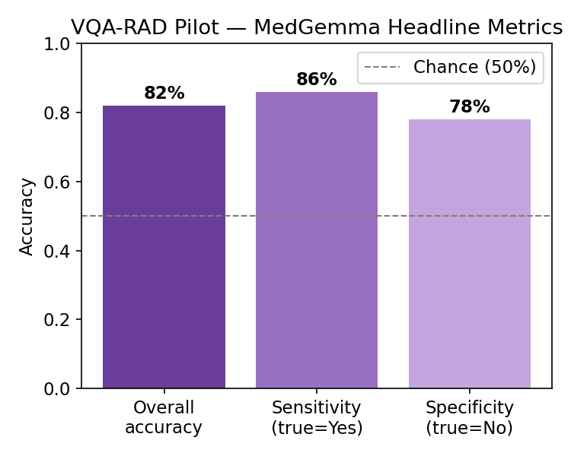

3. Confusion Matrix
 | Predicted: Yes | Predicted: No
True: Yes | 43 | 7
True: No | 11 | 39

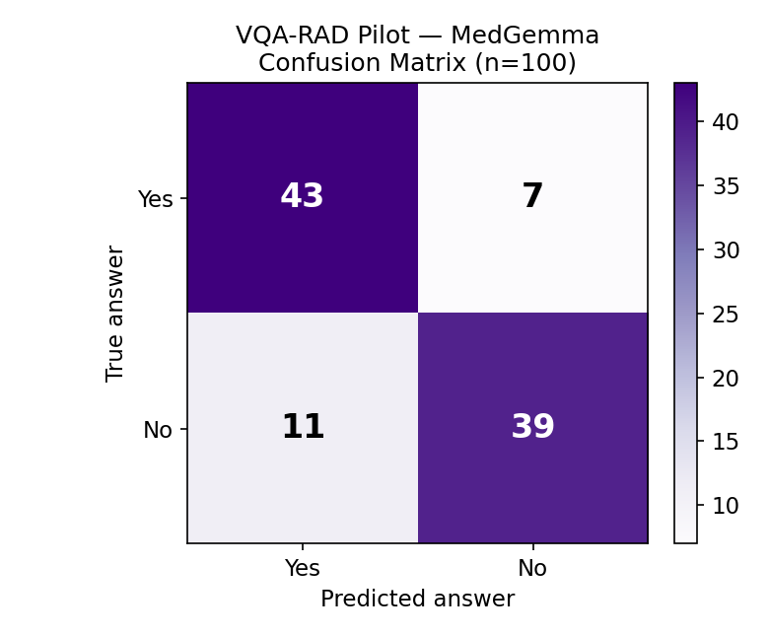

4. Exploratory Breakdown by Question Type
As with the earlier Qwen2.5-VL report, these categories are a keyword-based approximation built for this report, not official VQA-RAD metadata, and should be read as exploratory given the small per-category sample sizes.
Category | n | Accuracy | Note
Other / unmatched | 56 | 87.5% | Largest bucket; keyword rules did not match
Presence / absence | 24 | 83.3% | e.g. “is X present?”
Normal / abnormal | 10 | 70.0% | Weaker than overall average
Modality | 4 | 25.0% | Weakest category — but very small n
Size | 4 | 100% | Small n
Positioning | 2 | 50.0% | Very small n — not meaningful alone

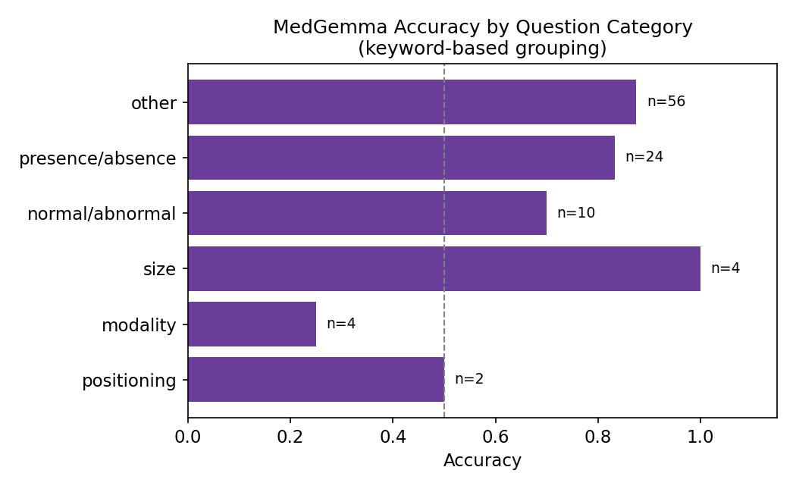

5. Qualitative Error Analysis
Of the 18 total errors, 11 were false positives (true “No”, model answered “Yes”) and 7 were false negatives (true “Yes”, model answered “No”) — a similar mild “yes-leaning” imbalance as the earlier Qwen2.5-VL pilot, though less extreme in proportion (61% vs. 39% of errors here, compared to a similar split previously).

False positive examples (true: No, predicted: Yes)
Question | True | Predicted
Is this an anterior-posterior image? | No | Yes
Is this a CT image? | No | Yes
Is this a saggital view of the brain? | No | Yes
Are there any pulmonary findings? | No | Yes

False negative examples (true: Yes, predicted: No)
Question | True | Predicted
Does this patient have a pneumothorax? | Yes | No
Are there gallstones? | Yes | No
Is the GB (gallbladder) normal? | Yes | No
Is the right hemidiaphragm higher than the left? | Yes | No

Unlike the Qwen2.5-VL pilot, where false positives clustered specifically around named-abnormality presence questions, MedGemma's false positives are more heterogeneous — notably including three modality/orientation identification questions (anterior-posterior view, CT vs. other modality, sagittal plane) that were answered incorrectly with “Yes.” This suggests a distinct weak point in basic image-orientation/modality recognition, separate from clinical-finding over-calling. The pneumothorax miss among false negatives is clinically notable, as this is a time-critical finding to miss.

6. Discussion
At n = 100, the 95% confidence interval on overall accuracy spans roughly 75–90%, narrower than the HAM10000 pilot's interval given the higher accuracy and larger effective per-class sample. The modality-question weakness (1 of 4 correct) is based on a very small sample and should be treated as a hypothesis for the full-scale study rather than a confirmed pattern.
This result stands in a notably different position from the HAM10000 MedGemma pilot: on this closed-ended VQA task, MedGemma's accuracy is well above the general-purpose comparison point from the earlier pilot, whereas on HAM10000 classification MedGemma performed below it. Formal comparison of both models on both tasks is planned as a separate step.

