VQA-RAD Pilot — Findings Report
Zero-Shot Closed-Ended Medical VQA — Qwen2.5-VL-3B-Instruct

1. Overview and Experimental Setup
- Model: Qwen2.5-VL-3B-Instruct, evaluated zero-shot (no fine-tuning, no few-shot examples)
- Dataset: VQA-RAD closed-ended (yes/no) subset
- Sample: 100 question-answer pairs, stratified to a balanced 50 “yes” / 50 “no” ground truth split
- Task: the model is shown a radiology image and a clinical question, and must answer with exactly “Yes” or “No”
- Scoring: exact-match accuracy against the reference answer
All 100 model responses parsed cleanly into a Yes/No answer with no ambiguous or unparsable outputs, indicating the zero-shot prompt format was well-specified for this model.

2. Quantitative Results
Metric | Value | 95% Confidence Interval
Overall accuracy | 68% | [58.9%, 77.1%]
Sensitivity (true = Yes) | 72% | [59.6%, 84.4%]
Specificity (true = No) | 64% | [50.7%, 77.3%]

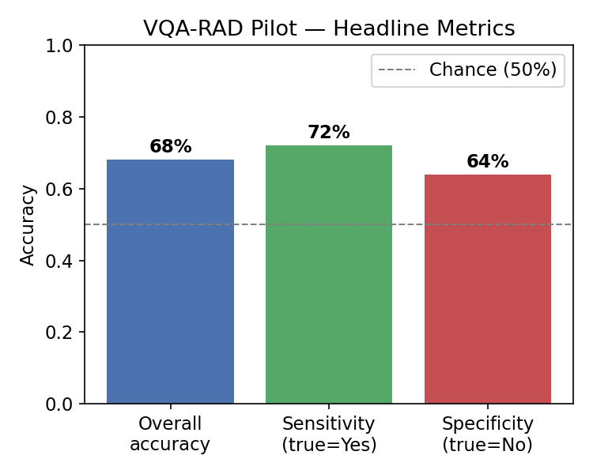

3. Confusion Matrix
 | Predicted: Yes | Predicted: No
True: Yes | 36 | 14
True: No | 18 | 32

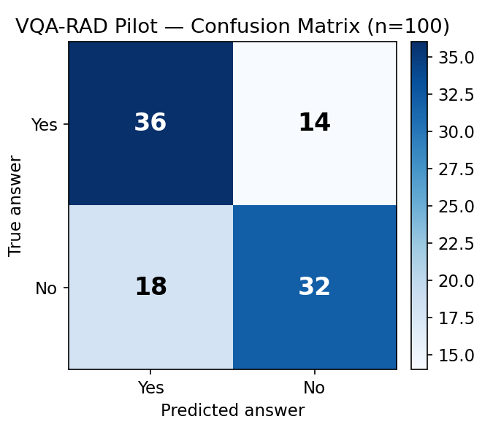

4. Exploratory Breakdown by Question Type
The public VQA-RAD release used for this pilot does not retain the original question-category metadata. The categories below are a keyword-based approximation built for this report (e.g. questions containing “present” or “evidence of” were grouped as “presence/absence”), not official dataset labels, and should be read as exploratory rather than definitive — several categories have very small sample sizes.
Category | n | Accuracy | Note
Other / unmatched | 58 | 72.4% | Largest bucket; keyword rules did not match
Presence / absence | 24 | 62.5% | e.g. “is X present?”
Normal / abnormal | 10 | 50.0% | Weakest category, but very small n
Size | 4 | 75.0% | Small n
Modality | 3 | 66.7% | Small n
Positioning | 1 | 100% | Single example — not meaningful alone

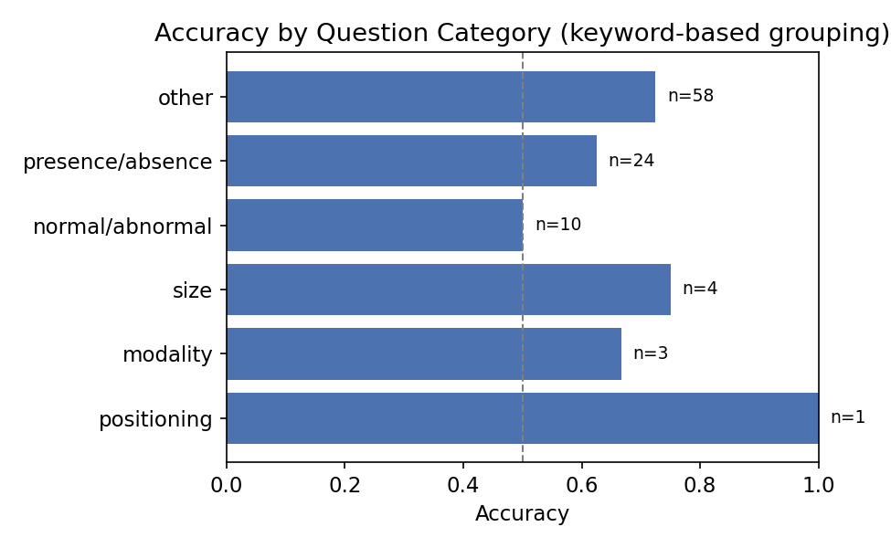

5. Qualitative Error Analysis
Of the 32 total errors, 18 were false positives (true answer “No”, model answered “Yes”) and 14 were false negatives (true answer “Yes”, model answered “No”). Combined with the model predicting “Yes” slightly more often overall (54 times vs. 50 true “Yes” cases), this points to a mild “over-calling” bias — the model leans toward reporting a finding as present when asked directly about a specific abnormality, even when the correct answer is that it is absent.

False positive examples (true: No, predicted: Yes)
Question | True | Predicted
Is mass effect present? | No | Yes
Is there a chest tube placed? | No | Yes
Is a subarachnoid bleed present? | No | Yes
Is there free air in the abdomen? | No | Yes

False negative examples (true: Yes, predicted: No)
Question | True | Predicted
Does this patient have a pneumothorax? | Yes | No
Is there a mass | Yes | No
Is there edema present near the lesion? | Yes | No
Is there swelling of the grey matter? | Yes | No

The false positives cluster around questions naming a specific abnormal finding (mass effect, chest tube, subarachnoid bleed, free air) — the model may be responding to the clinical plausibility or salience of the named finding rather than visual evidence in the image itself. The false negatives are more varied and do not show as clear a pattern, suggesting genuine visual-recognition misses rather than a systematic bias in that direction.

6. Discussion
At n = 100, the 95% confidence interval on overall accuracy spans roughly 59–77%, so this pilot should be read as a rough signal rather than a precise estimate — the full-scale study (using the full closed-ended pool of roughly 1,300 pairs) will narrow this considerably.

