How to Play:  
Run the program. When the game starts, 24 pairs of Pokemon images are shuffled into the screen.  
[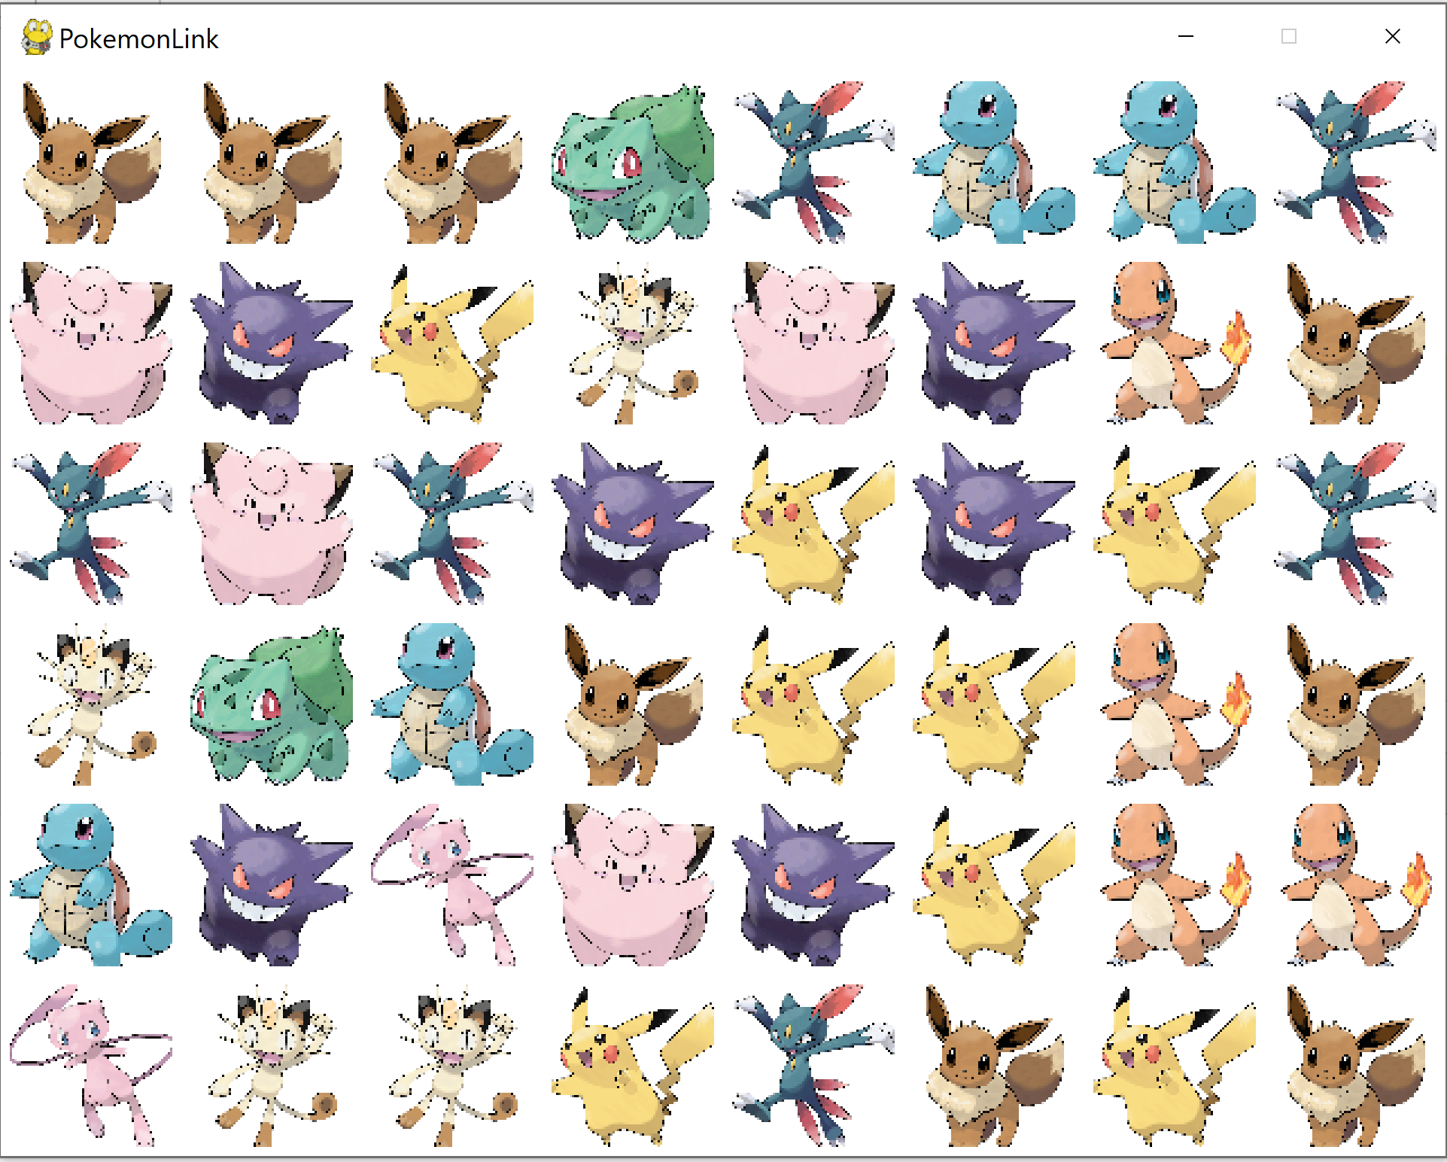](https://github.com/RXC0765/Assignment-3---Final-Project/blob/main/images/1.png) The player needs to find and click all the same Pokemon images that can be connected in pairs. Every time a pair is clicked, they will disappear.  
[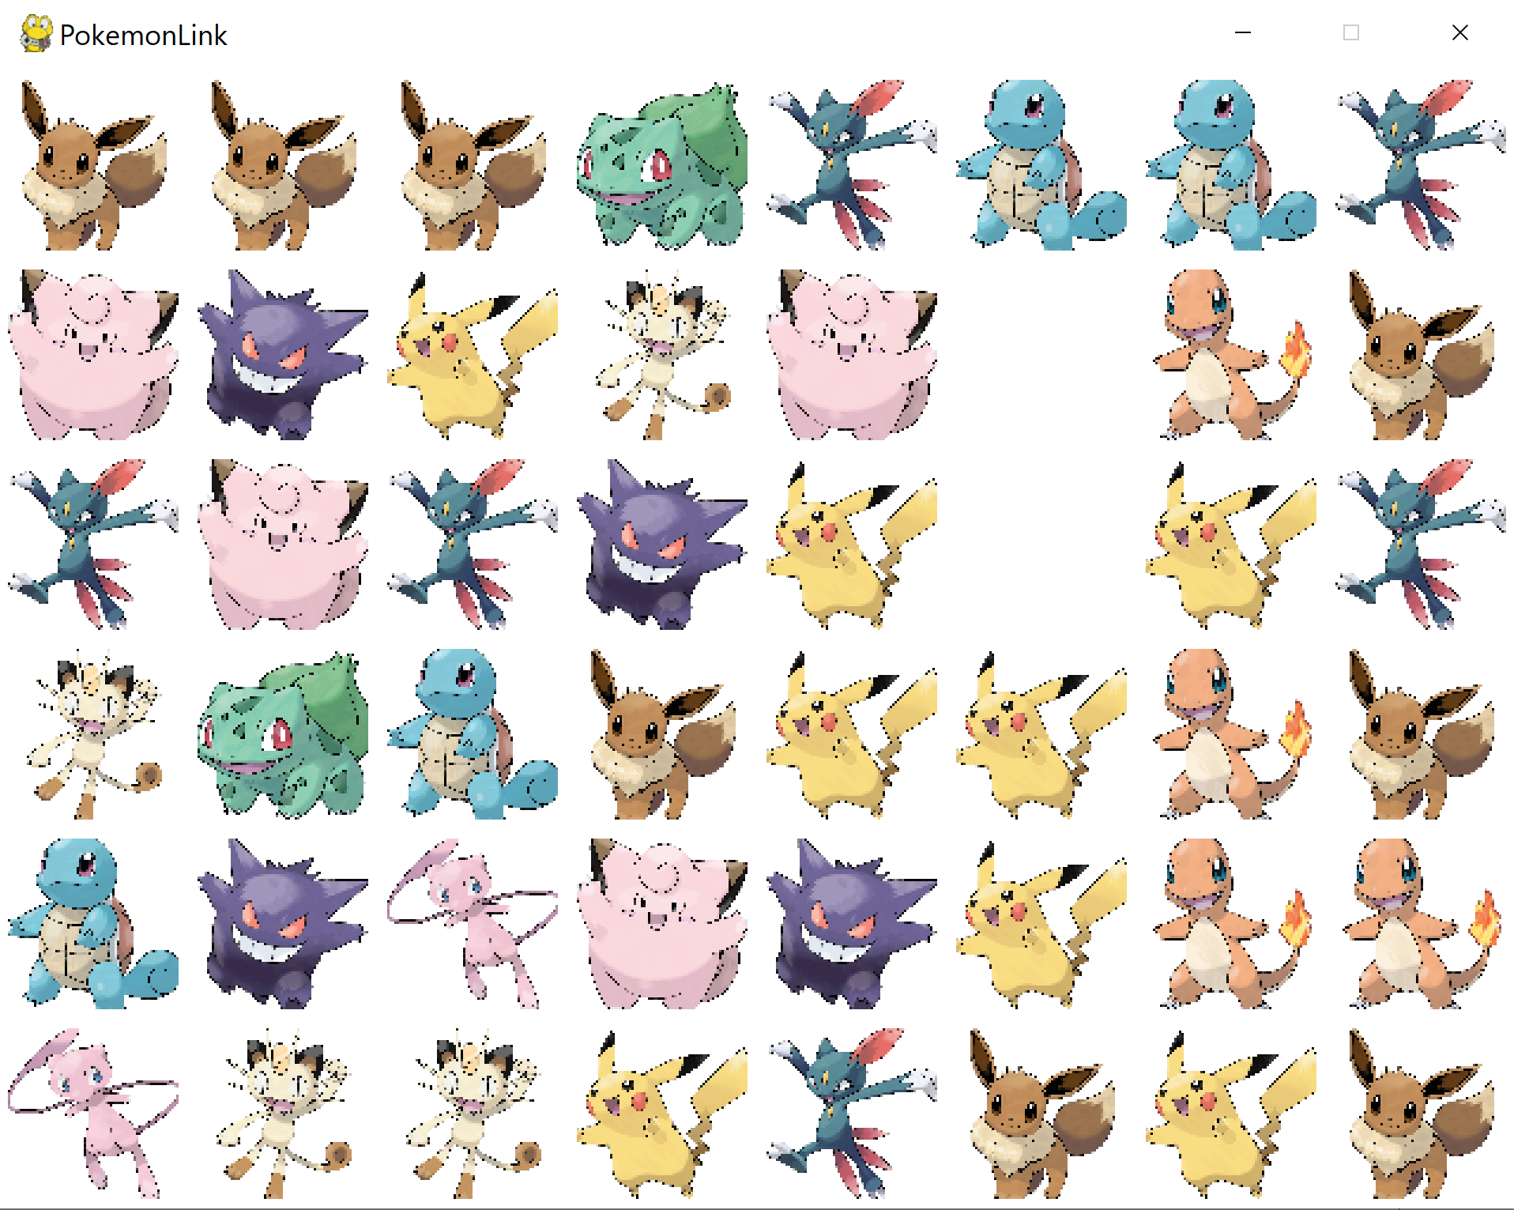](https://github.com/RXC0765/Assignment-3---Final-Project/blob/main/images/2.png) [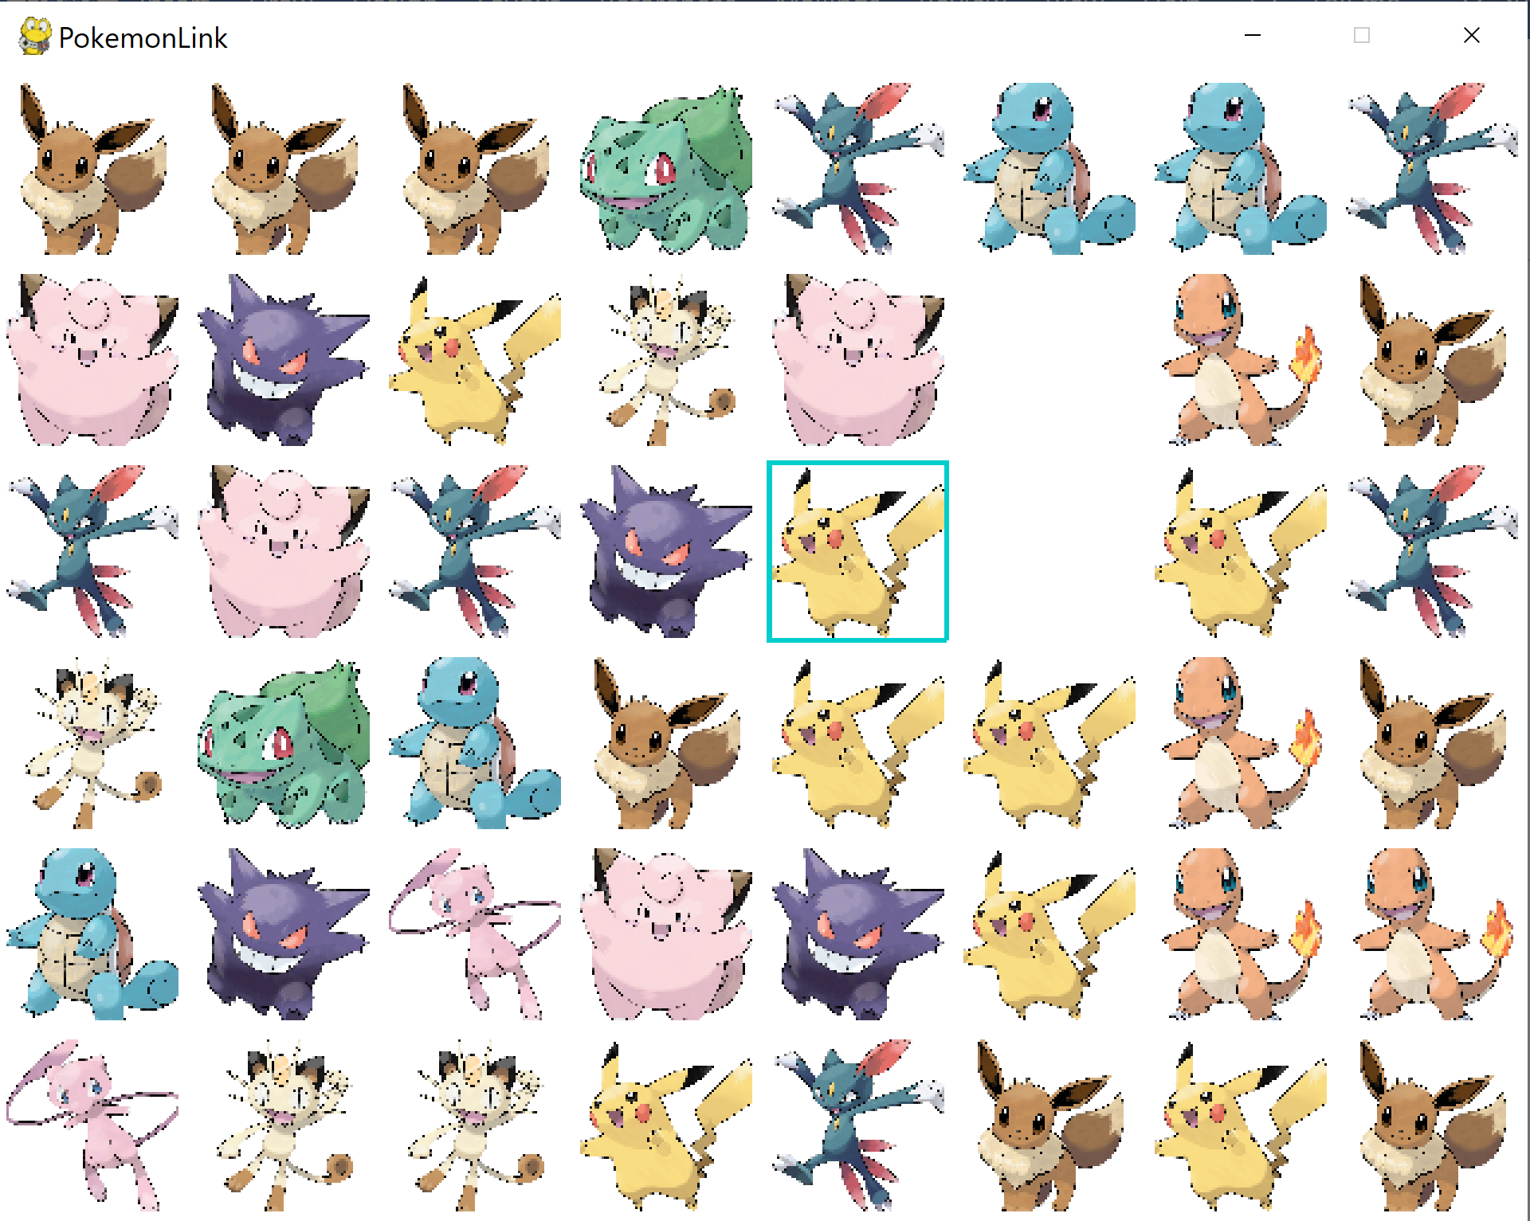](https://github.com/RXC0765/Assignment-3---Final-Project/blob/main/images/3.png) [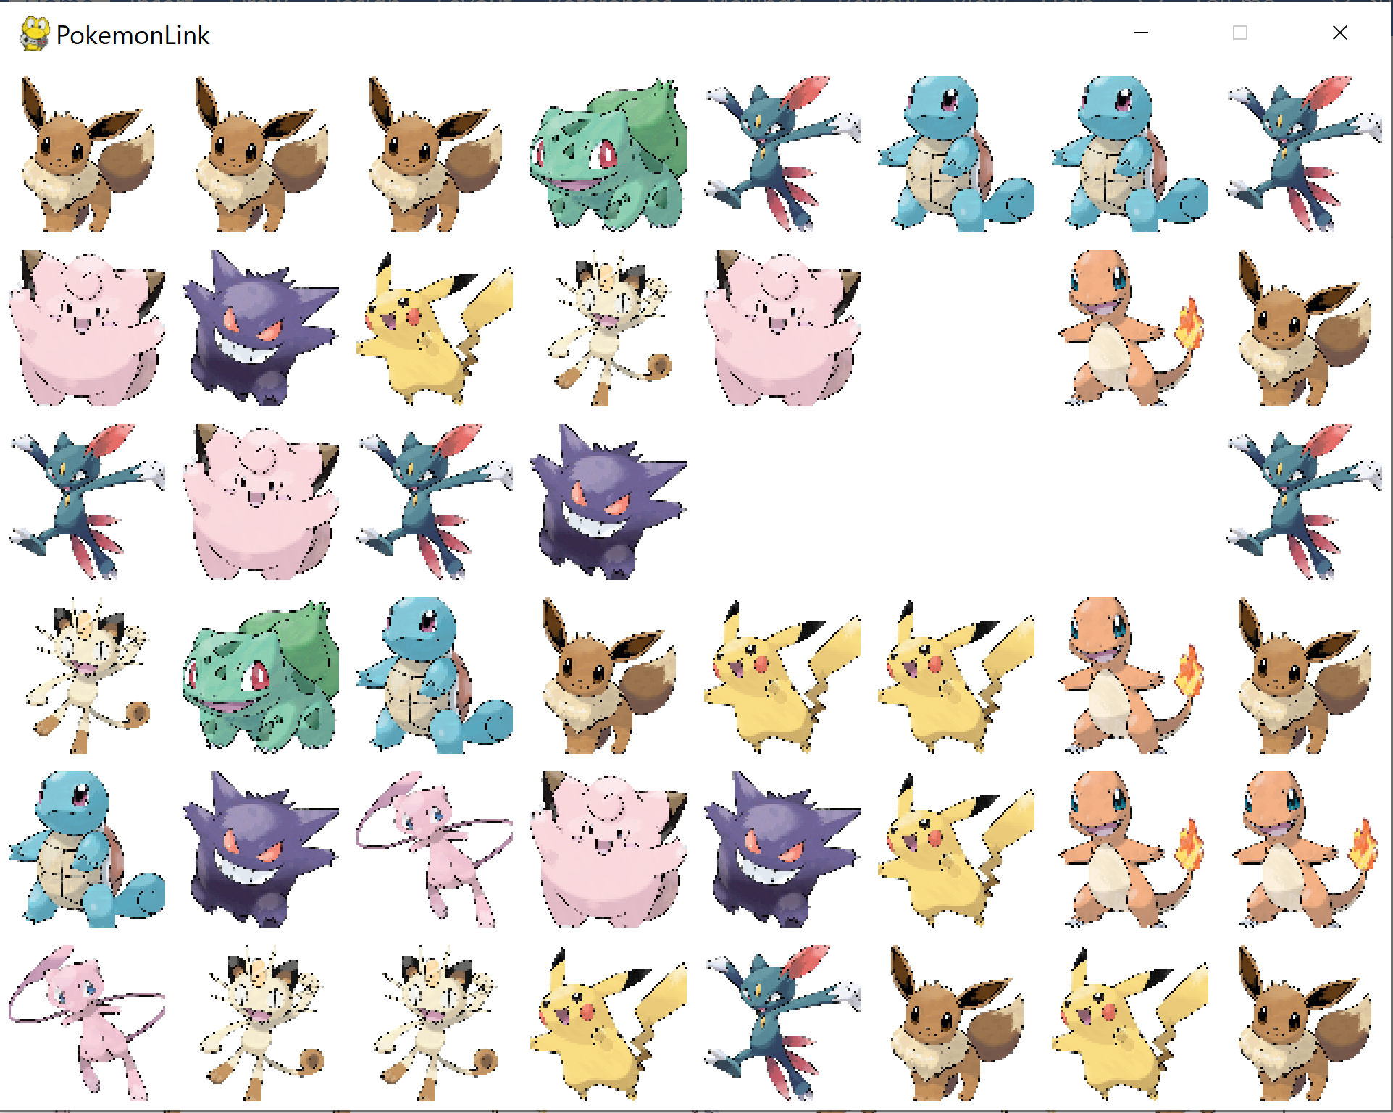](https://github.com/RXC0765/Assignment-3---Final-Project/blob/main/images/4.png) To be able to connect means that the connection from one image to another cannot be more than two bends, whether horizontal or vertical.  
This is an example of two images that can be cleared.  
[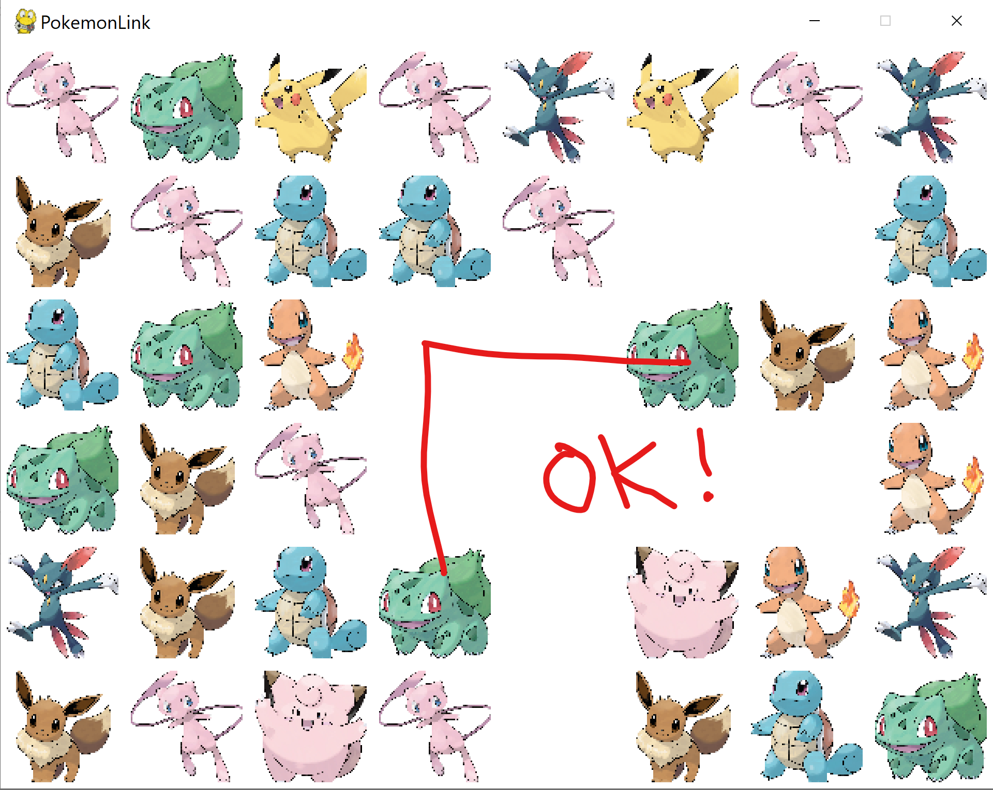](https://github.com/RXC0765/Assignment-3---Final-Project/blob/main/ok.png) This is an example of connection between two images is over two bends, which cannot be cleared.  
[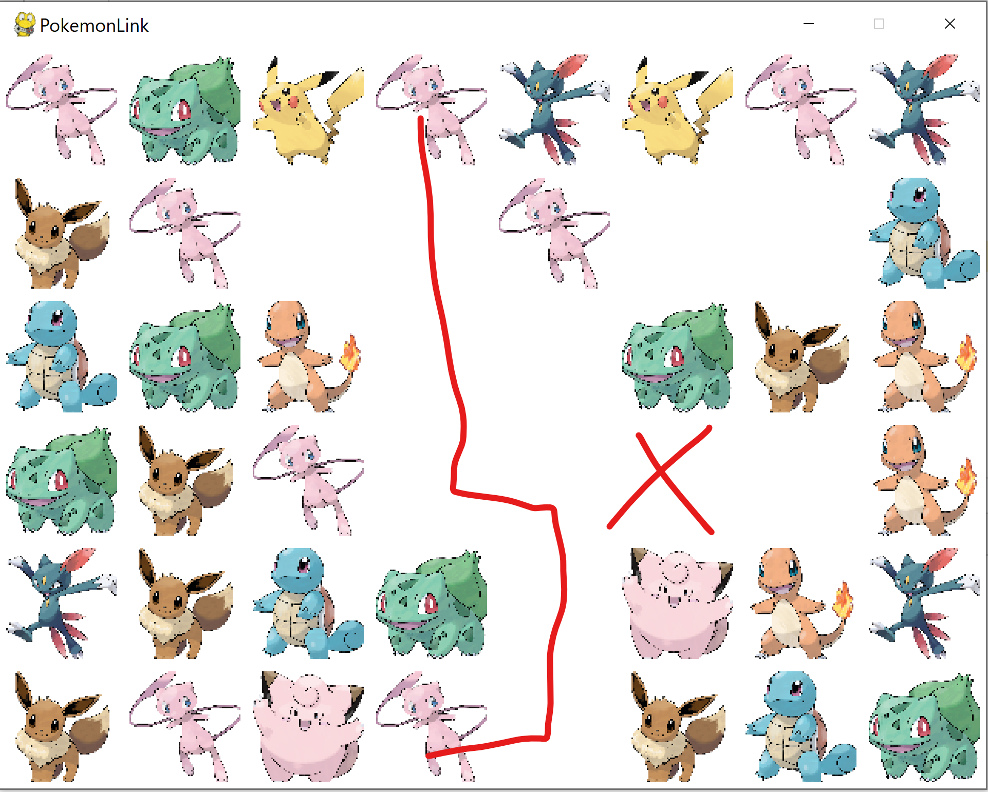](https://github.com/RXC0765/Assignment-3---Final-Project/blob/main/over2.png) The connection between two images also cannot pass over other images. [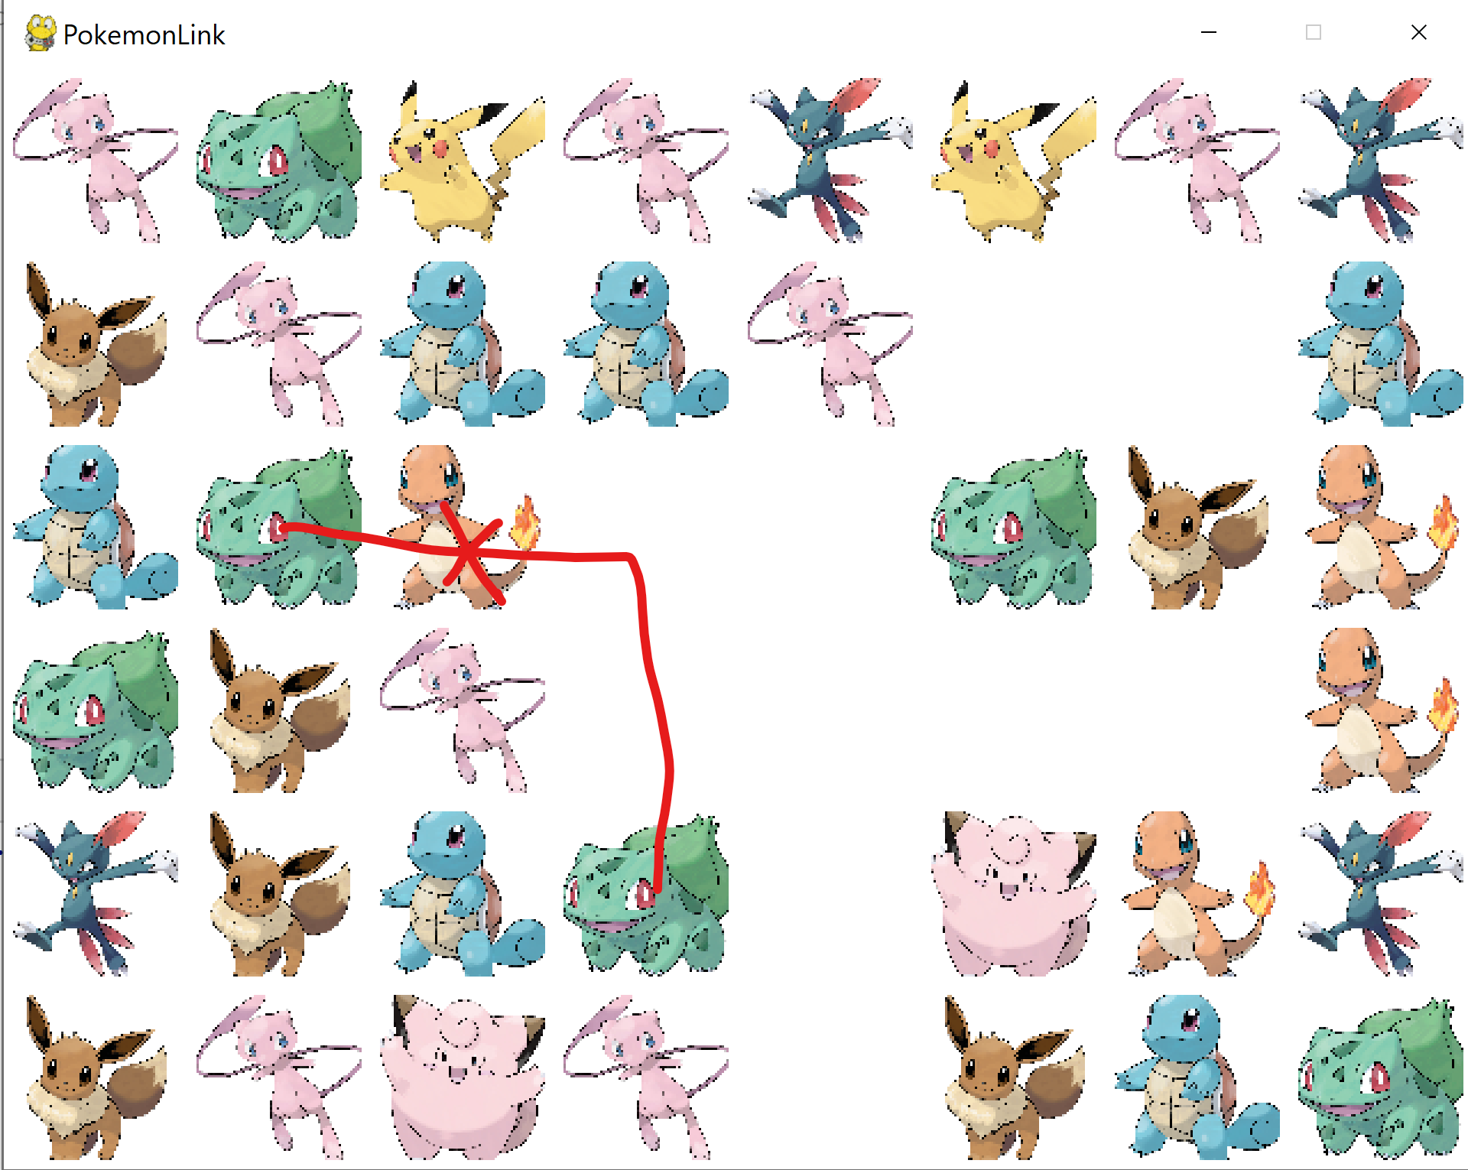](https://github.com/RXC0765/Assignment-3---Final-Project/blob/main/col.png) When all images are cleared, the player wins. [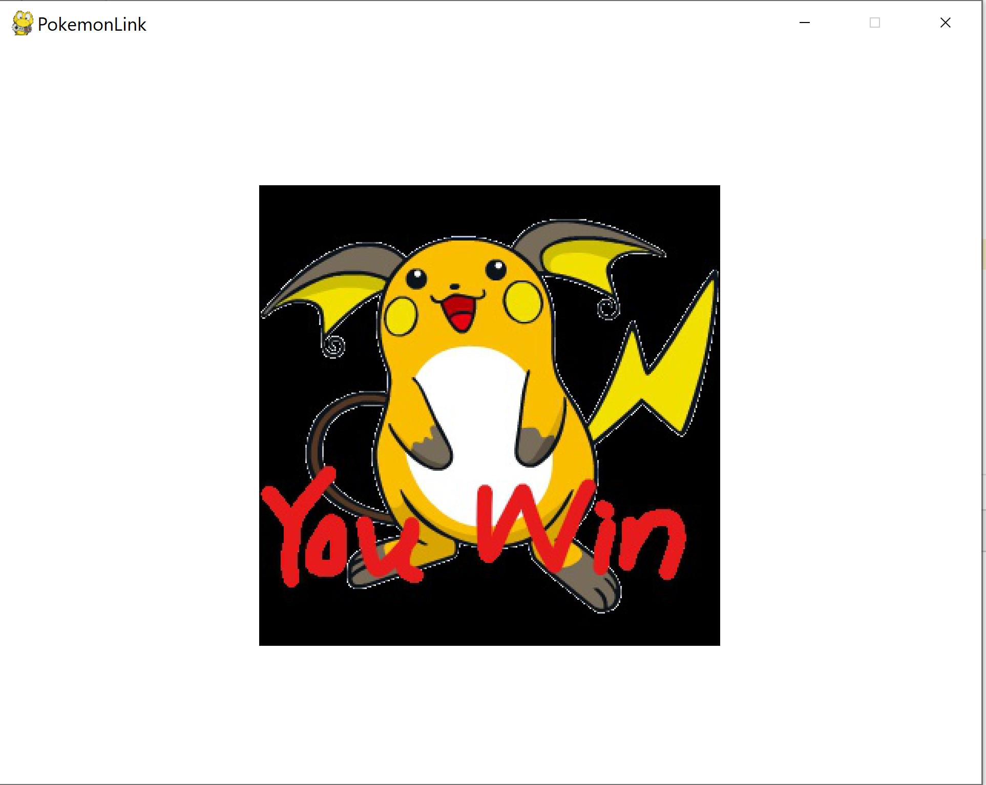](https://github.com/RXC0765/Assignment-3---Final-Project/blob/main/images/5.png)