第8章课后习题：
8.2, 8.3，8.8, 8.10, 8.11, 8.13，8.22(1)(2)
补充题：
1.If a byte-addressable machine with 32-bit words stores the hex value 98765432 at address 0x00, indicate how this value would be stored on a little- endian machine and on a big-endian machine.
2.Assume that there are two types of static memory chips: 128×8 bit (total 4 chips) and 512×4 bit (total 2 chips). Please use these memory chips to implement a 512×16 bit memory. Draw the figure of the memory organization.
3. A computer system has a cache organized in set associative manner, with 4 blocks per set and 64 words per block. The cache consists of 32 blocks and the main memory consists of 1024 blocks. The main memory is word-addressable.
(1)How many bits are there in main memory address?
(2)Calculate the number of bits in each of the TAG, SET, and WORD fields of the main memory address format.
(3)Assuming that the cache is initially empty. The processor fetches 3072 words sequentially from main memory locations 0, 1, …, 3071. Assume that the LRU algorithm is used for block replacement. Compute the hit rate of this cache.
4. A 4-way set associative mapped cache consists of 8 blocks. The main memory contains 32 blocks, each consisting of two 16-bit words. The memory is byte-addressable.
(1) How many bits are there in each of the Tag, Set, and Word fields?
(2) The processor reads data sequentially from the following hex addresses:
14, 3A, 4C, 72 ,64, 56
Assume that the cache is initially empty. Show the contents of the cache at the end of each data read. LRU replacement algorithm is used.
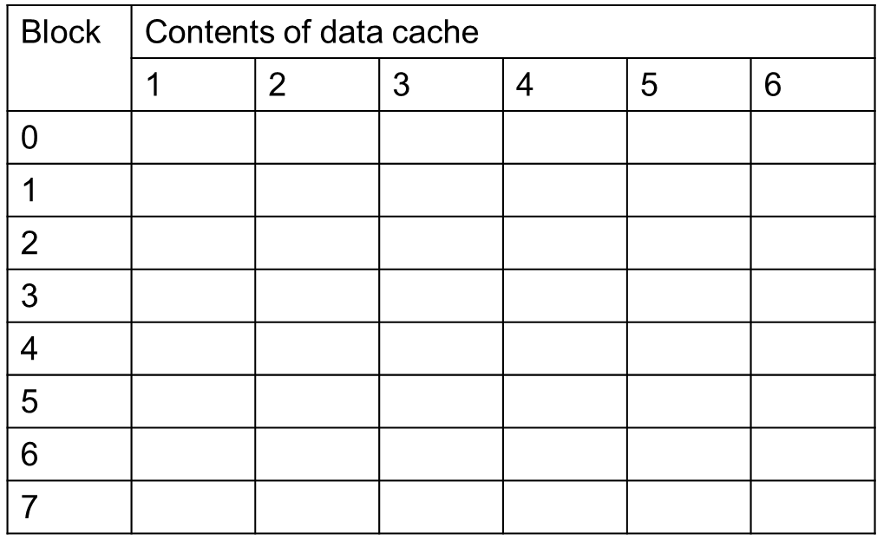
5. Consider the memory system with the following specifications:
● Byte-addressable.
● Virtual address space: 4G bytes.
● Main memory size: 16M bytes.
● Cache size: 512K bytes.
● Page size: 64K bytes.
● Block size: 32 bytes
● Mapping Strategies: Main Memory to Cache: 8-way set associative; Hard Disk to Main Memory: fully associative.
Virtual address is first translated to physical address. Then, it accesses the cache memory using the physical address.
(1) How many sets are there in the cache memory?
(2) How long is the tag field of the cache?
(3) Given a virtual address 0547AF33 (hexadecimal), its corresponding virtual page is stored in physical page 3B (hexadecimal).
① What is its physical address under such mapping?
② Which set can this address be possibly found in the cache?
③ Which byte does this address point to out of the 32 bytes in a block?

