《Discrete Mathematics》2019（A）

卷参考答案与评分标准
- Choose an answer to the following question. (10 x 2’ = 20’)
1—5 CAADD 6—10 CBDDA

2．Fill in the blanks. (10 x 2’ = 20’)
(1) $∀x ((¬p(x)∧¬q\left(x\right))∨(¬p(x)∧¬r\left(x\right)))$
(2) $¬$P , P
(3) x∈A $⋀$ x∈B
(4) {2,7} , {42,126}
(5) 14
(6) {0,1,…,100}
(7) $\left[\begin{aligned}\begin{matrix}0 \\ 2 \end{matrix}\begin{matrix}2 \\ 0 \end{matrix}\begin{matrix}2 \\ 2 \end{matrix}\begin{matrix}1 \\ 4\end{matrix} \\ \begin{matrix}2 \\ 1 \end{matrix}\begin{matrix}2 \\ 4 \end{matrix}\begin{matrix}0 \\ 1 \end{matrix}\begin{matrix}1 \\ 0\end{matrix}\end{aligned}\right]$
(8) abecfgijdhkl

3. Computation and Analysis.
(1) $\left(p→q ∨r\right)∧\left(q ∨r→s\right)$
$⇔$ $\left(¬p∨(q ∨r)\right)∧\left(¬(q ∨r)∨s\right)$
$⇔$ $\left(¬p∨q ∨r\right)∧\left((¬q ∧¬r)∨s\right)$
$$⇔¬p∧(¬q ∧¬r)∨q ∧(¬q ∧¬r)∨r∧(¬q ∧¬r)∨\left(¬p ∧s)∨(q∧s\right)∨(r∧s)$$
$$⇔(¬p∧¬q ∧¬r)∨\left(¬p ∧s)∨(q∧s\right)∨(r∧s)$$
$$⇔\left(¬p∧¬q ∧¬r\right)∨(¬p∧q ∧s)∨(¬p∧¬q∧r ∧s)∨(¬p∧¬q∧¬r ∧s)$$
$$∨(q∧s)∨(r∧s)$$
$$⇔\left(q∧s\right)∨(¬p∧¬q∧¬r)∨(r∧s)$$

最好使用真值表, 按照步骤给分.

(2)
$$w^{1}=\left[\begin{matrix}\begin{matrix}1 & 0 \\ 0 & 0\end{matrix} & \begin{matrix}0 & 1 \\ 1 & 0\end{matrix} \\ \begin{matrix}0 & 1 \\ 1 & 0\end{matrix} & \begin{matrix}0 & 0 \\ 0 & 1\end{matrix}\end{matrix}\right]$$
$$w^{2}=\left[\begin{matrix}\begin{matrix}1 & 0 \\ 0 & 0\end{matrix} & \begin{matrix}0 & 1 \\ 1 & 0\end{matrix} \\ \begin{matrix}0 & 1 \\ 1 & 0\end{matrix} & \begin{matrix}1 & 0 \\ 0 & 1\end{matrix}\end{matrix}\right]$$

$$w^{3}=\left[\begin{matrix}\begin{matrix}1 & 0 \\ 0 & 1\end{matrix} & \begin{matrix}0 & 1 \\ 1 & 0\end{matrix} \\ \begin{matrix}0 & 1 \\ 1 & 0\end{matrix} & \begin{matrix}1 & 0 \\ 0 & 1\end{matrix}\end{matrix}\right]$$
$$w^{4}=\left[\begin{matrix}\begin{matrix}1 & 0 \\ 0 & 1\end{matrix} & \begin{matrix}0 & 1 \\ 1 & 0\end{matrix} \\ \begin{matrix}0 & 1 \\ 1 & 0\end{matrix} & \begin{matrix}1 & 0 \\ 0 & 1\end{matrix}\end{matrix}\right]$$

结果正确可得4 分.
(3) a-c: a-c 4
a-b: a-b 6
a-d: a-d or a-c-d 7
a-e: a-b-e 9
a-g: a-d-g or a-c-d-g 9
a-f: a-c-f 11
a-h: a-d-g-h or a-c-d-g-h 13
方法正确, 结果错误, 得分4.
(4)
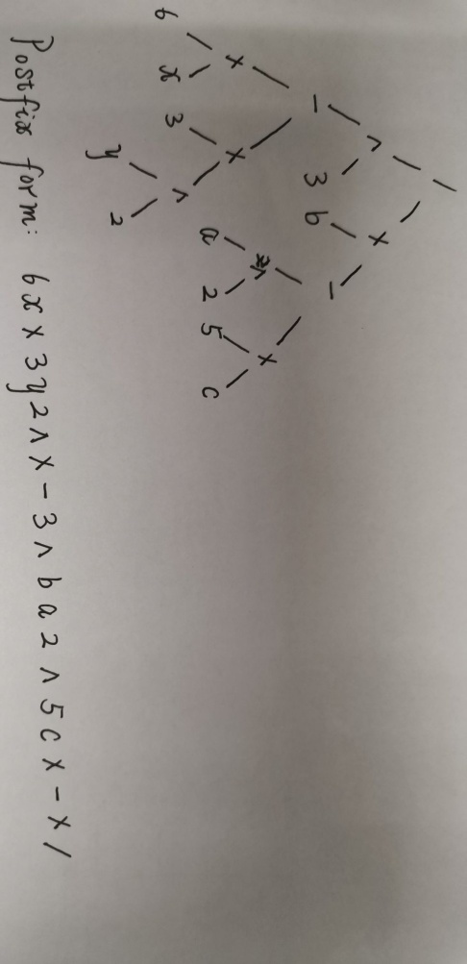

图得分3; 结果得分3.
(5) The following graphs are isomorphic.
f(1) = g
f(2) = d
f(3) = a
f(4) = f
f(5) = h
f(6) = c
f(7) = b
f(8) = e
* Other reasonable answers are also correct.

4.
(1) a b c d g e f h i
* Other reasonable answers are also correct.

(2)
考虑从S到F的必经之路, 确立3个节点ABC, 即最短路径必然包含
SA…BF或者SC…BF.

于是接下来的问题就是A...B之间或者B...C之间的最短路径问题.
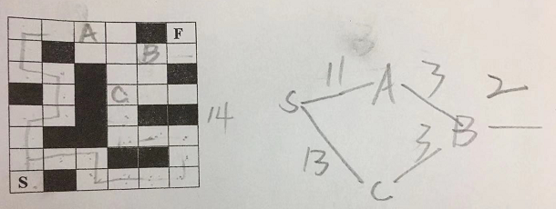

(3) the number of pentagons : x the number of hexagons: y

Euler's formula:
$v+\left(x+y\right)-e=2$

握手定理
5x+6y=$2e$
3v=$2e$
五边形点的关系
5x=v

Solution:
x=12, y=20, v=60, e=90.

以上4个关系, 每个1.5分

(4)
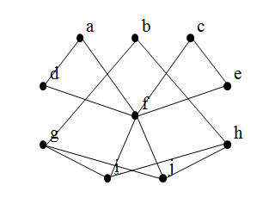
The minimum number of schedule times is 3.
1: f, g, h
2: a, b, c
3: d, e, i, j
* Other reasonable answers are also correct.
思路3 分;模型2分;结果1分

5
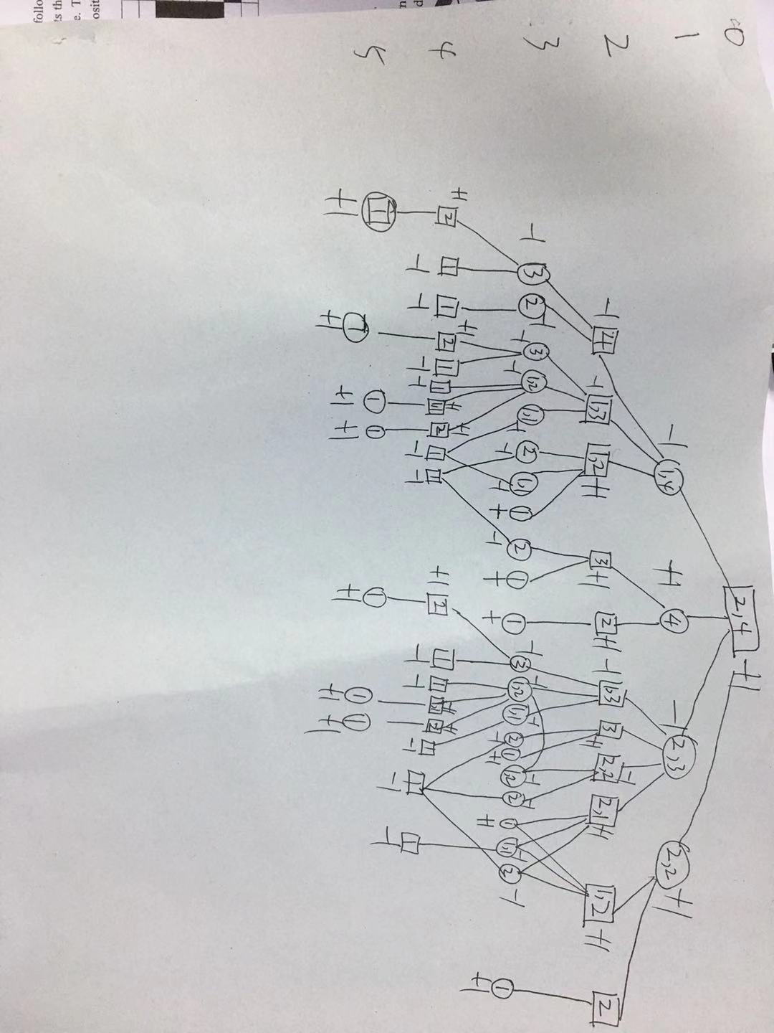

“The player who take the last coin is considered to win the game.” 上图值标反了, 标成了谁拿最后一个谁输

思路3 分;模型2分;结果1分

