WARNING: MISBEHAVIOR AT EXAM TIME WILL LEAD TO SERIOUS CONSEQUENCE.
SCUT Final Exam
《Discrete Mathematics》 Exam Paper A
Notice: 1. Make sure that you have filled the form on the left side of seal line.

2. Write your answers on the exam paper NOT the draft paper.
3. This is a close-book exam.
4. The exam with full score of 100 points lasts 120 minutes.

Question No. | I | II | III | IV | V | VI | VII | Sum
Score

- Choose an answer to the following question.$(10*2^{'}={20}^{'})$
(1) Which is a proposition? ( )
A) $x :=x+1$. B) 12 % 4.
C) It rained last night. D) Is someone there?

(2) How many cut edges does the complete bipartite graph $K_{6,10}$ have ? ( ).
A) 0. B) 6. C) 10. D) 16.
(3) Determine which of these statements is true. ( )
A) (3>6) → Shenzhen is the capital of Guangdong. B) $\left\{x\right\}∈\{x\}.$
C) $∅∈\{1,2,3,4,5\}$. D) $2xy-x^{2}-y^{2}>0$.
(4) Let R(x), S(x) be the statements “x is an employee of Company A,” and “x can speak French,” respectively. Express the sentence “Every employee of Company A can speak French.” in terms of R(x), S(x), quantifiers, and logical connectives. ( )
A) $∀x(R(x)∧S(x))$ B) $∀x(R(x)→¬S(x))$
C) $∃x(R(x)∨S(x))$ D) $∀x(R(x)→S(x))$
(5) The vertices in a given graph G are of degree 4 or 5. Suppose that the number of edges in the graph G can be divided by 59, what is the minimum possible number of vertices in the graph G? ( )
A) 6. B) 12. C) 18. D) 24.

(6) Which of the following matrices represents the relation R on the set S such that (S,R) is a lattice? ( )
A) $\left[\begin{matrix}\begin{matrix}1 & 1 \\ 0 & 1\end{matrix} & \begin{matrix}1 & 0 \\ 0 & 1\end{matrix} \\ \begin{matrix}0 & 1 \\ 0 & 0\end{matrix} & \begin{matrix}1 & 0 \\ 1 & 1\end{matrix}\end{matrix}\right]$ B) $\left[\begin{matrix}\begin{matrix}1 & 0 \\ 1 & 1\end{matrix} & \begin{matrix}1 & 0 \\ 1 & 0\end{matrix} \\ \begin{matrix}0 & 0 \\ 1 & 0\end{matrix} & \begin{matrix}1 & 0 \\ 1 & 1\end{matrix}\end{matrix}\right]$
C) $\left[\begin{matrix}\begin{matrix}1 & 1 \\ 0 & 1\end{matrix} & \begin{matrix}0 & 0 \\ 0 & 0\end{matrix} \\ \begin{matrix}1 & 1 \\ 0 & 1\end{matrix} & \begin{matrix}1 & 1 \\ 0 & 1\end{matrix}\end{matrix}\right]$ D) $\left[\begin{matrix}\begin{matrix}1 & 0 \\ 1 & 1\end{matrix} & \begin{matrix}0 & 0 \\ 0 & 1\end{matrix} \\ \begin{matrix}0 & 1 \\ 0 & 0\end{matrix} & \begin{matrix}1 & 1 \\ 0 & 1\end{matrix}\end{matrix}\right]$
(7) What is the chromatic number of the cycle graph $C_{9}$? ( )
A) 2. B) 3. C) 4. D) 5.
(8) which of the following matrices represents an anti-symmetric relation? ( )
A) $\left[\begin{matrix}\begin{matrix}1 & 0 \\ 0 & 1\end{matrix} & \begin{matrix}0 & 1 \\ 1 & 1\end{matrix} \\ \begin{matrix}1 & 1 \\ 0 & 0\end{matrix} & \begin{matrix}1 & 0 \\ 1 & 1\end{matrix}\end{matrix}\right]$ B) $\left[\begin{matrix}\begin{matrix}0 & 0 \\ 1 & 0\end{matrix} & \begin{matrix}1 & 1 \\ 0 & 1\end{matrix} \\ \begin{matrix}1 & 0 \\ 0 & 0\end{matrix} & \begin{matrix}0 & 0 \\ 1 & 0\end{matrix}\end{matrix}\right]$
C) $\left[\begin{matrix}\begin{matrix}1 & 0 \\ 0 & 0\end{matrix} & \begin{matrix}0 & 0 \\ 1 & 1\end{matrix} \\ \begin{matrix}0 & 1 \\ 0 & 1\end{matrix} & \begin{matrix}1 & 0 \\ 0 & 1\end{matrix}\end{matrix}\right]$ D) $\left[\begin{matrix}\begin{matrix}1 & 0 \\ 0 & 0\end{matrix} & \begin{matrix}0 & 0 \\ 1 & 0\end{matrix} \\ \begin{matrix}1 & 0 \\ 0 & 1\end{matrix} & \begin{matrix}1 & 1 \\ 0 & 0\end{matrix}\end{matrix}\right]$
(9) For the set S={a, b, c, d}, which is an equivalence relation? ( )
A) {(a,b), (a,c), (b,a), (b,d), (c,a), (c,d), (d,c), (d,b)}.
B) {(a,b), (b,a), (c,c), (c,d), (d,c), (d,d)}.
C) {(a,c), (a,b), (b,b), (c,c), (c,a), (d,b)}.
D) {(a,a), (a,b), (b,a), (b,b), (c,c), (d,d)}.

(10) Which of the given graphs has an Euler circuit? ( )
A) 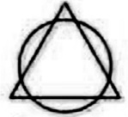 B) 
C) 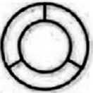 D) 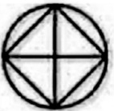

2．Fill in the blanks. $(10*2^{'}={20}^{'})$
(1) $¬(∃x (p(x)∨q(x)∧r(x)))⇔ ∀x$( ).
(2) If P⇒______⇒__________, then the statement P is considered as a Paradox.
(3) For the sets A and B, please use predicate logic to present their intersection $A∩B=\left\{x\right| _____________ \}$.
(4) For the poset ({2, 6, 7, 14, 18, 42, 126 },丨), the minimal elements are ________, and the upper bounds of {6, 14} are _________.
(5) There are _____ vertices, _____ edges in the wheel graph $W_{7}$.
(6) The value of age is included in the natural number set N, but in the student management system, the age of students can be only set to {0,1,…,100}. Suppose that f(x) is the function mapping students in the management system to the corresponding ages, the co-domain of f(x) is ______, and the range of f(x) is _____.
(7) With an adjacency matrix $\left[\begin{matrix}\begin{matrix}0__0 & __ \\ __ & __ \end{matrix} & \begin{matrix}__ & 0__0 \\ __ & __\end{matrix} \\ \begin{matrix}0__0 & __ \\ __ & __ \end{matrix} & \begin{matrix}__ & 0__0 \\ __ & __\end{matrix}\end{matrix}\right]$ to represent the multigraph below.
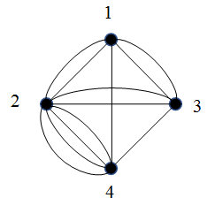

(8) _____________________ is the preorder traversal of the following tree.
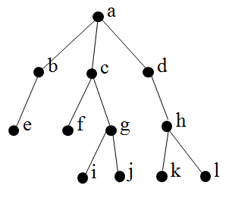

3. Computation and Analysis. $(5*6^{'}={30}^{'},$ The problem solving steps are necessary.)
(1) Prove $\left(p→q ∨r\right)∧\left(q ∨r→s\right)⇔\left(q∧s\right)∨(¬p∧¬q∧¬r)∨(r∧s)$.

(2) Consider the relation R on A={1,2,3,4} given by the adjacency matrix, apply Warshall’s algorithm to find the adjacency matrix of the transitive closure of R.
.
$$A=\left[\begin{matrix}\begin{matrix}1 & 0 \\ 0 & 0\end{matrix} & \begin{matrix}0 & 1 \\ 1 & 0\end{matrix} \\ \begin{matrix}0 & 1 \\ 1 & 0\end{matrix} & \begin{matrix}0 & 0 \\ 0 & 0\end{matrix}\end{matrix}\right]$$

(3) Find the shortest path from Vertex a to Vertex h.
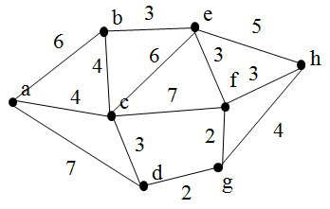

(4) Find the ordered rooted tree representing the proposition $\frac{{(6x-3y^{2})}^{3}}{b(a^{2}-5c)}$, then use this rooted tree to find the postfix form of this expression.

(5) Determine whether the following graphs are isomorphic. If isomorphic, show the mapping relationships by a bijective function, else identify difference.

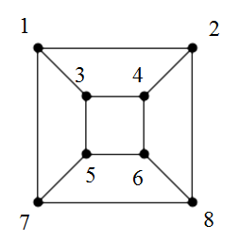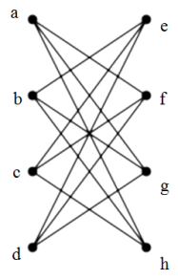

- Application of Discrete Mathematics. $(5*6^{'}={30}^{'},modeling 50\%, methodology \& solution 50\%)$
(1) A software development project can be divided into several tasks with the notations from “a” to “i”. And there are dependency relationships between the tasks. For a specific software project, the dependencies between tasks are shown in the directed graph below. Each vertex represents a task, and the initial vertex of an edge must be completed before the terminal vertex is carried out. Please give an order to complete the tasks into a feasible sequence satisfying their dependency relationships.
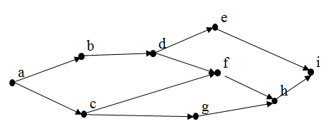

(2) The following figure shows a maze, where S represents the starting position, and F represents the goal position. It is allowed to take only one step left, right, up or down each time. The black areas are “no passing zones”. Find the shortest path from the starting position S to the goal position F.

F
S

(3) As shown in the following figure, the surface of a football is a combination of pentagons and hexagons. How many pentagons and hexagons are there, respectively?
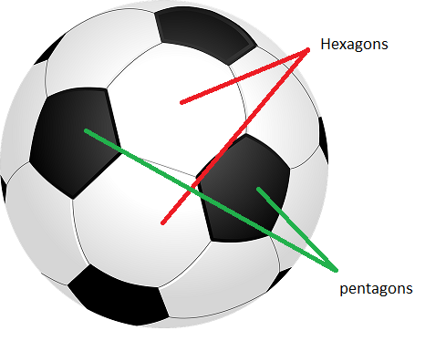

(4) There are ten academic classes in School of Software Engineering, South China University of Technology. The classes are notated with “a”, “b”,…, “j”. Let S_{a}, S_{b}, …, S_{j} be the set of students who are in “Class a”, “Class b”, …, “Class j”, respectively. The length of each class is the same. What is the minimum number of schedule times according to the following requirements?
S_{a}$∩$S_{d} ≠$∅$, S_{a}$∩$S_{f} ≠$∅$; S_{b}$∩$S_{g} ≠$∅$, S_{b}$∩$S_{h} ≠$∅$; S_{c}$∩$S_{f} ≠$∅$, S_{c}$∩$S_{e} ≠$∅$;
S_{d}$∩$S_{f} ≠$∅$; S_{e}$∩$S_{f} ≠$∅$; S_{f}$∩$S_{i} ≠$∅$, S_{f}$∩$S_{j} ≠$∅$;
S_{g}$∩$S_{i} ≠$∅$, S_{g}$∩$S_{j} ≠$∅$; S_{h}$∩$S_{i} ≠$∅$, S_{h}$∩$S_{j} ≠$∅$.

(5) Suppose there are two heaps with two, four coins respectively. In each turn, a player can choose only one heap and remove one coin or two coins from that heap. The player who take the last coin is considered to win the game. Develop the winning strategy for the player making the first turn with a game tree.

Heap 1: Heap 2:

