Script to plot out the signatures 1
Preparation 1
Box plots for seasonal transition 1
Box plots for each land-use & each land-use/depth 7
just for de-bugging 8

Script to plot out the signatures
publish('plot_main.m', 'doc') =========== BEGINNING OF THE CODE ============
clear all;
slCharacterEncoding('UTF-8');

Preparation
% Set path
cd("G:\Shared drives\Ryoko and Hilary\SoilMoistureSignature\GLDAS\3_codes_plotters");
in_path = "G:\Shared drives\Ryoko and Hilary\SoilMoistureSignature\GLDAS\2_out\";
out_path = "G:\Shared drives\Ryoko and Hilary\SoilMoistureSignature\GLDAS\4_out_plots\";
% Site information
site = ["Oznet"; "GLDAS"];
% read the format for the plots
sigT = readtable('sig_format.csv','HeaderLines',0,'Delimiter',',');

Box plots for seasonal transition
plot_seasonal(site, true, true, 'pdf');
% %% Box plots for each depth & all stations
% for s = 1:size(sigT,1)
% disp(s)
% plot_box_depth(string(sigT.sig_abb(s)), string(sigT.sig_fullname(s)), string(sigT.ylabel(s)), allsites, obs, true, true, 'pdf');
% end
fid =
10
fid =
10
fid =
10
fid =
10
fid =
10
fid =
10
fid =
10
fid =
10
fid =
10
fid =
10
fid =
10
fid =
10
fid =
10
fid =
10
fid =
10
fid =
10
fid =
10
fid =
10
fid =
10
fid =
10
fid =
10
fid =
10
fid =
10
fid =
10
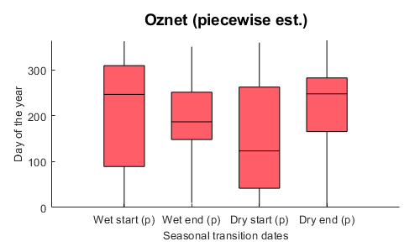
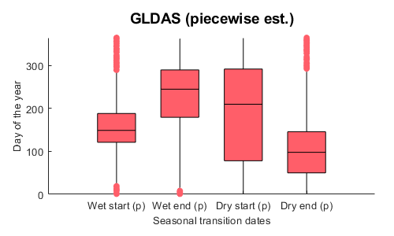
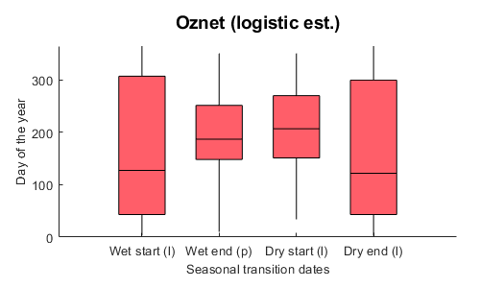
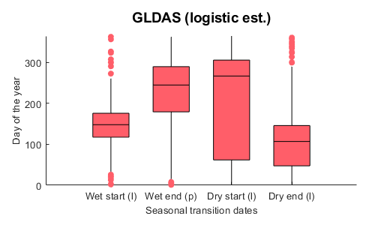
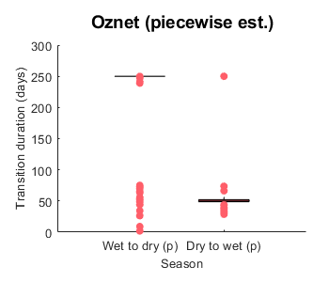
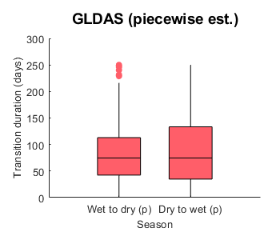
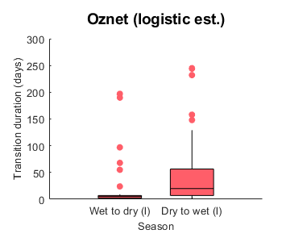
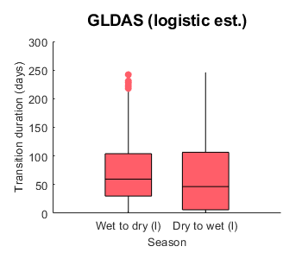

Box plots for each land-use & each land-use/depth
For all sites except WB for s = 1:size(sigT,1) disp(s) plot_box_lulc(string(sigT.sig_abb(s)), string(sigT.sig_fullname(s)), string(sigT.ylabel(s)), site, obs, true, true, 'pdf'); end
% Only for WB
% for s = 1:size(sigT,1)
% disp(s)
% plot_box_WBdef(string(sigT.sig_abb(s)), string(sigT.sig_fullname(s)), string(sigT.ylabel(s)), site2, obs, true, true, 'pdf');
% end

just for de-bugging
s=1 sig_abb = string(sigT.sig_abb(s)) sig_fullname = string(sigT.sig_fullname(s)) sig_ylabel = string(sigT.ylabel(s)) i = 1 j = 1 site = ["MQ";"OZ";"TX";"WB";"HB";"RM"];
% =========== END OF THE CODE ============
Published with MATLAB® R2020b

