read the time series of data 4
Get corresponding signature values 5
plot the time series of data 5
% publish('plot_seasonal_TS.m', 'doc')
% Set path
% in_path = "G:\Shared drives\Ryoko and Hilary\SoilMoistureSignature\GLDAS\0_data\";
% out_path = "G:\Shared drives\Ryoko and Hilary\SoilMoistureSignature\GLDAS\2_out\";
% Site information
site = ["Oznet";"GLDAS"];
depth = [3,4,15];
nstation = 38;
% read the format for the plots
sig_abb = ["seasontrans_sdate_wet2dry_p"; "seasontrans_sdate_wet2dry_l"; ...
"seasontrans_edate_wet2dry_p"; "seasontrans_edate_wet2dry_l"; ...
"seasontrans_sdate_dry2wet_p"; "seasontrans_sdate_dry2wet_l"; ...
"seasontrans_edate_dry2wet_p"; "seasontrans_edate_dry2wet_l"; ...
"seasontrans_duration_wet2dry_p"; "seasontrans_duration_wet2dry_l"; ...
"seasontrans_duration_dry2wet_p"; "seasontrans_duration_dry2wet_l"];
sig_abb2 = ["Wet end (p)"; "Wet end (l)"; ...
"Dry start (p)"; "Dry start (l)"; ...
"Dry end (p)"; "Dry end (l)"; ...
"Wet start (p)"; "Wet start (l)"; ...
"Wet to dry (p)"; "Wet to dry (l)"; ...
"Dry to wet (p)"; "Dry to wet (l)"];
% Initialize the struct
sig.network = [];sig.depth = [];sig.station = []; sig.type = []; sig.value = [];
for s = 1:size(sig_abb,1)
for i = 1:size(site,1)
% read the signature data in a struct format
fn = sprintf('%s_%s.txt', sig_abb(s), site(i,:));
fid = fopen(fullfile('G:\Shared drives\Ryoko and Hilary\SoilMoistureSignature\GLDAS\2_out',fn),'r')
if s <= 8
sig0 = textscan(fid, '%d %d %s \n','HeaderLines',0, 'Delimiter',',');
else
sig0 = textscan(fid, '%d %d %f \n','HeaderLines',0, 'Delimiter',',');
end
fclose(fid);
sig.network = [sig.network; repelem(string(site(i,:)),1,length(sig0{1}))'];
sig.depth = [sig.depth; sig0{1}];
sig.station = [sig.station; sig0{2}];
sig.type = [sig.type; repelem(sig_abb2(s),1,length(sig0{1}))'];
sig.value = [sig.value; sig0{3}];
clear sig0
clear fn
end
end
% loop for the depth
for k = 1:size(depth,2)
% loop for the station
for n = 1:nstation
statement = sprintf('Currently processing the data at depth %d cm, station %d', depth(k), n);
disp(statement)
Currently processing the data at depth 3 cm, station 1
Currently processing the data at depth 3 cm, station 2
Currently processing the data at depth 3 cm, station 3
Currently processing the data at depth 3 cm, station 4
Currently processing the data at depth 3 cm, station 5
Currently processing the data at depth 3 cm, station 6
Currently processing the data at depth 3 cm, station 7
Currently processing the data at depth 3 cm, station 8
Currently processing the data at depth 3 cm, station 9
Currently processing the data at depth 3 cm, station 10
Currently processing the data at depth 3 cm, station 11
Currently processing the data at depth 3 cm, station 12
Currently processing the data at depth 3 cm, station 13
Currently processing the data at depth 3 cm, station 14
Currently processing the data at depth 3 cm, station 15
Currently processing the data at depth 3 cm, station 16
Currently processing the data at depth 3 cm, station 17
Currently processing the data at depth 3 cm, station 18
Currently processing the data at depth 3 cm, station 19
Currently processing the data at depth 3 cm, station 20
Currently processing the data at depth 3 cm, station 21
Currently processing the data at depth 3 cm, station 22
Currently processing the data at depth 3 cm, station 23
Currently processing the data at depth 3 cm, station 24
Currently processing the data at depth 3 cm, station 25
Currently processing the data at depth 3 cm, station 26
Currently processing the data at depth 3 cm, station 27
Currently processing the data at depth 3 cm, station 28
Currently processing the data at depth 3 cm, station 29
Currently processing the data at depth 3 cm, station 30
Currently processing the data at depth 3 cm, station 31
Currently processing the data at depth 3 cm, station 32
Currently processing the data at depth 3 cm, station 33
Currently processing the data at depth 3 cm, station 34
Currently processing the data at depth 3 cm, station 35
Currently processing the data at depth 3 cm, station 36
Currently processing the data at depth 3 cm, station 37
Currently processing the data at depth 3 cm, station 38
Currently processing the data at depth 4 cm, station 1
Currently processing the data at depth 4 cm, station 2
Currently processing the data at depth 4 cm, station 3
Currently processing the data at depth 4 cm, station 4
Currently processing the data at depth 4 cm, station 5
Currently processing the data at depth 4 cm, station 6
Currently processing the data at depth 4 cm, station 7
Currently processing the data at depth 4 cm, station 8
Currently processing the data at depth 4 cm, station 9
Currently processing the data at depth 4 cm, station 10
Currently processing the data at depth 4 cm, station 11
Currently processing the data at depth 4 cm, station 12
Currently processing the data at depth 4 cm, station 13
Currently processing the data at depth 4 cm, station 14
Currently processing the data at depth 4 cm, station 15
Currently processing the data at depth 4 cm, station 16
Currently processing the data at depth 4 cm, station 17
Currently processing the data at depth 4 cm, station 18
Currently processing the data at depth 4 cm, station 19
Currently processing the data at depth 4 cm, station 20
Currently processing the data at depth 4 cm, station 21
Currently processing the data at depth 4 cm, station 22
Currently processing the data at depth 4 cm, station 23
Currently processing the data at depth 4 cm, station 24
Currently processing the data at depth 4 cm, station 25
Currently processing the data at depth 4 cm, station 26
Currently processing the data at depth 4 cm, station 27
Currently processing the data at depth 4 cm, station 28
Currently processing the data at depth 4 cm, station 29
Currently processing the data at depth 4 cm, station 30
Currently processing the data at depth 4 cm, station 31
Currently processing the data at depth 4 cm, station 32
Currently processing the data at depth 4 cm, station 33
Currently processing the data at depth 4 cm, station 34
Currently processing the data at depth 4 cm, station 35
Currently processing the data at depth 4 cm, station 36
Currently processing the data at depth 4 cm, station 37
Currently processing the data at depth 4 cm, station 38
Currently processing the data at depth 15 cm, station 1
Currently processing the data at depth 15 cm, station 2
Currently processing the data at depth 15 cm, station 3
Currently processing the data at depth 15 cm, station 4
Currently processing the data at depth 15 cm, station 5
Currently processing the data at depth 15 cm, station 6
Currently processing the data at depth 15 cm, station 7
Currently processing the data at depth 15 cm, station 8
Currently processing the data at depth 15 cm, station 9
Currently processing the data at depth 15 cm, station 10
Currently processing the data at depth 15 cm, station 11
Currently processing the data at depth 15 cm, station 12
Currently processing the data at depth 15 cm, station 13
Currently processing the data at depth 15 cm, station 14
Currently processing the data at depth 15 cm, station 15
Currently processing the data at depth 15 cm, station 16
Currently processing the data at depth 15 cm, station 17
Currently processing the data at depth 15 cm, station 18
Currently processing the data at depth 15 cm, station 19
Currently processing the data at depth 15 cm, station 20
Currently processing the data at depth 15 cm, station 21
Currently processing the data at depth 15 cm, station 22
Currently processing the data at depth 15 cm, station 23
Currently processing the data at depth 15 cm, station 24
Currently processing the data at depth 15 cm, station 25
Currently processing the data at depth 15 cm, station 26
Currently processing the data at depth 15 cm, station 27
Currently processing the data at depth 15 cm, station 28
Currently processing the data at depth 15 cm, station 29
Currently processing the data at depth 15 cm, station 30
Currently processing the data at depth 15 cm, station 31
Currently processing the data at depth 15 cm, station 32
Currently processing the data at depth 15 cm, station 33
Currently processing the data at depth 15 cm, station 34
Currently processing the data at depth 15 cm, station 35
Currently processing the data at depth 15 cm, station 36
Currently processing the data at depth 15 cm, station 37
Currently processing the data at depth 15 cm, station 38

read the time series of data
Oznet
fn0 = sprintf('sm_d%02d_s%02d.csv', depth(k), n);
fn = fullfile('G:\Shared drives\Ryoko and Hilary\SoilMoistureSignature\GLDAS\0_data\', "Oznet", fn0);
if exist(fn, 'file') == 2
fid = fopen(fn, 'r');
smtt0 = textscan(fid,'%q %f','HeaderLines',1,'DateLocale','en_US','Delimiter',',');
smtt_oz = timetable(datetime(smtt0{1}),smtt0{2});
fclose(fid);
if isempty(smtt_oz)
continue
end
sm_oz = smtt_oz.Var1;
clear smtt0 smtt1 fn0 fn
end
% GLDAS
fn0 = sprintf('depth_%dcm.csv', depth(k));
fn = fullfile('G:\Shared drives\Ryoko and Hilary\SoilMoistureSignature\GLDAS\0_data\', "GLDAS", fn0);
if exist(fn, 'file') == 2
fid = fopen(fn, 'r');
smtt0 = textscan(fid,'%d %q %f','HeaderLines',1,'DateLocale','en_US','Delimiter',',');
n_rows = find(smtt0{1} == n);
smttl = timetable(datetime(smtt0{2}),smtt0{3});
fclose(fid);
smtt1 = timetable(datetime(smtt0{2}),smtt0{3});
smtt_gl = smtt1(n_rows,'Var1');
if isempty(smtt_gl)
continue
end
smtt_gl = sortrows(smtt_gl, 'Time');
smtt_gl = retime(smtt_gl, 'regular', 'linear', 'TimeStep', hours(1));
sm_gl = smtt_gl.Var1;
clear smtt0 smtt1 fn0 fn
end
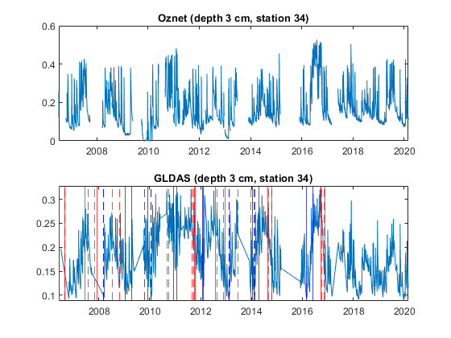

Get corresponding signature values
sig_abb2 = ["Wet end (p)"; "Wet end (l)"; ...
"Dry start (p)"; "Dry start (l)"; ...
"Dry end (p)"; "Dry end (l)"; ...
"Wet start (p)"; "Wet start (l)"; ...
"Wet to dry (p)"; "Wet to dry (l)"; ...
"Dry to wet (p)"; "Dry to wet (l)"];
Oznet
xline_format = ["--r"; "-r"; ...
"--r"; "-r"; ...
"--b"; "-b"; ...
"--b"; "-b"];

plot the time series of data
figure;
% Oznet
subplot(2,1,1);
plot(smtt_oz.Time, smtt_oz.Var1);hold on;
titlename = sprintf("Oznet (depth %d cm, station %d)", depth(k), n);
title(titlename);
row1 = logical(sig.depth == depth(k));
row2 = logical(sig.station == n);
row3 = logical(sig.network == "Oznet");
for s = [1,3,5,7]
row4 = logical(sig.type == sig_abb2(s));
row5 = row1&row2&row3&row4;
selected_sig = sig.value(row5);
clear row4 row5
if ~isempty(selected_sig)
for i2 = 1:length(selected_sig)
if char(selected_sig(i2)) ~= "NaN " && char(selected_sig(i2)) ~= "NaT "
x1 = datetime(selected_sig(i2));
xline(x1,xline_format(s));hold on;
end
end
end
end
for s = [2,4,6,8]
row4 = logical(sig.type == sig_abb2(s));
row5 = row1&row2&row3&row4;
selected_sig = sig.value(row5);
clear row4 row5
if ~isempty(selected_sig)
for i2 = 1:length(selected_sig)
if char(selected_sig(i2)) ~= "NaN " && char(selected_sig(i2)) ~= "NaT "
x1 = datetime(selected_sig(i2));
xline(x1,xline_format(s));hold on;
end
end
end
end
hold off;
% GLDAS
clear row3
row3 = logical(sig.network == "GLDAS");
subplot(2,1,2);
plot(smtt_gl.Time, smtt_gl.Var1)
titlename = sprintf("GLDAS (depth %d cm, station %d)", depth(k), n);
title(titlename);
for s = [1,3,5,7]
row4 = logical(sig.type == sig_abb2(s));
row5 = row1&row2&row3&row4;
selected_sig = sig.value(row5);
clear row4 row5
if ~isempty(selected_sig)
for i2 = 1:length(selected_sig)
if char(selected_sig(i2)) ~= "NaN " && char(selected_sig(i2)) ~= "NaT "
x1 = datetime(selected_sig(i2));
xline(x1,xline_format(s));hold on;
end
end
end
end
for s = [2,4,6,8]
row4 = logical(sig.type == sig_abb2(s));
row5 = row1&row2&row3&row4;
selected_sig = sig.value(row5);
clear row4 row5
if ~isempty(selected_sig)
for i2 = 1:length(selected_sig)
if char(selected_sig(i2)) ~= "NaN " && char(selected_sig(i2)) ~= "NaT "
x1 = datetime(selected_sig(i2));
xline(x1,xline_format(s));hold on;
end
end
end
end
hold off;
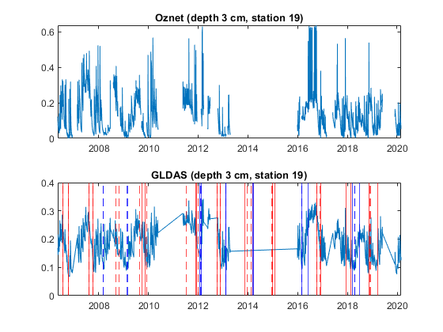
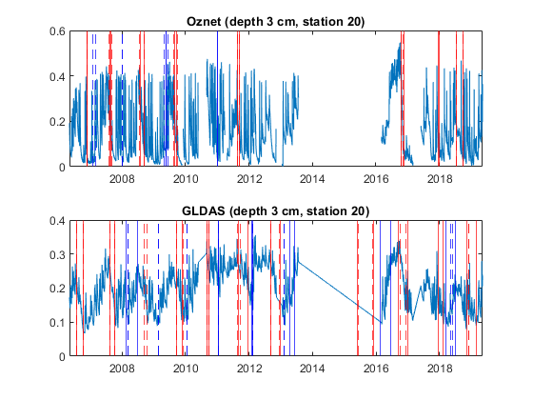
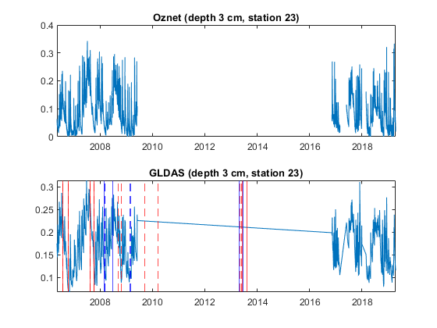
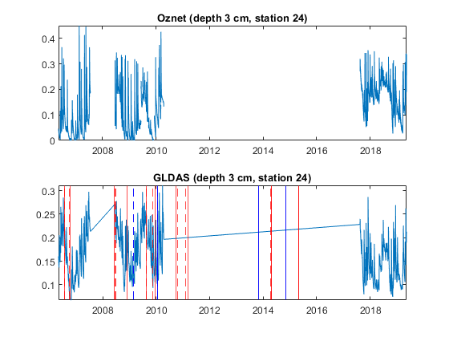
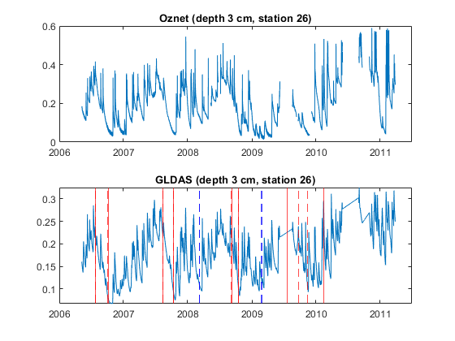
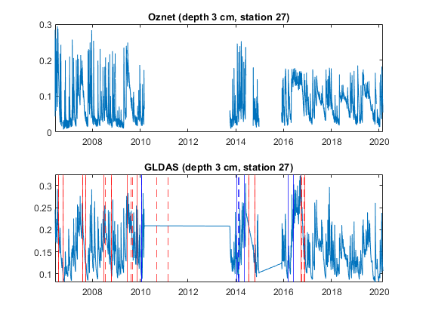
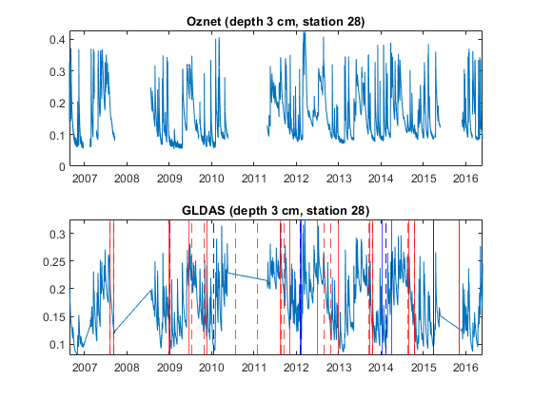
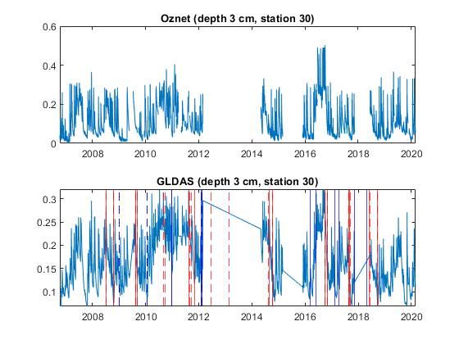
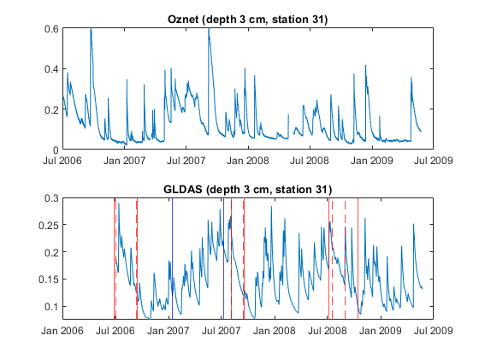
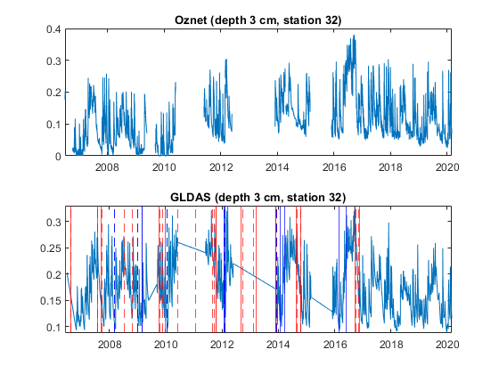
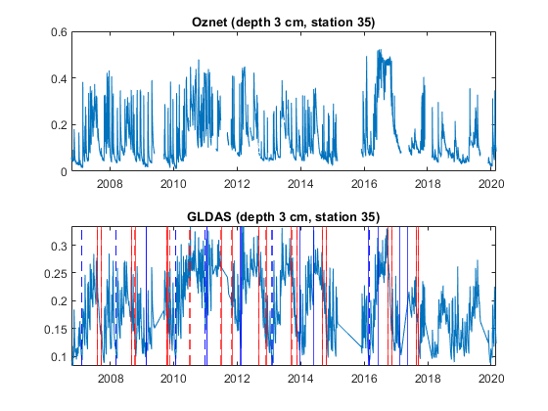
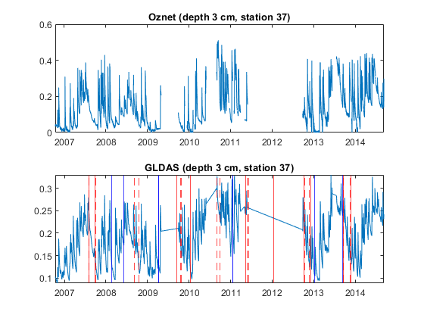
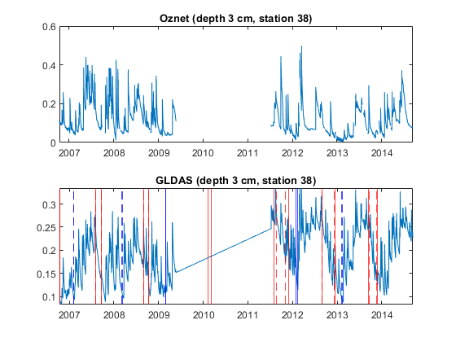
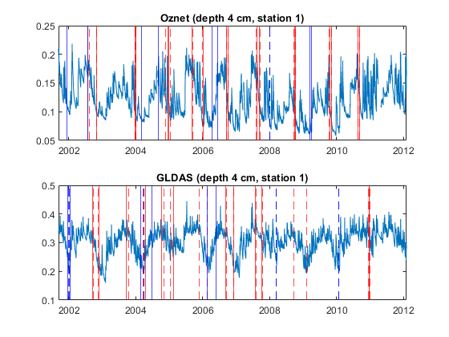
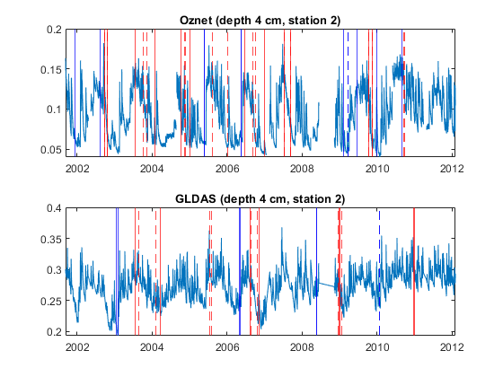
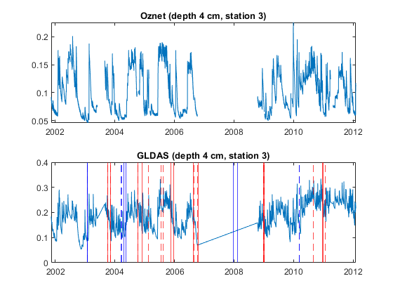
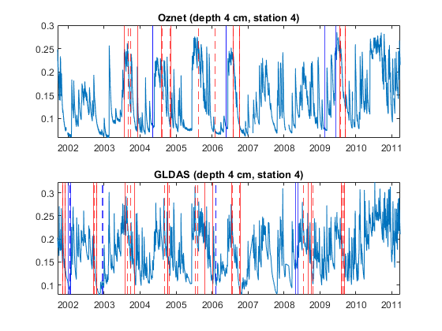
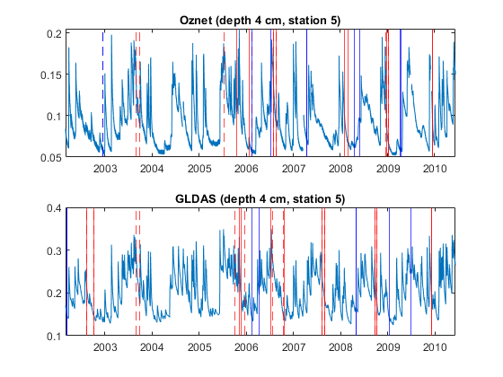
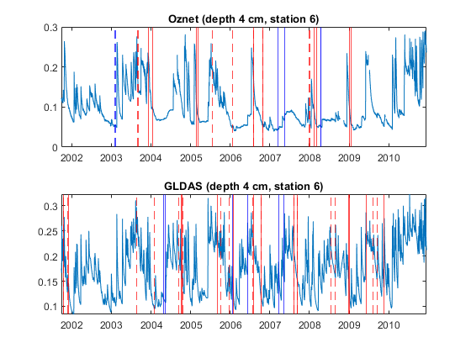
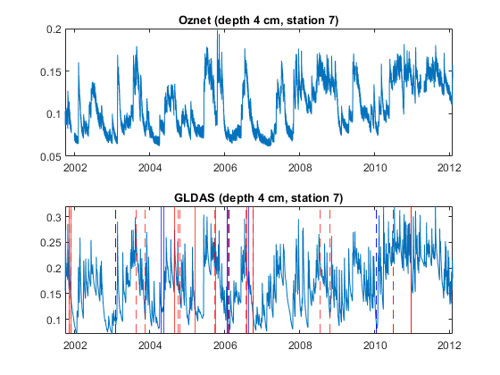
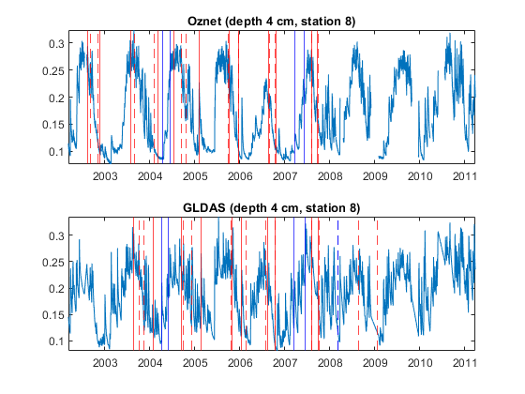
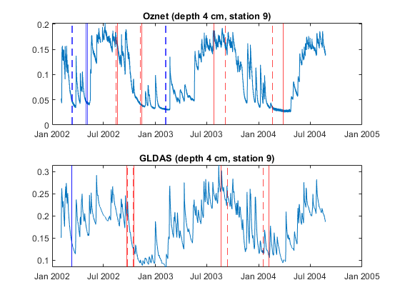
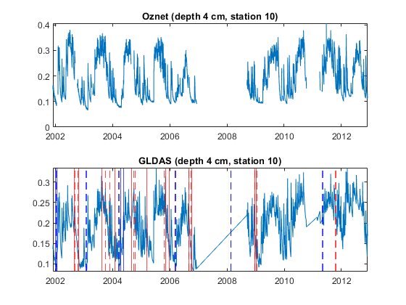
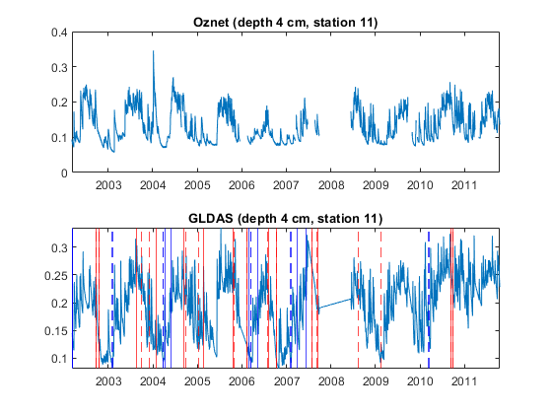
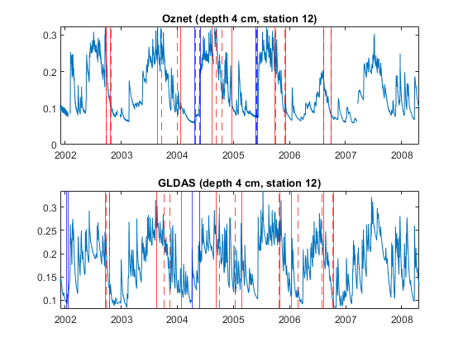
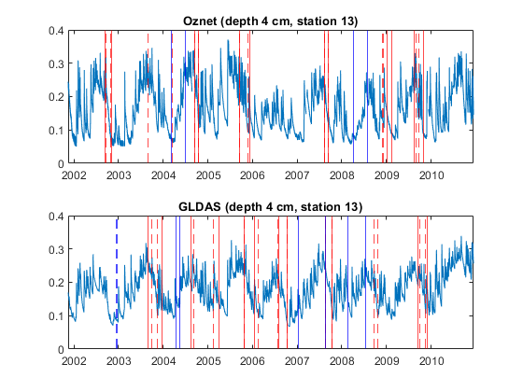
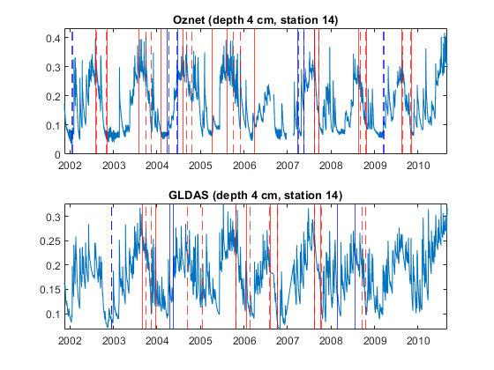
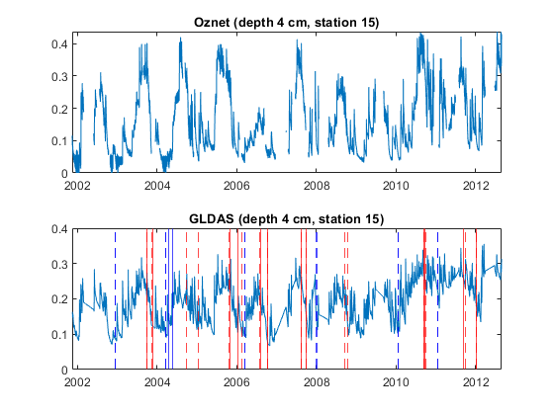
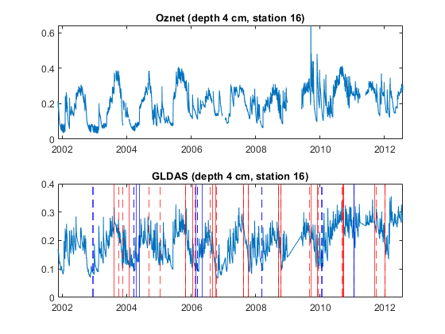
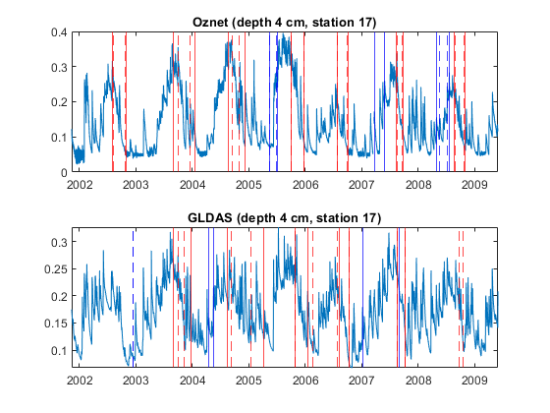
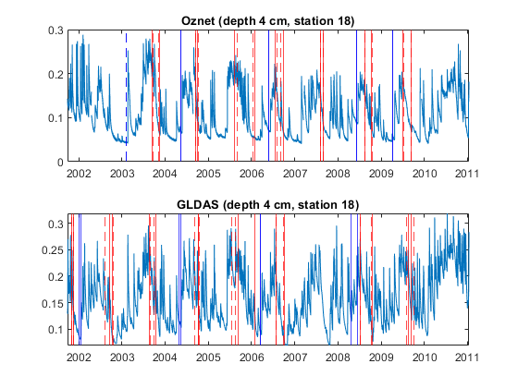
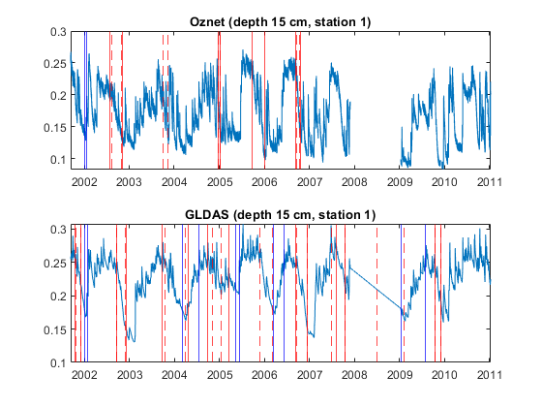
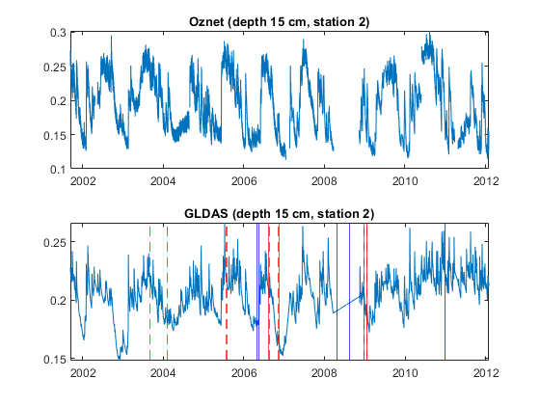
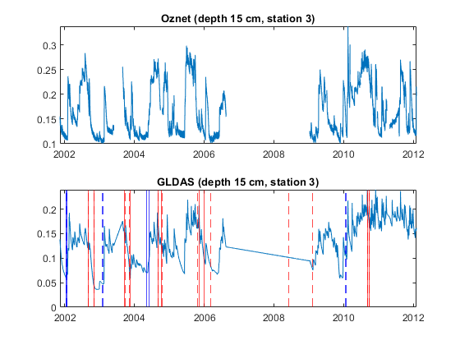
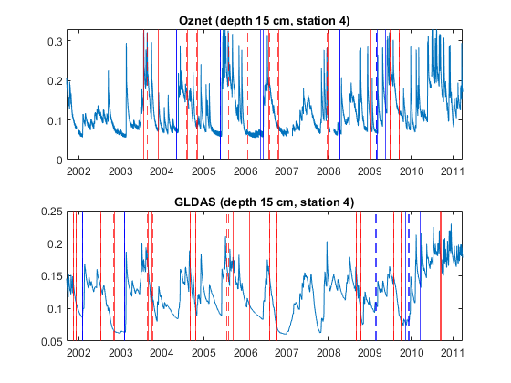
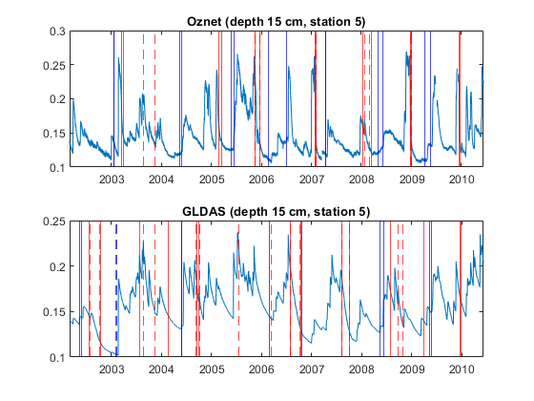
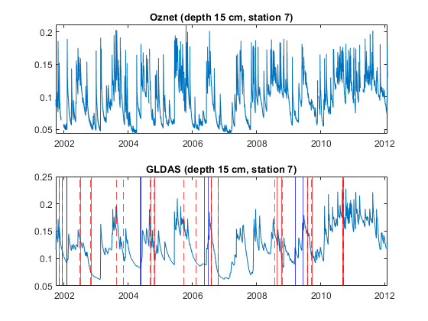
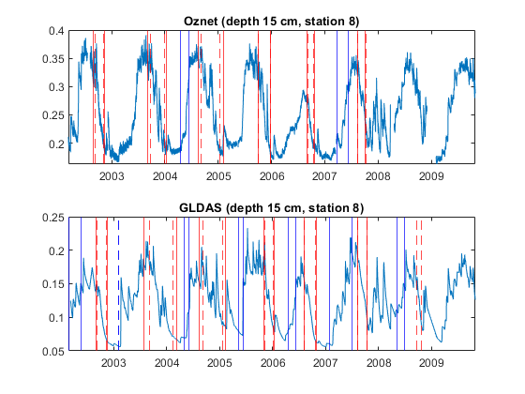
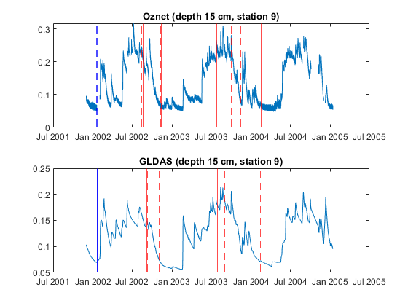
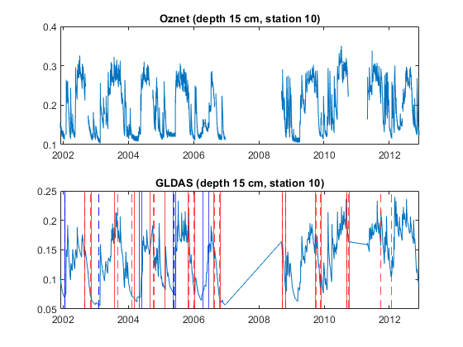
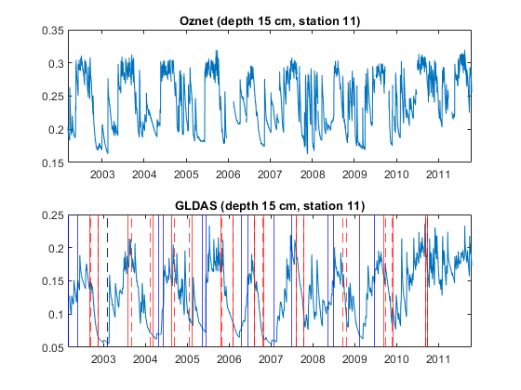
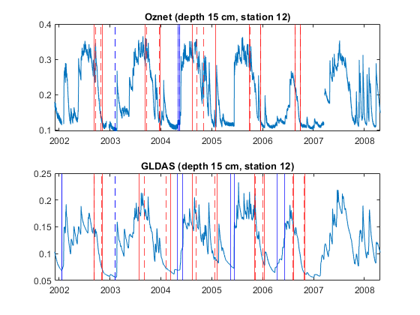
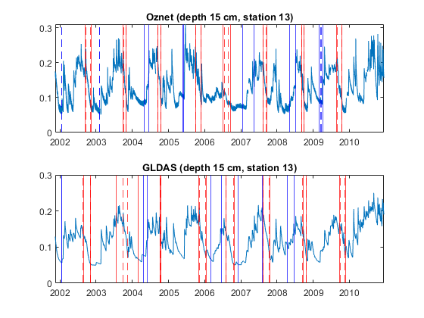
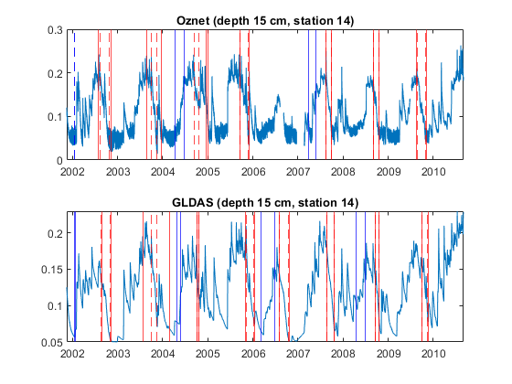
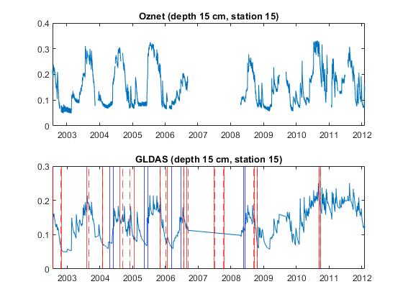
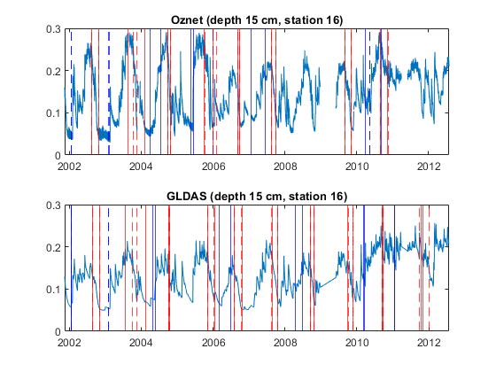
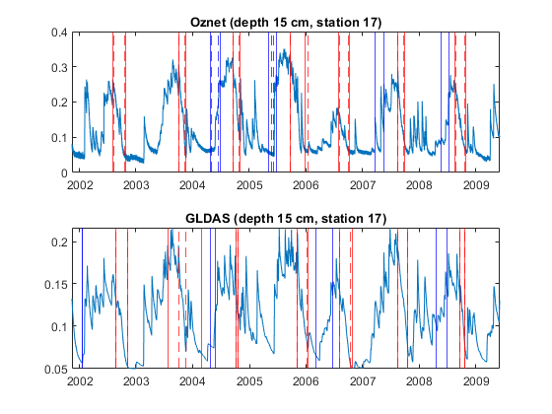
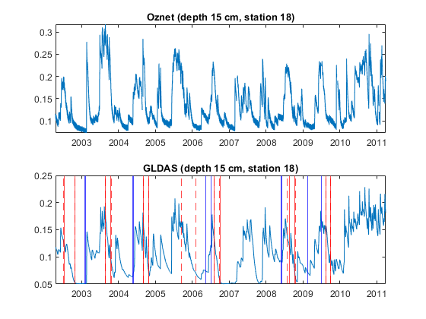
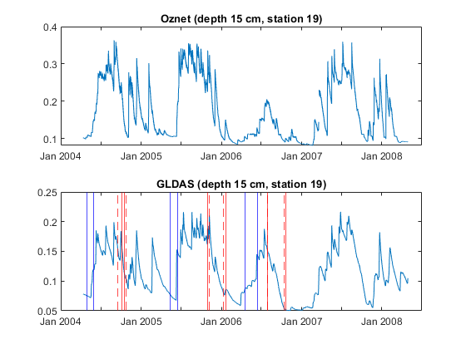
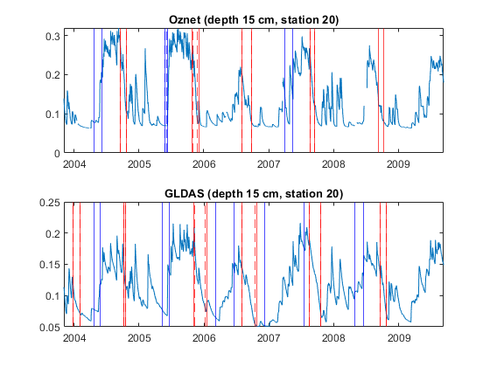
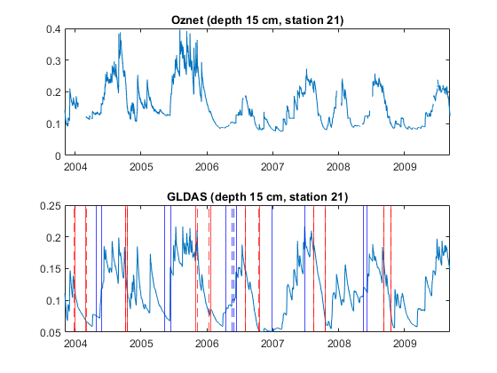
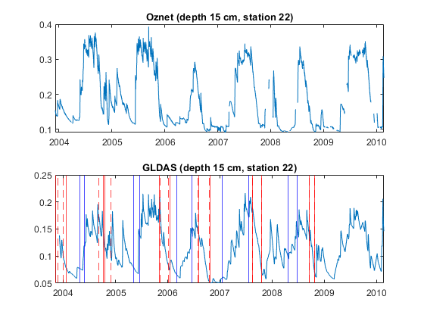
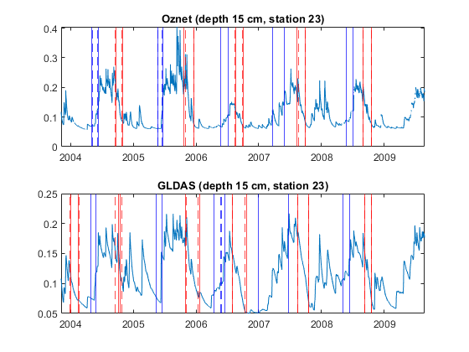
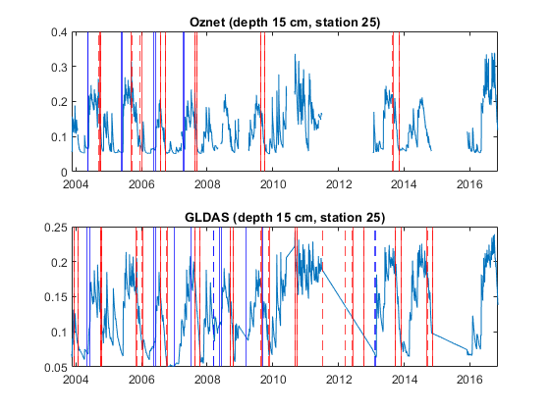
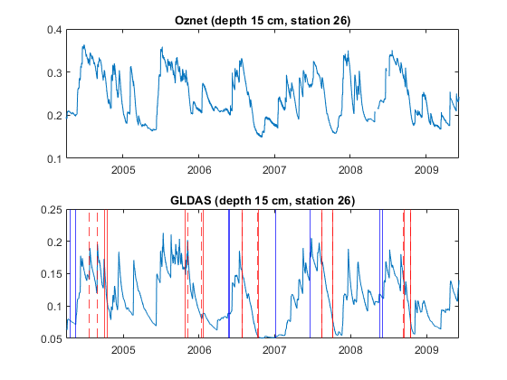
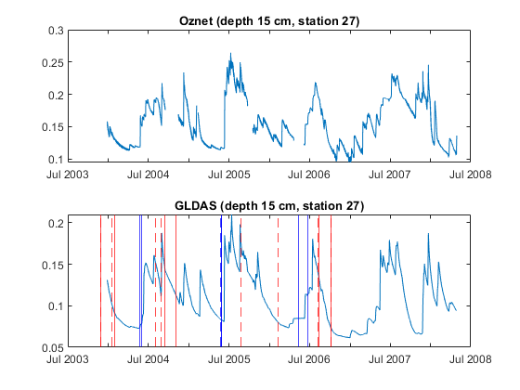
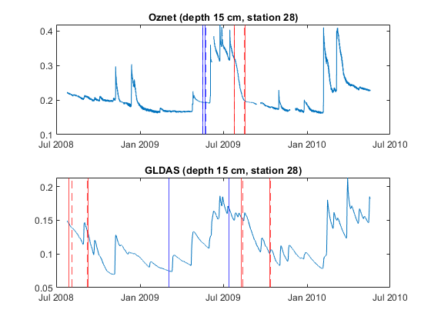
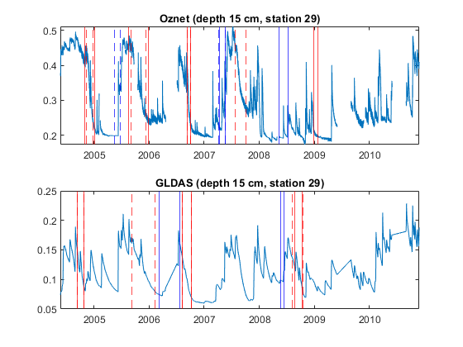
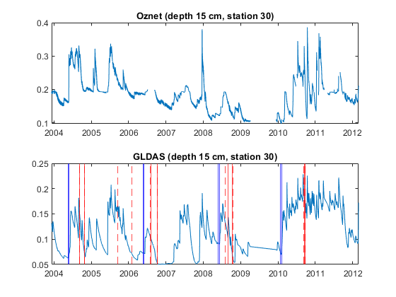
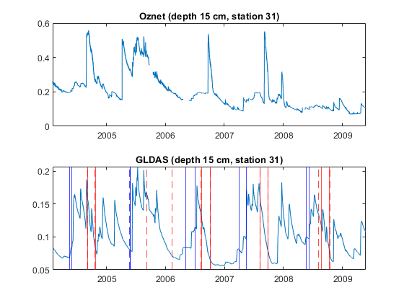
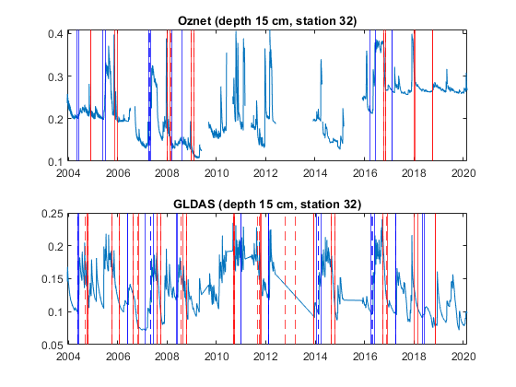
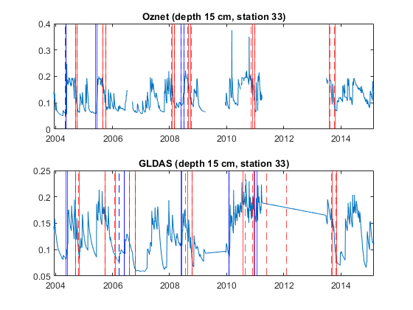
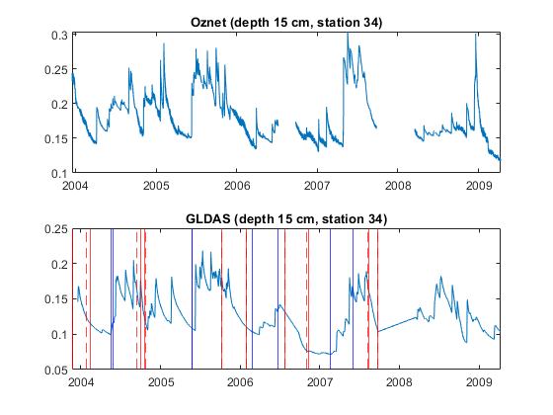
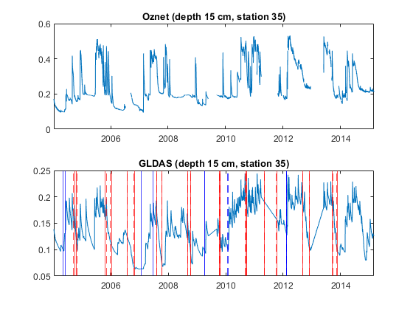
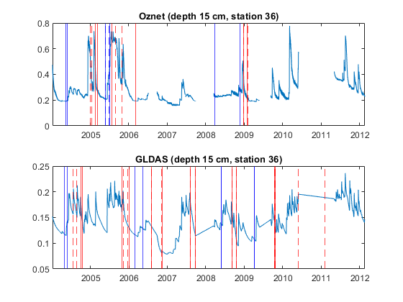
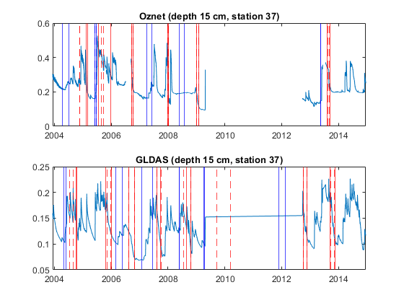
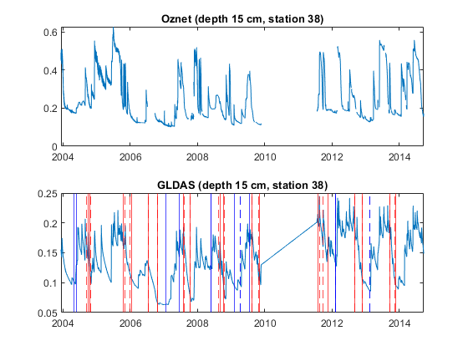
end
% plot the times series of data
% if the depth/station has the GLDAS/Oznet data,
% plot the seasonal transition timings (Piecewise)
% plot the seasonal transition timings (Logistic)
end
% if both GLDAS/Oznet has the data, find the close wet/drying seasons (within 50days of error or something?) and take the residuals
% save them as output
fid =
3
fid =
3
fid =
3
fid =
3
fid =
3
fid =
3
fid =
3
fid =
3
fid =
3
fid =
3
fid =
3
fid =
3
fid =
3
fid =
3
fid =
3
fid =
3
fid =
3
fid =
3
fid =
3
fid =
3
fid =
3
fid =
3
fid =
3
fid =
3
Published with MATLAB® R2020b

