Investment Context Engine (ICE): A lightweight Graph-Based Context-Aware AI Backbone for hedge fund workflows
Alpha Context Engine (ACE), Quantamental Context Engine (QCE), Context Graph (CG)

1. Executive Summary
Investment professionals are inundated with information – from portfolio data and watchlists to a flood of sell-side research emails and market news. Lean, traditional hedge funds face a disadvantage when competing against larger investment firms with greater resources. The proliferation of third-party AI tools, combined with democratization of cutting-edge large language models (LLMs) present a clear opportunity: lean hedge funds must become AI-ready to tap onto these tools to harness its potential and level the playing field with industry giants.
The Investment Context Engine (ICE) is a modular, lightweight AI system designed to serve as the cognitive backbone of a hedge fund’s core workflows—spanning idea generation, equity research, portfolio monitoring, risk management, and investor communications.

ICE integrates and encodes both external financial data (e.g., filings, news, earnings transcripts) and internal firm sources (e.g., research notes, emails, portfolio holdings) into a unified, compounding knowledge graph (KG) that continuously encodes the hedge fund’s DNA, mental models and investing philosophy. This KG structure enables multi-hop reasoning and long-term memory which is queried through a graph-aware retrieval-augmented generation (Graph-RAG) pipeline, processed by a monolithic but extensible agentic layer that is designed to be compatible with external Model Context Protocol (MCP)-based tools, databases, and models.

By combining structural graph context with semantic retrieval, ICE grounds large language models (LLMs) in the most relevant and complete firm-specific knowledge, allowing the investment teams to ask high-leverage questions such as:
- “What KPIs drive Uber’s stock performance?” or
- “Which companies in the portfolio holdings are exposed to the AI infrastructure buildout theme?”
Answering these queries would showcase ICE’s ability to synthesize fragmented data into structured, traceable and actionable insights – which accelerates and improves investment reasoning, aligns decision-making across teams, and builds a compounding knowledge asset that delivers sharper insights and more informed decision-making across different investment functions.

2. Problem Statement & Background
Modern equity research and portfolio management depend on synthesizing insights from an ever-expanding range of fragmented sources: earnings calls, SEC filings, market news, broker reports, internal research notes, emails, and price action. For lean boutique hedge funds, this process remains largely manual and disjointed—heavily reliant on human memory, speed, and judgment—placing them at a competitive disadvantage to larger funds with dedicated teams, advanced infrastructure, and vast resources.

This fragmentation creates four critical pain points for the lean investment fund:
- Delayed signal capture: Analysts may miss soft signals or early narrative shifts buried in transcripts, filings, or news flows. PMs and traders often react to events with latency or incomplete context.
- Low insight reusability: Investment theses, observations, and research remain siloed in decks, chats, or emails—rarely rediscovered or built upon across time and teams.
- Inconsistent decision context: Different team members interpret or prioritize information inconsistently, leading to fragmented understanding and reactive, uncoordinated decisions.
- Manual triage bottlenecks: Stitching together context from disparate data sources remains a fully manual task, limiting both speed and scale.

Despite a wave of AI products entering the investment domain, most remain generic. Off-the-shelf language models surface market-consensus insights rather than reflecting a fund’s unique mental models, thesis structures, or interpretations of risk. Their outputs are often static and disconnected—useful in isolation, but unlinked to institutional memory or compounding insight. At the same time, frontier models like ChatGPT have become powerful and widely accessible. But raw model capability is no longer the differentiator. The real challenge lies with context engineering in order to leverage on these models effectively—by tailoring an information-dense context that is complete, current, and aligned with the hedge fund’s proprietary knowledge, investment logic, and the user’s specific query. This engineered context can then serve as the anchor that grounds frontier LLMs—allowing them to reason across structured and unstructured signals, deliver explainable and traceable outputs, and generate responses that reflect the way the firm actually thinks.
This addresses the build-or-buy dilemma clearly: Build the “spine” (ICE), buy the muscles (e.g. third-party AI solution, databases, LLMs). For a small investment fund with limited resources and AI expertise, building isolated AI tools would likely be an unrewarding venture instead of subscribing to third party AI tools that may be offered cheaply and better. Also, outsourcing core cognitive infrastructure means ceding control over how investment logic is represented and remembered. Instead, a lightweight purpose-built in-house system that integrates firm-specific knowledge and enables modular interoperability with external tools (via standards like MCP) offers a more cost-effective, extensible, and defensible path for the lean investment funds.
Larger hedge funds solve this with dedicated functions, well-funded teams, and mature tooling. Boutique firms, however, face structural constraints on talent, bandwidth, and integration capacity—yet are equally exposed to the same information deluge. ICE addresses this asymmetry by acting not as another tool, but as the fund’s systemized memory, reasoning engine, and knowledge flywheel—growing more useful with every query, document, or insight added.

3. Proposed Solution: Investment Context Engine (ICE)
The Investment Context Engine (ICE) is a modular, lightweight AI system that engineers high-quality context by combining fragmented external data (e.g. earnings transcripts, filings, news) with internal firm knowledge (e.g. research notes, investment memos, emails and portfolio holdings information). Functioning as a dedicated context assembler for investment workflows, ICE structures a highly relevant context to ground frontier LLM outputs in the firm’s proprietary as well as relevant external information. This ensures every generated response is not only relevant, comprehensive and up-to-date, but also align with the fund’s investment philosophy and processes.

In ICE, the context is a structured composition of relevant facts (internal and external), signals and documents pulled from both the knowledge graph and the semantic & Lexical vector store, tailored to the query and aligned with the fund’s investment logic.
Context assemble involves two components:
- Short-term context: User’s current query, recent chat history, current market snapshots, and transient session memory.
- Long-term context: Includes path-aware subgraph expansion (e.g., NVDA TSMC China risk), capturing causal dependencies and links across entities (e.g. tickers, events, themes, drivers), enriched by semantic vector embeddings of relevant documents retrieved. Future extensions include long-term context retrieved from full knowledge graph.
ICE assembles a relevant, structured context to ground frontier LLMs in answering portfolio managers’ and analysts’ questions with precision, timeliness, and traceability. But this context is not static—it is a modular, reusable asset that can be repurposed across many different forms, shapes, and use cases. Whether it's a one-off ad hoc question about a single company, a comparative peer analysis, or a broader theme-driven query (e.g., “Which of our holdings are most exposed to China slowdown?”), ICE dynamically composes the most relevant slice of internal and external knowledge to support it.
This composability means ICE is not just a query-answering backend—it also powers higher-level workflows such as the automated generation of daily portfolio briefings. These briefings summarize the latest material changes and soft signals across all positions and watchlist names, each anchored in document evidence and causal reasoning chains. In this way, ICE acts as the connective tissue between fragmented data sources and the evolving information needs of the investment team—delivering structured insight at the speed of decision.

3.1. System Architecture Overview & Pipeline
At its core, ICE is a domain-specific knowledge graph (KG) that integrates both external financial data (e.g., earnings transcripts, filings, news) and internal firm knowledge (e.g., research notes, investment memos, portfolio holdings). This graph encodes key relationships — such as narrative linkages, KPI drivers, causal chains, and soft signals — aligned with the fund’s unique mental models and investment logic.
Queries to ICE—such as “Why did stock price of ABC fall post-earnings?” or “What companies are exposed to the EV subsidy narrative?”—are handled through a graph-aware retrieval-augmented generation (Graph-RAG) pipeline. ICE retrieves relevant nodes, paths, and documents from the graph and vector database, then passes that structured context to a monolithic agentic layer that simulates the triage logic of a human analyst: extract → reason → synthesize. The result is an explainable, traceable response grounded in the firm’s own mental models and context. Unlike SaaS tools or LLM wrappers that focus on access or summarization, ICE is purpose-built to reflect the fund’s unique investment processes and cognitive lens. It is MCP-compatible by design, enabling plug-and-play interoperability with future third-party tools, models, or internal systems.
Over time, ICE becomes the fund’s cognitive operating layer—a reusable infrastructure that encodes, evolves, and surfaces how the firm reasons about information and data. It transforms every research cycle into a contribution to institutional memory and enables faster, more consistent decision-making with each use.

Lazy Graph Retrieval Augmented Generation (RAG)
Traditional knowledge graphs, while powerful, are often too rigid, labor-intensive, and schema-heavy to suit the fast-paced, lean structure of a boutique hedge fund. They require exhaustive upfront modeling and continuous manual curation—an impractical burden when market narratives shift rapidly. ICE instead adopts a Lazy Graph-RAG approach, which retrieves sparse, high-signal subgraphs on demand using a few key edge types (e.g., depends_on, exposed_to), enabling dynamic reasoning paths without the overhead of a fully materialized graph. This balances precision, explainability, and build efficiency—ideal for answering analyst and PM queries in real time. Over time, the subgraphs generated through Lazy Graph-RAG will be retained, audited, and consolidated. In parallel, we will periodically apply traditional KG construction methods in batches—using LLM-assisted edge extraction and schema expansion—to systematically grow and refine the persistent graph. This hybrid approach ensures we get immediate value today, while building toward a full-scale knowledge graph aligned with the firm’s evolving mental models.

Key Characteristics of Lazy Graph RAG
MVP | Feature | Description
✅ | Temporal Edge Metadata | Use temporal attributes, not temporal edge types; Add timestamped metadata to existing edges.  {"edge_type": "exposed_to",  "source": "META",  "target": "AI Infrastructure",  "last_seen": "2024-07-25",  "first_seen": "2023-12-01",  "evidence_count": 6 }  Simple to update: When new evidence comes in, refresh timestamp or increment evidence_count.  Value: Enables trend tracking, recency relevance
✅ | Reversed Traversal | Bidirectional query capability; query in reverse when need (does not store reverse edge)  • “What companies are exposed to [Theme]?” → Traverse  Company ← exposed_to ← Theme  • “Which holdings depend on Supplier X?” → Traverse  Company ← depends_on ← Supplier ← holds ← Portfolio
✅ | Multi-path Reasoning | A single query (e.g. “Why is $META at risk from China?”) can be answered via multiple edge-paths.  Path 1: METAexposed_toChina risk  Path 2: METAdepends_onSupplierexposed_toChina Risk  Path 3: METAhas_soft_signalEvent (“mgmt. cautious on Asia Ops”)
✅ | Edge Confidence Score  (Confidence-weighted edges) | Add a confidence or evidence_count field to each edge  Derived from:  - Number of mentions,  - Recency of supporting evidence,  - Source quality  At query time, rank or filter reasoning chains by confidence.  Value: Improves answer quality, explainability, prioritization
✅ | Source-Aware Edge Attribution | Every edge stores its source doc/chunk  Value: Trust, auditability, analyst adoption
❌ | Edge Composition Chains (Graph-Memory) | After answering a complex query (e.g., “China Risk via Supply Chain”), persist the path used into the KG for reuse later.  Stores [NodeedgeNodeedgeNode] as named template.  Value: Speeds up future queries, learns reasoning patterns over time, builds a kind of institutional AI memory.
❌ | Query-Type-Aware Retrieval Profiles | Define template profiles:  - Earnings Q prioritise key_driver, has_surprise  - Thematic scan prioritise exposed_to, has_soft_signal  Adjust edge expansion and summarization heuristics accordingly.

The selected edge types were carefully chosen for their high business value, low construction complexity, and strong interoperability. Each edge can be rapidly built using readily available data sources—such as news articles, earnings transcripts, and internal portfolio holdings. They are designed to directly or indirectly address recurring questions from PMs and analysts, including theme exposures, KPI sensitivity, and causal drivers of stock movements.
Critically, these edges are synergistic by design—linking naturally from events → KPIs → themes → holdings—enabling the knowledge graph to surface rich, explainable insights from minimal inputs. This composability not only boosts the utility of individual edges but also amplifies their value when combined. For the MVP rollout, we will implement the knowledge graph in the priority order of the edge patterns listed, establishing a lightweight yet powerful foundation for investment reasoning and decision support.

Hybrid RAG: HyDE + Vector-based Search + Keyword Search + Lazy Graph RAG
Building on the Lazy Graph-RAG foundation, ICE employs a hybrid retrieval architecture in its information retrieval that integrates four complementary retrieval strategies:
- Semantic vector search for meaning-aligned document recall
- Keyword search for precision and symbol matching
- HyDE (Hypothetical Document Embedding) to expand abstract prompts into more informative pseudo-queries
- Lazy Graph-RAG to surface reasoning paths and entity relationships aligned with the firm’s cognitive lens
Each layer contributes distinct retrieval capabilities—together forming a flexible, high-recall, high-precision engine that assembles rich, traceable context bundles tailored to each query.
ICE orchestrates this architecture through a monolithic agentic workflow: a single, structured agent receives the user’s query and a curated context bundle, executes a deterministic reasoning pass (extract → reason → synthesize), and produces a grounded, audit-ready response. This design ensures consistency, transparency, and rapid inference—essential for real-time decision support in high-stakes investment workflows.

 | Components | Description
1 | Query Input, Understanding and Framing  Hypothetical Document Embedding (HyDE) | User Query Intake  Natural language query from:  - A PM/analyst (e.g. “What is NVDA at risk from China trade?”)  - Or a scheduled batch process trigger (e.g. daily ticker loop of portfolio holding) from portfolio.csv or watchlist.csv.  Query Understanding  Parse the intent and structure of the user’s query.  Use a small LLM call (or regex+NER fallback) to extract:  - Entities: tickers, themes, KPIs  - query_type: one of a fixed set (e.g. earnings_reasoning, theme_exposure, others)  - intent_flags: e.g. requires causal reasoning? Soft signal scan?  Output (query_entity_intent JSON):  {  "query": "Why is NVDA at risk from China trade?",  "entities": {  "tickers": ["NVDA"],  "themes": ["China Risk"]  },  "query_type": "THEME_RISK_SCAN"  }  Purpose: Used by downstream processes, Hybrid Retriever, Lazy Graph Expansion, Summariser agent  Query Plan Construction  Build a structured retrieval plan to guide downstream LazyGraphRAG.  Based on query_type, define:  - What edge types to expand  - Which documents to be included?  - Whether reverse traversal is allowed  - Graph hop depth (e.g. 1-, 2- or 3-hop)  - Any metadata filters  Output (retrieval_plan JSON), to use for Lazy Graph Expansion:  {  "expand_edges": ["exposed_to", "has_soft_signal"],  "reverse_lookup": true,  "graph_hops": 2,  "prioritize_recent": true,  "prioritize_confidence": true,  "document_sources": [“earnings_transcripts”, “broker_notes”, “high-relevance_news”],  }  Purpose: JSON gives explicit instructions to the graph traversal and RAG engine on how to guide reasoning expansion:  - Decide which typed edges to follow (e.g., exposed_to)  - Whether to allow reverse edge traversal  - How deep to expand (e.g. 1-, 2- or 3-hop reasoning path)  - Whether to filter/score nodes/paths by metadata (confidence, recency)  HyDE Embedding Construction  Use a strong LLM to generate a hypothetical “ideal answer” for better semantic recall during retrieval  Prompt template:  “You are a financial analyst. Based on the query ‘{query}’, what is the most complete, plausible answer grounded in known financial reasoning?”  Example output (HyDE text):  “NVDA may be exposed to China trade risks due to its reliance on TSMC and exposure to AI hardware demand in Asia…”  Generate two embeddings:  - Original user’s query  - HyDE “ideal response” output  Output (embeddings JSON):  {  "embedding_raw_query": [0.31, -0.12, ...],  "embedding_hyde_answer": [0.42, 0.03, ...],  "hyde_text": "NVDA may be exposed to..."  }  Purpose: Provides a semantic representation of the query (and HyDE embedding) for Hybrid Retriever, Re-ranker (optional) and RAG Evaluation.
2. | Hybrid Retrieval  (Retrieval & Expansion) | Retrieves the most relevant documents (and document metadata) for a given query using both semantic similarity and keyword precision.  Semantic Vector Retrieval  Perform vector search using both (separately):  - embedding_raw_query  - embedding_hyde_answer  Each returns top_k_semantic docs (e.g. 15-20 docs)  Lexical Keyword Retrieval  Perform keyword search for:  - Extracted tickers (“$NVDA”)  - Themes or KPI mentions (“China Risk”, “TSMC”)  Expand with synonyms / sector tags (optional)  Return top_k_lexical docs (e.g. 15-20)  Note: lexical retrieval is performed using key words found in the original user’s query only, and not from the HyDE “ideal answer”.  Contrarian Retrieval (Optional enhancement)  Use programmatically altered queries to retrieve counter-narratives. Generate a contrarian prompt, run lexical or semantic search on this contrarian query, prioritizing results with negative terms, merge results into main document pool (tag these as “retrieval mode”: ‘contrarian”)  e.g. “What are the risks of NVDA exposure to China?" or "What could go wrong with NVDA?"  Merge + Re-rank  Combine results from both searches (2 sets from semantic retrieval + 1 set from lexical retrieval)  - Deduplicate by doc ID.  - Score by:  - Source type match (from retrieval_plan.document_sources)  - Recency  - Exact keyword match  - Vector similarity (optional)  Return top_k (e.g. 20-40) documents + metadata + tags  Output (retrieved_document_package JSON):  {  "retrieved_documents": [  {  "doc_id": "doc123",  "title": "NVDA Q2 Earnings Call Transcript",  "source_type": "earnings_transcript",  "date": "2024-07-26",  "score": 0.92,  "entities": ["NVDA", "TSMC", "China Risk"],  "content_snippet": "Mgmt flagged supply chain risk tied to Taiwan operations..."  },  {  "doc_id": "doc456",  "title": "Broker Note: AI Infra Outlook",  "source_type": "broker_note",  "score": 0.87,  "date": "2024-07-24",  "entities": ["AI Infra", "NVDA"],  "content_snippet": "AI chip demand could face headwinds if China sanctions escalate..."  }  ],  "total_candidates": 38  }  Optional: explicitly include some contrarian retrieval – for instance, if all top documents seem to be saying one thing (e.g. analysts bullish on stock”), have the system also search for the opposite sentiment or risk factors (perhaps by programmatically tweaking the query to include terms like “downside” or “risk”. This can be done via keyword search on negative terms or by using another round of HyDE (“What could go wrong with X?” as a prompt).
3. | Lazy Graph Expansion  (Subgraph Construction) | To build a query-focused, typed, directed subgraph from retrieved documents, aligned with the query intent — and expand it just far enough to support high-quality reasoning.  Extract Entities & Candidate Edges from Documents  For each retrieved document (from the retrieval step):  - Use LLM or rule-based extraction to find:  - Nodes: Tickers, KPIs, Themes, Events, Companies  - Candidate typed edges:  - Company → exposed_to → Theme  - Company → has_soft_signal → Event  - Company → key_driver → KPI  - Company → depends_on → Supplier  - Each extracted edge is annotated with:  - confidence_score  - source_doc_id  - date_last_seen  - evidence_snippet  Note: Only extract edge types listed in retrieval_plan.expand_edges  Build Local Subgraph  Construct a directed graph (NetworkX DiGraph) with:  - Nodes: Companies, KPIs, Themes, Events  - Edges: From extracted data, with types and metadata  Example of Edge Object (JSON):  {  "source": "NVDA",  "target": "China Risk",  "edge_type": "exposed_to",  "confidence": 0.87,  "source_doc": "doc123",  "last_seen": "2024-07-26",  "snippet": "Mgmt noted rising concerns over US-China trade..."  }  Expand Neighbor Nodes via Typed Edge Traversal  From each root entity (e.g., “$NVDA”), traverse:  - Only edges allowed in expand_edges  - Up to graph_hops depth (e.g. 1-3 hops)  - Reverse traversal allowed if reverse_lookup=true  This creates a just-in-time local reasoning graph tailored to the query.  Filter Expanded Subgraph  Apply filters (from retrieval plan):  - Drop edges with confidence_score < 0.6  - Drop edges older than 30 days if prioritise_recent=True  - Rank or tag edges based on:  - Source priority  - Frequency of edge occurrence  - Sentiment or uncertainty markers (optional)  Output (expanded_subgraph JSON):  {  "nodes": ["NVDA", "China Risk", "TSMC", "AI Hardware"],  "edges": [  {  "source": "NVDA",  "target": "China Risk",  "edge_type": "exposed_to",  "confidence": 0.87,  "last_seen": "2024-07-26",  "source_doc": "doc123"  },  {  "source": "NVDA",  "target": "TSMC",  "edge_type": "depends_on",  "confidence": 0.9,  "last_seen": "2024-07-25",  "source_doc": "doc456"  },  {  "source": "TSMC",  "target": "China Risk",  "edge_type": "exposed_to",  "confidence": 0.8,  "last_seen": "2024-07-20",  "source_doc": "doc789"  }  ]  }  This lazy retrieval of neighbors enriches the context with relevant but not obviously similar info that might be missed by the vector search and lexical keyword search. Notably, this is done without precomputing all possible links – we simply use metadata like “Company: X” or “Topic: supply chain” as edges. This yields an expanded document set that includes the initial hits plus any additional documents linked via the graph relationships (common entities, citations, etc.).  The result of this step is one or more clusters or “communities” of documents centered around the query’s key themes. Each cluster might represent a distinct narrative thread or causal pathway relevant to the query.  These clusters provide semantically and structurally coherent “reasoning bundles” that can be independently summarized or scored. This design allows the system to reason over multi-hop, multi-perspective angles without relying on pure text similarity alone — enabling the discovery of latent risks, counterfactuals, and hidden dependencies. Critically, because this expansion is driven by typed, directed, and query-relevant edges, the process remains lightweight, interpretable, and tailored to the user’s intent.  Operationally, consolidate outputs into a single bundled JSON:  {  "retrieved_documents": [...], // enriched doc pool  "expanded_subgraph": {...}, // typed, confident edges  "query_type": "THEME_RISK_SCAN",  "root_entities": ["NVDA", "China Risk"]  }
4. | Claim Extraction & Evidence Tagging | Extract investment-relevant facts from each retrieved document, and tag each fact with its source, associated entities, and candidate typed edge(s).  This is to create structured, source-traceable claims that can later support graph-based reasoning.  For each retrieved document:  - Use LLM or NLP pipeline to extract:  - Facts (metrics, quotes, forward guidance, sentiment, risks)  - Associated metadata:  - date, source_type, confidence  - Entities involved  - Optional sentiment score or uncertainty flag  - Tag each claim with one or more linked_edges from the expanded_subgraph.  Output (claim_package JSON):  {  "claims": [  {  "claim_id": "c001",  "text": "Mgmt warned of potential delays in China shipments",  "linked_edge": ["NVDA", "exposed_to", "China Risk"],  "confidence": 0.87,  "doc_id": "doc123",  "source_type": "transcript",  "date": "2024-07-26",  "risk_signal": true  },  ...  ]  }
5. | Path Enumeration & Claim Alignment | Enumerate all valid reasoning chains (1–3 hops) through the subgraph, and match each path with the claims that support it.  To derive a causal logic frame (reasoning paths), and attach supporting evidence (claims) to each.  - Traverse the expanded_subgraph using root_entities.  - Enumerate all unique, typed 1-3 hop paths.  - For each path, match claims using:  - Exact or partial match on linked_edge  - Shared entities or KG node overlap  Output (reasoning_paths JSON):  {  "paths": [  {  "path_id": "p001",  "nodes": ["NVDA", "depends_on", "TSMC", "exposed_to", "China Risk"],  "depth": 3,  "supporting_claims": ["c001", "c002"]  },  ...  ]  }
6. | Claim Scoring | Score all extracted claims based on relevance to the user’s query, metadata quality, and salience signals.  To identify globally high-value insights across the entire claim pool, regardless of path.  For each claim:  - Compute semantic similarity to:  - Embedding_raw_query  - Embedding_hyde_answer  - Combined with:  - Recency  - Source quality  - Confidence  - Risk keywords / uncertainty signals.  Output a normalised relevance score ∈ [0, 1]  Output (ranked_claims JSON):  {  "claim_scores": [  {  "claim_id": "c001",  "score": 0.91  },  {  "claim_id": "c002",  "score": 0.85  }  ]  }
7. | Path Scoring | Compute an overall reasoning quality score for each path by combining its structural soundness with the relevance of its supporting claims.  To prioritize the most plausible and evidence-backed causal explanations for downstream synthesis.  For each path:  - Compute:  - Avg/min edge confidence  - Most recent edge or claim  - Highest source quality (among claims)  - Avg relevance score of claims (from claim_ranker)  - Query alignment (do path nodes match query entities?)  - Path depth penalty (shorter preferred)  - Optional: presence of risk words in claims  - Compute aggregate path_score  Output (ranked_paths JSON):  {  "ranked_paths": [  {  "path_id": "p001",  "score": 0.92,  "supporting_claims": ["c001", "c002"],  "coverage_tags": ["Supplier", "Theme"]  }  ]  }
8. | Narrative Trace Construction | “Convert each top-ranked reasoning path into a natural-language, source-backed causal explanation.”  To provide human-readable reasoning units the LLM can synthesize without hallucination.  For each top-ranked path:  - Retrieve the highest-ranked claims linked to that path  - Assemble a short narrative:  - Follow the chain of nodes + edges  - Use factual language from claims  - Cite sources, dates  - Preserve tone (e.g., cautious optimism)  Output (narrative_traces JSON):  {  "traces": [  {  "path_id": "p001",  "narrative": "NVDA is exposed to China Risk via its supplier TSMC, which recently flagged production concerns due to Taiwan logistics constraints (Q2 call, July 26).",  "sources": ["doc123", "doc456"]  }  ]  }
9. | Final Selection & Packaging | Select the top-N reasoning paths and claims, enforce coverage diversity, and output the final LLM-ready payload.  To prepare a compact, high-quality knowledge pack for synthesis or reporting.  - Select top K paths with highest path_score  - Ensure diverse tags (e.g. theme + supplier + KPI)  - Select top M individual claims  - Package everything into a final JSON bundle  Output (llm_context_package JSON):  {  "query": "Why is NVDA at risk from China trade?",  "ranked_reasoning_paths": [...], // includes path, narrative, sources  "top_claims": [...], // 1-2 line alerts  "query_embeddings": {...}, // optional for MCP  "query_plan": {...}  }
10. | LLM Answer Synthesis/  Generation | Generate the final answer by prompting a high-quality LLM with a curated bundle of reasoning paths and supporting claims.  Using the llm_context_package JSON, generate a clear, actionable, investment-grade response suitable for e.g.:  - Portfolio alerts  - Analyst Q&A  - Research summaries  - Decision support  Optionally, generates:  - TL;DR  - Risk flags  - Citations  - Sources  The LLM (e.g. GPT-3.5/4 via API or an open-source model like Llama2) will compose a final answer, using the provided facts to ground its response.  Return formatted answer with citations, trace paths, edge, source attributes.  Prompt Template:  “You are a financial analyst generating a concise reasoning memo based on structured reasoning data.  Query: {{query}}  Here are 2–4 causal reasoning paths explaining the query. Each is supported by evidence from transcripts, broker notes, and news.  Please:  1. Summarize the key reasoning threads, including causal links and source-backed statements.  2. Retain all dates, KPIs, and uncertainty language (e.g., "might", "warned", "expects").  3. Optionally return a 2-line TL;DR if requested.  4. Use clear, investment-grade language.  ---  Paths:  {{ranked_reasoning_paths[narrative + sources]}}  Top extracted claims:  {{top_claims}}  Answer:  ”  Graph-augmented retrieval ensures even information that wasn’t obviously related via pure semantics is included if it’s relevant by relationships.  In a batch use-case, these answers might be compiled into a daily report or alert for the investment team.  Output (final_response JSON):  {  "final_answer": "NVDA is at risk from China trade primarily through its dependence on TSMC, which flagged geopolitical yield challenges in Taiwan. Management, during the Q2 call on July 26, acknowledged uncertainty around export logistics. In addition, China represents a significant demand driver for NVDA's AI chips, and escalating sanctions could dampen that growth.  ⚠️ TL;DR: NVDA’s supply chain and AI chip sales face exposure to China-related risks via TSMC and export limitations.",  "citations": ["doc123", "doc456", "doc789"]  }
12. | User Interface / Output Renderer | Streamlit UI Design:  The UI for ICE is deliberately minimalist, designed to maximize usability while minimizing build effort and deployment complexity. At its core is a single-page Streamlit interface that offers a clean “Ask a question” box for ad-hoc equity queries—returning structured answers with source citations and a preview of the reasoning graph (e.g., how Company A’s outlook links to macro, sector, or peer-level signals). The UI also displays the daily markdown brief for all watch-list and portfolio tickers, allowing PMs and analysts to skim changes and drill down only when needed. This lightweight interface runs locally or via simple web-hosting tools (e.g., Streamlit Cloud)mand can optionally push notifications or summary highlights to the email. Crucially, it maintains full traceability—each answer shows which documents and knowledge paths were used, building trust without sacrificing speed. The UI prioritizes signal over noise: clean answers, fast load, zero distractions—perfect for high-pressure, time-boxed morning workflows.  An interactive subgraph viewer for the selected ticker  Works from either the query box input or selection from brief table (portfolio or watchlist)  Lightweight, using network for graph logic and pvis for interactive rendering.  - Real-Time Alert Feed (Table/List)  - Timestamp, Ticker, Event Summary, Source, Confidence Score  - Context Narrative Viewer  - Click event to expand narrative with sources and timeline overlays  - Knowledge Graph Visualiser  - Interactive graph of current portfolio + connected entities (e.g. customers/suppliers/themes/news co-mention/events)  - Search Bar  - Ask: “Why did ABC drop today?” or “What’s the latest on XYZ’s supplier risk?”  - Simple Script (or Streamlit dashboard) that outputs THEME Exposure  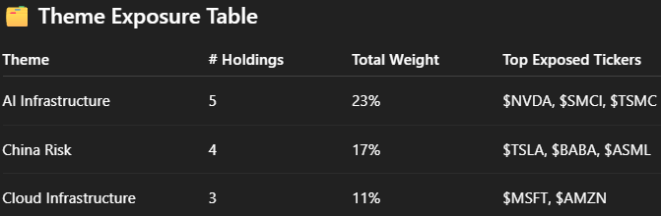  - SECTOR Exposure  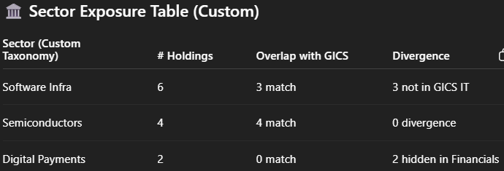  Alternatives: CLI, Email, PDF.

End-to-end traceability
The system should carry source references through every stage – each summarised fact should inherit an ID or citation from its source. That way, when the LLM produces the final answer, it can cite the sources of each claim (the design does intend to return “trace paths, and edge provenance”). Enforcing this not only aids explainability but also acts as a check on the summarizer: if a summary point has no source, maybe it was hallucinated and should be dropped. Technically, this could mean storing an array of source document IDs alongside each summary sentence and having the final prompt ask the LLM to output answers with those IDs as references.
Model Context Protocol (MCP Formatting & Wrapping)
Format the RAG context and query plan into standardised MCP-style JSON blocks. Ensure traceability, modularity, and compatibility.

To structure the input context to the LLM (and the LLM output) in a way that is MCP-styled.

RAG Evaluation
Evaluate the quality, completeness, and faithfulness of the answer relative to the query and retrieved context.

Data Confidentiality [Not the focus for MVP]
For internal documents, if an openAI API like GPT-4 is used, consider anonymizing the text (e.g., replace company names with aliases) before sending for summarization.
Use an open-source LLM hosted locally for that step.

3.2. Tech Stack and Components

 | Components | Description
1. | Data Sources & Ingestion | LangChain loaders + PyMuPDF/pdfplumber for PDFs; spaCy (NER) for entity tagging
1. | Data Sources & Ingestion
  Unified Python pipeline to parse filings, transcripts, news, internal notes; auto-generates metadata (tickers, dates, themes), market data reports, etc, used later for graph traversal
2. | Vector Store (Knowledge Base) | FAISS in-memory (MVP) → Chroma if persistent storage needed  If moderate infrastructure is acceptable, Qdrant or Weaviate (self-hosted) are options, offering robust features and some hybrid search capabilities
2. | Vector Store (Knowledge Base) | Fast semantic retrieval; zero external server; supports metadata filtering for lazy graph look-ups
3. | Embedding Model | Local Sentence-BERT (all-MiniLM) → optional OpenAI text-embedding-3-small for quality boost
3. | Embedding Model | Generates dense vectors for documents & HyDE queries; local model keeps cost ~0; API upgrade only if precision gap merits spend
4. | HyDE Generator | One-shot prompt with lightweight LLM GPT-3.5-turbo or Mixtral (≈ 10 tokens)
4. | HyDE Generator | Produces hypothetical answer → embedding for improved recall on ambiguous queries; negligible cost
5. | Hybrid Retriever | For hybrid retrieval:  - Semantic step – run the vector store’s similarity search (e.g., FAISS/Chroma) and take the top-k chunks.  - Keyword step – run a lightweight lexical search (inverted index, Whoosh/Lunr, or even a title scan) to capture exact-term matches the vector search might miss.  - Merge – combine (e.g., top 5 semantic + top 5 keyword), then de-duplicate and re-rank with either a weighted score or a quick LLM-based reranker.  - Return – pass back the pruned list of documents plus their metadata (entities, dates, source) for downstream graph expansion.  Notes: Weaviate, Milvus, and similar DBs can perform this “vector + lexical” query natively, and LangChain’s MultiVectorRetriever can orchestrate multiple retrievers for you. If we want maximum lean-ness, a small custom Python function that follows the above four steps works just as well.
5. | Hybrid Retriever | Combines semantic, keyword, and HyDE vectors; returns docs + metadata
6. | Lazy Graph Traversal | 1 . Metadata-first retrieval  After initial vector search, extract every entity tag (e.g., ticker, person, macro event) from the top-k hits. Run a metadata-filtered query in the same vector store for each tag to pull additional chunks that share that tag. Most vector DBs support this natively; fallback is a pre-built Python dict {entity: [doc_ids]} for O(1) look-ups. Apply date or relevance cut-offs to skip stale noise.  2 . Lightweight graph only if needed  For MVP scale, this “content-centric graph” lives in the vector store’s metadata—no separate graph DB required. If relations become dense (> ≈1 M edges) or you need complex path queries, migrate to a lightweight Neo4j instance or AWS GraphRAG Toolkit. Until then, simple Python/networkx structures keep infra lean and debuggable.  3 . Extensible tag schema  Begin with high-value relations—company tickers, themes, KPIs. Add new edge types later (e.g., event: Fed Hike) by tagging incoming docs; no re-ingest or schema rewrite. This preserves the agility and low-maintenance ethos of the lazy approach.
6. | Lazy Graph Traversal | On-demand subgraph expansion via shared entities/tags; avoid full KG materialisation cost.
7. | Intermediate Summarization & NLP | Orchestration Use LangChain or LlamaIndex to run a simple chain: for each document cluster, prompt an LLM to extract 1-2 query-relevant bullets, then rank the bullets.  Models Default: GPT-3.5-turbo (fast, cheap). Reserve GPT-4 only for final synthesis on mission-critical tasks. Offline fallback: local Llama-3 8B or Mistral 7B.  Ranking Either (a) let GPT-3.5 pick the top N bullets, or (b) score bullets by cosine similarity to the query using the same embedding model; lightweight rerankers (TSLR / KeyBERT) are optional.
7. | Intermediate Summarization & NLP
  Distils 10–20 source docs into concise, relevant context; ranking reduces final prompt length & cost.
8. | Generative Model | GPT-3.5-turbo (default) → GPT-4o only for critical, complex queries; local Llama-3 8B-Q4 offline mode
8. | Generative Model | Synthesises final, citation-ready answer; swap-able backend via LangChain LLM wrapper
9 | Knowledge-Graph Store | Same networkx object (pickle) → Neo4j Desktop / Aura Free for GUI introspection, Graphiti, Neon (database backend for KG)
9 | Knowledge-Graph Store | Stores typed-edge relations for multi-hop reasoning; trivial to snapshot & version
10 | Orchestration/ Scheduling | Python scripts + cron (batch jobs); optional LangChain RunnableGraph for modular flow
10 | Orchestration/ Scheduling | Keeps infra footprint tiny; single quant can debug locally
11 | Front-end or Interface | Run the workflow via a simple CLI or Jupyter notebook. Schedule it to execute once or twice each day, then automatically deliver the results—e.g., by email. When desired, layer on a lightweight UI such as a Streamlit dashboard or a minimal Flask web app for interactive queries.
11 | Front-end or Interface | Fastest delivery path; UI added only after core value proven

3.3. Data Infrastructure
The strength of ICE’s AI-driven insight engine lies in its ability to synthesize fragmented, multi-source data into a coherent causal knowledge graph by extracting relationships between entities—such as companies, suppliers, KPIs, and thematic drivers—and transforming raw, unstructured inputs into a structured reasoning substrate. This knowledge graph is powered by a deliberately diverse blend of data types: qualitative sources (e.g., earnings transcripts, filings, news, internal research notes) and semi-structured metadata (e.g., GICS tags, portfolio holdings), each contributing a distinct signal. This diversity is not just a feature—it is foundational to ICE’s reasoning fidelity, as it enables cross-source validation and reduces the risk of single-source bias. The result is a dynamic, high-trust framework that uncovers hidden drivers, anticipates ripple effects, and delivers audit-ready, explainable insights. By leveraging signal diversity to reinforce edge confidence, ICE transforms disconnected facts into robust, decision-grade intelligence.
Data Type | Description | Source | Cost | Notes
SEC Filings | Core filings with financials, risk factors, strategy disclosures, and governance details. Includes 10-Ks, 10-Qs, 8-Ks, DEF 14A, insider trades (forms 3/4/5) | SEC EDGAR APIs,  sec-edgar-downloader,  XBRL feeds | Free | Rich, reliable signal. Extracted directly from filings. Supports KPI anchors, governance edges.
Earnings Transcripts & Press Release | Contains official earnings announcement, forward guidance, Q&A, and tone-based signals around results. | AlphaSense  PRNewswire/ GlobeNewswire  Company’s IR site | Free → $$$ | High-signal soft edges (guidance, delays). Start with free sources; expand with premium later.
Investor Presentations | Visual summaries of earnings, strategy, and financial outlook. | Company’s IR site | Free | Useful for context extraction via OCR or PDF parsing. Add in later phases.
Proxy & Special Situation Fillings  Proxy Filings (SEC DEF 14A)  Other regulatory filings (8-K item 7.01, etc) | Annual proxy statements (executive compensation, shareholder proposals, governance)  Special situation filings, e.g. investor presentations furnished on 8-Ks, merger announcements, | SEC EDGAR | Free | Supports signals on control shifts, corporate actions, and risk.
News & Events | Financial News Feeds (RSS Aggregators)  News API services  Major Newswire Press Releases  Social Media Trending News | Yahoo Finance, Google News Finance section, MarketWatch, Reuters Finance, RSS feeds, Financial News APIs, FactSet API  NewsAPI, Finnhub News, Alpha Vantage  PR Newswrite, Business Wire, GlobeNewswire  Twitter; aggregators (e.g. FinTwit, Stocktwits trending tickers), Google Alerts | Free → $ | Triggers for “what changed”. Use for soft signals, trend events, and temporal anchoring.  Can add paid feeds later  Many newswire sites have free feeds or allow scraping of releases by timestamp or ticker  Need API or scraping and NLP for context.
Supply Chain Data | Supply Chain relationships  Import/Export and Shipping data  Industry Association Data | Public filings (10-Ks), LLM extraction, Factset (Revere)  Panjiva (S&P Global), ImportGenius, MarineTraffic  Auto (Wards, BEA), Semi (WSTS), airline traffic (BTS), energy inventories (EIA) | $ → $$$ | Don't need full FactSet SC  Supplier/customer mapping
Internal Firm Data | Research notes, emails, portfolio positions, trade logs | Emails, Analysts notes, portfolio holdings, trades (KIV)  CSV or xlsx files | Free | Proprietary signal. Defensible edge. Prioritize structured (portfolio) over unstructured initially.
Sell-side analysts reports and notes | Broker analyst reports with ratings, price targets, and qualitative argumenets. | Broker emails, Bloomberg, Factset, ResearchPool | Free $$$ | Valuable for triangulating KPI or theme strength
Third-party Research | Platforms where analysts and investors publish research notes. | SeekingAlpha, SmartKarma, Tegus, SumZero, Substack newsletters & blogs, podcasts, webcasts | $$$ | Add post-MVP. Valuable for diversity of opinion or long-tail insight.
Market & Pricing Data  (Optional in MVP) | Price, volume, consensus estimates (earnings & revenue), corporate actions  Real-time market data feeds | Yahoo Finance API  IEX Cloud  Nasdaq  Factset estimates  I/B/E/S | Free → $$$ | Use selectively for context. Not core in LLM-based MVP.
Financial Statement Data | Standardised fundamentals | Yahoo Finance API, Alpha Vantage, Financial Modelling Prep, SEC | $–$$ | Structured numeric data. Adds KPI grounding and validation.
Alt-data (optional in MVP) | Web traffic analytics  Search trends (google trends)  Social media sentiment (twitter/X)  Reddit & crowdsourced forums  Jobs data (hiring and layoffs)  Employee sentiment  Satellite & geospatial  Credit card transaction data  Geolocation foot traffic  Web scraped product data | SimilarWeb, LinkedIn, SafeGraph, Thinknumetc. | $–$$$ | Add once signal/ROI is proven. Useful for alternative edge generation.
NLP/ML Corpora & tools  Financial Corpus | Pretrained financial models and datasets for QA, classification, summarization. | FinBERT pre-trained model  Financial PhraseBank  FiQA & DocFinQA (financial QA datasets)  Financial News Archives (Reuters)  HuggingFace EDGAR Corpus  Sentiment Lexicons (Loughran-McDonald) | Free | Finance corpora contain annotated relationships, domain-specific terminology, and pretrained representations that encode financial entity and event understanding.  Use pretrained corpora in these four bounded roels to reduce cost while maintaining trust:  1. Boostrapping High-Confidence Pattern  2. Pre-filtering and Candidate Generation  3. Type Pattern Validation via Distant Supervision  4. Graph Densification via Semantic Matching
Web-search AI tools |  | Perplexity.AI | $$ $$$
Regulatory & Government Data | SEC RSS Feeds (filling alerts)  Regulatory news & press releases  Macro-economic Data | FDA drug approval announcements (for biotech stocks), FCC announcements (telecom), EPA rulings (energy), NHTSA recalls (autos), etc.  RSS Feeds, email alerts of their press releases  FRED API
Crowdsourced & Sentiment Intelligence | Estimize (Crowdsourced Earnings Estimates)  WhaleWisdom / 13 F hedge fund holdings  AAII surveys (retail investor sentiment)  Kalshi / Predictlt (prediction markets)

Using Financial Corpora (***)
Financial corpora provide curated, labeled data for QA, classification, and sentiment analysis, embedding high-quality relationships like company-to-KPI links or sentiment-to-earnings effects. More importantly, they capture the canonical language patterns used by analysts and financial media, making them ideal not just as content sources, but as domain-tuned "edge grammar" tutors for training relation extraction, semantic parsing, and edge typing models in knowledge graph construction.
Use financial corporate as validation layer to reinforce patterns, candidate generation for reasoning hops, but never let them directly populate the KG without evidence. Instead, extract edges from retrieved, timestamped documents using models enhanced by the corpus.
Use pretrained corpora in these four bounded roles to reduce cost while maintaining trust:
      - Bootstrapping High-Confidence Patterns
- Use corpora like FiQA or EDGAR Corpus to train/finetune NER + RE (relation extraction) pipelines on common financial edges.
- Apply them conservatively (e.g., to validate common templates like Company → key_driver → KPI in earnings call text).
- Safeguard: only accept edges if match confidence > threshold and they’re sourced from actual documents (with timestamp + citation)
      - Pre-filtering and Candidate Generation
- Use corpus-trained embeddings or sentence similarity to retrieve likely document snippets from news, filings, transcripts.
- Run Lazy Graph Expansion only over these scoped results.
- Safeguard: LLM never generates facts—it only extracts from retrieved documents.
      - Type Pattern Validation via Distant Supervision
- Example: if you want Company → exposed_to → Theme, you can use corpus-annotated examples to test your extractions from live data.
- This helps enforce edge typing and prevent "semantic drift".
- Safeguard: Retain edge type schema strictly. Never allow freeform edges into graph memory.
      - Graph Densification via Semantic Matching
- When you already have Company A → depends_on → Supplier B, and you find a similar pattern in corpus for another industry, you can suggest a new edge as a weak hypothesis.
- Safeguard: Store this as a “candidate edge” or “hypothetical” until confirmed by real-world data.
Edge Type | Corpus Role | Example Corpus
Company → key_driver → KPI | Sentence classification + RE | FiQA, FinBERT
Company → exposed_to → Theme | Named entity + similarity match | EDGAR Corpus
Company → has_soft_signal → Event | Tone/sentiment + QA | Financial PhraseBank
Supplier → exposed_to → Theme | Propagation patterns | EDGAR, broker notes
Portfolio → holds → Company | Not needed from corpus (internal) | N/A

Lazy Graph Expansion Powered by Web Search AI Tools (***)
Similarly, we can use web search tools like Perplexity.ai (or similar high-quality retrieval engines) as a critical part of the Lazy Graph Expansion process – but it must be done with care and safeguards.
Perplexity (or similar tools) excel at:
- Query rewriting (semantic expansion)
- Precision retrieval across the web and academic / financial content.
- Citation-based ranking of responses.
Steps | System Design: Lazy Graph Expansion Powered by Web Search
Step 1 | Step 1: Structured Query Decomposition  Break down user queries into typed edge templates, e.g.:  - “Is NVDA exposed to China risk?” → Company → exposed_to → Theme  - “What KPIs drive META?” → Company → key_driver → KPI  This limits the type of edge you’re looking for → boosts extraction precision.
Step 2 | Step 2: Precision Web Search via Perplexity or Similar  - Use structured query to form prompt:  → "What KPIs drive META’s stock price according to recent earnings call, analysts or financial news?"  - Feed this to Perplexity (or a vertical search API), then extract citations from results.  - Perplexity’s advantage is it returns citations with passage-level evidence—these can serve as input documents to the KG extraction pipeline.
Step 3 | Step 3: Causal Edge Extraction from Retrieved Evidence  For each returned passage:  - Run fine-tuned NER + RE models (e.g., from FiQA or your custom model) to extract edges like:  - META → key_driver → Ad Spend  - META → has_soft_signal → Q2 slowdown  - META → exposed_to → Privacy Regulation  - Store each edge with:  - edge_type  - confidence score  - citation (URL)  - last seen date  - evidence span  This becomes a verifiable, explainable KG fragment, suitable for downstream use (reasoning, alerts, etc).
Step 4 | Step 4: Cache & Rank for Lazy Graph Expansion  Store extracted edges in an intermediate cache:  - Group by source, timestamp, and relevance to portfolio  - Score for:  - Recency  - Evidence count (how often a relation is supported)  - Confidence from model extraction  Only include top-N edges when expanding the subgraph for visualization or reasoning.

🔐 Safeguards
To minimize hallucination or spurious facts:
- Never use Perplexity summaries as edge input—only extracted spans from cited passages
- Edge only added to KG if it passes:
  - Confidence threshold
  - Matches typed schema
  - Comes from verifiable timestamped source

3.4. Build Plan
Our approach to developing ICE is guided by three core principles:
      - Leverage existing technologies – Prioritise adopting proven, readily available technologies over building from scratch. Smithery provides a platform of MCP-compatible solutions and databases that accelerate development while ensuring compatibility and scalability.
      - Modular, value-driven development phases – The solution will be built in incremental, self-contained modules – each delivering immediate business value upon completion. This approach ensures that even if future development is paused or adjusted, the built components thus far can remain functional and beneficial to stakeholders. Unlike monolithic architectures (where the system fails if any single module is missing), our design allows for graceful fallback at every stage.
      - Future-proofing with minimal redundancy – Minimise technical debt by designing extensible foundations. Current implementations will be structured to support future expansions (e.g., Knowledge Graph construction for Hybrid RAG) without requiring rework. This reduces wasted effort and ensures seamless scalability in the future.
Note: For Hybrid RAG, this phase focuses on the core workflow, with subsequent extension (e.g., full KG construction) to be incorporated iteratively.

Phrase | Objective / Description
1 | Basic RAG MVP  Deliver a MVP that can answer questions using retrieval augmented generation on our data, without graph enhancements yet. This proves the concept and provides immediate value.  • Data Ingestion & Embeddings: Ingest a representative sample of your documents (e.g. a subset of news and reports) and create a vector index. For MVP simplicity, you might combine all text into one corpus or chunk large docs into paragraphs. Generate embeddings using a quick method (e.g. a sentence-transformer model). Ensure each document chunk is stored with metadata (source, date, key entities).  • Simple Retrieval & QA: Implement a straightforward RAG pipeline: given a query, do a pure vector similarity search to fetch top-$k$ documents. Feed those (perhaps truncated or concatenated if small) into an LLM prompt along with the question. Get the answer from the LLM. This is essentially a standard RAG flowanalyticsvidhya.comanalyticsvidhya.com. You can do this in a notebook or script, using either LangChain’s QA chain or writing your own prompt.  • Validate Output Quality: Test with a few example questions relevant to your workflow. For instance, “Summarize the latest developments for Company X” or “What risks are mentioned regarding Product Y’s rollout?” Evaluate if the answers seem accurate and grounded in the retrieved docs (you can have the LLM also output which sources it used, to manually verify correctness). This phase will likely highlight any glaring issues like irrelevant retrievals or model errors, which you can then adjust (e.g. tweaking the prompt or number of docs).  • Tech Choices Finalized: By the end of Phase 1, we’ll have chosen the basic tools: which vector store to use (e.g. decided on Chroma vs FAISS), which embedding model, and which LLM for generation (likely GPT-3.5 at this stage for convenience). The output of Phase 1 is a working Q&A system on a small scale, which demonstrates the baseline functionality
2 | Enhanced Retrieval (Hybrid Search & Lazy Graph Links)  Improve the retrieval relevance and breadth by adding the hybrid search and on-the-fly graph expansion. This phase implements the distinguishing features of our architecture to capture those indirect but important connections.  - Introduce Keyword Search: Augment the retriever from Phase 1 with a keyword-based component. For example, implement a simple full-text search over document titles or content (even a Python regex or a library like Whoosh). Use it to catch documents that vector search might miss – such as ones containing specific names or terms from the query. Develop a strategy to combine results: e.g., take top 5 from vector and top 5 from keyword, de-duplicate any overlaps. If order or scoring is needed, you might use a heuristic like giving priority to vector results (assuming they’re generally more relevant) but appending any unique keyword hits. This ensures higher recall on facts that a purely semantic search might overlook (for instance, a document that mentions “Fictitious Canal” explicitly will be pulled if the query contains that term, even if the semantic model didn’t consider it close).  - Implement Lazy Graph Expansion: Now integrate the graph-based retrieval step. Use the metadata tags (from ingestion) to find related docs. Concretely: after the initial hybrid retrieval, collect all unique entity tags from those top docs. For each tag, fetch additional documents (maybe up to 3-5 per tag) that were not already retrieved. This can be done by querying the vector store with a filter on that tag or by looking up an index/dictionary. If the number of tags is large, you might focus on the most relevant ones – e.g., if the query is about Company X in Europe, prioritize tags like “Company X” and “Europe” rather than every person name that appeared. The output is an expanded set of documents.  - Clustering or Grouping (if needed): Depending on how many docs we have now, it might help to group them by theme to manage the next steps. You can cluster by the main entity or simply by the tag that fetched them (e.g. all docs under “Company X” vs all under “LogisticsCo”). This isn’t strictly necessary for correctness, but it helps if we plan to summarize per cluster. In practice, you could implicitly cluster by running separate summarizations for each tag’s documents.  - Prototype this process: At this point, run a few queries through the new retrieval pipeline. Check that the expanded results indeed include those less-obvious documents that add context. For example, verify that for a multi-faceted query, you now see documents covering each facet. You might see that without expansion, the answer missed a risk factor, but with expansion, it’s now included – mirroring the example from AWS where the supply chain delay article gets pulled in via the LogisticsCo connectionaws.amazon.com. This will confirm the hybrid+graph retrieval is working as intended.  - Monitor Performance & Adjust: Adding more retrieval steps increases computation. Make sure it’s still reasonably fast for batch use (since batch mode can tolerate minutes per query, this should be fine). If some queries bring in too many docs (noise), consider limiting the expansion scope (maybe only expand on top 3 entities instead of all, or filter out very generic entities). The goal is to keep the context focused and not flood the next stage with irrelevant text. By the end of Phase 2, we should have a robust retrieval subsystem that maximizes relevant info for each query, setting the stage for better answers.
3 | Context Processing and Answer Generation Refinement  Incorporate the summarization, ranking, and answer generation steps to produce high-quality, concise answers from the retrieved data. Ensure the final output is accurate, well-structured, and delivers the needed business value (actionable insight for the investment workflow).  • Summarize or Extract Key Points: Implement the intermediate processing of documents. One approach is to use the LLM to summarize each cluster of docs. For example, take all docs related to “Company X” cluster and prompt: “Summarize the key information from these documents relevant to [the query].” Do the same for the “LogisticsCo/supply chain” cluster, etc. The result might be a paragraph per cluster. Another approach is more granular: have the LLM extract a list of bullet-point facts or claims from each document individually that answer the query. This might yield many small pieces which you then aggregate. Choosing between these depends on what works better in testing – bullet extraction gives fine-grained control for ranking, whereas cluster-summary yields a broader overview. We could even do both and compare. Importantly, this step condenses possibly 10-20 documents into a much smaller set of content. This makes it feasible to feed into the final model. It also can reduce redundancy (multiple articles might repeat the same fact, which a summary would mention just once).  • Ranking of Information: If we have multiple clusters or many extracted facts, apply a ranking to pick the most relevant pieces for the final answer. For example, if we ended up with 10 bullet points, we might only need the top ~5 in the answer due to token limits. We can rank by relevance to query (embedding similarity approach: embed each bullet and compare to query embedding score), or by importance: perhaps the cluster summaries are inherently high-level so all are used. Another idea is to prompt an LLM: “Given the question and these candidate facts, which ones should definitely be included in the answer?” A simpler heuristic: ensure at least one point from each major cluster (so the answer is well-rounded) unless the query is very narrow. Implement this and select the final context pieces.  • Finalize Prompt Template: Design the prompt for the final answer generation. It might look like: “You are a financial assistant. Using the information provided, answer the query. Query: ... Context: ... Answer:”. Include the selected facts in a clear format (possibly as bullet points or as numbered references) so the LLM can easily incorporate them. We will also instruct the model to be concise and factual. Test this prompt with the chosen LLM (GPT-3.5 or others) on some training questions. Evaluate the outputs: Are they accurate and comprehensive? Do they mention the key figures and caveats? If something is off (e.g. the model ignores a piece of context), we can refine the prompt, perhaps by explicitly telling it to consider all points or by increasing the number of points provided.  • Include Source References (Optional): For internal use, it might be valuable to know which source document supports each part of the answer. During this phase, we can implement a simple referencing mechanism. Since we track metadata, we can append a reference tag after each fact in the context (like [Doc3]) and ask the LLM to preserve those in the answer. Or we could have the LLM answer, then in a post-process attach sources to each sentence by matching it to original docs (this is more complex). For an MVP, it might suffice that the quant or end-user can look up the metadata of the retrieved docs themselves. But it’s worth noting that the system can be extended to produce a research report with footnotes linking to source docs – which increases trust in the output.  • User Acceptance Testing: At the end of Phase 3, run the system on real-world queries or even historical scenarios to see if it provides useful insights. For example, feed it a question about an event (like “How might the sudden resignation of CEO of Company Z affect its stock?” if your data has such an event) and see if it picks up both the resignation news and perhaps related context (like the company’s succession plan or similar past cases). This is where the business value is validated – does the answer help a trader/analyst make a better decision or save time? Collect feedback on answer quality, and fine-tune as necessary (adjust retrieval parameters, add any missing data sources, etc.).
4 | Deployment  Objective: (Optional, after MVP) Make the solution more accessible for daily use and integrate it into the workflow. While the initial focus is batch usage, here we consider improvements for usability and real-time querying if needed.  - Batch Automation: Productionize the batch mode. This could mean scheduling the system to run specific queries every morning before market open, generating a briefing for the team. We can use cron jobs or a simple scheduler script. Ensure logging is in place (so if a query fails or if the LLM returns an error, it’s caught and can be retried). Also, monitor the costs of API usage over time to stay within budget – this might involve adding caching (if the same question is asked repeatedly, reuse previous answer if underlying data hasn’t changed).  - Lightweight User Interface: If beneficial, implement a simple front-end or chat interface. For instance, a small web app using Streamlit could allow team members to type in ad-hoc questions and see answers with sources. Given our Python-only constraint, Streamlit is a good choice (pure Python, no need to deal with JS frameworks). Alternatively, integrate with an existing tool – e.g., perhaps output to Slack or email. The key is not to spend too much time here until the core system is stable and useful. A basic UI can significantly improve adoption (people are more likely to use it if they can just ask a question on demand). Since in Phase 3 we developed and tested prompts, this interactive mode is mostly about hooking up input/output, not changing the core logic.  - Scaling & Optimization: As usage grows, consider performance tuning. For real-time queries, total latency might need to come down. Some strategies: parallelize steps (for example, retrieval and expansion can be parallel since each tag search is independent), use faster embedding models or smaller LLM for intermediate steps, and only use the big model at the end. The lazy GraphRAG approach is already quite efficient (only ~4% of the query cost of a full graph search in testslinkedin.com), but we can always profile where the most time is spent (likely LLM calls) and see if any step can be pruned or cached.
5 | Full Knowledge Graph Construction  [XXX]  Periodically (e.g. Monthly or Quaterly), run batch “KG Enrichment” job to enrich, refactor and expand the KG that the Lazy GraphRAG has started building.  - Traverse and clean existing graph by deduplicating noisy edges, drop stale or low-confidence links, normalise nodes (e.g., alias mapping for “Meta” vs “Facebook”)  - Mine new edges from older documents or relationships not captured lazily; Use LLMs to extract latent relations from backlogs (eg.. earnings call, management guidance); add second- and third-hop edges; reclassify or group nodes (e.g., theme super-theme hierarchy).  - Generate summary nodes (e.g. “Narrative cluster: AI Infrastructure”), edge weights (E.g., edge strength based on mention frequency or document confidence), community clusters (e.g. “high china exposure companies”

4. MVP Scope
The Investment Context Engine (ICE) is a modular, graph-native AI system that serves as a context assembler for investment workflows. By fusing fragmented external signals (e.g., earnings transcripts, filings, news) with internal firm knowledge (e.g., research notes, memos, portfolio data), ICE grounds cutting-edge LLMs in a structured, explainable knowledge graph. This architecture transforms noisy, unstructured inputs into decision-grade insights that are transparent, traceable, and aligned with the firm’s investment philosophy.
The MVP version of ICE focuses on the highest-leverage surface area—public equities portfolio monitoring—where fast, interpretable insight generation can yield immediate value for PMs and analysts. Built around a Lazy Graph RAG (retrieval-augmented generation) stack, this MVP prioritizes a single-question interface backed by subgraph-based reasoning, enabling targeted questions like “Why is NVDA at risk from China?” to be answered in seconds with context-rich, explainable outputs. The MVP interface, as shown in the accompanying mockups, balances interpretability and feasibility, delivering value from day one while laying the groundwork for modular expansion.

Focus | Description | Why this scope for MVP?
Asset Class | Public equities | The fund’s core investment / asset class focus
Stock Universe | S&P500 constituents | S&P 500 names offers highest coverage and lowest data acquisition cost.
Investment workflow focus | In order of priority:  1. Portfolio management  2. Investment research  3. Risk management  4. Trading | Prioritises low-risk, high-trust usage where AI augments, not replaces, analyst judgements; prioritization balances business value and feasibility.
Data | Publicly available qualitative external data | Plays to LLMs’ strength in unstructured data; future work may layer quantitative inputs.
Typed Edge Patterns | Focus on minimally three typed edge patterns for the Lazy Graph RAG, with incremental value beyond the three, in order of priority:  1. Portfolio/Watchlist -holdsCompany  2. Company – exposed_to Theme  3. Company – key_driver KPI  4. Company – sector GICS_sector  5. Company – industry GICS_industry  6. Company A -supplier/customer Company B  7. Company – has_soft_signal Event | Order of priority of typed edge patterns is planned based on the maximization of business value to the PMs and users, in relation to the difficult and feasibility.  Delivers the most decision-relevant insights with minimum engineering lift; prioritization balances business value and feasibility.
Processing Frequency | Batch processing (daily or intraday) instead of real-time alert | Simpler to implement, sufficient for early signal detection.
Graph Construction Technique | Lazy graph expansion instead of full graph construction | Avoids upfront full-graph cost; performant and targeted.
RAG Architecture | Up to 3-hop lazy traversal based on successfully implemented typed edge patterns mentioned above.  Lazy Graph RAG traversal instead of full RAG traversal.  Monolithic instead of multi-agentic workflow | Enables rich reasoning without complexity explosion;  prioritization balances business value and feasibility.
AI Interaction Design | Single QA box instead of full conversational chat box with memory;  Sequential modular implementation approach for building the AI solution, where each development phase delivers standalone value. Staged rollout ensures business values are realised at every milestone, creating incremental ROI while de-risking the overall project. | Highest-value queries surfaced early with minimal UX overhead.
Interoperability | MCP-style standardisation | Straightforward to implement; enables plug-and-play extensibility down the line.

The MVP version of ICE, as illustrated in the mockup provided below, is scoped in a way that delivers a streamlined, high-leverage dashboard designed for lean equity hedge fund teams to assist in areas of portfolio management, trading, investment research and risk management. This version surfaces only the most material drivers of change, explains them in human-readable form, and grounds each insight in verifiable source evidence.

MVP Hop reasoning chain retrieval priority
The MVP ICE aims to target up to 3-hop queries in the following areas. The pipeline should support 1-3 hop enumeration, reverse traversal, and temporal/confidence scoring out of the box. No heavy graph DB; just NetworkX + metadata and lazy expansion form the retrieved documents set. The retrieval plan explicitly sets expand_edges, reverse_lookup, and graph_hops, so that we can cap depth per query to contain cost and noise.

In order of importance, the build plan will focus the retrieval for 1-hop, 2-hop, followed by 3-hop, in the order of difficulty. These give clear incremental value from each phrases of the build plan. Capping reasoning chains at less than 3 hops covers the majority of PM/analysts questions while keeping extraction, ranking, and synthesis simple enough for a single quant MVP.

1-hop (fastest ROI, trivial to extract)
Theme exposure for a ticker | Path: Company —exposed_to→ Theme  Query: “Is TSMC exposed to China risk?” / “What themes drove META this week?”  Value: immediate narrative context for price action and screening. Edges pull cleanly from headlines/transcripts.  Data Sources: Earnings transcripts, news articles and headlines, sell-side reports, 10-K risk factors
KPI driver for a ticker | Path: Company —key_driver→ KPI  Query: “What KPIs actually drive UBER?”  Value: centers research on the 1–2 metrics that move the stock; cheap to mine from earnings  Data sources: Earnings transcripts, investor decks, earnings presentations, sell-side models, analyst initiation reports, earnings call summaries.
Soft-signal scan | Path: Company —has_soft_signal→ Event  Query: “Any early negative signals on AMD?”  Value: surfaces pre-consensus drift (tone, delays, layoffs); captures narrative drift before the numbers; great for alerts  Data sources: News headlines / wire services, internal investment team notes and emails, sell-side notes, earnings calls (Q&A or mgmt. caution)

2-hop (portfolio-aware & causal stubs)
Portfolio theme exposure | Path: Portfolio —holds→ Company —exposed_to→ Theme  Query: “Which of our holdings are exposed to GLP-1/China risk/AI infra?”  Value: instantly turns themes into book-level views; trivial ownership edge from CSV.  Data sources: Internal portfolio positions/watchlist CSVs, news / earnings transcripts theme links, LLM-extracted entity-theme co-occurrence from documents.
Post-earnings “why move?” | Path: Company —key_driver→ KPI + Company —has_soft_signal→ Event  Query: “Why did META drop post-earnings?”  Value: ties the KPI anchor to fresh management commentary/soft signals to explain direction without modeling magnitude.  Data sources: Earnings call transcripts, press release, pre/post-market newswire and alers, soft signals from internal notes or analysts presentations.
Supplier/Customer narrative propogation | Path: Company —depends_on→ Supplier/Customer —exposed_to→ Theme  Query: “How does China risk reach NVDA via TSMC?”  Value: explains second-order impacts with two extra extractions; easy to rank by recency/confidence.  Data sources: Supply chain disclosures / vendor lists, industry supply chain database (e.g. Factset RBICS, Bloomberg SPLC), news events or filings linking supplier to theme.
Theme→names reverse lookup | Path: Theme ←exposed_to— Company (reverse traversal)  Query: “Show names tied to ‘AI infrastructure’ with most recent evidence.”  Value: reverse traversal is native in the design—no reverse edges stored.  Data sources: LLM-tagged co-occurrence of company and theme in documents, earnings transcripts, press releases, news articles and thematic commentary

3-hop (high signal)
Full causal trace for risk | Path: Company —depends_on→ Supplier —exposed_to→ Theme —(recent soft signal)← has_soft_signal — Company (two companies or the same chain)  Query: “Lay it out: how is NVDA exposed to China risk via TSMC, and what’s the freshest mgmt tone?”  Value: the classic desk explanation path; still within 3 hops; scored by edge confidence, last_seen, evidence_count.  Data sources: Data sources for #6, #1& #3; temporal metadata for last_seen, confidence scoring model for each edge (from RAG/LLM extraction)
Portfolio-first risk sweep | Path: Portfolio —holds→ Company —has_soft_signal→ Event —(implies)→ Theme (or return both Event & Theme tags)  Query: “Which holdings flashed cautionary signals in the last 30 days, and what themes do they touch?”  Value: converts soft signals into book-level action items; recency filters keep noise out.  Data sources: Portfolio CSV, Soft signals from news/internal notes, lightweight event-to-theme ontology (e.g. layoffs macro slowdown), recency timestamping + confidence thresholds.
Supplier/Customer concentration check | Path: Portfolio —holds→ Company —depends_on→ Supplier/Customer  Query: “Which positions rely on the same supplier (single points of failure)?”  Value: simple, actionable consolidation for risk meetings; uses only CSV + a lightweight supplier edge.  Data sources: Portfolio CSV, supply chain database/disclosures, Factset RBICS supply chain module or Bloomberg SPLC.
Theme→KPI lens for a name | Path: Theme ←exposed_to— Company —key_driver→ KPI  Query: “For GOOG’s AI infra exposure, which KPI should we watch next?”  Value: joins narrative to a measurable anchor; perfect for pre-earnings prep.  Data sources: Theme extraction from transcripts / press, KPI drivers from investor materials and calls, sell-side notes and keyword scoring.
Event narrative via supplier | Path: Company —depends_on→ Supplier —has_soft_signal→ Event  Query: “Does a TSMC production warning matter for ASML today?”  Value: shows whether upstream soft signals plausibly propagate into names we care about.  Data sources: Supplier disclosures or inferred links, news and filings with soft signals, event timestamping, tone and confidence.

5. User Interface and Mockup
The ICE MVP interface is designed to prioritise immediate usability and high-impact insights while laying the groundwork for iterative expansion. By focusing on core workflows—natural language queries, ticker-specific intelligence, and portfolio-level alerts—this lean design delivers three critical advantages:
- Speed-to-Value: PMs/analysts gain actionable, causality-grounded answers within seconds, bypassing manual data aggregation.
- Transparency: Every output is backed by auditable evidence chains (sources, causal paths, confidence scores), building trust in AI-driven insights.
- Adaptability: The modular architecture ensures seamless integration of future enhancements (e.g., conversational AI, automated alerts) without disrupting existing functionality.
Below is the phased feature breakdown:
Module 1: Ask ICE a Question (LLM Query Interface)

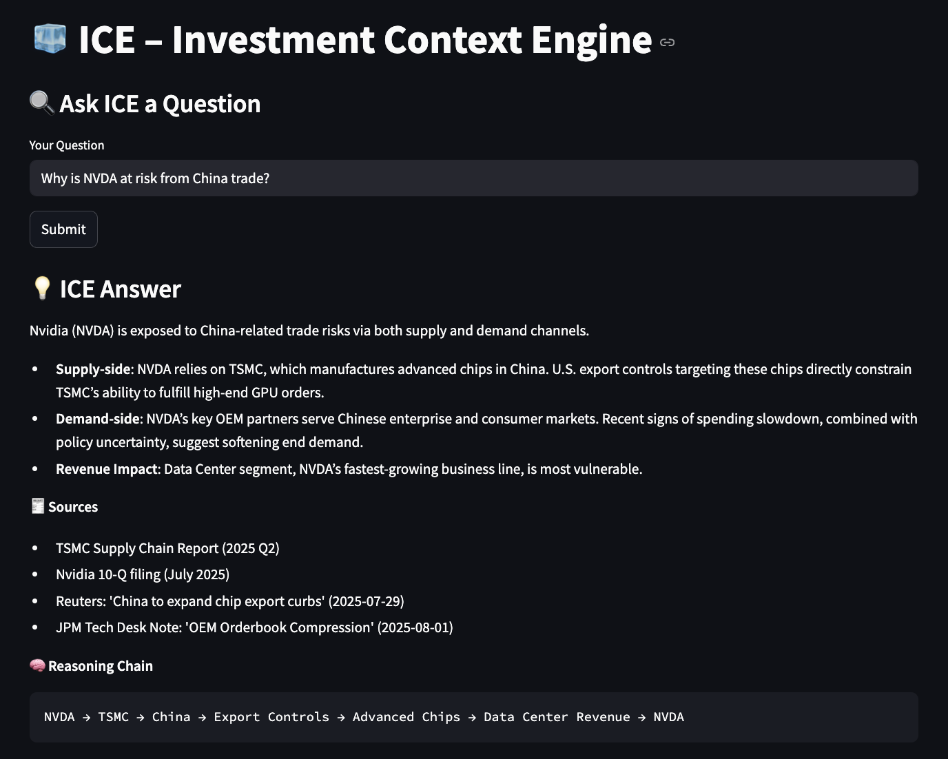
This module is a QA query that allows PMs/analysts to input natural language questions, asking targeted, forward-looking questions and receive structured, explainable answers grounded in causal reasoning. Responses are broken down into key drivers—such as supply chain dynamics, demand shifts, or revenue exposure—backed by cited evidence and visualized through an interpretable causal chain. It transforms noisy, fragmented information into clear, decision-grade insight within seconds. The output generates a narrative response (from RAG), including the reasoning chain and source trace.
Future iteration: Evolves into a full-blown conversational interface for iterative, multi-turn analysis.
Module 2: Per-Ticker View – Intelligence Panel
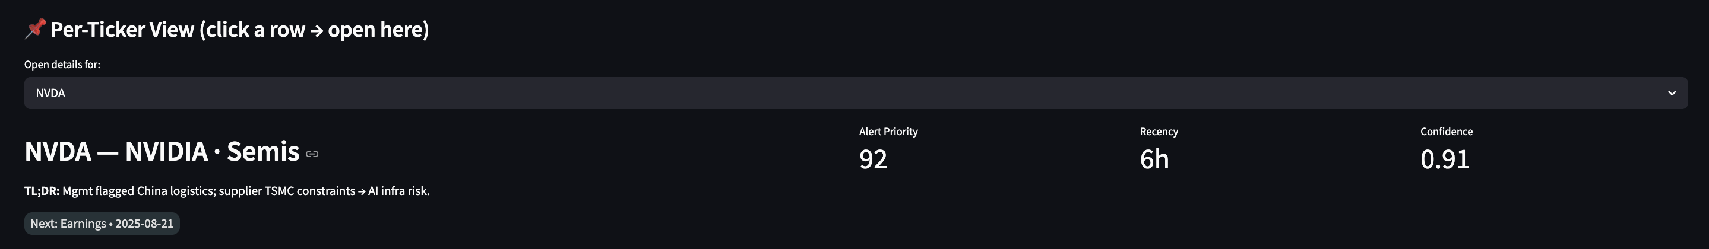
The Per-Ticker View offers an in-depth drill-down analysis on any company/stock in the portfolio, watchlist or QA query box. Each view opens with a TL;DR summary, alert priority, confidence score, recency of the last signal, key KPI drivers, themes, soft signals and top causal path, with source traces and causal paths to these information. Additionally, this also opens up the subgraph of the core entity for users to see the causal links.
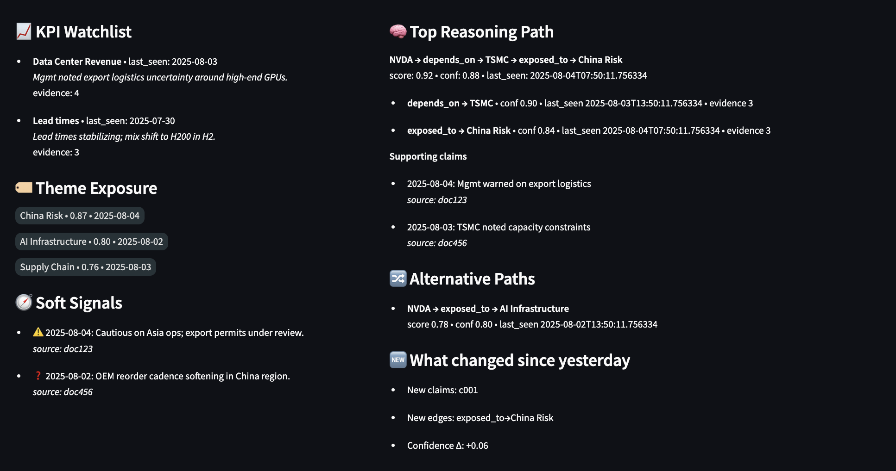
This panel reveals the full analytical stack: KPI pressure points, thematic exposures, early soft signals, and supporting causal chains. The top reasoning path unpacks the most probable causal narrative, grounded in timestamped evidence, while alternative paths present competing interpretations. A “What Changed” module tracks deltas in evidence, edges, and confidence—enabling fast re-evaluation when rechecking the same name. This design balances compactness with depth, surfacing the insights that matter most in a single glance.

Module 3: Mini Subgraph Viewer (chained to Per-Ticker View module)
The Mini Subgraph Viewer is an interactive visual module built from ICE’s path engine that reveals the causal reasoning paths around a focal node (ticker-in-question). Centered on the selected company, it enables users to explore 1–3 hop relationships across the knowledge graph—surfacing linked suppliers, demand drivers, macro themes, KPIs, and policy shocks.
Customizable filters for hop depth, recency, edge type, confidence, and contrarian signals allow analysts to isolate the most relevant relationships. Fully integrated with the Per-Ticker View, this graph offers a transparent and intuitive map of “what’s going on and why”—translating complex interdependencies into immediate, decision-grade insights.
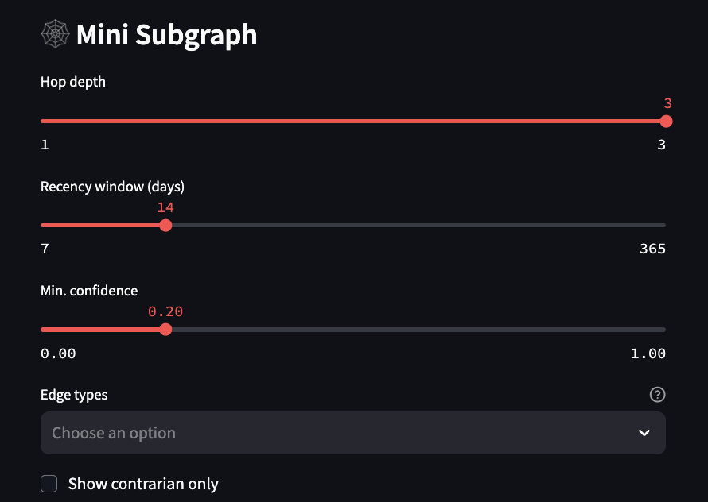
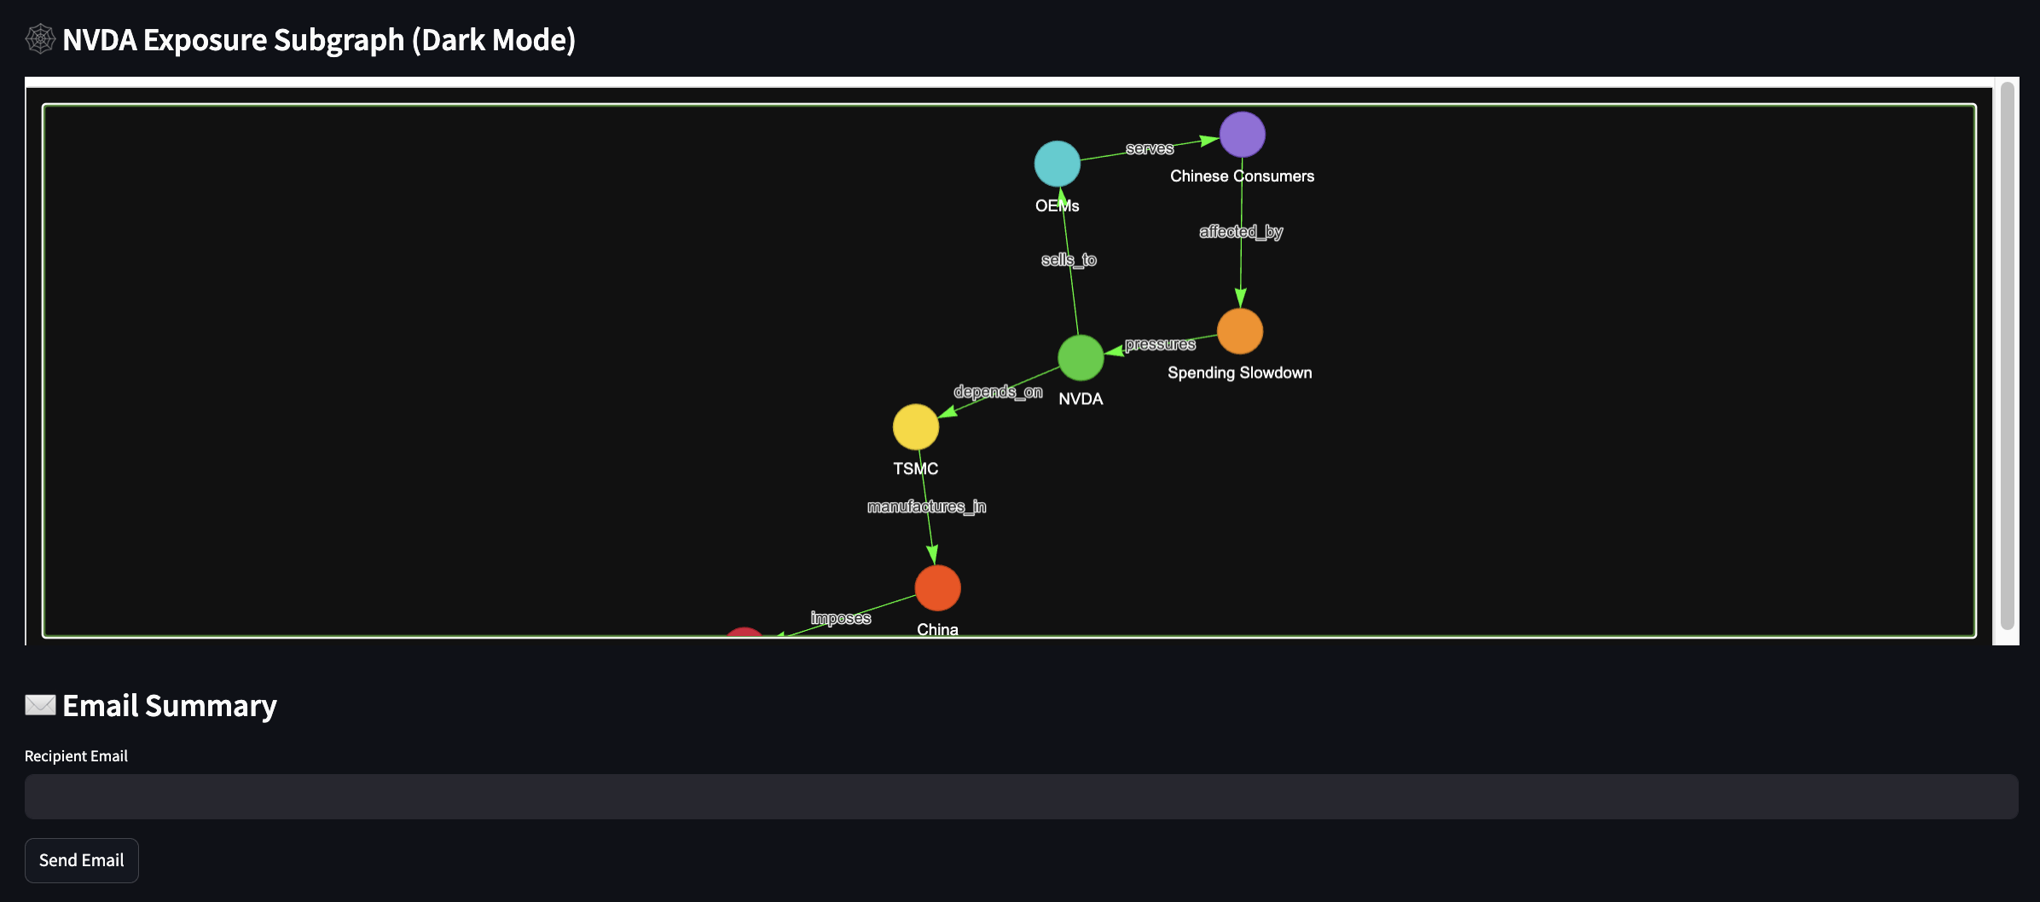

Module 4: Daily Portfolio / Watchlist Brief Tables

These high-signal tables deliver a concise, daily-updating snapshot of emerging risks and opportunities across portfolio and watchlist names, ranked by “Alert Priority”. Each row represents a stock/company and the columns highlight what changed, the top causal driver, relevant themes and KPIs, soft signals, recency of supporting evidence, and a confidence score for that entity. Optimized for rapid scanning and triage, this interface enables PMs and analysts to quickly identify which holdings require attention. Clicking on any ticker instantly opens the detailed Per-Ticker View, unlocking deeper causal reasoning, supporting claims, and interactive subgraph analysis—all in a few clicks.
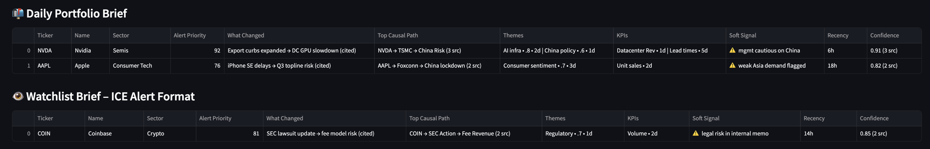

Optional: Portfolio Exposure Charts (Pie chart)
Sector exposure breakdown of current holdings in the portfolio.
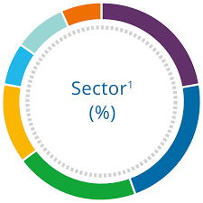

Optional: Bubble chart of theme exposure based on market value size of holdings related to the theme.
Thematic exposure visualized by frequency and value of stocks linked to the specific themes.
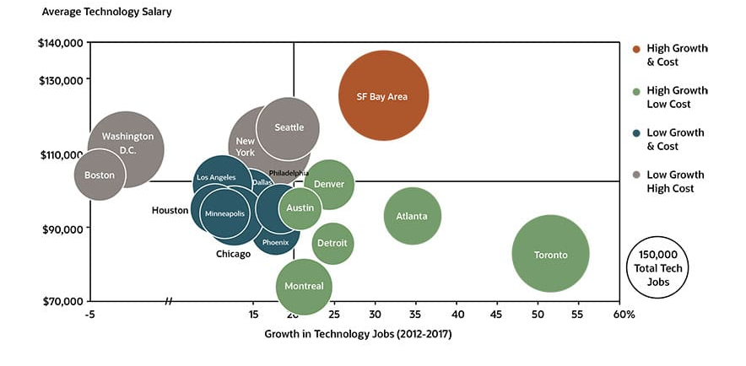

Module 5: Email Module
The email module enables lightweight, proactive delivery of insights directly to individual users or the broader team—ensuring timely context reaches the right people conveniently. Lets user enter email to receive summaries of the current output of ICE.
Future extensions: Auto-push alerts, templated email formats, PM summary digests.

6. Feasibility Analysis

Constraint | Details | Solution / Workaround
Time | 3 months for MVP | Optionality to extend to 6 months
People | 1 quant analyst building (limited technical knowledge) | Assisted with AI coding tools (e.g. Claude Code, Cursor)
Infra | Limited/no cloud backend; laptop-scale compute | Minimise this in MVP,  - batch processing instead of real-time  - Lazy Graph RAG instead of full KG construction  - Zero-ops deployment, all code in one repo, runs on analyst’s desktop; no servers or cloud creds needed for MVP
Data | Public + internal docs, no live OMS/API integration yet | Assess as it goes, amend use case depending on successful connection to different databases.  Approach data vendors (e.g., Factset or Bloomberg) for trial on AI related support.
Architectural Design | Lazy Graph RAG is a relatively new approach that may not be mature or well-documented by the community. | Fall back to traditional graph construction and traversal, reduce scope of MVP to make it more manageable.

[SCOPE of MVP]
- S&P 500 universe.
- Batch processing (daily)
- Daily portfolio context summarizer.
  - Input: Portfolio holdings CSV or Watchlist CSV
  - D[]

- Portfolio holdings data + one / two key external info, rather than an over-extended graph.
  - Daily AI-powered portfolio context summarizer – Maximise insights density per ticker while keeping the graph schema, lighweight, clean and feasible to build.
  - “Portfolio-centric Context Summarizer”: A batch-mode AI engine that summarises the most important recent developments for each portfolio company, with causal links, KPI risks, and narrative shifts – grounded in internal + external data.
    - Input: Company tickers from a watchlist or portfolio CSV
    - Data: SEC filings, earnings transcripts, major news, internal notes
    - Retrieval: Hybrid RAG (vector + keyword) with HyDE
    - Lightweight KG: Only 2-3 edge types (e.g., companyKPI, companytheme); stick to 1-3 hops
    - Graph use: Lazy graph expansion using tags (no graph DB)
    - Summarisation: Hierarchical summarizer: extract top bullets per ticker.
    - Generation: GPT-3.5 / Mixtral: Final synthesis of “What’s going on with [ticker]?”
    - Construct the graph in priority of the typed edge patterns, targeting at least 3 for MVP:
- KPI Driver edge
- Narrative theme exposure edge
- Soft signal edge
- Causal link edge (encode macro/micro event linkages)
- Ownership context/Portfolio edge
- Earnings Surprise Edge (optional); would be partially fulfilled by the causal link edge.
    - UI/Output: Daily email / Streamlit dashboard with
      - Ticker
      - Event summary
      - Causal reasoning (e.g. earnings miss guidance down stock drop)
      - Supporting sources
      - KPI exposure bullets
    - Example:
Ticker | Summary
$META | “Q2 EPS beat by 12%, but cautious Q3 guidance triggered a 6% selloff. Mgmt cited soft ad demand in Europe. DAU growth continues, but Reels engagement flatlined. Our KG links META to ‘AI infra theme’, but no updates there.”

- “What KPIs drive Uber’s stock?”, the system could retrieve not just a textual answer, but also a small table of historical KPI vs stock correlations or surprise analysis; technically, this can be done with open-source data (e.g. pulling 10-Q financials or using Yahoo Finance API for price vs metric correlation) and caching these results in the graph or document store. The LLM then has grounded numbers to refer to. Use the LLM as a last-mile reasoning layer atop a quantitative foundation. That is, do the heavy lifting of data crunching with simpler statistical tools or scripts, and let the LLM focus on explanation and synthesis. Essentially, whenever possible, ground the LLM’s reasoning in numbers and factual evidence, instead of letting it fill in blanks from its training data or general knowledge. All of these refinements are feasible with open-source tools (pandas for data, existing APIs, simple correlation analysis) and add only modest extra coding, but significantly enhance alignment with real-world investing needs.
- Focus on high-level thematic questions, a coarse graph link might suffice (e.g. “Company A is exposed to Theme B”).
- Sparse KG Catastrophes
- Hallucination risk
- No Reconciliation: Conflicts between sell-side reports (e.g., "Uber DAUs growing") and internal analyst views ("DAUs peaking") are unresolved.
- Siloed Vector Stores: Separate embeddings for filings (FAISS) and internal docs (Chroma) prevent cross-source grounding, leading to contradictory evidence retrieval.
- Token Explosion: Processing a subgraph + 20 retrieved documents for a query like "Why did NVDA drop?" exceeds 16K context windows, forcing truncation.
- Stale or Spurious Knowledge Graph relationship - The danger is that the system treats these edges as evergreen truths driving its reasoning. This can lead to contradictory or nonsensical investment reasoning: the AI might insist that “Theme X causes KPI Y to move” because the graph has that connection, even when current data disproves it. In worst cases, the engine could push the fund toward crowded trades or outdated theses (following old “mental models” encoded in the graph) and miss new causal drivers that aren’t yet in the graph.
  - Implement dynamic weighting and decay for graph edges; treat each relationship not as a binary fact but as a hypothesis with a strength that can change over time. This can be as simple as tagging each edge with a timestamp or “last evidence date” and down-weighting edges that haven’t been reaffirmed recently.
  - For example, if “trade war hurts tech stock X” was an edge from 2018 news, and there’s been no mention of it in two years, the system should either drop it or severely discount it for current queries. Conversely, if new data emerges (e.g. a fresh news article linking them), the edge weight goes back up. Technically, this could be done by tracking how often and how recently each relation was mentioned in the processed sources (a small script can update a weight attribute during weekly batch ingestion)
- Narrow the scope and type of edges to those with high confidence/reliability, low effort and high business value.

Focus the MVP on the highest ROI functionality -for example, start with portfolio monitoring and fundamental research support (which tolerate batch latency) and defer real-time insights generation.
Implement a minimal set of core components well, rather than all components poorly. For instance, begin with a basic hybrid retrieval (vector + keyword) and a lightweight knowledge index for portfolio companies, without the full multi-hop graph traversal. This could involve using a simple in-memory graph (e.g. NetworkX) with only a few critical edge types initially (such as sector classification and key revenue drivers) instead of the full 10-edge schema, which is more feasible to build and validate quickly.
Focus on the fund’s own portfolio data and key external info, rather than an over-extended graph.
For instance, the system might identify that a stock dropped due to an “earnings surprise” and “broker sentiment”, but an LLM could struggle to quantify how much of the drop was due to the earnings miss (hard data) versus negative tone in commentary (soft data). For MVP and in fact solution as a whole, limit usage of the solution relying on the direction (as opposed to numerical magnitude) of the model’s outputs.
Avoid use-cases that require quantitative rigor or precise numerical reasoning (implement disclaimer on user queries that require quantitative rigor).
Modularise the architecture, rather than one monolithic pipeline, design clear interfaces so that each part (data ingestion, retrieval, reasoning) can function independently. This way, if the knowledge graph module isn’t ready or is unreliable, the system can still fall back to simpler vector RAG workflow.
Staged rollout for use-cases – Initially, target fundamental research queries (e.g. “What drives the stock’s earnings”) in batch mode.
Bias and Information Loss: The multi-step retrieval and summarization process in ICE, while powerful, introduces risks of bias, information loss, and even inadvertent information leakage.
- Using a Hypothetical Document Embedding (HyDE) means the retrieval is based on an LLM-generated “ideal answer”; if the LLM’s guess is biased or overly narrow, the documents fetched will be skewed towards that narrative, potentially missing contrary evidence.
- The summarization stage condenses documents, which risks omitting subtle but critical points (say, a one-line risk factor buried in a filing), might oversimplify and drop nuance. This risk is amplified with the use of cheaper models or even rule-based methods for summarisation to save costs, as proposed in this proposal
Importantly, leverage open-source tools in their default, simplest forms (e.g. use a pre-built LangChain retrieval QA chain) to avoid reinventing the wheels.
MVP score and timeline.
Cost consideration – Most core components (vectorDB, data processing, orchestration) are open-source Python libraries that run on commodity hardware. The main variable costs is the LLM API calls. By doing multi-step retrieval and summarization, we minimize the context length fed into the expensive final generation step, thereby saving tokens. Lazy GraphRAG is explicitly shown to cut costs drastically compared to naive approacheslinkedin.com. For example, it avoids embedding or summarizing every document in the corpus (which would be very costly) and instead targets only what’s likely relevant, akin to scanning 1% of data to answer a question instead of 100%. Additionally, by performing a lot of filtering and logic in Python (which is essentially free aside from development time), we ensure we use the paid LLM only for tasks that truly require its reasoning.
Address typed edge patterns in sequence.
Based on the phased build plan to incrementally develop and validate the solution, aligning with the resource constraints and priorities. At each phase, to have already provide immediate value.
Selected queries group to address in MVP.
Phased execution of product.
Constraints: Token limits. IT constraint. Knowledge and expertise constraint. Time constraint.
- KGs are sparse graphs, not massive dense matrices; we can easily store 10K-100K nodes/edges using NetworkX or Neo4j on a laptop.
  - NetworkX handles 100K+ edges efficiently in memory
  - Neo4j’s free version supports ~1M nodes on consumer hardware.
- The challenge with KGs in the past lies in constructing of the KG – manual curation or rule-based extraction was time-consuming and laborious. However, current breakthroughs in LLM-powered KG construction (e.g. using GPT-4, Claude or open-source Llama 3) have dramatically automated this process (“AutoKG: LLM-based knowledge graph construction”, 2023; Microsoft’s GraphRAG).
  - Entity/relation extraction: LLMs can parse unstructured text (earnings calls, filings) into structured triples (company, metric, value) with high accuracy.
  - Schema flexibility: Unlike traditional NLP pipelines, LLMs adapt to domain-specific ontologies without extensive retraining.
  - Scalability: Tools like LangChain or LlamaIndex now streamline KG population from diverse sources (e.g., SEC filings ‚Üí KG nodes/edges).
Advances in open-source LLMs, vector databases, innovative graph design tooling make it possible for a small team to build a custom, lightweight reasoning layer. Combined with agentic frameworks and MCP-style modularity, ICE can be deployed by a single quant within 4 months – delivering hedge-fund-grade cognitive infrastructure without requiring expensive enterprise stacks or AI teams.

Technical Challenge | Solutions / Workarounds / Explanation
Lack of IT infrastructure like databases, cloud… | Go light with architecture and implementation for purpose of MVP
Lack of budget | Cost optimization: Model distillation and intelligent caching  LazyGraphRAG instead of full KG construction  Selected low-cost/free data sources for MVP
KG construction too laborious | LLM-based method available now to expediate KG construction
Hallucination risk | The mechanism to trace sources for every generated response allow for human verification of the fact via reading its source. Solution is not meant to make decision, but only serve to improve the information retrieval process for the human to make the final actionable decisions.  - Multi-model routing: Primary model (GPT-4), fallback model (Claude 3.5), cost cutting model (Qwen models); two-LLM consensus approach for reducing hallucination risk and two embedding retrievals (original user query and HyDE ideal answer) for better retrieval.  - Validation with human oversight and verification – teach-in and education for users of ICE, sources traces available  - Traceability in every output ensures validation capability  - Source citation and human-in-the-loop verification  - Pilot program deployment in non-critical research functions instead of affecting key decision-making function  - Gradual integration with existing hedge fund workflows and systems
Information loss during summarisation | Afford the use of better LLM for summarization. Use strong intermediate summarization models to balance cost-quality trade-offs.  Intermediate summarization controlled and focused (bullet points extraction) rather than aggressive document condensation.
Sparse or Stale KG data risks | Temporal metadata and confidence-based edge scoring dynamically updates relationship strength, mitigating stale edge influence.  Incremental, batch-driven KG refinement and edge pruning for long-term data health.
Forward interoperability | Enabled by MCP style format
Lack of internal data collection system | Not addressed in MVP, just work with existing data
Sparse data | Multi-path sparse-dense retrieval combing BM25, dense vectors, metadata and HyDE apprpoaches.
Lack of computer science or engineering expertise | Seek assistance from ChatGPT, Cursor and Claude
Lack of time for completion | Possibility to extend to a 6-month timeline (by Feb 2026); streamline existing solution to a lighter version; Perform development in sequence with business value delivered at each stage; Adjust focus to prioritise on more core components.

Implement temporal quadruple representation with KGTransformer architecture
Deploy Senzing-style entity resolution with confidence scoring
Adopt intelligent query routing between LazyGraphRAG and traditional approaches (KIV)
Implement tensor-based reranking using ColBERT architecture
Deploy multi-way recall fusion combing dense, sparse and full-text search.

7. Use Cases and Business Value
The use cases of ICE are broad. In its MVP state, ICE as an information retrieval exemplified in the portfolio management workflow. Quatitatively, fewer or just one less missed insights (a competitive edge for the fund) could be attributed to basis points returns for the investment fund. A 1 percentage point impact for a $200mil hedge fund would translate to $2mil in PnL swings. Keeping our toes on the fundamental and innings of the companies are imperative to the alpha of the fund. A sudden order win news by a holding company could spur the traders to enter into a trade in time for the ride. This solution could save the portfolio managers and analysts at least 30 mins per day on understanding the current state of their portfolio. How to think about the 30 mins? In portfolio management context, significant time savings (30+ mins/day) frees PMs for high-value decisions. In trading context, this 30 mins or even 5 mins can mean a world between being in and out of a investment which can translate to percentage points difference in returns for the fund or millions of dollars. The decision threshold of this AI solution is straightforward, if the AI solution is just able to flag out a key quality driver change for the investment fund that results in a 10 basis points difference in returns, for a $200mn AUM, that effectively translates to $200,000 in gains, tying this pnl difference to the use of this tool would easily point to the monetary worth of this AI solution.
However, the opposite may be true, a hallucinated information retrieval AI might cost millions $ of losses for the hedge fund if it outputs the wrong information that PMs act on. That is why, education for the users of this or any AI solution is key, the is ai solution does not serve to automate the key investment decision making responsibility, it only serves to enhance information retrieval, one with source traceability where the users need to verify the source of the information before basing on it to make investment decisions.
Also, it is not a solution that can be easily bought from third-party vendors now or in the future for couple of reasons, data privacy being one of them.

Custom-built, privacy-preserving infrastructure not readily outsourceable.
Differentiates the fund’s intellectual edge through compounding, proprietary reasoning capability.
Offers extensibility for future workflows and use-cases beyond initial MVP.

https://scholarworks.lib.csusb.edu/cgi/viewcontent.cgi?article=1378&context=ciima
https://ink.library.smu.edu.sg/cgi/viewcontent.cgi?article=1057&context=etd_coll

However, beyond the MVP solution, ICE in its ultimate form is not limited to particular use case. Instead, it seeks to be the AI backbone of the lean hedge fund and an enabler for the fund to easily connect to potential third-party AI tools and database in the future, but grounded in the fund’s context. The graph built on demand has the potential to be expanded with full traditional knowledge graph construction in the future. With more uses, the knowledge graph can compound in its usefulness and uniqueness to the investment fund. The equity hedge fund is not in the business of creating and managing AI solution. Instead, it should focus on generating returns and performance for its investors by being AI-ready.

Over 80% of top hedge funds are already using AI platforms for their investment workflow one way or another.

Use cases:
- Automate daily briefings with portfolio-contextual sumamries
- Detect emergent risk clusters in the graph (e.g., multiple holdings exposed to same regulatory theme)
- Track edge decay over time to deprecate stale context
- Measure the freshness of a piece of information.
- Surface weak signals from unstructured texts (e.g. “negative surprise” phrases in call transcripts)

8. Future Plans / Extensions

Future Enhancements plan
- Traditional GraphRAG for comprehensive analysis requiring extensive multi-hop reasoning.
- Tool callings from the 4 categories (https://www.latent.space/p/agent)
  - Internal retrieval (RAG, SQL queries, even many bash commands)
  - Web search
  - Code interpreter
  - Actions (anything with a side-effect: editing a file, triggering a UI, etc)
- Feature to include documents upload.
- Multi-agentic workflow
- Multiple thinking steps to improve task handling: Thinking – tool call – tool call – thinking – tool call – tool call - thinking
- Extend to include quantitative data into the solution. (e.g. financial performance of companies)
- Feedback learning: if users mark some answers as incorrect or incomplete, feed that back into the system to avoid similar issues Multi-agentic workflow: Triage logic of research analysts through components like Extractor, Reasoner and Synthesizer agents. These agents interact with the KG and retrieval layer to deliver tailored, explainable and traceable outputs for analysts and PM workflows.
- Expansion of KG Trades information internal data
- As an enhancement, edges could store not just a type but also an “evidence snippet” or source pointer, so the agent can quote why it thinks XY (grounding the relation in context and making it explainable). Over time, a library of proven relationships (e.g., “interest rates ↑ → Banks’ NIM ↑” with data backing it) can be maintained as the fund’s proprietary ontology, while tenuous ones are pruned. This ensures the graph remains a source of truth, not mythology.
- Fundamental vs Flow driver classifier Often stock moves can be driven by fundamental news (earnings beat, guidance change) or by technical flows (index rebalancing, a hedge fund’s liquidation, options gamma squeeze, etc.). This project builds a classifier to distinguish the primary driver of large stock price moves, enabling the fund to respond appropriately. Using a mashup of data – news headlines, volume spikes, option delta-hedging metrics, short interest changes, and price pattern – the model (possibly a simple ensemble of rules/ML) will classify a given >X% daily move as “flow-driven” vs “fundamental-driven”. For example, a sudden 5% drop on no news but high volume and rising borrow cost might be classified as flow-driven (perhaps a forced seller or a macro shock), whereas a 5% drop with negative news and estimate cuts is fundamental. The benefit is actionable insight: a flow-driven dislocation in a stock the fund likes fundamentally could be a great entry point (temporary mispricing), whereas a fundamentally-driven move might warrant changing the position. The tool could also summarize contributing factors (e.g. “90th percentile trading volume, put/call spiked – likely flow-driven”). By systematically doing this for watchlist names, the team can prioritize research effort (e.g. “ignore that dip, it’s an index deletion effect” or “dig into this drop, something real might be wrong”). In hindsight, many alpha opportunities come from recognizing when price moves diverge from value – this classifier aims to make such instances obvious in real time. Implementation can leverage open news APIs, market data, and some heuristics, all achievable in a few months. The result is smarter trading – buying the dips that aren’t fundamentally justified and avoiding fool’s rallies, thereby improving stock-specific alpha.
- Building the KG as a compounding knowledge is central to ever building an agentic hedge fund in the future. Be it portfolio monitoring agents, research summarisation agents or signal generation and trading agents for a agentic hedge fund would require an in-house personalised knowledge graph that powers these different agents.

9. Conclusion

Resources
- https://youtu.be/p0FERNkpyHE?si=lbSghk1kmjIqaI1S (agentic graph rag template)

User Interface
[Refers to Appendix for UI mock-up]
Per-ticker View
- Theme
- Subgraph
Portfolio / Watchlist View (Daily Brief)
- Table showing (for each holding)
  - Ticker / Name / Sector
  - Alert Priority
    - Priority = 0.35*Recency + 0.25*PathScore + 0.15*SoftSignalFlag + 0.15*PriceSignal + 0.10*UpcomingCatalyst
    - Recency: hours since latest evidence on any hop (log-decayed)
    - PathScore: max path score from ICE (edge confidence × claim relevance × depth penalty)
    - SoftSignalFlag: 1 if any has_soft_signal claim in last 72h else 0
    - PriceSignal (optional): |1D return – sector| z-score or volume ratio>1.5x (skip if no market feed)
    - UpcomingCatalyst: 1 if earnings/major event ≤7d
  - What changed? (24hr to 72hr)
    - 1-2 line TD;DR bullet (no more than ~160 chars)
    - Take the highest-ranked claim/narrative trace and compress with a template
  - Top causal path (1-3 hops)
    - Short inline path string with hop icoons + [#sources]
    - NVDA → depends_on → TSMC → exposed_to → China Risk (3 src)
    - Display the best scoring path.
  - Latest Theme exposures
    - Up to 3 themes (template: Theme (confidence • last_seen) )
    - From company exposed_to Theme edges filtered by recency/score.
  - KPI drivers
    - Up to 2 KPIs with last mention (e.g. DAU • 3d, Gross Margin • 1d)
    - From company key_driver KPI edges + latest claim timestamps.
  - Soft Signal Flag
    - Presence of recent has_soft_signal claim
    - Show top snippet with source hover
  - Date
  - Source

- Text box to ask about the portfolio
- Pie chart and table output for sector exposure of portfolio
- Pie chart and table output for theme exposure of portfolio
- Clicking on the specific holding will show in the ticker on the “per-ticker” information card.

Section | Bare-minimum capability delivered in MVP | Why it matters | Effort
Daily portfolio context brief | Overnight batch script ingests the day’s SEC filings, earnings-call transcripts and top-tier news for every ticker in a watch-list/positions CSV; returns a one-page markdown or e-mail per name with:• 3-sentence “What changed?” summary• 1-2 causal reasoning paths (e.g., NVDA → depends-on → TSMC → exposed-to → China risk)• Bullet citations | Gives PMs and traders a 5-min read before market open; even one captured insight (that still requires human verification) can swing $200 k on a $200 m book. | 4 weeks
Hybrid Retrieval core | Vector + keyword + HyDE + “lazy” graph hop (max three typed edges: exposed_to, key_driver, has_soft_signal) implemented in Python (FAISS + Whoosh + NetworkX). | Delivers recall comparable to full GraphRAG at ≪ 1 % of cost and infra | 2 weeks
Traceable answer synthesis | GPT-3.5-turbo (or Llama-3 8B-Q4 offline) prompted with the curated bundle; inline citations carry the original doc-IDs. | Reduces hallucination risk; lets humans audit before acting | 1 week
Zero-ops deployment | All code in one repo; cron (or Windows Task Scheduler) triggers python run_daily.py; outputs markdown to /reports and optionally posts to Slack. | Runs on the quant’s laptop; no servers or cloud creds needed | 1 week
Micro-UI (optional) | One-page Streamlit “Question box + answer + graph preview” for ad-hoc queries. | Fast adoption; built when core engine is stable | 2 weeks (parallel)

Appendix [XX]
# | Edge Name / Type | Purpose | Edge Template | Example Edges | Data Sources | Business Value | Example Queries
1 | Thematic Membership/ Exposure Edge / Narrative Cluster Edge  (Directed Thematic Edge) | Group companies into evolving themes or active market narratives | [Company] → (part_of_narrative / exposed_to) → [Theme/Narrative] | [Nvidia] → (part_of_narrative) → [AI Infrastructure]  [TSMC] → (exposed_to_theme) → [China Supply Chain Risk] | News, analysts reports, earnings call commentary, internal notes, brokers notes, LLM-tagged news, analysts commentary | Group companies into themes; thematic exposure; macro exposure mapping | Which companies benefit from deglobalization trends? What names are exposed to the obesity/GLP-1 drug theme?  Who is exposed to AI infra? What China-risk names do we hold?
2 | Valuation Driver Edge / Anchor KPI Edge  (Valuation Driver Edge) | Identify core KPIs that drive company valuation/stock performance | [Company] → (key_driver) → [KPI or Metric] | [Meta] → (key_driver) → [DAUs] | Earnings transcripts, financials, broker models, internal notes | Valuation anchoring and KPI tracking | Which firms are sensitive to ad CPM trends? What KPIs drive Uber’s valuation?
3 | Early Signal Edge / Soft Signal Edge  (Early Signal Edge) | Detect early signals before hard data emerges | [Company] → (has_soft_signal) → [Event/Soft Signal] | [AMD] → (has_soft_signal) → [Chip launch delay] | News, press releases, earnings calls | Qualitative foresight and early signal capture | Which firms are undergoing restructuring? What soft signals precede earnings miss for semis?
4 | Ownership Context Edge (Portfolio Holding Edge)  (Watchlist Edge) | Encode firm-specific positions and exposures | [Portfolio/Watchlist] → (holds) → [Stock/Company] | [Portfolio A] → (holds) → [TSLA] | Internal portfolio data, OMS, watchlists | Position tracking and portfolio exposure analysis | What narratives are we exposed to? Which high-beta names are in our book? What is the sector/industry exposures of our portfolio?
5 | Causal Link Edge (Directed Causal Edge) | Model impact of events on KPIs/Companies; Forward scenario modelling | [Event] → (likely_impacts/causes) → [Company/Metric] | [Fed Hike] → (likely_impacts) → [Mortgage volume] | Brokers reports, macro notes, news | Event impact modeling and risk propagation | Which companies are impacted if oil prices spike? What metrics are affected by China’s deflationary environment?
6 | Business Model / Peer Similarity Edge  (Symmetric Similarity Edge) | Group companies by revenue model, monetization, or operating logic | [Company A] →(similar business model) → [Company B] | [Shopify] →(similar business model) → [BigCommerce] | Company descriptions (10-K), Yahoo, broker notes | Identify better peer comps; thematic clusters | Who has similar biz model to Roblox? Peers for Snowflake?
7 | Revenue Composition Edge  (Segment exposure edge) | Break down company revenue by geography, product line, customer | [Company] →(generates_revenue_from) → [Segment/Product/Region/Customer] | [Apple] →(generates_revenue_from) → [China (35%)]  [Microsoft] → (generates_revenue_from) → [Azure] | Segment data in 10-K, FactSet, broker models | Model geopolitical exposure or revenue dependency | Which firms earn >50% in EU? Cloud revenue breakdown for MSFT?
8 | Functional Exposure Edge/ Operating Domain Edge  (Directed Product/Role Map) | Map companies to what problems they solve or tools they are | [Company] → (powers/enables/supports) → [Function/Use Case/Problem Domain] | [Snowflake] → (powers) → [Enterprise Data Infra]  [Palantir] → (enables) → [Government Surveillance Analytics] | Product docs, broker reports, company websites | Use-case thematic baskets and overlap avoidance | Which companies offer ML model serving? DevOps infra providers?
9 | Value Chain Edge / Supplier or Customer or Platform Dependency  (Directed Relational Edge) | Model upstream/downstream relationships and dependencies between firms—e.g. supplier, customer, platform | [Supplier] → (supplies) → [Customer]  [Platform] → (enables) → [User/Client]  [Company A] → (depends_on) → [Company B] | [TSMC] → (supplies) → [Apple]  [Shopify] → (depends_on) → [Stripe] | 10-K risk disclosures, broker reports, product docs, S&P CapIQ, news | Enables knock-on impact reasoning, supplier risk hedging, thematic propagation;  Supply chain risk analysis, disruption modeling, input-output propagation | Which companies depend on Nvidia GPUs?  Who are Apple’s key suppliers?  What are the downstream customers of TSMC?
10 | Sector & Industry Classification Edge (Directed Taxonomic Edge) | Categorize firms into canonical or custom industry/sector clusters | [Company] → (classified_as) → [Sector/Industry] | [ASML] → (classified_as) → [Semiconductor Equipment][Uber] → (classified_as) → [Mobility Platform] | GICS codes (public), FactSet/CapIQ, analyst commentary, internal mapping | Enables sector exposure analysis, comp grouping, risk aggregation;  Portfolio construction, sector risk attribution, filtering & screening; | Which companies in our book are software infra? Show all holdings classified under semiconductors  Which firms are in fintech but not classified by GICS?

Question | Typed Edges Activated
What companies in our portfolio are exposed to a deteriorating China narrative? | Portfolio Holding → Narrative Theme → Causal Link (Macro)
Why did [Ticker] drop post-earnings? | Earnings Surprise → KPI Edge → Soft Signal → Broker Sentiment
Which names are similarly exposed to rising rates as [Ticker]? | Quant Sensitivity → Peer Similarity → Sector Taxonomy
What themes drove alpha this quarter? | Theme Exposure → Portfolio Holdings → Narrative Edge
What metrics are most at risk if EV credit ends? | Theme → Causal → KPI Anchor

# | User’s Query | Delivery Method | Why it matters? | Edges Used | Data Sources | Business Value | Failure Risk / Build Complexity
1 | What names are exposed to the obesity/GLP-1 drug theme?  What is driving the performance of Uber recently? | Chat interface |  | 1-hop:  Company -> exposed_to -> Theme / News  2-hop:  Theme / News ->
2 | Theme exposure of our portfolio.  What are the most important narrative themes affecting our book this week? | Streamlit Dashboard/Table | On a high level, PM wants to understand the sector or theme exposure of the fund’s portfolio. | 2-hop:  Portfolio -> holds -> Company -> exposed to -> Theme |  |  | Very low /
 | Sector exposure for our portfolio. | Streamlit Dashboard/Table | Investor relation materials update | 2-hop:  Portfolio -> holds -> Company -> classified_as -> Sector |  |  | Very low /
3 | What KPI drives $Meta share performance or valuation? | Chat interface |  | 1-hop:  Company → key_driver → KPI
4 | Is TSMC exposed to China risk?  What is the theme driving the performance of TSMC recently? | Chat interface |  | 1-hop:  Company → exposed_to → Theme
5 | How might China risk impact KPIs across our books? | Chat interface |  | 3-hop:  Portfolio → holds → Company → exposed_to → Theme → likely_impacts → KPI
 | Which companies are exposed to [Theme]? | Chat interface |  | 1-hop (reversed):  Company -> exposed_to -> Theme

Appendix [XX]
Step | 1. Thematic Exposure Edge | 2. Valuation Driver Edge | 3. Early Signal Edge | 4. Ownership Context Edge | 5. Causal Link Edge | 6. Business Model Similarity Edge | 7. Revenue Composition Edge | 8. Functional Exposure Edge | 9. Value Chain Edge | 10. Sector & Industry Classification Edge
How to build? | Extract from headlines and semantic clusters using sentence-transformer + LLM for edge typing; validate with manual seed list; LLM + rule-based tagging + clustering | Use LLM + prompt templates to extract KPI mentions and causal relationships from earnings transcripts; optionally use dictionary of KPI terms | Use LLM with weak supervision rules to extract corporate actions like layoffs, leadership changes, or delays. Use news scrapping pipelines + regex pre-filters | Direct from position tables; edge creation is trivial (fund name â†’ holdings). Can be refreshed daily/weekly from OMS exports or static files | Named entity recognition (NER) + LLM extraction of causality; rule-based event tagging | Text embedding (e.g., all-MiniLM) + cosine sim threshold | Regex + LLM parsing from 10-K segment tables. SEC 10-Ks/10-Qs (especially segment tables), FactSet/CapIQ segment breakdowns, broker models | LLM classification against taxonomy. Extract functional roles or client use cases from descriptions. | LLM + rule-based extraction from 10-Ks and analyst notes; use templates like “X supplies Y” or “Y relies on X”. | Use GICS for standard mapping; optionally enrich with LLM + analyst-informed category taxonomy.
Source | Broker reports, LLM-tagged news, analyst commentary | Earnings transcripts, broker models, financials | News, press releases, earnings calls | Internal OMS, watchlists, 13F filings | News, macro notes, economic calendar | 10-Ks, company descriptions, broker notes | SEC 10-Ks/10-Qs (segment tables), FactSet, broker models | Product sites, investor decks, broker notes | 10-Ks, broker notes, CapIQ supply chain, news | GICS codes, broker reports, internal sector mapping
Ingestion | LLM preprocessed news/document pipeline | Transcript loader + chunker | News/article scrapers or RSS + document loader | Position table ingestion from OMS | Document/news fetcher, economic calendar scrapers | Company doc parser + web scraper | SEC Edgar scraper, XLS/CSV parsers | Website/document crawler, HTML extractors | 10-K/Risk section parser + broker model parser | Static mapping (GICS/CapIQ); internal mapping table
Preprocessing | Focus on theme/sector-related sentence clusters | Identify KPI mentions + causality context | Filter for early signal keywords or “soft” tone events | Normalize fund/position names; dedupe | Identify economic/corporate events; locate cause-effect windows | Identify monetization models, pricing terms, descriptors | Extract tables + commentary sections | Focus on product descriptions & use cases | Focus on “supplies”, “relies on”, “depends on” etc. | Normalize industry names; handle overlap with other categories
LLM/Parsing Strategy | Use LLM to tag themes (e.g. “China Supply Chain Risk”) | Prompt-based KPI extraction with weak supervision | Weak signal classifiers or regex + LLM templates | None required (structured data) | Event window extraction + LLM-based causal labeling | Embedding-based similarity + business model classifier | Regex/table parsing + LLMs to label segments (e.g. “Cloud”) | Use LLM to extract functions (e.g., “ML Ops”, “ERP backend”) | Use LLM rules or templates: “X is supplier of Y”, “Y depends on X” | LLM optional; rules/classifier to map firm → sector
Extraction Strategy | Use sentence-transformer embeddings (e.g., all-MiniLM) to cluster semantically similar news/headlines → LLMs label clusters with themes → match companies via co-mentions and contextual proximity | Prompt-based extraction of KPI mentions from earnings transcripts using LLMs → filtered by common valuation indicators (DAU, GM%, AOV, etc.) → validate with KPI dictionaries | Heuristic pre-filtering (e.g., regex for “delays”, “layoffs”, “pause”) + weakly supervised LLM templates over headlines → tag early warning corporate events | Extract directly from OMS/13F/position tables (structured) — no LLM needed; transform rows into fund → holds → ticker edges | Event detection via news scrapers → sentence window extraction → LLM templates for causal relationship detection (e.g., “X will impact Y”) + NER to identify targets | Text embedding model (e.g., all-MiniLM) on company descriptions + cosine similarity scoring → optionally filtered using NAICS/SIC or monetization keyword overlap | Use LLMs or table parsers to extract product/segment/geographic revenue breakdowns from earnings reports or filings.  Map each revenue source as a node linked to the company, optionally tagged with % or YoY figures. | Use LLMs to extract functional roles (e.g., "enables payments") from company descriptions, IR, or broker notes.  Map companies to standardized functional tags using sentence-level parsing and embedding-based classification. | Extract supplier/customer/platform links via rule-based patterns (e.g., “X supplies Y”, “Y relies on X”) in 10-Ks, broker decks, CapIQ → validate with co-occurrence + entity linking | Use static mapping table (e.g., GICS codes), or run firm descriptions through LLMs to assign fine-grained sectors — map to standard taxonomy tree
Edge Formation | Company → (exposed_to) → Theme | Company → (key_driver) → KPI | Company → (has_soft_signal) → Event | Fund → (holds) → Company | Event → (likely_impacts) → Metric/Company | Company A → (similar_biz_model) → Company B | Company → (generates_revenue_from) → Segment/Region (with % attr) | Company → (powers/enables) → Functional Unit | Supplier → (supplies) → Customer, Customer → (depends_on) → Platform | Company → (classified_as) → Industry/Sector
Validation | Backtest theme membership across news sets | Analyst curation or KPI dictionary | Manual sampling + pattern QA | Direct match from OMS/13F | Human check of impact pairs or scenario examples | Cosine similarity thresholds, seed list validation | Cross-check across multiple filings/models | Taxonomy alignment for functional categories | Cross-source check: CapIQ vs 10-K vs broker model | Validate against sector ETF constituents, analyst sector decks

[]
# | Edge Pattern | What the question really requires | Why generic ChatGPT-4o & “AI search” tools fail
1 | Thematic / Narrative membership[Co] → part_of_narrative → [Theme] | - Up-to-date, fund-specific view of which tickers belong to bespoke narratives (e.g. “China de-risking”)- Must reflect internal taxonomy and override sell-side buzzwords | • LLM only “guesses” based on public text it has seen; no notion of your custom theme definitions or analyst tag overrides.• No portfolio overlay → can’t filter to “names we hold”.
2 | Valuation Driver / Anchor KPI[Co] → key_driver → [KPI] | Identify the one or two KPIs that senior analysts agreed truly move the stock | • ChatGPT might list ten metrics scraped from 10-K.• Cannot know which KPI the fund decided is the anchor (e.g., DAUs vs Reels engagement for META).• No link to your forecast model columns.
3 | Early / Soft Signal[Co] → has_soft_signal → [Event] | Mine faint hints (lay-offs, exec departures) that precede consensus downgrades | • Generic LLMs rely on widely reported sources; early signals often live in niche local press or internal emails.• No confidence filter or timestamp guarantee → risk of hallucinated rumours.
4 | Ownership Context[Fund] → holds → [Co] | Overlay every answer with our real-time book + watch-list positions | • Portfolio positions are private; ChatGPT has zero visibility.• Third-party SaaS copilot can’t ingest OMS exports without bespoke integration.
5 | Causal Link[Event] → likely_impacts → [Metric/Co] | Hard-coded, analyst-approved cause-effect priors (e.g., “Fed hike ↓ mortgage origination”) | • LLM may hallucinate counter-intuitive links; no guardrails.• Needs explicit edge to connect macro event to granular metric.
6 | Peer / Business-model Similarity[A] ↔ similar_business_model ↔ [B] | Peer sets based on revenue mechanics, not just SIC/GICS | • LLM often returns same-sector giants (e.g., Meta vs Apple) rather than right revenue analogs.• No access to your factor model or custom embeddings that encode “usage-based SaaS” vs “seat-based SaaS”.
7 | Revenue Composition[Co] → generates_revenue_from → [Segment] | Accurate % splits by geography / product | • GPT answers vary by source year; cannot quote exact % without pulling latest segment table.• Often mixes calendar vs fiscal years or uses outdated sell-side figures.
8 | Functional Exposure[Co] → enables → [Problem Domain] | Map vendors to use-case clusters (e.g., “data ingestion”, “model serving”) | • Off-the-shelf models rely on marketing copy; they over-generalise (“Snowflake does analytics”) and miss nuanced roles you track.
9 | Value-Chain / Supplier-Customer[Supplier] → supplies → [Customer] | Curated list of production dependencies for scenario stress | • Public LLMs guess (“Foxconn supplies Apple”) but miss niche B-2-B parts; cannot ensure completeness.• No timestamp ⇒ can’t know if relationship ended last quarter.
10 | Sector & Industry Classification (custom)[Co] → classified_as → [Sector*] | Your bespoke taxonomy (e.g. split “Software Infra” vs “Dev-Tools”) | • GPT defaults to GICS/NAICS; does not honor internal overrides.• Cannot consistently tag new tickers with your in-house schema.

APPENDIX: ICE User Interface (Mock-up)
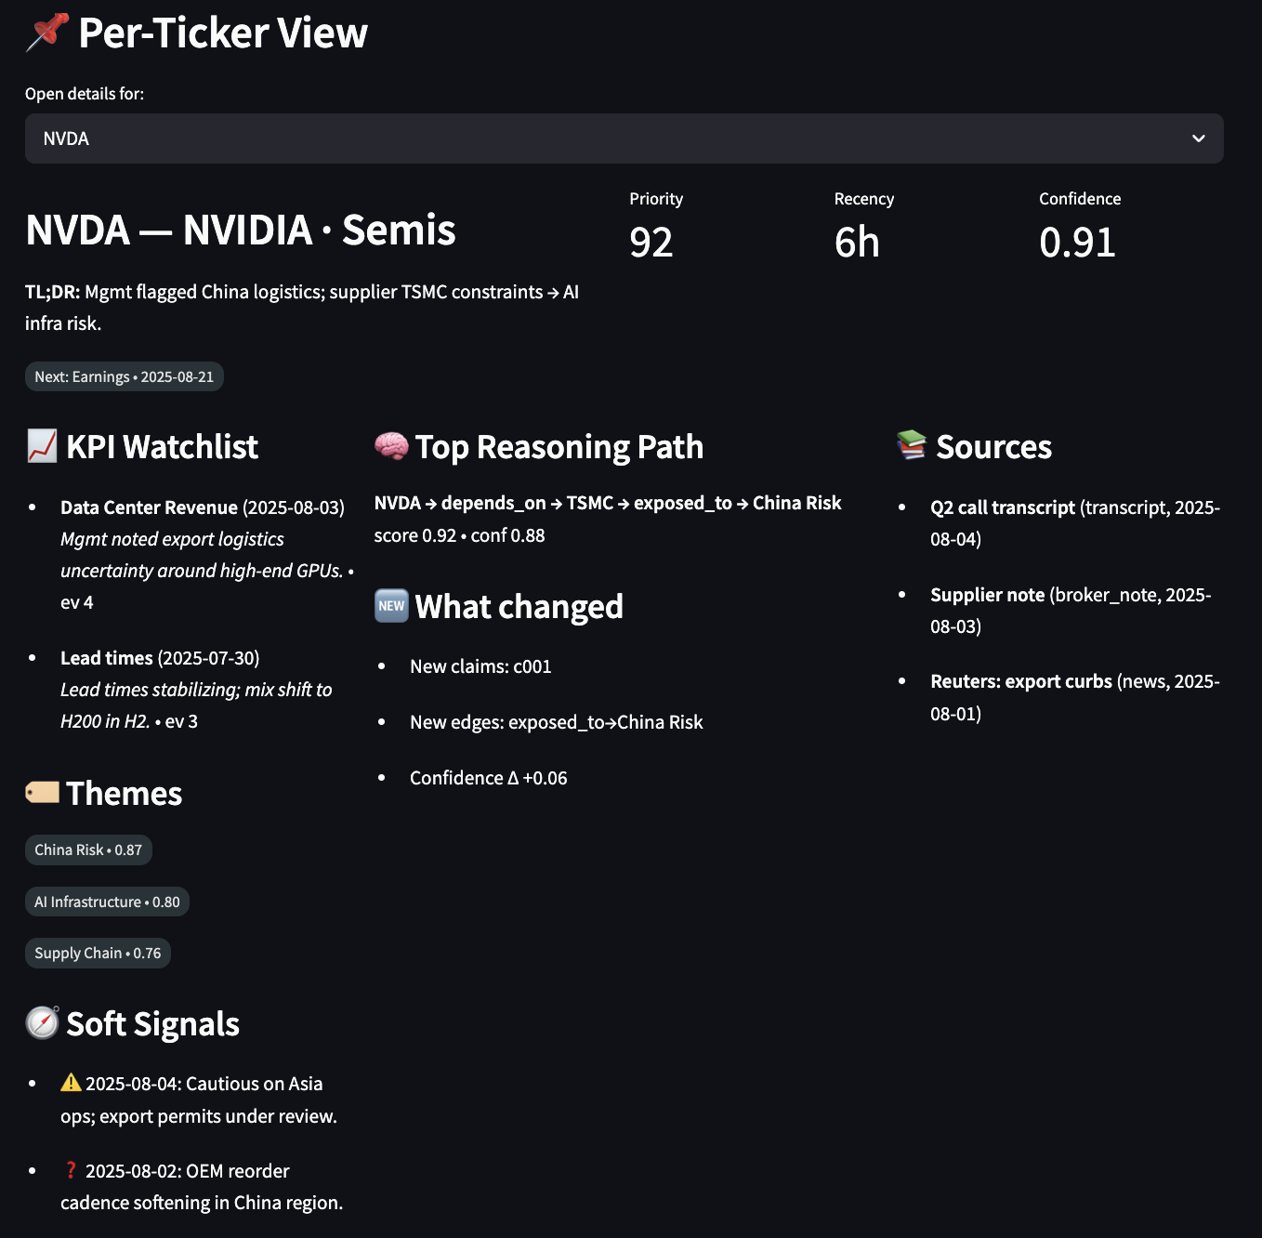
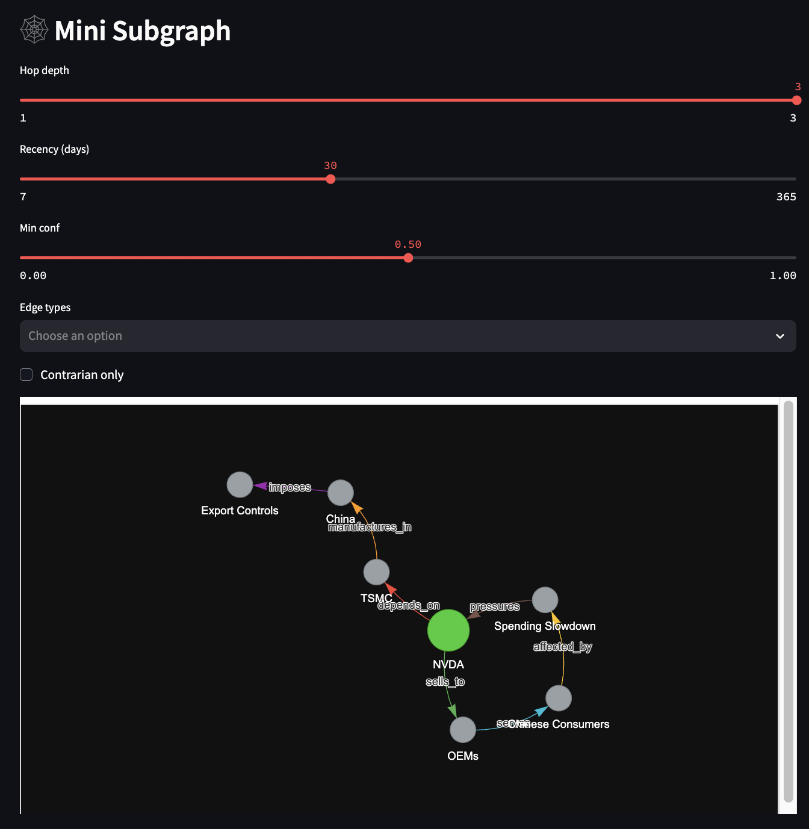
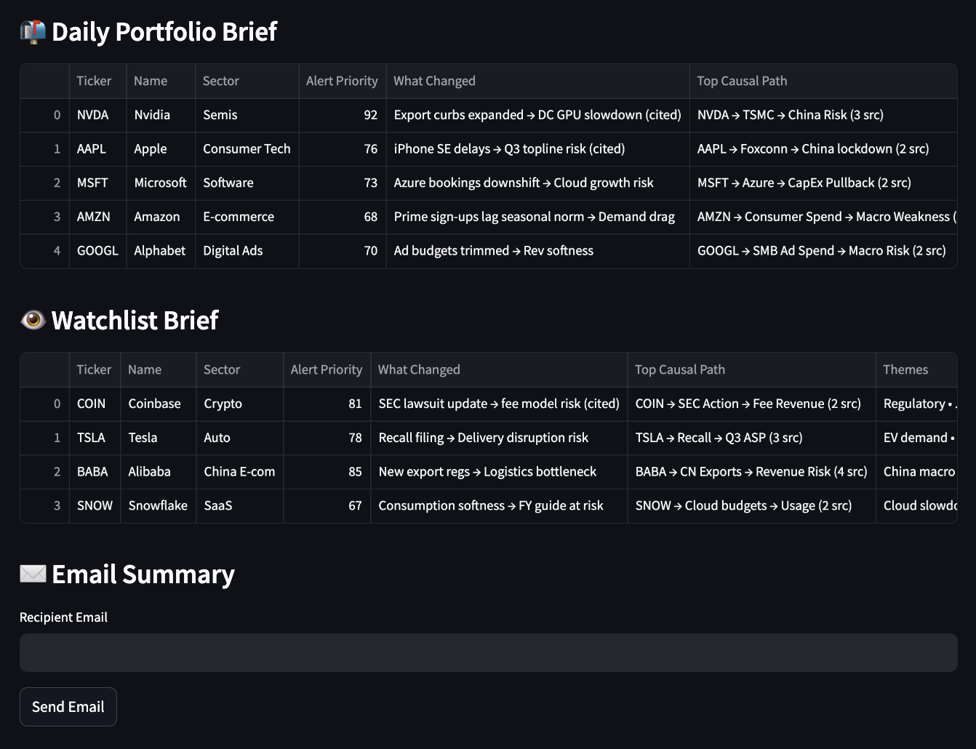
Appendix: User Interface Mock-up
3 segments
1. single ticker query (include subgraph of the ticker)
Information to show
  - Ticker
  - Alert Type (e.g. Price move, earnings, thematic drift, peers news, earnings miss, guidance change, narrative shift, event)
  - Recent key drivers to take note of (one-line driver)
  - 3-sentence Summary
  - Linked entities
  - Soft-signal highlights (bullet points)
  - Confidence score (e.g. high/med/low) signals whether to trust or double-check
  - Source links (Bullet citations)
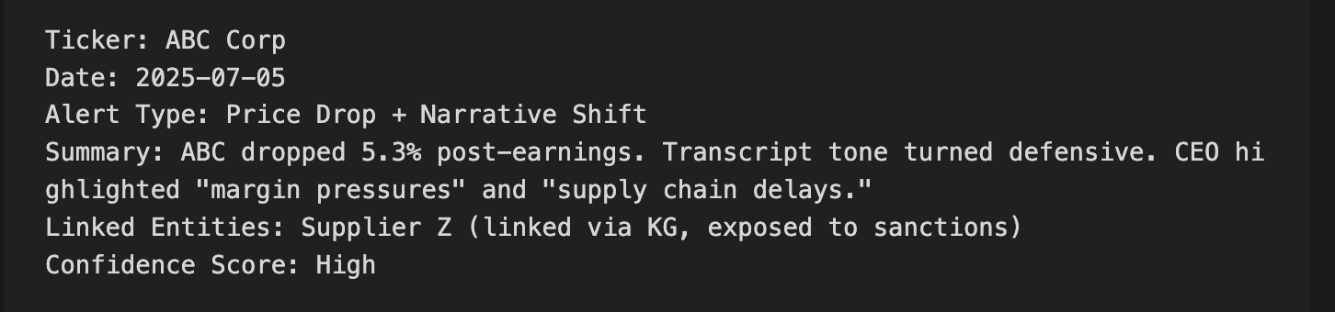
2. Daily portfolio/watchlist context summariser
- Q&A summaries about the portfolio of holdings
- What is the thematic exposure of the portfolio (bubble chart, showing individual holdings by market value)
- What is the sector exposure of the portfolio

ICE comprises of four key components:
- Knowledge Graph: Encodes relationships between companies, events, analysts, metrics, and narratives.
  - Check out Smithery (MCP libraries)
- Hybrid RAG with Lazy GraphRAG:
Propose a hybrid RAG architecture with a lazy GraphRAG approach. “Hybrid” refers to combining vector semantic search, keyword search and graph-based retrieval that can capture relationships between facts to enable multi-hop reasoning and richer context beyond what flat documents provide. The “lazy GraphRAG” aspect means we avoid unfront heavy knowledge-graph construction; instead, we dynamically discover and use relationships at query time. This design maximises cost-efficiency and scalability: Microsoft’s Lazy GraphRAG achieves similar answer quality to full GraphRAG while cutting indexing costs to ~0.1% and query costs by 100x (https://www.linkedin.com/pulse/ai-innovations-unveiling-latest-breakthroughs-bayeslabs-lccac/). The focus will be on batch-mode usage (e.g. daily research reports / mid-day reports) rather than real-time chat, given limited resources. We will also favor Python-based, cost-effective components (open-source or inexpensive APIs), only opting for higher-cost services if they significantly boost performance.
  - Instead of retrieving raw text snippets, GraphRAG traverses the KG to contextually expand queries before retrieval, improving answer relevance. Then, an LLM agent dynamically navigates the graph, deciding which nodes/edges to explore next, mimicking human-like reasoning by iteratively refining heuristic search. Finally, the frontier LLM synthesizes answers using both the retrieved subgraph and its inherent reasoning capabilities. Relationships in the graph provide explicit logical structure, reducing the risk of hallucinations.
  - Hypothetical Document Embedding (HyDE): Generate a hypothetical “ideal answer” to a user query using a lightweight LLM, then embed that generated answer and using it as the retrieval query vector – rather than embedding the original question.
  - Vector-based Retrieval: For unstructured content like transcripts, earnings, notes.
  - Lazy Graph-RAG: For structured multi-hop reasoning over a typed-edge knowledge graph.
- Monolithic Agent System: Simple triage model with Extractor, Reasoner, and Synthesizer agents.
- Model Context Protocol (MCP): Standardizes message passing between agents in a structured, interpretable format.
At its core is a domain-specific knowledge graph (KG) that integrates both external financial data (e.g., earnings transcripts, filings, news) and internal firm knowledge (e.g., research notes, investment memos, portfolio holdings). This graph encodes key relationships — such as narrative linkages, KPI drivers, causal chains, and soft signals — aligned with the fund’s unique mental models and investment logic.
Queries to ICE—such as “Why did stock price of ABC fall post-earnings?” or “What companies are exposed to the EV subsidy narrative?”—are handled through a graph-aware retrieval-augmented generation (Graph-RAG) pipeline. ICE retrieves relevant nodes, paths, and documents from the graph and vector database, then passes that structured context to a monolithic agentic layer that simulates the triage logic of a human analyst: extract → reason → synthesize. The result is an explainable, traceable response grounded in the firm’s own mental models and context. Unlike SaaS tools or LLM wrappers that focus on access or summarization, ICE is purpose-built to reflect the fund’s unique investment processes and cognitive lens. It is MCP-compatible by design, enabling plug-and-play interoperability with future third-party tools, models, or internal systems.
Over time, ICE becomes the fund’s cognitive operating layer—a reusable infrastructure that encodes, evolves, and surfaces how the firm reasons about information and data. It transforms every research cycle into a contribution to institutional memory and enables faster, more consistent decision-making with each use.

Key Components
Component | Value Proposition | Simplicity & Maintainability
Knowledge Graph  (Lazy Graph Expansion) | Encodes relationships between entities, enabling multi-hop reasoning, long-term memory, and alignment with investment logic. | Built using familiar tools like NetworkX or Neo4j; schema evolves modularly with the fund’s logic.  - Neo4j: easy querying, visualization, supports typed edges  - NetworkX: Lightweight, pythonic, file-based.  Updates handled via:  - Edge additional/removal  - Node attribute updates (e.g. last seen, evidence count)
Hybrid RAG | Contextually expands queries by traversing the KG and retrieving semantically relevant evidence. Improves relevance and grounding of answers (reduces hallucination)  HyDE + Vector-based Search + Keyword Search + Lazy Graph RAG | Lightweight Graph-RAG wrapper using FAISS + graph traversal; easy to extend with heuristic search.
Monolithic Agent  Workflow | Simulates analyst triage logic (extract → reason → synthesize) in a unified flow for traceable and explainable outputs. | One orchestrated agent; no inter-agent complexity. Easy to debug, iterate, and evolve over time.  Multi-agent orchestration as future works.
MCP (Model Context Protocol) | Plug-and-play protocol for AI ecosystems; future-proof solution | Lightweight, modular, compatible with future extensibility, Doesn’t add infrastructure overhead.
Streamlit UI | Provides an intuitive front-end for PMs and analysts to query ICE, review outputs, and visualize reasoning trails. | Low-code, fast, lightweight frontend

Full Knowledge Graph Construction
At the core of our AI solution lies a purpose-built typed knowledge graph (KG) designed specifically to support fundamental, bottom-up investment reasoning. The conceptual design begins by consolidating the key categories of high-value queries commonly asked by equity PMs and analysts—such as theme exposure, KPI sensitivity, peer comps, or narrative shifts. These query archetypes directly inform the typed edge patterns that define the KG schema. Building a unified graph is critical: it enables multi-hop, cross-domain reasoning across companies, themes, and metrics while simplifying retrieval by providing a single lookup space for downstream Graph-RAG.
The KG is constructed through a LLM-assisted, rule-enhanced pipeline, not agents. Typed edges are extracted via prompt-based LLM passes (e.g., “extract KPI driver edge from this earnings paragraph”), followed by rule-based filters to ensure data quality and schema conformance. An initial one-off ingestion run parses historical corpora—filings, earnings transcripts, memos, research emails—to bootstrap KG v1.0. Thereafter, incremental updates are triggered by new documents, where candidate edges are added only if confidence thresholds are met (via LLM scoring or optional human confirmation). Edges and node metadata are persisted to disk or a graph database, with weekly batch jobs handling incremental updates. This method ensures the KG stays accurate, interpretable, and reflective of evolving investment knowledge.
Lazy Knowledge Graph Expansion

Key Characteristics of Lazy GraphRAG
 | Feature | Description
✅ | Temporal Edge Metadata | Use temporal attributes, not temporal edge types; Add timestamped metadata to existing edges.  {"edge_type": "exposed_to",  "source": "META",  "target": "AI Infrastructure",  "last_seen": "2024-07-25",  "first_seen": "2023-12-01",  "evidence_count": 6 }  Simple to update: When new evidence comes in, refresh timestamp or increment evidence_count.  Value: Enables trend tracking, recency relevance
✅ | Reversed Traversal | Bidirectional query capability; query in reverse when need (does not store reverse edge)  • “What companies are exposed to [Theme]?” → Traverse  Company ← exposed_to ← Theme  • “Which holdings depend on Supplier X?” → Traverse  Company ← depends_on ← Supplier ← holds ← Portfolio
✅ | Multi-path Reasoning | A single query (e.g. “Why is $META at risk from China?”) can be answered via multiple edge-paths.  Path 1: METAexposed_toChina risk  Path 2: METAdepends_onSupplierexposed_toChina Risk  Path 3: METAhas_soft_signalEvent (“mgmt. cautious on Asia Ops”)
✅ | Edge Confidence Score  (Confidence-weighted edges) | Add a confidence or evidence_count field to each edge  Derived from:  - Number of mentions,  - Recency of supporting evidence,  - Source quality  At query time, rank or filter reasoning chains by confidence.  Value: Improves answer quality, explainability, prioritization
✅ | Source-Aware Edge Attribution | Every edge stores its source doc/chunk  Value: Trust, auditability, analyst adoption
 | Edge Composition Chains (Graph-Memory) | After answering a complex query (e.g., “China Risk via Supply Chain”), persist the path used into the KG for reuse later.  Stores [NodeedgeNodeedgeNode] as named template.  Value: Speeds up future queries, learns reasoning patterns over time, builds a kind of institutional AI memory.
  ❌
 | Query-Type-Aware Retrieval Profiles | Define template profiles:  - Earnings Q prioritise key_driver, has_surprise  - Thematic scan prioritise exposed_to, has_soft_signal  Adjust edge expansion and summarization heuristics accordingly.
  ❌

The selected edge types were carefully chosen for their high business value, low construction complexity, and strong interoperability. Each edge can be rapidly built using readily available data sources—such as news articles, earnings transcripts, and internal portfolio holdings. They are designed to directly address recurring questions from PMs and analysts, including theme exposures, KPI sensitivity, and causal drivers of stock movements.
Critically, these edges are synergistic by design—linking naturally from events → KPIs → themes → holdings—enabling the knowledge graph to surface rich, explainable insights from minimal inputs. This composability not only boosts the utility of individual edges but also amplifies their value when combined. For the MVP rollout, we will implement the knowledge graph in the priority order of the edge patterns listed, establishing a lightweight yet powerful foundation for investment reasoning and decision support.

