**Solution for Ex1**

**Question 1**

1. File quickstart.css  
   section {  
    width: 80%;  
    height: 200px;  
    background: green;  
    margin:auto;  
    padding: 2px;  
   }  
   div#A{  
    background: white;  
   }  
   div#B{  
    width: 24%;  
    height: 200px;  
    background: LightGreen;  
    float: left;  
   }  
   div#C{  
    width: 15%;  
    height: 200px;  
    background: yellow;  
    float: left;  
   }  
   div#D{  
    width: 15%;  
    height: 200px;  
    blackground: cyan;  
    float: left;  
   }  
     
   #myForm span{  
   color:red;  
   font-size:14px  
   }
2. Index.html  
     
   <!DOCTYPE html>  
   <html>  
    <head>  
    <meta charset="UTF-8">  
    <meta name="viewport" content="width=device-width, initial-scale=1.0">  
    <title>Wine Tours Vienna</title>  
    <link rel="stylesheet" type="text/css" href="quickstart.css">  
    <script src="https://ajax.googleapis.com/ajax/libs/jquery/1.12.2/jquery.min.js"></script>  
    <script type="text/javascript" src="mouseOverandOut.js"></script>  
    </head>  
      
    <body><div id="A">  
    <h1>  
    Wine Tours Vienna  
    </h1>  
    </div>  
    <div id="reg" style="background-color: #FFD700;height: 50px;width: 100px;float: left;">  
    <span class="QWE">  
    <b>Registration</b>  
    </span>  
    </div>  
    <div id="log" style="background-color: #EEEEEE;height: 50px;width: 100px;float: left;">  
    <span class="IOP">  
    <b>Login</b>  
    </span>  
    </div>  
    <div id="footer" style="clear:both;text-align:left;">  
    <span id="0eventBACK"></span>  
    </div>  
    <p></p>  
    </body>  
   </html>
3. File quickstart_10.html  
   <!DOCTYPE html>  
   <html>  
    <head>  
    <title>loading Registration</title>  
    <meta charset='UTF-8'>  
    <meta name='viewport' content='width=device-width, initial-scale=1.0'>  
    <script src="https://ajax.googleapis.com/ajax/libs/jquery/1.12.2/jquery.min.js"></script>  
    <script type="text/javascript" src="Dem1.js"></script>  
    </head>  
    <body>  
    <form action="" id="myForm" method="post" name="Registration">  
    Your full Name:<span id="20"></span><br>  
    <input type="text" name="name" id="0" onblur="validate('name', this.value)" >  
    <span id="name"></span>  
    <br><br>  
    Email:<span id="21"></span><br>  
    <input type="email" name="useremail" id="1" onblur="validate('useremail', this.value)">  
    <span id="useremail"></span>  
    <br><br>  
    Type in new password:<span id="22"></span><br>  
    <input type="text" name="password" id="2" onblur="validate('password', this.value)">  
    <span id="password"></span>  
    <br><br>  
    <input type="hidden" name="GEN" id="GEN" class="GEN" value="1234567890">   
    <p>  
    <input type="button" name="submit" value="submit" onclick="msg()" />  
    <span class="ASD"></span>  
    </p>   
    </form>  
    </body>  
   </html>
4. file quickstart_11.html  
   <!DOCTYPE html>  
   <html>  
    <head>  
    <title>loading Login</title>  
    <meta charset='UTF-8'>  
    <meta name='viewport' content='width=device-width, initial-scale=1.0'>  
    <script src="https://ajax.googleapis.com/ajax/libs/jquery/1.12.2/jquery.min.js"></script>  
    <script type="text/javascript" src="mouseOverandOut.js"></script>  
    <script type="text/javascript" src="Dem1.js"></script>  
    </head>  
    <body>  
    <form action="" id="myForm" method="post" name="Login">  
    Customer ID:<span id="23"></span><br>  
    <input type="text" name="CustomerID" id="3" onblur="validate('CustomerID', this.value)" >  
    <span id="CustomerID"></span>  
    <br><br>  
    Type in your password:<span id="24"></span><br>  
    <input type="text" name="renewpassword" id="4" onblur="validate('renewpassword', this.value)">  
    <span id="renewpassword"></span>  
    <br><br>  
    <p>  
    <input type="button" name="submit" value="submit" onclick="changeContent()"/>  
    </p>  
      
    </form>  
    </body>  
   </html>
5. file quickstart_100.html  
   <!DOCTYPE html>  
   <html>  
    <head>  
    <meta charset='UTF-8'>  
    <meta name='viewport' content='width=device-width, initial-scale=1.0'>  
    <title>loading images</title>  
    </head>  
    <body>  
    <img src="123.png" alt="wine" height="500" width="500" >  
    </body>  
   </html>
6. file validation.php  
   <?php  
     
   $value = $_GET['query'];  
   $formfield = $_GET['field'];  
     
   //Check name length is/isnot small than 5 alphabets;  
   if ($formfield == "name") {  
    if ( strlen($value) < 5 || ! ctype_alpha($value) ) {  
    echo "Error : At least 5 alphabets.";  
    } else {  
      
    }  
   }  
     
   //Check email is/is not correct.   
   if ($formfield == "useremail") {  
    if ( !preg_match("/([\w\-]+\@[\w\-]+\.[\w\-]+)/", $value) ) {  
    echo "Error : Invalid email address";  
    } else {  
      
    }  
   }  
     
   //Check password is/is not 5 digits.   
   if ($formfield == "password") {  
    if ( strlen($value) != 5 || $value < 1 || !is_numeric($value) ) {  
    echo "Error : Password should be 5 digits ";  
    } else {  
      
    }  
   }  
     
   //Check CustomerID is/is not 5 digits.   
   if ($formfield == "CustomerID") {  
    if ( strlen($value) != 5 || $value < 1 || !is_numeric($value) ) {  
    echo "Error : CustomerID should 5 digits";  
    echo $value;  
    } else {  
      
    }  
   }  
     
   if ($formfield == "renewpassword"){  
    if ( strlen($value) != 5 || $value < 1 || !is_numeric($value) ) {  
    echo "Error : CustomerID should 5 digits";  
    echo $value;  
    } else {  
      
    }  
   }  
     
   ?>
7. file Dem1.js  
   var text = "";  
   //Gen random number for CustomerID  
   $(document).ready(function(){  
    var possible = $("input.GEN").val();  
    for( var i=0; i < 5; i++ ){  
    text += String(possible).charAt(Math.floor((Math.random() * String(possible).length)));  
    }  
    $("input.GEN").val(text);  
   });  
     
   //Use ajax to get php for validation to checking Input things is correct  
   function validate(field,query){  
    //console.log(query);  
    //console.log(field);  
    var xmlhttp;  
    if (window.XMLHttpRequest) { // for IE7+, Firefox, Chrome, Opera, Safari  
    xmlhttp = new XMLHttpRequest();  
    } else { // for IE6, IE5  
    xmlhttp = new ActiveXObject("Microsoft.XMLHTTP");  
    }  
    xmlhttp.onreadystatechange = function() {  
    if (xmlhttp.readyState != 4 && xmlhttp.status == 200) {  
    document.getElementById(field).innerHTML = "Validating..";  
    } else if (xmlhttp.readyState == 4 && xmlhttp.status == 200) {  
    document.getElementById(field).innerHTML = xmlhttp.responseText;  
    } else {  
    document.getElementById(field).innerHTML = "Error Occurred. <a href='index.php'>Reload Or Try Again</a> the page.";  
    }  
    }  
    xmlhttp.open("GET", "validation.php?field=" + field + "&query=" + query, false);  
    xmlhttp.send();  
      
      
   }  
     
     
     
     
   //post the text into hidden Object  
   function msg(){   
    $("span.ASD").html(text);  
   }
8. file mouseOverandOut.js  
   //use jquery ajax to the get quickstart_100 when quickstart_11 submit button click  
   function changeContent(){  
    //jquery ajax to get the quickstart_100.html's data  
    $.get("quickstart_100.html",function(data){  
    $("p").html(data);  
    });  
   }  
     
   $(document).ready(function(){  
    //use jquery ajax to the get index when mouseover Registration  
    $("span.QWE").mouseover(function(){  
    //make sure than the mouseover Registration is functionable.  
    document.getElementById("reg").style.color = "red";  
    //jquery ajax to get the quickstart_10.html's data  
    $.get("quickstart_10.html",function(data){  
    $("p").html(data);  
    });  
    });  
      
    //get back when mouseout  
    $("span.QWE").mouseout(function(){  
    //make sure than the mouseout Registration is functionable.  
    document.getElementById("reg").style.color = "black";  
    });  
      
    //use jquery ajax to the get index when mouseover Login  
    $("span.IOP").mouseover(function(){  
    //make sure than the mouseover login is functionable.  
    document.getElementById("log").style.color = "blue";  
    //jquery ajax to get the quickstart_11.html's data  
    $.get("quickstart_11.html",function(data){  
    $("p").html(data);  
    });  
    });  
      
    //get back when mouseout  
    $("span.QWE").mouseout(function(){  
    //make sure than the mouseout login is functionable.  
    document.getElementById("reg").style.color = "black";  
    });  
      
   });

**Question2**

Testcases (Total 3 marks)

Preconition/setup for the test: Chrome and index.html

a. GUI layout test

Item number Execution Expected results(PASS/FAIL criteria)  
1. Mouse icon on registration tag can show a form for register. PASS

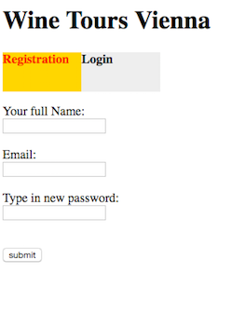

2. Mouse icon on login tag can show a form for login. PASS

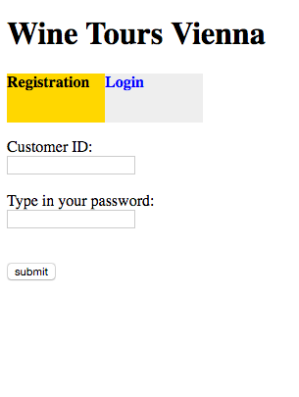

b.Functional tests for the index.html

1. each Input textfield can show the error of each Input textfield when   
 input alphabets or digits. PASS

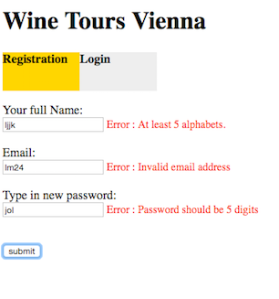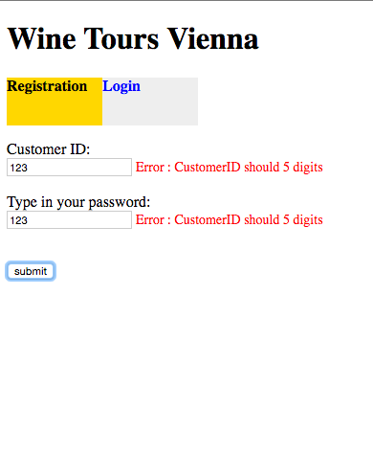

2. Submit button for the Registration tag can general the digit CustomerID

on the button left hand sign. PASS

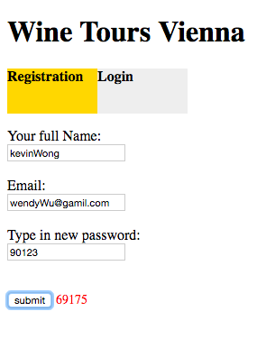

3. Submit button for the login tag can change subpage with wine.png. PASS

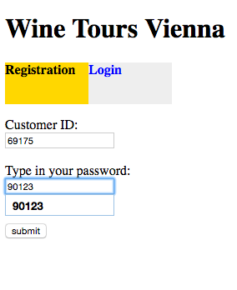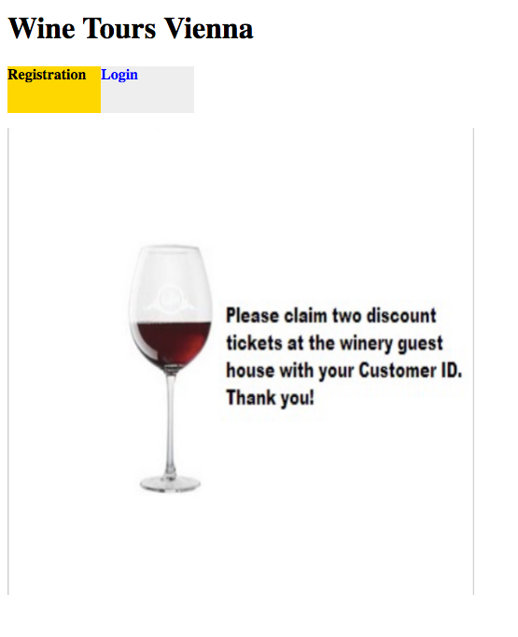

Question3

Written summary(Total 2 marks)

Precondition/setup for the test:Browser Chorme

**Summary(300 words)**: Wine Tours Vienna want to offers a new experience to registered customers.Following the Wine Tours Vienna's requirement, We design a web Application

within using html, javascript, Ajax,php and CSS3.

**Purpose:** To allow customers to view use can register or login on the index.html and get them discout win tasting tickets in the summer season.

**Web page contents and layout design:**The index page have name of Wine Tours Vienna and the position is on the top-left corner. The Registration tag is yellow color, and the login tag is grey color.So that The CSS3 and html can make the arrangement of the layOut.

Functional Requirements:

1. When the mouse is Over the Registration tag that, it will set up layout for Registration form include the 3 Input textfeild and Submit. The first is Your full name, second is email, third is password.Another one for the login most like that, but only have 2 Input textfeild for CustomerID and password.The Requirement middle mention that need to check a Your full name, password, email, CustomerID in correct format. Your full name is at least 5 alphabets, password and CustomerID should be only 5 digits, email should be use xxxxxx @ xxxxx.com.
2. When clicking the submit button and the tag is Registration, it gen theCustomerID for 5 digits on the submit button right hand side.
3. When clicking the submit button and the tag is login, it will change the   
   subpage for get Image.

**Server/client side scripting language used:** PHP/Javascript

Source code: mouseOverandOut.js,Dem1.js and validation.php

**Algorithms and the internals:** it should prepare to html like this Registration form, using jquery Ajax to get the data of this html, and make it join together with first page. Another subpage for login in make it again with CustomerID and password.  
We use php and Ajax to make communications for validation to check the 5 input textfelid.Although it ready input textfeild have a value, the input type is hidden. it use javascript and jquery put the value for gen CustomerID and show CustomerID for using id on there.