Tindo Fotio Joel Maxime

[tindofotio.maxime@ictuniversity.edu.cm](mailto:tindofotio.maxime@ictuniversity.edu.cm)

(+237) 6 59432668

Professional Summary A motivated and enthusiastic android and web developer with a certificate in Web Applications for Everybody from the University Of Michigan. Skilled in Flutter , React Native, HTML, CSS, JavaScript, PHP and MySQL. Experienced in creating responsive and user-friendly websites for various clients and projects

* Completed a comprehensive online course on web development, covering topics such as web design, databases, security, APIs and web services.
* Created several web applications using HTML, CSS, JavaScript, PHP and MySQL, such as a calculator, a chat room, a photo gallery and a blog.
* Received a certificate of completion with a grade of A.

**Bachelor of Science in Software engineering ICT University, Yaoundé, Cameroon September 2021- present**

* Studied core subjects such as programming, data structures, algorithms, software engineering, networking and artificial intelligence.
* Completed several projects using various programming languages and tools, such as Java, Python, C++, Visual Studio and Eclipse.

**Work Experience Web Developer Freelance January 2022 – Present**

* Designed and developed websites for various clients using HTML, CSS, JavaScript, PHP and MySQL.
* Communicated with clients to understand their needs and preferences and provide them with solutions that met their expectations.
* Tested and debugged websites using various tools and methods to ensure optimal performance and functionality.
* Maintained and updated websites according to client.

Skills

* Mobile application development
* Android Development
* JavaScript
* jQuery
* Software programming
* PHP
* MySQL
* Web Design
* Web Development

**References To certifications**

* Web Applications for Everybody

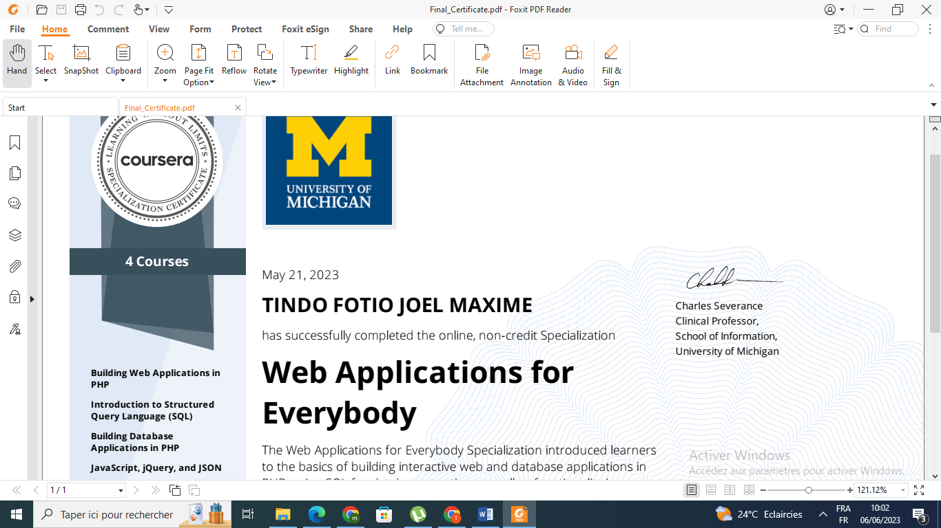

<https://coursera.org/share/464c76425aad341bf139518c771b81eb>

Github Developer account

<https://github.com/MAXIME765356>