BEEE LAB EVALUATION

Design a system for car stereo systems such that whenever the increase volume button is pressed, a red background given by red LED blinks the number of times the button is pressed.

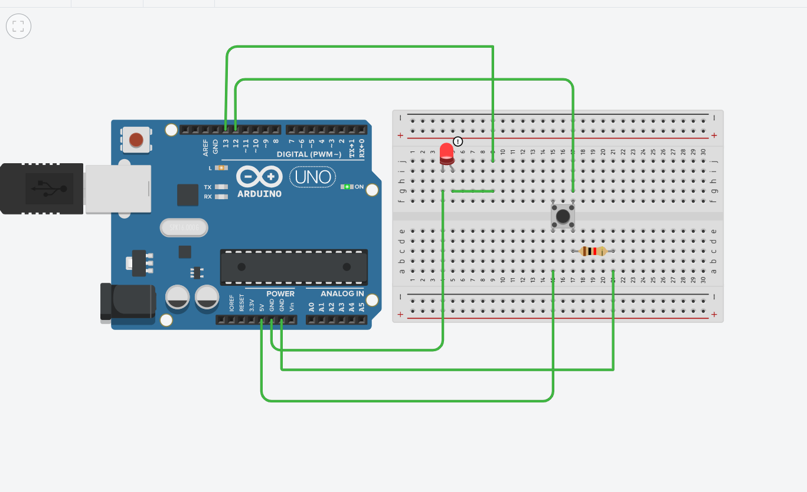CIRCUIT DIAGRAM:

THEORY:

### CONCEPT USED:

### Arduino is an open-source electronics platform based on easy-to-use hardware and software. The pushbutton is a component that connects two points in a circuit when you press it. Digital inputis taken through push button and that is detected by Arduino. This input is processes by Arduino and it send digital command to attached LED.

LEARNING AND OBSERVATIONS:

1.Connections in Breadboard and wiring.

2.How to control Arduino and its coding.

3.Use of multimeter for continuity.

OBSERVATIONS:

1.Blinking of leds the number of times the aswitch is pressed.

2.Connection between hardware and software.

PROBLEMS & TROUBLESHOOTING:

o To select the right port and type of arduino

o To check the loose connections

o To check the connections according to the codes

o To check the continuity of the circuit

o To check the flow of current in the circuit

PRECAUTIONS:

o Handle tools carefully

o Wear gloves

o Do not connect arduino till the circuit is complete

LEARNING OUTCOMES:

It can be used for car stereo systems .

CODE:

const int buttonPin = 12;

const int ledPin = 13;

int buttonPushCounter = 0;

int buttonState = 0;

int lastButtonState = 0;

void setup()

{

pinMode(buttonPin, INPUT);

pinMode(ledPin, OUTPUT);

Serial.begin(9600);

}

void loop()

{

buttonState = digitalRead(buttonPin);

if (buttonState != lastButtonState) {

if (buttonState == HIGH) {

buttonPushCounter++;

Serial.println("on");

Serial.print("number of button pushes: ");

Serial.println(buttonPushCounter);

} else {

Serial.println("off");

delay(50);

}

lastButtonState = buttonState;

while (buttonPushCounter!=0)

{

for(int i=0;i<buttonPushCounter;i++)

{

digitalWrite(ledPin, HIGH);

delay(500);

digitalWrite(ledPin, LOW);

delay(500);

buttonPushCounter=buttonPushCounter-1;

}

}

}

}