1. <http://localhost:8080/upload>
2. Send from postman

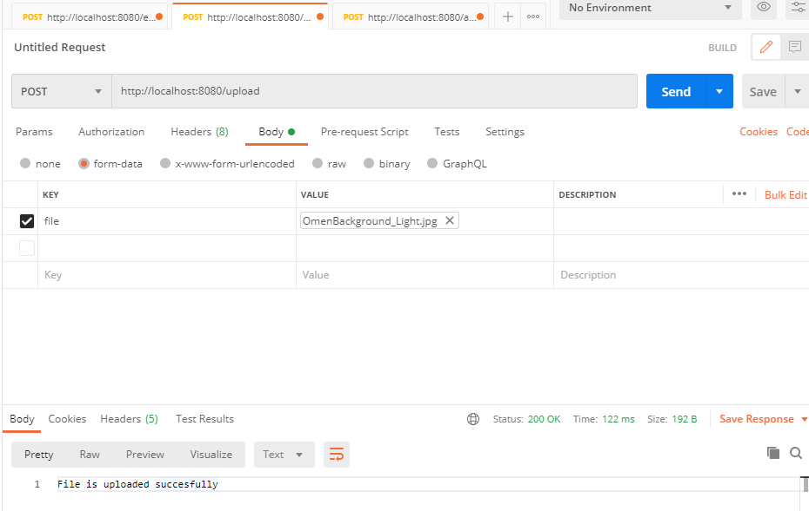

1. Send from html

Copy and paste this link <http://localhost:63342/latihan/templates/uploadForm.html?_ijt=n1m1t8jsf722gta1bckk351kvn>

lalalalalal