PROJECT-**PORTFOLIO WEBSITE**

**HOME PAGE**

<!DOCTYPE html>

<html lang="en">

<head>

    <meta charset="UTF-8">

    <meta name="viewport" content="width=device-width, initial-scale=1.0">

    <title>R.Y.BHATTU</title>

</head>

<body>

    <header>

        <center><h1>My Portfolio</h1></center>

        <nav><center><h1>

            <a href="./p1.html">About</a>

            <a href="./p2.html">Contact</a></h1></nav></header></center>

        </nav>

    </header>

    <h2>About Me</h2>

    <p>Hello! I am a passionate web developer with experience in creating dynamic and responsive websites. I love coding and constantly learning new technologies to improve my skills.</p>

    <h2>PROJECTS</h2>

    <h3>PROJECT-1-MOVIE RANKING</h3>

    <img src="../p1.png" alt="project1" width="400">

    <hr>

    <p>In This website I mentioned top movies which i like most.</p>

    <h3>PROJECT-2-Birthday invitation</h3>

    <p>In This Project I used some of the html tags like hyperlinks and image tag.</p>

    <img src="../p2.png" alt="project-2" width="400">

</body>

</html>

**OUTPUT**

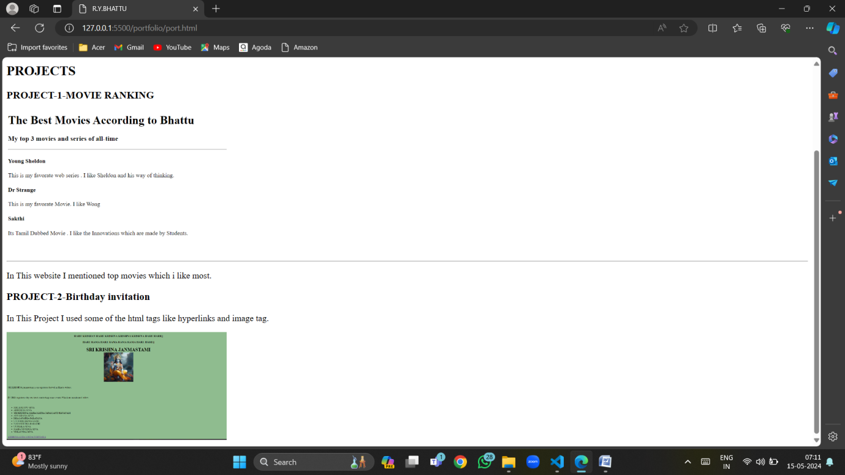

**ABOUT PAGE:**

<!DOCTYPE html>

<html lang="en">

<head>

    <meta charset="UTF-8">

    <meta name="viewport" content="width=device-width, initial-scale=1.0">

    <title>ABOUT</title>

</head>

<body>

<center><h1>ABOUT ME</h1></center>

<table>

    <tr><td>

        <img src="./its.jpeg" alt="profile">

    </td>

    <td>

        <h2>RAMPA YADAGIRI BHATTU</h2>

    </td></tr>

</table>

<hr>

    <h2>EDUCATION</h2>

    <table border="2">

        <tr><th>YEAR</th>

            <th>INSTITUTION</th>

            <th>COURSE</th>

        </tr>

        <tr>

            <td>2019</td>

            <td>SSC</td>

            <td>Z P H School</td>

        </tr>

        <tr>

            <td>2019-21</td>

            <td>inter</td>

            <td>GAYATRI JR College</td>

        </tr>

        <tr>

            <td>2021-24</td>

            <td>B.Sc-CS</td>

            <td>K.S.A.D.C</td>

        </tr>

    </table>

    <hr>

    <h2>SKILLS</h2>

    <ul>

        <li>JAVA</li>

        <li>PYTHON</li>

        <li>C</li>

        <LI>DBMS</LI>

    </ul>

    <center><h2>

        <a href="./port.html">HOME</a>

        <a href="./p2.html">Contact</a></h2></header></center>

</body>

</html>

**OUTPUT:**

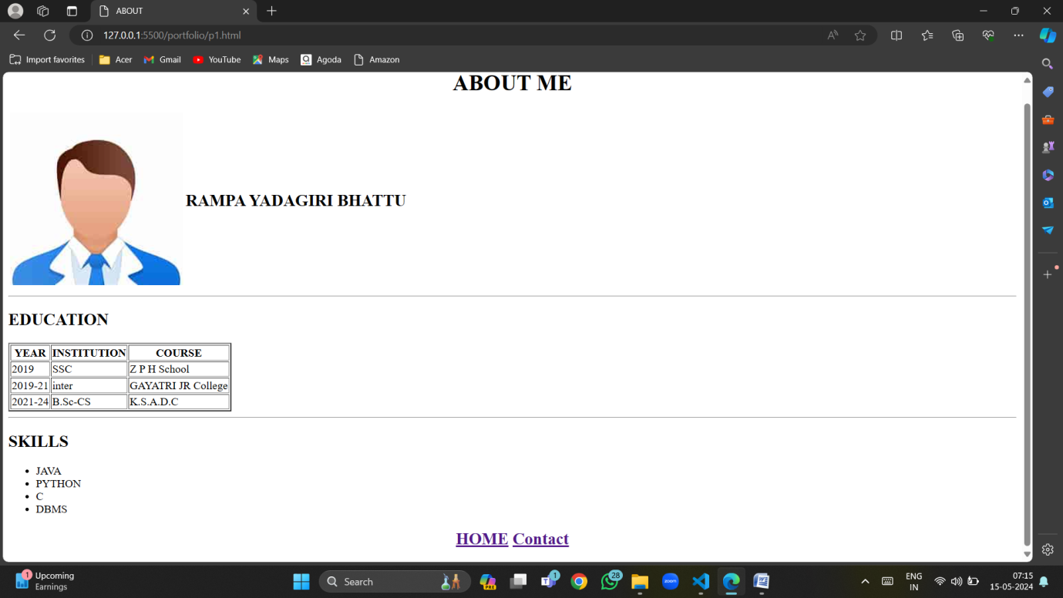

**CONTACT PAGE:**

<!DOCTYPE html>

<html lang="en">

<head>

    <meta charset="UTF-8">

    <meta name="viewport" content="width=device-width, initial-scale=1.0">

    <title>CONTACT</title>

</head>

<body>

    <center><h1>Contact ME</h1></center>

    <form action=""><center>

        <table>

            <tr>

                <td><label for="fn">FULL NAME:</label></td>

                <td> <input type="text" id="fn">

                    </td>

            </tr>

            <tr>

                <td>

                    <label for="EMAIL">EMAIL ID:</label>

                </td>

                 <td><input type="email"></td>

            </tr>

            <tr>

                <td><label for="mobile">Mobile</label></td>

                <td><input type="number"></td>

            </tr>

            <tr>

                <td><input type="SUBMIT" name="submit" id="submit"></td>

                <td><input type="reset"></td>

            </tr>

        </table></center>

    </form>

    <center><h2>

        <a href="./p2.html">CONTACT</a>

        <a href="./port.html">HOME</a> </center></h2>

</body>

</html>

**OUTPUT:**

