Part 1

Create a Swing GUI application that displays the following graphics of red and blue cups. The structure is always built from bottom row to top row, left to right in each row

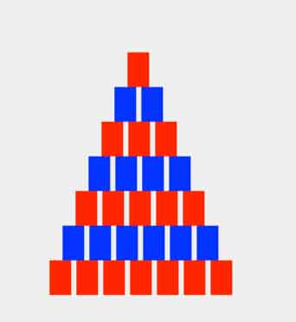

Part 2

Modify part1 so that the cups look like real cups. Write a newclass Cups2 in the same package for this part.

