Roots & Trees Product Explorer
Project report following the Software Development Life Cycle
Problem statement: Making Product Information Clear and Easy to Understand for Online Customers
Sector: Retail Trade Engagement: Gig work Deliverable: MVP + business model / pitch deck

Item | Detail
Technology | React 18, Vite 5, plain CSS, browser localStorage
Approach | Working MVP with local sample data and browser state; backend planned as next phase
Team | (add team name and members)
Project guide | (add name)
Institution | (add institution)
Date | October 2026

Contents
1. Introduction
2. SDLC Model Used
3. Planning
4. Requirements Analysis
5. Design
6. Implementation
7. Testing
8. Deployment
9. Maintenance and Future Work
10. Business Model and Impact
11. Demo Walkthrough
12. Conclusion
Appendix A: Project Files
Appendix B: Key Source Code

1. Introduction

1.1 The problem
Roots & Trees is a Bengaluru botanical D2C brand. The problem statement describes customers who browse the website but do not receive enough educational information about the products: how they are used, their benefits, their traditional use and their ecological purpose. Product variants such as raw versus sprouted ragi powder, blue pea powder and different quantities are poorly differentiated, with inconsistent fonts, unclear pricing and missing category listings.
The statement quotes a cart abandonment rate of 60-70%. Customers cannot work out which variant matches their need, so many leave or go back to large marketplaces. This reduces revenue for the boutique brand and for the smallholder farmers who supply it in Bangalore Rural, Kolar and Tumkur.

1.2 Case study persona
Priya Sharma is a 32-year-old IT project manager and mother of a toddler in Kalyan Nagar, Bangalore. She wants authentic, preservative-free sprouted ragi flour for her baby and pure cold-pressed coconut oil for her family. She visits the website after hearing about the brand and needs to understand which product and variant is right for her. All design decisions in this project are checked against what Priya needs.

1.3 Objective
Build a working Minimum Viable Product (MVP) that demonstrates how the problem can be solved: unclear product information, confusing variants, inconsistent prices and insufficient product education.

1.4 The solution in brief
The Product Explorer is a single-page web application built with React and Vite. It has four screens:
- Home: Roots & Trees branding, shop-by-category tiles and a short explanation of what makes the information clearer.
- Shop: a product catalogue with pictures, prices, a category filter and search.
- Product page: a two-step variant selector (form, then size), dynamic price and price per 100 g, six education tabs, a comparison table of all options, and a seasonal note for coconut oil.
- Cart: add products, change quantities, remove items, and see subtotal, delivery fee and total.

1.5 Chosen approach
The project follows a fast MVP approach: React + Vite with local sample data and browser state. This is quicker than setting up a backend and database first, and it lets the team demonstrate the actual user experience. The architecture and a proposal for a PostgreSQL + Express backend are explained as the next phase. Those backend parts are not implemented in this MVP and the report does not claim they are.

1.6 Project history
A first prototype was written in plain HTML, CSS and JavaScript. It was then rebuilt in React + Vite to follow the agreed approach. The business logic (price per 100 g, filtering, cart maths) and the sample content carried over and were converted into modules with unit tests. This report describes the React + Vite version.

2. SDLC Model Used
The project uses an iterative (Agile-style) model with short sprints. The scope is small and the requirements are clear from the problem statement, so the team built a working screen early in each sprint and corrected problems as they appeared. The phases are documented in order below, but work looped back when testing found a problem.
Phase | What was produced | Section
1. Planning | Scope, feasibility, schedule, risks, tools | 3
2. Requirements analysis | Stakeholders, user story, functional and non-functional requirements, traceability | 4
3. Design | Architecture, component tree, state design, data model, wireframes, visual design | 5
4. Implementation | React components, logic module, storage module, styling | 6
5. Testing | 21 unit tests, end-to-end browser run, manual test cases | 7
6. Deployment | Run locally, production build, hosting options | 8
7. Maintenance and future work | How to extend; backend proposal; limitations | 9

3. Planning

3.1 Scope
In scope (MVP):
- Homepage with Roots & Trees branding and product categories
- Product catalogue with pictures and prices
- Product education: description, benefits, traditional use, sourcing, preparation and storage
- Variant selector: raw versus sprouted ragi and different package sizes, with dynamic pricing
- Shopping cart: add, remove, change quantity, calculate totals
- Responsive design for laptops and phones
Out of scope (planned for the next phase):
- Real backend, database and API (PostgreSQL + Express proposed in section 9)
- Payments, customer accounts, real order management and courier integration
- Admin screen for staff to edit products
- Real product photographs

3.2 Feasibility
Type | Finding
Technical | React, Vite and plain CSS are free, well documented and run on any laptop with Node.js 18+. Feasible.
Economic | No licence cost. Can be hosted free on Netlify, Vercel or GitHub Pages.
Operational | Product content is held in a single data file, so the owner can change prices and text without touching the components.
Schedule | The problem statement allows 20-43 weeks for a full solution. The MVP is deliberately small enough to finish in a short working session.

3.3 Planned schedule
The MVP was planned as a two-hour build with the following time boxes. The order of the boxes is the order in which the code was written.
Time | Activity | Output
0-15 min | Setup | Vite + React project created and running
15-45 min | Homepage and product catalogue | Navigation, category tiles, product cards, styling
45-75 min | Product details and variants | Education tabs, variant selection, dynamic pricing
75-95 min | Shopping cart | Add, remove, quantity change, totals
95-110 min | Testing and polish | Main user flow checked, visible issues fixed
110-120 min | Demo preparation | Short walkthrough and explanation of future backend work (section 11)

3.4 Tools
Tool | Use
Node.js 18+ and npm | Run the project and install packages
Vite | Development server and production build
React 18 | User interface components
VS Code | Code editor
Node built-in test runner | Unit tests (no extra libraries)
Chromium (Playwright) | Automated browser run for end-to-end checks

3.5 Risks
Risk | Plan
Too much scope for the time available | Local data and browser state instead of a backend; one page per feature; no router library
Health claims could mislead customers | Benefits and traditional-use tabs carry a note that the text is general food information, not medical advice
Sample prices differ from the real shop | All prices live in one file and are labelled sample data
localStorage blocked in private mode | Storage code is wrapped in try/catch; the cart still works until refresh
Backend work being mistaken for finished work | The report states clearly that PostgreSQL and Express are the next phase and not implemented

4. Requirements Analysis

4.1 Stakeholders
Stakeholder | Interest
Customers (for example Priya Sharma) | Understand the product, choose the right variant, compare prices and buy with confidence
Founders Sapna and Prashanth | Fewer abandoned carts and higher revenue
Retail staff at the Horamavu outlet | Fewer product questions to answer manually because the website explains the product
Smallholder farmers | More sales of local produce when customers trust the information

4.2 User stories
- As a parent buying for my baby, I want to see which ragi form is suitable and how to use it, so that I can decide without calling the shop.
- As a shopper, I want the price per 100 g for every size, so that I can compare 250 g with 1 kg fairly.
- As a shopper, I want to browse by category and search by name, so that I can find a product quickly.
- As a shopper, I want to change quantities and see the total before I check out.
- As a customer in a cool Bangalore winter, I want to know why my coconut oil has turned solid, so that I do not think it is spoiled.

4.3 Functional requirements
ID | Requirement | Problem it answers
FR1 | Home page shows branding and one tile per category; a tile opens the shop filtered to that category | Missing category listings
FR2 | Shop page lists products as cards with picture, category, tagline and a from price; filter by category and search by text | Hard to find the right product
FR3 | Product page separates form (raw, sprouted) from size; choosing a form shows only its sizes | Poorly differentiated variants
FR4 | Price and price per 100 g/ml update when the selection changes | Unclear pricing
FR5 | Six tabs: what it is, benefits, traditional use, where it comes from, how to use, storage and shelf life | Insufficient product education
FR6 | Comparison table of every form and size with the selected row highlighted | Variants hard to compare
FR7 | Seasonal note on the coconut oil page explaining why it solidifies in winter | Customer queries in cool months
FR8 | Cart: add, change quantity, remove, subtotal, delivery fee, total; cart survives a page refresh | Purchasing
FR9 | Demo checkout that empties the cart and clearly states no payment is taken | Complete user flow for demonstration

4.4 Non-functional requirements
ID | Requirement | How it is met
NFR1 | Easy to run | npm install, then npm run dev
NFR2 | Works on laptops and phones | CSS grid, a media query below 720 px, table scrolls sideways inside its own container
NFR3 | Accessible | Real buttons for every action, aria-pressed on choice buttons, aria-selected on tabs, aria-live for status messages, visible focus outline
NFR4 | Easy to maintain | Content in one data file; logic separated from components
NFR5 | Readable code | Plain JavaScript syntax, small components, a comment on every function
NFR6 | Consistent look | One stylesheet with CSS variables for colour and one type scale on every page

4.5 Traceability: problem statement to feature
Problem statement says | Feature
Customers do not receive sufficient educational information | FR5 education tabs
Product variants are poorly differentiated | FR3 two-step selector, FR6 comparison table
Unclear pricing | FR4 price and price per 100 g
Inconsistent fonts | NFR6 single stylesheet and type scale
Missing category listings | FR1 and FR2
Cold-pressed coconut oil freezes in Bangalore winters, raising customer queries | FR7 winter note
High cart abandonment | Combined effect of FR3 to FR6, measured after launch (section 10)

5. Design

5.1 Architecture
The MVP is a client-side single-page application. There is no server: the product data is a JavaScript module and the cart is stored in the browser.
Browser
+-----------------------------------------------------------+
| main.jsx -> App.jsx (shared state) |
| | |
| Header Home Catalogue ProductDetail Cart |
| \ | | / |
| ProductCard / Pack (pictures) |
| |
| utils/logic.js pure functions (price, filter, cart) |
| utils/storage.js cart in localStorage |
| data/products.js local sample data |
+-----------------------------------------------------------+

Layers
- Data (data/products.js): products, forms and variants.
- Logic (utils/logic.js): price per 100 g, size labels, filtering, cart maths. No React code, so it can be tested with plain Node.
- Storage (utils/storage.js): reads and writes the cart in localStorage.
- View (components/*.jsx): React components that turn data and state into the screen.

5.2 Component tree
Component | File | Job
App | App.jsx | Owns shared state and decides which screen to show
Header | components/Header.jsx | Top bar, navigation, cart count
Home | components/Home.jsx | Hero, category tiles, promises, featured products
Catalogue | components/Catalogue.jsx | Search box, category chips, product grid
ProductCard | components/ProductCard.jsx | One product in a grid
ProductDetail | components/ProductDetail.jsx | Variant selector, price, tabs, comparison table
Cart | components/Cart.jsx | Cart lines, quantity buttons, totals, demo checkout
Pack | components/Pack.jsx | Draws the pouch or bottle picture as SVG

5.3 State design
React state is kept as close as possible to where it is used.
Where | State | Purpose
App | view | Which screen is showing: home, shop, product or cart
App | productId | Which product is open on the product page
App | category | Current shop filter (shared so a home tile can set it)
App | cart | List of { variantId, qty }; loaded from and saved to localStorage
Catalogue | search | Text in the search box
ProductDetail | formId, variantId, tab, quantity, message | Current selection on that page
Cart | ordered | Whether the demo checkout has just been done

Navigation uses a simple view variable instead of a router library. This keeps the MVP small. The trade-off is that pages do not have their own web addresses; React Router is listed as a future improvement.

5.4 Data model
Product
id, name, category, tagline, color, pack ("pouch" | "bottle")
summary, benefits[], traditionalUse, sourcing, howToUse[]
storage, shelfLife, ingredients, winterNote
forms[] -> { id, label, description, bestFor }
variants[] -> { id, formId, amount, unit ("g" | "ml"), price }

Cart line { variantId, qty }

Key design decision: form and size are separate. A variant is one form at one size. This is what turns a long, confusing dropdown into two clear choices (raw or sprouted, then 250 g or 500 g or 1 kg) and makes the price per 100 g comparison possible.

5.5 Wireframes
HOME
[ Roots & Trees Product Explorer Home Shop Cart(0) ]
Know what is in the jar [ pictures of products ]
before it is in your cart
[Shop all products]
Shop by category: [Flours] [Oils] [Herbs] [Greens] [Spices] [Sweeteners]
Clear variants | Fair prices | Know before you cook
Featured products: [card] [card] [card]

PRODUCT
Shop / Sprouted Ragi Flour
[picture] Title, tagline
Form: (Raw flour) (Sprouted flour) one-line explanation
Size: (250 g) (500 g) (1 kg)
Rs 220 Rs 44 per 100 g
[- 1 +] [Add to cart] [View cart]
[What it is | Benefits | Traditional use | Where it comes from | How to use | Storage]
Compare all options (table)

CART
Name, form, size, price [- 2 +] line total Remove
Subtotal / Delivery / Total [Checkout (demo)]

5.6 Visual design
- Palette: forest green (#17352a) for text and header, moss (#3f6b4e) for actions, turmeric gold (#d99a1e) for highlights and notices, soft sage (#f1f4ee) for the page background. These follow the natural-product world of the brand.
- Type: Fraunces (serif) for headings and Source Sans 3 for body text, with Georgia and Segoe UI as fallbacks. One scale across all screens answers the inconsistent-fonts complaint.
- Pictures: kraft-paper pouches and a bottle drawn as inline SVG in each product's colour, so there are no image files to manage.
- Layout: left-aligned text, line length under 80 characters, tables that scroll inside their own box on phones.

5.7 User flow
Home -> pick a category tile (or Shop all)
-> Shop: search or filter -> open a product
-> choose form -> choose size -> read tabs / compare table
-> Add to cart -> Cart -> change quantity -> Checkout (demo)

6. Implementation
This section explains exactly how the project was built, in the order the code was written. All file paths are relative to the project folder roots-trees.

6.1 Step 1: Setup
npm create vite@latest roots-trees -- --template react
cd roots-trees
npm install
npm run dev

Vite creates the project and runs a development server with instant reload. The default demo files were replaced by the structure shown in Appendix A. The final package.json has two runtime dependencies (react and react-dom) and two development dependencies (vite and @vitejs/plugin-react).

6.2 Step 2: Product data (src/data/products.js)
Six sample products were written as plain JavaScript objects: ragi flour, cold-pressed coconut oil, blue pea flower, moringa leaf powder, turmeric and jaggery powder. Ragi has two forms (raw, sprouted) and five variants. Blue pea has two forms (whole flower, powder) and four variants. The `pack` field tells the Pack component whether to draw a pouch or a bottle. Every price is sample data.

6.3 Step 3: Logic module (src/utils/logic.js)
All rules were written as small pure functions with no React code. This makes them easy to read and to unit test.
Function | What it does
formatPrice(n) | Returns the price with the rupee sign
sizeLabel(variant) | Shows 1000 g as 1 kg, 1000 ml as 1 L, otherwise amount and unit
pricePer100(variant) | price / amount x 100, rounded to one decimal. Rs 220 for 500 g gives Rs 44
lowestPrice(product) | Cheapest variant, shown as the from price on cards
getVariantsForForm(product, formId) | Only the sizes belonging to the chosen form
getCategories(products) | Unique category names for tiles and chips
filterProducts(products, category, text) | Keeps a product only if it passes both filters; an empty string skips a filter
addToCart / changeQty / removeLine | Return a new cart list (React needs a new list to notice a change). A line reaching quantity 0 is removed
cartLines / cartSubtotal / cartCount | Combine cart and product data, add up totals and item count
deliveryFee(subtotal) | Rs 40 below Rs 499, free from Rs 499, nothing for an empty cart

6.4 Step 4: Storage (src/utils/storage.js)
loadCart and saveCart read and write the cart in localStorage under the key rt_cart. Both are wrapped in try/catch so a blocked or broken browser store gives an empty cart instead of an error. This is the "browser state" in the agreed approach.

6.5 Step 5: Pictures (components/Pack.jsx)
Pack returns an SVG. For a bottle it draws a cap, neck, body and label; otherwise it draws a kraft pouch with a coloured label band. The colour comes from the product, so every product looks different without image files.

6.6 Step 6: App and Header (App.jsx, components/Header.jsx)
- App holds four pieces of state: view, productId, category and cart.
- The cart is created with useState(loadCart), which reads the saved cart once at start-up.
- A useEffect saves the cart to localStorage every time it changes.
- navigate, openShop and openProduct set the state and scroll to the top.
- App renders the Header and then exactly one screen depending on view.
- ProductDetail is given key={product.id} so its own state resets when a different product is opened.
- Header shows the cart item count from cartCount(cart) and highlights the active link.

6.7 Step 7: Home and catalogue (Home.jsx, Catalogue.jsx, ProductCard.jsx)
- Home shows the hero text, three product pictures, one tile per category (with its product count), three short promises and the first three products as featured items.
- A category tile calls onOpenShop(name). App stores the category and switches to the shop, so the shop opens already filtered.
- Catalogue shows a search box and chips. It calls filterProducts on every render, so results update as the user types. The text "N of 6 products" is an aria-live region so screen readers hear the change.
- When nothing matches, an empty-state message tells the user what to do.
- ProductCard is a button, so it works with the keyboard as well as the mouse.

6.8 Step 8: Product page (components/ProductDetail.jsx)
This is the most important component because it answers most of the problem statement.
- Five pieces of state: formId, variantId, tab, quantity and message.
- Form buttons appear only when a product has more than one form. A one-line explanation of the chosen form is always shown (description and best use).
- chooseForm(id) sets the form and jumps to that form's first size, so an impossible combination (such as raw 250 g) can never be selected.
- Size buttons list only the sizes of the chosen form, using getVariantsForForm.
- The price and price per 100 g are calculated from the selected variant on every render.
- Quantity is limited to 1-20. Add to cart calls onAdd(variantId, quantity) and shows "Added to cart."
- Six tabs show the education content. The Benefits and Traditional use tabs include a short note that the text is not medical advice.
- If a product has a winterNote (coconut oil), a highlighted notice is shown above the tabs.
- The comparison table lists every variant with form, size, price, price per 100 g and best use; the selected row is highlighted.

6.9 Step 9: Cart (components/Cart.jsx)
- Lines are built with cartLines(cart, PRODUCTS), so each line shows the product, form, size and price.
- Plus and minus call changeQty; Remove calls removeLine.
- Totals use cartSubtotal and deliveryFee. Free delivery starts at Rs 499.
- Checkout (demo) empties the cart and shows a thank-you screen that states no payment was taken and that real orders belong to the next phase.
- An empty cart shows a friendly message with a button back to the shop.

6.10 Step 10: Styling (src/styles.css)
One stylesheet with CSS variables for the palette. A CSS grid lays out the product cards. A media query below 720 px stacks the hero and product page into one column. The comparison table sits in an overflow-x container so the page itself never scrolls sideways. Keyboard focus has a visible gold outline, and animations are switched off for users who prefer reduced motion.

6.11 Step 11: Tests (tests/logic.test.js)
Twenty-one unit tests use Node's built-in test runner (node:test and node:assert), so no extra library is needed. Run them with npm test. Details are in section 7.

6.12 Screenshots of the working application
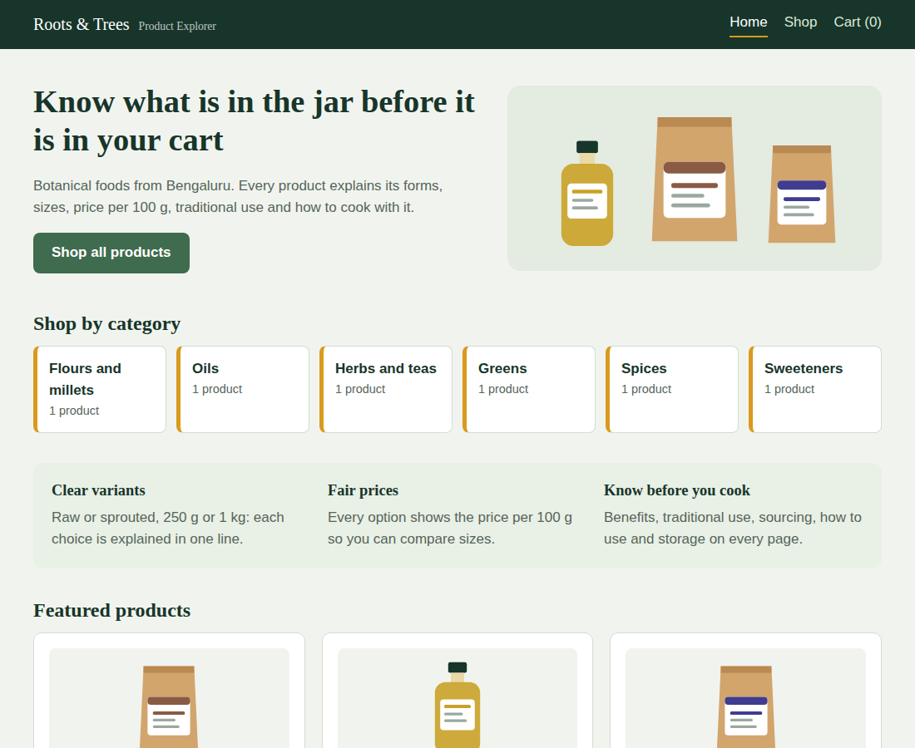
Figure 1: Home page with category tiles
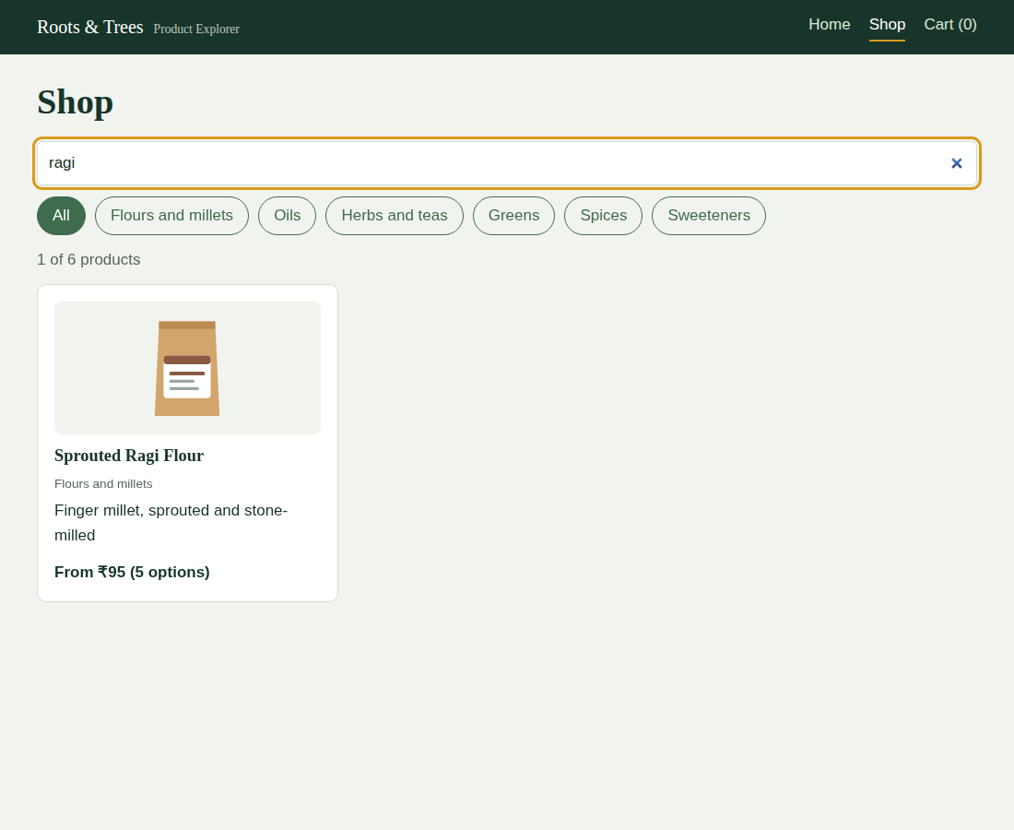
Figure 2: Shop page with search filter applied
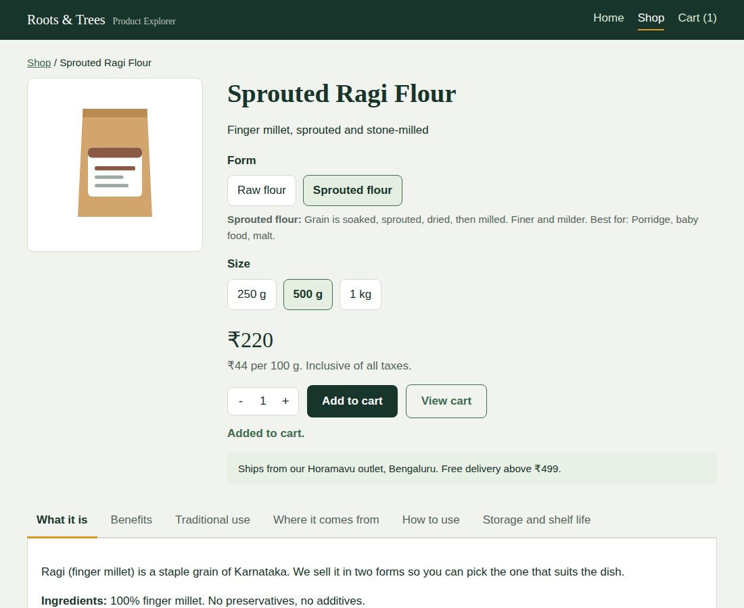
Figure 3: Product page with form and size selected, price and tabs
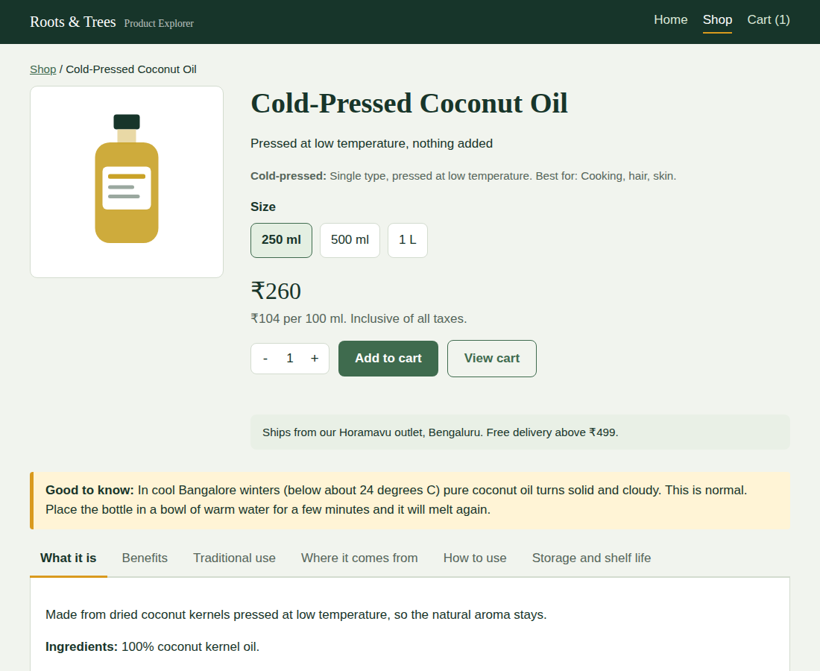
Figure 4: Coconut oil page with the winter note
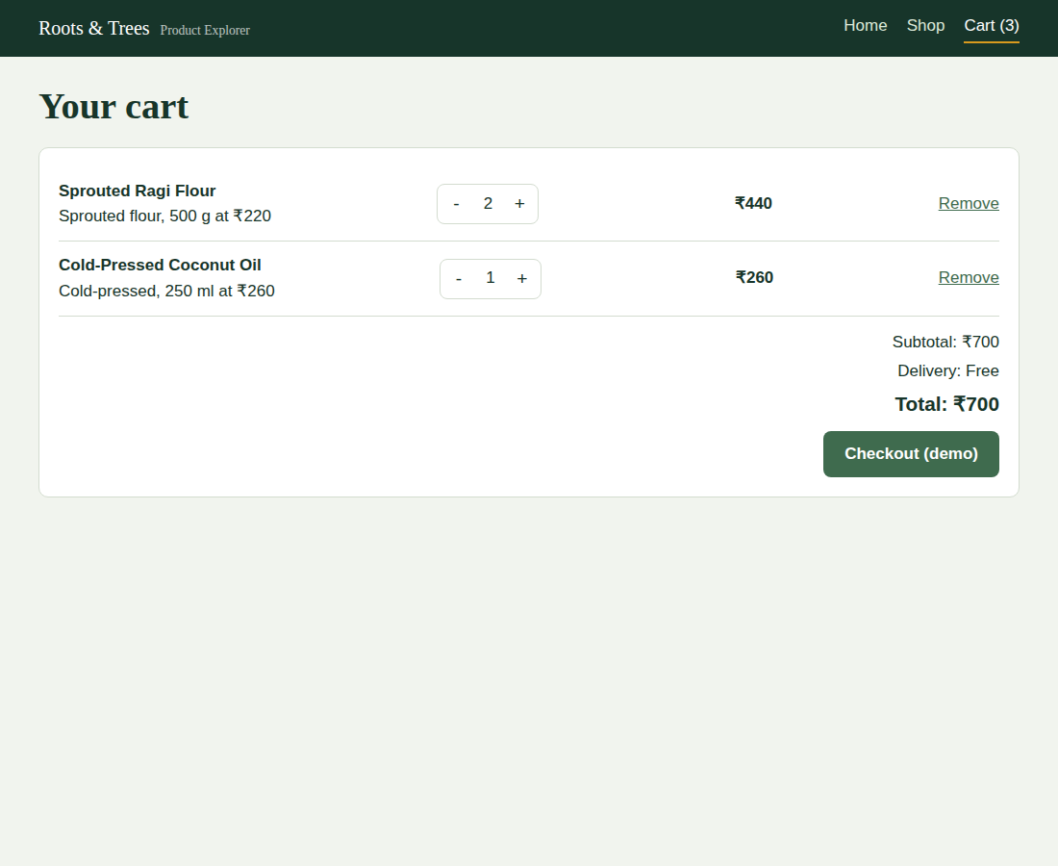
Figure 5: Cart with quantity buttons, delivery fee and total
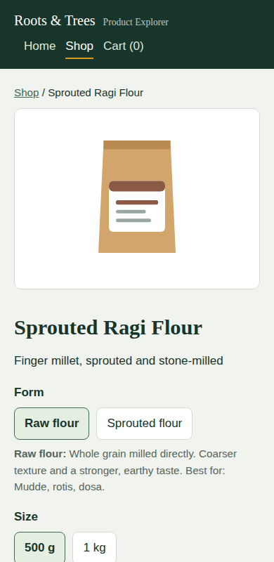
Figure 6: Product page on a phone-sized screen (390 px wide)

7. Testing

7.1 Strategy
Level | Method | Tool
Unit | Test every logic function on its own | npm test
Data validation | Check the product file is consistent | Same test file
System (end to end) | Click through the whole flow in a real browser on the production build | Scripted headless Chromium
Manual / acceptance | Checklist in 7.4, to be repeated by the team and guide | Browser

7.2 Unit tests: 21 of 21 passed
Area | Tests
Data | Every product has forms and variants; every variant points to a real form; variant ids are unique; every pack type is pouch or bottle
Price and size | sizeLabel for g, ml, kg and L; pricePer100 (Rs 220 / 500 g = Rs 44); lowestPrice of ragi is Rs 95
Catalogue | 6 categories; no filters returns all; category filter returns only that category; search ignores case; unknown search returns nothing
Variants | Sprouted ragi has 3 sizes and raw has 2; unknown product id returns null
Cart | Same variant adds quantities and the old cart is not changed; changeQty and removal at 0; removeLine; subtotal; item count; unknown ids ignored; delivery fee at 0, 498 and 499

7.3 End-to-end run on the production build: passed
The production build (npm run build) was served with vite preview and driven by a scripted headless browser. The results were:
Check | Result
Home shows one tile per category | 6 tiles
Clicking the Oils tile opens the shop filtered | 1 product shown
Selecting All | 6 products shown
Searching for ragi | 1 product shown
Ragi: choose Sprouted flour then 500 g | Price shows Rs 220
Add to cart | "Added to cart." shown; header changes to Cart (1)
How to use tab | Shows the porridge instruction
Coconut oil page | Winter note is present
Cart with ragi 500 g sprouted + oil 250 ml | Subtotal Rs 480, delivery Rs 40, total Rs 520
Increase ragi quantity to 2 | Total Rs 700 (delivery now free)
Refresh the page | Cart still has 2 lines (saved in localStorage)
Checkout (demo) | Thank-you screen; header shows Cart (0)
Phone width (390 px) | No horizontal page scroll
JavaScript errors in the console | None

7.4 Manual test cases (please run and tick)
# | Steps | Expected | Pass
M1 | Open the home page | 6 category tiles, 3 featured products | [ ]
M2 | Click the Spices tile | Shop opens with only turmeric | [ ]
M3 | Type zzz in search | "No products match" message | [ ]
M4 | Ragi: click Raw flour | Only 500 g and 1 kg appear | [ ]
M5 | Ragi: compare raw 500 g and raw 1 kg in the table | Rs 19 and Rs 17.5 per 100 g | [ ]
M6 | Click each of the six tabs | Content changes; selected tab underlined | [ ]
M7 | Open Cold-Pressed Coconut Oil | Winter note visible | [ ]
M8 | Add the same item twice | One cart line with quantity 2 | [ ]
M9 | Keep cart under Rs 499, then go above | Delivery Rs 40, then Free | [ ]
M10 | Press minus on a line with quantity 1 | The line disappears | [ ]
M11 | Refresh the browser on the cart page | Cart contents remain | [ ]
M12 | Click Checkout (demo) | Thank-you screen; cart count 0 | [ ]
M13 | Narrow the window to phone width | Layout stacks; page does not scroll sideways | [ ]
M14 | Use the Tab key through the product page | Focus outline visible on every control | [ ]

7.5 Defects found and fixed
Defect | Fix
npm test failed in Node 22 because the script pointed at the tests folder instead of a file | Script changed to node --test tests/logic.test.js
README listed the wrong number of tests | Corrected to 21

Note: the end-to-end run was done by script. The manual checklist above is for the team to repeat by hand before the demo.

8. Deployment

8.1 Run locally
npm install
npm run dev # development server, open the URL shown
npm test # unit tests
npm run build # creates the dist folder
npm run preview # serve the production build locally

8.2 Publish online (free options)
- Netlify: build command npm run build, publish directory dist.
- Vercel: import the repository; the Vite preset is detected automatically.
- GitHub Pages: build, then publish the dist folder (set base in vite.config.js to the repository name).

8.3 Requirements
Node.js 18 or newer to develop. Visitors need any current browser. Google Fonts are loaded from the internet; without a connection the site falls back to Georgia and Segoe UI.

9. Maintenance and Future Work

9.1 How to maintain the MVP
- Add a product: copy a product block in src/data/products.js, change the values, and add forms and variants. Run npm test to catch duplicate ids or wrong form ids.
- Change a price: edit the price field of the variant.
- Change the delivery rule: edit FREE_DELIVERY_FROM and DELIVERY_FEE in src/utils/logic.js.
- Add a category: give a product a new category name; tiles and chips are built from the data.

9.2 Known limitations
- No backend or database: data is in a file and the cart lives in one browser.
- Checkout is a demo: no payment, no order record, no order tracking.
- Pictures are drawn illustrations, not photographs.
- No router: screens do not have their own web addresses.
- Prices, delivery terms and food-information statements are sample content and must be reviewed by the brand before going live.

9.3 Next phase: PostgreSQL and Express (proposed, not implemented)
The agreed approach is to explain the backend as the next phase. The proposal below shows how the current data model maps onto a database and API. None of it exists in this MVP.
Table | Main columns
products | id, name, category, tagline, summary, traditional_use, sourcing, storage, shelf_life, winter_note
product_forms | id, product_id, label, description, best_for
variants | id, form_id, amount, unit, price
orders | id, customer_name, total, status, created_at
order_items | id, order_id, variant_id, qty, unit_price

Proposed API | Purpose
GET /api/products | List products (replaces data/products.js)
GET /api/products/:id | One product with forms and variants
POST /api/orders | Create an order from the cart
GET /api/orders/:id | Order status for tracking

The React components would not need to change much: the data would be fetched with fetch() instead of imported, and the logic module would stay as it is.

9.4 Other future enhancements
- Real product photographs and printable ingredient cards
- Customer accounts and saved addresses
- Payment gateway (UPI)
- Order tracking with courier integration
- Kannada and Hindi language support
- React Router for shareable product links
- Admin screen for staff to edit products and prices

10. Business Model and Impact (for the pitch deck)
Item | Description
Customer value | Decide without calling the shop; compare sizes fairly; know how to use the product
Brand value | Fewer abandoned carts, fewer repeated staff questions, and the farmers' story shown on every product page
Revenue logic | More completed checkouts from the same traffic, plus larger baskets because category tiles and featured products lead customers to related items
Alignment with SDGs | Goal 11 (sustainable cities and communities) and Goal 9 (industry, innovation and infrastructure), as listed in the problem statement

Suggested measures after launch (not measured in this MVP): cart abandonment rate, time on product page, number of staff product questions per week, and the share of orders choosing larger sizes.

11. Demo Walkthrough (about 5 minutes)
- State the problem in one sentence: customers cannot tell which product or variant is right, and prices are unclear.
- Home: show the branding and the category tiles. Click Spices to show filtering from the home page.
- Shop: clear the filter, search for ragi, and open Sprouted Ragi Flour.
- Variants: click Raw flour and then Sprouted flour. Point out the one-line explanation of each form and that only the sizes of that form appear.
- Pricing: choose 250 g, 500 g and 1 kg and point to the price per 100 g falling as the size grows. Show the comparison table.
- Education: open the tabs, especially How to use and Where it comes from.
- Coconut oil: open the page and show the winter note that answers a real customer question.
- Cart: add two items, change a quantity, and show the delivery fee becoming free above Rs 499. Refresh the page to show the cart is kept.
- Close with the next phase: PostgreSQL + Express for real products and orders, payments, and order tracking. State clearly that these are planned and not part of the MVP.

12. Conclusion
The Product Explorer answers the main points of the problem statement with a small, readable React code base: clearer variants through a two-step selector, fair comparison through price per 100 g and a comparison table, and real product education on every page. The project followed the full SDLC, from a planned scope and traceable requirements through a layered design, step-by-step implementation, unit and end-to-end testing, and a clear path for maintenance and growth. Because the MVP uses local data and browser state, it can be demonstrated immediately, and the backend phase is described honestly as future work.

Appendix A: Project Files
roots-trees/
index.html page shell and Google Fonts link
package.json scripts and dependencies
vite.config.js Vite + React plugin
README.md how to run
src/
main.jsx entry point
App.jsx shared state and screen switching
styles.css all styling
data/products.js local sample data (6 products)
utils/logic.js pure functions: price, filter, cart
utils/storage.js cart saved in localStorage
components/
Header.jsx top bar and navigation
Home.jsx hero, categories, featured products
Catalogue.jsx search, category chips, product grid
ProductCard.jsx one product card
ProductDetail.jsx variants, price, tabs, comparison table
Cart.jsx cart and demo checkout
Pack.jsx SVG pouch / bottle pictures
tests/logic.test.js 21 unit tests
docs/ this report and screenshots

Appendix B: Key Source Code
The listings below are copied directly from the project files.

B.1 src/utils/logic.js
// logic.js - small pure functions (no React, no browser).
// They are easy to read and are unit tested in tests/logic.test.js.

// "Rs 220" style price text
export function formatPrice(amount) {
return "\u20B9" + amount;
}

// Turns 500 g into "500 g" and 1000 g into "1 kg"
export function sizeLabel(variant) {
if (variant.amount >= 1000) {
const big = variant.amount / 1000;
return big + (variant.unit === "g" ? " kg" : " L");
}
return variant.amount + " " + variant.unit;
}

// Price per 100 g (or 100 ml) so customers can compare sizes fairly
export function pricePer100(variant) {
const value = (variant.price / variant.amount) * 100;
return Math.round(value * 10) / 10; // one decimal place
}

// Cheapest variant of a product (shown as "From Rs X")
export function lowestPrice(product) {
let lowest = product.variants[0].price;
for (const v of product.variants) {
if (v.price < lowest) lowest = v.price;
}
return lowest;
}

export function findProduct(products, id) {
for (const p of products) {
if (p.id === id) return p;
}
return null;
}

export function findForm(product, formId) {
for (const f of product.forms) {
if (f.id === formId) return f;
}
return null;
}

export function findVariant(product, variantId) {
for (const v of product.variants) {
if (v.id === variantId) return v;
}
return null;
}

// Only the sizes that belong to one form (e.g. sprouted sizes)
export function getVariantsForForm(product, formId) {
return product.variants.filter((v) => v.formId === formId);
}

// Unique category names (for the filter buttons and home tiles)
export function getCategories(products) {
const list = [];
for (const p of products) {
if (!list.includes(p.category)) list.push(p.category);
}
return list;
}

// Filter by category and search text. Pass "" to skip a filter.
export function filterProducts(products, category, searchText) {
const text = searchText.toLowerCase().trim();
return products.filter((p) => {
const okCategory = category === "" || p.category === category;
const words = (p.name + " " + p.tagline + " " + p.category).toLowerCase();
const okText = text === "" || words.includes(text);
return okCategory && okText;
});
}

// ---------- Cart ----------
// A cart is a list like [{ variantId: "ragi-raw-500", qty: 2 }].
// Every function returns a NEW list (React needs this to notice changes).

export function addToCart(cart, variantId, qty) {
const exists = cart.some((line) => line.variantId === variantId);
if (exists) {
return cart.map((line) =>
line.variantId === variantId ? { ...line, qty: line.qty + qty } : line
);
}
return [...cart, { variantId, qty }];
}

// Change a quantity by +1 or -1. A line that reaches 0 is removed.
export function changeQty(cart, variantId, step) {
return cart
.map((line) =>
line.variantId === variantId ? { ...line, qty: line.qty + step } : line
)
.filter((line) => line.qty > 0);
}

export function removeLine(cart, variantId) {
return cart.filter((line) => line.variantId !== variantId);
}

// Combine cart + product data into display lines
export function cartLines(cart, products) {
const lines = [];
for (const item of cart) {
for (const product of products) {
const variant = findVariant(product, item.variantId);
if (variant) {
lines.push({ product, variant, qty: item.qty, lineTotal: variant.price * item.qty });
}
}
}
return lines;
}

export function cartCount(cart) {
let total = 0;
for (const line of cart) total += line.qty;
return total;
}

export function cartSubtotal(lines) {
let total = 0;
for (const line of lines) total += line.lineTotal;
return total;
}

// Free delivery from Rs 499. Empty cart = no fee.
export const FREE_DELIVERY_FROM = 499;
export const DELIVERY_FEE = 40;
export function deliveryFee(subtotal) {
if (subtotal === 0) return 0;
if (subtotal >= FREE_DELIVERY_FROM) return 0;
return DELIVERY_FEE;
}

B.2 src/utils/storage.js
// storage.js - keeps the cart in the browser (localStorage) so it
// survives a page refresh. This is the "browser state" in the plan.

const CART_KEY = "rt_cart";

export function loadCart() {
try {
const text = localStorage.getItem(CART_KEY);
return text ? JSON.parse(text) : [];
} catch (error) {
return []; // blocked or broken storage: start with an empty cart
}
}

export function saveCart(cart) {
try {
localStorage.setItem(CART_KEY, JSON.stringify(cart));
} catch (error) {
// storage blocked (private mode): the cart still works until refresh
}
}

B.3 src/App.jsx
// App.jsx - the top-level component. It owns the shared state:
// view = which page is showing (home / shop / product / cart)
// productId = which product is open
// category = the shop filter
// cart = the shopping cart (saved in localStorage)
import { useState, useEffect } from "react";
import { PRODUCTS } from "./data/products.js";
import { findProduct, addToCart, changeQty, removeLine, cartCount } from "./utils/logic.js";
import { loadCart, saveCart } from "./utils/storage.js";
import Header from "./components/Header.jsx";
import Home from "./components/Home.jsx";
import Catalogue from "./components/Catalogue.jsx";
import ProductDetail from "./components/ProductDetail.jsx";
import Cart from "./components/Cart.jsx";

export default function App() {
const [view, setView] = useState("home");
const [productId, setProductId] = useState(null);
const [category, setCategory] = useState("");
const [cart, setCart] = useState(loadCart); // start from the saved cart

// Save the cart every time it changes
useEffect(() => {
saveCart(cart);
}, [cart]);

function navigate(name) {
if (name === "shop") setCategory("");
setView(name);
window.scrollTo(0, 0);
}

function openShop(categoryName) {
setCategory(categoryName);
setView("shop");
window.scrollTo(0, 0);
}

function openProduct(id) {
setProductId(id);
setView("product");
window.scrollTo(0, 0);
}

const product = findProduct(PRODUCTS, productId);

return (
<>
<Header view={view} cartItems={cartCount(cart)} onNavigate={navigate} />

{view === "home" && <Home onOpenShop={openShop} onOpenProduct={openProduct} />}

{view === "shop" && (
<Catalogue category={category} onCategoryChange={setCategory} onOpen={openProduct} />
)}

{view === "product" && product && (
<ProductDetail
key={product.id}
product={product}
onAdd={(variantId, qty) => setCart(addToCart(cart, variantId, qty))}
onBack={() => openShop("")}
onGoToCart={() => navigate("cart")}
/>
)}

{view === "cart" && (
<Cart
cart={cart}
onChangeQty={(variantId, step) => setCart(changeQty(cart, variantId, step))}
onRemove={(variantId) => setCart(removeLine(cart, variantId))}
onClear={() => setCart([])}
onShop={() => openShop("")}
/>
)}
</>
);
}

B.4 src/components/ProductDetail.jsx
// ProductDetail.jsx - one product: variant selector, price, education tabs
// and the comparison table.
import { useState } from "react";
import Pack from "./Pack.jsx";
import {
formatPrice, sizeLabel, pricePer100, findForm, findVariant,
getVariantsForForm, FREE_DELIVERY_FROM,
} from "../utils/logic.js";

// The tabs shown under the buy box
const TABS = [
{ key: "overview", label: "What it is" },
{ key: "benefits", label: "Benefits" },
{ key: "traditional", label: "Traditional use" },
{ key: "sourcing", label: "Where it comes from" },
{ key: "usage", label: "How to use" },
{ key: "storage", label: "Storage and shelf life" },
];

// Turns a list of strings into a bullet list
function BulletList({ items }) {
return (
<ul>
{items.map((item) => <li key={item}>{item}</li>)}
</ul>
);
}

export default function ProductDetail({ product, onAdd, onBack, onGoToCart }) {
// The page remembers four choices
const [formId, setFormId] = useState(product.forms[0].id);
const [variantId, setVariantId] = useState(getVariantsForForm(product, product.forms[0].id)[0].id);
const [tab, setTab] = useState("overview");
const [quantity, setQuantity] = useState(1);
const [message, setMessage] = useState("");

const form = findForm(product, formId);
const variant = findVariant(product, variantId);
const sizes = getVariantsForForm(product, formId);

// Choosing a form jumps to its first size, so the combination is always valid
function chooseForm(id) {
setFormId(id);
setVariantId(getVariantsForForm(product, id)[0].id);
setMessage("");
}

function changeQuantity(step) {
const next = quantity + step;
if (next >= 1 && next <= 20) setQuantity(next);
}

function handleAdd() {
onAdd(variantId, quantity);
setMessage("Added to cart.");
}

// What the selected tab shows
function renderTab() {
if (tab === "overview") {
return (<><p>{product.summary}</p><p><strong>Ingredients:</strong> {product.ingredients}</p></>);
}
if (tab === "benefits") {
return (<><BulletList items={product.benefits} /><p className="small-print">General food information, not medical advice.</p></>);
}
if (tab === "traditional") {
return (<><p>{product.traditionalUse}</p><p className="small-print">Traditional uses are cultural knowledge, not medical claims.</p></>);
}
if (tab === "sourcing") return <p>{product.sourcing}</p>;
if (tab === "usage") return <BulletList items={product.howToUse} />;
return (<><p><strong>Storage:</strong> {product.storage}</p><p><strong>Shelf life:</strong> {product.shelfLife}</p></>);
}

return (
<main className="wrap">
<p className="crumb"><button className="link" onClick={onBack}>Shop</button> / {product.name}</p>

<div className="detail">
<div className="picture"><Pack product={product} size={150} /></div>

<div>
<h1>{product.name}</h1>
<p>{product.tagline}</p>

{/* Step 1: the form (only when there is a choice) */}
{product.forms.length > 1 && (
<>
<p className="option-label">Form</p>
<div className="options">
{product.forms.map((f) => (
<button key={f.id} className="opt" aria-pressed={f.id === formId} onClick={() => chooseForm(f.id)}>
{f.label}
</button>
))}
</div>
</>
)}
<p className="form-note"><strong>{form.label}:</strong> {form.description} Best for: {form.bestFor}.</p>

{/* Step 2: the size */}
<p className="option-label">Size</p>
<div className="options">
{sizes.map((s) => (
<button key={s.id} className="opt" aria-pressed={s.id === variantId} onClick={() => { setVariantId(s.id); setMessage(""); }}>
{sizeLabel(s)}
</button>
))}
</div>

{/* Price changes with the selection */}
<p className="big-price">{formatPrice(variant.price)}</p>
<p className="per-unit">{formatPrice(pricePer100(variant))} per 100 {variant.unit}. Inclusive of all taxes.</p>

<div className="buy-row">
<div className="qty">
<button aria-label="Decrease quantity" onClick={() => changeQuantity(-1)}>-</button>
<span>{quantity}</span>
<button aria-label="Increase quantity" onClick={() => changeQuantity(1)}>+</button>
</div>
<button className="btn" onClick={handleAdd}>Add to cart</button>
<button className="btn secondary" onClick={onGoToCart}>View cart</button>
</div>
<p className="status" aria-live="polite">{message}</p>

<div className="delivery">
Ships from our Horamavu outlet, Bengaluru. Free delivery above {formatPrice(FREE_DELIVERY_FROM)}.
</div>
</div>
</div>

{product.winterNote && (
<div className="notice"><strong>Good to know:</strong> {product.winterNote}</div>
)}

{/* Education tabs */}
<div className="tabs" role="tablist">
{TABS.map((t) => (
<button key={t.key} className="tab" role="tab" aria-selected={t.key === tab} onClick={() => setTab(t.key)}>
{t.label}
</button>
))}
</div>
<div className="panel" role="tabpanel">{renderTab()}</div>

{/* Comparison table: every form and size side by side */}
<h2 className="table-title">Compare all options</h2>
<div className="table-scroll">
<table>
<thead>
<tr><th>Form</th><th>Size</th><th>Price</th><th>Price per 100</th><th>Best for</th></tr>
</thead>
<tbody>
{product.variants.map((v) => {
const f = findForm(product, v.formId);
return (
<tr key={v.id} className={v.id === variantId ? "selected" : ""}>
<td>{f.label}</td>
<td>{sizeLabel(v)}</td>
<td>{formatPrice(v.price)}</td>
<td>{formatPrice(pricePer100(v))} per 100 {v.unit}</td>
<td>{f.bestFor}</td>
</tr>
);
})}
</tbody>
</table>
</div>
</main>
);
}

B.5 src/components/Cart.jsx
// Cart.jsx - the shopping cart: change quantities, remove, see totals.
import { useState } from "react";
import { PRODUCTS } from "../data/products.js";
import {
cartLines, cartSubtotal, deliveryFee, formatPrice, sizeLabel, findForm,
} from "../utils/logic.js";

export default function Cart({ cart, onChangeQty, onRemove, onClear, onShop }) {
const [ordered, setOrdered] = useState(false);

const lines = cartLines(cart, PRODUCTS);
const subtotal = cartSubtotal(lines);
const fee = deliveryFee(subtotal);

// Demo checkout: no payment, no server. Shows a message and empties the cart.
function handleCheckout() {
onClear();
setOrdered(true);
}

if (ordered) {
return (
<main className="wrap">
<h1 className="page-title">Thank you</h1>
<div className="box">
<p>This was a demo checkout, so no payment was taken and nothing will be shipped.</p>
<p>In the next phase, orders will be saved by a backend and linked to payment.</p>
<button className="btn" onClick={onShop}>Back to shop</button>
</div>
</main>
);
}

if (lines.length === 0) {
return (
<main className="wrap">
<h1 className="page-title">Your cart</h1>
<div className="box">
<p>Your cart is empty.</p>
<button className="btn" onClick={onShop}>Browse products</button>
</div>
</main>
);
}

return (
<main className="wrap">
<h1 className="page-title">Your cart</h1>
<div className="box">
{lines.map((l) => (
<div className="cart-line" key={l.variant.id}>
<div>
<strong>{l.product.name}</strong><br />
{findForm(l.product, l.variant.formId).label}, {sizeLabel(l.variant)} at {formatPrice(l.variant.price)}
</div>
<div className="qty">
<button aria-label={"Decrease quantity of " + l.product.name} onClick={() => onChangeQty(l.variant.id, -1)}>-</button>
<span>{l.qty}</span>
<button aria-label={"Increase quantity of " + l.product.name} onClick={() => onChangeQty(l.variant.id, 1)}>+</button>
</div>
<div className="line-total">{formatPrice(l.lineTotal)}</div>
<button className="link" onClick={() => onRemove(l.variant.id)}>Remove</button>
</div>
))}

<div className="totals">
<p>Subtotal: {formatPrice(subtotal)}</p>
<p>Delivery: {fee === 0 ? "Free" : formatPrice(fee)}</p>
<p className="grand">Total: {formatPrice(subtotal + fee)}</p>
<button className="btn" onClick={handleCheckout}>Checkout (demo)</button>
</div>
</div>
</main>
);
}

B.6 tests/logic.test.js
// tests/logic.test.js - run with: npm test
// Uses the test runner built into Node.js (no extra libraries).
import test from "node:test";
import assert from "node:assert";
import { PRODUCTS } from "../src/data/products.js";
import {
sizeLabel, pricePer100, lowestPrice, findProduct, findForm, getVariantsForForm,
getCategories, filterProducts, addToCart, changeQty, removeLine, cartLines,
cartCount, cartSubtotal, deliveryFee,
} from "../src/utils/logic.js";

// ---- data checks ----
test("every product has forms and variants", () => {
for (const p of PRODUCTS) assert.ok(p.forms.length > 0 && p.variants.length > 0, p.id);
});
test("every variant points to a real form", () => {
for (const p of PRODUCTS) for (const v of p.variants) assert.ok(findForm(p, v.formId), v.id);
});
test("variant ids are unique across the catalogue", () => {
const seen = new Set();
for (const p of PRODUCTS) for (const v of p.variants) {
assert.ok(!seen.has(v.id), "duplicate " + v.id);
seen.add(v.id);
}
});
test("every product has a pack type of pouch or bottle", () => {
for (const p of PRODUCTS) assert.ok(["pouch", "bottle"].includes(p.pack), p.id);
});

// ---- price and size ----
test("sizeLabel shows 1000 g as 1 kg, 250 ml as 250 ml, 1000 ml as 1 L", () => {
assert.strictEqual(sizeLabel({ amount: 1000, unit: "g" }), "1 kg");
assert.strictEqual(sizeLabel({ amount: 250, unit: "ml" }), "250 ml");
assert.strictEqual(sizeLabel({ amount: 1000, unit: "ml" }), "1 L");
});
test("pricePer100: Rs 220 for 500 g is Rs 44 per 100 g", () => {
assert.strictEqual(pricePer100({ price: 220, amount: 500 }), 44);
});
test("lowestPrice of ragi is 95", () => {
assert.strictEqual(lowestPrice(findProduct(PRODUCTS, "ragi")), 95);
});

// ---- catalogue ----
test("6 categories, one per product", () => {
assert.strictEqual(getCategories(PRODUCTS).length, 6);
});
test("no filters returns all products", () => {
assert.strictEqual(filterProducts(PRODUCTS, "", "").length, PRODUCTS.length);
});
test("category filter returns only that category", () => {
const list = filterProducts(PRODUCTS, "Oils", "");
assert.deepStrictEqual(list.map((p) => p.id), ["coconut-oil"]);
});
test("search is not case sensitive", () => {
assert.strictEqual(filterProducts(PRODUCTS, "", "RAGI").length, 1);
});
test("unknown search returns an empty list", () => {
assert.strictEqual(filterProducts(PRODUCTS, "", "xyz123").length, 0);
});

// ---- variants ----
test("sprouted ragi has 3 sizes, raw ragi has 2", () => {
const ragi = findProduct(PRODUCTS, "ragi");
assert.strictEqual(getVariantsForForm(ragi, "sprouted").length, 3);
assert.strictEqual(getVariantsForForm(ragi, "raw").length, 2);
});
test("findProduct returns null for a bad id", () => {
assert.strictEqual(findProduct(PRODUCTS, "nope"), null);
});

// ---- cart ----
test("addToCart adds quantities for the same variant and does not change the old cart", () => {
const start = [];
const one = addToCart(start, "ragi-raw-500", 1);
const two = addToCart(one, "ragi-raw-500", 2);
assert.deepStrictEqual(two, [{ variantId: "ragi-raw-500", qty: 3 }]);
assert.deepStrictEqual(start, []);
});
test("changeQty +1 and -1 work, and a line at 0 is removed", () => {
let cart = [{ variantId: "tur-100", qty: 1 }];
cart = changeQty(cart, "tur-100", 1);
assert.strictEqual(cart[0].qty, 2);
cart = changeQty(cart, "tur-100", -1);
cart = changeQty(cart, "tur-100", -1);
assert.strictEqual(cart.length, 0);
});
test("removeLine removes only that line", () => {
const cart = [{ variantId: "a", qty: 1 }, { variantId: "b", qty: 1 }];
assert.deepStrictEqual(removeLine(cart, "a"), [{ variantId: "b", qty: 1 }]);
});
test("subtotal = price x quantity for every line", () => {
const cart = [{ variantId: "ragi-sprouted-500", qty: 2 }, { variantId: "tur-100", qty: 1 }];
assert.strictEqual(cartSubtotal(cartLines(cart, PRODUCTS)), 220 * 2 + 90);
});
test("cartCount adds up all quantities", () => {
assert.strictEqual(cartCount([{ variantId: "a", qty: 2 }, { variantId: "b", qty: 3 }]), 5);
});
test("unknown variant ids are ignored", () => {
assert.strictEqual(cartLines([{ variantId: "gone", qty: 1 }], PRODUCTS).length, 0);
});
test("delivery fee: 0 for empty, 40 below 499, free at 499", () => {
assert.strictEqual(deliveryFee(0), 0);
assert.strictEqual(deliveryFee(498), 40);
assert.strictEqual(deliveryFee(499), 0);
});

B.7 src/data/products.js (first product shown as an example)
// products.js - all product content (the "local sample data").
// In the next phase this file is replaced by an API + database.
// NOTE: names, prices and delivery details are SAMPLE data for the demo.
//
// Each product has:
// forms = the type of product (raw / sprouted ...)
// variants = one form at one size, with its own price
// pack = which picture to draw: "pouch" or "bottle"

export const PRODUCTS = [
{
id: "ragi",
name: "Sprouted Ragi Flour",
category: "Flours and millets",
tagline: "Finger millet, sprouted and stone-milled",
color: "#8a5a44",
pack: "pouch",
summary: "Ragi (finger millet) is a staple grain of Karnataka. We sell it in two forms so you can pick the one that suits the dish.",
benefits: [
"Naturally rich in calcium and fibre compared with most refined flours",
"Sprouting softens the grain, so the flour tastes milder and is easier to digest",
"Gluten-free, so it suits people who avoid wheat",
],
traditionalUse: "Ragi mudde (steamed balls eaten with curry) and ragi malt are everyday foods in Karnataka. Ragi porridge is a traditional first food for babies.",
sourcing: "Ragi is rain-fed and drought tolerant, so it needs far less water than rice. We buy from smallholder farmers around Tumkur and Kolar.",
howToUse: [
"Porridge: stir 2 tbsp into 1 cup of water, boil for 5 minutes",
"Roti and dosa: mix with a little rice flour for a softer texture",
"Baby food: ask your paediatrician before starting any new food",
],
storage: "Keep in an airtight jar away from sunlight.",
shelfLife: "Raw: 3 months. Sprouted: 4 months.",
ingredients: "100% finger millet. No preservatives, no additives.",
winterNote: "",
forms: [
{ id: "raw", label: "Raw flour", description: "Whole grain milled directly. Coarser texture and a stronger, earthy taste.", bestFor: "Mudde, rotis, dosa" },
{ id: "sprouted", label: "Sprouted flour", description: "Grain is soaked, sprouted, dried, then milled. Finer and milder.", bestFor: "Porridge, baby food, malt" },
],
variants: [
{ id: "ragi-raw-500", formId: "raw", amount: 500, unit: "g", price: 95 },
{ id: "ragi-raw-1000", formId: "raw", amount: 1000, unit: "g", price: 175 },
{ id: "ragi-sprouted-250", formId: "sprouted", amount: 250, unit: "g", price: 120 },
{ id: "ragi-sprouted-500", formId: "sprouted", amount: 500, unit: "g", price: 220 },
{ id: "ragi-sprouted-1000", formId: "sprouted", amount: 1000, unit: "g", price: 410 },
],
},
{
id: "coconut-oil",
name: "Cold-Pressed Coconut Oil",
category: "Oils",
tagline: "Pressed at low temperature, nothing added",
color: "#c9a227",
// ... five more products in the same format ...

