1. SQL> create table employee(

2 emp_no number(5),

3 emp_name varchar(20),

4 emp_address varchar(50));

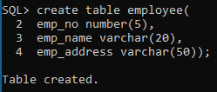

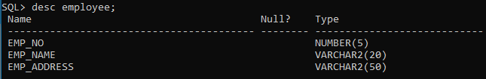

1. insert into employee values(10001, 'Ram', 'Mangalore');

insert into employee values(10002, 'Bhavya', 'Manipal');

insert into employee values(10003, 'Maya', 'Delhi');

insert into employee values(10004, 'Pulkit', 'Mumbai');

insert into employee values(10005, 'Lakshay', 'Nepal');

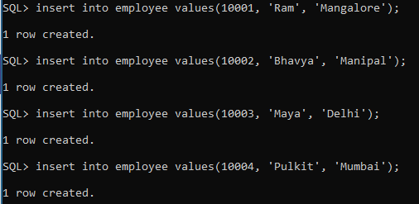

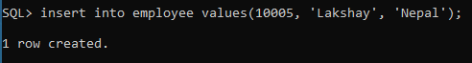

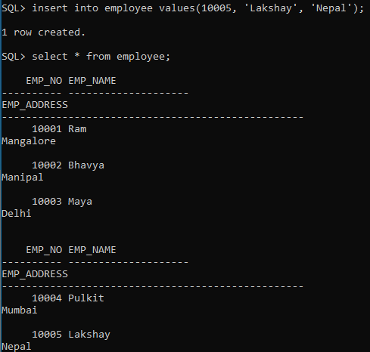

1. select emp_name from employee;

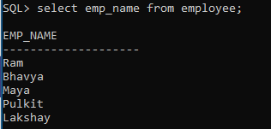

1. select emp_name from employee where emp_address = 'Manipal';

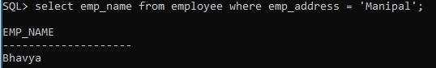

1. alter table employee add salary number(10);

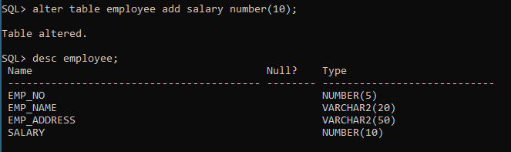

1. update employee set salary = 100000;

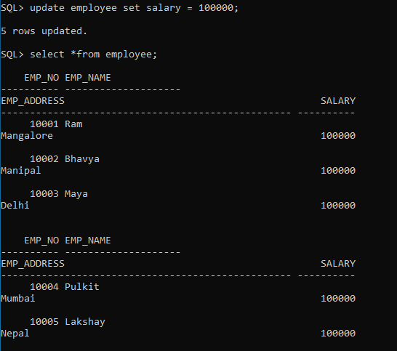

1. desc employee;

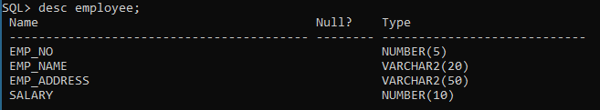

1. delete from employee where emp_address = 'Mangalore';

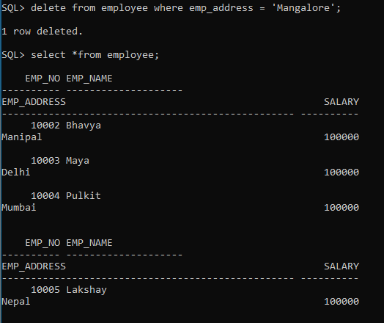

1. rename employee to employee1;



1. drop table employee1;

